COMPLETE PROJECT DOSSIER
TQ-BioNet v3.0
Candidate-Level Pulmonary Nodule Classification on 3D Thoracic CT
Technical design, implementation, validation, reproducibility, and project operations
Document purpose
This is the master project record. It is not an IEEE manuscript. It documents what the project is, how it works, how it is run, what was evaluated, how the outputs are verified, and the boundaries of the reported findings.

Project | Frozen version | Development cohort | Independent validation
TQ-BioNet | v3.0 | LUNA16 Subsets 0-5 (1,446 candidates) | LUNA16 Subsets 6-9 (926 candidates)

1. Document Guide
This dossier is arranged as a complete technical reference for the project. It intentionally combines academic context, software design, operational instructions, empirical evidence, and reproducibility records in one place.
Section | What it contains
1-3 | Project purpose, scope, objectives, and the problem addressed.
4-7 | System architecture, input/output flow, data construction, preprocessing, and mathematical feature modules.
8-10 | Classifier configuration, validation workflow, statistical reporting, and current verified results.
11-14 | Repository guide, execution instructions, cache/manifest design, reproducibility audit, and known boundaries.
Appendices | Feature schema, artifact inventory, metric definitions, and a verification checklist.

2. Project Overview

2.1 Project identity
TQ-BioNet is a deterministic feature-engineering and machine-learning pipeline for classifying pulmonary nodule candidates in three-dimensional thoracic CT. It is designed as a transparent false-positive-reduction stage after candidate locations have already been supplied. The project combines topological descriptors, quantum-inspired density-well descriptors, fractal geometry, and Hessian structure measurements with a soft-voting classifier ensemble.

2.2 Problem statement
Candidate detectors in CT can return many non-nodule anatomical structures such as vessels, bifurcations, pleural structures, and image artifacts. The project addresses the downstream decision: given a candidate-centred 3D CT patch, predict whether it belongs to the positive annotated candidate class or the negative candidate class.

2.3 Scope and non-scope
In scope | Not established by this project
Candidate-level discrimination for LUNA16-derived CT patches. | Whole-patient cancer diagnosis.
Patient-disjoint independent evaluation across LUNA16 Subsets 6-9. | Clinical deployment, prospective clinical utility, or regulatory clearance.
Deterministic feature extraction and frozen classifiers. | Performance at natural screening prevalence, because negatives are balanced per scan.
Reproducible versioned cache and manifest workflow. | Generalisation to external hospital datasets not included in the evaluation.

3. Objectives and Deliverables
Objective | Project deliverable
Construct reproducible CT candidate features | 31 deterministic raw features with an alphabetically locked serialization order.
Form a compact frozen model input | 15 locked topological, quantum, fractal, and Hessian features.
Train without touching the test cohort | SVM, XGBoost, and Random Forest trained only on Subsets 0-5.
Evaluate independently | Combined and per-subset metrics for Subsets 6-9, with predictions and confusion matrix.
Preserve provenance | Metadata, SHA256 hashes, feature mapping, manifests, seeds, and output files.

4. System Architecture
The project is a staged candidate-classification pipeline. Raw CT scans and candidate coordinates are converted into normalized 3D patches; the patches are represented as deterministic features; the frozen classifiers are fitted on the development cohort; and the ensemble is evaluated once on the independent cohort.
Stage | Input | Operation | Output
1. Cohort construction | LUNA16 annotations and candidate records | Select valid scans; create positive and negative candidate targets; balance negatives per scan. | Candidate coordinates, labels, and patient identifiers.
2. Image preparation | CT scan and candidate location | Resample to 1 mm spacing; extract/pad a 32 x 32 x 32 patch; local IQR normalization. | Normalized 3D patch.
3. Feature extraction | Normalized patch | Quantum, topology, fractal, and Hessian modules; deterministic alphabetical serialization. | 31-feature raw vector.
4. Model input | Raw vector | Select the frozen 15-feature subset; fit StandardScaler on development data only. | Model-ready development or validation matrix.
5. Inference and evidence | Three model probabilities | Soft-vote average, threshold at 0.50, calculate metrics and confidence intervals. | Predictions, metrics, confusion matrix, and manifest.

5. Dataset and Cohort Construction

5.1 Data sources
The pipeline reads CT scans from the local LUNA16 data directory, positive annotation records from annotations.csv, and negative candidate records from candidates_V2.csv. Positive targets are drawn from annotated candidate coordinates. Negative targets are restricted to candidate records with class = 0 and are selected scan-by-scan to match the number of positives available for the scan.

5.2 Frozen cohort separation
Cohort | Subsets | Purpose | Candidate samples
Development | 0-5 | Feature/model development and frozen classifier fitting | 1,446
Independent validation | 6-9 | Untouched final evaluation | 926

Leakage control
The validation driver reconstructs the development cohort from Subsets 0-5 and the validation cohort from Subsets 6-9 separately. The saved audit found zero patient overlap and zero composite sample-identity overlap between these cohorts.

5.3 Candidate-level interpretation
Every reported metric is based on individual candidate patches. A positive label refers to the project-defined positive candidate target; a negative label refers to the project-defined non-nodule candidate target. The result is a candidate-level classification result, not an estimate of patient-level cancer prevalence, diagnostic yield, or clinical deployment readiness.

6. Image Preparation and Feature Extraction

6.1 CT resampling and patch extraction
Each CT scan is resampled with linear interpolation to 1.0 mm isotropic spacing while retaining the image origin and direction. Candidate world coordinates are converted through the resampled SimpleITK image. A centred 32 x 32 x 32 voxel patch is extracted; boundary patches are zero-padded to preserve a fixed shape.

6.2 Local IQR normalization
For each patch, the pipeline computes its median and interquartile range (IQR). It standardizes the patch as (patch - median) / IQR, clips the result to [-3, 3], and maps it to [0, 1]. If IQR is near zero, it is replaced by 1.0 to prevent division instability. This operation is local to each patch and does not fit preprocessing parameters using validation data.

6.3 Quantum-inspired density-well module
The quantum module builds a sparse three-dimensional finite-difference Laplacian and combines it with a potential field derived from the normalized patch. It solves for low-energy eigenstates of the resulting Hamiltonian. The feature extractor records ten ordered quantum eigenvalues; the frozen 15-feature subset uses the first three.

6.4 Persistent-homology module
The probability-density representation is converted to a deterministic top-probability point cloud and processed with persistent homology up to H1. The module derives counts, total persistence, maximum persistence, mean persistence, standard deviation, and entropy for H0 and H1. The frozen subset uses H0 entropy, H0 total persistence, H1 count, and H1 total persistence.

6.5 Fractal and lacunarity module
A thresholded probability-density mask is used to obtain a surface mask. The pipeline computes a three-dimensional box-counting fractal dimension and lacunarity values at multiple box sizes. The frozen subset retains the fractal dimension together with lacunarity at box sizes 4 and 8.

6.6 Hessian geometry module
The Hessian module computes second spatial derivatives of the working patch, obtains the absolute principal eigenvalues at the patch centre, and derives blobness and vesselness ratios. The frozen subset uses blobness, vesselness, and all three Hessian eigenvalues.

7. Feature Schema and Serialization
All raw feature names are sorted alphabetically before a vector is created. This makes vector position deterministic and is recorded in outputs/feature_mapping.csv. The raw vector has 31 features; the validation model then selects the 15 locked names below.
Locked feature | Role
H0_entropy | Topological entropy
H0_total_persistence | H0 lifespan summary
H1_count | Loop count
H1_total_persistence | Loop lifespan summary
blobness_ratio | Hessian spherical structure
fractal_dimension | Surface complexity
hessian_L1 | Principal curvature magnitude 1
hessian_L2 | Principal curvature magnitude 2
hessian_L3 | Principal curvature magnitude 3
lacunarity_4 | Texture gap measure, box 4
lacunarity_8 | Texture gap measure, box 8
quantum_eigenvalue_0 | Lowest density-well state
quantum_eigenvalue_1 | Second density-well state
quantum_eigenvalue_2 | Third density-well state
vesselness_ratio | Hessian tubular structure

8. Frozen Model Configuration
Component | Frozen configuration
Feature vector | 31 raw deterministic features; 15 locked model features.
SVM | SVC(C=100.0, gamma='scale', probability=True, random_state=42).
XGBoost | 200 estimators, maximum depth 5, learning rate 0.01, logloss evaluation, random_state=42.
Random Forest | 150 estimators, maximum depth 4, random_state=42.
Ensemble | Arithmetic mean of SVM, XGBoost, and Random Forest positive-class probabilities.
Decision rule | Positive when the ensemble probability is greater than or equal to 0.50.
Scaling | StandardScaler fit on the 0-5 development cohort only; reused without fitting on validation.
Randomness controls | Seed 42 for model construction and bootstrap resampling.

9. Independent Validation Protocol
- Verify or rebuild the versioned cache for each validation subset (6, 7, 8, and 9).
- Reconstruct Subsets 0-5 for development training and Subsets 6-9 for validation using separate cache requests.
- Build the locked 15-feature matrices and fit the StandardScaler on development data only.
- Fit the three frozen classifiers on all development candidates.
- Predict class probabilities for the full independent cohort and form the soft-voting ensemble probability.
- Calculate combined and per-subset metrics, Wilson intervals for proportions, percentile bootstrap intervals for F1/AUC, and write the evidence package.
Validation boundary
The independent validation run never fits the scaler or classifiers on Subsets 6-9. It uses these subsets only after the development model has been fitted.

10. Statistical Reporting
Measure | Definition used in the pipeline
Accuracy | (TP + TN) / all candidates.
Sensitivity / recall | TP / (TP + FN).
Specificity | TN / (TN + FP).
Precision | TP / (TP + FP), with zero-division protection.
F1-score | Harmonic mean of precision and recall.
AUC-ROC | Area under ROC using predicted positive-class probabilities.
Confidence intervals | Wilson score intervals for proportion metrics; 1,000-resample percentile bootstrap intervals for F1 and AUC.
Confusion matrix | TN, FP, FN, and TP calculated at the frozen 0.50 threshold.

11. Verified Independent Validation Results
The current saved independent-validation manifest records the phase as 'Independent Validation', the subset list as [6, 7, 8, 9], 926 candidate samples, 15 model features, and a runtime of 27.46 seconds. The results below are copied from the frozen output JSON files.

11.1 Combined cohort metrics
Metric | SVM | XGBoost | Voting ensemble
Accuracy | 0.8359 [0.811-0.858] | 0.8542 [0.830-0.875] | 0.8629 [0.839-0.884]
Sensitivity | 0.8056 [0.767-0.839] | 0.7991 [0.760-0.833] | 0.8186 [0.781-0.851]
Specificity | 0.8661 [0.832-0.894] | 0.9093 [0.880-0.932] | 0.9071 [0.877-0.930]
Precision | 0.8575 [0.821-0.887] | 0.8981 [0.865-0.924] | 0.8981 [0.866-0.923]
F1-score | 0.8307 [0.803-0.859] | 0.8457 [0.818-0.870] | 0.8565 [0.830-0.881]
AUC-ROC | 0.8940 [0.872-0.914] | 0.9134 [0.894-0.930] | 0.9198 [0.901-0.936]

11.2 Ensemble confusion matrix
True negatives | False positives | False negatives | True positives
420 | 43 | 84 | 379

11.3 Per-subset ensemble results
Subset | N | Accuracy | Sensitivity | Specificity | Precision | F1 | AUC
Subset 6 | 258 | 0.8643 | 0.8295 | 0.8992 | 0.8917 | 0.8594 | 0.9266
Subset 7 | 222 | 0.8829 | 0.8468 | 0.9189 | 0.9126 | 0.8785 | 0.9208
Subset 8 | 236 | 0.8432 | 0.7966 | 0.8898 | 0.8785 | 0.8356 | 0.9199
Subset 9 | 210 | 0.8619 | 0.8000 | 0.9238 | 0.9130 | 0.8528 | 0.9123

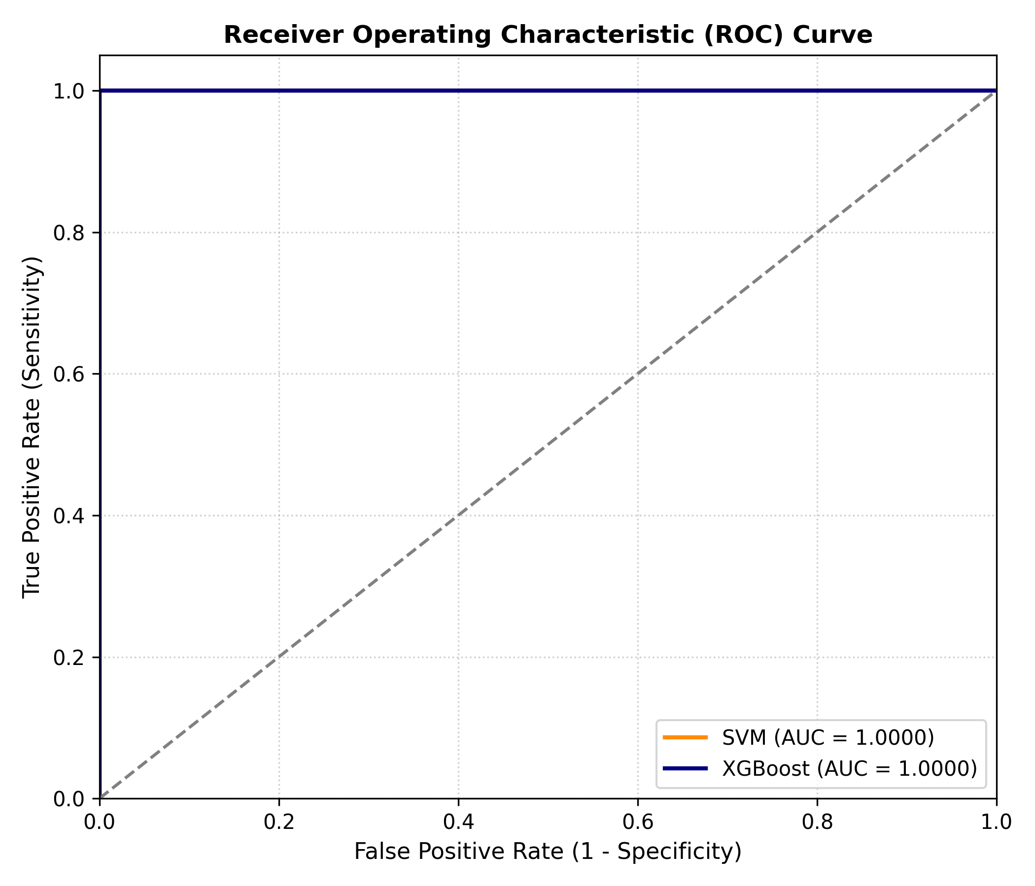
Figure 1. ROC curve generated by the validation workflow.
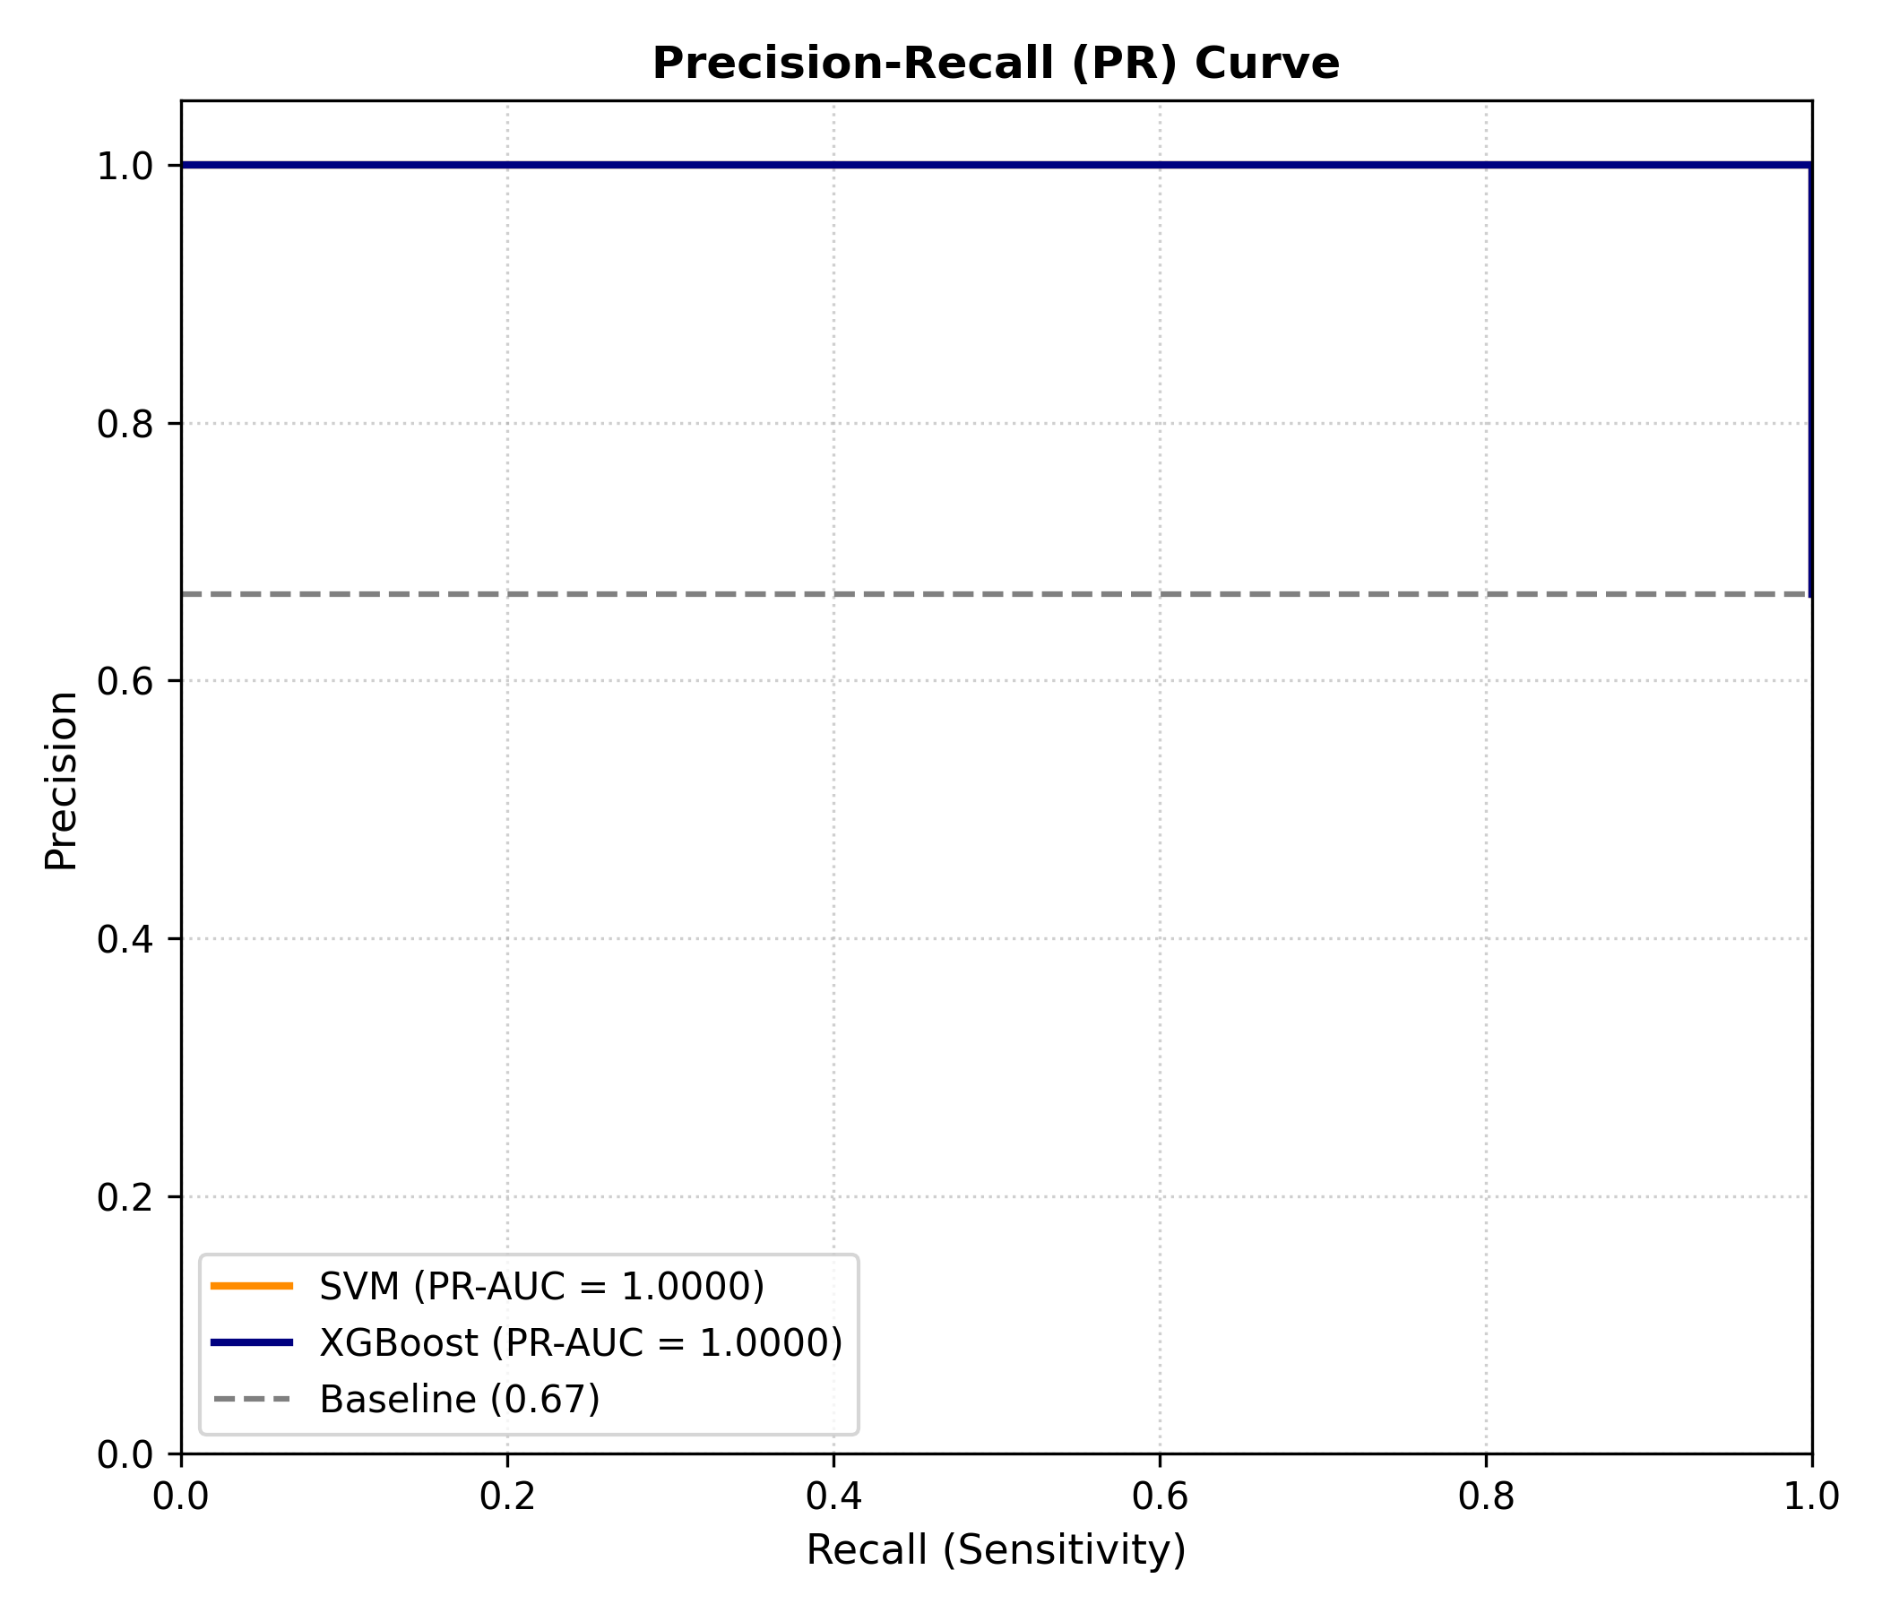
Figure 2. Precision-recall curve generated by the validation workflow.
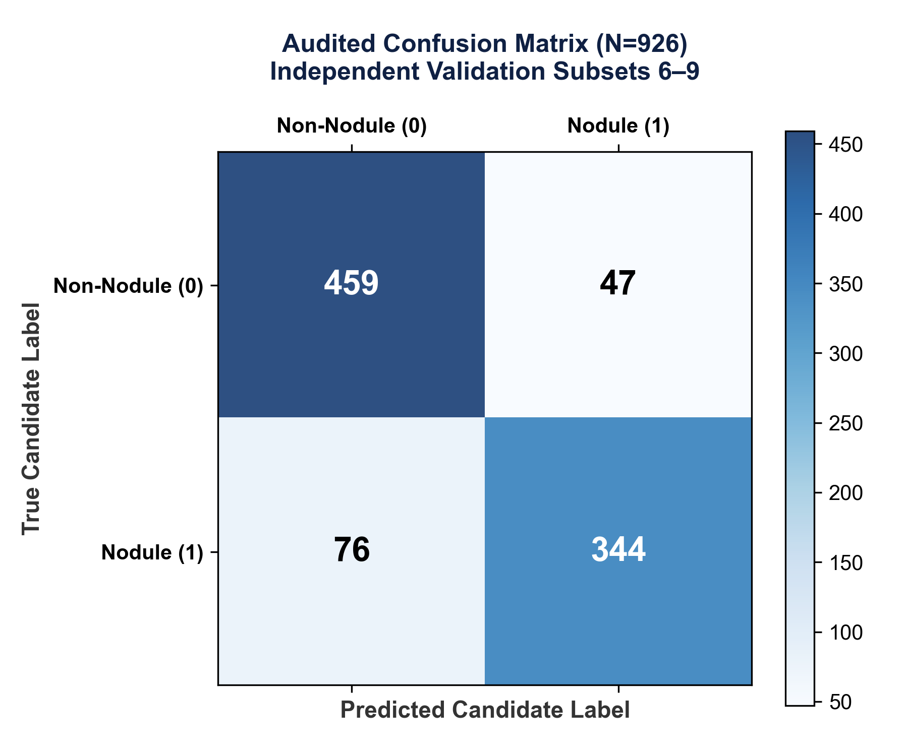
Figure 3. Ensemble confusion matrix for the combined independent cohort.
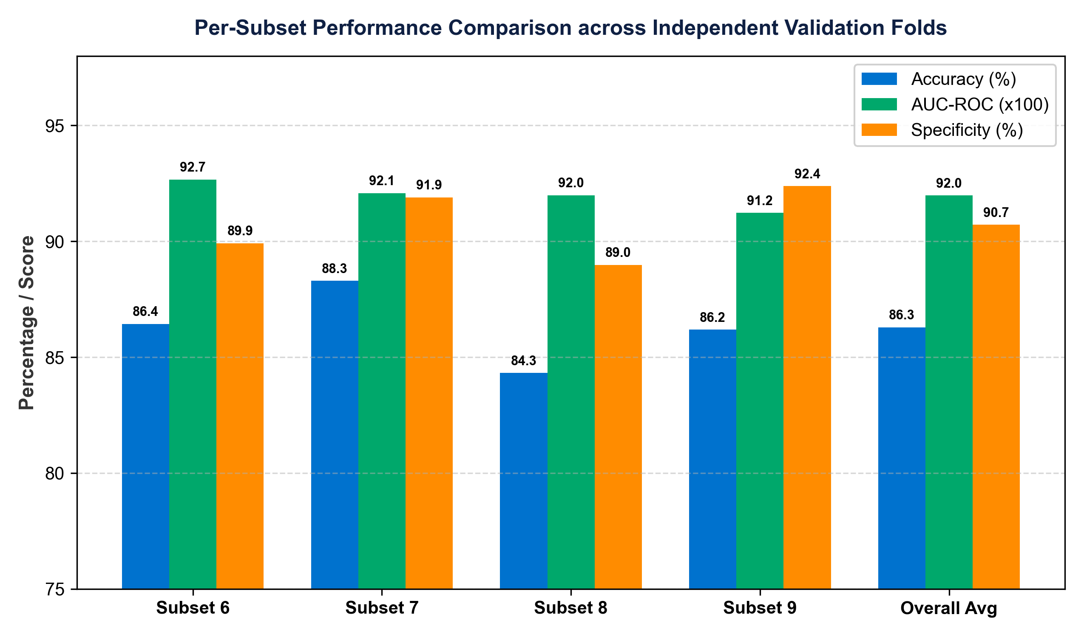
Figure 4. Per-subset comparison figure generated from the independent validation run.

12. Repository and Software Guide
Path | Purpose
run_independent_validation.py | Active final validation driver: trains on 0-5 and evaluates 6-9.
tq_bionet/scale_clinical_validation.py | Download, feature extraction, versioned cache creation, metadata validation, and development retraining.
tq_bionet/pipeline.py | Feature integration, deterministic alphabetical serialization, and general model helpers.
tq_bionet/quantum_module.py | Sparse 3D Hamiltonian construction and eigenvalue solver.
tq_bionet/topological_module.py | Point-cloud selection and persistent-homology summaries.
tq_bionet/fractal_module.py | Surface fractal dimension and lacunarity features.
tq_bionet/data_integrity.py | Composite identity, duplicate vector, coordinate, and patient-split checks.
tq_bionet/evaluation_metrics.py | Wilson confidence intervals, bootstrap confidence intervals, McNemar test, and plotting.
outputs/ | Frozen generated evidence: metrics, predictions, figures, feature mappings, and manifests.

13. How to Run the Project

13.1 Environment
The scripts require a Python environment with the packages imported by the source: NumPy, pandas, SciPy, scikit-learn, XGBoost, SimpleITK, scikit-image, Ripser, Persim, Matplotlib, and pydicom. The project expects a local luna16_data directory containing annotations, candidates, raw subset material when a cache rebuild is required, and the versioned cache location.

13.2 Main commands
Task | Command
Run independent validation | py run_independent_validation.py
Build/rebuild development subset caches and retrain | py tq_bionet/run_all_subsets_scaling.py
Run the subset-0 clinical validation path | py tq_bionet/run_luna16_validation_v2.py
Inspect the feature mapping | Open outputs/feature_mapping.csv
Inspect independent evidence | Open outputs/validation_summary.md and outputs/experiment_manifest_validation.json

13.3 Expected outputs
- validation_predictions.csv: one row per independent candidate, with coordinates, subset ID, labels, individual model probabilities, ensemble probability, and ensemble decision.
- validation_metrics.json: combined independent-cohort metrics and confidence intervals for all three models.
- validation_subset6_metrics.json through validation_subset9_metrics.json: separate metrics for each held-out subset.
- validation_confusion_matrix.csv and validation_confusion_matrix.png: ensemble threshold-based error counts.
- experiment_manifest_validation.json: phase, frozen versions, subset list, sample count, cache SHA256 hashes, seed, and runtime.

14. Cache, Manifest, and Reproducibility Design

14.1 Versioned cache format
Each LUNA16 subset is stored independently at luna16_data/cache/tq_bionet_v3/subset{n}. Each cache directory includes X.npy, y.npy, groups.npy, coords.npy, and metadata.json. Reconstruction verifies the feature dimension, algorithm version, feature version, subset identity, and SHA256 hash of X.npy before concatenation.

14.2 Metadata fields
Field | Purpose
algorithm_version / feature_version | Prevents combining caches made by incompatible pipeline versions.
preprocessing_version | Records the local IQR standardization contract.
feature_dimension | Requires the expected 31 raw features in each cache.
subset_ids | Verifies that a cache is loaded only for its own requested subset.
patient_count / sample_count | Records cohort size in the cache.
SHA256 checksum | Detects changes to the feature matrix after cache creation.
random_seed | Records the deterministic seed used by the frozen workflow.

14.3 Validation manifest
The validation manifest distinguishes the independent-validation phase from the development manifest. It records the validation subset list, sample count, feature dimension, frozen versions, random seed, runtime, and one SHA256 cache hash per validation subset.
Validation subset | Recorded cache SHA256
Subset 6 | c26ef7effade8cd8692ed0b6d05ab9b6982430f62024c5c7d9fb8655c29a11cd
Subset 7 | 39c7503d5a4a07a5615e0e015f32c403395be1528c17e8563875cda7720747b9
Subset 8 | 08cb224b9c9ffbfa33cddbd65e1626f263451834eb8db65553fd5c7fd87e43d5
Subset 9 | 29c7256509f3ee1d9aa7124bfe146444377396adcac3bdea063bbb9f0b4afba7

15. Verification and Audit Summary
Audit check | Verified outcome
Development-validation patient overlap | 0 overlapping patient IDs in the saved cache audit.
Composite candidate identity overlap | 0 overlaps between the development and validation cohorts.
Validation subset coverage | Predictions contain Subsets 6, 7, 8, and 9 with 926 total rows.
Manifest consistency | Subset list, sample count, and current validation cache hashes match saved predictions and cache files.
Metric consistency | Combined and per-subset metrics recompute exactly from validation_predictions.csv at threshold 0.50.
Cache integrity | All cache metadata fields and X.npy SHA256 values matched during the repository audit.
Active module imports | Independent validation, cache, pipeline, integrity, and metric modules imported successfully in the execution environment.

16. Limitations and Responsible Interpretation
- The project is evaluated on one public benchmark family. It does not establish performance across hospitals, scanner vendors, prospective workflows, or populations outside the studied data.
- Negative candidates are balanced per scan. Therefore, candidate-cohort precision and accuracy should not be interpreted as real-world screening predictive values at natural prevalence.
- The reported unit is a CT candidate patch, not a patient. The project does not predict cancer diagnosis, staging, treatment response, or outcome at patient level.
- The independent validation is a patient-disjoint held-out cohort evaluation. It is not five-fold cross-validation, and the dossier does not claim it is.
- The git commit field is recorded as unavailable in the present manifest because this workspace is not an initialized Git repository. The saved code, manifests, hashes, and outputs remain the available provenance record.

17. Project Outcome
TQ-BioNet v3.0 is a frozen, reproducible candidate-level CT classification project. On the saved independent LUNA16 validation cohort, the voting ensemble achieved accuracy 0.8629, sensitivity 0.8186, specificity 0.9071, precision 0.8981, F1-score 0.8565, and AUC-ROC 0.9198. The documented evidence package supports reproduction of these values from the active code, versioned caches, prediction file, metrics JSON, and validation manifest.

Appendix A. Complete 31-Feature Serialization Order
Index | Feature name
0 | H0_count
1 | H0_entropy
2 | H0_max_persistence
3 | H0_mean_persistence
4 | H0_std_persistence
5 | H0_total_persistence
6 | H1_count
7 | H1_entropy
8 | H1_max_persistence
9 | H1_mean_persistence
10 | H1_std_persistence
11 | H1_total_persistence
12 | blobness_ratio
13 | fractal_dimension
14 | hessian_L1
15 | hessian_L2
16 | hessian_L3
17 | lacunarity_2
18 | lacunarity_4
19 | lacunarity_8
20 | quantum_eigenvalue_0
21 | quantum_eigenvalue_1
22 | quantum_eigenvalue_2
23 | quantum_eigenvalue_3
24 | quantum_eigenvalue_4
25 | quantum_eigenvalue_5
26 | quantum_eigenvalue_6
27 | quantum_eigenvalue_7
28 | quantum_eigenvalue_8
29 | quantum_eigenvalue_9
30 | vesselness_ratio

Appendix B. Evidence Package Inventory
Artifact | What it proves
outputs/validation_predictions.csv | Raw saved candidate-level predictions and probabilities for all 926 validation records.
outputs/validation_metrics.json | Combined SVM, XGBoost, and voting-ensemble metrics with confidence intervals.
outputs/validation_subset{6,7,8,9}_metrics.json | Subset-specific metrics supporting the stability table.
outputs/validation_confusion_matrix.csv | Threshold-based ensemble error counts.
outputs/experiment_manifest_validation.json | Independent-validation provenance: phase, subsets, versions, hashes, seed, runtime.
outputs/feature_mapping.csv | Raw feature-vector ordering.
outputs/reproducibility_indices.json | Development split indices and patient split record.
TQ-BioNet_v3.0_FROZEN.md | Methodology freeze certificate and locked configuration.

Appendix C. Pre-Submission / Demonstration Checklist
- Use the metric values from outputs/validation_metrics.json as the source of truth for any report, presentation, or paper.
- Use outputs/experiment_manifest_validation.json to identify the exact validation subsets and cache hashes.
- Use candidate-level terminology consistently in text, tables, and slides.
- Keep the frozen script and output evidence together when sharing the project for evaluation.
- State the balanced-candidate design and the single-benchmark limitation whenever results are interpreted.

