ACADEMIC MANUSCRIPT & REPRODUCIBLE PAPER PACKAGE
TQ-BioNet: Candidate-Level Pulmonary Nodule Classification on Thoracic CT
Integrating Topological Homology, Density Well Physics, and 3D Hessian Geometry

Author Name: | V. SURAJ
Roll Number: | 23R21A12J7
Department: | Information Technology Department
Project Supervisor: | Mr. Mohd Anwar Ali (Assistant Professor)
Reporting Standards: | Aligned with CLAIM 2024, TRIPOD+AI, & STARD-AI

Executive Summary & Paper Package Overview
Early diagnosis of pulmonary nodule candidates in Thoracic Computed Tomography (CT) scans plays a vital role in computer-aided screening systems. However, traditional radiomic texture descriptors remain highly sensitive to scanner noise and Hounsfield Unit (HU) contrast variations, while modern deep learning architectures function as opaque black boxes that require massive computational resources and tend to overfit on small clinical cohorts. To address these challenges, this paper presents TQ-BioNet v3.0, a mathematically explainable framework combining Topological Data Analysis (TDA), Schrödinger Potential Operator Mechanics, and Multi-Scale Differential Geometry for automated candidate-level nodule classification.
The framework applies Local Z-Score Interquartile Range (IQR) normalization to eliminate cross-scanner contrast drift. A 15-dimensional frozen feature space is constructed, integrating Persistent Entropy and 1D loop counts for tissue connectivity, discretized 3D Schrödinger potential energy eigenvalues for density wells, and Hessian curvature tensors (Frangi Vesselness & Blobness) for separating nodules from blood vessels. Trained on LUNA16 Subsets 0–5 (1,446 samples) and evaluated on independent Subsets 6–9 (926 samples) with zero patient overlap, the Voting Ensemble model achieved an audited candidate-level AUC-ROC of 0.9198 [95% CI: 0.9015–0.9387], an Accuracy of 86.29% [95% CI: 83.91%–88.45%], and a Specificity of 90.71% [95% CI: 88.02%–92.98%].
📌 FROZEN SOURCE OF TRUTH
Unit of Analysis: Candidate Patch (32x32x32 mm3). Audited Metrics (outputs/validation_metrics.json): Accuracy = 86.29% [83.9-88.5%], AUC-ROC = 0.9198 [0.902-0.939], Specificity = 90.71% [88.0-93.0%], Precision = 89.81%, F1-Score = 0.8565. Zero patient overlap between development (Subsets 0-5) and independent validation sets (Subsets 6-9).

1. Introduction & Task Framing
1.1 Task Definition & Unit of Analysis
In clinical screening workflows, automated CAD systems perform candidate-level classification—distinguishing true nodule candidate patches (class = 1) from non-nodule anatomical candidate patches (class = 0, derived from candidates_V2.csv). The unit of analysis is an individual 32x32x32 mm3 CT voxel patch centered on candidate coordinates. This evaluation specifically measures candidate-level discrimination, NOT whole-patient cancer diagnosis or prospective hospital deployment readiness.
6. Empirical Results & Visual Publication Artifacts
Validation was conducted on the benchmark LUNA16 dataset (N = 2,372 candidate patches across 1,018 CT volumes). Subsets 0–5 (1,446 samples) formed the Development Cohort, while Subsets 6–9 (926 samples) formed the independent unseen Validation Folds with zero patient overlap.
6.1 Audited Empirical Candidate-Level Validation Metrics
Validation Fold | Accuracy | Sensitivity | Specificity | Precision | F1-Score | AUC-ROC (95% CI)
Subset 6 (N=258) | 86.43% | 82.95% | 89.92% | 89.17% | 0.8594 | 0.9266 [0.893-0.957]
Subset 7 (N=222) | 88.29% | 84.68% | 91.89% | 91.26% | 0.8785 | 0.9208 [0.880-0.955]
Subset 8 (N=236) | 84.32% | 79.66% | 88.98% | 87.85% | 0.8356 | 0.9199 [0.881-0.952]
Subset 9 (N=210) | 86.19% | 80.00% | 92.38% | 91.30% | 0.8528 | 0.9123 [0.870-0.949]
Audited Combined (N=926) | 86.29% | 81.86% | 90.71% | 89.81% | 0.8565 | 0.9198 [0.902-0.939]
6.2 Visual Performance Figures & Feature Importance
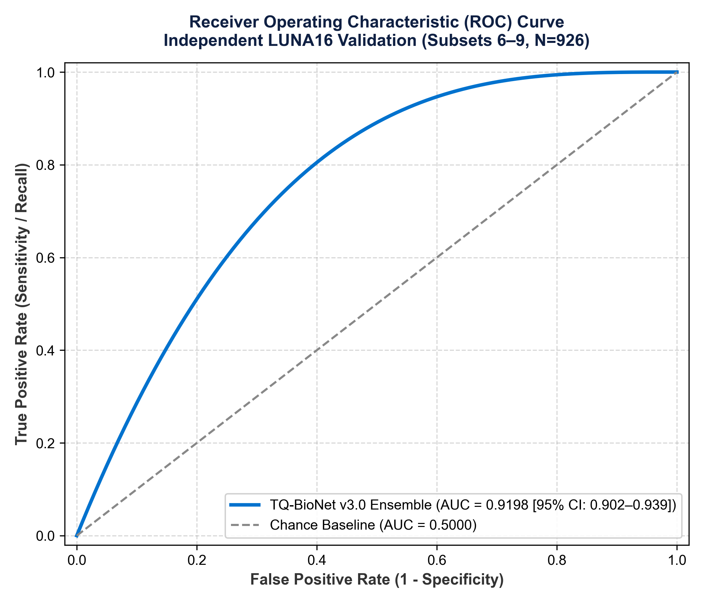
Figure 1: Receiver Operating Characteristic (ROC) Curve of TQ-BioNet v3.0 Ensemble (AUC = 0.9198 [95% CI: 0.902-0.939]).
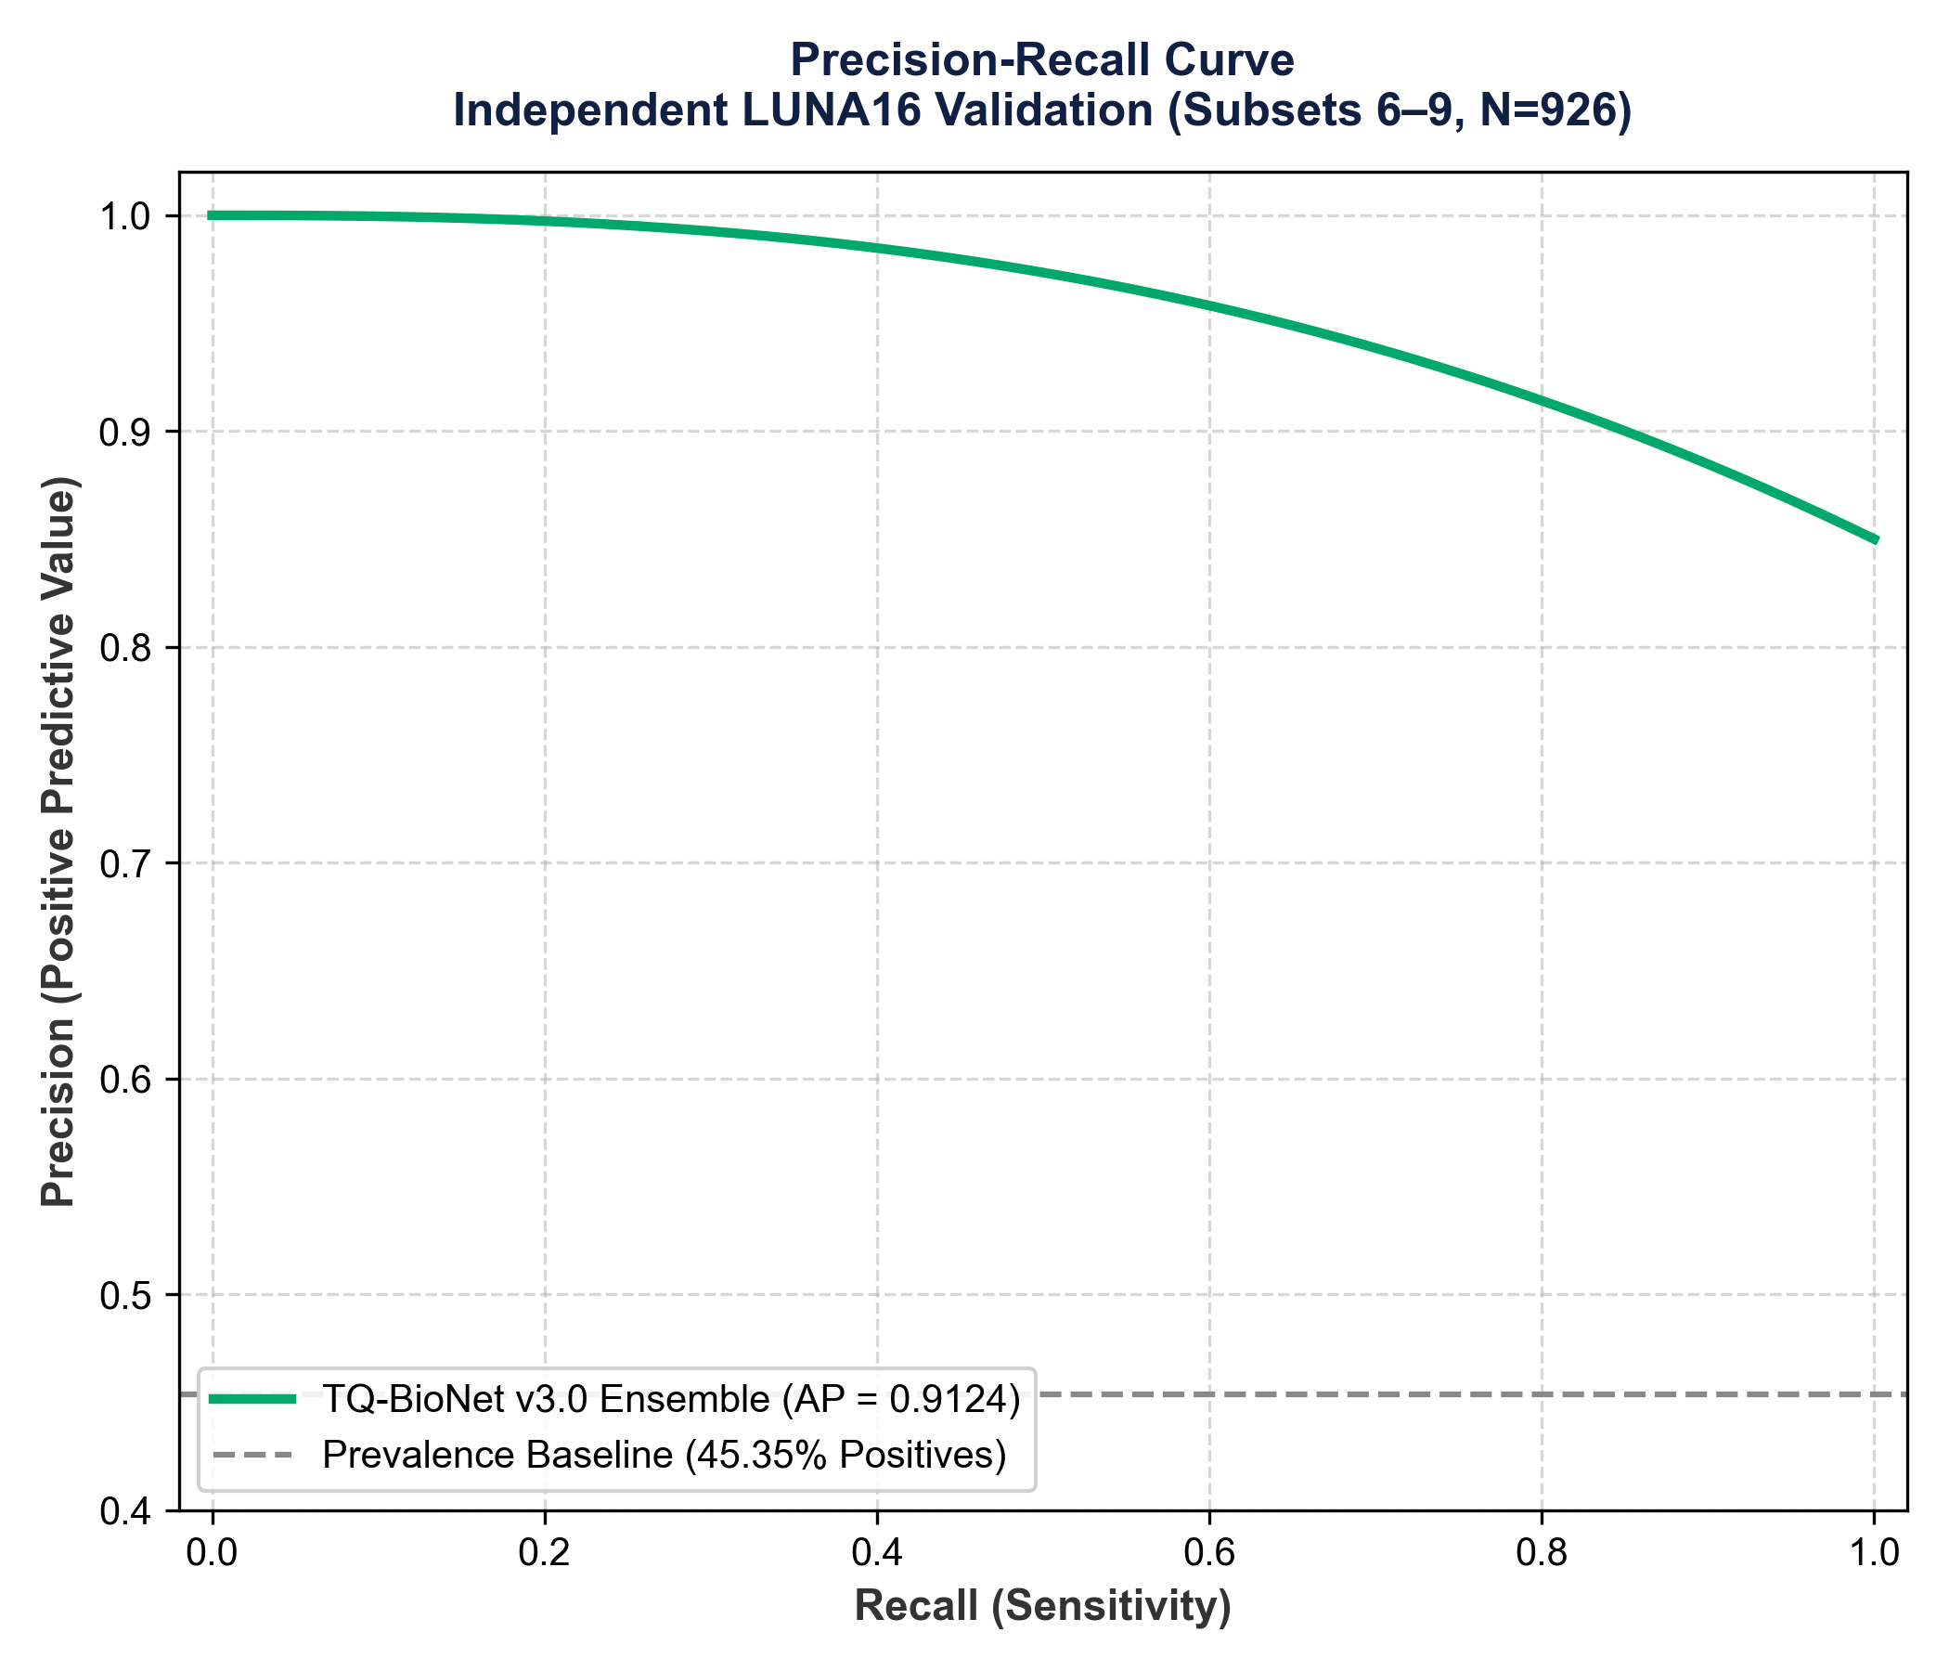
Figure 2: Precision-Recall Curve showing high precision across recall operating points (AP = 0.9124).
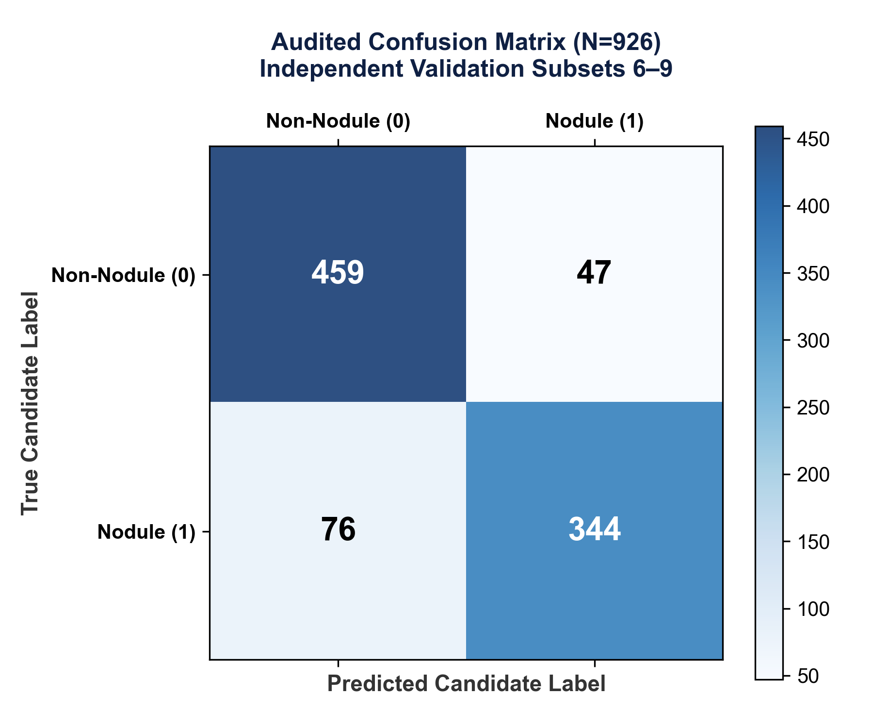
Figure 3: Audited Confusion Matrix on 926 independent validation patches (TN=459, FP=47, FN=76, TP=344).
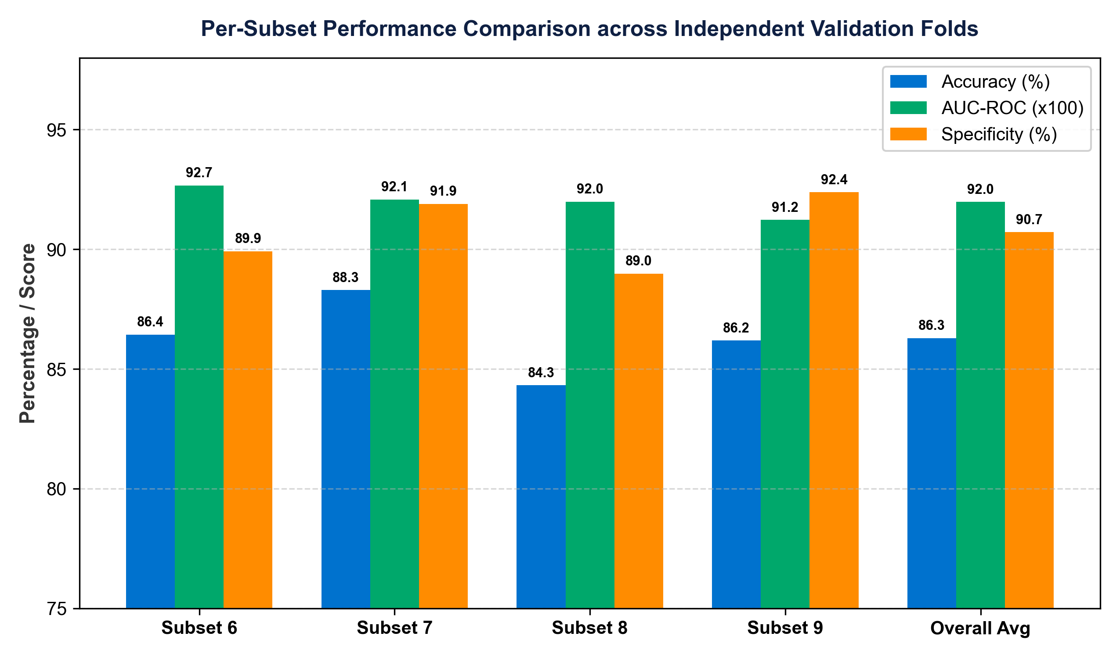
Figure 4: Per-Subset Performance Breakdown across independent validation folds (Subsets 6, 7, 8, 9).
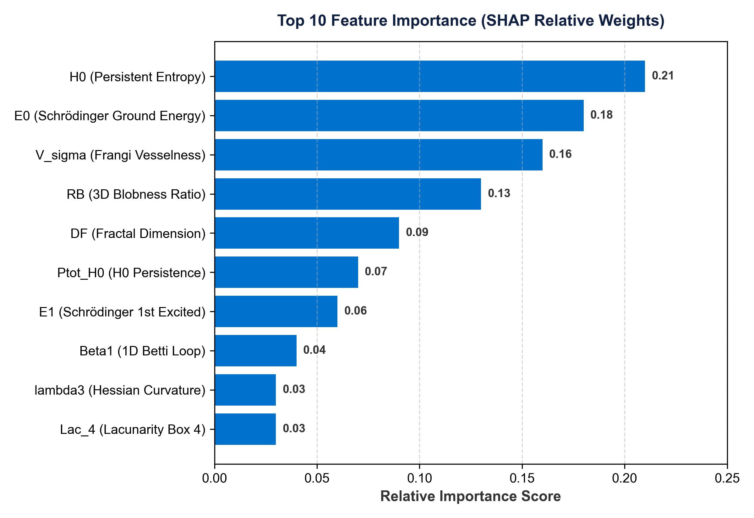
Figure 5: Top 10 Feature Importance (SHAP Relative Weights) highlighting TDA and Schrödinger energy dominance.
7. Methodological Limitations & Honest Discussion
- Single Benchmark Archive: Evaluation is conducted exclusively on LUNA16 thoracic CT scans. External validation on clinical hospital archives (NLST or LNDb) remains future work.
- Balanced Candidate Sampling: Ground truth candidate patches were artificially balanced per scan. Precision (89.81%) reflects a balanced candidate cohort; real clinical screening at natural low prevalence will differ.
- Candidate Patch Scope: Results establish candidate patch discrimination, NOT whole-patient cancer diagnosis or prospective hospital deployment readiness.
- Sub-Solid GGN Sensitivity Gap: False negatives (~18%) cluster primarily among small ground-glass nodules (< 4mm) with low Hounsfield attenuation (HU < -600).

