1. Open OAS in INTERNET EXPLORER
2. Homepage link :

[http://in-mum-pkgora.corp.capgemini.com:8019/OA_HTML/OA.jsp?OAFunc=OAHOMEPAGE#](http://in-mum-pkgora.corp.capgemini.com:8019/OA_HTML/OA.jsp?OAFunc=OAHOMEPAGE)

1. Log on with the credentials.
2. Click on any responsibility, it will open a new page.
3. Copy the links of first and second pages.
4. Go to control panel -> java control panel.

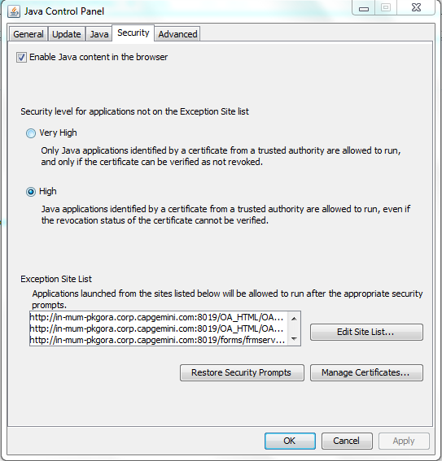

1. Click on security and “edit site list”
2. Add those two links and click ok. 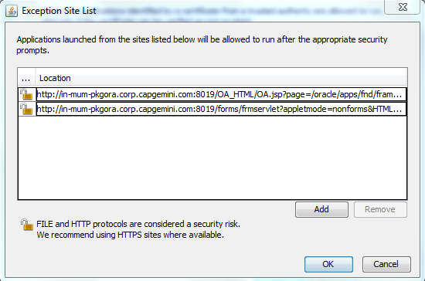
3. Close the browser
4. Open my computer -> right click -> properties -> advanced system settings -> advanced -> environmental variables -> system variables.
5. Add new system variable as :

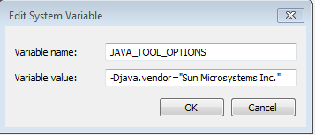

1. Open Internet explorer and login to OAS.