## 3.1: Joins and Subqueries

**1.** Write a query which displays Staff Name, Department Code, Department Name, and Salary for all staff who earns more than 20000.

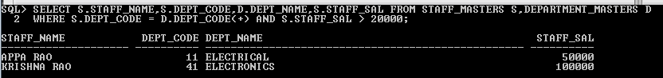

**2.** Write a query to display Staff Name, Department Code, and Department Name for all staff who do not work in Department code 10 and have ‘A’ in their name.

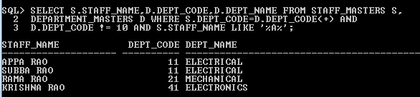

**3.** Display Staff Code, Staff Name, Department Name, and his manager’s number and name. Label the columns Staff#, Staff, Mgr#, Manager.

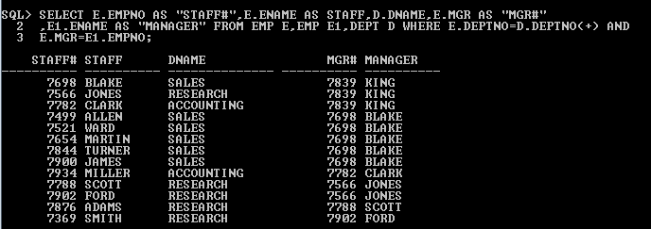

**4.** Create a query that will display Student Code, Student Name, Department Name, Subjec1, Subject2, and Subject3 for all students who are getting 60 and above in each subject from department 10 and 20.



**5**. Create a query that will display Student Code, Student Name, Book Code, and Book Name for all students whose expected book return date is today.



**6.** Create a query that will display Staff Code, Staff Name, Department Name, Designation, Book Code, Book Name, and Issue Date. For only those staff who have taken any book in last 30 days.

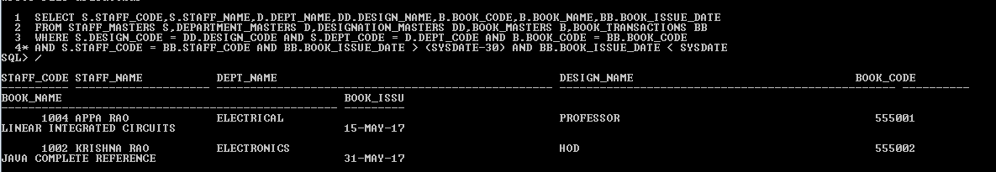

**7.** Generate a report which contains the following information.

Staff Code Staff Name Designation Department Name

Department Head

For all staff excluding HOD (List should not contain the details of Department head).

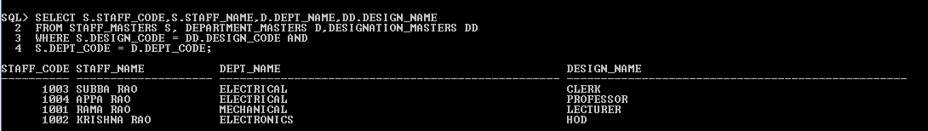

**8.** Generate a report which contains the following information

Student Code Student Name Department Name Total Marks

HOD Name

Sort the output on Department Name and Total Marks.

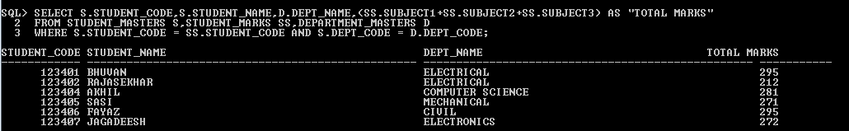

**9**. Generate a report which contains the following information.

Staff Code, Staff Name, Designation, Department, Book Code, Book Name,

Author, Fine

For the staff who have not return the book. Fine will be calculated as Rs. 5 per day.

Fine = 5 * (No. of days = Current Date – Expected return date).

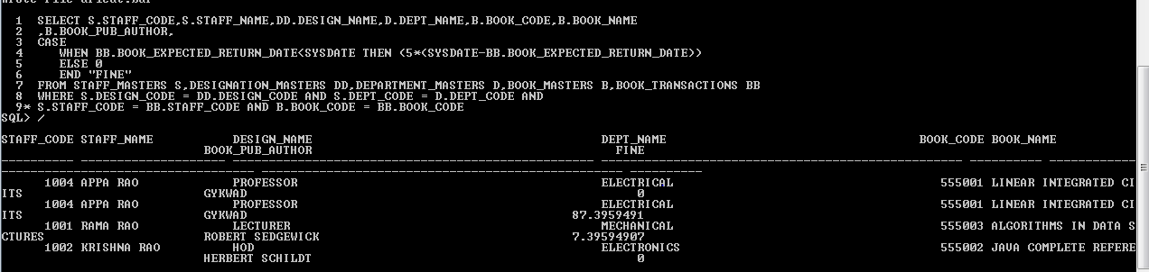

**10.** List Staff Code, Staff Name, and Salary for those who are getting less than the average salary of organization.

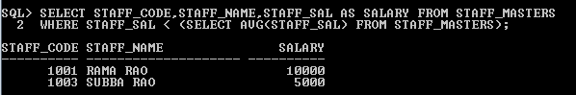

**11.** List the Staff Code, Staff Name who are not Manager.

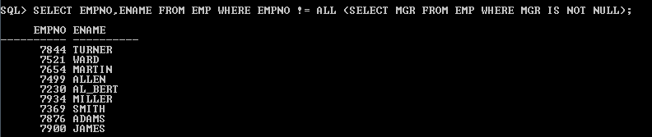

**12.** Display Author Name, Book Name for those authors who wrote more than one book.

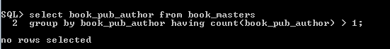

**13**. Display Staff Code, Staff Name, and Department Name for those who have taken more than one book.

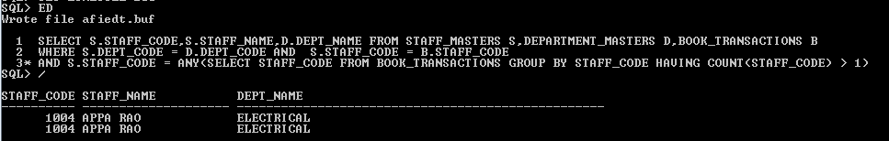

**14.** Display top ten students for a specified department. Details are:

Student Code, Student Name, Department Name, Subject1, Subject2,

Subject3, Total.

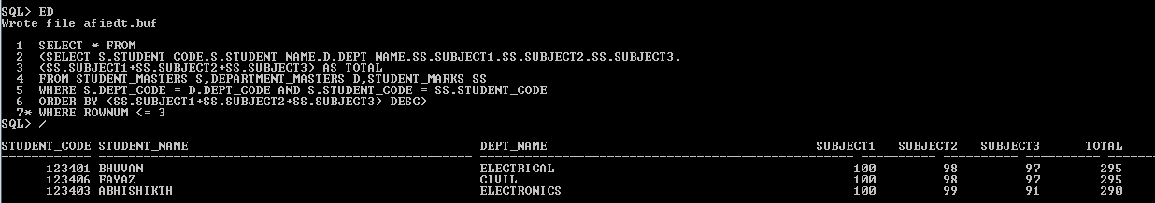

**15.** Display the Staff Name, Department Name, and Salary for those staff who are getting less than average salary in their own department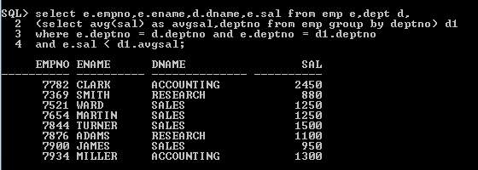

**16.** Create a query that will display the Staff Name, Department Name, and all the staff that work in the same department as a given staff. Give the column as appropriate label.

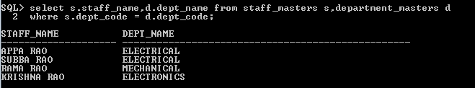

**17.** List the Student Code, Student Name for that student who got highest marks in all three subjects in Computer Science department for current year.

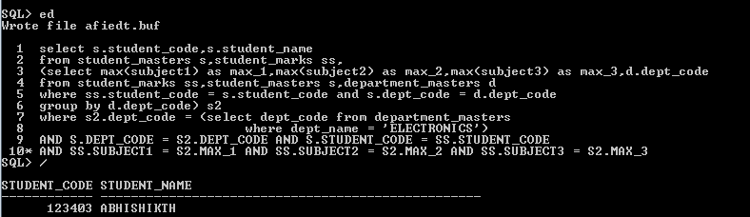

**18.** Display the Student Code, Student Name, and Department Name for that department in which there are maximum number of student are studying.

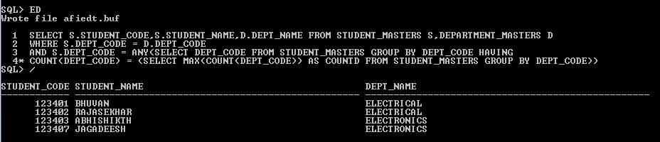

**19.** Display Staff Code, Staff Name, Department Name, and Designation for those who have joined most recently.

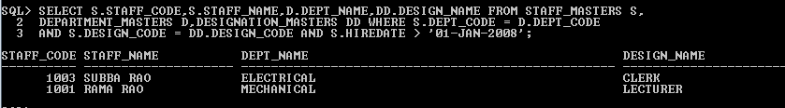

**20.** Display the Manager Name and the total strength of his/her team.

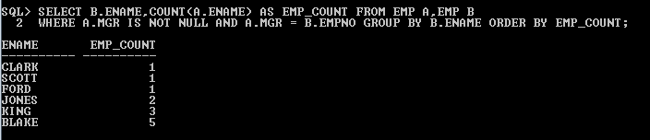

## 3.2: Set Operators

Observe the following queries and do the given assignments.

create table previous_products (

pid int,

name varchar(40),

unit varchar(40),

price int,

stock int );

Example 1: Sample Code

create table current_products (

pid int,

name varchar(40),

unit varchar(40),

price int,

stock int );

Example 2: Sample Code

insert into previous_products values(7,'Uncle Bob''s Organic Dried Pears','12 - 1 lb pkgs.',30.00,15);

insert into previous_products values(8,'Northwoods Cranberry Sauce','12 - 12 oz jars',40.00,6);

insert into previous_products values(1,'Chang','24 - 12 oz bottles',19.00,17);

insert into previous_products values(3,'Aniseed Syrup','12 - 550 ml bottles',10.00,13);

insert into previous_products values(4,'Chef Anton''s Cajun Seasoning','48 - 6 oz jars',22.00,53);

insert into previous_products values(5,'Chef Anton''s Gumbo Mix','36 boxes',21.35,0);

insert into previous_products values(6,'Grandma''s Boysenberry Spread','12 - 8 oz jars',25.00,120);

Example 3: Sample Code

insert into current_products values(7,'Uncle Bob''s Organic Dried Pears','12 - 1 lb pkgs.',30.00,15);

insert into current_products values(8,'Northwoods Cranberry Sauce','12 - 12 oz jars',40.00,6);

insert into current_products values(9,'Mishi Kobe Niku','18 - 500 g pkgs.',97.00,29);

insert into current_products values(10,'Ikura','12 - 200 ml jars',31.00,31);

insert into current_products values(11,'Queso Cabrales','1 kg pkg.',21.00,22);

insert into current_products values(5,'Chef Anton''s Gumbo Mix','36 boxes',21.35,0);

insert into current_products values(6,'Grandma''s Boysenberry Spread','12 - 8 oz jars',25.00,120);

Example 4: Sample Code

**1.** Get the details of all products irrespective of the fact whether they are in previous set or current set.

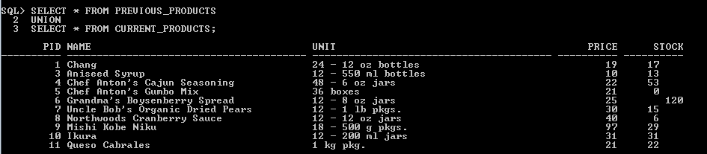

**2.** Get the details of all products along with the repetition of those that were present both in the previous and current sets.

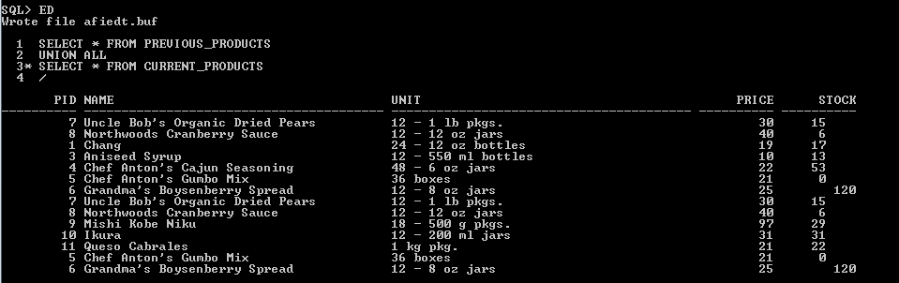

**3.** Get the details of only those products which were present in the previous set and are still continuing.

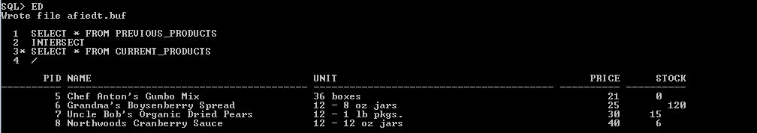

**4.** Get the details of all obsolete products (no longer continued).

