## 5.1: Data Manipulation Language

**1.** Create Employee table with same structure as EMP table.

SQL>Create table employee as select \* from emp where 1=3

SQL>desc employee

|  |  |  |
| --- | --- | --- |
| **Name** | **Null?** | **Type** |
| EMPNO | NOT NULL | NUMBER(4) |
| ENAME |  | VARCHAR2(10) |
| JOB |  | VARCHAR2(50) |
| MGR |  | NUMBER(4) |
| HIREDATE |  | DATE |
| SAL |  | NUMBER(7,2) |
| COMM |  | NUMBER(7,2) |
| DEPTNO |  | NUMBER(2) |

SQL>select \* from employee

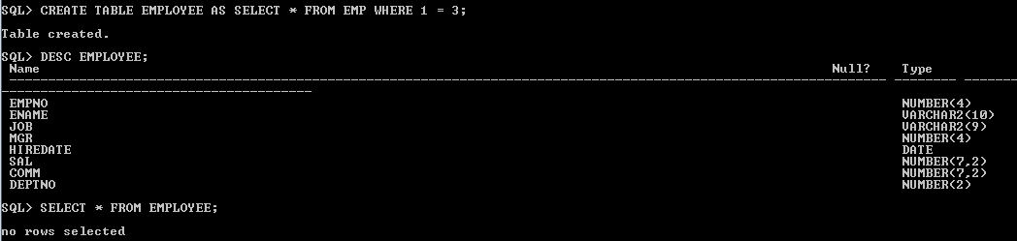

**2.** Write a query to populate Employee table using EMP table’s empno, ename, sal, deptno columns.

SQL>select \* from employee

|  |  |  |  |  |  |  |  |
| --- | --- | --- | --- | --- | --- | --- | --- |
| **EMPNO** | **ENAME** | **JOB** | **MGR** | **HIREDATE** | **SAL** | **COMM** | **DEPTNO** |
| 7369 | SMITH |  |  |  | 800 |  | 20 |
| 7499 | ALLEN |  |  |  | 1600 |  | 30 |
| 7521 | WARD |  |  |  | 1250 |  | 30 |
| 7566 | JONES |  |  |  | 2975 |  | 20 |
| 7654 | MARTIN |  |  |  | 1250 |  | 30 |
| 7698 | BLAKE |  |  |  | 2850 |  | 30 |
| 7782 | CLARK |  |  |  | 2450 |  | 10 |
| 7788 | SCOTT |  |  |  | 3000 |  | 20 |
| 7839 | KING |  |  |  | 5000 |  | 10 |
| 7844 | TURNER |  |  |  | 1500 |  | 30 |
| 7876 | ADAMS |  |  |  | 1100 |  | 20 |
| 7900 | JAMES |  |  |  | 950 |  | 30 |
| 7902 | FORD |  |  |  | 3000 |  | 20 |
| 7934 | MILLER |  |  |  | 1300 |  | 10 |

14 rows selected.

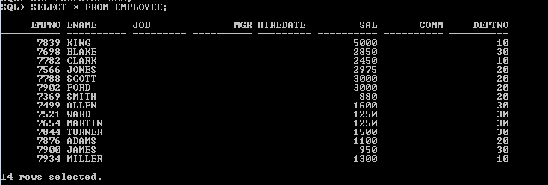

**3.** Write a query to change the job and deptno of employee whose empno is 7698 to the job and deptno of employee having empno 7788.

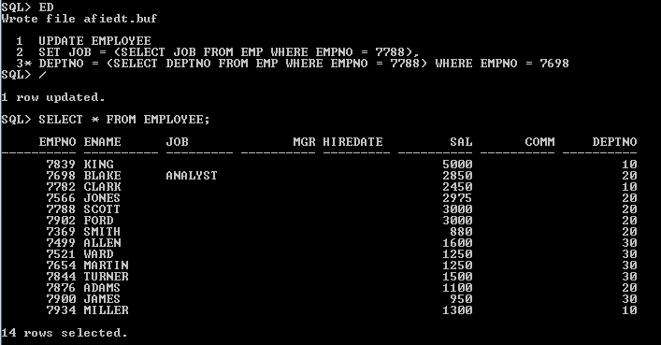

**4.** Delete the details of department whose department name is ‘SALES’.

D:\Abhishikth\SQL_PLSQL\SQL\LAB5\5.4.PNG

**5.** Write a query to change the deptno of employee with empno 7788 to that of employee having empno 7698.

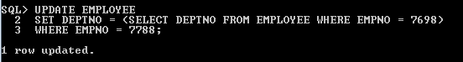

**6.** Insert the following rows to the Employee table through parameter substitution.

* 1000,Allen, Clerk,1001,12-jan-01, 3000, 2,10
* 1001,George, analyst, null, 08 Sep 92, 5000,0, 10
* 1002, Becker, Manager, 1000, 4 Nov 92, 2800,4, 20
* 1003, 'Bill', Clerk, 1002, 4 Nov 92,3000, 0, 20

