Slide 20 example

1. Create table emp1 with 4 columns - empno, ename, sal, deptno.

SQL> desc emp1;

Name Null? Type

----------------------------------------- -------- ----------------------------

EMPNO NOT NULL NUMBER(4)

ENAME VARCHAR2(10)

SAL NUMBER(7,2)

DEPTNO NUMBER(2)

1. Ensure that the table is empty. This is an important condition as the data can only be loaded into an empty table.

SQL> select \* from emp1;

EMPNO ENAME SAL DEPTNO

---------- ---------- ---------- ----------

11 ScottTiger 1000 10

12 FrankNaude 500 30

15 Sachin 1200 20

SQL> delete from emp1;

3 rows deleted.

SQL> select \* from emp1;

no rows selected

1. Now create the data file and name it mydata.csv with the following content –

10001,"Scott Tiger", 1000, 40

10002,"Frank Naude", 500, 20

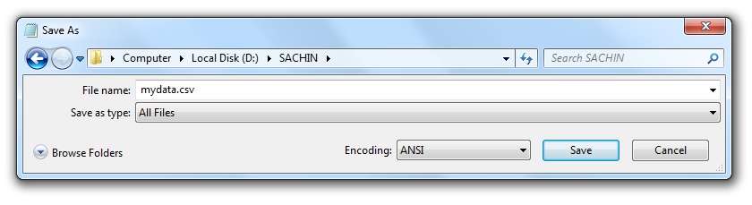

1. Now create the loader file with following content and save on the disk – loader.ctl

load data

infile 'd:\sachin\mydata.csv'

into table emp1 fields terminated by ","

optionally enclosed by '"' ( empno, ename, sal, deptno )

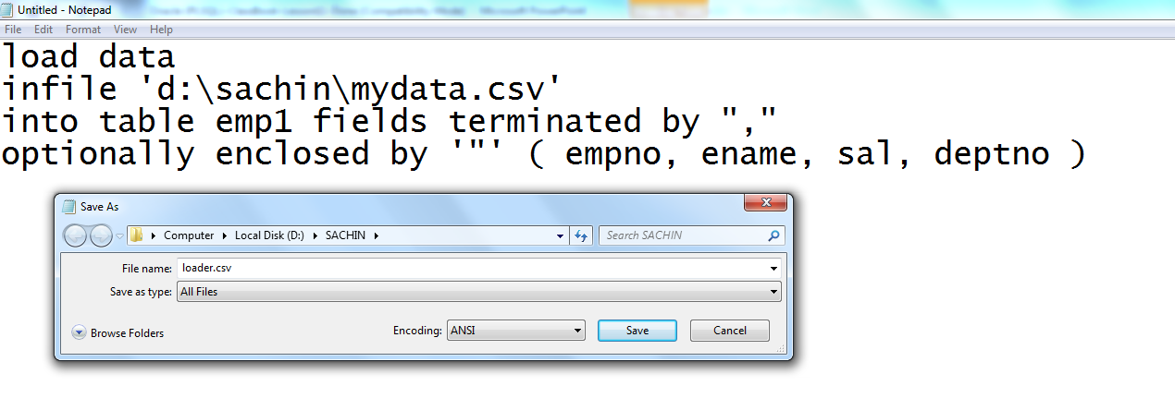

1. Now from the command prompt reach the point where you have sql loader utility stored and then type in the following command to invoke the loader –

Sqlldr scott/tiger@orcl control=d:\sachin\loader.ctl

1. The above command should invoke the loader and display following message that the data has been successfully loaded.

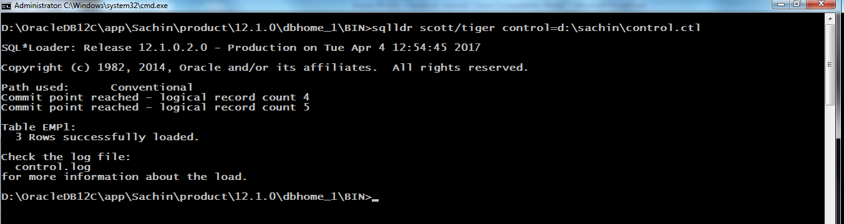

1. Finally query the table – emp1 to check if the data is populated.



1. Check for bad file if created. Bad file is created to hold all data that is not loaded to the table.

