1.1: Get the details of all the database objects and their types created by the current user.

D:\Abhishikth\SQL_PLSQL\PLSQL\LAB1\1.1.PNG

1.2 Get the details of all the table names owned by current user

D:\Abhishikth\SQL_PLSQL\PLSQL\LAB1\1.2.PNG

1.3 Get the details of table names and corresponding column names

**D:\Abhishikth\SQL_PLSQL\PLSQL\LAB1\1.3.PNG**

1.4 Get the details of column names and corresponding constraint names

**D:\Abhishikth\SQL_PLSQL\PLSQL\LAB1\1.4.PNG**

1.5: Get the details of the constraints and corresponding table name.

D:\Abhishikth\SQL_PLSQL\PLSQL\LAB1\1.5.PNG

1.6: Get the details of all the View names and corresponding Text of the same.

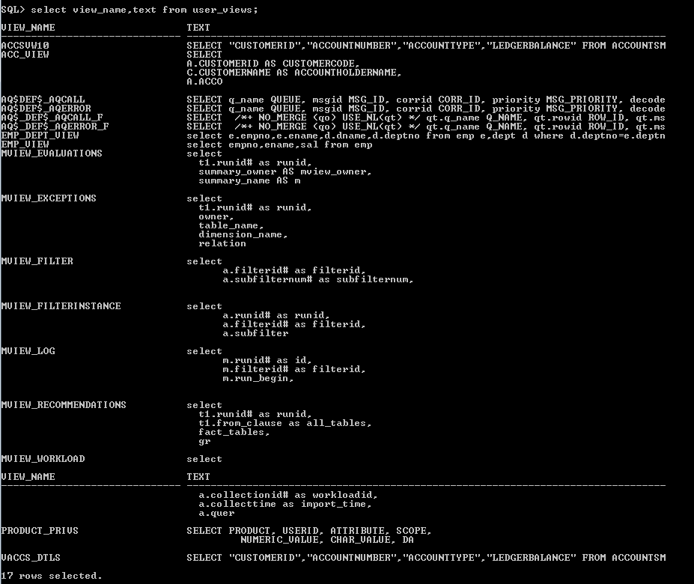

1.7: Get the details of all the Sequence names and their last numbers reached so far.

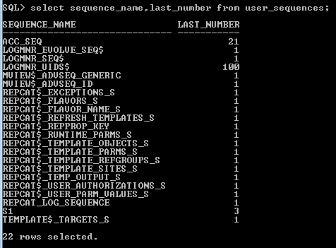

1.8: Get the details of all the Synonym names and their parent object names.

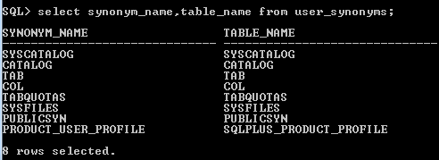

1.9: Get the list of all the Index names

D:\Abhishikth\SQL_PLSQL\PLSQL\LAB1\1.9.PNG