2.1

Identify the problems(if any) in the below declarations:

DECLARE

V_Sample1 NUMBER(2);

V_Sample2 CONSTANT NUMBER(2) ;

V_Sample3 NUMBER(2) NOT NULL ;

V_Sample4 NUMBER(2) := 50;

V_Sample5 NUMBER(2) DEFAULT 25;

Example 1: Declaration Block

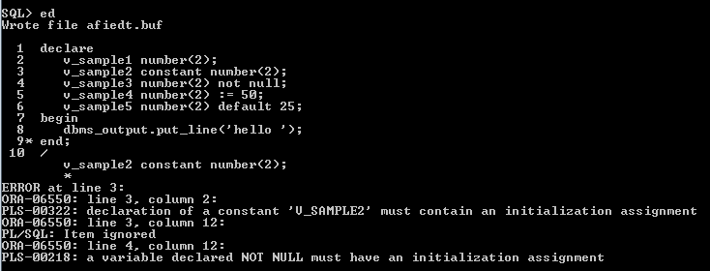

2.2

The following PL/SQL block is incomplete.

Modify the block to achieve requirements as stated in the comments in the block.

DECLARE --outer block

var_num1 NUMBER := 5;

BEGIN

DECLARE --inner block

var_num1 NUMBER := 10;

BEGIN

DBMS_OUTPUT.PUT_LINE('Value for var_num1:' ||var_num1);

--Can outer block variable (var_num1) be printed here.If Yes,Print the same.

END;

--Can inner block variable(var_num1) be printed here.If Yes,Print the same.

END;

Example 2: PL/SQL block

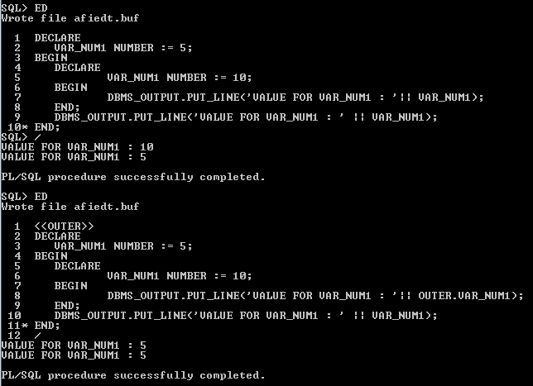

2.3. Write a PL/SQL block to retrieve all staff (code, name, salary) under specific department number and display the result. (Note: The Department_Code will be accepted from user. Cursor to be used.**)**

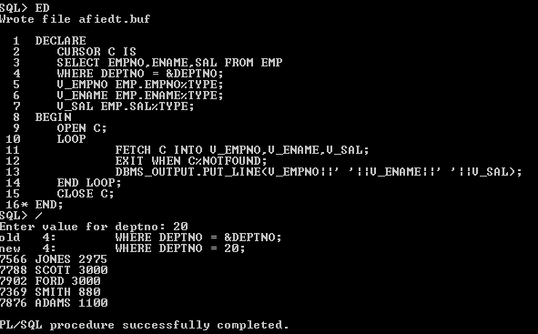

2.4.Write a PL/SQL block to increase the salary by 30 % or 5000 whichever minimum for a given Department_Code.

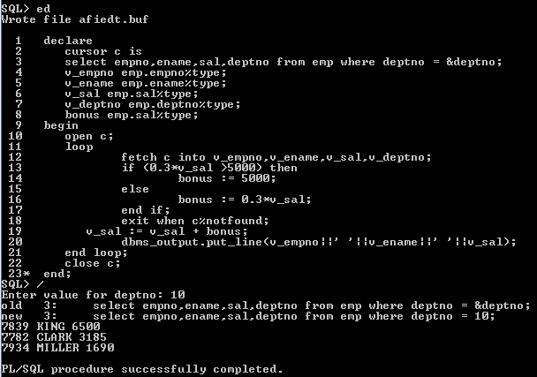

2.5. Write a PL/SQL block to generate the following report for a given Department code

Student_Code Sudent_Name Subject1 Subject2 Subject3 Total Percentage Grade

Note: Display suitable error massage if wrong department code has entered and if there is no student in the given department.

For Grade:

Student should pass in each subject individually (pass marks 60).

Percent >= 80 then grade= A

Percent >= 70 and < 80 then grade= B

Percent >= 60 and < 70 then grade= C

Else D

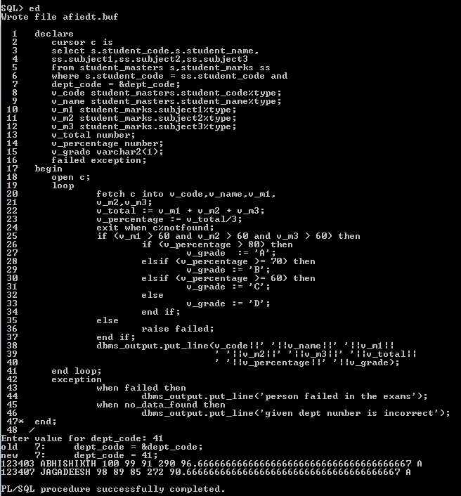

2.6. Write a PL/SQL block to retrieve the details of the staff belonging to a particular department. Department code should be passed as a parameter to the cursor.

