3.1: Modify the programs created in Lab2 to implement Exception Handling

3.2 The following PL/SQL block attempts to calculate bonus of staff for a given MGR_CODE. Bonus is to be considered as twice of salary. Though Exception Handling has been implemented but block is unable to handle the same.

Debug and verify the current behavior to trace the problem.

DECLARE

V_BONUS V_SAL%TYPE;

V_SAL STAFF_MASTER.STAFF_SAL%TYPE;

BEGIN

SELECT STAFF_SAL INTO V_SAL

FROM STAFF_MASTER

WHERE MGR_CODE=100006;

V_BONUS:=2*V_SAL;

DBMS_OUTPUT.PUT_LINE('STAFF SALARY IS ' || V_SAL);

DBMS_OUTPUT.PUT_LINE('STAFF BONUS IS ' || V_BONUS);

EXCEPTION

WHEN NO_DATA_FOUND THEN

DBMS_OUTPUT.PUT_LINE('GIVEN CODE IS NOT VALID.ENTER VALID CODE');

END;

Example 3: PL/SQL block

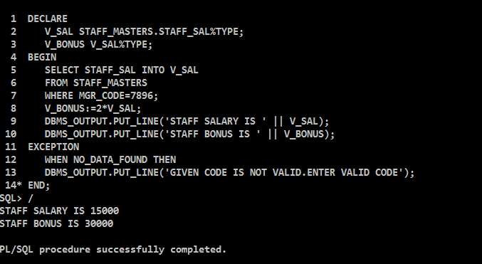

3.3 Rewrite the above block to achieve the requirement.

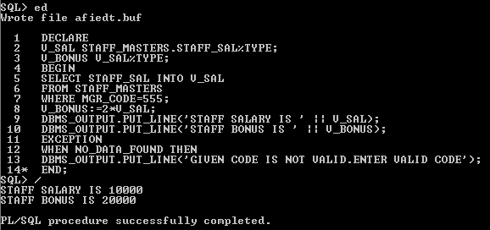

3.4

Predict the output of the following block ? What corrections would be needed to make it more efficient?

BEGIN

DECLARE

fname emp.ename%TYPE;

BEGIN

SELECT ename INTO fname

FROM emp

WHERE 1=2;

DBMS_OUTPUT.PUT_LINE('This statement will print');

EXCEPTION

WHEN OTHERS THEN

DBMS_OUTPUT.PUT_LINE('Some inner block error');

END;

EXCEPTION

WHEN NO_DATA_FOUND THEN

DBMS_OUTPUT.PUT_LINE('No data found in fname');

WHEN OTHERS THEN

DBMS_OUTPUT.PUT_LINE('Some outer block error');

END;

Example 4: PL/SQL Block with Exception Handling

3.5 Debug the above block to trace the flow of control.

Additionally one can make appropriate changes in Select statement defined in the

block to check the flow.

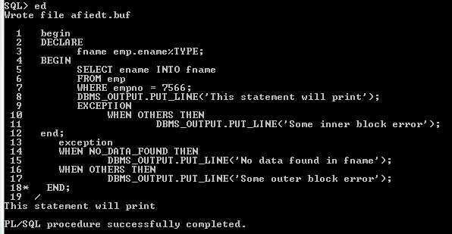

3.6: Write a PL/SQL program to check for the commission for an employee no 7369. If no commission exists, then display the error message. Use Exceptions.

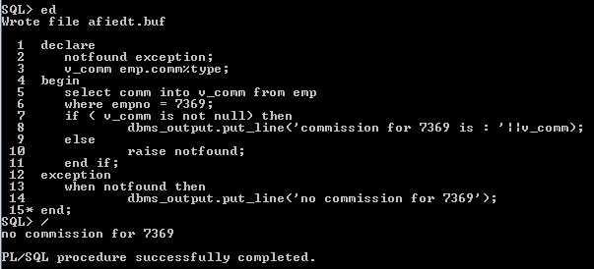

3.7: Write a PL/SQL block to drop any user defined table.

