4.1Write a PL/SQL block to find the maximum salary of the staff in the given department. Note: Department code should be passed as parameter to the cursor.

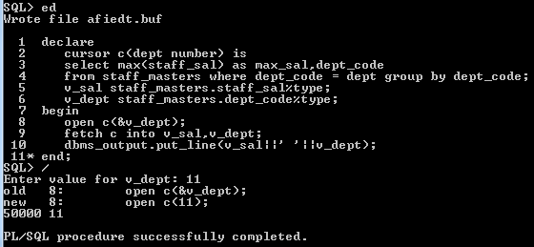

4.2. Write a function to compute age. The function should accept a date and return age in years.

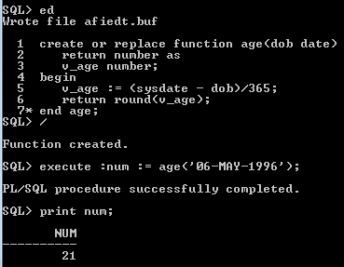

4.3. Write a procedure that accept staff code and update staff name to Upper case. If the staff name is null raise a user defined exception.

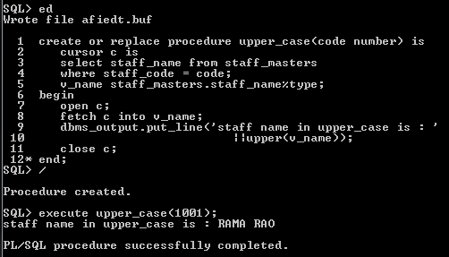

4.4 Write a procedure to find the manager of a staff. Procedure should return the following – Staff\_Code, Staff\_Name, Dept\_Code and Manager Name.

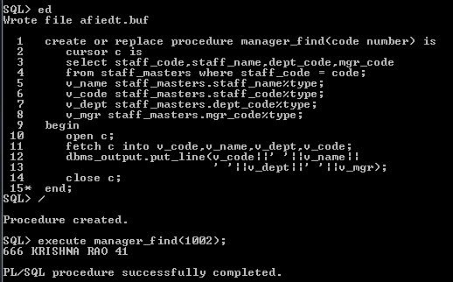

4.5. Write a function to compute the following. Function should take Staff\_Code and return the cost to company.

DA = 15% Salary, HRA= 20% of Salary, TA= 8% of Salary.

Special Allowance will be decided based on the service in the company.

< 1 Year Nil

>=1 Year< 2 Year 10% of Salary

>=2 Year< 4 Year 20% of Salary

>4 Year 30% of Salary

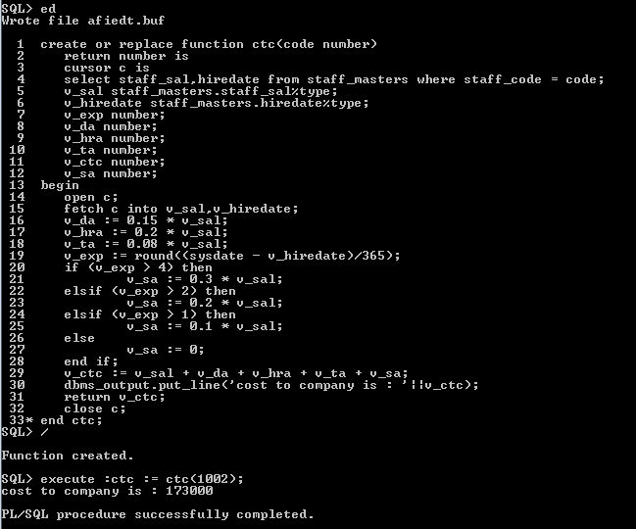

4.6. Write a procedure that displays the following information of all staff

Staff\_Name Department Name Designation Salary Status

Note: - Status will be (Greater, Lesser or Equal) respective to average salary of their own department. Display an error message Staff\_Master table is empty if there is no matching record.

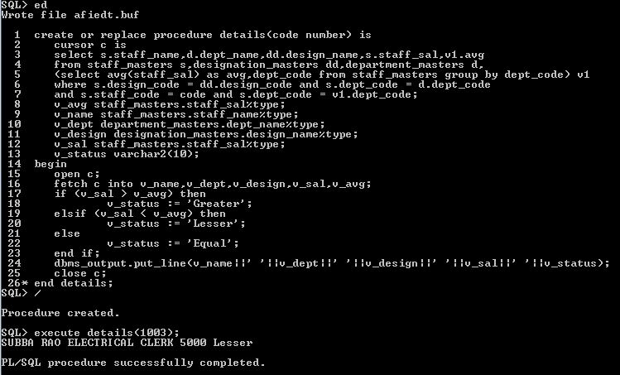

4.7. Write a procedure that accept Staff\_Code and update the salary and store the old salary details in Staff\_Master\_Back (Staff\_Master\_Back has the same structure without any constraint) table.

Exp < 2 then no Update

Exp > 2 and < 5 then 20% of salary

Exp > 5 then 25% of salary

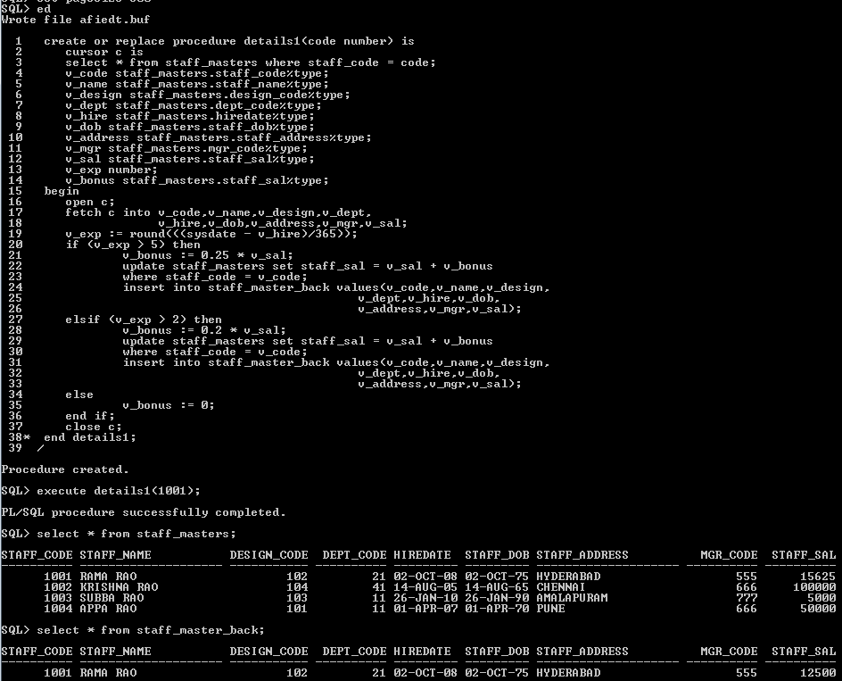

4.8. Create a procedure that accepts the book code as parameter from the user. Display the details of the students/staff that have borrowed that book and has not returned the same. The following details should be displayed

Student/Staff Code Student/Staff Name Issue Date Designation Expected Ret\_Date

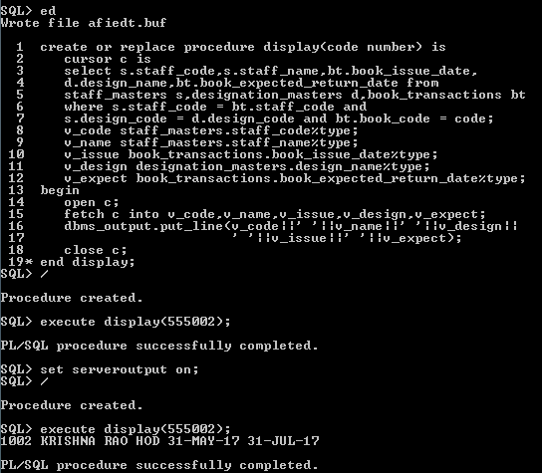

4.9. Write a package which will contain a procedure and a function.

Function: This function will return years of experience for a staff. This function will take the hiredate of the staff as an input parameter. The output will be rounded to the nearest year (1.4 year will be considered as 1 year and 1.5 year will be considered as 2 year).

Procedure: Capture the value returned by the above function to calculate the additional allowance for the staff based on the experience.

Additional Allowance = Year of experience x 3000

Calculate the additional allowance and store Staff\_Code, Date of Joining, and Experience in years and additional allowance in Staff\_Allowance table.

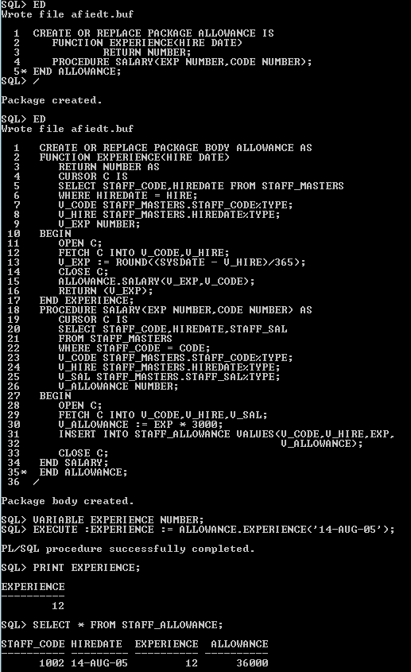

4.10. Write a procedure to insert details into Book\_Transaction table. Procedure should accept the book code and staff/student code. Date of issue is current date and the expected return date should be 10 days from the current date. If the expected return date falls on Saturday or Sunday, then it should be the next working day.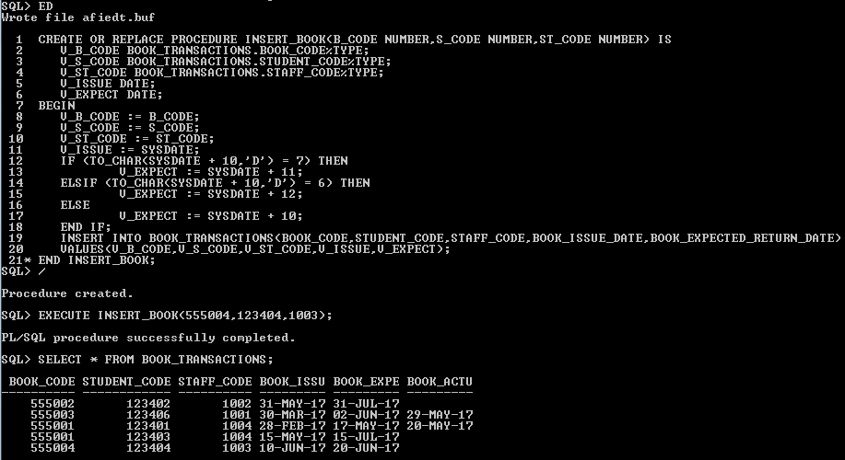

4.11: Write a function named ‘get\_total\_records’, to pass the table name as a parameter, and get back the number of records that are contained in the table. Test your function with multiple tables.

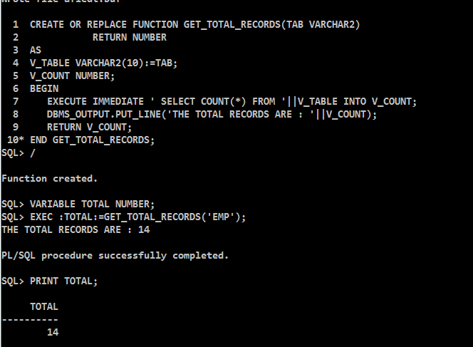

4.12

**Tune the following Oracle Procedure enabling to gain better performance.**

**Objective:**The Procedure should update the salary of an employee and at the same time retrieve the employee's name and new salary into PL/SQL variables.

CREATE OR REPLACE PROCEDURE update\_salary (emp\_id NUMBER) IS

v\_name VARCHAR2(15);

v\_newsal NUMBER;

BEGIN

UPDATE emp\_copy SET sal = sal \* 1.1

WHERE empno = emp\_id;

SELECT ename, sal INTO v\_name, v\_newsal

FROM emp\_copy

WHERE empno = emp\_id;

DBMS\_OUTPUT.PUT\_LINE('Emp Name:' || v\_name);

DBMS\_OUTPUT.PUT\_LINE('Ename:' || v\_newsal);

END;

Example 5: Oracle Procedure

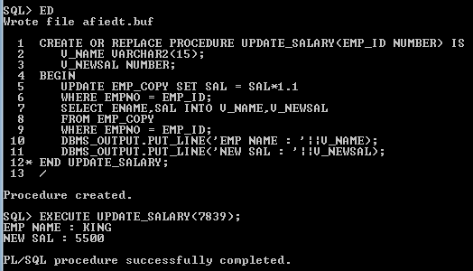

4.13

The following procedure attempts to delete data from table passed as parameter.This procedure has compilation errors. Identify and correct the problem.

CREATE or REPLACE PROCEDURE gettable(table\_name in varchar2) AS

BEGIN

DELETE FROM table\_name;

END;

Example 6: Oracle Procedure

**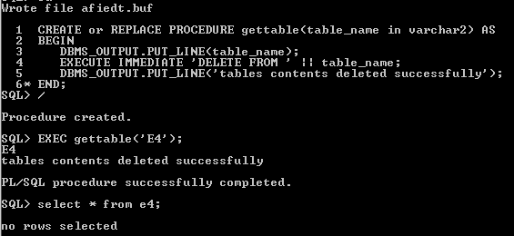**

4.14

Write a procedure which prints the following report using procedure:

The procedure should take deptno as user input and appropriately print the emp details.

Also display :

Number of Employees,Total Salary,Maximum Salary,Average Salary

**Note:** The block should achieve the same without using Aggregate Functions.

Sample output for deptno 10 is shown below:

Employee Name : CLARK

Employee Job : MANAGER

Employee Salary : 2450

Employee Comission :

\*\*\*\*\*\*\*\*\*\*\*\*\*\*\*\*\*\*\*\*\*\*\*\*\*\*\*\*\*\*\*\*\*\*\*\*

Employee Name : KING

Employee Job : PRESIDENT

Employee Salary : 5000

Employee Comission :

\*\*\*\*\*\*\*\*\*\*\*\*\*\*\*\*\*\*\*\*\*\*\*\*\*\*\*\*\*\*\*\*\*\*\*\*

Employee Name : MILLER

Employee Job : CLERK

Employee Salary : 1300

Employee Comission :

\*\*\*\*\*\*\*\*\*\*\*\*\*\*\*\*\*\*\*\*\*\*\*\*\*\*\*\*\*\*\*\*\*\*\*\*

Number of Employees : 3

Total Salary : 8750

Maximum Salary : 5000

Average Salary : 2916.67

------------------------------------

Figure 1 :Report

**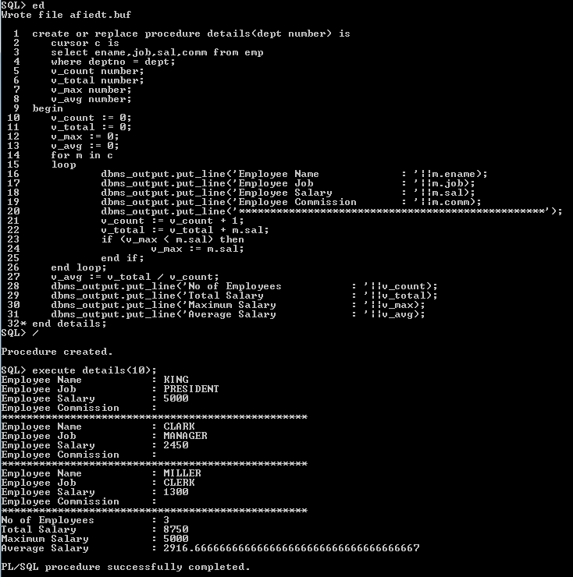**

4.15: Write a query to view the list of all procedures ,functions and packages from the Data Dictionary.

D:\Abhishikth\SQL_PLSQL\PLSQL\LAB4\4.15.png