Consider the following tables for the case study.

**Customer_Masters**

|  |  |  |
| --- | --- | --- |
| **Name** | **Null?** | **Type** |
| Cust_Id | Not Null | Number(6) |
| Cust_Name | Not Null | Varchar2(20) |
| Address |  | Varchar2(50) |
| Date_of_acc_creation |  | Date |
| Customer_Type |  | Char(3) |

Note: Customer type can be either IND or NRI

**Account_Masters Table**

|  |  |  |
| --- | --- | --- |
| **Name** | **Null?** | **Type** |
| Account_Number | Not Null | Number(6) |
| Cust_ID |  | Number(6) |
| Account_Type |  | Char(3) |
| Ledger_Balance |  | Number(10) |

Note: Account type can be either Savings (SAV) or Salary (SAL) account.

For savings account minimum amount should be 5000.

**Transaction_Masters**

|  |  |  |
| --- | --- | --- |
| **Name** | **Null?** | **Type** |
| Transaction_Id | Not Null | Number(6) |
| Account_Number |  | Number(6) |
| Date_of_Transaction |  | Date |
| From_Account_Number | Not Null | Number(6) |
| To_Account_Number | Not Null | Number(6) |
| Amount | Not Null | Number(10) |
| Transaction_Type | Not Null | Char(2) |

Note: Transaction type can be either Credit (CR) or Debit (DB).

Procedure and function should be written inside a package.

All validations should be taken care.

5.1 Create appropriate Test Cases for the case study followed up by Self/Peer to Peer

Review and close any defects for the same.

5.2Write a procedure to accept customer name, address, and customer type and account type. Insert the details into the respective tables.

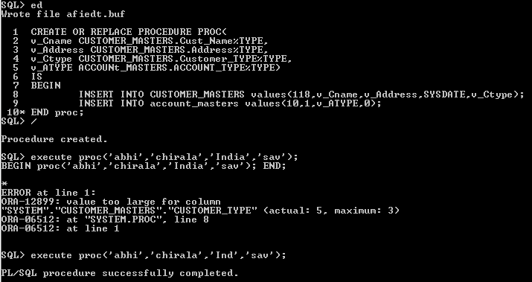

5.3. Write a procedure to accept customer id, amount and the account number to which the customer requires to transfer money. Following validations need to be done

* Customer id should be valid
* From account number should belong to that customer
* To account number cannot be null but can be an account which need not exist in account masters (some other account)
* Adequate balance needs to be available for debit

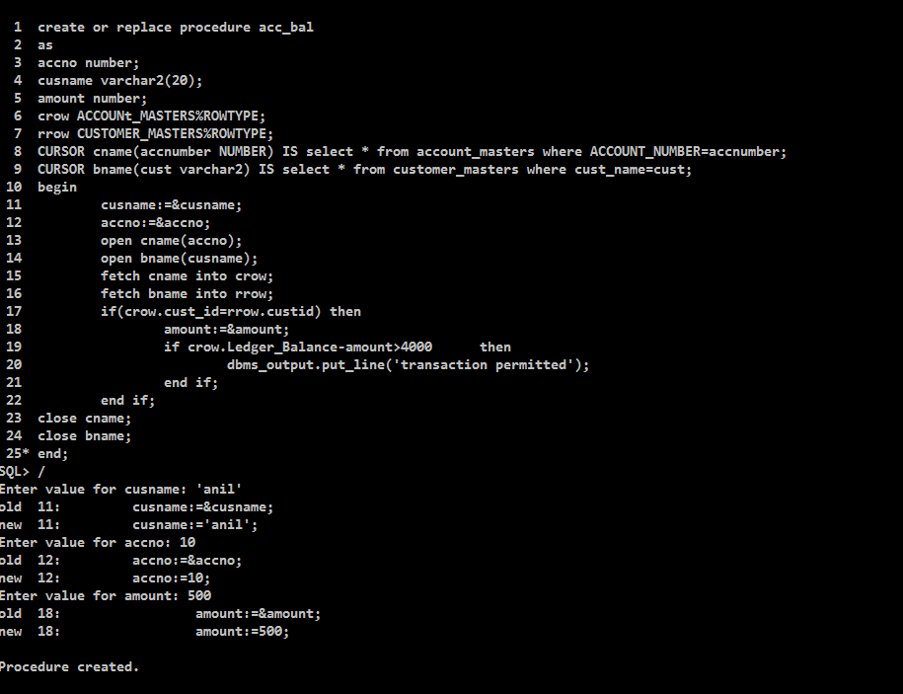

5.4 Ensure all the Test cases defined are executed. Have appropriate Self/Peer to Peer

Code Review and close any defects for the same.