Consider the following table (myEmp) structure for the case study

EmpNo Ename City Designation Salary

-------------------------------------------------------------------

The following procedure accepts Task number and based on the same performs an

appropriate task.

PROCEDURE run_task (task_number_in IN INTEGER)

IS

BEGIN

IF task_number_in = 1

THEN

add_emp;

--should add new emps in myEmp.

--EmpNo should be inserted through Sequence.

--All other data to be taken as parameters.Default location is Mumbai.

END IF;

IF task_number_in = 2

THEN

raise_sal;

--should modify salary of an existing emp.

--should take new salary and empno as input parameters

--Should handle exception in case empno not found

--upper limit of rasing salary is 30%. should raise exception appropriately

END IF;

IF task_number_in = 3

THEN

remove_emp;

--should remove an existing emp

--should take empno as parameter

--Handle exception if empno not available

END IF;

END run_task;

Example 7: Sample Oracle Procedure

However ,it has been observed the method adopted in above procedure is inefficient.

6.1

Create appropriate Test Cases for the case study followed up by Self/Peer to Peer

Review and close any defects for the same.

6.2

Recreate the procedure (run_task) which is more efficient in performing the same.

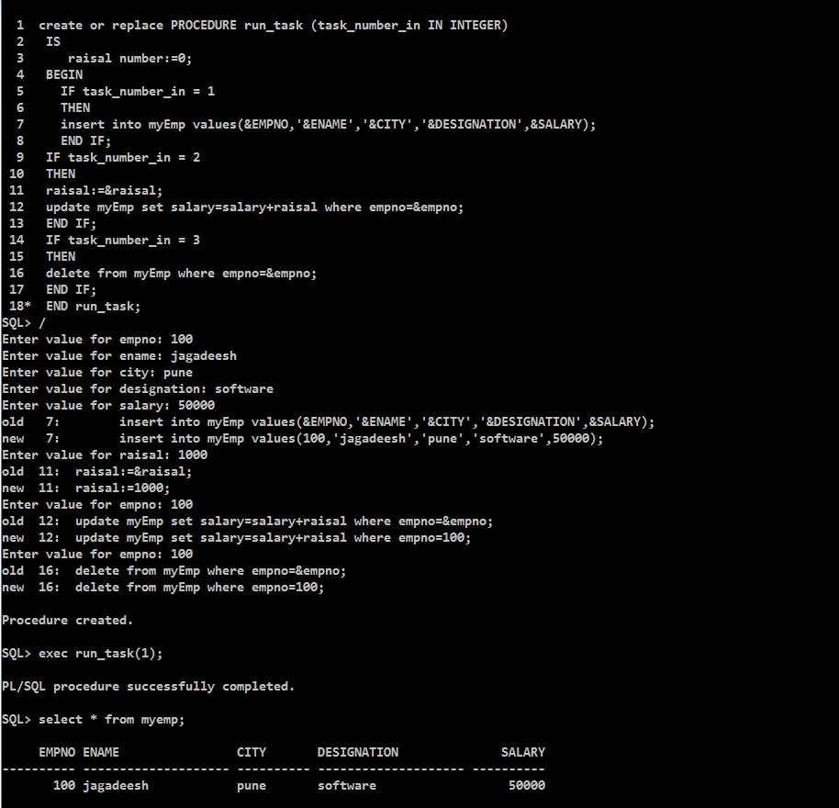

6.3

Also, create relevant procedures (add_emp , raise_sal ,remove_emp)

with relevant logic (read comments)to verify the same.

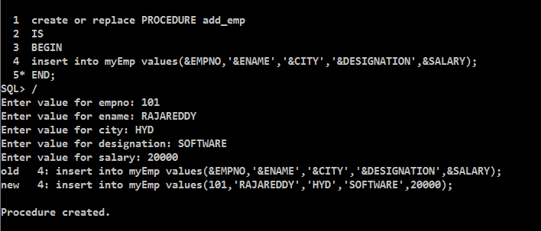

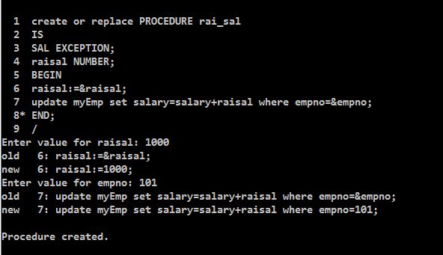

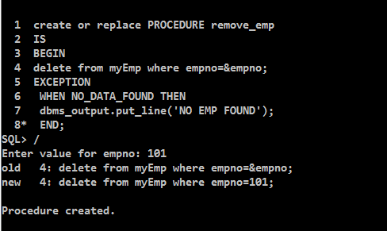

6.4 Extend the above implementation using Packages

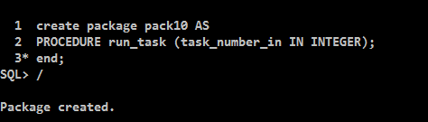

6.5) Ensure all the Test cases defined are executed. Have appropriate Self/Peer to Peer

Code Review and close any defects for the same.