8.1: Using Multiple Spacing Techniques

Suppose you have more than one column in your ORDER BY clause and wish to insert space when each column’s value changes. Each BREAK command you enter replaces the previous one.

Now consider a scenario where you want to do either of the following:

* to use different spacing techniques in one report, or
* to insert space after the value changes in more than one ordered column

Then you must specify “multiple columns” and “actions” in a single BREAK command.

**Step 1:** Combine the Spacing Techniques.

SELECT DEPARTMENT_ID, JOB_ID, LAST_NAME, SALARY FROM EMP_DETAILS_VIEW

WHERE SALARY>12000

ORDER BY DEPARTMENT_ID, JOB_ID;

Example 9: Sample Code

Now, to skip a page when the value of DEPARTMENT_ID changes, and to skip one line when the value of JOB_ID changes, key in the following command:

BREAK ON DEPARTMENT_ID SKIP PAGE ON JOB_ID SKIP 1

Example 10: Sample Code

To show that SKIP PAGE has taken effect, create a TTITLE with a page number:

TTITLE COL 35 FORMAT 9 'Page:' SQL.PNO

Example 101: Sample Code

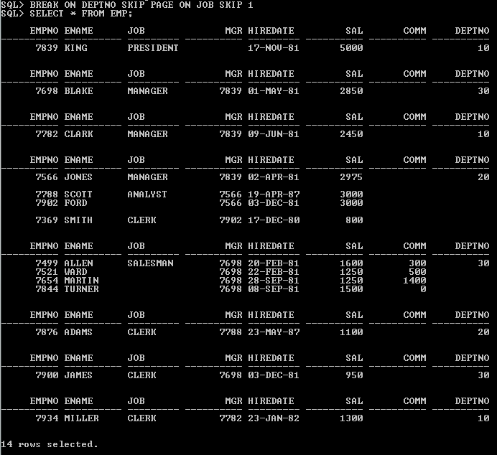

Page: 1

DEPARTMENT_ID JOB_ID LAST_NAME SALARY

------------- ---------- ------------------------- ----------

20 MK_MAN Hartstein 13000

Page: 2

DEPARTMENT_ID JOB_ID LAST_NAME SALARY

------------- ---------- ------------------------- ----------

80 SA_MAN Russell 14000

Partners 13500

Page: 3

DEPARTMENT_ID JOB_ID LAST_NAME SALARY

------------- ---------- ------------------------- ----------

90 AD_PRES King 24000

AD_VP Kochhar 17000

De Haan 17000

6 rows selected.

Figure 2: Report

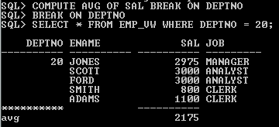

**Step 2:** Produce a report that does the following when the value of JOB_ID changes:

* prints duplicate job values,
* prints the average of SALARY, and
* inserts one blank line

Additionally the report should do the following when the value of DEPT_ID changes:

* prints the sum of SALARY, and
* inserts another blank line

The details should be displayed for all departments respective to jobs. **(To Do)**

DEPT_ID JOB_ID ENAME SALARY

------- ------ ------------- ----------

50 SH_CLERK Taylor 3200

SH_CLERK Fleaur 3100

.

.

.

SH_CLERK Gates 2900

********** -----------

Avg: 3000

DEPT_ID JOB_ID ENAME SALARY

------- --------- ------------- ----------

50 SALESMAN Perkins 2500

SALESMAN Bell 4000

.

.

.

SALESMAN Grant 2600

********** ----------

Avg: 3215

DEPT_ID JOB_ID ENAME SALARY

------- ------ ------------- ---------

******** ----------

sum 64300

-

-

-

-

-

25 rows selected.

Figure 3: Report

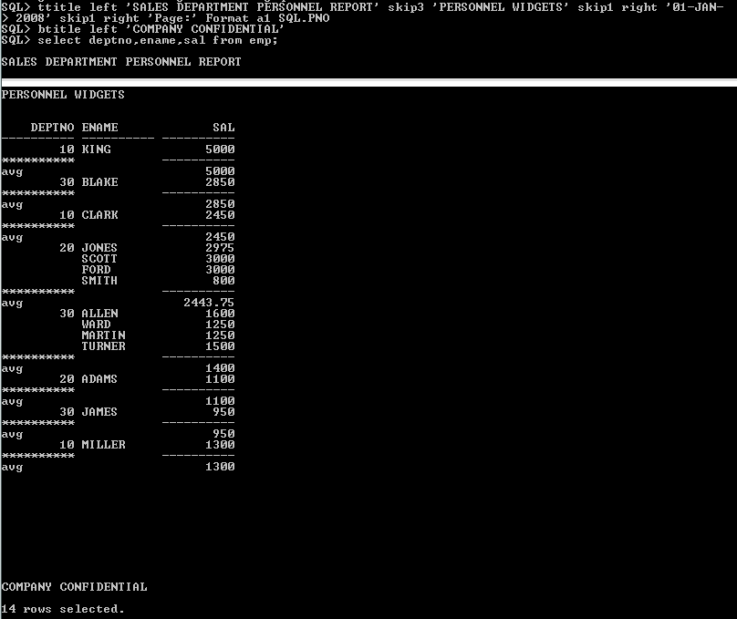

8.2: Computing and Printing Subtotals

**Step 1:** Generate SQL Report in the following format.

SALES DEPARTMENT PERSONNEL REPORT

PERFECT WIDGETS

01-JAN-2008

PAGE: 1

DEPARTMENT_ID LAST_NAME SALARY

------------- ------------------------- ----------

20 Hartstein 13000

80 Russell 14000

80 Partners 13500

90 King 24000

90 Kochhar 17000

90 De Haan 17000

----------

98500

COMPANY CONFIDENTIAL

6 rows selected.

Figure 4: SQL Report

**Step 2:** Generate SQL Report in the following format.

Dept Job No. of Average

No. Name Employees Salary/Job

---- -------- ------------- -------------

10 SALES 4 $13,000.00

CLEARK 2 $10,666.00

20 MANAGER 3 $14,000.00

SALES 6 $11,000.00

30 CLERK 10 $13,500.00

MANAGER 3 $15,000.00

SALES 4 $10,000.00

40 PRESIDENT 1 424,000.00

.

.

.

----------

Grand Total of Sal: $98,560.00

No. Of Employees: 100

Figure 5: SQL Report

