Oracle Apps
Mini Project

Copyright © 2011 iGATE Corporation. All rights reserved. No part of this publication shall be reproduced in any way, including but not limited to photocopy, photographic, magnetic, or other record, without the prior written permission of iGATE Corporation.
iGATE Corporation considers information included in this document to be Confidential and Proprietary.

Document Revision History

Date | Revision No. | Author | Summary of Changes
10-Jul-2012 | 1.0 | Amit Sali | Content Creation

Table of Contents
- Introduction 4
Setup Checklist for Mini Project 4
Instructions 4
- Problem Statement 5
Objective 5
Abstract of the project 5
Functional components of the project 5
- Implementation in Oracle Apps LOT 6
Summary of the functionality to be built 6
Guidelines on the functionality to be built 6

- Introduction

This document outlines a mini project for the Oracle Apps LOT. The project is to implement Book Management System. This document contains the work flow of the system and gives guidelines on how to build the functionality gradually in each of the course modules of the Systems LOT

Setup Checklist for Mini Project
Minimum System Requirements
- Intel Pentium 90 or higher (P166 recommended)
- Microsoft Windows 95, 98, or NT 4.0, 2k, XP, Access to UNIX server through Telnet
- Memory: 32MB of RAM (64MB or more recommended)
- forms 6i, reports 6i, putty, filezilla, plsql developer and oracle application instance

Instructions
- The code modules in the mini project should follow all the coding standards.
- Create a directory by your name in drive <drive>. In this directory, create a subdirectory MiniProject. Store your Project here.
- You can refer to your course material.

- Problem Statement

Objective
Development of a Book Management System

Abstract of the project
This project is aimed at developing a Book Management System for the Company ‘ABC Computers’. This system can be used to search for Books, add the Books, add the authors, and remove the books.

Functional components of the project
Following is a list of functionalities of the system. Wherever, the description of functionality is not adequate; you can make appropriate assumptions and proceed.

- The System should able to read file author.dat and import the data into custom table (using SQL Loader).
- The System should able to read file books_dd_mm_yyyy.dat and import the data into custom table (using PL/SQL).
- In a System there must a form to create the author.
- In a System there must a form to add books to the author (Master Detail Form)
- The system should generate an author wise books report

- Implementation in Oracle Apps LOT

Summary of the functionality to be built
The participants need to develop the book management system by building the functionality in each of the course modules of Oracle Apps LOT.

Sr. No | Course | Pre-requisites | Duration  (in PDs) | No of Saturday | Remark
 | Oracle | BCS | 6 | 1
 | Unix | BCS | 2
 | D2k | Oracle | 8 | 2
 | Oracle Apps | D2k, Oracle , Unix | 10 | 2
 | Systems Big Picture | All of the above | 0.5

Guidelines on the functionality to be built

Import Author from legacy system

There is a Legacy system called IDDR which will place author.dat file at a particular location on the oracle Application server. Every day at 5:00 PM the system was supposed to keep the file.
The file is pipe separated file with the details like (author id, author name, gender, Birth date, Mother tongue etc).
For Example: The structure of the file is author.dat

Author id|Author name|Gender|Birth date|Mother tongue
234|Sumukh Savali|M|27/06/1982|Marathi
2|Sheela Shah|F|20/09/1972|Tamil
2456|Sujay Subbu||11/01/1982|Hindi
2244|N G Ramarav|M|3/04/1956|Bagala

You need to write a concurrent program in Oracle Application using SQL Loader which will read the file and put it in custom table.
While importing the data from the file you need to take care
- There should not be any unnecessary space present in the data, if it is present remove it
- If gender is missing by default the author is Female
- Author Id is unique

Import Books from legacy system

The internet based system which is not directly connected to the oracle application system is everyday generating books_dd_mm_yyyy.dat file which they are suppose to kept at a particular location on the oracle Application server.
The file is position separated file with the details like (book name, author id, ISBN, pages, cost, publishing date, book type etc).
For Example: The structure of the file is books_dd_mm_yyyy.dat

Let us C 234 5673456 767 27-Jan-2011 Fiction
Let us C++ 234 5673445 300 7-Feb-2010 Fiction
Three M 24 99573456 76 20-Jan-1983 Fiction
Sea 34 995673456 700 3-Feb-1982 Fiction

You need to write a concurrent program in Oracle Application using PL/SQL which will read the file and put it in custom table.
Your concurrent program should archive the data/file you have uploaded in the system.
It should have three parameters ISBN from, ISBN to, Validate Only. The default Validate Only parameter should be Yes (From the option Yes/No). Also if the user provides “ISBN from” only then from that ISBN accept any ISBN number. If the user Provide “ISBN to” only then accept any ISBN up-till that ISBN number. If the user provides none then accept all ISBN numbers in the file.
While importing the data from the file you need to take care
- Book Id is auto generated column
- Author Id should be already present if it is not error out the record
- ISBN must be a number, and should not be already present in the system
- Size, cost of the book cannot be negative
- Publishing date should be proper date if it is missing take it as a System date
- Book type should be Fiction, Non-Fiction, Business, and Audio. If book type other than, then error out the record

Add author using form

Develop a master form to add authors in the oracle application system. While developing form take care of
- The form should get register in oracle application in XXPATNI Custom responsibility under a submenu developed by you
- It should perform all possible validations
- Make maximum use of Value-set, Radio buttons, Check Box.
- It should have a button to save, re-set, First, Last, Next and Previous.

Add books using form

Develop the master-detail form to add books to the proper authors in the oracle application system. While developing form take care of
- The form should get register in oracle application in XXPATNI Custom responsibility under a submenu developed by you
- It should perform all possible validations mention in “Import Books from legacy system” section
- The layout of the form should be like

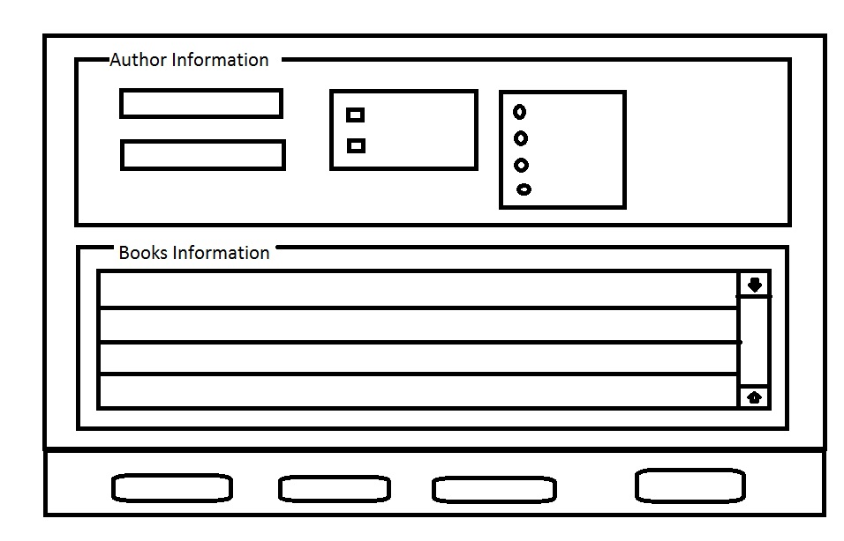

Generate detailed author wise report
Develop a Concurrent program which will generate a report with the following layout.

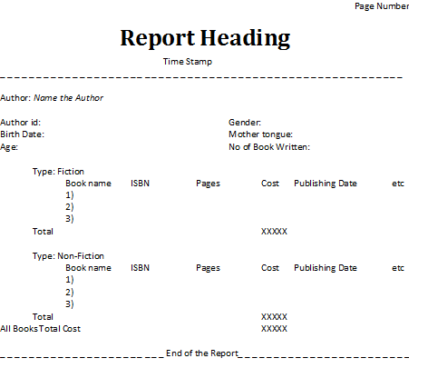
While developing report you should take care
- For a particular Author if Books are not there you should not display that authors record
- If there are zero authors present in the system then the report should display “No Data Found”, also it should not display any layout.

Following points will be considered for giving marks

Sr. No | Points to be considered | Marks
1. | SQL Loader development | 12
2. | PL/SQL development | 16
3. | Form Development | 18
4. | Report Development | 14
5. | Oracle Apps Registration and use | 22
6. | Use of coding standard | 10
7. | Using AIM methodology | 8

