Connecting to the Unix Server

Goals | - Learn to connect to the Unix server  - Learn to log out of the Unix server
Time | 5 min

1.1: Connecting to the Unix Server
Step 1: Enter your login name and password to login to the UNIX system.
user29
user29

1.2: Logging out of the system
Step 1: Type the exit command at $ prompt or else, press ctrl and d together to log out
exit.

- Unix Basic Command

Goals | - Learn to use basic Unix commands
Time  Lab Setup | 100 min  Telnet with Unix Server

2:1 Executing basic commands:
- To display the current working directory, the command is:
pwd
The output is as follows.
/home/user29

- Display the path to and name of your HOME directory.
/home/user29

- Display the login name using which you have logged into the system
login name : user29

- Display the hidden files of your current directory.
ls –a
[user29@NDAUnix ~]$ ls -a
. employee.dat friends.txt myfile telephonedirectory.txt
.. emp.lst friend.txt myfile^c temp
abc.txt emp.sh func.sh name test
ass.sh emp.txt function.sh names ucf
.bash_history errfile .gnome2 newfile vaishali
.bash_logout etc help num .viminfo
.bash_profile f1 hemanshu perms xyz.txt
.bashrc file1.sh ijk.txt prems yf
chap.txt files .lesshst sf yourfile
c_prog files1 logincheck.sh size
dir file.sh mf smith
ed.sh first.unix .mozilla smoth
.emacs fl my smyth

- List the names of all the files in your home directory.
[user29@NDAUnix ~]$ ls
abc.txt errfile friend.txt myfile^c smoth
ass.sh etc func.sh name smyth
chap.txt f1 function.sh names telephonedirectory.txt
c_prog file1.sh help newfile temp
dir files hemanshu num test
ed.sh files1 ijk.txt perms ucf
employee.dat file.sh logincheck.sh prems vaishali
emp.lst first.unix mf sf xyz.txt
emp.sh fl my size yf
emp.txt friends.txt myfile smith yourfile

- Using the long listing format to display the files in your directory.
sol:ls –l
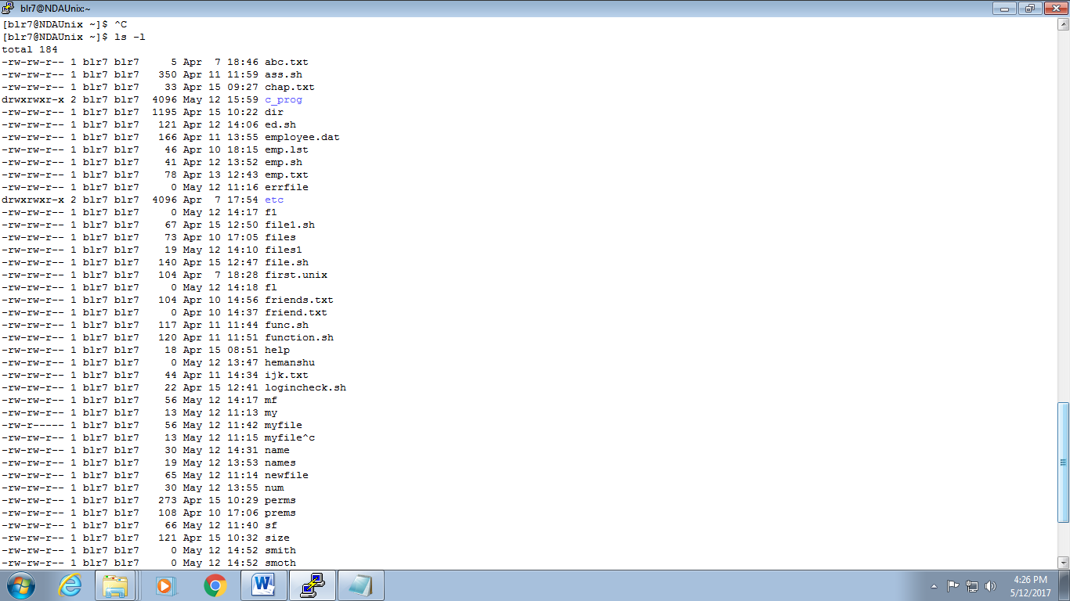

- List the files beginning with chap followed by any number or any lower case alphabet. (Example, it should display apwdll files whose names are like chap1, chap2, chap3 ……., chapa,ahapb,chapc,……..)
[user29@NDAUnix ~]$ ls chap[0-9] chap[a-z]
chap1 chap4 chap5 chap9 chapa

- Give appropriate command to create a directory called C_prog under your home directory. (Note: Check the directory using ls)
cd home/user29/
mkdir c_prog
ls

[user29@NDAUnix ~]$ ls
a chap5 c_prog emp.sh file1.sh fl help my newfile size temp yf
abc.txt chap9 dir emp.txt files friends.txt hemanshu myfile num smith test yourfile
ass.sh chapa ed.sh errfile files1 friend.txt ijk.txt myfile^c perms smoth ucf
chap1 chapab employee.dat etc file.sh func.sh logincheck.sh name prems smyth vaishali
chap4 chap.txt emp.lst f1 first.unix function.sh mf names sf telephonedirectory.txt xyz.txt

- Create the following directories under your home directory. (Note: Check using ls)
newdir
newdirectory

[user29@NDAUnix ~]$ mkdir newdir
[user29@NDAUnix ~]$ mkdir newdirectory
[user29@NDAUnix ~]$ ls
a chap5 c_prog emp.sh file1.sh fl help my newdir prems smyth vaishali
abc.txt chap9 dir emp.txt files friends.txt hemanshu myfile newdirectory sf telephonedirectory.txt xyz.txt
ass.sh chapa ed.sh errfile files1 friend.txt ijk.txt myfile^c newfile size temp yf
chap1 chapab employee.dat etc file.sh func.sh logincheck.sh name num smith test yourfile
chap4 chap.txt emp.lst f1 first.unix function.sh mf names perms smoth ucf

- List the names of all the files, including the contents of the sub directories under your home directory.

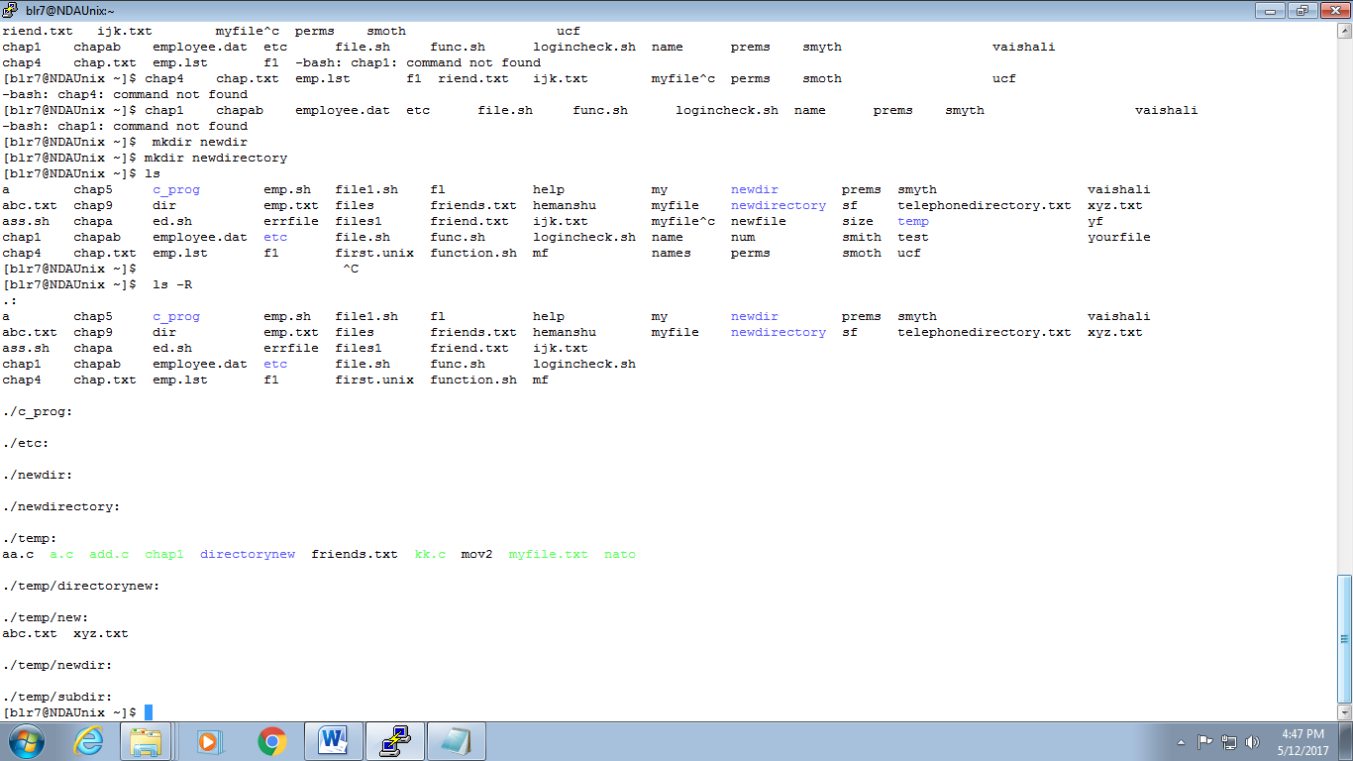

- Remove the directory called newdirectory from your working directory.
[user29@NDAUnix ~]$ rmdir newdirectory
[user29@NDAUnix ~]$ ls
a chap5 c_prog emp.sh file1.sh fl help my newdir sf telephonedirectory.txt xyz.txt
abc.txt chap9 dir emp.txt files friends.txt hemanshu myfile newfile size temp yf
ass.sh chapa ed.sh errfile files1 friend.txt ijk.txt myfile^c num smith test yourfile
chap1 chapab employee.dat etc file.sh func.sh logincheck.sh name perms smoth ucf
chap4 chap.txt emp.lst f1 first.unix function.sh mf names prems smyth vaishali

- Create a directory called temp under your home directory.
[user29@NDAUnix ~]$ mkdir temp1
[user29@NDAUnix ~]$ ls
a chap5 c_prog emp.sh file1.sh fl help my newdir sf telephonedirectory.txt vaishali
abc.txt chap9 dir emp.txt files friends.txt hemanshu myfile newfile size temp xyz.txt
ass.sh chapa ed.sh errfile files1 friend.txt ijk.txt myfile^c num smith temp1 yf
chap1 chapab employee.dat etc file.sh func.sh logincheck.sh name perms smoth test yourfile
chap4 chap.txt emp.lst f1 first.unix function.sh mf names prems smyth ucf

- Remove the directory called newdir under your home directory and verify the above with the help of the directory listing command.
[user29@NDAUnix ~]$ rmdir newdir
[user29@NDAUnix ~]$ ls
a chap5 c_prog emp.sh file1.sh fl help my newfile size temp xyz.txt
abc.txt chap9 dir emp.txt files friends.txt hemanshu myfile num smith temp1 yf
ass.sh chapa ed.sh errfile files1 friend.txt ijk.txt myfile^c perms smoth test yourfile
chap1 chapab employee.dat etc file.sh func.sh logincheck.sh name prems smyth ucf
chap4 chap.txt emp.lst f1 first.unix function.sh mf names sf telephonedirectory.txt vaishali

- Create another directory directorynew under the temp directory.
[user29@NDAUnix ~]$ cd temp1
[user29@NDAUnix temp1]$ mkdir -p temp1/directorynew1
[user29@NDAUnix temp1]$ ls
directorynew1 temp1

- Change the directory to your home directory.
[user29@NDAUnix temp1]$ cd /home/user29/
[user29@NDAUnix ~]$

- From your home directory, change the directory to directorynew using relative and absolute path.
Relative path: cd /temp1/directorynew1
Absolute path: cd /home/user29/temp1/directorynew1

- Remove the directory called c_prog, which is in your home directory.
[user29@NDAUnix ~]$ rmdir c_prog
[user29@NDAUnix ~]$ ls
a chap5 dir emp.txt files friends.txt hemanshu myfile num smith temp1 yf
abc.txt chap9 ed.sh errfile files1 friend.txt ijk.txt myfile^c perms smoth test yourfile
ass.sh chapa employee.dat etc file.sh func.sh logincheck.sh name prems smyth ucf
chap1 chapab emp.lst f1 first.unix function.sh mf names sf telephonedirectory.txt vaishali
chap4 chap.txt emp.sh file1.sh fl help my newfile size temp xyz.txt
- Change to the directory /etc and display the files present in it.
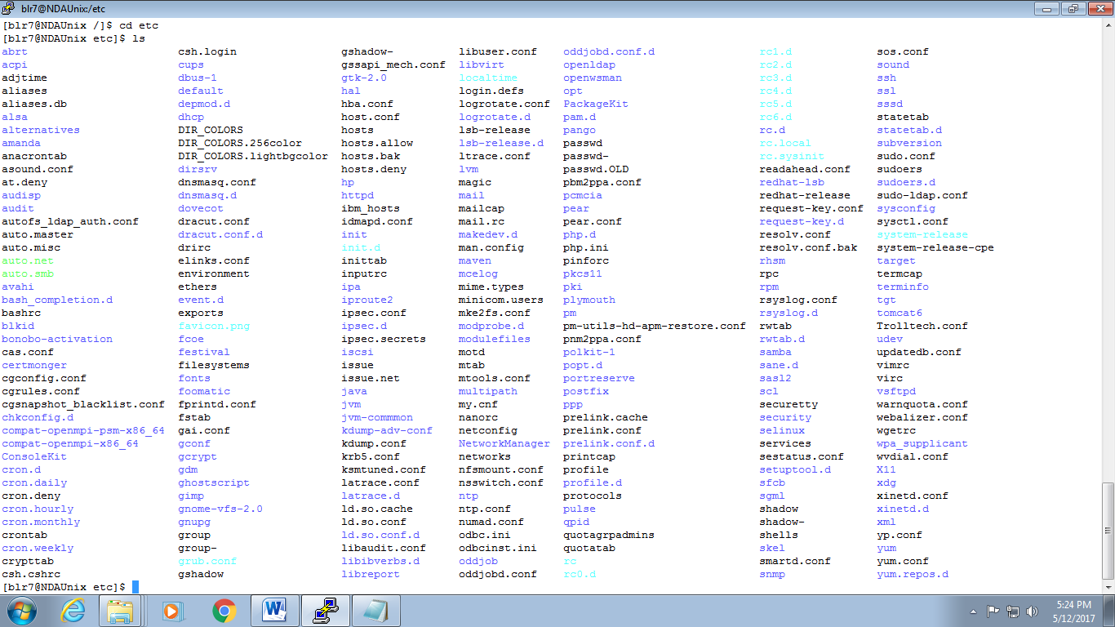

- List the names of all the files that begin with a dot in the /usr/bin directory.
[user29@NDAUnix bin]$ cd
[user29@NDAUnix ~]$ pwd
/home/user29
[user29@NDAUnix ~]$ cd /usr/bin
[user29@NDAUnix bin]$ ls -a | grep "^\."
.
..
.fipscheck.hmac
.ssh.hmac
- Create a file first.unix with the following contents.
Hi! Good Morning everybody.
Welcome to the First exercise on UNIX.
Hope you enjoy doing the assignments.
s[user29@NDAUnix ~]$ cat first_unix1

hii good morning everybody,
welcome to the first excersice of the unix,
hope you enjoy doing assessments.
- Copy the file first.unix in your home directory to first.unics.
(Note: checked using ls, first.unix file also should exist along with first.unics)

[user29@NDAUnix ~]$ cat first_unics1
hii good morning everybody,
welcome to the first excersice of the unix,
hope you enjoy doing assessments.

- List the contents of first.unix and first.unics with a single command.
[user29@NDAUnix ~]$ cat first_unix1 first_unics1
hii good morning everybody,
welcome to the first excersice of the unix,
hope you enjoy doing assessments

hii good morning everybody,
welcome to the first excersice of the unix,
hope you enjoy doing assessments

- Create a new directory under the temp directory.
Cd temp
mkdir new_directory
[user29@NDAUnix ~]$ ls temp
aa.c add.c directory directorynew1 kk.c myfile.txt new new_directory second.unix users
a.c chap1 directorynew friends.txt mov2 nato.c newdir newfriends.txt subdir

- From your home directory, copy all the files to the directory created under the temp sub directory.

[user29@NDAUnix ~]$ cp -avr temp new_directory
`temp' -> `new_directory'
`temp/newdir' -> `new_directory/newdir'
`temp/a.c' -> `new_directory/a.c'
`temp/mov2' -> `new_directory/mov2'
`temp/myfile.txt' -> `new_directory/myfile.txt'
`temp/directorynew' -> `new_directory/directorynew'
`temp/new_directory' -> `new_directory/new_directory'
`temp/aa.c' -> `new_directory/aa.c'
`temp/second.unix' -> `new_directory/second.unix'
`temp/add.c' -> `new_directory/add.c'
`temp/directory' -> `new_directory/directory'
`temp/friends.txt' -> `new_directory/friends.txt'
`temp/newfriends.txt' -> `new_directory/newfriends.txt'
`temp/directorynew1' -> `new_directory/directorynew1'
`temp/subdir' -> `new_directory/subdir'
`temp/chap1' -> `new_directory/chap1'
`temp/users' -> `new_directory/users'
`temp/kk.c' -> `new_directory/kk.c'
`temp/new' -> `new_directory/new'
`temp/new/xyz.txt' -> `new_directory/new/xyz.txt'
`temp/new/abc.txt' -> `new_directory/new/abc.txt'
`temp/nato.c' -> `new_directory/nato.c
'
- Move the file first.unix to the directory temp as second.unix
[ user29@NDAUnix ~]$ cat first.unix
hi 1 good morning everybody
welcome to the first exercise on unix
hope you enjoy doing the assignments.
[user29@NDAUnix ~]$ mv first.unix new_directory
[user29@NDAUnix ~]$ cat new_directory
hi 1 good morning everybody
welcome to the first exercise on unix
hope you enjoy doing the assignments.
- Remove the file called first.unics from the home directory.
[user29@NDAUnix ~]$ rm -ri first_unics1
rm: remove regular file `first_unics1'? y

- Change your directory to temp and issue the command rm *. What do you observe?
[user29@NDAUnix ~]$ cd temp
[user29@NDAUnix temp]$ rm *
rm: cannot remove `directory': Is a directory
rm: cannot remove `directorynew': Is a directory
rm: cannot remove `directorynew1': Is a directory
rm: cannot remove `new': Is a directory
rm: cannot remove `newdir': Is a directory
rm: cannot remove `new_directory': Is a directory
rm: cannot remove `subdir': Is a directory

- Move all files whose names end with a, c and o to the HOME directory.
[user29@NDAUnix ~]$ mv a* c* o* /home/user29
mv: `a' and `/home/user29/a' are the same file
mv: `abc.txt' and `/home/user29/abc.txt' are the same file
mv: `ass.sh' and `/home/user29/ass.sh' are the same file
mv: `chap1' and `/home/user29/chap1' are the same file
mv: `chap4' and `/home/user29/chap4' are the same file
mv: `chap5' and `/home/user29/chap5' are the same
mv: `chap9' and `/home/user29/chap9' are the same file
mv: `chapa' and `/home/user29/chapa' are the same file
mv: `chapab' and `/home/user29/chapab' are the same file
mv: `chap.txt' and `/home/user29/chap.txt' are the same file
mv: cannot stat `o*': No such file or directory

- Copy all files that end with a ‘UNIX’ to the temp directory.
[user29@NDAUnix ~]$ cat > 1first.unix
hii gud morning hav a nice day
[user29@NDAUnix ~]$ cd temp
[user29@NDAUnix temp]$ cp *unix /home/user29/
[user29@NDAUnix temp]$ ls
directory directorynew1 first_unics newdir subdir
directorynew first_12unix new new_directory

- Issuing a single command, remove all the files from the directory temp and the directory itself.
[user29@NDAUnix ~]$ rm -ri temp
rm: descend into directory `temp'? y
rm: remove directory `temp/newdir'? y
rm: remove regular file `temp/first_12unix'? y
rm: remove regular file `temp/first_unics'? y
rm: remove directory `temp/directorynew'? y
rm: descend into directory `temp/new_directory'? y
rm: remove regular file `temp/new_directory/first_unix1'? y
rm: remove directory `temp/new_directory'? y
rm: remove directory `temp/directory'? y
rm: remove directory `temp/directorynew1'? y
rm: remove directory `temp/subdir'? y
rm: descend into directory `temp/new'? y
rm: remove regular file `temp/new/xyz.txt'? y
rm: remove regular file `temp/new/abc.txt'? y
rm: remove directory `temp/new'? y
rm: remove directory `temp'? y
- Try commands cp and mv with invalid number of arguments and note the results.
cp file1.sh test hello.txt file4.sh

output : cp: target `file4.sh' is not a directory

cp file1.sh test ques31 ques31

output : cp: target `ques31' is not a directory (ques31 is a directory)

mv file1.sh test hello.txt file4.sh

output : mv: target `file4.sh' is not a directory

- Use the cat command to create a file friends, with the following data:
Madhu 6966456 09/07/68
Jamil 2345215 08/09/67
Ajay 5546785 01/04/66
Mano 7820022 09/07/68
David 8281292 09/09/60
Simmi 7864563 12/12/70
Navin 2224311 30/05/68
The fields should be separated by a tab.
user29@NDAUnix ~]$ cat >friends.lst
Madhu 6966456 09/07/68
Jamil 2345215 08/09/67
Ajay 5546785 01/04/66
Mano 7820022 09/07/68
David 8281292 09/09/60
Simmi 7864563 12/12/70
Navin 2224311 30/05/68
[user29@NDAUnix ~]$ cat friends.lst
Madhu 6966456 09/07/68
Jamil 2345215 08/09/67
Ajay 5546785 01/04/66
Mano 7820022 09/07/68
David 8281292 09/09/60
Simmi 7864563 12/12/70
Navin 2224311 30/05/68

- Display contents of the file friends.

[user29@NDAUnix ~]$ cat friends.lst
Madhu 6966456 09/07/68
Jamil 2345215 08/09/67
Ajay 5546785 01/04/66
Mano 7820022 09/07/68
David 8281292 09/09/60
Simmi 7864563 12/12/70
Navin 2224311 30/05/68

- Copy contents of friends to newfriend without using the cp command.
[user29@NDAUnix ~]$ cat friends.lst>newfriends.lst
[user29@NDAUnix ~]$ cat newfriends.lst

- Display contents of the file friends and newfriends in a single command.
[user29@NDAUnix ~]$ cat friends.lst newfriends.lst
Madhu 6966456 09/07/68
Jamil 2345215 08/09/67
Ajay 5546785 01/04/66
Mano 7820022 09/07/68
David 8281292 09/09/60
Simmi 7864563 12/12/70
Navin 2224311 30/05/68

Madhu 6966456 09/07/68
Jamil 2345215 08/09/67
Ajay 5546785 01/04/66
Mano 7820022 09/07/68
David 8281292 09/09/60
Simmi 7864563 12/12/70
Navin 2224311 30/05/68

- Find all users currently working on the system and store the output in a file named as users.
[user29@NDAUnix ~]$ who|cat >users
[user29@NDAUnix ~]$ cat users
blr1 pts/0 2017-04-26 10:07 (atrgoracle.corp.capgemini.com)
blr22 pts/1 2017-05-06 10:51 (blrwfd5158.igatecorp.com)
user2 pts/2 2017-05-10 13:13 (10.207.172.235)
user7 pts/3 2017-05-12 20:39 (10.207.172.183)
user29 pts/4 2017-05-13 08:59 (blrwfd20727.corp.capgemini.com)
blr20 pts/5 2017-05-13 08:59 (blrwfd18344.corp.capgemini.com)
blr11 pts/6 2017-05-13 09:01 (blrwfd65485.corp.capgemini.com)
blr12 pts/7 2017-05-13 09:06 (blrwfd2721.corp.capgemini.com)
blr30 pts/9 2017-05-13 09:11 (blrwfd5079.corp.capgemini.com)
blr8 pts/10 2017-05-13 09:26 (blrwfdtcadmin.corp.capgemini.com)
blr9 pts/11 2017-05-13 09:31 (blrwfd5013.corp.capgemini.com)
user2 pts/12 2017-05-12 12:46 (10.207.172.186)
blr24 pts/14 2017-05-13 09:31 (blrwfd6141.corp.capgemini.com)
user1 pts/17 2017-05-12 16:45 (blrwfd18655.corp.capgemini.com)
user4 pts/41 2017-05-12 10:05 (10.207.172.194)
blr18 pts/53 2017-05-12 09:54 (blrwfd865321.corp.capgemini.com)
user3 pts/65 2017-05-12 10:48 (10.207.172.64)

- Append contents of friends file to the file, users.
[user29@NDAUnix ~]$ cat friends.lst>>users

Madhu 6966456 09/07/68
Jamil 2345215 08/09/67
Ajay 5546785 01/04/66
Mano 7820022 09/07/68
David 8281292 09/09/60
Simmi 7864563 12/12/70
Navin 2224311 30/05/68

- Display current system date and time and record your observations. How is the time displayed?
date
the date is displayed as follows :
Thu Nov 3 17:11:27 IST 2016
- Display calendar for the month and year of your birth.
[user29@NDAUnix ~]$ cal 04 1994
April 1994
Su Mo Tu We Th Fr Sa
1 2
3 4 5 6 7 8 9
10 11 12 13 14 15 16
17 18 19 20 21 22 23
24 25 26 27 28 29 30

- Try following commands and record your observations.
date “+ %”
date “+%m”
date “+%D”
date “+%/%Training Activity”
date “+%Training Activity”
date “+%r”

date "+ %"
output : %

date "+%m"
output : 05

date "+%D"
output : 13/05/17
date "+%/%Training Activity"
[user29@NDAUnix ~]$ date "+%/%Training Activity"
%/09:47:49raining Activity

date "+%Training Activity"
output :
09:50:55raining Activity

date "+%r"
output : 09:52:17 AM

- UNIX File System & Permissions

Goals | - Learn to grant and to remove permissions and to view the file system
Time  Lab Setup | 15 min  Telnet with Unix Server

3.1: Viewing the File System and Granting/Removing Permissions

(Note: Create required files if doesn’t exists.)

- Give the execute permission for the user for a file chap1
[user29@NDAUnix ~]$ ls -l chap1
-rwxrw-r-- 1 user29 user29 5 May 12 16:30 chap1
- Give the execute permission for user, group and others for a file add.c
[user29@NDAUnix ~]$ ls -l chap1
-rwxrwxr-x 1 user29 user29 5 May 12 16:30 chap1

- Remove the execute permission from user, give read permission to group and others for a file aa.c
chmod u-x g+r o+r aa.c
ls -l aa.c
-rw-rw-r-- 1 user29 user29 10 May 13 09:58 aa.c
- Give execute permission for users for a.c, kk.c, nato and myfile using single command
chmod u+x a.c kk.c nato myfile
- Change the directory to root directory. Check the system directories, like bin, etc, usr etc
cd /
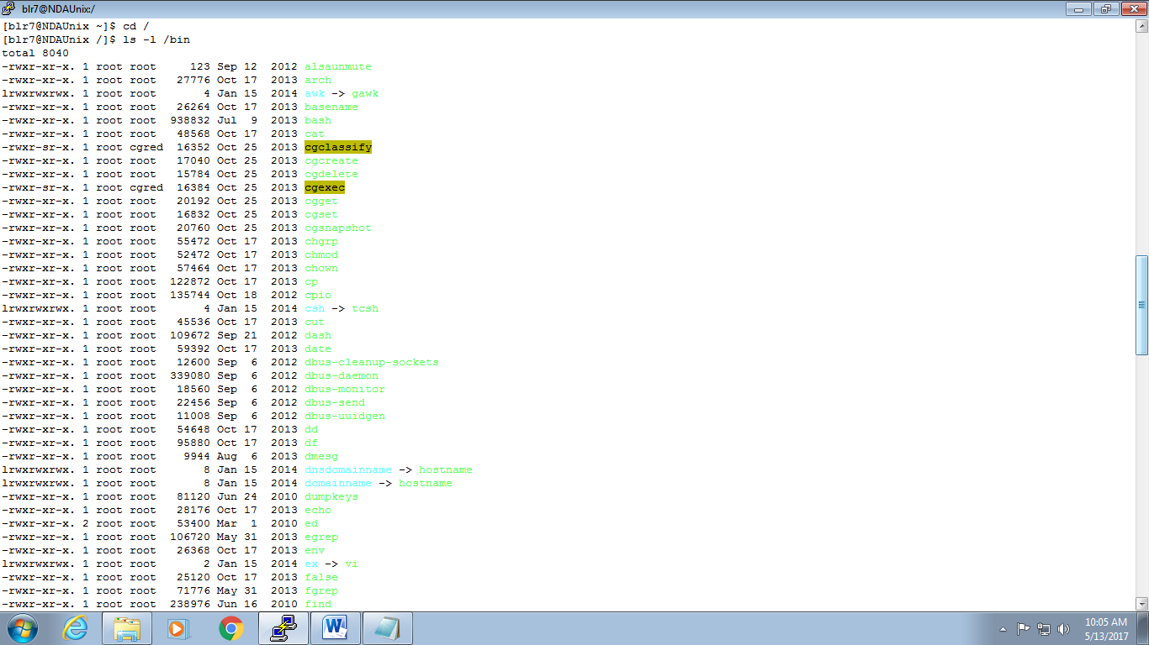

Ls –l /etc

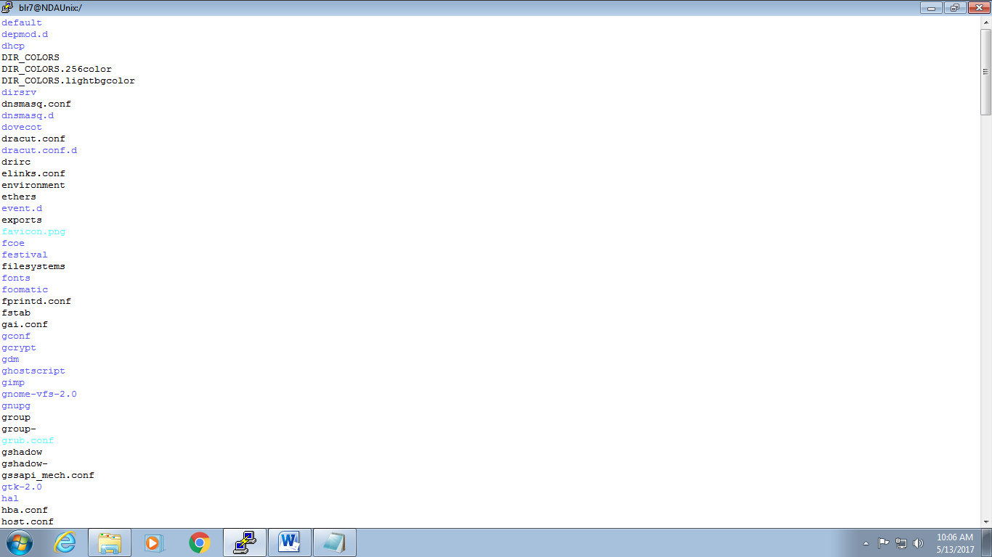

Ls –l /
[user29@NDAUnix /]$ ls -l /usr
total 208
dr-xr-xr-x. 2 root root 69632 Apr 10 11:50 bin
drwxr-xr-x. 2 root root 4096 Jun 28 2011 etc
drwxr-xr-x. 2 root root 4096 Jun 28 2011 games
drwxr-xr-x. 144 root root 12288 Jan 15 2014 include
dr-xr-xr-x. 31 root root 4096 Jan 15 2014 lib
dr-xr-xr-x. 123 root root 69632 Apr 10 11:50 lib64
drwxr-xr-x. 28 root root 12288 Jan 15 2014 libexec
drwxr-xr-x. 12 root root 4096 Jan 15 2014 local
dr-xr-xr-x. 2 root root 16384 Apr 10 11:31 sbin
drwxr-xr-x. 222 root root 4096 Jan 15 2014 share
drwxr-xr-x. 4 root root 4096 Jan 15 2014 src
lrwxrwxrwx. 1 root root 10 Jan 15 2014 tmp -> ../var/tmp
[user29@NDAUnix /]$

- Simple and Advance Filetrs

Goals | - Learn to use Pipes & Filters in UNIX
Time  Lab Setup | 100 min  Telnet with Unix Server

4.1: Using Pipes and Filters:

1: Redirect the content of the help document ls, into a file called as lsdoc.
Man ls > lsdoc

ls [OPTION]... [FILE]...

DESCRIPTION
List information about the FILEs (the current directory by default).
Sort entries alphabetically if none of -cftuvSUX nor --sort.

Mandatory arguments to long options are mandatory for short options
too.

-a, --all
do not ignore entries starting with .

-A, --almost-all
do not list implied . and ..

2: Display the content of the lsdoc page wise.

[user29@NDAUnix ~]$ more lsdoc 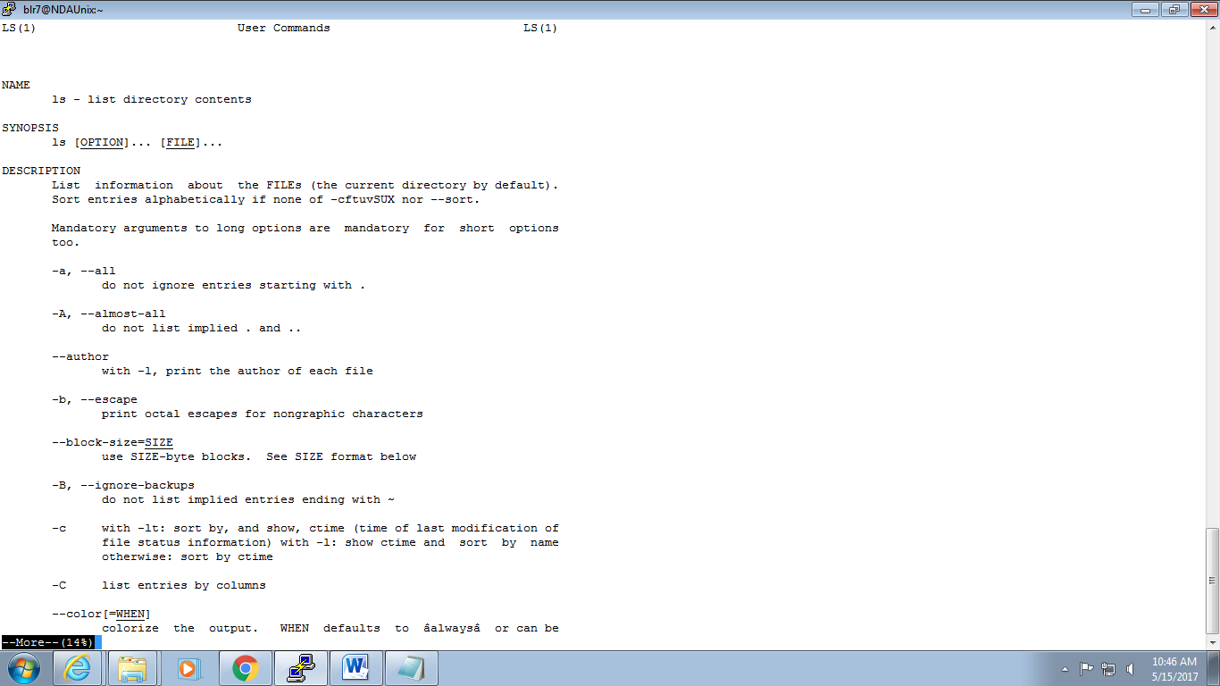

3: Display only the first 4 lines of the lsdoc file.
[user29@NDAUnix ~]$ head -4 lsdoc
LS(1) User Commands LS(1)

4: Display only the last 7 lines of the file lsdoc.
[user29@NDAUnix ~]$ tail -7 lsdoc
info coreutils 'ls invocation'

should give you access to the complete manual.

GNU coreutils 8.4 October 2013 LS(1)
[user29@NDAUnix ~]$ head -4 lsdoc
LS(1) User Commands LS(1)

5: Remove the file lsdoc.
[user29@NDAUnix ~]$ rm -i lsdoc
rm: remove regular file `lsdoc'? y

6: There will be B’day celebration from the friends file, find how many B’day parties will be held. If two of the friends have the B’date on the same day, then we will be having one party on that day.
[user29@NDAUnix ~]$ cut -f2 -d" "|sort -n friends.txt | uniq –u | wc -l
Madhavi 2000
Madrid 2001
Sangi 2004
Sindhu 2005
Vaishali 2001

7: Display the lines starting with Ma, in the file friends.
[user29@NDAUnix ~]$ grep "^Ma|i$|id$" friends.txt
Madhu 25698 08/08/78
Mathi 89768 09/09/78

8: Display the lines starting with Ma, ending with i or ending with id, in the file friends.
[user29@NDAUnix ~]$ cut -f1 -d" " friends.txt|egrep "^Ma|id$|i$"
Madhavi
Madrid
David
[user29@NDAUnix ~]$ cat friends.txt
Madhavi 2000
Madrid 2001
David 2003

9: Print all the files and the directory files from the current directory across all the sub directories, along with its path
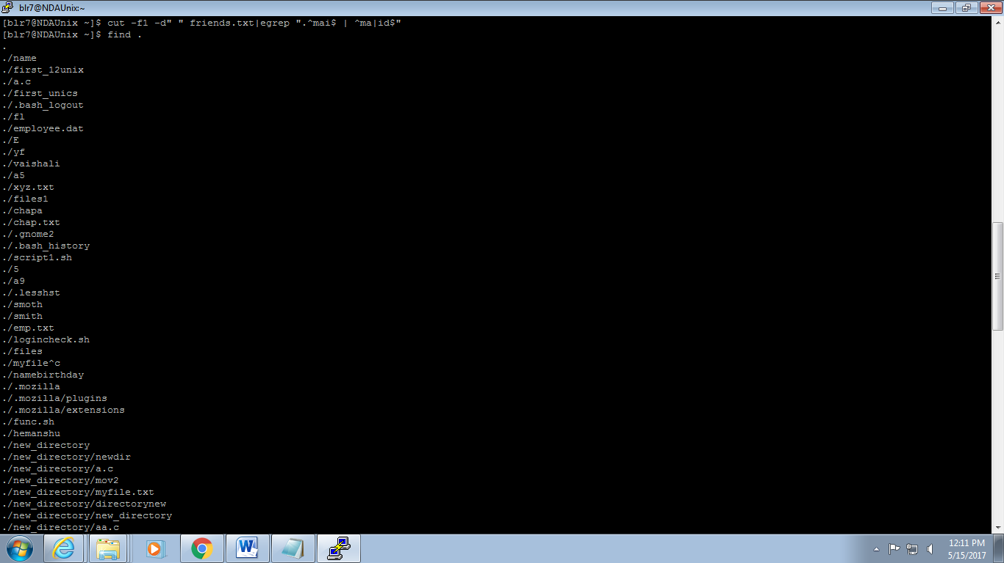

10: Print only the Directory files.

[user29@NDAUnix ~]$ ls -d */
etc/ new_directory/ temp1/

11: Display the files starting with chap, along with its path.
[user29@NDAUnix ~]$ ls chap*
chap1 chap4 chap5 chap9 chapa chapab chap.txt

12: Sort the file friends in ascending order of names.
[user29@NDAUnix ~]$ sort friends.txt
Ajay 27896 07/07/89
Jimmi 78973 12/02/68
Madhu 25698 08/08/78
Mathi 89768 09/09/78
Navin 67856 07/07/69

13: Display the contents of the file friends in uppercase letters.
[user29@NDAUnix ~]$ tr "[a-z]" "[A-Z]" < friends.txt
AJAY 27896 07/07/89
MADHU 25698 08/08/78
JIMMI 78973 12/02/68
NAVIN 67856 07/07/69
MATHI 89768 09/09/78

14: Store the contents of your home directory in a file called dir.
Ls –l <dir
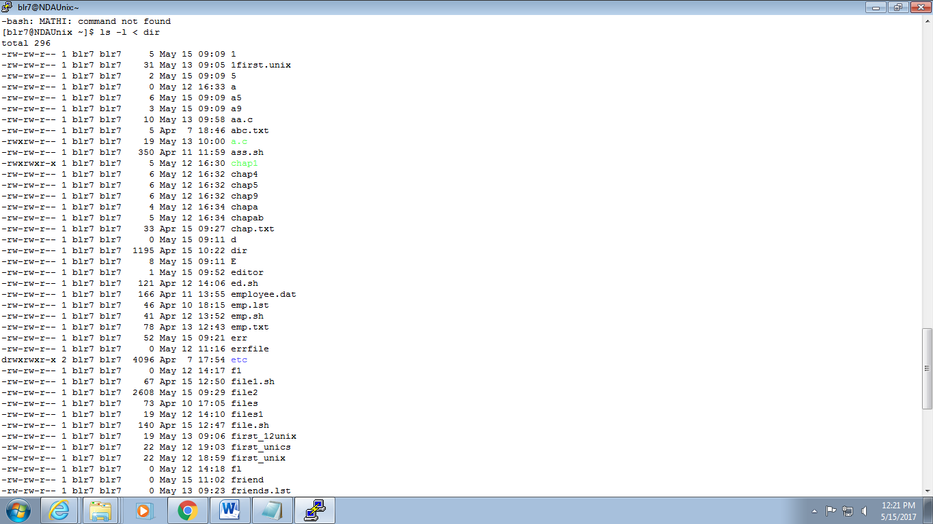

15: From the above file dir, display the file permissions and the name of the file only.
-rw-rw-r--
[user29@NDAUnix ~]$ cat dir|tr -s ' '|cut -d " " -f1,9
total
-rw-rw-r-- abc.txt
-rw-rw-r-- ass.sh
-rw-rw-r-- chap.txt
-rw-rw-r-- dir
-rw-rw-r-- ed.sh
-rw-rw-r-- employee.dat
-rw-rw-r-- emp.lst
-rw-rw-r-- emp.sh
-rw-rw-r-- emp.txt
drwxrwxr-x etc
-rw-rw-r-- files
-rw-rw-r-- file.sh
-rw-rw-r-- first.unix
-rw-rw-r-- friends.txt
-rw-rw-r-- friend.txt
-rw-rw-r-- func.sh
-rw-rw-r-- function.sh
-rw-rw-r-- help
-rw-rw-r-- ijk.txt
-rw-rw-r-- prems
-rw-rw-r-- size
-rw-rw-r-- telephonedirectory.txt
drwxrwxr-x temp
-rw-rw-r-- xyz.txt

16: From the same dir file, store only the file names in a file called files.
[user29@NDAUnix ~]$ cat dir|tr -s ' '|cut -d " " -f9 >files
[user29@NDAUnix ~]$ cat files

abc.txt
ass.sh
chap.txt
dir
ed.sh
employee.dat
emp.lst
emp.sh
emp.txt
etc
files
file.sh
first.unix
friends.txt
friend.txt
func.sh
function.sh
help
ijk.txt
prems
size
telephonedirectory.txt
temp
xyz.txt

17: From the same dir file, store only the permissions of files in a file called perms.
[user29@NDAUnix ~]$ cat dir|tr -s ' '|cut -d " " -f1 >perms
[user29@NDAUnix ~]$ cat perms
total
-rw-rw-r--
-rw-rw-r--
-rw-rw-r--
-rw-rw-r--
-rw-rw-r--
-rw-rw-r--
-rw-rw-r--
-rw-rw-r--
-rw-rw-r--
drwxrwxr-x
-rw-rw-r--
-rw-rw-r--
-rw-rw-r--
-rw-rw-r--
-rw-rw-r--
-rw-rw-r--
-rw-rw-r--
-rw-rw-r--
-rw-rw-r--
-rw-rw-r--
-rw-rw-r--
-rw-rw-r--
drwxrwxr-x
-rw-rw-r--

18: From the same dir file, store only the file sizes in a file called sizes.
[user29@NDAUnix ~]$ cat dir|tr -s ' '|cut -d " " -f5|cat >filesize
[user29@NDAUnix ~]$ cat filesize

5
350
33
0
121
166
46
41
78
4096
73
12
104
104
0
117
120
18
44
108
46
93
4096
5
19: Display the file names, sizes and permissions from your directory in that order.
Cat files filesize perms

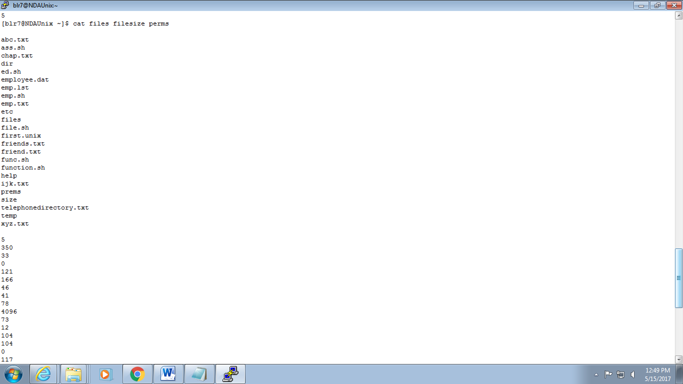



20: Display the number of users working on the system.
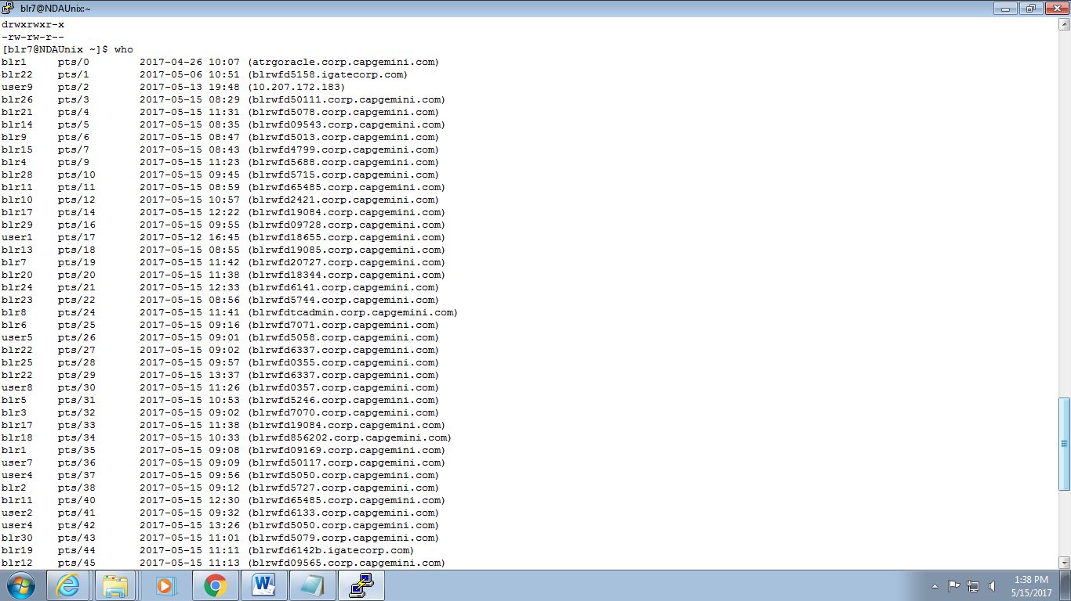

21: Find out the smallest file in your directory.

22: Display the total number of lines present in the file friends.
Wc –l friends.txt
5

23:Create the following fixed record format files (with “|” delimiter between fields) with the structure given below, and populate them with relevant data use these files to solve following questions
emp.lst: Empid(4),Name(18),Designation(9),Dept(10),Date of Birth(8),Salary(5)
dept.lst : Dept.Code(2),Name(10),Head of Dept’s id(4)
desig.lst: Designation Abbr.(2), Name (9)
- Find the record lengths of each file.
- Display only the date of birth and salary of the last employee record.
- Extract only employee names and designations. (Use column specifications). Save output as cfile1.
- Extract Emp.id, dept, dob and salary. (Use field specifications). Save output as cfile2.
- Fix the files cfile1 and cfile2 laterally, along with the delimiter.
- Sort the emp.lst file in reverse order of Emp. Names.
- Sort the emp.lst file on the salary field, and store the result in file srtf.
- Sort the emp.lst file on designation followed by name.
- Sort the emp.lst file on the year of birth.
- Find out the various designations in the employee file. Eliminate duplicate listing of designations.
- Find the non-repeated designation in the employee file.
- Find the number of employees with various designations in the employee file.
- Create a listing of the years in which employees were born in, along with number of employees born in that year.
- Use nl command to create a code table for designations to include designation code (Start with dept. code 100, and subsequently 105, 110 …).

wc -l emp.lst
output : 6 emp.lst
wc -l dept.lst
output : 2 dept.lst
wc -l desig.lst
output : 4 desig.lst
2. cat emp.lst|cut -d '|' -f5,6
3. cat emp.lst|cut -d '|' -f2,3|cat >cfile1
4. cat emp.lst|cut -d '|' -f1,2,4,6|cat >cfile2
6. sort -r -k2 emp.lst
7. sort -k6 emp.lst >srtf
8. sort -k2 -k3 emp.lst
9. sort -t"|" -k5.7 emp.lst
10. cut -d"|" -f3 emp.lst >temp |uniq temp
11. Same as 23.10
12. cut -d"|" -f3 emp.lst |uniq -c
13. cut -c70-75 emp.lst |uniq -c
14. cut -d"|" -f4,3 emp.lst|nl

24: PCS has its offices at Pune, TTC and Mumbai. The employees’ data is stored separately for each office. Create appropriate files (with same record structure as in previous assignment) and populate with relevant data.

- List details about an employee ‘Manu Sharma’ in the Mumbai office.
- List only the Emp.Id. And Dept. of Manu Sharma.
- List details of all managers in all offices. (O/P should not contain file names.).
- Find the number of S.E. in each office.
- List only the Line Numbers and Employee names of employees in ‘H/W’ in Pune file.
- Obtain a listing of all employees other than those in ‘HR’ in the Mumbai file and save contents in a file ‘nonhr’.
- Find the name and designation of the youngest person who is not a manager.
- Display only the filename(s) in which details of employee by the name ‘Seema Sharma’ can be found.
- Locate the lines containing saxena and saksena in the Mumbai office.
- Find the number of managers who earn between 50000 and 99999 in the Pune office.
- List names of employees whose id is in the range 2000 – 2999: in Pune Office; in all offices.
- Locate people having same month of birth as current month in Pune office.
- List details of all employees other than those of HR and Admin in file F1.
- Locate for all Dwivedi, Trivedi, Chaturvedi in Pune file.
- Obtain a list of people in HR, Admin and Recr. depts. sorted in reverse order of the dept.

1. grep "Manu Sharma" emp_pcs_pune.dat
2. grep "Manu Sharma" emp_pcs_pune.dat | cut -d"," -f1,4
3. grep "Manager" emp_pcs_mumbai.dat emp_pcs_ttc.dat emp_pcs_pune.dat
4. grep "SSE" emp_pcs_mumbai.dat emp_pcs_ttc.dat emp_pcs_pune.dat -c
5. grep "SSE" emp_pcs_pune.dat | nl | cut -d"," -f1,2
6. grep -v 'HR' emp_pcs_pune.dat
7. grep -v 'HR' emp_pcs_pune.dat emp_pcs_mumbai.dat emp_pcs_ttc.dat| sort -k5 |head -1
8. grep 'Seema Sharma' emp_pcs_pune.dat emp_pcs_mumbai.dat emp_pcs_ttc.dat
9. fgrep check emp_pcs_mumbai.dat |nl|cut -f1
12. egrep '[1-30]/11/[1900-2999]' emp_pcs_pune.dat
13. grep -v 'HR' 'Admin' emp_pcs_pune.dat
14. egrep title emp_pcs_pune.dat

Stretched assignments:

25: Write a command sequence that prints out date information in this order: time, day of week, day number, month, year:
13:44:42 IST Sun 16 Sept 1994

12:18:45 IST Tue 16 May 2017

26: Write a command sequence that prints the names of the files in the current directory in the descending order of number of links

Ls –l | cut f1,9 –d” ”| sort -r
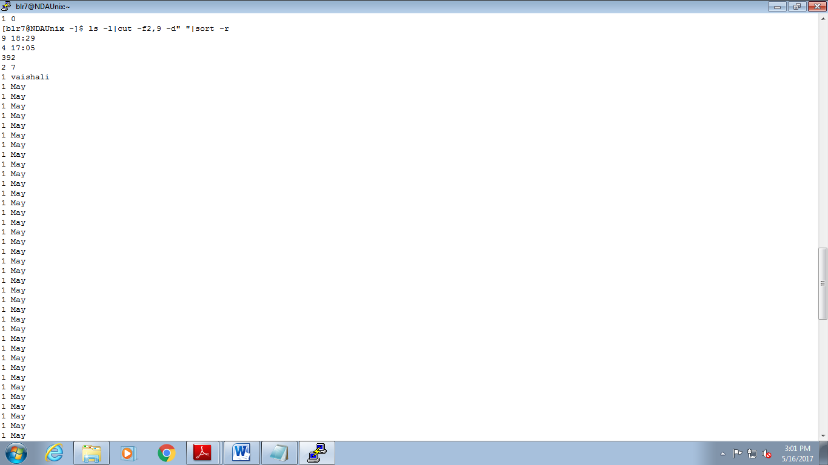

27: Write a command sequence that prints only names of files in current working directory in alphabetical order

Ls –l |tr –s ‘ ‘|cut –f9 –d” “

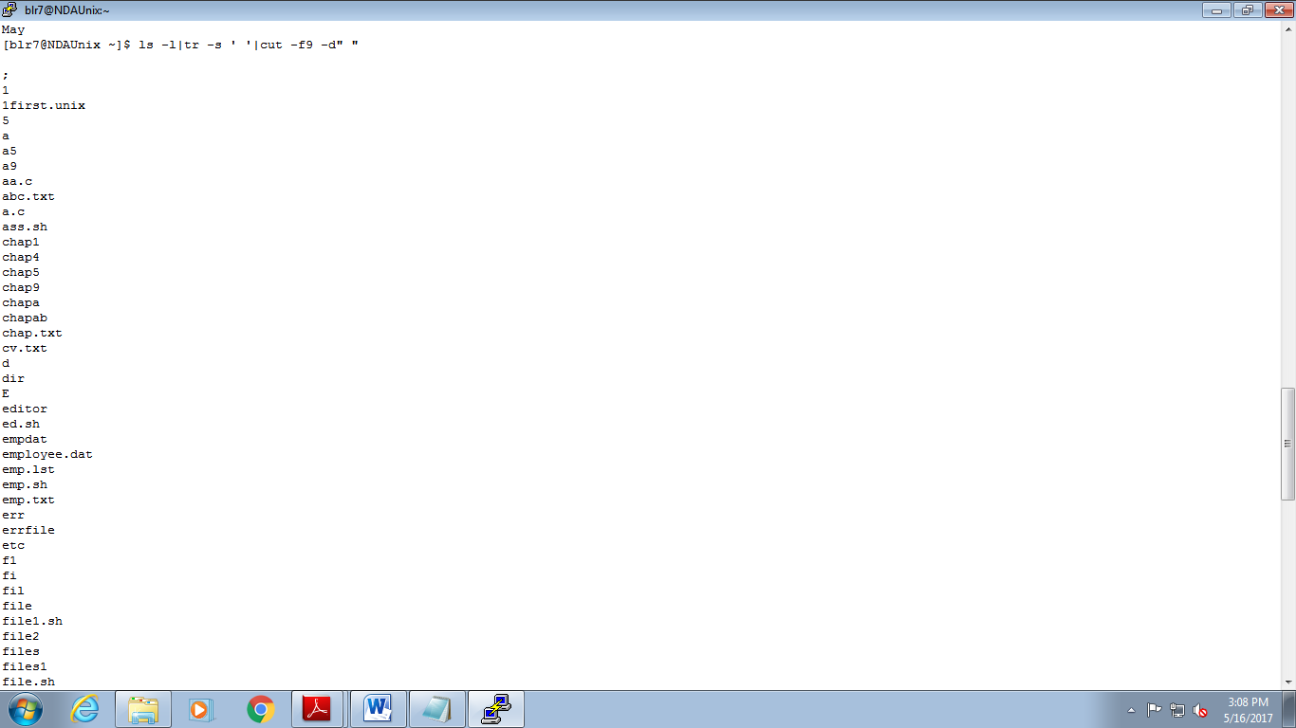

28: Write a command sequence to print names and sizes of all the files in current working directory in order of size

ls -l|tr -s ' '|cut -d ' ' -f5,9|sort -n
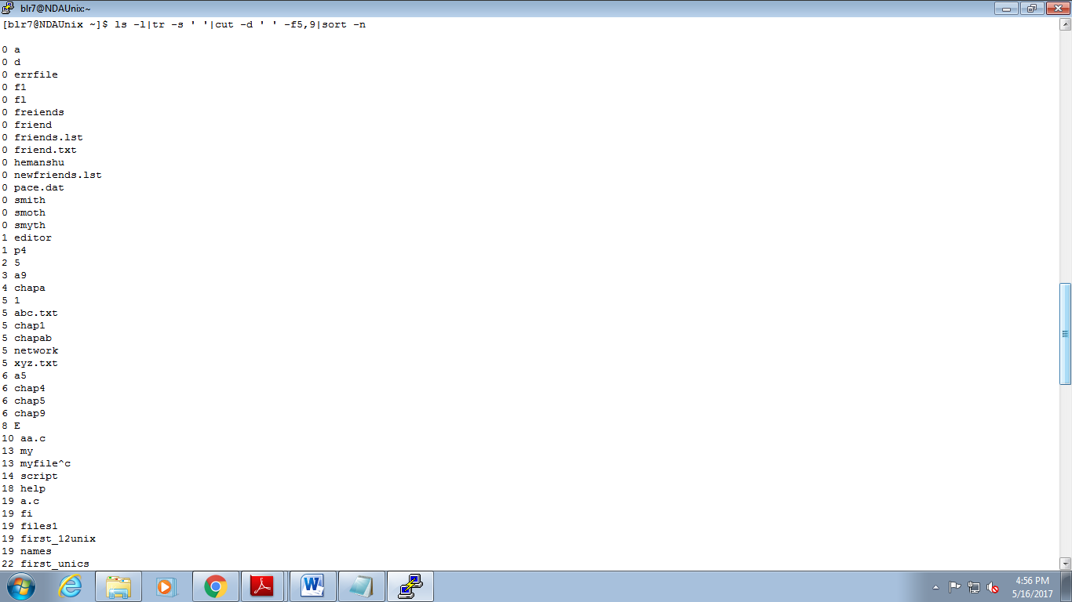

29: Determine the latest file updated by the user

ls -l|tr -s ' '|cut -d ' ' -f6,7,8,9|sort
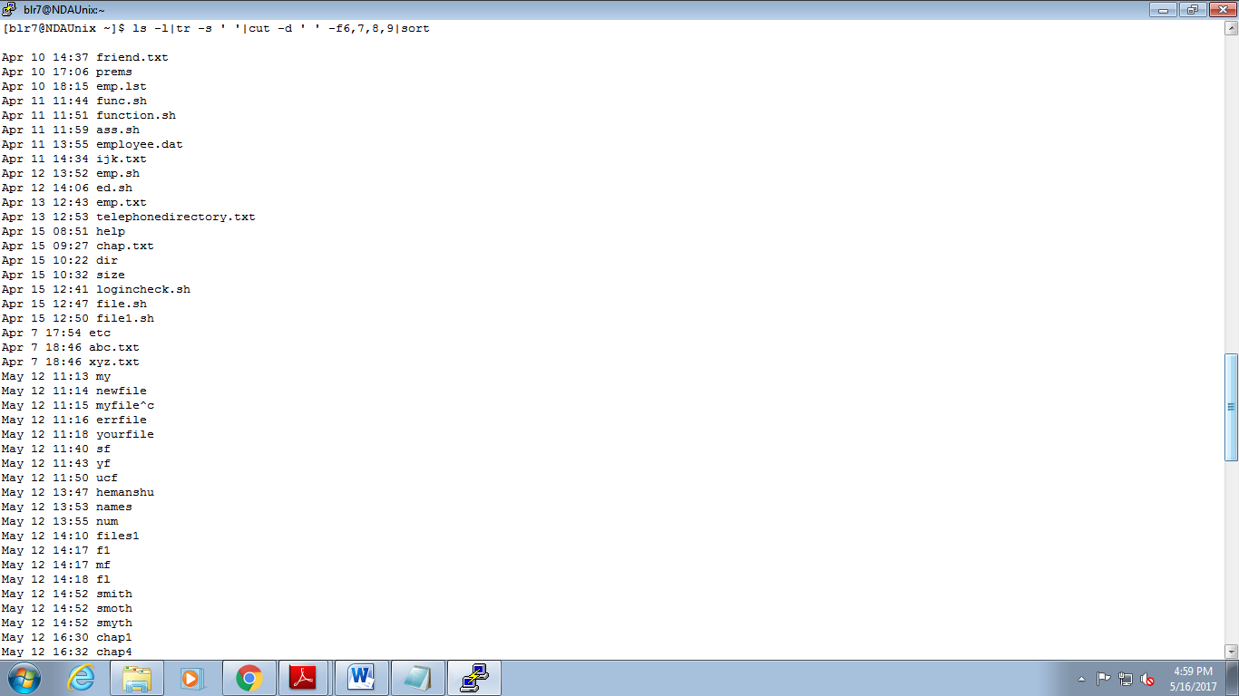
- Vi Editor

Goals | Work with Vi Editor in Unix
Time  Lab Setup | 30 min  Telnet with Unix Server

5.1: Working wth Vi Editor
- Create a file using Vi. Enter the following text:
A network is a group of computers that can communicate with each other, share resources, and access remote hosts or other networks. Netware is a computer network operating system designed to connect, manage, and maintain a network and its services. Some of the network services are Netware Directory Services (NDS), file system, printing and security.

- Change the word “Netware” in the second line to “Novell Netware”.
- Insert the text “(such as hard disks and printers)” after “share resources” in the first line.
- Append the following text to the file:
“Managing NDS is a fundamental administrator role because NDS provides a single point for accessing and managing most network resources.”

Solution:
Network
a) Press Esc and go to the line where we need to insert Novell and press "i"
b) Press Esc and go to the line where we need to add content (such as hard disks and printers) and press "i"
c) Go to end of the line by pressing Esc and $ and then press "a" to append the line

2: Create the data files, used in the previous lab sessions using vi editor.
vi emp.dat
vi dept.dat
vi desig.dat
- SED Commands

Goals | Learn to use SED Commands in Unix
Time  Lab Setup | 15 min  Telnet with Unix Server

6.1: Using SED Commands
- Create a file “Employee.dat” with text as follows.

James 76382 PACE Chennai
John 34228 GRIT Hyderabad
Peter 22321 GE Bangalore
Albert 32342 GRIT Pune
Mathew 23222 PACE Mumbai
Richard 23232 ACS Pune

[user29@NDAUnix ~]$ cat employee.dat
James |76382 |PACE |chennai
John |34228 |GRIT |hyderabad
Peter |22321 |GE |bangalore
Albert|32342 |GRIT |pune
Mathew|23222 |PACE |mumbai
Richa |23232 |ACS |pune

- Write a sed command to print only the lines starting at line 2 and ending with the letters “Pune”
[user29@NDAUnix ~]$ sed -n '1d' employee.dat|sed -n '/pune$/p' employee.dat
Albert|32342 |GRIT |pune
Richa |23232 |ACS |pune

- Write a sed command that will display the top 5 lines from the file
[user29@NDAUnix ~]$ sed 5q employee.dat
James |76382 |PACE |chennai
John |34228 |GRIT |hyderabad
Peter |22321 |GE |bangalore
Albert|32342 |GRIT |pune
Mathew|23222 |PACE |mumbai
- Write a sed command that will substitute the word “Chennai” for "Pune" used in all instance of the word
[user29@NDAUnix ~]$ sed 's/chennai/Pune/' employee.dat
James |76382 |PACE |Pune
John |34228 |GRIT |Hyderabad
Peter |22321 |GE |bangalore
Albert|32342 |GRIT |pune
Mathew|23222 |PACE |mumbai
Richa |23232 |ACS |pune

- Write a sed command that will replace occurrence of the character e with the string UNIX in all lines. (Use –e option)
[user29@NDAUnix ~]$ sed -e 's/e/UNIX/g' employee.dat
JamUNIXs |76382 |PACE |chUNIXnnai
John |34228 |GRIT |hydUNIXrabad
PUNIXtUNIXr |22321 |GE |bangalorUNIX
AlbUNIXrt|32342 |GRIT |punUNIX
MathUNIXw|23222 |PACE |mumbai
Richa |23232 |ACS |punUNIX

- Write a sed command to delete blank lines
[user29@NDAUnix ~]$ sed '/^$/d' employee.dat
James |76382 |PACE |chennai
John |34228 |GRIT |hyderabad
Peter |22321 |GE |bangalore
Albert|32342 |GRIT |pune
Mathew|23222 |PACE |mumbai
Richa |23232 |ACS |pune

- Write a sed command to delete lines from 3 to 5

[user29@NDAUnix ~]$ sed '3,5d' employee.dat
James |76382 |PACE |chennai
John |34228 |GRIT |hyderabad
Richa |23232 |ACS |pune

2: Create a new file “PACE.dat which has only the lines that contain the word “PACE” from Employee.dat

[user29@NDAUnix ~]$ sed -n '/PACE/p' employee.dat | cat >PACE.dat
[user29@NDAUnix ~]$ cat PACE.dat
James |76382 |PACE |chennai
Mathew|23222 |PACE |mumbai
- Process Related Commands

Goals | Learn to use process-related commands in Unix
Time  Lab Setup | 15 min  Telnet with Unix Server

7.1: Using Process-Related Commands
- Find out the PID of the processes that are activated by you
[user29@NDAUnix ~]$ ps -u
Warning: bad syntax, perhaps a bogus '-'? See /usr/share/doc/procps-3.2.8/FAQ
USER PID %CPU %MEM VSZ RSS TTY STAT START TIME COMMAND
user29 17671 0.0 0.0 108472 1892 pts/30 Ss 16:55 0:00 -bash
user29 19598 0.0 0.0 110240 1128 pts/30 R+ 17:23 0:00 ps -u

- Find out the information about all the processes that are currently active
[user29@NDAUnix ~]$ ps -l
F S UID PID PPID C PRI NI ADDR SZ WCHAN TTY TIME CMD
0 S 1175 17671 17670 0 80 0 - 27118 wait pts/30 00:00:00 bash
0 R 1175 19951 17671 0 80 0 - 27033 - pts/30 00:00:00 ps

- Start a different process in the background. Find out the status of the background process using the PID of the same.
[user29@NDAUnix ~]$ vi vaishu &
[3] 46120
[user29@NDAUnix ~]$ ps -l
F S UID PID PPID C PRI NI ADDR SZ WCHAN TTY TIME CMD
0 S 1175 45710 45709 0 80 0 - 27118 wait pts/28 00:00:00 bash
0 T 1175 45917 45710 0 80 0 - 35368 signal pts/28 00:00:00 vim
0 T 1175 46090 45710 0 80 0 - 35368 signal pts/28 00:00:00 vim
0 T 1175 46120 45710 0 80 0 - 35368 signal pts/28 00:00:00 vim
0 R 1175 46126 45710 0 80 0 - 27035 - pts/28 00:00:00 ps

[3]+ Stopped vim vaishu
[user29@NDAUnix ~]$ ps -l 46120
F S UID PID PPID C PRI NI ADDR SZ WCHAN TTY TIME CMD
0 T 1175 46120 45710 0 80 0 - 35368 signal pts/28 0:00 vim vaishu

- AWK

Goals | Learn to write awk scripts
Time  Lab Setup | 30 min  Telnet with Unix Server

8.1: Writing awk-Scripts
1. Consider the results are stored in following format:

EmpID Name Subject Marks(/50)
E001 Nilesh Unix 30
E002 Suresh DSA 20
Like these you have 10 records ( 5 of DSA and 5 of Unix)
- Display First 5 records.
[user29@NDAUnix ~]$ awk 'NR==1,NR==5 {print NR" " $0}' Student
1 E001 Nilesh Unix 30
2 E002 Suresh DSA 20
3 E003 Siva Unix 40
4 E004 Rahul DSA 10
5 E005 Rajitha Unix 50
- Display Employees who belongs to subject Unix
[user29@NDAUnix ~]$ awk '$3=="Unix" {print $0}' Student
E001 Nilesh Unix 30
E003 Siva Unix 40
E005 Rajitha Unix 50
E007 Vimal Unix 35
E009 Irfan Unix 15

- Display employee names that got less than 30 marks in DSA subject.
[user29@NDAUnix ~]$ awk '($4<30) && ($3=="DSA") {print $0}' Student
E002 Suresh DSA 20
E004 Rahul DSA 10
E008 Vishal DSA 25
E010 Shiv DSA 5

- Display only even numbered records
[user29@NDAUnix ~]$ awk 'NR%2==0 {print NR,$0}' Student
2 E002 Suresh DSA 20
4 E004 Rahul DSA 10
6 E006 Krish DSA 45
8 E008 Vishal DSA 25
10 E010 Shiv DSA 5

- Display Employee id of records whose name start with N.
[user29@NDAUnix ~]$ awk '($2~/^N/){print $1,$2}' Student
E001 Nilesh
- Shell Script

Goals | Learn to write simple shell scripts
Time  Lab Setup | 150 min  Telnet with Unix Server

9.1: Writing Shell-Scripts
- Display the Primary and Secondary prompt. Change the primary prompt to your name: temporarily
[user29@NDAUnix ~]$ echo PS1
PS1
[user29@NDAUnix ~]$ PS1="[vaishali]"
[vaishali]

2: As soon as you login, the prompt should be changed to your name: also the name of the home directory should be automatically displayed.
[user29@NDAUnix ~]$ PS1="[vaishali]"
[vaishali]
[vaishali] PS1="[\u@\h\w]\\$"
[user29@NDAUnix~]$

3: Check the content of the Environmental variable SHELL.

[user29@NDAUnix~]$echo $SHELL
/bin/bash

4: Try the below exercise and check the output.

Note: Type every line and press enter, do not type the entire code in a vi editor.

$continent=”Africa”
$echo “$continent”
------------→ Africa
$sh
$echo “$continent”
------------→ No Response
$continent=”Asia”
$echo “$continent”
------------→ Asia
$ctrl + d
$echo “$continent”
------------→ Africa
$sh
$echo “$continent”
------------→ No Response
$ctrl + d

5: Try the below exercise and check the output. (Export variables)

Note: Type every line and press enter, do not type the entire code in a vi editor.

$continent=”Africa”
export continent
$echo “$continent”
------------→ Africa
$sh
$echo “$continent”
------------→ Africa
$continent=”Asia”
$echo “$continent”
------------→ Asia
$ctrl + d
$echo “$continent”
------------→ Africa

6: Write a shell script that takes the user name as input and reports whether he / she has logged in or not.
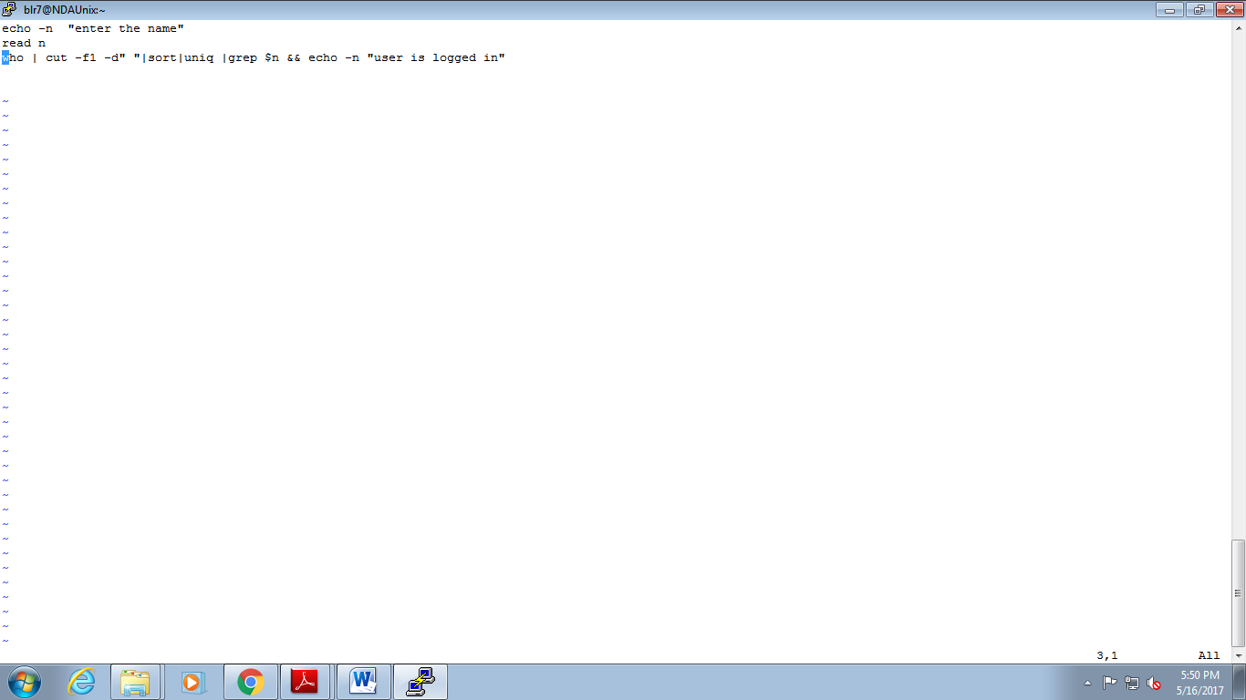

[user29@NDAUnix~]$vi script1
[user29@NDAUnix~]$sh script1
enter the nameuser29
user29
user is logged in[user29@NDAUnix~]$

7: Write a shell script to display the file name and its contents of all the files that is there in the current directory.

8: Write a shell script, which will take a file name as argument and check whether the file exists and display its access permissions for user.
[user29@NDAUnix~]$vi file
[user29@NDAUnix~]$sh file
enter file name
vaishu
grep: echo: No such file or directory
-rw-rw-r-- 1 user29 user29 29 May 16 18:10 vaishu
grep: filename exist: No such file or directory
[user29@NDAUnix~]$vi file
[user29@NDAUnix~]$sh file
enter file name
vaishu
grep: echo: No such file or directory
grep: filename exist: No such file or directory
-rw-rw-r-- 1 user29 user29 29 May 16 18:10 vaishu
[user29@NDAUnix~]$cat file
echo "enter file name"
read filename

ls -l|tr -s ' '|cut -f9 -d" "|grep -e $filename echo "filename exist" | ls -l $filename

9: Pass three numbers as command line arguments and display the largest number in the given three numbers.
[user29@NDAUnix~]$vi large
[user29@NDAUnix~]$sh large 10 45 25
enter the num1:10
enter the num2:45
enter the num3:25
largets num:45
[user29@NDAUnix~]$cat large
echo "enter the num1:$1"
echo "enter the num2:$2"
echo "enter the num3:$3"
if [ $1 -gt $2 ] && [ $1 -gt $3 ]
then
echo "largest num:$1"
elif [ $2 -gt $1 ] && [ $2 -gt $3 ]
then
echo "largets num:$2"
else
echo "largest num:$3"
fi

10: Write a shell script which will accept a pattern and a file name. The pattern will be searched in the file provided. Display appropriate messages and perform necessary validations on file.
[user29@NDAUnix~]$sh pattern
enter the pattern
sanju
enter the filename
vaishu
file doesnot exist

[user29@NDAUnix~]$cat pattern
echo "enter the pattern"
read pattern
echo "enter the filename"
read filename
grep -e $pattern $filename && echo "file and pattern exist" || echo "file doesn ot exist"

11: To create a menu program for a) creating a file, b) Creating a directory, c) copying a file, d) moving a file. (use functions)
  - If the file exists already give the appropriate message
  - If the dir exists already give the appropriate error message
  - Source file should exist if not give a message, It should have read permission if not another message, Destination file either there or not, if not there then create it and copy it. If there, then ask whether to overwrite or not, if yes then overwrite it or else give a message file exists already and not overwritten.
- [blr8@NDAUnix ~]$ cat s11
- f1()
- {
- echo -n Enter the file name to be created:
- read fn
- if [ -f $fn ]
- then
- echo "the file exists"
- else
- cat > $fn
- echo "file created"
- fi
- }

- f2()
- {
- echo -n "Enter the directory name to be created:"
- read dn
- if [ -d $dn ]
- then
- echo the given directory already exists
- else
- mkdir $dn
- echo "directory created"
- fi
- }
- f3()
- {
- echo enter file names to copy
- echo enter file1:
- read file1
- echo enter file2:
- read file2
- cp $file1 $file2
- echo file is copied
- }

- f4()
- {

- echo enter file name to movie
- echo enter src:
- read filename
- echo enter dest:
- read des
- cp $filename $des
- echo file is moved

- }

- echo -n "Select From the below menu:"
- echo "1. Create a File"
- echo "2. Create a Directory"
- echo "3.Copy a File"
- echo "4.Move a File"
- echo -n "Enter your choice:"
- read c
- case $c in 1)f1;;
- 2)f2;;
- 3)f3;;
- 4)f4;;
- esac

12: Write a function yesno() to display question to user and accept answer as y/n. If answer to the question is y the function should return 0 otherwise 1.
Use yesno functions for asking different questions. Question will be passed as parameter to the function.
Accept filename from user check whether it is file or directory. Use yesno() function to display question do you really want to delete file? If the ans is y, then delete the file or directory.

13: Write a shell script to store names of four employees and check whether those employees are currently logged in or not. Display appropriate message.
emp=( "user29" "blr8" "blr6" "blr9" )
for i in {0..3}
do
who | cut -f1 -d" "|sort|uniq|grep ${emp[$i]} && echo user logged in: ${emp[$i]} || echo user not logged in: ${emp[$i]}
done

[user29@NDAUnix ~]$ sh lab13
user29
user logged in: user29
blr8
user logged in: blr8
blr6
user logged in: blr6
blr9
user logged in: blr9

14: Accept the user's first and last name and the echo the entire name along with some suitable comment.
[user29@NDAUnix ~]$ cat lab14
echo "enter first name"
read frst
echo "enter last name"
read last
echo $frst $last
[user29@NDAUnix ~]$ vi lab14
[user29@NDAUnix ~]$ sh lab14
enter first name
vais
enter last name
jain
vais jain

15: List all files that have been modified today.
[user29@NDAUnix ~]$ ls -l|tr -s ' '|cut -f6,7,8,9 -d" " |sort -r| grep "May 17"
May 17 09:45 lab14
May 17 09:41 lab13
May 17 09:23 employer
May 17 09:12 program
May 17 08:39 krishna
May 17 08:38 sindu
May 17 08:37 sangi

16: Display long listing of only the regular files in the current directory.
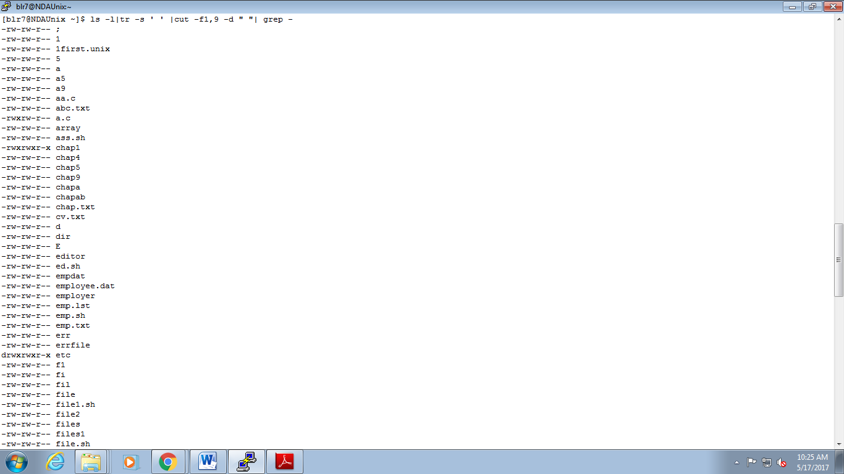
17: Display details of all files in the 2 “paths” accepted from user. The display should be screen by screen.
18: Let the script display its name and its PID.
[user29@NDAUnix ~]$ vi lab18
[user29@NDAUnix ~]$ sh lab18
my script is: lab18
my PID is : 29110
[user29@NDAUnix ~]$ cat lab18
echo "my script is: $0"
echo "my PID is : $$"

19: Get the concatenated o/p of 2 files into a third file: Take 3 command line arguments: The first argument is the name of a destination file, and the other two arguments are :names of files whose contents are to be placed in the destination file.

Stretched Assignments:

20: Write a menu driven shell program to:
a. Display calendar of current month
- Search for a pattern in all the files/subdirectories from current directory.
- Count the no. of directories / sub directories in current directory

21: Display day of week for a given date. (ddmmyyyy)
If day is Monday, display message “Monday Blues”
Friday display message “yeh! It’s week end.”
Similarly display different messages for each day of the week.

22: Display the contents of all .lst files in the current directory.

23: Design a simple calculator, which will add/subtract/multiply/divide 2 numbers.
eg. cal 10 20 + will give o/p as 30.
[user29@NDAUnix ~]$ vi sum
[user29@NDAUnix ~]$ sh sum 8 4
enter the num:8
enter the 2nd name:4
sum =12
dif =4
[user29@NDAUnix ~]$ cat sum
echo -n "enter the num:"
read num1
echo -n "enter the 2nd name:"
read num2
echo sum =$(( num1 + num2))
echo dif =$((num1 - num2))
echo mul =$(( num1 \* num2))
echo div =$((num1 / num2))

24: For a student file with the following fields, rollno, name, marks, Generate 2 files ‘Pass’ and ‘Fail’ containing records of student who have passed or failed. Also count the number of students who have passed or failed.

25: Accept a date string from terminal and display employees born after the input date.

- Source Code Control System

Goals | - Learn the concept of version management  - Understand the steps involved in version management using SVN as a tool
Time  Lab Setup | 60 min  Linux Operating System and SVN client

11.1: Repository Creation
This is a Linux Administrator task and assumes that he has created the repository at location “/home/demo_project_repository”.

11.2: Initial Project Setup
Option 1: Using System administrator/ Normal User (If the project is newly started)
Creating a folder
[root@pace ~]# svn mkdir file:///home/demo_project_repository/Analysis -m "Creating Project Analysis directory"

Committed revision 1.

Deleting a folder
[root@pace ~]# svn rm file:///home/demo_project_repository/Analysis -m "Removing Project Analysis directory"

Committed revision 2.

Checking log file
[root@pace ~]# svn log file:///home/demo_project_repository
----------------------------------------------------------------
r2 | root | 2013-09-30 09:47:17 +0530 (Mon, 30 Sep 2013)| 1 line
Removing Project Analysis directory
----------------------------------------------------------------
r1 | root | 2013-09-30 09:46:49 +0530 (Mon, 30 Sep 2013)| 1 line
Creating Project Analysis directory
----------------------------------------------------------------

Option 2: Using client (if the directory structure of project is already defined)
Note: - This activity is call project import
Initial project directory structure at client side
[testuser1@pace project]$ tree -a
.
|-- Analysis
| |-- ReadMe.txt
| `-- Software_Requirement_Specification.docx
|-- Coding
|-- Design
| |-- High_Level_Design_1.2.docx
| `-- Low_Level_Design_1.2.docx
|-- Query_Tracking_Sheet
|-- Testing
| `-- test_case-lv1.0.xls
`-- Timesheet

Importing the Initial Project to Repository
[testuser1@pace project]$ svn import /home/testuser1/project file:///home/demo_project_repository -m 'Initial import'
Adding /home/testuser1/project/Query_Tracking_Sheet
Adding /home/testuser1/project/Coding
Adding /home/testuser1/project/Analysis
Adding /home/testuser1/project/Analysis/Software_Requirement_Specification.docx
Adding /home/testuser1/project/Analysis/ReadMe.txt
Adding /home/testuser1/project/Timesheet
Adding /home/testuser1/project/Design
Adding /home/testuser1/project/Design/High_Level_Design_1.2.docx
Adding /home/testuser1/project/Design/Low_Level_Design_1.2.docx
Adding /home/testuser1/project/Testing
Adding /home/testuser1/project/Testing/test_case-lv1.0.xls

Committed revision 3.

The project was imported to the SVN, now delete the local directories

11.3: Creating the working copy of project (Check out)
Login to the client, go to the folder where working copy is to be created and fire the following commands
[testuser2@pace project]$ ls -a
. ..
[testuser2@pace project]$ svn checkout file:///home/demo_project_repository
A demo_project_repository/Query_Tracking_Sheet
A demo_project_repository/Analysis
A demo_project_repository/Analysis/Software_Requirement_Specification.docx
A demo_project_repository/Analysis/ReadMe.txt
A demo_project_repository/Coding
A demo_project_repository/Timesheet
A demo_project_repository/Design
A demo_project_repository/Design/High_Level_Design_1.2.docx
A demo_project_repository/Design/Low_Level_Design_1.2.docx
A demo_project_repository/Testing
A demo_project_repository/Testing/test_case-lv1.0.xls
Checked out revision 3.
[testuser2@pace project]$ tree ./demo_project_repository
./demo_project_repository
|-- Analysis
| |-- ReadMe.txt
| `-- Software_Requirement_Specification.docx
|-- Coding
|-- Design
| |-- High_Level_Design_1.2.docx
| `-- Low_Level_Design_1.2.docx
|-- Query_Tracking_Sheet
|-- Testing
| `-- test_case-lv1.0.xls
`-- Timesheet

11.4: Modifying, updating, creating new file in the project
Login to the client, go to the folder where working copy is stored, do the changes and fire the following commands
[testuser2@pace demo_project_repository]$ cd Analysis
[testuser2@pace Analysis]$ touch SignOff.doc
[testuser2@pace Analysis]$ touch Open_Item.doc
[testuser2@pace Analysis]$ vi ReadMe.txt
[testuser2@pace Analysis]$ svn status
? SignOff.doc
? Open_Item.doc
M ReadMe.txt
[testuser2@pace Analysis]$ cd ..
[testuser2@pace demo_project_repository]$ svn add Analysis/SignOff.doc Analysis/Open_Item.doc
A Analysis/SignOff.doc
A Analysis/Open_Item.doc
[testuser2@pace demo_project_repository]$ svn commit -m 'User Confirmation Document Added'
Adding Analysis/Open_Item.doc
Sending Analysis/ReadMe.txt
Adding Analysis/SignOff.doc
Transmitting file data ...
Committed revision 4.

11.5: The lock-modify-unlock Cycle
Login to the client with user1, go to the folder where working copy is stored, lock the file on which user1 want to work
[testuser1@pace demo_project_repository]$ svn lock Analysis/ReadMe.txt -m "Locking a File for Change"
'ReadMe.txt' locked by user 'testuser1'.

Login to the client with user2, go to the folder where working copy is stored, try to change the same file which has been locked by user1.
[testuser2@pace demo_project_repository]$ cd Analysis
[testuser2@pace Analysis]$ vi ReadMe.txt
[testuser2@pace Analysis]$ svn commit -m 'User Confirmation Document Added'
Sending Analysis/ReadMe.txt
Transmitting file data .svn: Commit failed (details follow):
svn: User testuser2 does not own lock on path '/Analysis/ReadMe.txt' (currently locked by testuser1)

Now user1 can either perform the changes in the file and commit it (This will automatically release the lock) or just unlock the file so that user2 will start working on it.
[testuser1@pace demo_project_repository]$ svn unlock Analysis/ReadMe.txt
'ReadMe.txt' unlocked.

Now user2 can perform the changes and commit it.
[testuser2@pace Analysis]$ svn commit -m 'User Confirmation Document Added'
Sending Analysis/ReadMe.txt
Transmitting file data .

11.6: <TODO> Working on SVN
- Create four folders in SVN repository with following structure
|-- YourUserName
| |-- Research
| |-- Development
| |-- RND

- Remove the directory RND from the repository
- Add two files code.txt under folder Research and process.doc under folder Development
- Lock file code.txt , change the contents of the file and update the changes to SVN server

