**Group – 3**

**Book Management System**

Team:

129078 Manepalli Satya Sai Akhil (Team Lead)

129065 Valeti Abhishikth

129069 Syed Manshad

129067 Gogana Sai Saranya

129070 Motamarri Geetha Pavani Devi

129071 Mittanosala Narmada

The following are the screenshots for the outputs of Book Management System:

1. Author Form:

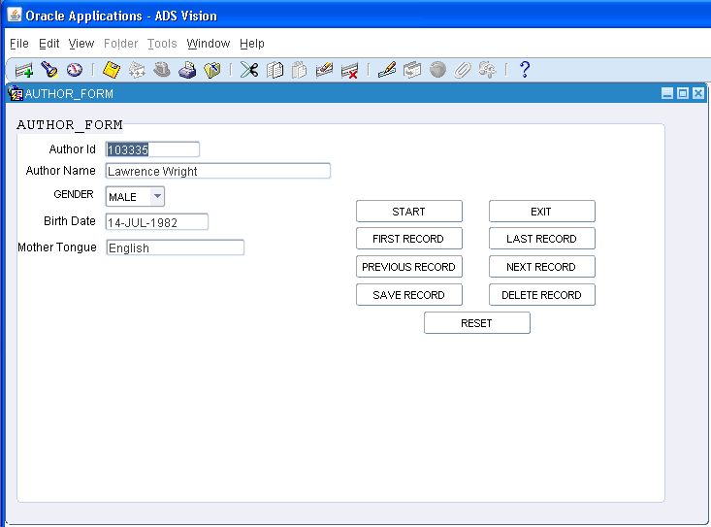

1. Book Master Form:

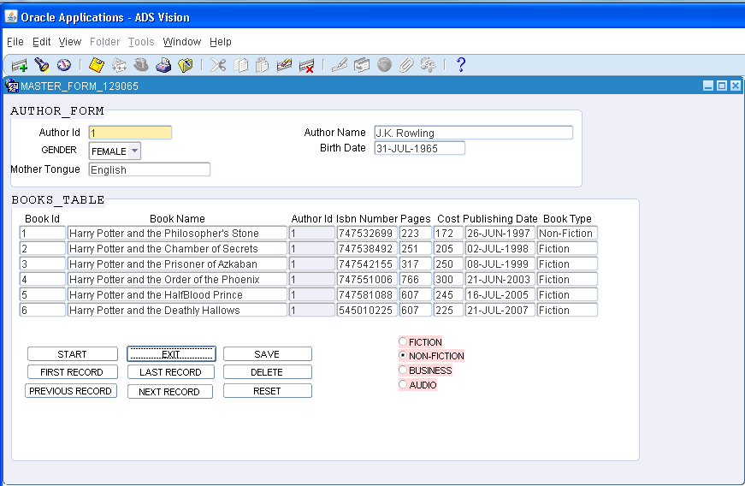

1. Author Database:

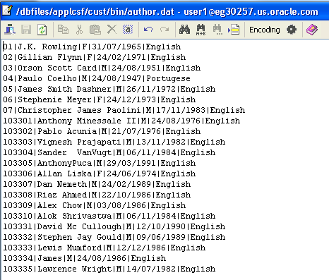

1. Author control file:

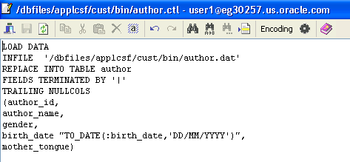

1. Books Databases:

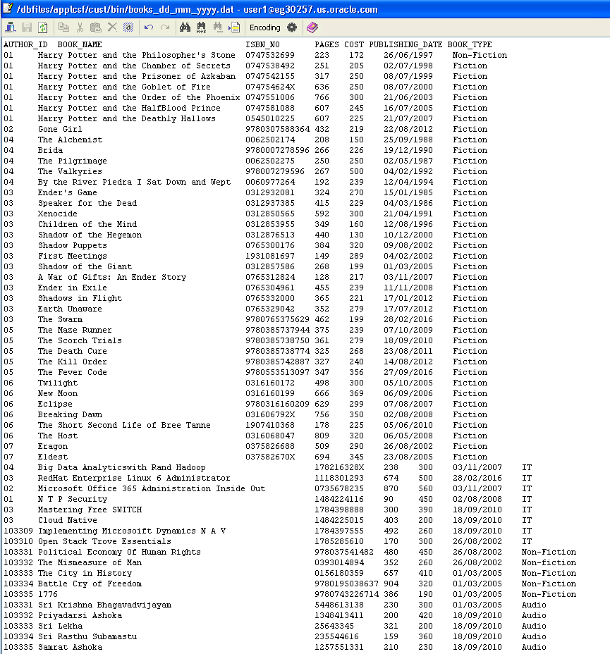

1. Books control file:

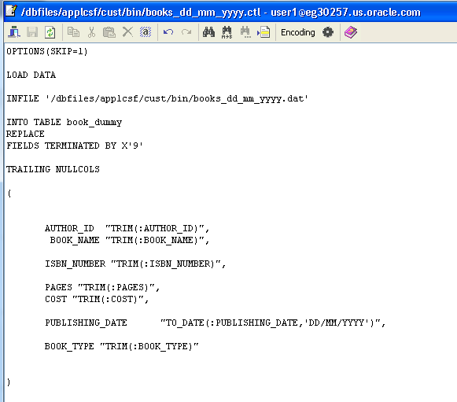

1. Report Data Model:

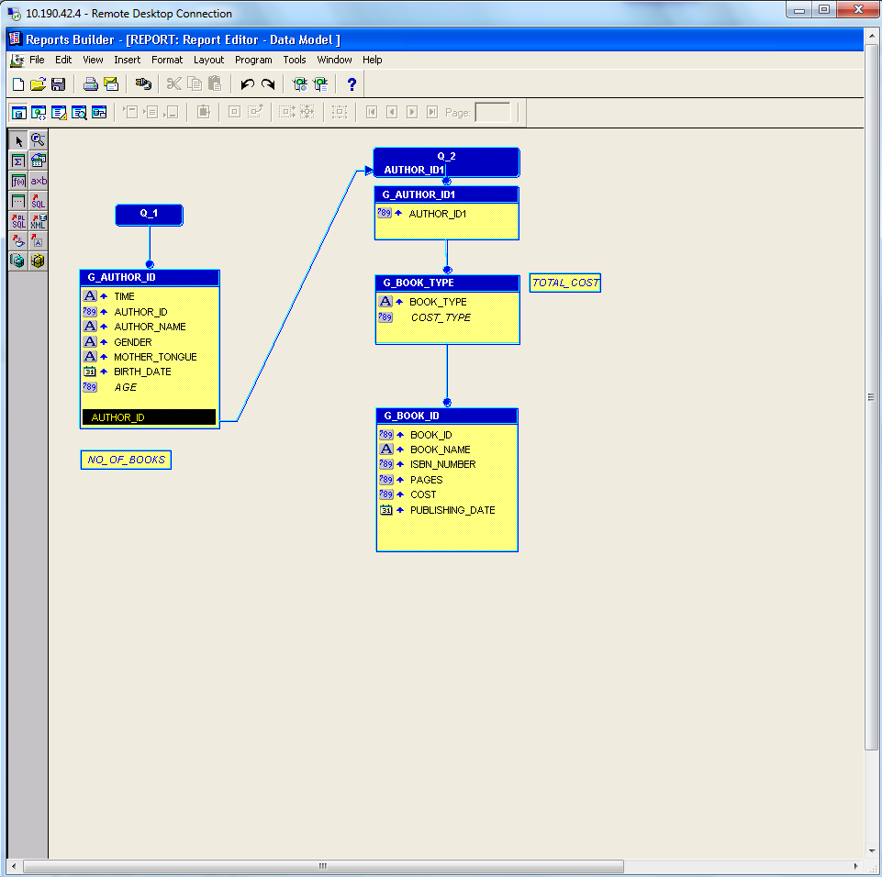

1. Generated Report for Output:

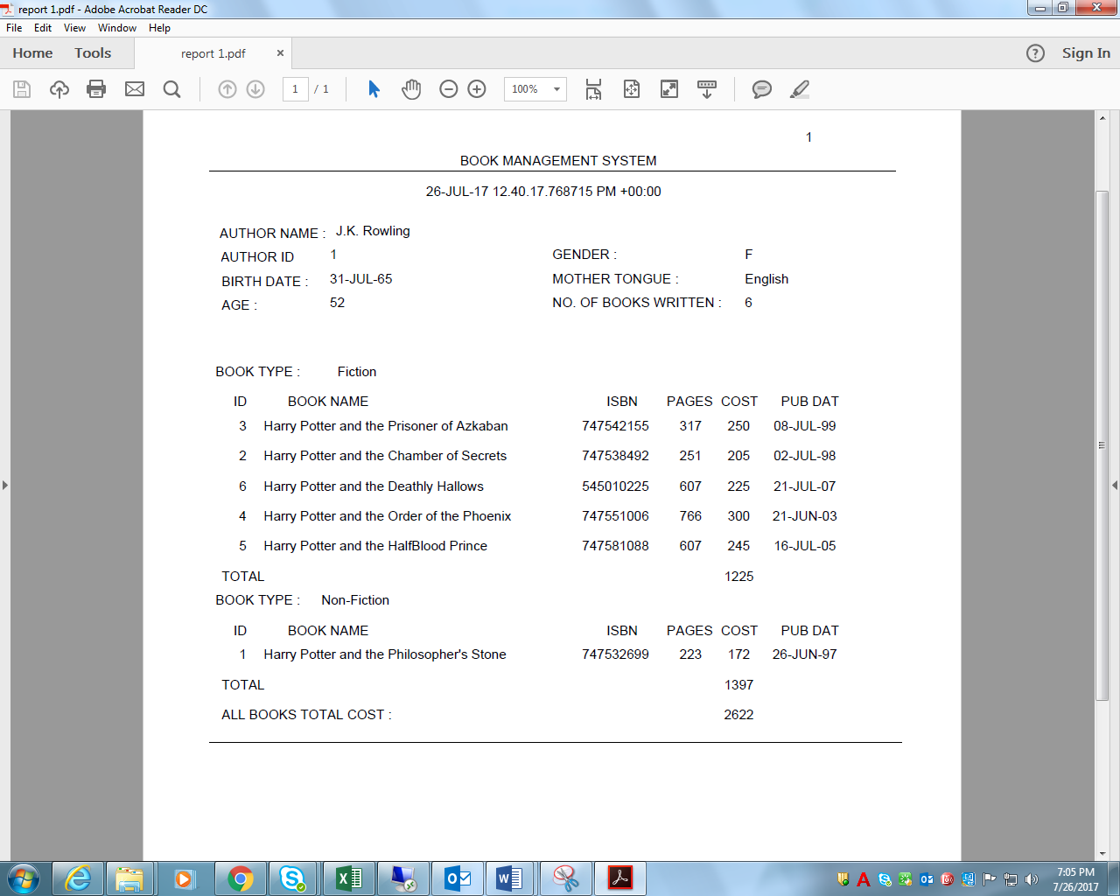

1. Generated Report for Output:- NO DATA FOUND

