Bandgap Design

This is a 1V bandgap circuit, designed on 0.13 um Sky130 PDK.

The reference for this design is from [Ref_bgr](http://www.renesas.com/us/en/document/whp/how-make-bandgap-voltage-reference-one-easy-lesson-paul-brokaw)

The following modifications were done to the original reference design

1. Added the startup nmos to Vd2 node for robust PVT performance

Tools used

Schmatic entry: Xschem

Simulator: ngSpice

Schematic

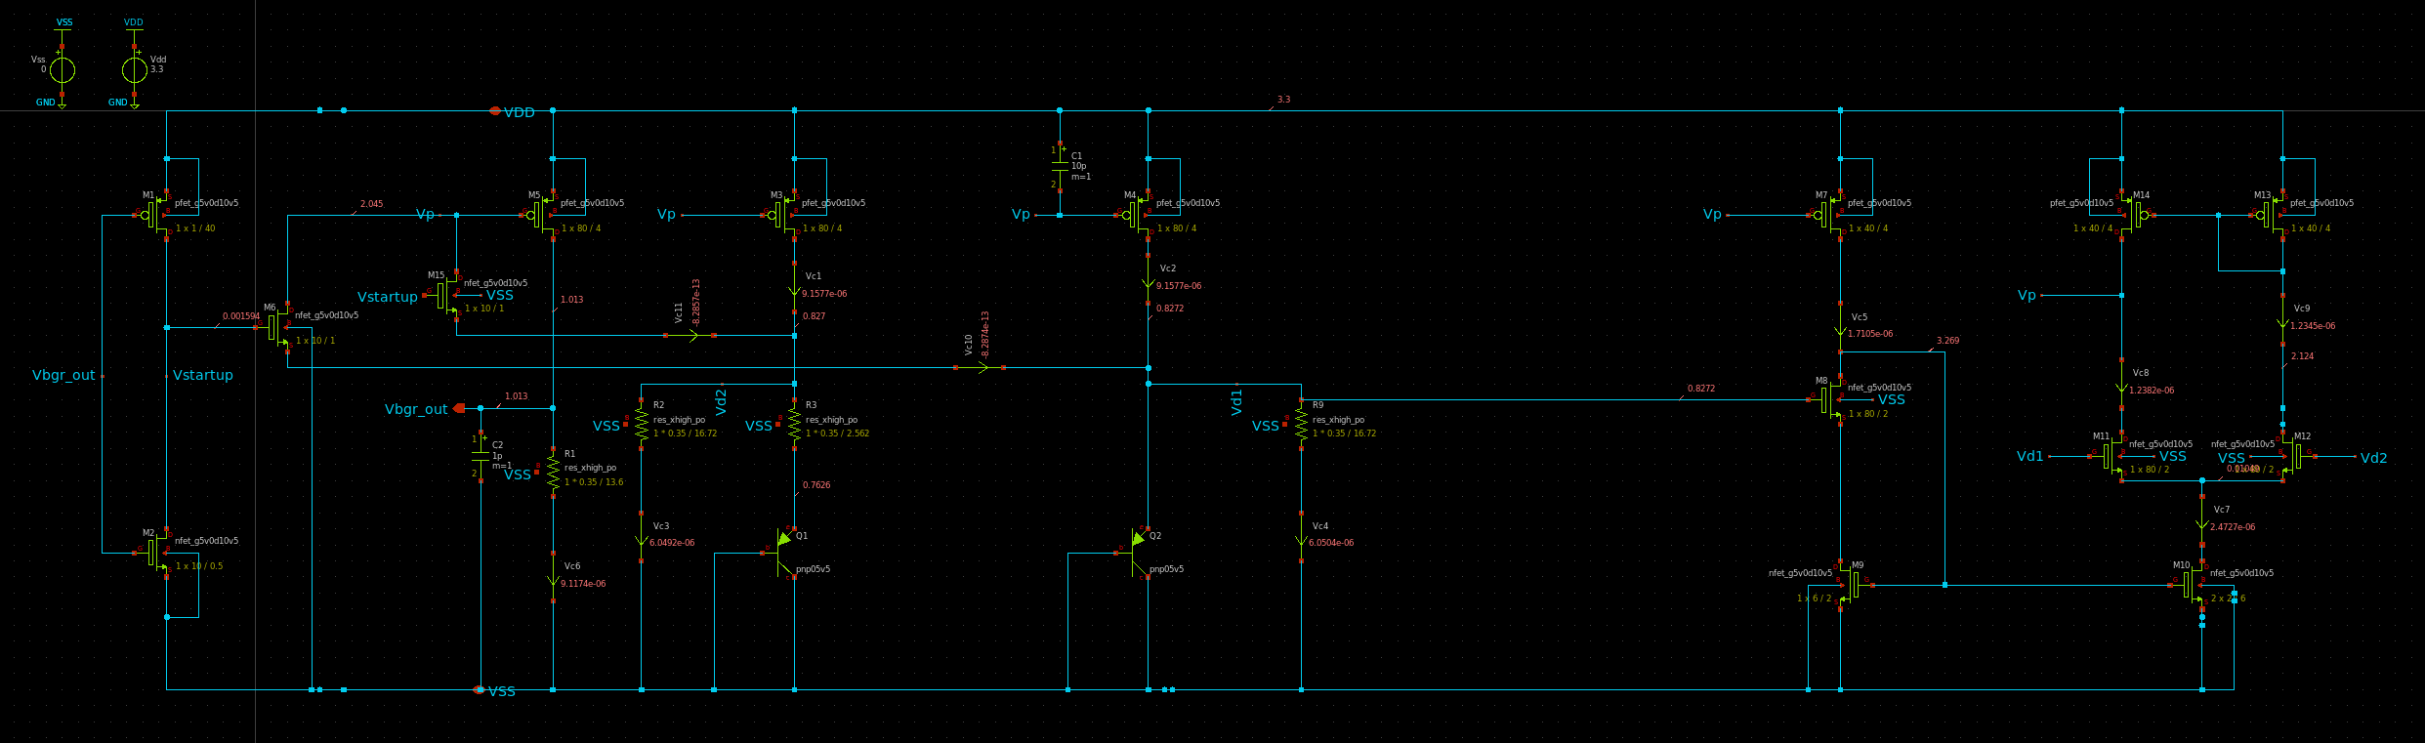

Simulation results:

# Temp variation TT/3.3V

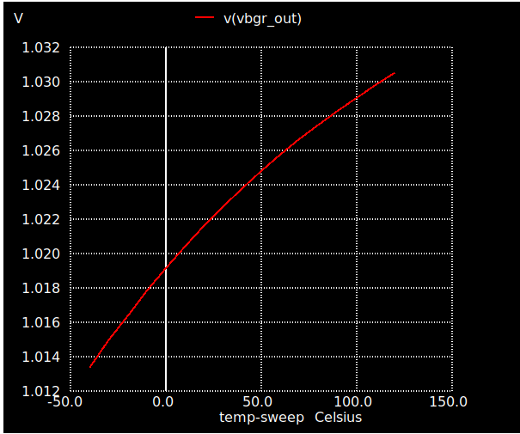

# Transient sims TT/27Deg/3.3V

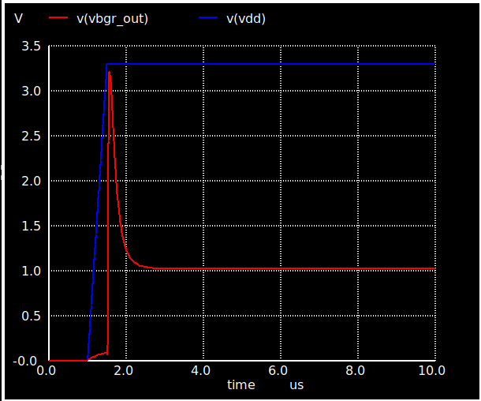

# DC Sweep TT/27Deg

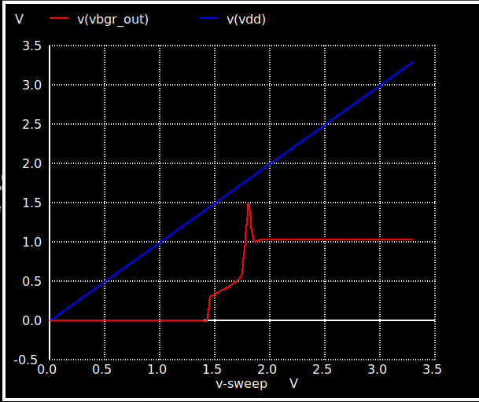

# PT variations

|  |  |  |  |
| --- | --- | --- | --- |
| Vdd=3.3 | -40 | 27 | 125 |
| ss | 1.014 | 1.02500 | 1.0353 |
| tt | 1.0133 | 1.02240 | 1.03 |
| ff | 1.011 | 1.01928 | 1.0265 |

# Things to do:

1. 3 bit output voltage trimming
2. Curvature compensation
3. Modify Opamp design

# Thanks and acknowlegements

1. Stefan Schippers for his [Youtube videos](https://www.youtube.com/channel/UCEgBTPGi5GcVJdReXL-UBNg) on Xschem + sky130 pdk installations
2. [bminch Youtube channel](https://www.youtube.com/user/bminch/videos)