Bandgap Design

This is a 1V bandgap circuit, designed on 0.13 um Sky130 PDK.
The reference for this design is from Ref_bgr
The following modifications were done to the original reference design
- Added the startup nmos to Vd2 node for robust PVT performance

Tools used
Schmatic entry: Xschem
Simulator: ngSpice

Schematic

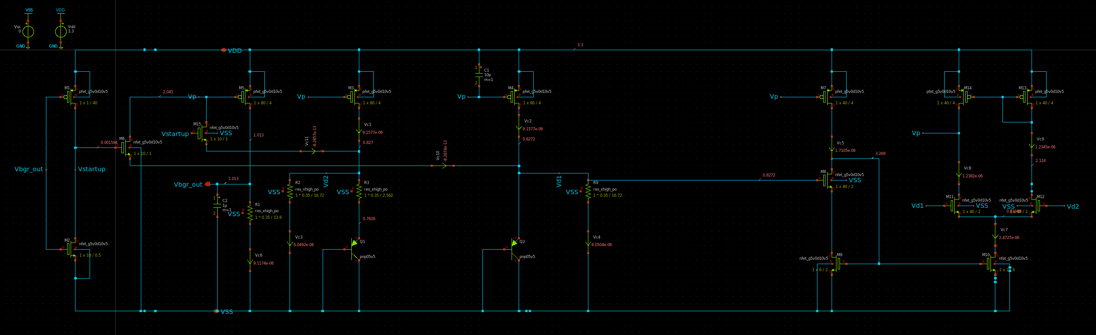

Simulation results:

Temp variation TT/3.3V
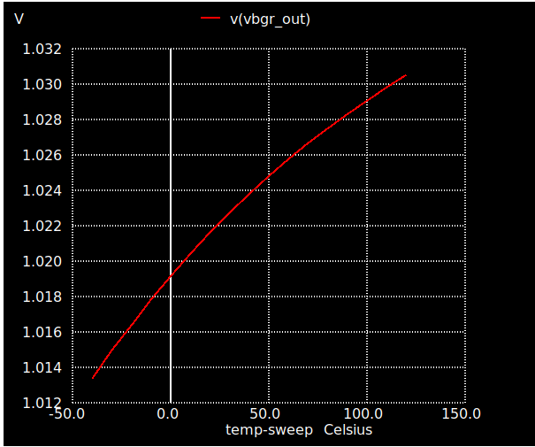

Transient sims TT/27Deg/3.3V

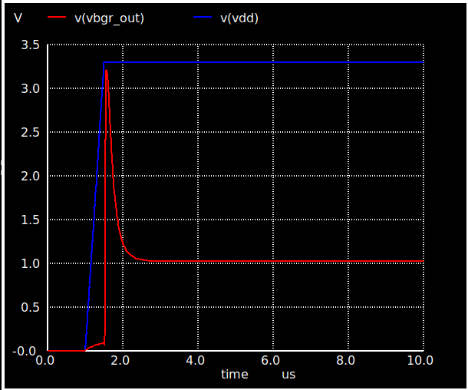

DC Sweep TT/27Deg

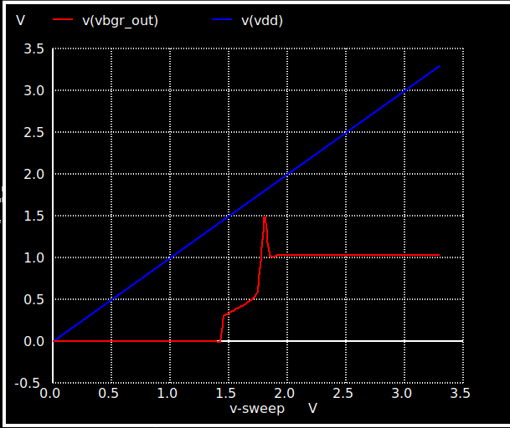

PT variations
Vdd=3.3 | -40 | 27 | 125
ss | 1.014 | 1.02500 | 1.0353
tt | 1.0133 | 1.02240 | 1.03
ff | 1.011 | 1.01928 | 1.0265

Things to do:
- 3 bit output voltage trimming
- Curvature compensation
- Modify Opamp design

Thanks and acknowlegements

- Stefan Schippers for his Youtube videos on Xschem + sky130 pdk installations
- bminch Youtube channel

