Supervisor: Calana Chan

Team leader: Derek Dong

Team member: Bowie Liu

Franz Fang

Database Design

1. ER diagram

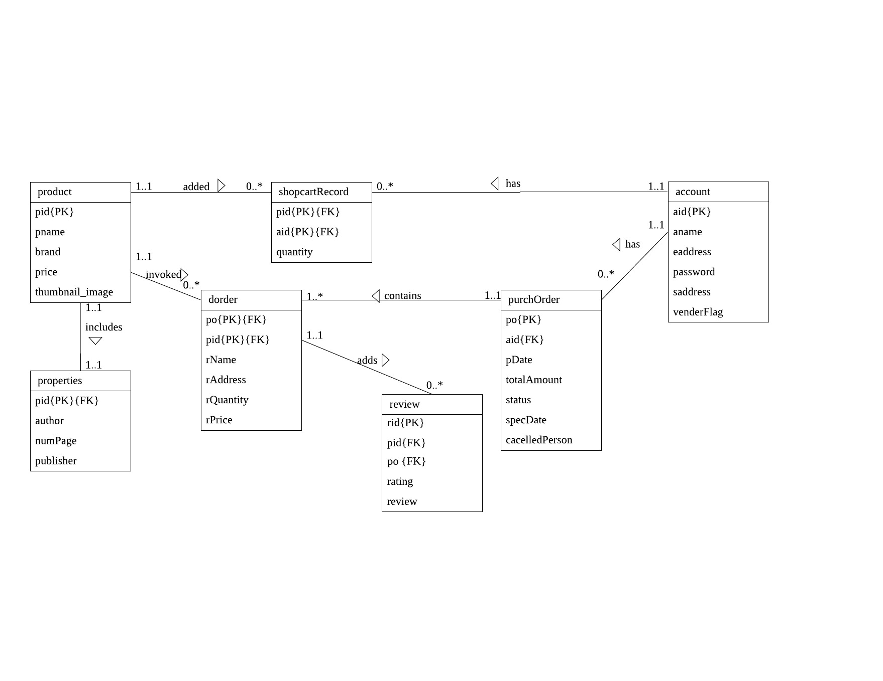

1. Schema
2. product (pid, pname, brand, price, thumbnail_image)
3. properties (pid, author, numPage, publisher)

**Foreign key** pid **references** product (pid)

**on_delete:** cascade

**on_update:** cascade

1. account (aid, aname, eaddress, password, saddress, venderFlag)
2. shopcartRecord (pid, aid, quantity)

**Foreign key** pid **references** product (pid)

**on_delete:** cascade

**on_update:** cascade

**Foreign key** aid **references** account (aid)

**on_delete:** cascade

**on_update:** cascade

1. purchOrder (po, aid, pDate, totalAmount, status, specDate, cancelledPerson)

**Foreign key** aid **references** account (aid)

**on_delete:** cascade

**on_update:** cascade

1. dorder (po, pid, rName, rAddress, rQuantity, rPrice)

**Foreign key** po **references** purchOrder (po)

**on_delete:** cascade

**on_update:** cascade

**Foreign key** pid **references** product (pid)

**on_delete:** no action

**on_update:** no action

1. review (rid, pid, po, rNumber, rating, review)

**Foreign key** pid **references** product (pid)

**on_delete:** cascade

**on_update:** cascade

**Foreign key** po **references** purchOrder (po)

**on_delete:** cascade

**on_update:** cascade

1. Data Dictionary

|  |  |  |  |
| --- | --- | --- | --- |
| Entity name | Attributes | Description | Data Type & Length |
| product | pid  pname  brand  price  thumbnail_image | Product ID  Product name  Product brand  Product price  Product image | 10 variable characters  15 variable characters  15 variable characters  5 variable doubles  JPEG |
| properties | pid  author  numPage  publisher | Reference table product (pid)  Book author  The number of pages  Book publisher | 10 variable characters  15 variable characters  10 variable doubles  15 variable characters |
| account | aid  aname  eaddress  password  saddress  venderFlag | Account ID  Account name  Email address  Account password  Shipping address  Determine whether the account is a customer or a vendor.  (0: customer;1: vendor) | 10 variable characters  15 variable characters  30 variable characters  10 variable characters  50 variable characters  1 integer (0 or 1) |
| shopcartRecord | pid  aid  quantity | Reference table product (pid)  Reference table account (aid)  Quantity of an item | 10 variable characters  10 variable characters  5 variable integers |
| purchOrder | po  aid  pDate  totalAmount  status  specDate  cancelledPerson | Purchase order  Reference table account (aid)  Purchase Date  Total order amount  Purchase order status (including pending, hold, shipped, cancelled)  According to the status, if status is ‘cancelled’, it will be cancelled date. if status is ‘shipped’, it will be shipped date. Otherwise, it will be null.  If status is ‘cancelled’, show cancelled person (customer or vendor). Otherwise, it will be null. | 10 variable characters  10 variable characters  Date  10 variable doubles  1 character (p or h or s or c)  Date  1 character (c or v ) |
| dorder | po  pid  rName  rAddress  rQuentity  rPrice | Reference table purchOrder (po)  Reference table product (pid)  Product name in the order  Shipping address in the order  Quantity in the order  Unit price in the order | 10 variable characters  10 variable characters  15 variable characters  50 variable characters  5 variable integers  5 variable integers |
| review | rid  pid  po  rating  review | Review ID  Reference table product (pid)  Reference table dorder (po)  Customer’s rating for a product  Short reviews for a product | 10 variable characters  10 variable characters  10 variable characters  2 variable doubles  text |