**Context**

**Modules**

1. **Real-time Energy Monitoring:** This module enables constant monitoring of energy consumption in different areas of the building and provides real-time data.
2. **Intelligent Automation:** This module allows for the automation of systems such as lighting, HVAC, and ventilation based on occupancy and environmental conditions to optimize energy efficiency.
3. **Load Management:** It controls the electrical load of devices and systems to prevent demand spikes and reduce energy costs.
4. **Inefficiency Detection:** Utilizes sensors and algorithms to detect energy inefficiencies, such as unnecessary lights or faulty equipment.
5. **Reporting and Analysis Generation:** This module collects consumption data and generates reports and analyses to identify patterns, trends, and improvement opportunities.
6. **User Management:** Manages user accounts and permissions to ensure that only authorized personnel can access and make changes to the system.
7. **Alarm and Notification Management:** Configures automatic alarms and notifications in case of critical events or detected inefficiencies.

**Personnel**

1. **Project Manager:** Responsible for project planning, coordination, and overall management, including resource allocation and schedule supervision.
2. **Electrical Engineer:** Expert in energy systems and energy efficiency, responsible for designing and overseeing the implementation of energy management solutions.
3. **Software Developer:** Programmer with experience in developing applications and software for system management and control.
4. **Automation Engineer:** Specialist in control system automation, capable of designing and implementing intelligent automation solutions.
5. **Network Engineer:** Responsible for designing and maintaining the communication infrastructure to connect all devices and systems.
6. **Data Analyst:** Professional in charge of collecting, analyzing, and presenting data for decision-making and report generation.
7. **Renewable Energy Expert:** Specialist in renewable energy sources, responsible for the integration of solar, wind, or other sustainable sources.
8. **Designer (UI/UX):** Designs the system's user interface to be intuitive and user-friendly.
9. **Expert in Energy Legislation and Regulations:** Ensures that the system complies with local and national energy regulations and standards.
10. **Database Administrator:** to ensure that databases run efficiently, securely, and are always available.

**Money**

1. Project Manager: $20,500 mxn per month.
2. Electrical Engineer: $10,000 mxn per month.
3. Software Developer: $10,000 mxn per month.
4. Automation Engineer: $10,000 mxn per month.
5. Network Engineer: $10,000 mxn per month.
6. Data Analyst: $9,000 mxn per month.
7. Renewable Energy Expert: $10,500 per month.
8. UI/UX Designer: $9,000 mxn per month.
9. Expert in Energy Legislation and Regulations: $12,500 mxn per month.
10. Database Administrator: $10,000 mxn per month.

Overall Monthly Salary = $111,500

Project Cost (10 months) = $1,115,000

**Time**

10 months.

**CR1**

**New Requirement:**

* **Additional remote server:** The client requests an additional master remote server for getting reports of usage for several buildings in different cities, it includes a module in your original project that connects to the remote server.

**Modules**

1. **Centralized Building Management:** This module will act as a central platform that allows adding and managing multiple buildings within the system. It enables the creation of profiles for each building and facilitates centralized administration.
2. **Remote Connection:** Adds secure remote connection functionalities, such as VPN or cloud access, to ensure authorized users can access all building systems securely and remotely.
3. **Update Multi-site Notification Module:** Expand the alarm and notification management module to include alerts that cover multiple buildings. This allows receiving notifications about critical events in any location.
4. **Update Multi-site Reporting Module:** Expand reporting generation capabilities to create consolidated reports covering multiple buildings, making it easier to compare and analyze data across multiple locations.

**Personnel**

1. **Security Expert:** Responsible for ensuring the security of project data and systems against cyber threats.
2. **Quality Control Specialist:** Responsible for ensuring the system meets quality and performance standards.
3. **Technical Support Staff:** Provides support and technical assistance to users and resolves operational issues.
4. **Training Personnel:** Provides training to end-users and the team on system usage.

**Money**

1. **Security Expert:** $11,500 mxn per month.
2. **Quality Control Specialist:** $10,000 mxn per month.
3. **Technical Support Staff:** $7,500 mxn per month.
4. **Training Personnel:** $8,500 mxn per month.

Overall Monthly Salary = $37,500 mxn.

Project Cost (12 months) = $447,996 mxn.

Total = $1,788,000 mxn.

**Time**

2 months - this would be **%20**

**Effort**

The amount to increase is $673,000 mxn - this would be **%60**

**CR2**

**New Requirement:**

* **Customization:** the system must include screen customization according to the needs of the company's image, including screen color, logo configuration and addition/deletion.

**Modules**

* **User profile:** a new module will be created that will serve to configure the profile of each company in which the system is implemented, where the user will be able to manage the customization of the screen according to their needs.

**Personnel**

To add these new requirement it will not be necessary to hire new personnel.

**Time**

2 months - this would be **%20**

**Money**

The amount of the monthly salary remains the same, only two more months of production will be increased, remaining as follows:

Overall Monthly Salary = $111,500.

Project Cost (12 months) = $1,338,000.

**Effort**

The amount to increase is $223,000 - this would be **%20.**

**CR3**

**New Requirement:**

* **State of the components:** due to the new characteristics of sensors and actuators, the client requests a more interoperable architecture that records the internal state of each component. Statuses range from operable, off, broken, and running.

**Modules**

* **Device and sensor management:** a new module must be added which will record the internal state of each component.

**Personnel**

* **Hardware Engineer:** Helps design the architecture needed to collect internal data from devices and sensors.
* **Firmware Developer:** Works on developing the firmware necessary to collect and record the internal state of components.

**Time**

4 months - this would be **%40.**

**Money**

1. **Hardware Engineer**: $19,000 mxn per month.
2. **Firmware Developer**: $16,000 mxn per month.

Overall Monthly Salary = $35,000 mxn.

Project Cost (14 months) = $2,051,000 mxn.

**Effort**

The amount to increase is $936,000 - this would be **%83.**

**CR4**

**New Requirement:**

* **Automatic reports:** Due to a new ecological standard, every system must report the energy efficiency of the monthly operation of the system.

**Modules**

* **Multisite reporting module update:** add new functionality that allows the generation of automatic reports. This new feature allows users to configure the desired date range for generating their reports.

**Personnel**

To add these new requirement it will not be necessary to hire new personnel.

**Time**

1 month. - this would be **%10.**

**Money**

The amount of the monthly salary remains the same, only one more month of production will be increased, remaining as follows:

Overall Monthly Salary = $111,500 mxn.

Project Cost (11 months) = $1,226,500 mxn.

**Effort**

The amount to increase is $111,500 - this would be **%10**

**Criteria**

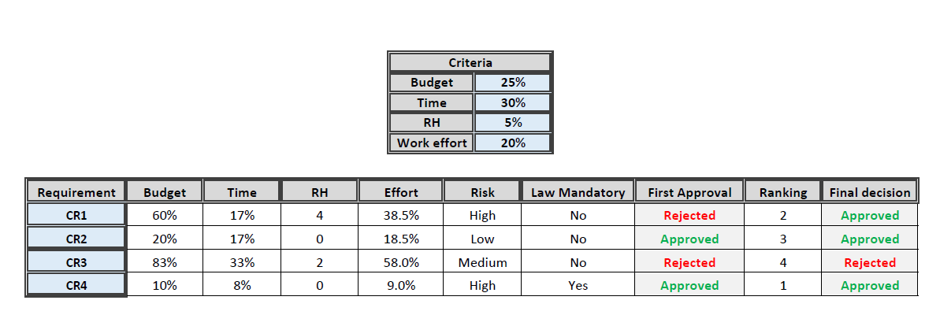

The approval of these requirements is based on fundamental considerations to enhance the system's functionality and meet the client's expectations and needs.

1. Firstly, the inclusion of an additional remote server is justified by the client's need to obtain reports on the usage of various buildings in different cities. This not only optimizes centralized monitoring but also strengthens the system's ability to scale and expand, which is crucial for efficient management on a large scale.
2. The customization of the system directly addresses the adaptation to the client's corporate image. Allowing visual adjustments, such as screen colors and logo configurations, not only improves the user experience but also ensures a consistent and professional integration of the system into the business environment.
3. The approval of automatic reporting is grounded in the need to comply with new ecological regulations. This not only ensures compliance with environmental regulations but also demonstrates the project's commitment to sustainable practices. The automatic report generation contributes to environmental responsibility and enables continuous assessment of the system's energy efficiency, ensuring alignment with current standards.
4. Lastly, the request for implementing "Component Status" was declined due to cost and time considerations. While we acknowledge its importance in recording the internal state of each component, the added complexity and significant increase in resources required for implementation do not fully justify the additional benefits compared to current solutions. The decision was made to ensure the economic and temporal viability of the project, prioritizing functionalities that strike an optimal balance between added value and efficiency in resource utilization.