 

**Project Report**

**Submitted By**

**Name : Vacha Buch & Stavan Shah**

**Enrolment No.: 12202130501085 & 12202130501087**

***In Partial fulfillment for the award of the degree of***

**BACHELOR OF TECHNOLOGY**

**In**

**Computer Science And Design**

**G. H. Patel College of Engineering & Technology**

**The Charutar Vidya Mandal (CVM) University, Vallabh Vidyanagar – 388120**

**Objectives:**

* **Automate Identity Verification** – Use AI to verify if the uploaded ID matches the user’s selected document type.
* **Enhance Security and Fraud Detection** – Prevent identity fraud by ensuring the ID is authentic and aligns with bank records.
* **Improve Processing Speed** – Automate e-KYC verification to reduce manual effort and speed up customer onboarding.
* **Provide a Seamless User Experience** – Simplify the verification process for customers with an intuitive and efficient system.

**Dataset:**

The dataset used in this project includes identity documents such as Aadhar cards, PAN cards, and Voter ID cards. For Aadhar cards, we utilized a publicly available dataset from [Roboflow](https://universe.roboflow.com/cutm-iwh4a/aadhaar-card-details/dataset/1). The PAN and Voter ID datasets were manually collected to ensure diversity and realism.

To improve the model's robustness, the images were preprocessed using a variety of augmentation techniques. These included converting some images to black and white, adding grainy textures, and applying random rotations. This preprocessing step helped simulate real-world document conditions and enhanced the model’s ability to generalize across varying image qualities.

**Model Chosen: YOLOv8**

**Why YOLOv8?**

We chose **YOLOv8 (You Only Look Once, version 8)** due to its remarkable balance of **speed, accuracy, and efficiency**, which is essential for real-time document verification in e-KYC systems. It is the latest and most optimized version in the YOLO family, offering several architectural improvements over previous versions.

**Key Features of YOLOv8**

* **Anchor-free architecture**: Simplifies model training and improves performance.
* **Real-time inference**: Suitable for time-sensitive applications like live document verification.
* **High detection accuracy**: Detects even small and fine-grained features on documents.
* **Advanced backbone (C2f)**: Enhances feature extraction from input images.
* **Modular design**: Easy to integrate with downstream classification or validation tasks.

**Application in the Project**

In the context of identity document verification, YOLOv8 is used for:

1. **Authenticity Verification**  
   By detecting the presence and layout of expected elements, YOLOv8 helps validate if the document follows the standard format of genuine government-issued IDs.
2. **Document Classification Aid**  
   Detection outputs provide spatial clues that are used along with additional logic to classify the document as:
   * Aadhar Card
   * PAN Card
   * Driving License
   * Voter ID

This integration of YOLOv8 into our AI-driven e-KYC pipeline significantly improves the **security**, **efficiency**, and **scalability** of document verification processes in modern banking systems.

**Performance Metrics:**

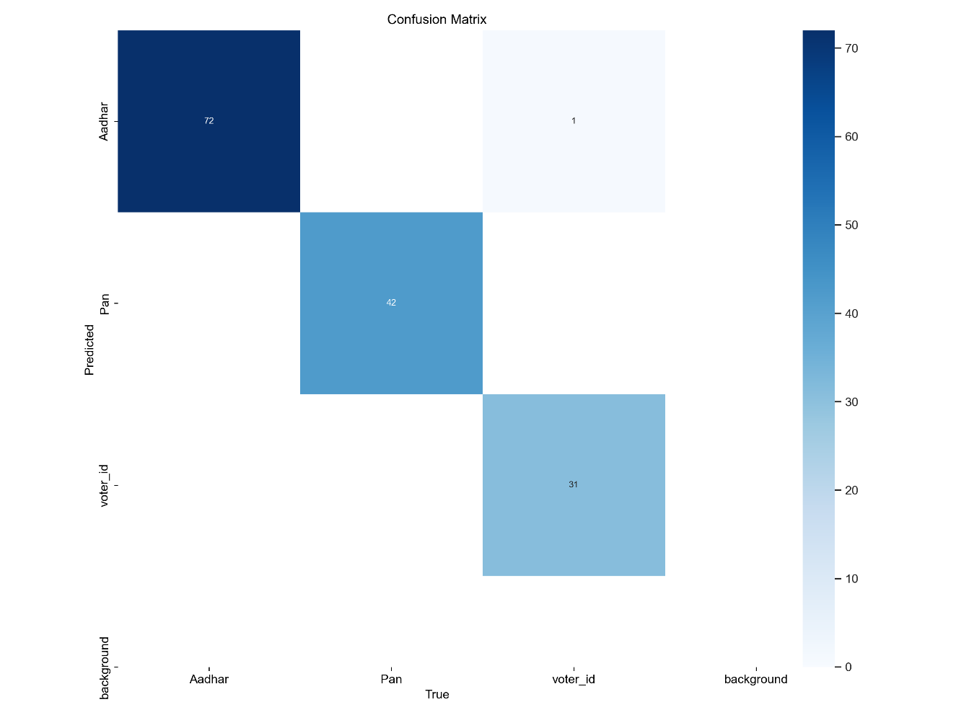

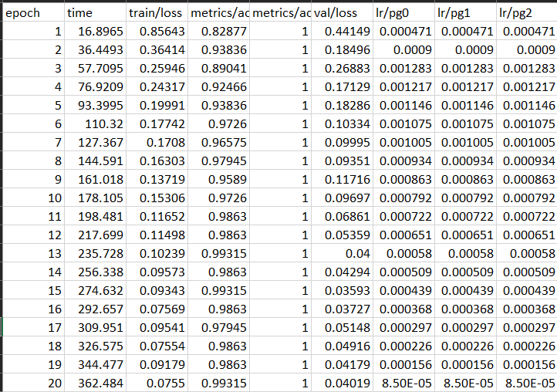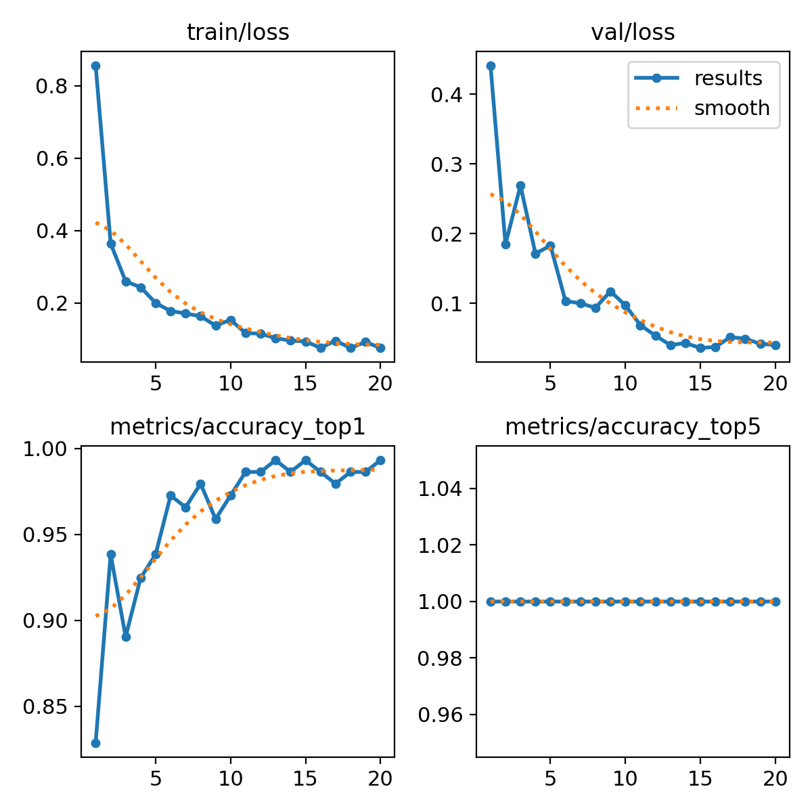

**Challenges Faced:**

1. **Dataset Collection**  
   Gathering a diverse and realistic dataset of identity documents was one of the most time-consuming tasks.
   * While Aadhar card data was sourced from Roboflow, PAN card and Voter ID images were manually collected.
   * Ensuring variety in layouts, and quality was crucial for training a robust model.
2. **Data Preprocessing**  
   The raw images required significant preprocessing to simulate real-world scenarios.
   * Images were made **grayscale**, **rotated**, or made **grainy** to mimic worn-out or scanned documents.
   * This step ensured that the model generalized well to practical, imperfect inputs.
3. **Hyperparameter Tuning**  
   To achieve high detection accuracy, extensive experimentation was done with YOLOv8’s training parameters.
   * Adjustments to **batch size**, **learning rate**, **confidence threshold**, and **augmentation strategies** were iteratively tested.
   * Balancing training time and model performance required deep understanding of YOLOv8 internals.
4. **Testing Edge Cases**  
   The model was rigorously tested on challenging inputs such as:
   * Partially visible documents
   * Fake or manipulated IDs
   * Overexposed or underlit images  
     Ensuring accurate predictions under such conditions was critical for real-world deployment.

**Key Learnings:**

• **Application of Deep Learning in Real-world Scenarios**  
Learned how to translate theoretical deep learning concepts into practical, impactful solutions within the banking domain.

• **Model Evaluation and Interpretability**  
Understood how to evaluate object detection models using metrics like precision, recall, and mAP, and interpret their predictions meaningfully.

• **Importance of Domain Knowledge**  
Realized how understanding the document formats (Aadhar, PAN, Voter ID, etc.) is crucial for designing a system that aligns with real-world use cases.

• **Efficient Team Collaboration**  
Improved collaboration using tools like Git and documentation platforms, and experienced how version control streamlines team-based projects.

• **Designing for Scalability and Accuracy**  
Gained insights into building systems that are not only accurate but also scalable and adaptable to future document types or use cases.

**Conclusion:**

This project successfully demonstrates the potential of AI-driven solutions in automating and enhancing the e-KYC process for the banking sector. By integrating YOLOv8 and deep learning techniques, we developed a real-time document verification system capable of accurately detecting and classifying various identity proofs. The model achieved an impressive **accuracy of 99.31%**, significantly reducing manual effort and improving fraud detection. This solution not only ensures security and scalability but also delivers a seamless experience for both banks and customers.

**Repository:** [**GitHub Repository**](https://github.com/vachakb/AIML-Project.git)