Design Phase Report
Team ID: 4D08
Category: Application Development

Title: Ginning Industry Data Management System
Requirements Specification:
Storing, accessing and modifying employee, supplier, customer, raw material, product and bill details

ER Design:

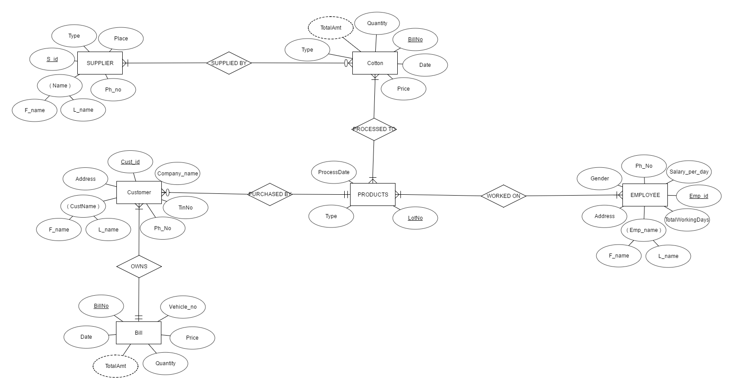

ER to Relation Mapping:
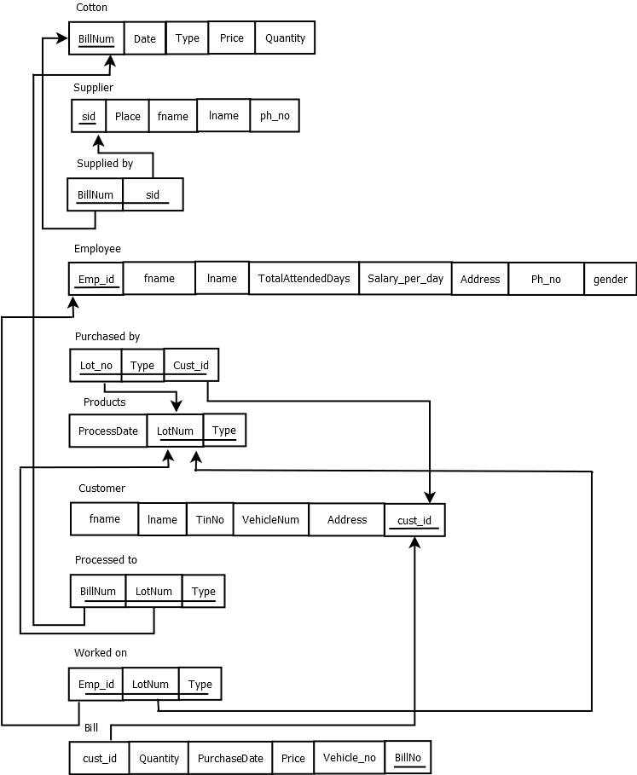

Data Dictionary:
Format for data dictionary is as follows:
Object (Entity) | Name (Attribute) | Type  (Data type) | Description | Primary Key | Foreign Key
Cotton | BillNo | Varchar2 | Bill number of the raw material purchased | Yes | No
 | Date | Date | Date on which raw material was purchased | No | No
 | Price_per_qtl | Number | Price per quintal | No | No
 | Quantity | Number | Quantity supplied | No | No
 | Type | Varchar2 | Cotton types | No | No
 | Total_amt | Number | Quantity*Price_per_qtl | No | No
Supplier | Place | Varchar2 | Place to which the supplier belongs | No | No
 | fname | Varchar2 | First name of the supplier | No | No
 | Lname | Varchar2 | Last name of supplier | No | No
 | Ph_No | Varchar2 | Supplier’s phone number | No | No
 | Sid | Varchar2 | Supplier id | Yes | No
Employee | fname | varchar2 | First name of the employee | No | No
 | Lname | Varchar2 | Last name of employee | No | No
 | empId | varchar2 | Employee id | Yes | No
 | Gender | Varchar2 | Gender of the employee | No | No
 | Salary_per_day | Number | Employee salary per day | No | No
 | Total_working_days | Number | Total number of days the employee has worked | No | No
 | Address | Varchar2 | Employee address | No | No
 | Ph_no | Varchar2 | Employee contact no | No | No
Customer | fname | Varchar2 | Customer first name | No | No
 | lname | Varchar2 | Customer last name | No | No
 | Cust_id | Varchar2 | Customer id | Yes | No
 | Tin_no | Number | Tin number | No | No
 | Address | Varchar2 | Customer address | No | No
 | Ph_no | Varchar2 | Customer contact no | No | No
 | companyName | Varchar2 | Company to which a customer works for | No | No
Products | Lot_no | Number | Product lot no | Yes | No
 | Type | Varchar2 | Product type (seeds/lint) | Yes | No
 | Processed_date | Date | Date on which cotton got processed | No | No
Bill | Bill_no | Number | Customer bill number | Yes | No
 | Date | Date | Purchase date | No | No
 | Quantity | Number | Quantity bought by company | No | No
 | Price | Number | Price per lot | No | No
 | Total_amt | Number | Total_amt=Quantity * price | No | No
 | Vehicle_no | Varchar2 | Vehicle number through which products are transported | No | No
 | Cust_id | Number | Customer id | No | Yes

Question 1: Normalization:
Normalized solution 1:
We have the following relations
Cotton(billNo,date,price_per_qtl,quantity,type,total_amt)
Supplier(sid,place,name,ph_no)
Employee(empid,Empname,gender,salary_per_day,total_working_days,address,ph_no)
Customer(cust_id,cust_name,tin_no,address,ph_no,company_name)
Bill(bill_no,date,quantity,price,total_amt,vehicle_no)
Product(lot_no,type,processed_date)
All the relations are in 2NF

Normalized solution 2:
We have the following FDs

For cotton we have
billNo→price_per_qtl, date, quantity, type, total_amt
date → price_per_qtl

After normalizing we get
Cotton1(date, quantity, type, total_amt, billNo)
Cotton2(date, price_per_qtl)
Its in BCNF

For product we have
(Lot_no, type) → processed_date
Its in BCNF

For bill we have
Bill_no →date, quantity, price, total_amt, vehicle_no
Its in BCNF

For supplier we have
Sid→place,name,ph_no
Supplier is in BCNF.

For customer we have
Custid → cust_name,tin_no,address,ph_no,company_name
Tin_no →company_name
Company_name →cust_name,address, ph_no
After normalizing we get
Cust1(cust_id,tin_no)
Cust2(tin_no,company_name)
Cust3(company_name,cust_name,address,ph_no)

For employee relation we have
empId →empname,gender,salary_per_day,total_working_days
Empname → Gender,address,phno
Gender → salary_per_day
After normalizing we get
Emp1(empname,emp_id,total_working_days)
Emp2(empname,gender,address,phno)
Emp3(gender,salary_per_day)
The relation is in BCNF

Question 2: Choose the optimal normalized schema from Question 1 and justify why you think this is an optimal solution.
The second normalized solution is an optimal solution since all the relations are in BCNF.

Question 3: User Interface (UI) design

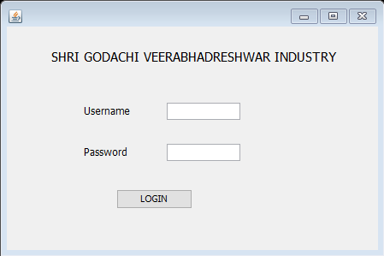

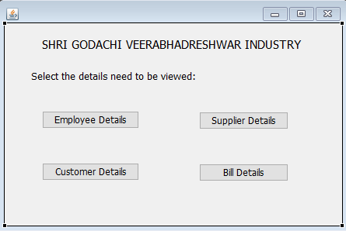

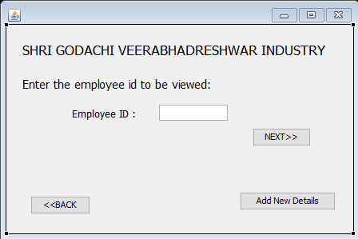

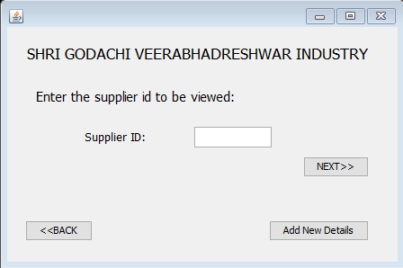

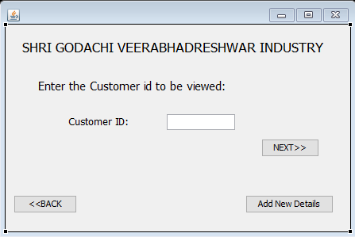



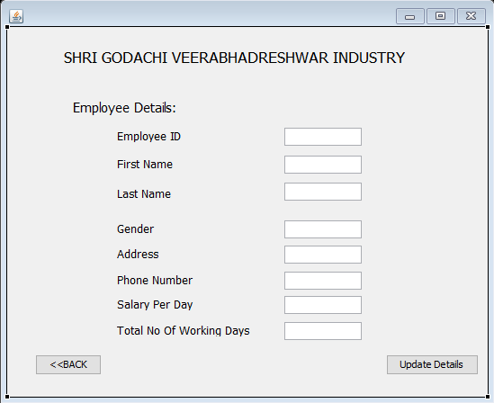

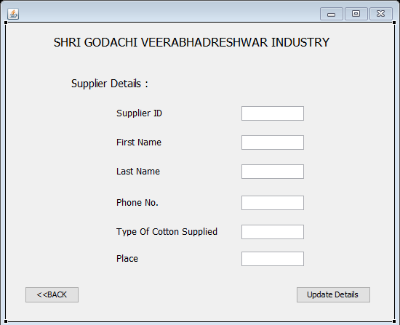

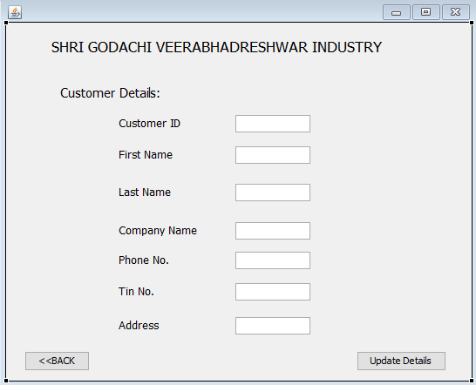

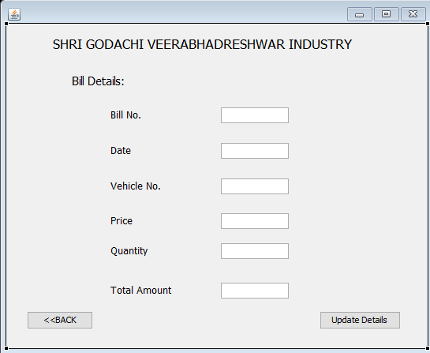

Question 4: Implemented requirements completed till date.
Storing employee, raw material, supplier, customer and bill details.

References:
https://erdplus.com/#/standalone
Dia design tool

Submission Date: 10/3/2017

