**Task-7:- Views**

Select * from Orders;

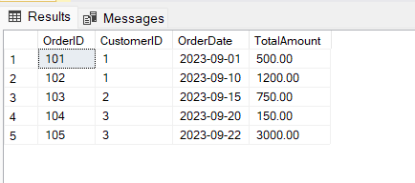

Select * from Customers;

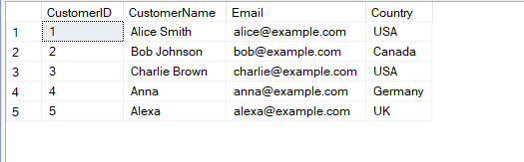

1.View: Customers from USA

CREATE VIEW US_Customers AS

SELECT CustomerID, CustomerName, Email FROM Customers

WHERE Country = 'USA';

select * from US_Customers;

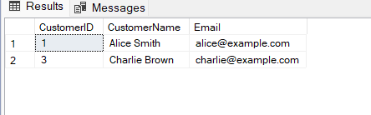

2.View: High Value Orders (TotalAmount above 1000)

CREATE VIEW HighValueOrders AS

SELECT OrderID, CustomerID, OrderDate, TotalAmount FROM Orders

WHERE TotalAmount > 1000;

select * from HighValueOrders;

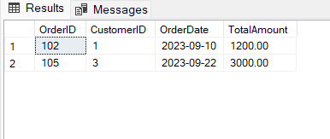

3.View: Customer Order Summary (Join View)

CREATE VIEW CustomerOrderSummary AS

SELECT c.CustomerID, c.CustomerName, o.OrderID, o.OrderDate, o.TotalAmount

FROM Customers c

JOIN Orders o ON c.CustomerID = o.CustomerID;

select * from CustomerOrderSummary;

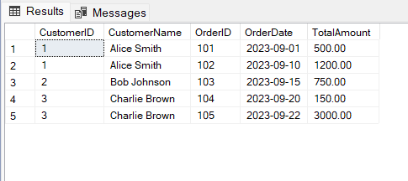

4.Update Data Using a View

UPDATE US_Customers

SET Email = 'alice_new@example.com'

WHERE CustomerID = 1;

