**OUTCOME:**1. SELECT * FROM EMPLOYEE_DATA;

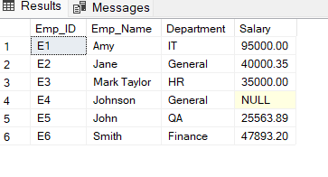

2. SELECT Emp_ID, Emp_Name, Department FROM EMPLOYEE_DATA;

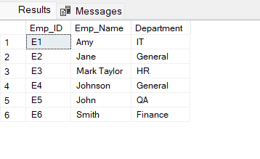

3. SELECT Emp_ID, Emp_Name, Salary

FROM EMPLOYEE_DATA WHERE Salary > 50000;

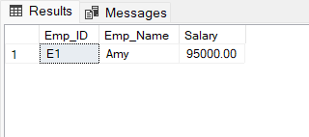

4. SELECT Emp_Name, Department, Salary

FROM EMPLOYEE_DATA WHERE Department = 'IT' AND Salary > 60000;

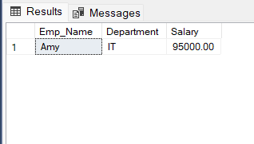

5. SELECT Emp_Name, Department, Salary

FROM EMPLOYEE_DATA WHERE Department = 'HR' OR Department = 'Finance';

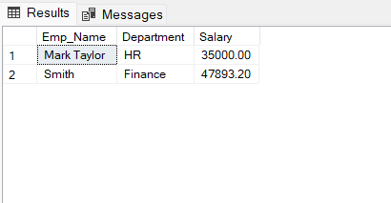

6. SELECT Emp_ID, Emp_Name

FROM EMPLOYEE_DATA WHERE Emp_Name LIKE '%an%';

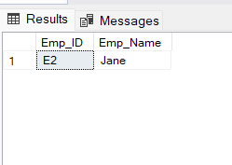

7. SELECT Emp_ID, Emp_Name, Salary

FROM EMPLOYEE_DATA WHERE Salary BETWEEN 40000 AND 70000;

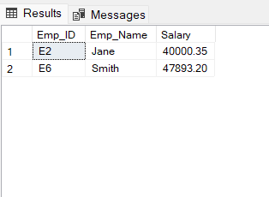

8. SELECT Emp_ID, Emp_Name, Department

FROM EMPLOYEE_DATAWHERE Department IN ('IT', 'Finance');

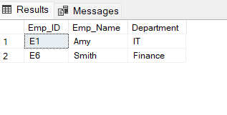

9. SELECT Emp_ID, Emp_Name, Salary

FROM EMPLOYEE_DATA ORDER BY Salary ASC;

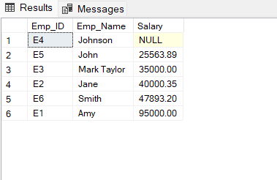

10. SELECT Emp_ID, Emp_Name, Salary

FROM EMPLOYEE_DATA ORDER BY Salary DESC;

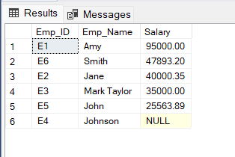

11. 1SELECT TOP 2 Emp_ID, Emp_Name, Salary FROM EMPLOYEE_DATA

ORDER BY Salary DESC;

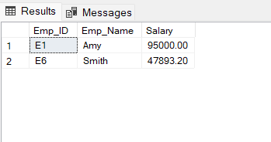

12.SELECT DISTINCT Department

FROM EMPLOYEE_DATA;

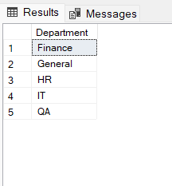

13. SELECT Emp_Name AS Employee, Salary AS Monthly_Salary

FROM EMPLOYEE_DATA;

