**OUTCOME:**

--SUM

1. SELECT Department, SUM(Salary) AS Total_Salary

FROM EMPLOYEE_DETAILS

GROUP BY Department;

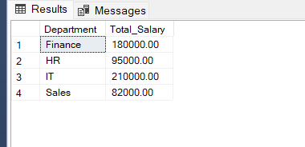

--AVG

2.SELECT Department, AVG(Salary) AS Avg_Salary

FROM EMPLOYEE_DETAILS

GROUP BY Department;

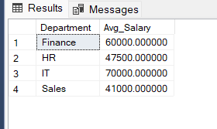

--COUNT

3.SELECT Department, COUNT(*) AS Employee_Count

FROM EMPLOYEE_DETAILS

GROUP BY Department;

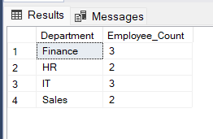

--MAX

4.SELECT Department, MAX(Salary) AS Highest_Salary

FROM EMPLOYEE_DETAILS

GROUP BY Department;

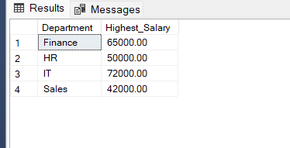

--MIN

5.SELECT Department, MIN(Salary) AS Lowest_Salary

FROM EMPLOYEE_DETAILS

GROUP BY Department;

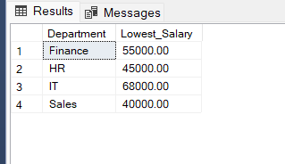

--HAVING

6.SELECT Department, COUNT(*) AS Employee_Count

FROM EMPLOYEE_DETAILS

GROUP BY Department

HAVING COUNT(*) > 2;

