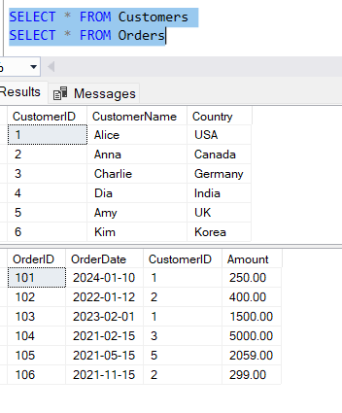

-- 1. INNER JOIN

SELECT C.CustomerName, O.OrderID, O.Amount

FROM Customers C

INNER JOIN Orders O ON C.CustomerID = O.CustomerID;

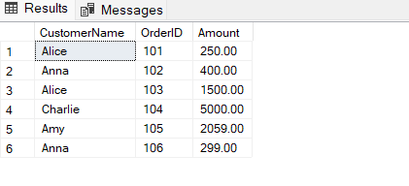

-- 2. LEFT JOIN

SELECT C.CustomerName, O.OrderID, O.Amount

FROM Customers C

LEFT JOIN Orders O ON C.CustomerID = O.CustomerID;

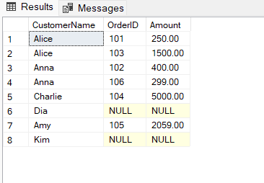

-- 3. RIGHT JOIN

SELECT C.CustomerName, O.OrderID, O.Amount

FROM Customers C

RIGHT JOIN Orders O ON C.CustomerID = O.CustomerID;

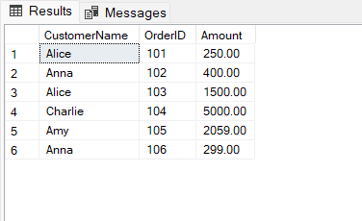

-- 4. FULL OUTER JOIN

SELECT C.CustomerName, O.OrderID, O.Amount

FROM Customers C

FULL OUTER JOIN Orders O ON C.CustomerID = O.CustomerID;

