**Safertek SQL Backend**

**ID:** 2100032473

**NAME:** Vachaspathi Gnaneswar Garlapati

1. CREATE DATABASE safertek;

USE safertek;

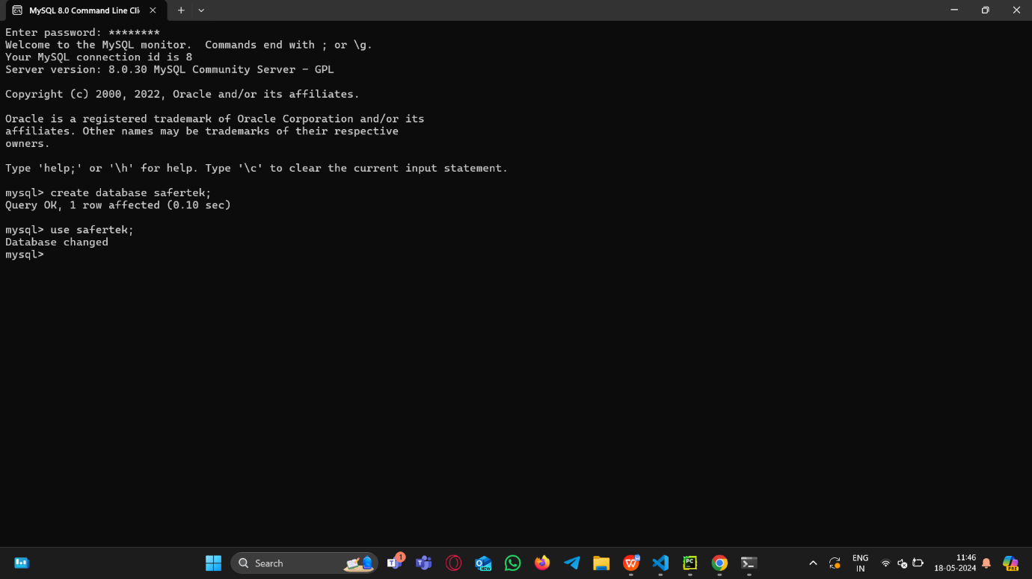

1. CREATE TABLE Customers ( CustomerID INT PRIMARY KEY, FirstName VARCHAR(50), LastName VARCHAR(50), Email VARCHAR(100), DateOfBirth DATE );

CREATE TABLE Products ( ProductID INT PRIMARY KEY, ProductName VARCHAR(100), Price DECIMAL(10, 2) );

CREATE TABLE Orders ( OrderID INT PRIMARY KEY, CustomerID INT, OrderDate DATE, FOREIGN KEY (CustomerID) REFERENCES Customers(CustomerID) );

CREATE TABLE OrderItems ( OrderItemID INT PRIMARY KEY, OrderID INT, ProductID INT, Quantity INT, FOREIGN KEY (OrderID) REFERENCES Orders(OrderID), FOREIGN KEY (ProductID) REFERENCES Products(ProductID));

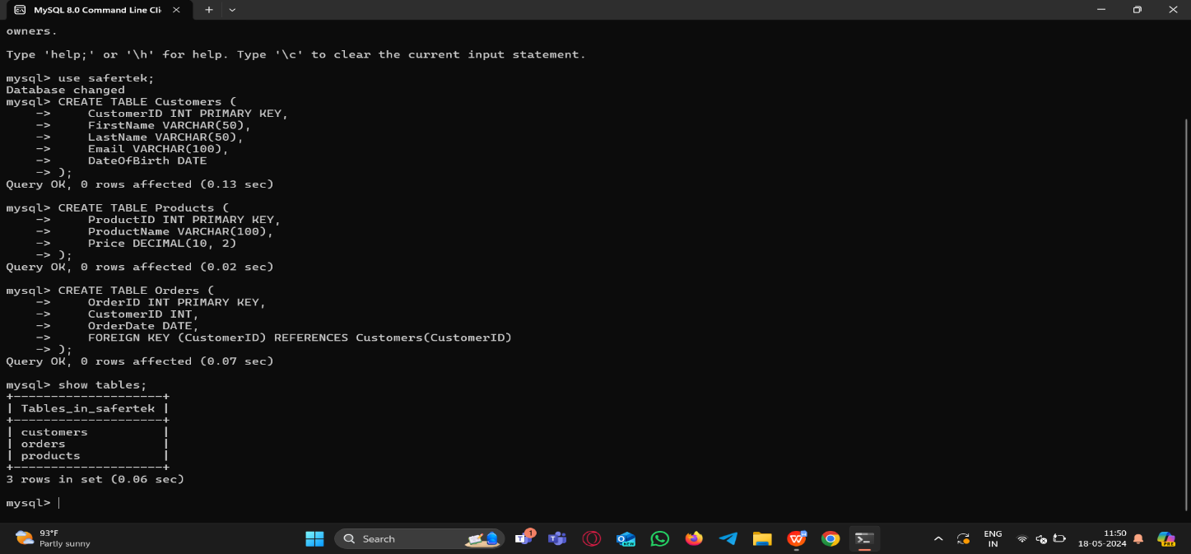

1. INSERT INTO Customers (CustomerID, FirstName, LastName, Email, DateOfBirth) VALUES (1, 'John', 'Doe', 'john.doe@example.com', '1985-01-15'), (2, 'Jane', 'Smith', 'jane.smith@example.com', '1990-06-20');

INSERT INTO Products (ProductID, ProductName, Price) VALUES (1, 'Laptop', 1000.00), (2, 'Smartphone', 600.00), (3, 'Headphones', 100.00);

INSERT INTO Orders (OrderID, CustomerID, OrderDate) VALUES (1, 1, '2023-01-10'), (2, 2, '2023-01-12');

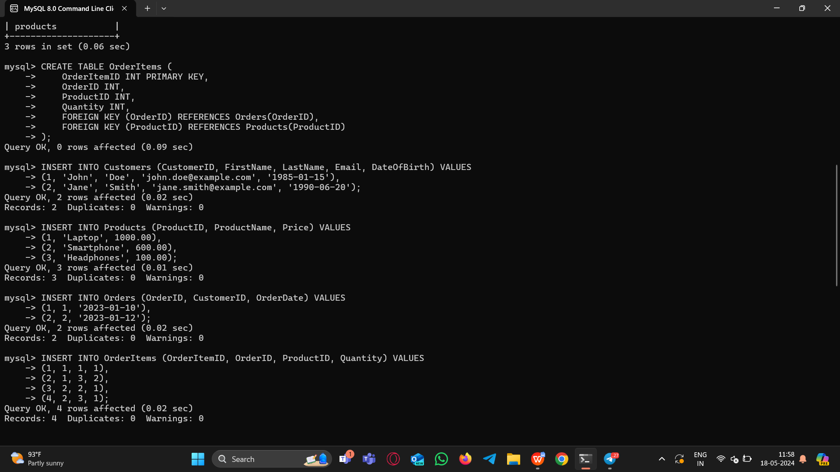INSERT INTO OrderItems (OrderItemID, OrderID, ProductID, Quantity) VALUES (1, 1, 1, 1), (2, 1, 3, 2), (3, 2, 2, 1), (4, 2, 3, 1);

1. **To list all customers from the Customers table:**

Query: SELECT * FROM Customers;

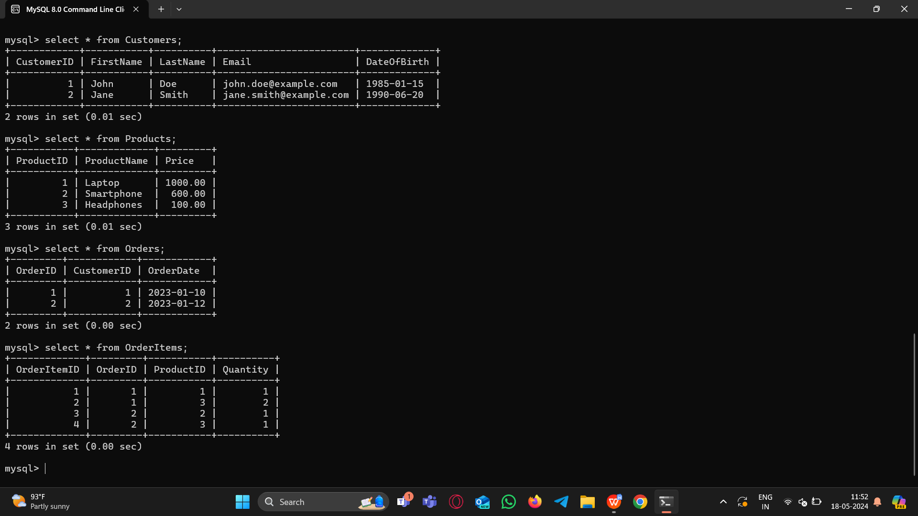

1. **To find all orders placed in January 2023:**

Query: SELECT * FROM Orders WHERE OrderDate >= '2023-01-01' AND OrderDate <= '2023-01-31';

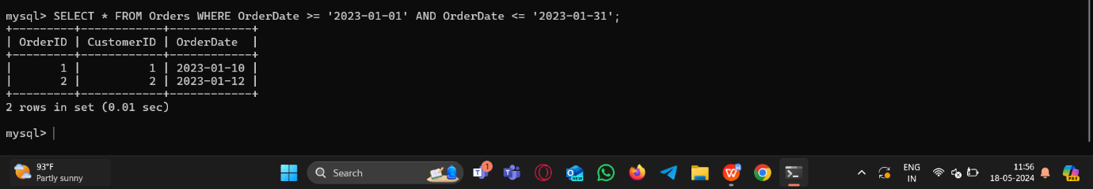

1. **To get the details of each order, including the customer’s name and email.**

Query: SELECT O.OrderID, O.OrderDate, C.FirstName, C.LastName, C.Email FROM Orders O JOIN Customers C ON O.CustomerID = C.CustomerID;

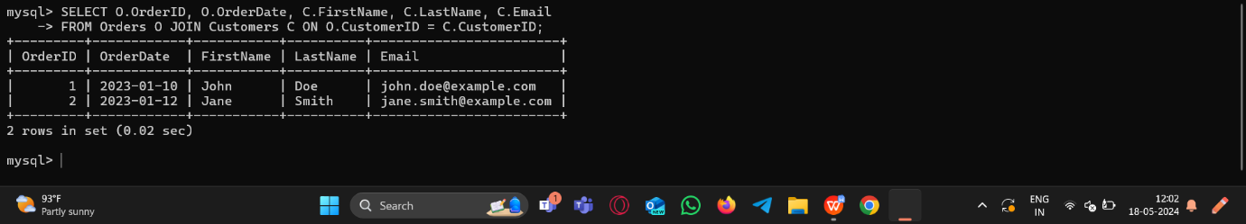

1. **To list the products purchased in a specific order (e.g., OrderID = 1).**

Query: SELECT P.ProductName, O.Quantity FROM OrderItems O JOIN Products P ON O.ProductID = P.ProductID WHERE O.OrderID = 1;

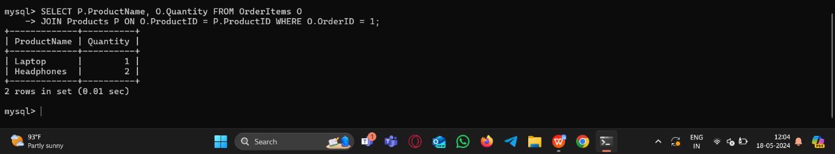

1. **To calculate the total amount spent by each customer.**

Query: SELECT C.CustomerID, C.FirstName, C.LastName, C.Email, SUM(P.Price * OI.Quantity) AS TotalAmountSpent FROM Customers C JOIN Orders O ON C.CustomerID = O.CustomerID JOIN OrderItems OI ON O.OrderID = OI.OrderID JOIN Products P ON OI.ProductID = P.ProductID GROUP BY C.CustomerID, C.FirstName, C.LastName, C.Email;

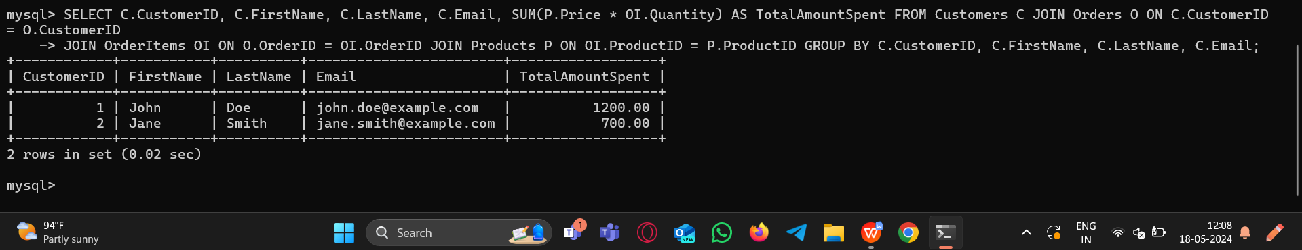

1. **To find the most popular product (the one that has been ordered the most).**

Query: SELECT P.ProductID, P.ProductName, SUM(OI.Quantity) AS TotalQuantityOrdered FROM Products P JOIN OrderItems OI ON P.ProductID = OI.ProductID GROUP BY P.ProductID, P.ProductName ORDER BY TotalQuantityOrdered DESC LIMIT 1;

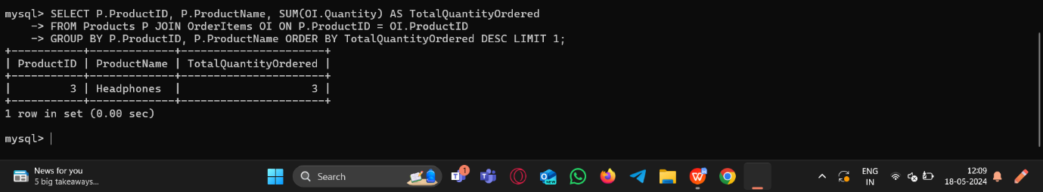

1. **To get the total number of orders and the total sales amount for each month in 2023.**

Query: SELECT YEAR(OrderDate) AS Year, MONTH(OrderDate) AS Month, COUNT(*) AS TotalOrders, SUM(Price * Quantity) AS TotalSalesAmount FROM Orders O JOIN OrderItems ON O.OrderID = OrderItems.OrderID JOIN Products ON OrderItems.ProductID = Products.ProductID WHERE YEAR(OrderDate) = 2023 GROUP BY YEAR(OrderDate), MONTH(OrderDate) ORDER BY YEAR(OrderDate), MONTH(OrderDate);

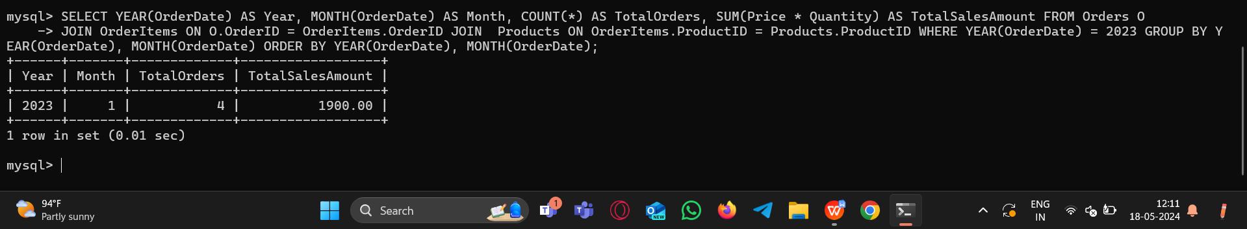

1. **To find customers who have spent more than $1000.**

Query: SELECT C.CustomerID, C.FirstName, C.LastName, C.Email, SUM(P.Price * OI.Quantity) AS TotalSpent FROM Customers C JOIN Orders O ON C.CustomerID = O.CustomerID JOIN OrderItems OI ON O.OrderID = OI.OrderID JOIN Products P ON OI.ProductID = P.ProductID GROUP BY C.CustomerID, C.FirstName, C.LastName, C.Email HAVING TotalSpent > 1000;

