DATA REPORT
Intended Audience
Intended for the analytics team at Toronto Police Service, Municipal planners for Community Safety, and City officials, this data report served as reference material for accurate and trustworthy insight into historical Crime data so that it can be effectively used in developing a Crime prevention program(s) based upon empirical evidence, thereby making all levels of City Government accountable as committed to.

1. Introduction
Robbery remains one of the most persistent and disruptive criminal offenses in cities, including Toronto. A robbery, as well as a greater incidence rate in larger metropolitan areas, can pose a considerable threat to their residents and businesses, commuters and neighbourhoods alike. Because of the many factors that influence a robbery (e.g., time of day, access to opportunity, crime geographical location, etc.), it is critical to understand the time, location, and the conditions that led to the commission of a robbery when developing community safety initiatives. This analysis will provide a comprehensive examination of robbery incidents occurring in Toronto based upon publicly available open data from the Toronto Police Service. Through this report, patterns of robberies related to time, location, and robbery type will be identified to better inform the development of effective crime prevention and response strategies. To clean, transform, and statistically prepare data for this project, SAS was used. In addition, Tableau was utilized to create visualizations that illustrate how frequently robbery incidents occur. By using Tableau dashboards and breakdowns, robbery data can be examined based upon the following factors: hour of day, day of week, month, and year; robbery frequency by neighbourhood or geography; premises and/or type of offence; and seasonality or holiday patterns.
The content of this report is shaped by the following essential research questions:
- Where in Toronto are robbery incidents concentrated, and are there any differences in terms of geographic division/neighbourhood?
- When (hour/day/month/season) are robbery incidents being committed?
- Do robbery incidents spike during certain holidays and special events?
- How do robbery incidents vary based on the location of the offence or type of robbery?
- How have robbery incident trends changed over time and which areas have experienced these changes?
By answering these questions, this report will provide valuable information to help inform risk-based policing practices, community outreach efforts, and public safety planning.

2. Dataset Description

The data set used in this analysis was the Toronto Police Service's Robbery Open Data, which has been provided publicly through the Toronto Police Service's public open data portal and can be accessed through: Toronto Police Service Public Safety Data Portal, n.d. https://data.torontopolice.on.ca/.

The Robbery Open Data provides an incident-level representation on all the different types of robbery events that have occurred within the City of Toronto, with all robbery incidents listed appearing as single-row observations in the data set. Some of the notable variables are:
- Occurrence Year, Occurrence Month, Occurrence Day, Occurrence Hour (OCC_YEAR, OCC_MONTH, OCC_DAY, OCC_HOUR)
- Occurrence Day of the Week (OCC_DOW)
- Name of Neighbourhood (NEIGHBOURHOOD_158; NEIGHBOURHOOD_140 depending on version)
- Police Division (DIVISION)
- Location of the Event, / Type of Premises, / Geography (e.g. street versus apartment versus store)
- Description of the Offence (e.g., robbery with Weapon/Robbery-Other)
- Latitude/Longitude (X/Y; LAT/LONG, respectively); To be able to generate mapping images of all locations

The dataset is being offered anonymised and does not contain any personal Identifiable Information (P.I.I.), including names and addresses. Rather, it will provide the opportunity to conduct spatial and temporal analysis while still protecting the user's privacy.
Many difficulties arose when we started our project. Some of the variables were formatted incorrectly (e.g., "STREET", "Street", "ROADWAY") because they contained inconsistent categorical data. Some of the neighbourhood classifications had not been updated for an extended period of time and are now considered obsolete. The way Timestamps are formatted varied as well as how they were recorded; therefore, some dates were recorded as being from different years. Several of the variables that we retrieved from ArcGIS were unnecessary for our analysis, and we removed them. We also noted some records were missing neighbourhood names & had incomplete category names.
However, regardless of the above challenges, this dataset has sufficient detail for our analyses to be conducted temporally, spatially, and contextually, using SAS & Tableau.

3. Data Cleaning Summary (SAS)
To create a dataset for visualization using SAS, the first step was to clean and prepare the data, or in other words, through a series of processes to remove unwanted fields, fix formatting issues, and build or create new variables as necessary to facilitate data analysis.
- Importing & Cleaning Data: The importing of the dataset utilized PROC IMPORT, and the review of the content of the Dataset utilized PROC CONTENTS for verification of the names and formats of the variables. This process of verification determined that the dataset contained geometry fields that were not necessary for this analysis and had missing or mismatched TIMESTAMP formats that required further cleanup.
- Elimination of Unnecessary and Redundant Columns: The geometry fields of ArcGIS (X and Y) were eliminated as Tableau will utilize the cleaned latitude and longitude that is contained in the dataset. Other unused metadata, duplicate neighbourhood classifications, and UCR codes were removed to eliminate potential confusion.
- Formatting of Time Variables: As defined, OCC_HOUR is a numerical representation of the hour of the day. OCC_HOUR was reformatted to be in SAS time format (ie., hh:mm:ss) to allow for the use of OCC_HOUR for time series.
- Removal of Duplicate Records: Duplicate records were removed based on EVENT_UNIQUE_ID. Each record will only represent one robbery incident.
- Standardized Month Field: Some datasets included month names; others contained numerical representation of a month (ie., 1-12). The month names have been standardized via SAS by uppercasing each month and trimming spaces; SAS then assigned a number to January-December. A variable called Month_Start was then created to represent January 1, February 1, etc., to support visualizations of monthly robbery trends.
- Inconsistent Date Fields Dropped: The OCC_DATE field was not consistent over all years because different formats were used; therefore, the date field has been dropped due to error issues. The OCC_YEAR, OCC_MONTH, and OCC_DAY are now utilized.
- New variables were needed for the analysis:
"Holiday Period" flags incidents taking place in or near the holiday periods between December 20 to 31 (winter holidays), January 1 to 5 (New Year period), and March 10 to 20 (March Break).
Another variable is "Season". Seasons are categorized according to meteorological seasons: winter (December—February), spring (March—May), summer (June—August), and fall (September—November).
Holiday and seasonal variables can be used for more specific analysis related to holidays and seasonal patterns.

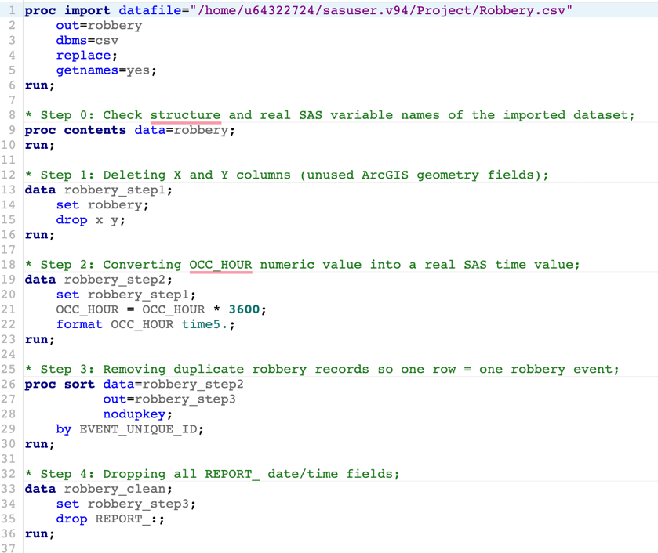

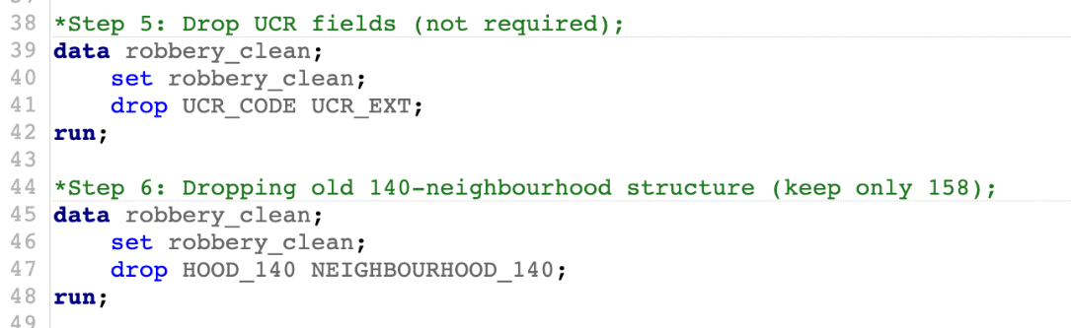

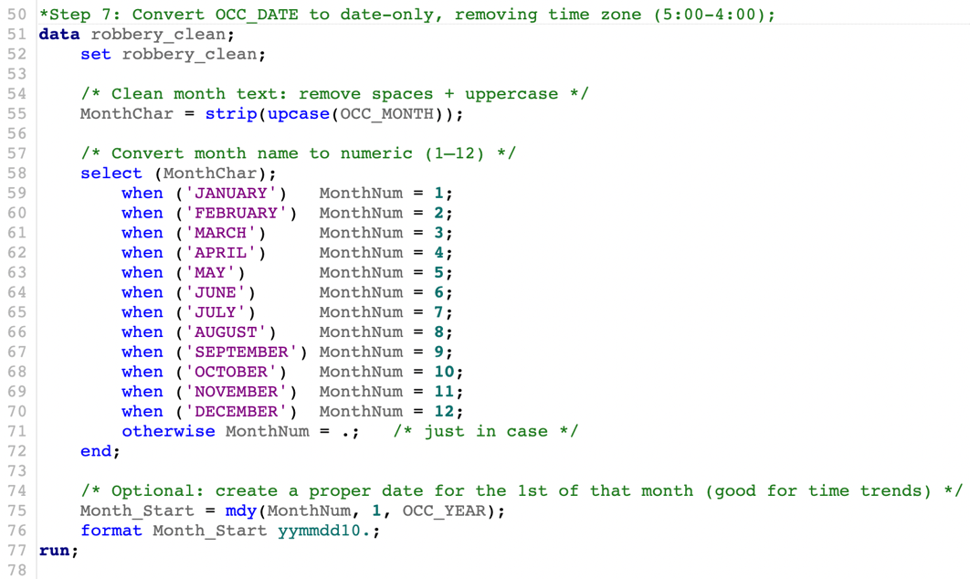
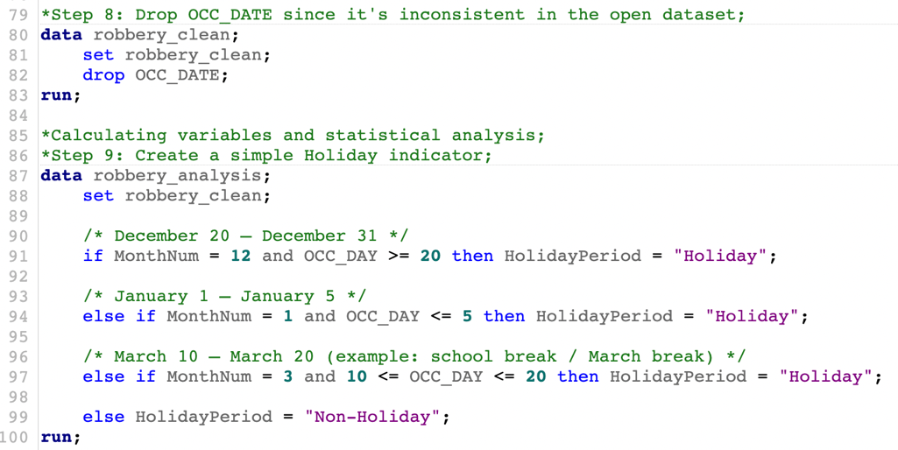

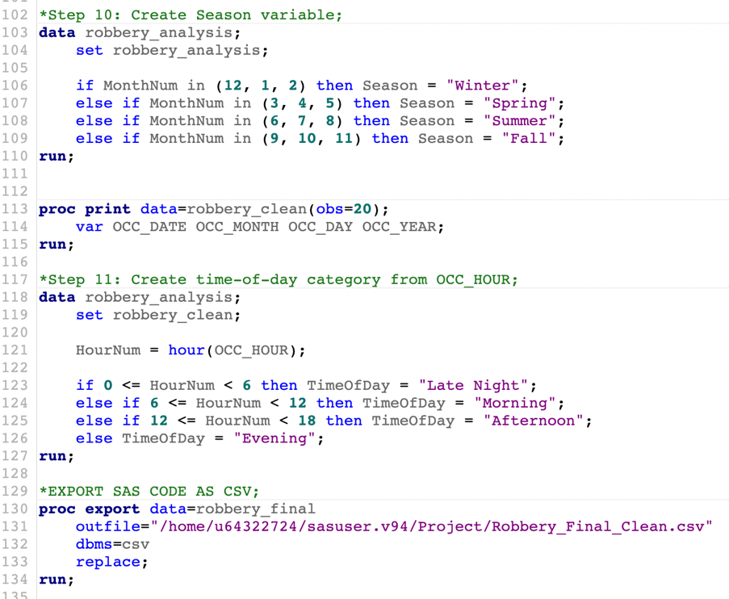

4. Statistical Analysis Summary
We examined the distribution of robberies based on geographic location and time of year using descriptive statistics before making various visual representations of the data. To accomplish this, we created frequency tables using PROC FREQ to analyze the neighbourhoods, divisions, premises, and types of offences committed. The frequency tables produced from this analysis identified how many robberies occurred in certain locations compared to other locations, and which offence types were most frequently committed.

Robberies showed a clear variability based on time of year. Frequency distributions revealed higher robbery counts later in the evening (especially between 6 p.m. and 11 p.m.). Robberies were consistently prevalent throughout the week, with some increase in robberies on weekends. A monthly frequency distribution identified peaks of robbery frequency in warmer months, from May to October.

The PROC MEANS function was used to create a year-by-year summary, which helped build the trend charts in Tableau. The statistics from PROC MEANS showed that there were fluctuations in the number of robberies during each year, which also aligned with the general trend of increased crime throughout the city.

When reviewing the outliers associated with the number of robberies, it was observed that there were many spikes in particular neighbourhoods and divisions. These areas were often located in parts of the city where there was a large concentration of people or near major transportation hubs. The results of the outlier analysis also helped to shape the format of the Tableau dashboards.

5. Findings (with Charts)

5.1 Robberies by Hour
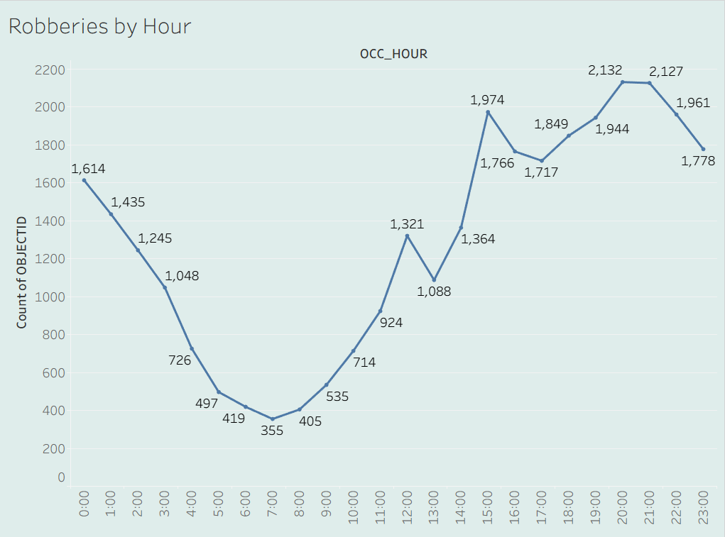
The daytime pattern of Robbery indicates an increase in incidents in the late afternoon, peaking between 6-11 pm (18:00-23:00). This trend corresponds with the peak times for foot traffic and closing times of many businesses. During overnight hours (from midnight to 5 am), the number of robbery incidents is substantially reduced compared to the day and evening hours, making it reasonable to conclude that enhanced policing and/or community safety measures during early evening hours will have the greatest potential for preventing robbery.

5.2 Robberies by Day of Week
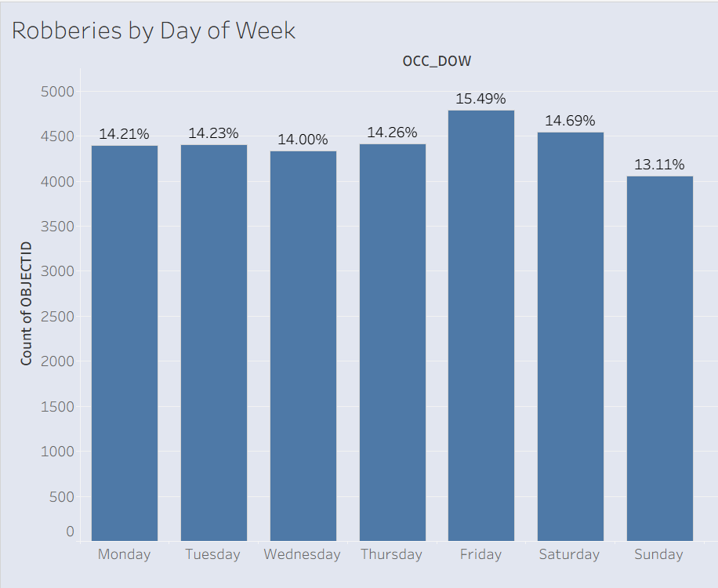
The overall volume of robbery offenses across the week is fairly stable with only small surges. A small rise in Friday/Saturday robberies is seen likely related to the increased amount of activity taking place at night on these days. Additionally, the absence of any significant variations in weekday robbery offenses illustrates that robbery risk is a broad-based risk, with no day of the week offering a much higher probability of an occurrence than another.

5.3 Robberies by Month / Season
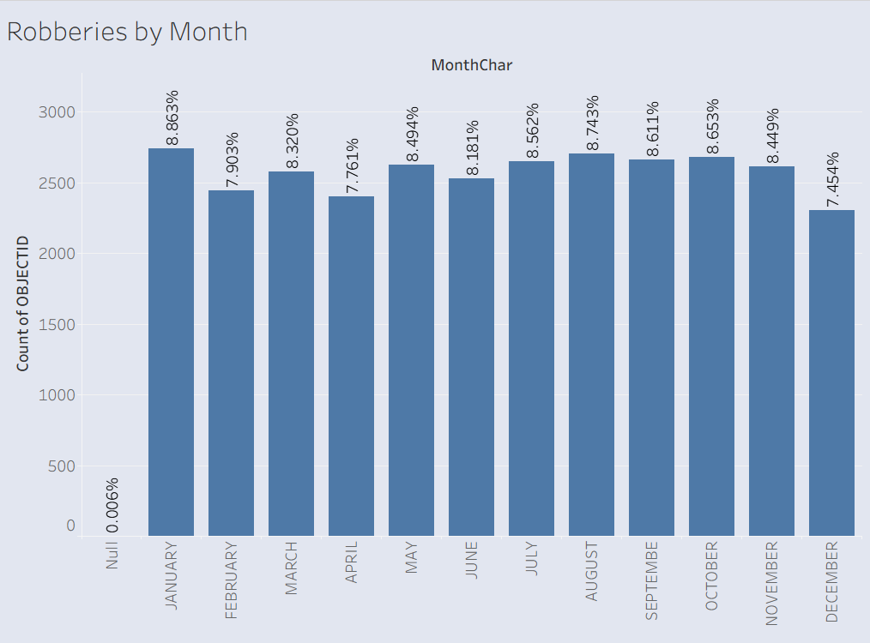
The patterns seen in robberies on a monthly basis are highlighted by high levels of robbery activity during the spring, summer, and early fall seasons. More exposure to the outdoor environment (due to the warmer months), as well as the longer daylight hours, and greater levels of socialization, provide increased opportunity to commit these offenses. Cold weather months see an equally noticeable decrease in robbery activity during these months. Research conducted in other Canadian municipalities also corroborates the seasonal trends shown here.

5.4 Robberies by Year (Trend)
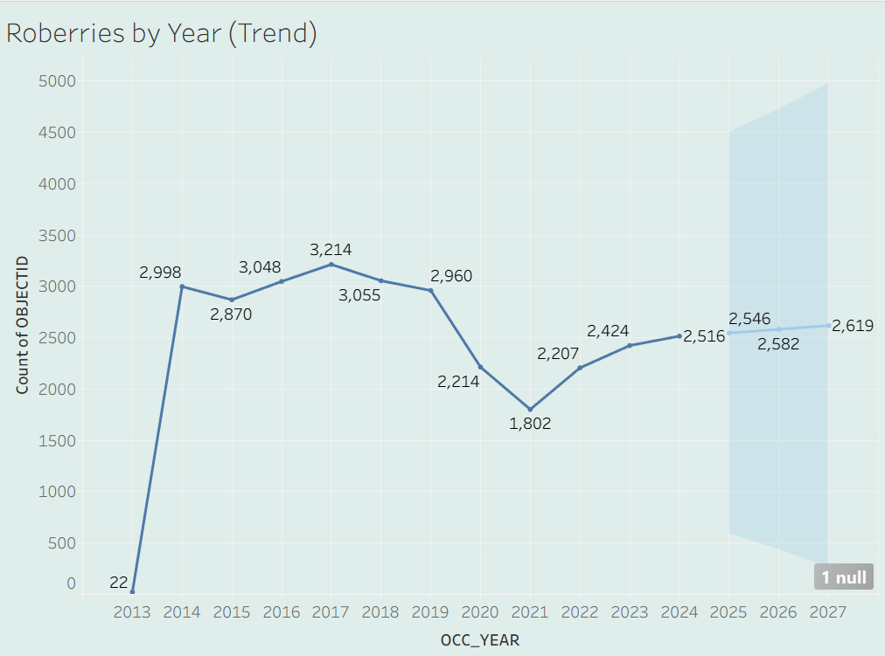
In examining the year trend, it is clear that there have been variations from 1 year to the next for robbery activity. This is most likely due to fluctuations in socio-economic conditions across Canada at that time or changes in policing strategies during each of those years. Long-term trend information will assist in the development of forecasting and operational planning.

5.5 Robberies by Neighbourhood & Division
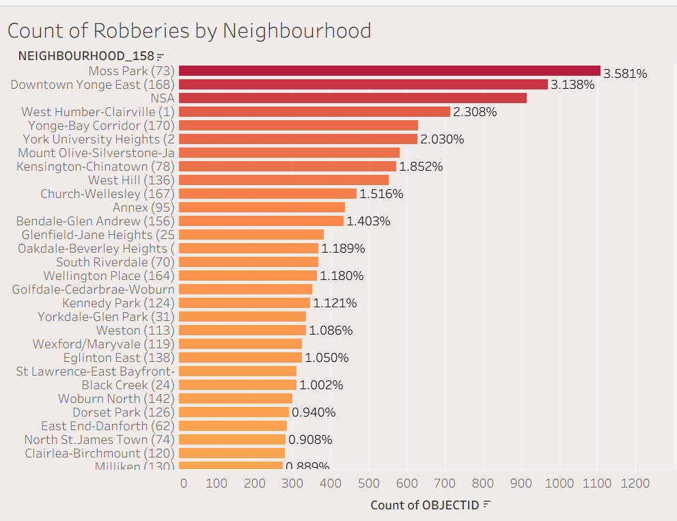
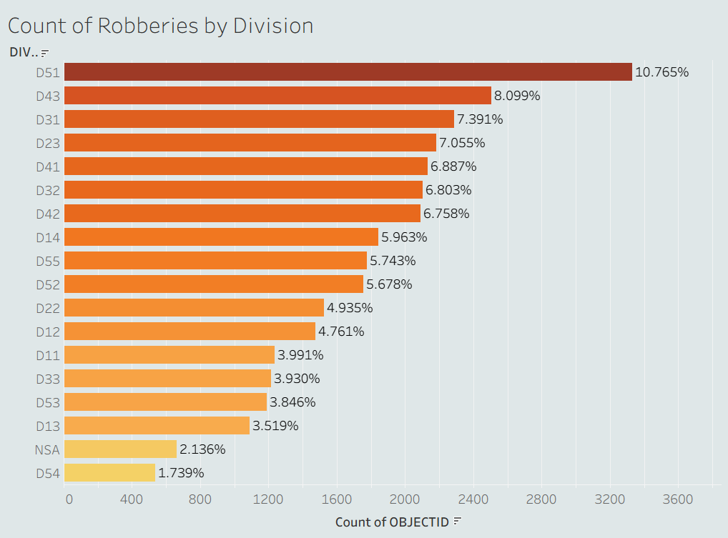
An analysis of neighborhood crime-data reveals areas having a higher density of robbery incidents have unique characteristics that cause them to have a higher concentration in comparison with surrounding neighborhoods. Neighbourhoods, such as those near downtown or east end neighbourhoods, which experience large volumes of street traffic, as well as have large numbers of businesses located along their commercial corridors, report the highest incidence of robbery crimes.
Analysis at the division level shows robbery incidents continue to be concentrated in high-volume areas, such as Division 14 and Division 51, which are identified as the two divisions with the highest number of robberies. Such concentration or clustering assists in establishing high-priority locations for focused patrolling.

5.6 Premises Type and Offence Type
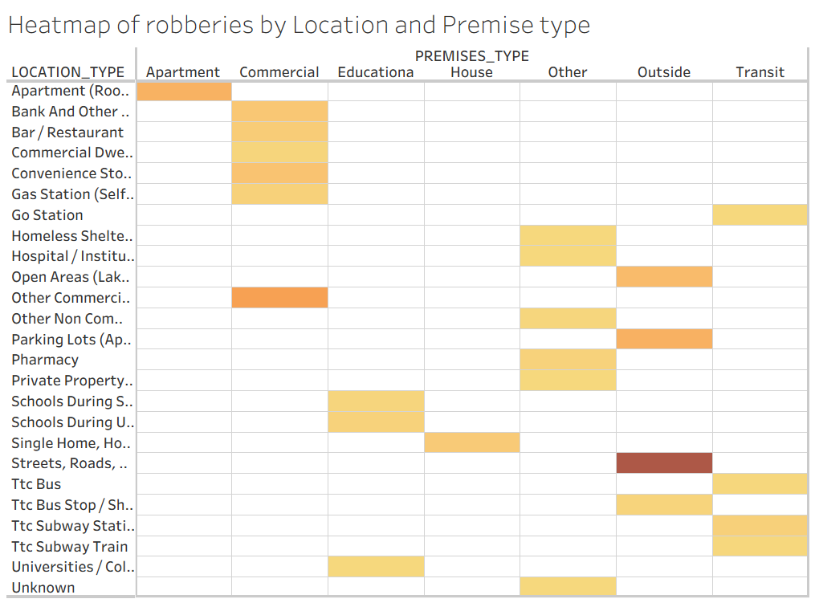
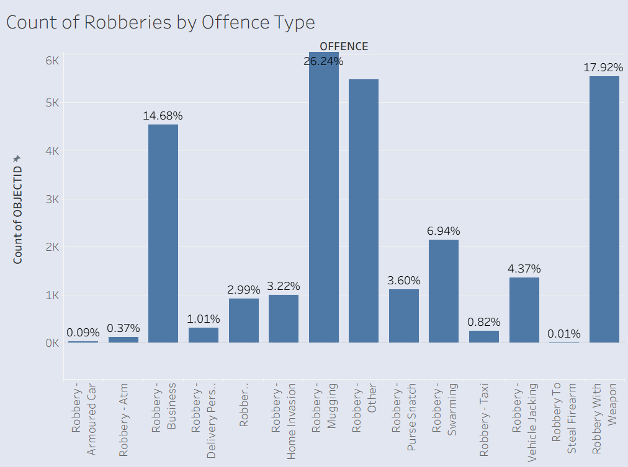
The overwhelming majority of robbery incidents are street-level robberies, followed by robberies of commercial establishments (store or restaurant). The heatmap depicting types of robbery offences, assists in identifying specific neighbourhoods or time periods with high occurrence of specific weapon-related robbery offences. These analysis-based observations and significant contextual data allow for the development of more targeted safety and crime prevention efforts.

6. External Sources
- Statistics Canada – Police-Reported Crime Statistics
https://www150.statcan.gc.ca/n1/pub/85-002-x/2023001/article/00001-eng.htm
According to Statistics Canada, robbery is not only prevalent in populated urban centers but also increases with temperature and is typically more sporadic during busy public movement seasons. Commercial centers, along with transit hubs in urban regions, typically have a much higher density of robberies than their less populous counterparts. In keeping with the national trend, our locations, especially in Toronto, have a high propensity for robbery activity during the spring to fall seasons, especially in areas that contain large concentrations of people and come alive during the evening hours. Ultimately, the national data provides empirical validation for the temporal and spatial patterns that we have identified through our dashboard analysis.
- City of Toronto – Neighbourhood Profiles
https://www.toronto.ca/city-government/data-research-maps/neighbourhoods-communities/
Toronto's neighbourhood profiles include many demographic elements, including density, proximity to transit, and commercial businesses. Areas with a lot of pedestrian and vehicle traffic and business corridors provide many more opportunities for robbers than less-populated areas, which align well with our findings of hot spots in downtown and transit-centric neighbourhoods. The neighbourhood profiles also explain why some area divisions have a higher frequency of robbery activity consistently throughout our analysis.
- Canadian Centre for Justice Statistics – Urban Crime Trends
https://www150.statcan.gc.ca/n1/en/type/data?MM=1
In Canada, robbery is particularly concentrated in urban areas and is strongly correlated with the presence of nightlife districts, transit routes, and economic activity. The highest levels of robbery nationally occur during the evening hours in the largest cities, which is supported by our analysis of the City of Toronto. As a result, this national context reinforces our understanding of the spatial and temporal robbery trends we observe.

7. Recommendations
Considering the study's findings, there are several recommendations that could be made to improve safety in these communities.

- Increase patrols during the day and evening: The police department believes that the best way to minimize the occurrence of thefts is to increase the number of patrols during the hours with the highest number of thefts, specifically between 6:00 PM and 11:00 PM.
- Focus on high-risk neighbourhoods and divisions: The police department recommends that PD develop additional safety initiatives, business engagement programs, and enhance the use of surveillance in neighbourhoods and divisions with the highest crime levels.
- Seasonal Policing Strategies: The number of robberies increases during the summer; therefore, planning resources based on the time of year is very important.
- Cut through Crime: Analysis of the holiday period variable indicates substantial increases in crime between late December and early January. Increasing community awareness and increasing police presence in commercial areas during this time may reduce crime rates.
- Working Together: As a significant portion of robbery incidents occur in commercial premises, working with local businesses to develop strategies to prevent robberies would be beneficial.

8. Conclusion
This study has shown how data together with SAS and Tableau can identify important trends related to Robbery patterns across Toronto. By knowing both when and where a robbery occurs along with its contextual information allows Law Enforcement Organizations (LEOs) and Policy Makers to develop more effective and targeted strategies for preventing crime from occurring. The study shows that there are both time & neighbourhood-based approaches for allocating resources to improve Public Safety.
References
Toronto Police. Robbery open data. (n.d.). https://data.torontopolice.on.ca/datasets/d0e1e98de5f945faa2fe635dee3f4062_0/explore?location=13.616481%2C-39.817614%2C2.16
Government of Canada, Statistics Canada. (2023, January 12). Victimization of men and boys in Canada, 2021. https://www150.statcan.gc.ca/n1/pub/85-002-x/2023001/article/00001-eng.htm
Toronto, C. O. (2022, April 12). Neighbourhoods & communities. City of Toronto. https://www.toronto.ca/city-government/data-research-maps/neighbourhoods-communities/
Government of Canada, Statistics Canada. (2025, December 2). Data. https://www150.statcan.gc.ca/n1/en/type/data?MM=1

