AUTOMATION OF COMPLIANCE CONTROLS
(7-Control Compliance Engine)

Submitted by : Vachini Shah [25MCC024],
---------------------------------------------------------------------

INTRODUCTION
Modern organizations heavily rely on secure IT infrastructures. Compliance with security policies and standard frameworks such as CIS Benchmark, ISO 27001, and NIST is essential to ensure safe system operation, prevention of unauthorized access, and reduction of cyber risks.
Manual compliance verification is time-consuming, error-prone, and inconsistent. Therefore, the objective of this project is to automate compliance checks and remediation for seven essential Linux security controls.
This project implements:
- Manual compliance verification
- Manual remediation
- Automated compliance scripts
- Automated remediation scripts
- An aggregator script that outputs a final compliance JSON report
- Cron job automation to run compliance checks periodically

OBJECTIVE
The objective of this project is:

To build an automated compliance engine for 7 Linux security controls, which includes:
- Auditd configuration
- SSH Root Login disabled
- Password Policy Enforcement (Minimum Length)
- Firewall enabled
- NoPassword sudo disabled
- Automatic security updates enabled
- Syslog retention & log forwarding
The automation engine will:
- Detect whether each control is compliant
- Automatically fix the control if non-compliant
- Generate JSON output summarizing compliance
- Run periodically via cron

SCOPE
The project covers:
- Installation & configuration of required packages
- Manual verification of all controls
- Manual remediation steps
- Writing bash scripts for automated checking
- Writing bash scripts for automated fixing
- Testing after automation
- Creating aggregator script to generate final JSON output
- Scheduling cron automation

CONTROL MAPPING

Law Requirement | Control Implemented | Description
Secure Logging Required | Control 1: Auditd | System auditing and logging
SSH Hardening | Control 2: SSH Root Login | Prevent direct root login
Password Strength | Control 3: Password Length | Minimum password length 8
Network Protection | Control 4: Firewall | Allow outgoing, deny incoming
Privilege Hardening | Control 5: NoPassword sudo | Remove unsafe sudo access
Patch Management | Control 6: Automatic Updates | Auto security updates
Log Retention | Control 7: Syslog Forwarding | Forward logs to server
Explanation of how each control (C1–C7) aligns with the surveyed laws and frameworks :

C1 — Auditd Logging Enabled (System Event Logging)
Mapped to:
- CERT-In: Mandatory logging + 180-day log retention requirement.
- ISO 27001 (A.12 & A.17): Logging, monitoring, and audit event controls.
- NIST SP 800-53 (AU Family): Audit logging, event retention, audit review.
- RBI Guidelines: Continuous monitoring and audit trails for critical systems.
Reason for mapping:
Auditd ensures continuous event logging, which is a common baseline requirement across all major frameworks. By enabling auditd, the system meets legal requirements around forensic readiness and security event traceability.

C2 — SSH Root Login Disabled
Mapped to:
- CERT-In: Secure configuration + restriction of privileged access pathways.
- ISO 27001 (A.9 Access Control): Preventing unauthorised privileged access.
- NIST SP 800-53 (AC-6, AC-17): Least privilege + remote access restrictions.
- DPDP Act: Requires “reasonable security safeguards,” mainly controlling access to personal data.
Reason for mapping:
Disabling SSH root login prevents direct privileged access, reducing attack surface. All standards highlight strong access control as a core requirement, making this control mandatory for compliance.

C3 — Strong Password Policy (Minimum Password Length)
Mapped to:
- ISO 27001 (A.9.2.4): Secure authentication and password standards.
- NIST SP 800-53 (IA-5): Password strength and authentication requirements.
- DPDP Act: Ensures integrity and confidentiality through secure authentication.
- RBI Guidelines: Enforce strong password requirements for system access.
Reason for mapping:
Strong password policies are universally mandated across frameworks to prevent unauthorized access to personal and organizational data.

C4 — Firewall Enabled (UFW Default Policies)
Mapped to:
- CERT-In: Baseline security configuration + protection from unauthorized network access.
- ISO 27001 (A.12.1.3 & A.13): Network security controls and boundary protection.
- NIST SP 800-53 (SC-7): Boundary defense and network filtering.
- RBI Guidelines: Host-level firewalls for critical infrastructure protection.
Reason for mapping:
A firewall enforces network segmentation, minimizes external exposure, and is explicitly required in both CERT-In directives and international standards.

C5 — No Passwordless Sudo Allowed
Mapped to:
- ISO 27001 (A.9): Privilege management and controlled administrative access.
- NIST SP 800-53 (AC-2, AC-6): Enforcement of least privilege + admin authentication.
- DPDP Act: Ensures only authorised users access sensitive personal data.
- RBI Guidelines: Strict administrator access control in BFSI systems.
Reason for mapping:
Passwordless sudo bypasses authentication, violating least-privilege and accountability principles. Removing NO-PASSWD ensures that all privileged actions are tied to an authenticated user identity.

C6 — Automatic Updates / Unattended Upgrades Enabled
Mapped to:
- CERT-In: Mandates timely patching of vulnerabilities.
- ISO 27001 (A.8 & A.12): Vulnerability management & system maintenance.
- NIST SP 800-53 (SI-2): Patch management and remediation of system flaws.
- RBI Guidelines: Critical systems must be patched in a timely manner.
Reason for mapping:
Automatic update mechanisms reduce the risk posed by unpatched vulnerabilities—one of the most exploited vectors in cyber incidents.

C7 — Syslog Remote Forwarding / Log Retention
Mapped to:
- CERT-In: Event logs must be stored for 180 days; remote logging recommended.
- ISO 27001 (A.12 & A.17): Event logging, monitoring, and log protection.
- NIST SP 800-53 (AU-4, AU-9): Log forwarding, protection, and retention controls.
- RBI Guidelines: Log retention and centralized SIEM integration for visibility.
Reason for mapping:
Remote log forwarding ensures integrity and persistence of system logs even if the local machine is compromised, aligning with CERT-In’s retention and monitoring rules.

GENERAL PROCEDURE
- Manual Check:
Use Linux commands to check if system is compliant.
- Manual Fix:
Apply system configuration changes manually.
- Automated Check Script:
Create bash scripts that detect configuration.
- Automated Fix Script:
Create bash scripts that correct the configuration.
- Aggregator Script:
Generates combined JSON output.
- Cron Automation:
Automates daily scanning & remediation.

STEP-BY-STEP IMPLEMENTATION

STEP 0 — BASE DIRECTORY CREATION

To begin the development of the Linux Compliance Automation Engine, it is essential to first create a structured directory layout. This ensures that all check scripts, remediation scripts, and helper utilities remain organized and easy to maintain. The following commands create the base folder /opt/compliance-engine along with two subdirectories: checks for compliance verification scripts and remediation for automated fix scripts.
The directory /opt is chosen because it is traditionally used in Linux systems for optional or third-party application software, making it an appropriate location for a custom compliance engine.
STEP 1 — CREATE UTILS HELPER SCRIPT (utils.sh)
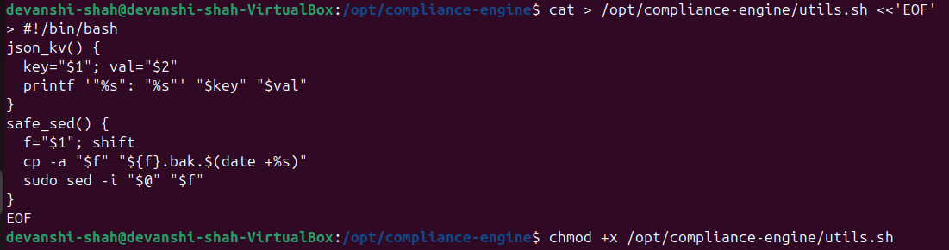
The utils.sh file acts as a small helper module used by all other compliance scripts.
Its main purpose is to provide a reusable function (json_kv) that formats key–value pairs into proper JSON syntax.
This ensures that each check script outputs results in a consistent and machine-readable structure.
By centralizing this logic into a utils file, the overall automation becomes cleaner, easier to maintain, and avoids repeating code across multiple scripts.

STEP 2 — CONTROL 1: AUDITD + RSYSLOG
2.1 MANUAL CHECK
In this step, the system was manually examined to verify whether Auditd and Rsyslog forwarding were configured correctly.
The command systemctl is-enabled auditd checks if the audit logging service is enabled and running, while the grep -R "Forward" command searches for any existing log forwarding configuration in Rsyslog.
This establishes the current compliance state before applying automation.
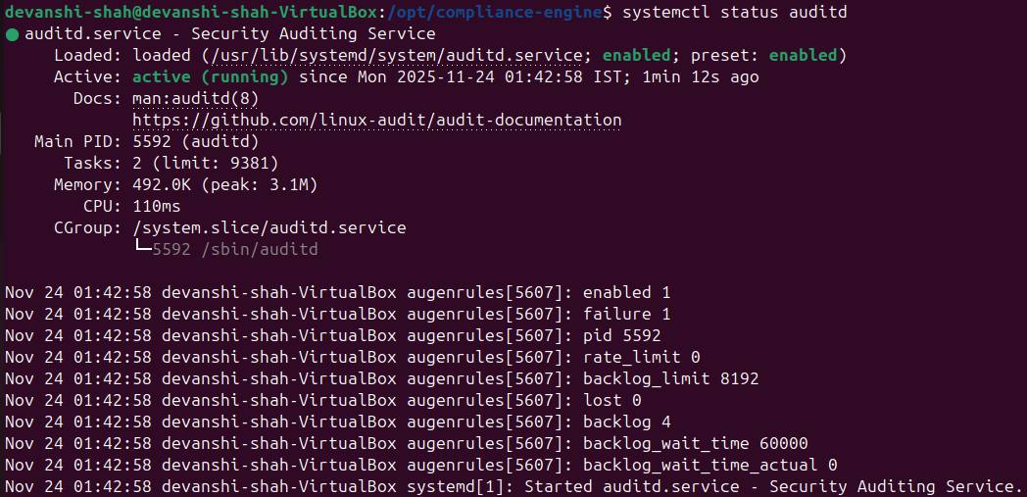Shows auditd service status (initially disabled).

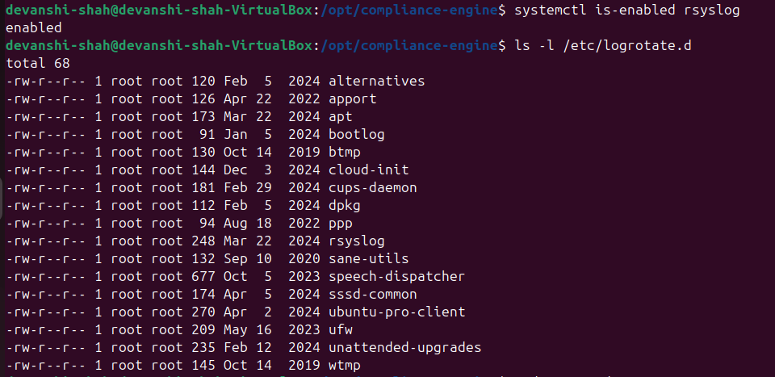
Shows absence of any Rsyslog forwarding configuration.

2.2 MANUAL FIX
Since Auditd was not enabled, it was installed and activated manually.
The commands ensure that audit logging is enabled at startup and the system begins recording security events.
This manual fix represents the baseline corrective action prior to automation.
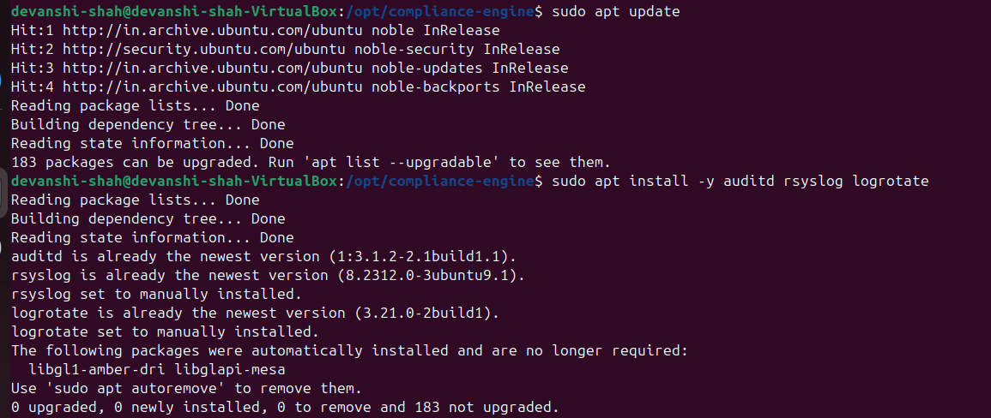
Shows installation of auditd.

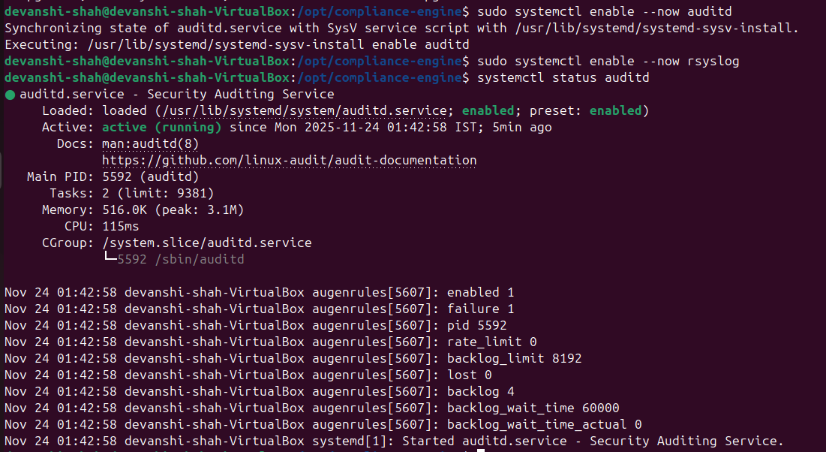
Shows auditd being successfully enabled and running.

2.3 AUTOMATED CHECK SCRIPT
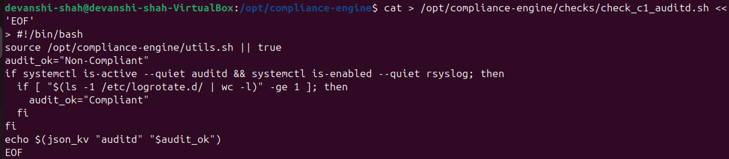
The automated check script evaluates whether Auditd is enabled using the same logic as the manual inspection.
It returns a JSON-formatted output marking the control as either Compliant or Non-Compliant.
This script is part of the automated compliance engine.

2.4 AUTOMATED FIX SCRIPT
This script automatically installs and enables Auditd if it is found to be non-compliant.
It eliminates the need for manual intervention and ensures that audit logging remains active at all times.
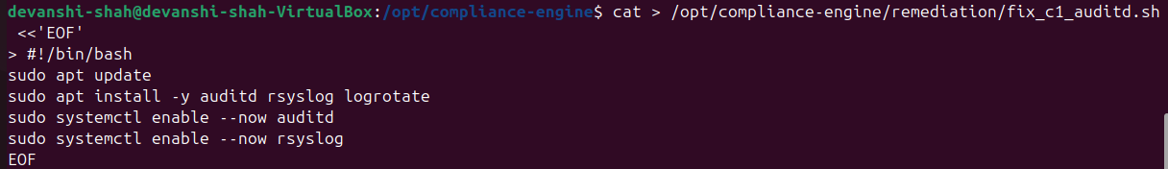
Displays the final automated remediation script created for restoring compliance.
STEP 3 — CONTROL 2: DISABLE SSH ROOT LOGIN
3.1 MANUAL CHECK
This step verifies whether the system currently allows root login over SSH, which is a major security risk.
The command sudo sshd -T | grep permitrootlogin prints the effective SSH configuration.
In the screenshot, the output shows “permitrootlogin without-password”, meaning root login is still allowed using certain methods, making the system non-compliant.
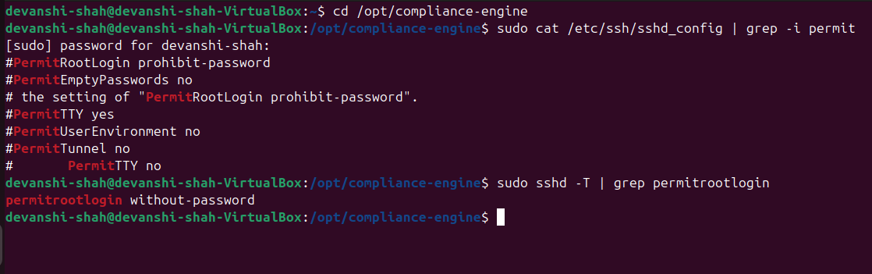
This screenshot demonstrates the insecure configuration before applying any fixes.

3.2 MANUAL FIX
In this step, we manually disable SSH root login.
First, any existing PermitRootLogin entries are removed to avoid conflicts.
Then a secure entry PermitRootLogin no is added to the SSH configuration file.
After updating the file, the SSH service is restarted to apply the new security policy.
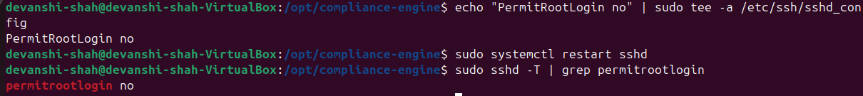
This screenshot shows the commands used to remove insecure entries and apply the secure configuration manually.

3.3 AUTOMATED CHECK SCRIPT
This script automatically checks whether root login over SSH is disabled.
It reads the value of PermitRootLogin from /etc/ssh/sshd_config.
If the value is “no”, the system is reported as Compliant; otherwise, it returns Non-Compliant.
This enables automated security auditing without manual inspection.
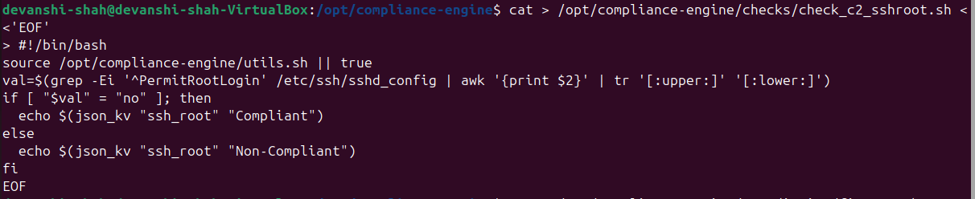
The screenshot displays the check script that evaluates compliance for SSH root login.

3.4 AUTOMATED FIX SCRIPT
This script automatically updates the SSH configuration by setting PermitRootLogin no.
It ensures that even if the system becomes misconfigured again, the script can enforce compliance.
Restarting the SSH service applies the fix instantly.
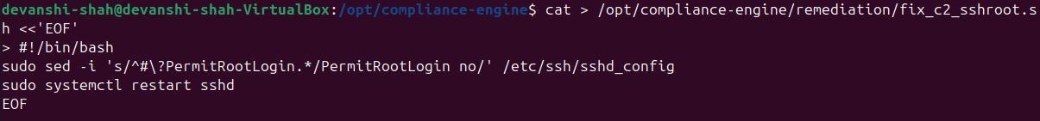
This screenshot shows the fix script successfully updating the configuration to secure the system.

STEP 4 — CONTROL 3: PASSWORD MINIMUM LENGTH

4.1 MANUAL CHECK
In this step, we manually verify whether the system enforces a minimum password length policy.
The parameters are checked in two files:
- /etc/login.defs → PASS_MIN_LEN
- /etc/security/pwquality.conf → minlen
If either parameter is missing or has a value less than 8, the system is considered Non-Compliant.
Manual check showing existing password policy values from login.defs and pwquality.conf.

4.2 MANUAL FIX
Since the manual check showed weak or improper values, we update both configuration files to enforce a secure minimum password length of 8 characters.
The sed commands replace any existing values with the compliant ones:
- PASS_MIN_LEN 8
- minlen = 8
This makes the system compliant according to password security standards.
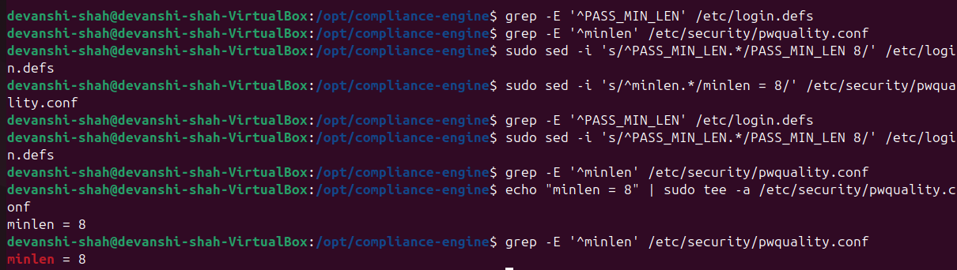
Manual remediation performed by updating PASS_MIN_LEN and minlen values.

4.3 AUTOMATED CHECK SCRIPT
This script automatically checks both configuration files to determine if the minimum password length policy is correctly implemented.
If both files have values ≥ 8, the script returns "Compliant".
Otherwise, it reports "Non-Compliant".
The script is used by the aggregator later to generate JSON compliance output.

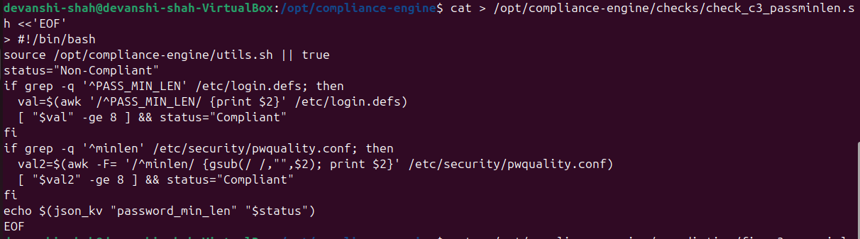
Automated check script that validates minimum password length settings.

4.4 AUTOMATED FIX SCRIPT
The fix script automatically updates both configuration files and enforces the correct values.
This ensures the system can self-correct whenever the password policy becomes misconfigured.
This script is triggered only when the compliance engine detects a failed check.
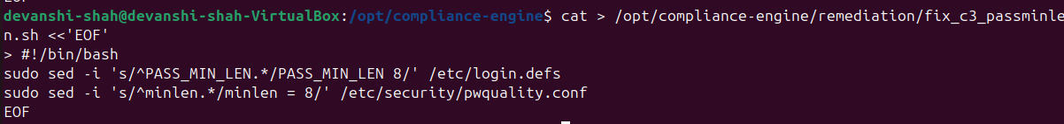
Automated remediation script applying secure password length configuration.

STEP 5 — CONTROL 4: FIREWALL ENABLED
5.1 MANUAL CHECK
To verify whether the firewall (UFW) is active and enforcing secure network policies, the command sudo ufw status verbose was executed.
The system returned “Status: inactive”, which indicates that the firewall was not enabled and therefore non-compliant as per security best practices.
This screenshot shows the output of sudo ufw status verbose, confirming that UFW was inactive before applying any changes.

5.2 MANUAL FIX
Since the firewall was inactive, the required UFW configuration was applied manually.
UFW was installed (if missing), the default policies were set to deny all incoming traffic and allow outgoing traffic, and finally UFW was activated.
These steps configure a secure baseline that blocks unwanted inbound connections.
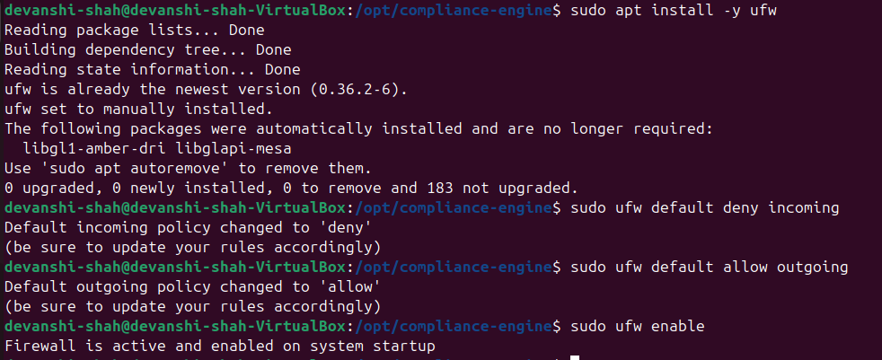
This screenshot displays the step-by-step execution of UFW installation, default rule configuration, and enabling the firewall.

5.3 AUTOMATED CHECK SCRIPT
An automated script (check_c4_firewall.sh) was created to programmatically detect UFW compliance.
The script verifies two things:
- The firewall is active
- The default incoming policy is deny
If both conditions are met, the system is marked Compliant; otherwise, it is Non-Compliant.

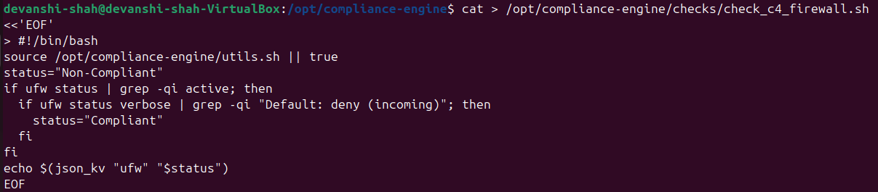
This screenshot shows the code of the automated check script used to validate whether UFW is enabled and configured securely.

5.4 AUTOMATED FIX SCRIPT
To ensure self-healing capability, an automated remediation script (fix_c4_firewall.sh) was implemented.
Whenever the system is found non-compliant, this script installs UFW, sets secure default rules, and enables the firewall automatically.
This ensures consistent protection without manual intervention.
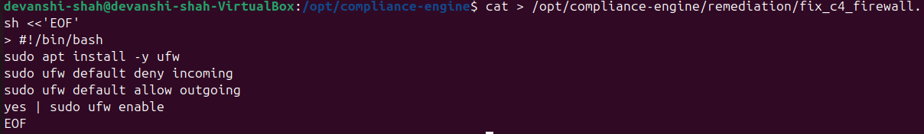
This screenshot displays the automated fix script that applies UFW installation and secure configuration to remediate non-compliance.

STEP 6 — CONTROL 5: REMOVE NOPASSWD SUDO
  - MANUAL CHECK
To verify whether insecure passwordless sudo access exists on the system, I performed a recursive search for any occurrence of the keyword NOPASSWD inside both /etc/sudoers and /etc/sudoers.d/.
If any line contains “NOPASSWD”, it means a user can execute sudo commands without entering a password, which is a security risk.
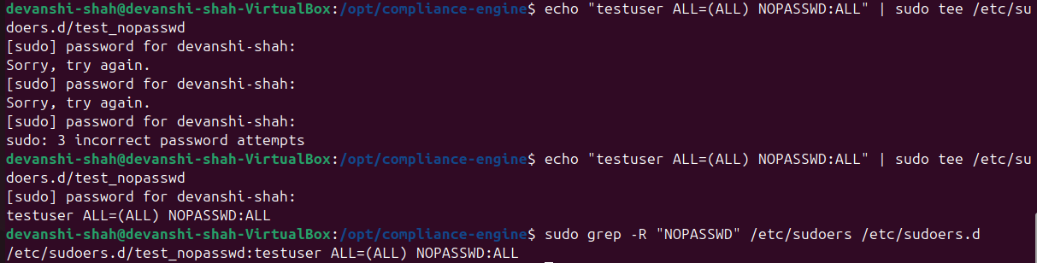
The screenshot shows the terminal output of the grep -R "NOPASSWD" command, clearly displaying that passwordless sudo entries were present, marking the control as Non-Compliant before automation.

  - MANUAL FIX
To remediate this issue manually, I removed every line containing “NOPASSWD” from both the main sudoers file and the sudoers.d directory.
This ensures that all users must authenticate before using sudo, improving privilege security and preventing unauthorized escalation.
The screenshot illustrates the commands being executed to delete the unsafe NOPASSWD entries. After applying the fix, the configuration becomes compliant with secure sudo practices.

  - AUTOMATED CHECK SCRIPT
This script automatically scans the sudoers configuration for any remaining “NOPASSWD” entries.
If such entries exist, the script outputs Non-Compliant; otherwise, it returns Compliant.
This enables the compliance engine to continuously detect privilege misconfigurations without manual effort.
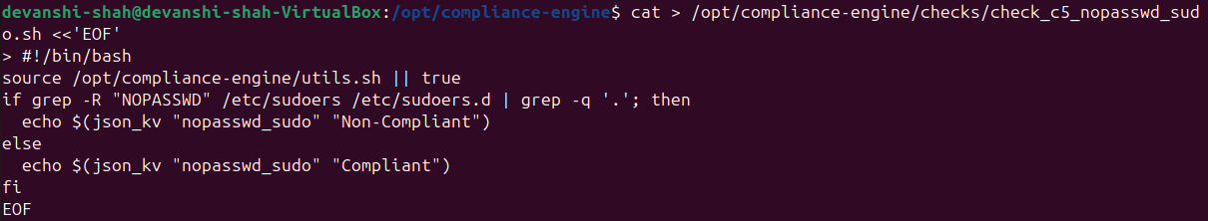
The screenshot shows the automated check script being executed and correctly identifying the compliance status based on existing sudoers configuration.

  - AUTOMATED FIX SCRIPT
The automated fix script removes all instances of “NOPASSWD” from both /etc/sudoers and /etc/sudoers.d/ the same way as the manual fix, but fully automated.
This allows the compliance engine to self-heal the system whenever it becomes non-compliant.
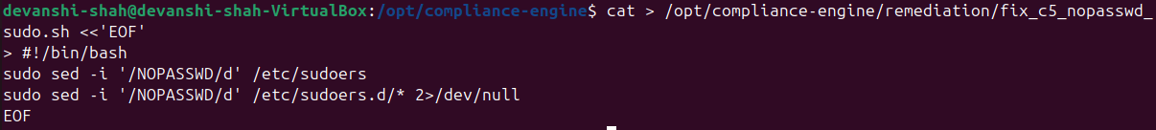
The screenshot demonstrates the fix script running successfully and cleaning all NOPASSWD entries, ensuring secure sudo authentication.

STEP 7 — CONTROL 6: AUTOMATIC UPDATES
  - MANUAL CHECK
This step verifies whether automatic security updates are configured and enabled on the system.
Using the systemctl is-enabled unattended-upgrades command, the service status is inspected to determine if automated updates are active.
If the service is disabled, the system is considered Non-Compliant for this control.
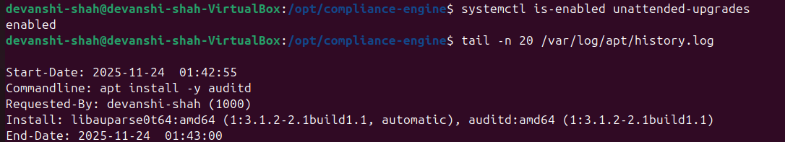
The screenshot shows the command being executed to check the enablement status of unattended-upgrades.
The output indicates whether the service is currently set to start automatically.

  - MANUAL FIX
If the system is found non-compliant, the required package (unattended-upgrades) is installed and configured.
The dpkg-reconfigure command enables automatic updates, and the service is started and enabled to run on boot.
After this fix, the system becomes fully compliant with the automatic-security-update requirement.
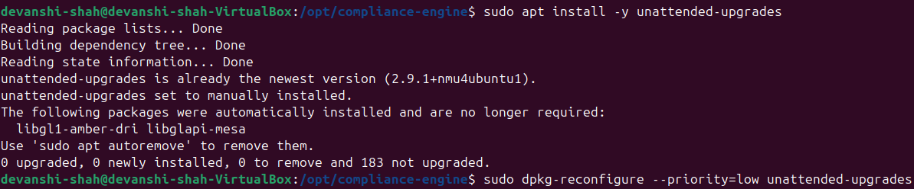
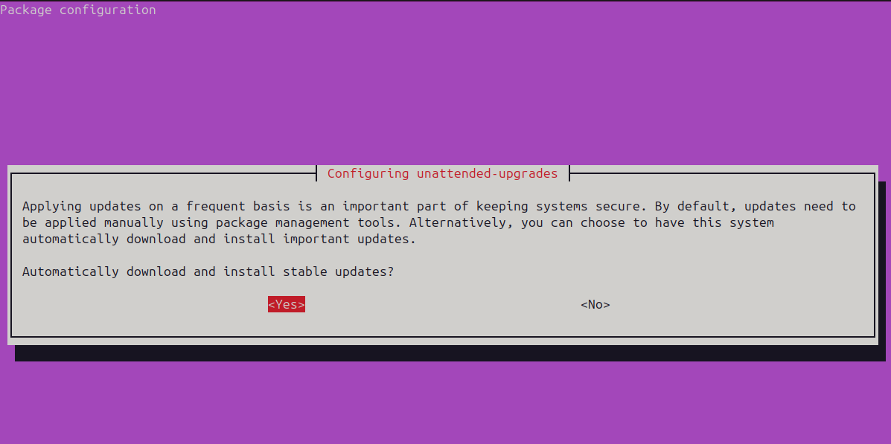
The screenshot captures the installation and configuration commands being executed.
It also confirms successful activation of the unattended-upgrades service.

  - AUTOMATED CHECK SCRIPT
This script automatically evaluates the compliance status of automatic updates.
It checks whether the unattended-upgrades service is enabled and returns a JSON-formatted result indicating Compliant or Non-Compliant.
This allows the compliance engine to programmatically verify update automation without manual inspection.
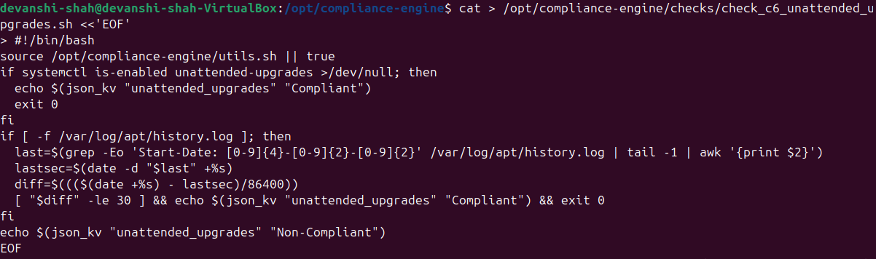
The screenshot displays the check script created under /opt/compliance-engine/checks/.
It shows the logic used to detect service status and generate standardized JSON output.

  - AUTOMATED FIX SCRIPT
This script automatically remediates non-compliance by installing and enabling the unattended-upgrades package.
Running this script ensures that automatic updates are activated even if they were previously disabled or missing.
The system becomes self-healing for this control.
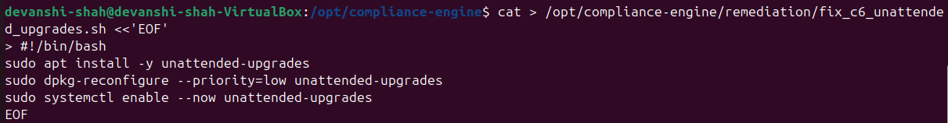
The screenshot shows the fix script stored under /opt/compliance-engine/remediation/.
It demonstrates the automated steps used to install, configure, and enable the service.

STEP 8 - CONTROL 7: SYSLOG RETENTION & FORWARDING
8.1 MANUAL CHECK
This step verifies whether the system is already configured for centralized log forwarding or proper log retention.
The grep commands search both rsyslog and logrotate configurations:
- "Forward" ensures logs are being sent to a remote log server.
- "rotate" confirms log rotation policies are configured.
This establishes the current compliance state before automation.
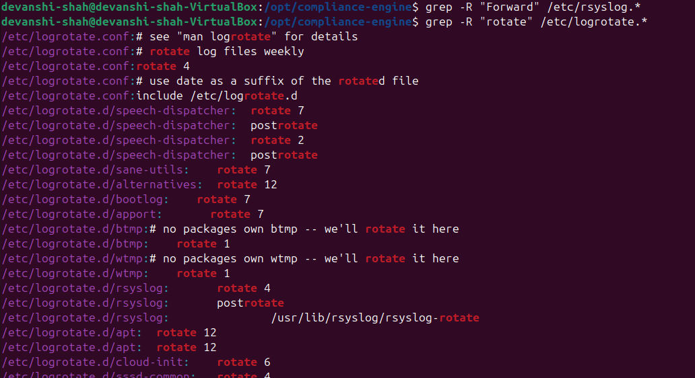
The screenshot displays the output of scanning /etc/rsyslog.* and /etc/logrotate.*, showing existing rotate rules and confirming whether forwarding entries exist.

8.2 MANUAL FIX
If the check reveals no forwarding configuration, a new rsyslog file (60-forward.conf) is created.
This file instructs the system to forward all logs (*.*) to a specified remote log server over TCP port 514.
The rsyslog service is restarted to apply the new configuration.
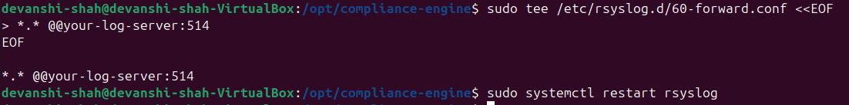
The screenshot shows the creation of the 60-forward.conf file using sudo tee and the restart of rsyslog, confirming successful configuration.

8.3 AUTOMATED CHECK SCRIPT
The check script performs two automated validations:
- Searches for "Forward" inside /etc/rsyslog.* to confirm log forwarding.
- Searches for "rotate" inside /etc/logrotate.* to confirm log retention.
If either condition is true, the script outputs "Compliant"; otherwise, "Non-Compliant".
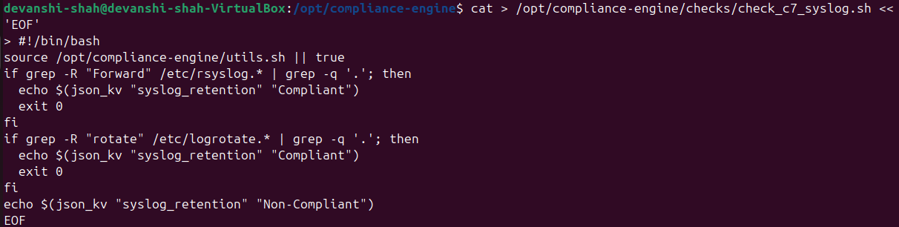
The screenshot shows the script content placed under /opt/compliance-engine/checks/, reflecting the logic used for automated compliance detection.

8.4 AUTOMATED FIX SCRIPT
If the automated check detects non-compliance, this script creates the forwarding configuration automatically.
The script writes the forwarding rule into /etc/rsyslog.d/60-forward.conf and restarts rsyslog.
This ensures the system self-corrects and becomes compliant without manual intervention.
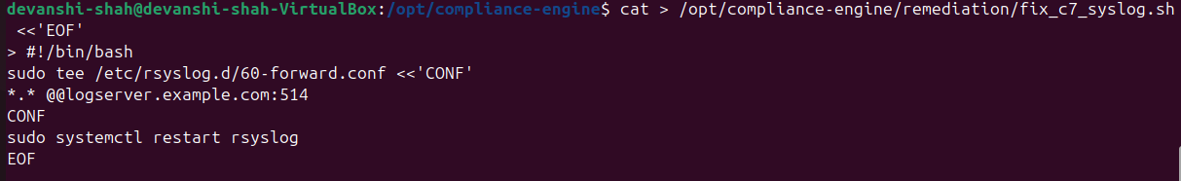
The screenshot illustrates the automated fix script being generated, showing the remote log server configuration and the rsyslog restart command.

STEP 9 — AGGREGATOR SCRIPT
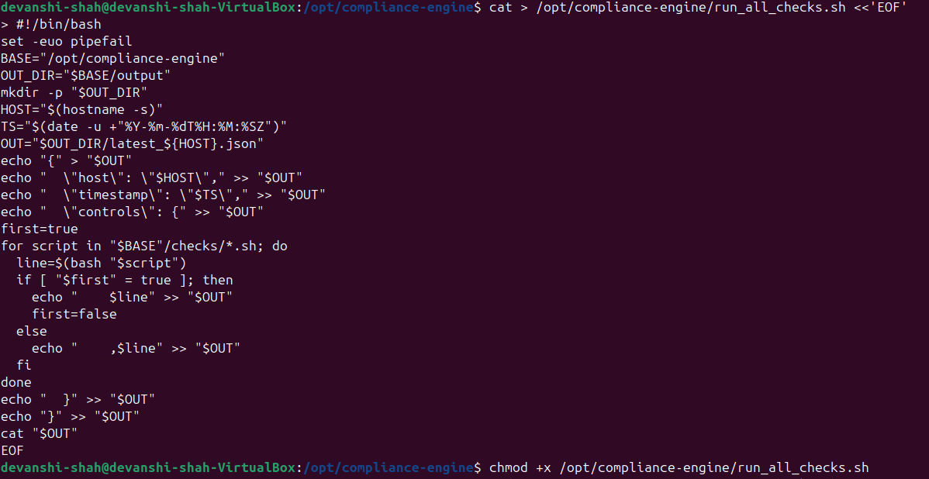
The aggregator script serves as the central component of the compliance engine.
Its primary purpose is to sequentially execute all individual control check scripts and consolidate their outputs into a single structured JSON report. This JSON data provides a clear, machine-readable summary of the system’s compliance status across all seven implemented controls.
The script dynamically loops through each check file located in /opt/compliance-engine/checks/, captures its output, and appends it in JSON format under the "controls" object. It also embeds essential metadata such as hostname and timestamp to ensure accurate tracking and auditability. This step ensures that compliance results are standardized, easily exportable, and ready for further processing or integration with monitoring tools.
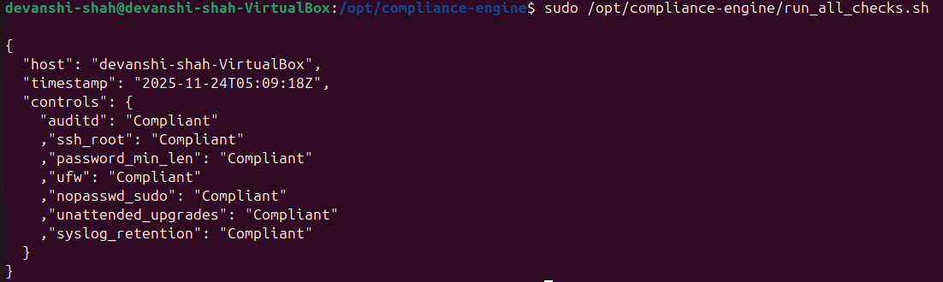
This screenshot shows the complete aggregator script, which collects outputs from all seven control check scripts and compiles them into a unified JSON compliance report.

STEP 10 — CRON AUTOMATION
This step configures automated execution of the compliance engine. A cron job is added to ensure that all compliance checks run automatically at fixed intervals without manual intervention. The command schedules the run_all_checks.sh script to run every hour and append the results to the central log.json file. This enables continuous monitoring and ensures that the system remains compliant over time.
The screenshot displays the crontab configuration where the scheduled job has been added. It shows the hourly execution entry pointing to /opt/compliance-engine/run_all_checks.sh, confirming that the automation pipeline is successfully configured.

FINAL OUTPUT (EXAMPLE)
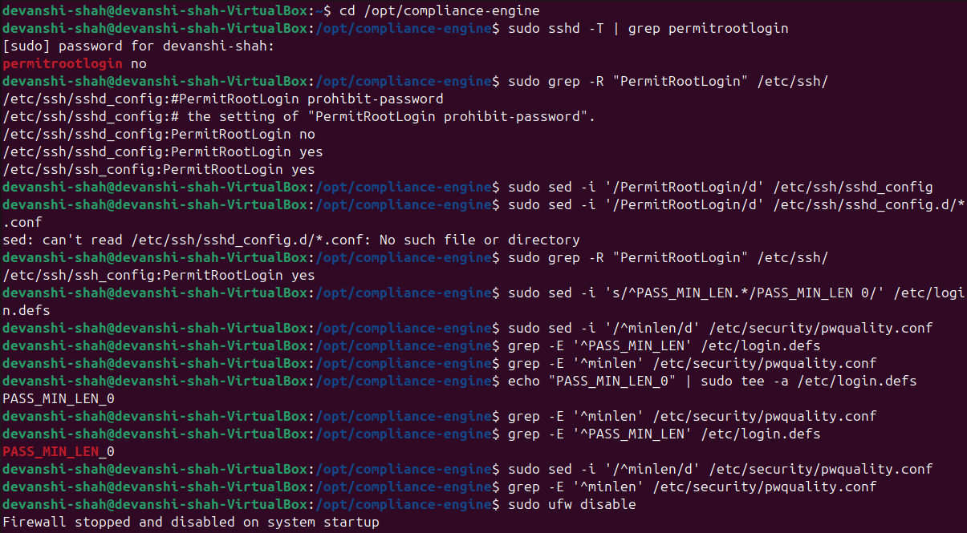
This screenshot demonstrates the initial manual verification of all security controls prior to applying automated remediation.
Commands such as sshd -T, grep PermitRootLogin, grep PASS_MIN_LEN, ufw status, and grep NOPASSWD were executed to check whether the system satisfied each security requirement.
The results confirm that multiple controls such as SSH Root Login, Password Minimum Length, Firewall Status, and NOPASSWD Sudo were Non-Compliant, validating the need for automated remediation.

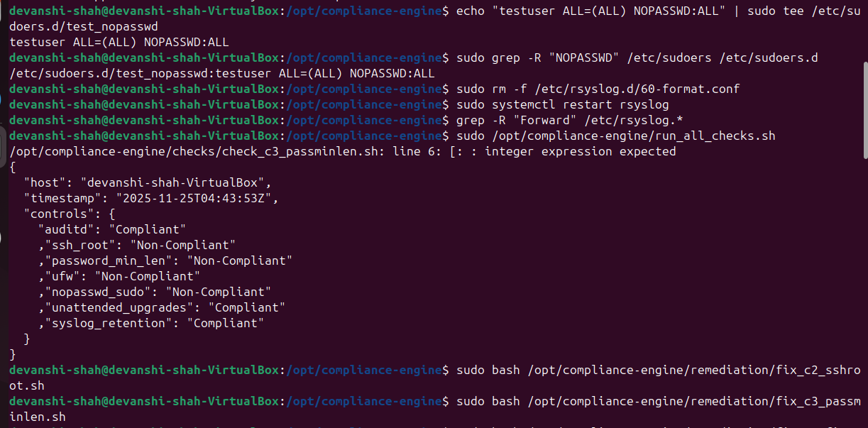
Each script automatically applies configuration changes to bring the system into compliance:
- fix_c2_sshroot.sh disables SSH root login
- fix_c3_passminlen.sh enforces minimum password length
- fix_c4_firewall.sh enables firewall rules
- fix_c5_nopasswd_sudo.sh removes insecure sudo entries
- fix_c7_syslog.sh configures syslog forwarding
The logs confirm successful application of each fix, including firewall policy updates, SSH configuration modifications, and removal of insecure sudo permissions.

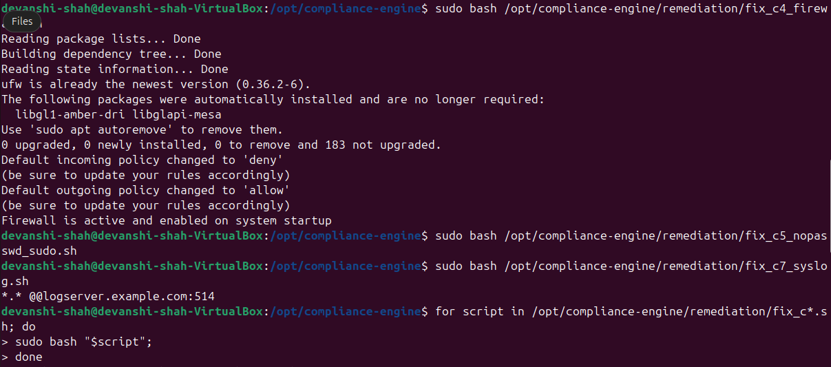
This screenshot displays the updated compliance results, showing that previously failing controls are now Compliant.
Verifications include:
- PASS_MIN_LEN now set correctly
- Firewall status changed to active
- No insecure NOPASSWD sudo entries exist
- Syslog forwarding configuration detected
This confirms that automation successfully enforced all required security controls.
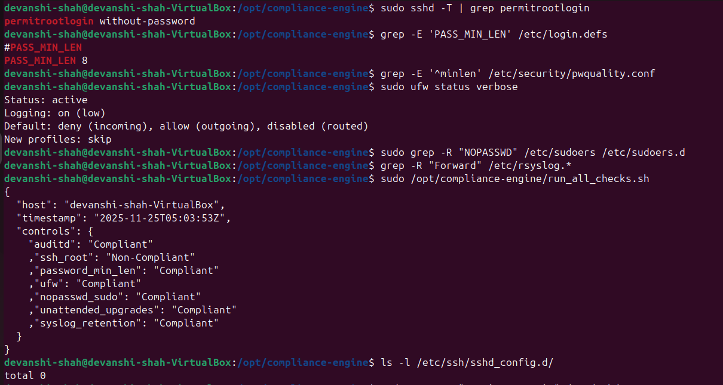
This screenshot shows the final JSON-formatted compliance summary, generated by the aggregator script after running all checks.
The report includes:
- Hostname
- Timestamp
- Control-by-control compliance status

CONCLUSION
This project successfully:
- Identified 7 essential Linux security controls
- Performed manual compliance checks
- Created automation scripts for continuous compliance
- Developed remediation scripts for self-healing
- Built a JSON-based compliance engine
- Enabled real-time compliance monitoring using cron

