Enterprise Network Security Architecture & Implementation
Author: Vachini shah
Tools: Cisco Packet Tracer, Cisco ASA, Obsidian
- This document presents the design, implementation, and validation of a secure
- Enterprise network architecture with practical security controls and a light
- governance perspective.

  - Project Overview
Enterprise Network Security Implementation
    - This project showcases the end-to-end design and implementation of a secure enterprise network using Cisco Packet Tracer.
    - The primary goal was to build and validate a realistic corporate network supporting internal users, guest users, wireless connectivity, public-facing services, and centralized security controls.
    - Security was treated as a core design requirement, not an afterthought.

Design Rationale

    - The network was designed to resemble a real enterprise environment rather than a flat lab network.
    - Key decisions included separating trust zones, centralizing security controls, and enforcing policy
    - at the network perimeter instead of relying on endpoint security alone.

2.1 Topology Overview
Topology & Architecture Overview
The network follows a layered enterprise architecture with clearly defined trust zones.

Major Components

- Core Layer (Layer-3 Switch)
- Distribution & Access Switches
- Edge Router
- Stateful Firewall (ASA)
- ISP Router & Internet Simulation
- Internal and DMZ Servers
- Wireless Infrastructure
Trust Zones

- Internal Network (HR, Engineering)
- Guest Network
- Management Network
- Authentication Network
- DMZ
- Internet (Untrusted)
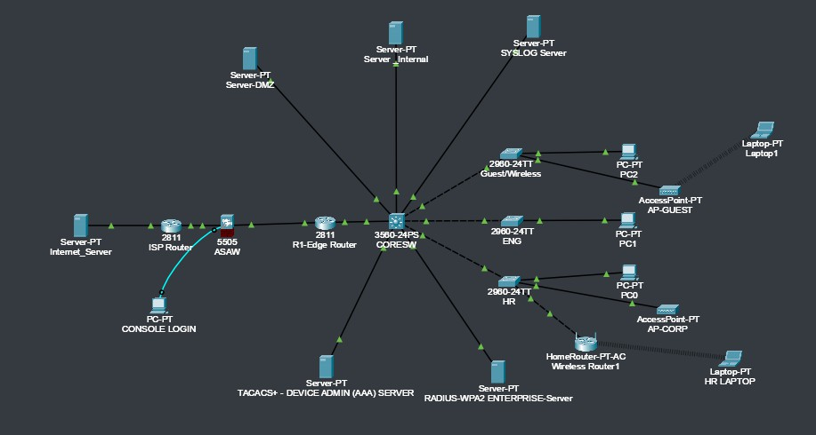

  - VLANs and Routing
VLAN Design & Inter-VLAN Routing
The internal network is segmented using VLANs to separate users, servers, and infrastructure components.
Each VLAN represents a distinct trust boundary and operational function.

VLAN Breakdown

- VLAN 10 – HR Department
- VLAN 20 – Engineering Department
- VLAN 30 – Guest Users
- VLAN 40 – Voice Network
- VLAN 100 – Internal Servers
- VLAN 110 – Authentication Services
- VLAN 254 – Network Management

Inter-VLAN Routing
Inter-VLAN routing is implemented on the Core Switch using Layer-3 SVI interfaces.
Each VLAN has a dedicated default gateway configured on the switch.

This design allows:

- Centralized routing control
- Efficient internal traffic flow
- Simplified policy enforcement using ACLs

DHCP relay ( ip helper-address ) is configured on each user VLAN to forward DHCP requests to the internal DHCP server.
Security Consideration

- Segmenting the network using VLANs reduces the risk of lateral movement in case a single host is compromised.
- Guest users are explicitly isolated from internal resources to prevent unauthorized access.
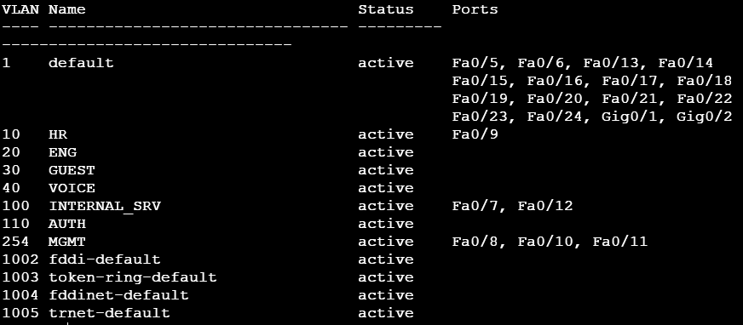

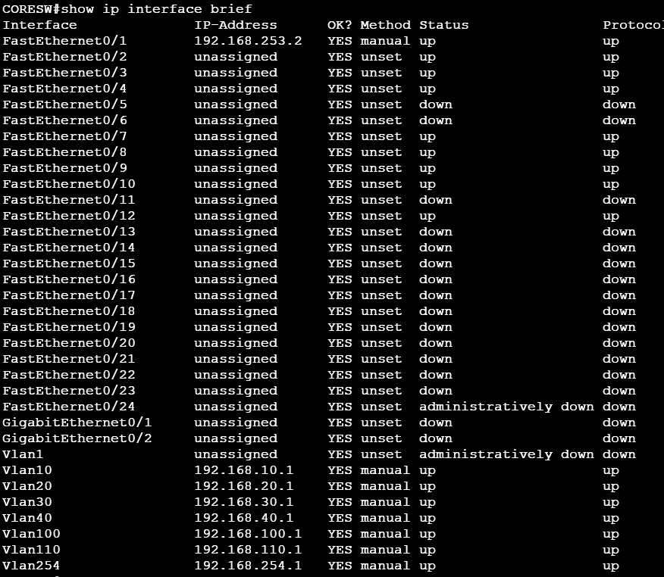
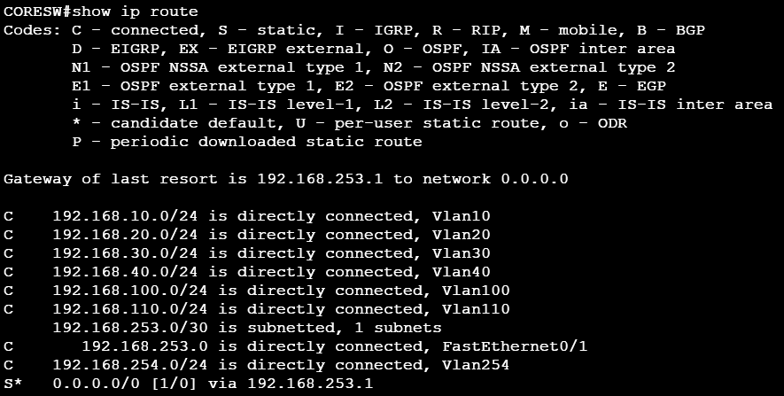
  - Wireless Implementation
# Wireless Network Implementation

The wireless infrastructure supports both trusted internal users and untrusted guest users.

Corporate Wireless Network

- Uses WPA2-Enterprise authentication
- User credentials are validated via a centralized RADIUS server
- Provides individual accountability and centralized access control

Guest Wireless Network

- Uses WPA2-PSK for ease of access
- Mapped to a dedicated Guest VLAN
- Internet-only access is enforced using ACLs

Design Rationale

- Wireless networks are treated as untrusted entry points.
- By separating corporate and guest wireless access, the design prevents guest users from accessing sensitive internal systems.
WPA-2 Enterprise Wifi Setup
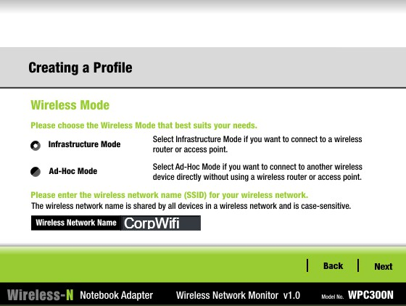

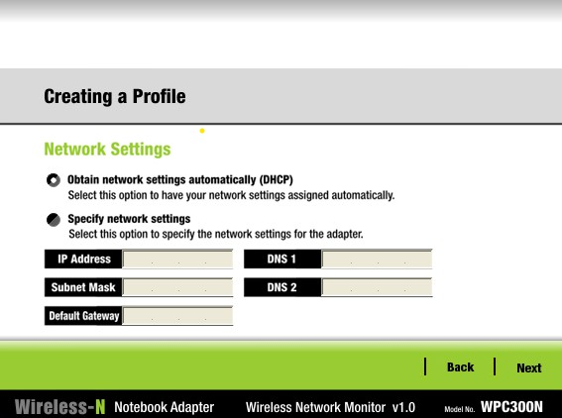
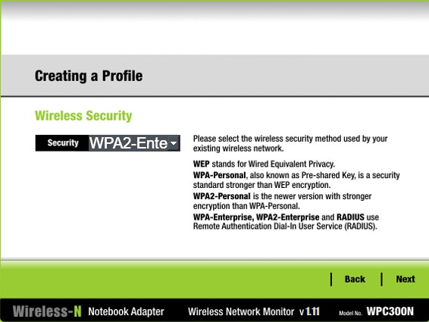

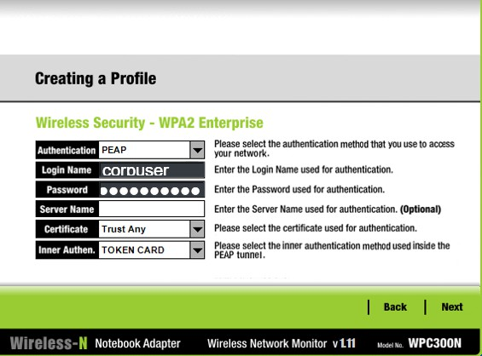

Access Point Setup of WPA2-Enterprise Setup
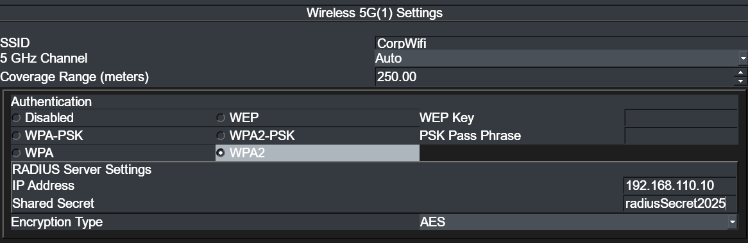

Radius Server Config for WPA2 - Enterprise

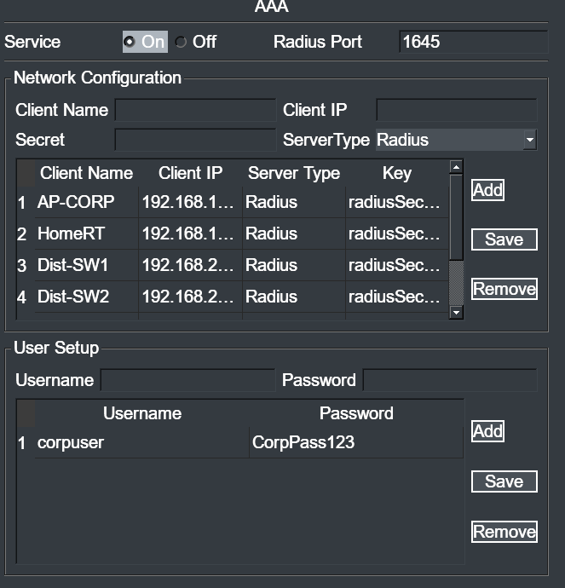

WPA2-PSK Wifi Setup

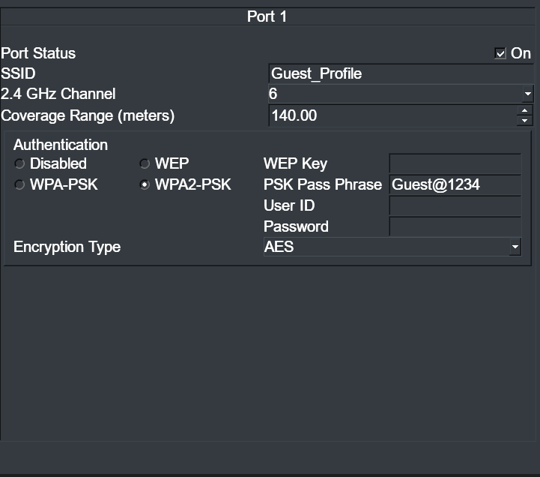
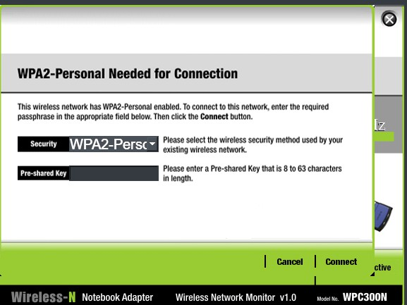

  - Firewall and DMZ
Firewall & DMZ Design
The Cisco ASA firewall is deployed as the primary security control at the network perimeter.

The firewall operates using a stateful inspection model, meaning that return traffic is automatically permitted
only for connections initiated from trusted zones.

Firewall Policy

- Inside → Outside traffic is allowed by default and tracked statefully
- Outside → Inside traffic is denied by default
- Only explicitly permitted services are allowed from the Internet

Permitted Inbound Services

- HTTP (Port 80)
- HTTPS (Port 443)
- FTP (Port 21 )
- SMTP (Port 25)

All other inbound traffic, including ICMP, is blocked.

DMZ Architecture
Public-facing services are hosted in a dedicated DMZ network.
A static NAT mapping is configured to expose the DMZ web server using a public IP address.

This ensures:

- Internal IP addressing is hidden
- Public services remain reachable
- Internal networks are protected even if the DMZ server is compromised

Threat Perspective
If the DMZ server is compromised, the attacker remains restricted to the DMZ network.
Direct access to internal VLANs is prevented by the firewall and routing policies.

IP Interface Brief

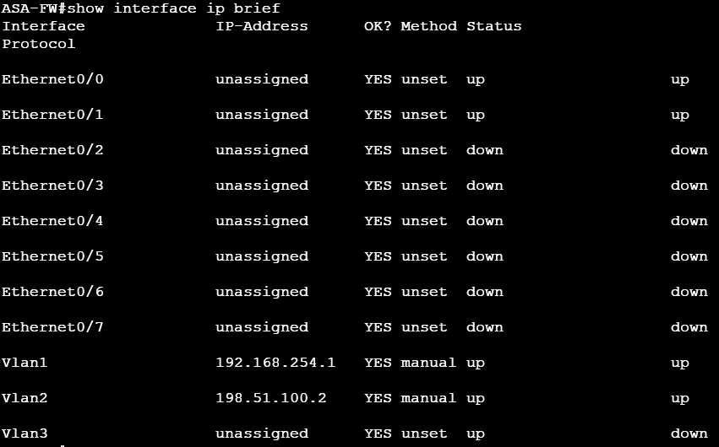

ASA NAT
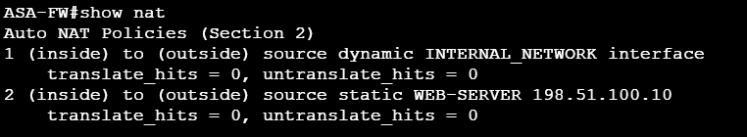

ASA Access-Control List
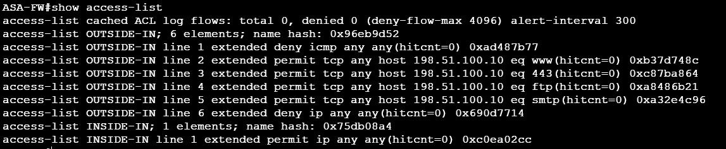

DMZ IP Config

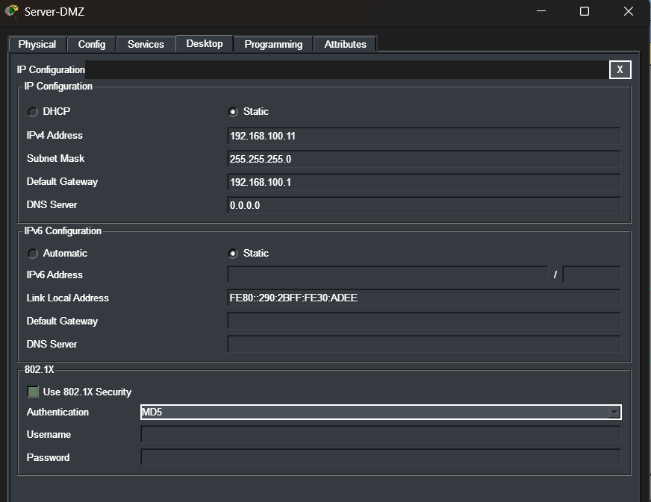
  - AAA and Logging
AAA Architecture Overview
Authentication, Authorization, and Accounting (AAA) services are implemented to centralize identity management and enforce controlled access to both network devices and wireless infrastructure.
Rather than relying on local device credentials, centralized AAA improves accountability, consistency, and auditability.

TACACS+ for Network Device Administration
TACACS+ is used to authenticate administrative access to critical network devices such as routers, switches, and the firewall.
Implementation Details

- Network devices are configured to forward login requests to a centralized TACACS+ server.
- Local user accounts are retained only as a fallback mechanism.
- Administrative access is restricted to secure management protocols (SSH).

Security Benefits

- Centralized credential management
- Role-based privilege enforcement
- Individual administrator accountability
- Reduced risk from shared or unmanaged credentials
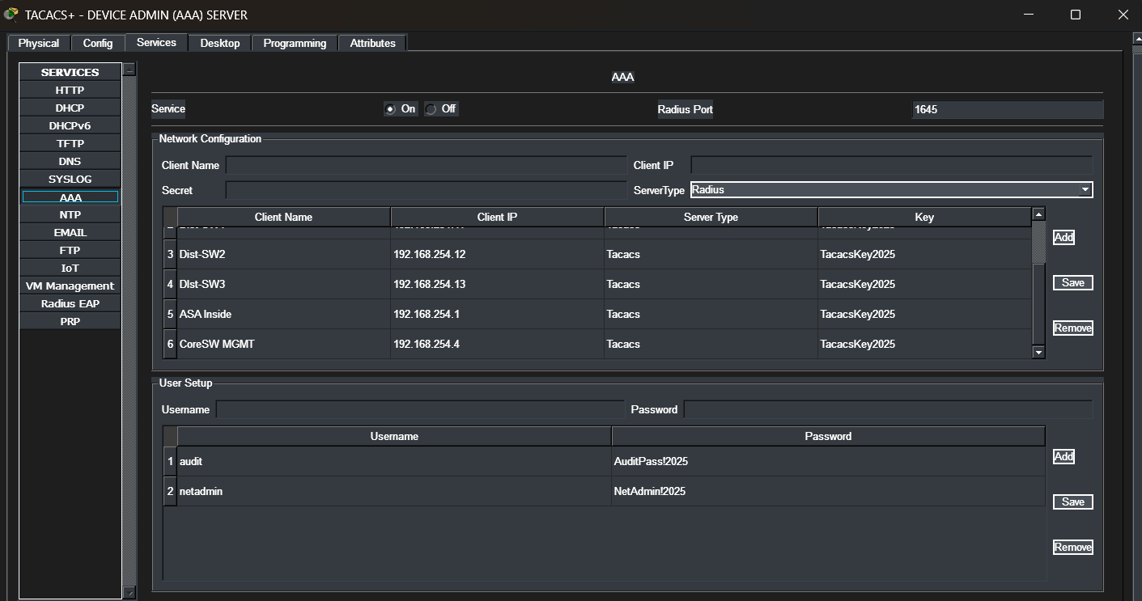
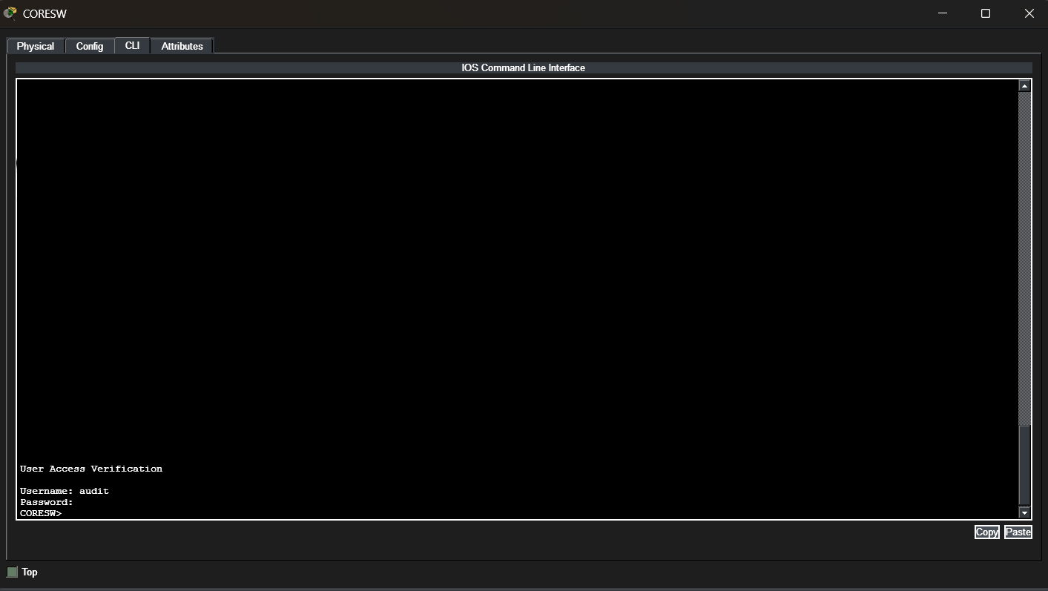

RADIUS for Wireless Authentication
RADIUS is used to authenticate users connecting to the corporate wireless network using WPA2-Enterprise.

Implementation Details

- Wireless clients submit credentials to the access point.
- The access point forwards authentication requests to the RADIUS server.
- Access is granted only upon successful validation.

Security Benefits

- Eliminates shared wireless passwords
- Enables per-user authentication
- Allows future integration with directory services
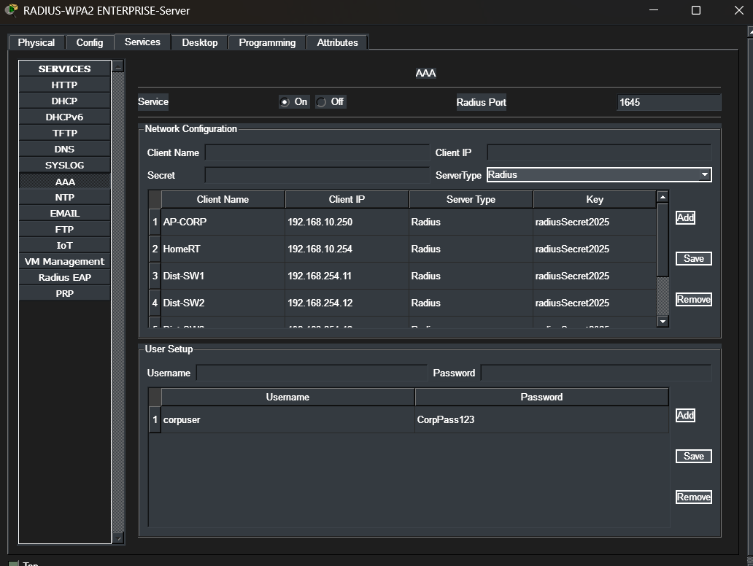
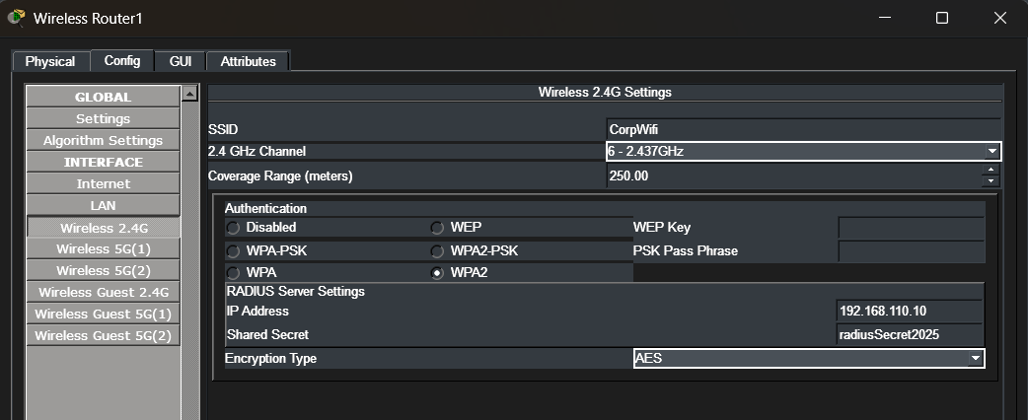

Centralized Logging (Syslog)
A centralized syslog server is implemented to collect logs from all critical network components.
Devices Sending Logs

- Core Switch
- Router
- Firewall (ASA)

Logged Events

- Authentication attempts
- Interface state changes
- Firewall policy enforcement
- Routing and connectivity events

Centralized logging ensures that security-relevant events are preserved even if a device is compromised.
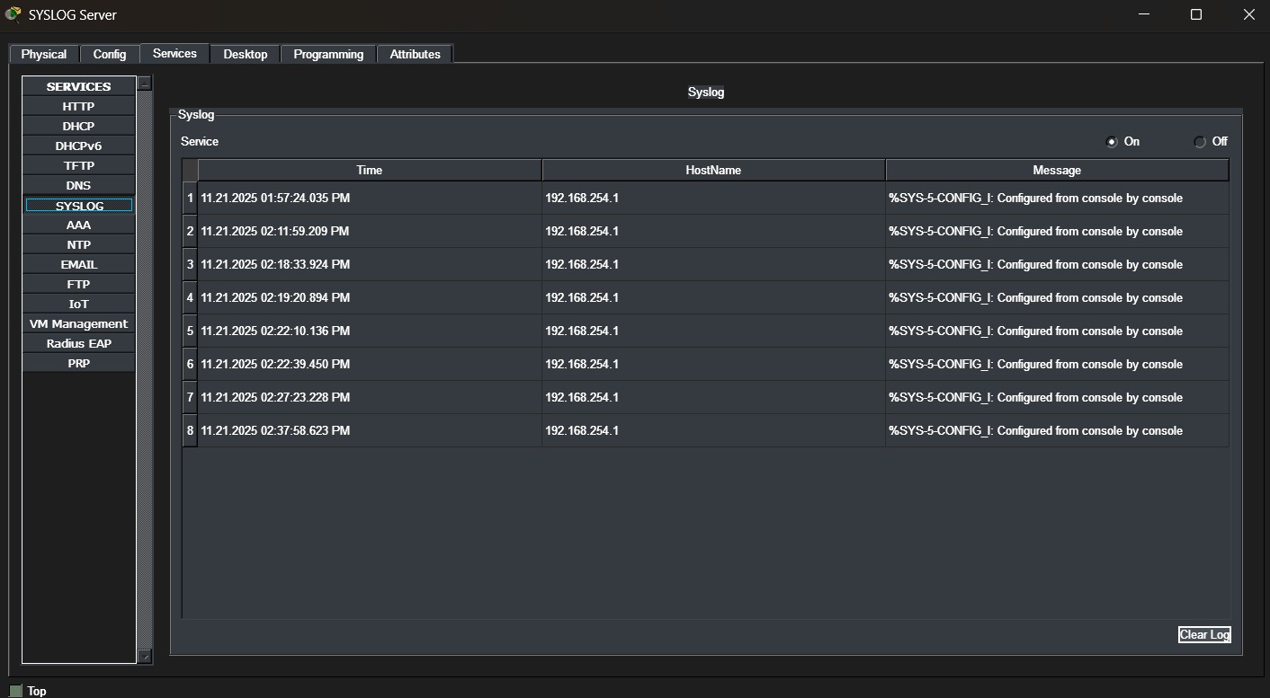

Time Synchronization (NTP)
Network Time Protocol (NTP) is configured across all devices to ensure consistent timestamps in logs.
Why This Matters

Accurate timestamps are critical for:

- Incident investigation
- Event correlation
- Compliance and audit reporting

Without time synchronization, log analysis becomes unreliable.

  - Internet to Internal User Traffic Flow (Blocked by Design)
This traffic flow describes an attempt by an external Internet host to directly communicate with an internal user. Such traffic is intentionally blocked to protect internal systems.
    - An Internet host generates a packet destined for an internal private IP address.
    - The packet reaches the ISP router, which forwards it toward the organization.
    - The packet arrives at the ASA firewall on the outside interface.
    - The ASA evaluates the packet against its security policy.
    - Since the traffic is:
      - Initiated from an untrusted zone (Internet), and
      - Destined for an internal private address, and
      - Not associated with an existing stateful connection, the packet does not match any permitted rule.
    - The ASA firewall drops the packet by default.
    - No packet is forwarded to the gateway router or internal network.
    - The internal user never receives the traffic.

Internet to Internal Network Packet Fail

  - Internet User to DMZ Server
Internet User to DMZ Server Traffic Flow

    - An Internet user initiates an HTTP request to the public IP address.
    - The ISP router forwards the packet to the ASA firewall.
    - The ASA matches the static NAT rule and translates the destination address.
    - The firewall ACL permits the specific service (HTTP/HTTPS).

    - The request reaches the DMZ web server.
    - Responses follow the same path back to the Internet.

HTTPS Packet Config for Internet Server to DMZ Server Functionality
NAT Working Functionality
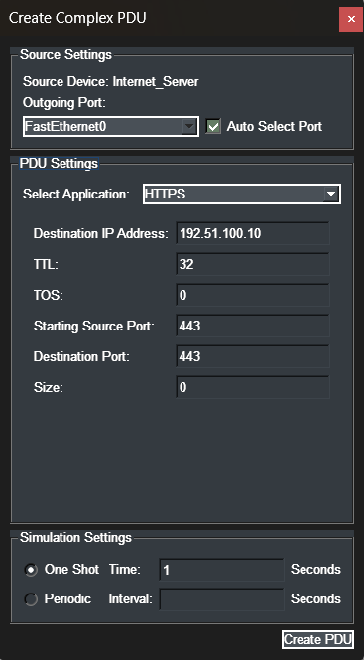

Internet -> DMZ HTTPS Success
Action: HTTPS to public IP (192.51.100.10)

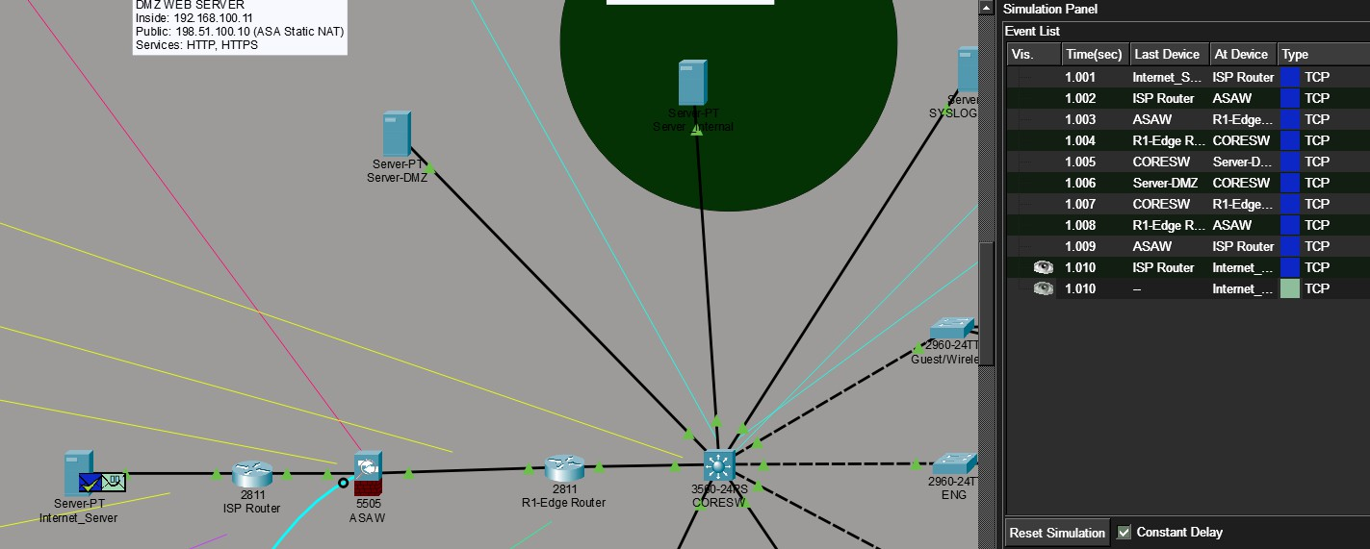
  - Guest Network Restriction
Guest Network Traffic Restriction

    - Guest users connect to the Guest Wi-Fi network.
    - Traffic is placed into the Guest VLAN.
    - ACLs prevent access to internal server VLANs.
    - Only Internet-bound traffic is permitted.

  - Failure Scenarios
Failure Scenarios & Enforcement

- Inbound traffic that does not match an existing state entry is dropped.
- Guest VLAN traffic attempting to reach internal servers is blocked by ACLs.
- Unauthorized inbound services are denied at the firewall.

6.1 Testing and Validation
Testing & Validation
All implemented security controls were validated through functional and security testing to ensure the network behaves as designed.
Testing focused on both allowed and denied traffic scenarios.

Connectivity Validation

Internal Network Testing

- Verified inter-VLAN communication between internal departments.
- Confirmed default gateway and routing behavior.
- Validated DHCP address assignment for all VLANs.

Internet Connectivity

- Confirmed outbound Internet access for internal users.
- Verified NAT translations on the firewall.
- Ensured return traffic was permitted via stateful inspection.

Firewall Policy Validation
Firewall rules were tested using multiple traffic scenarios:

Allowed Traffic

- HTTP/HTTPS access from internal users to Internet servers
- Public access to DMZ web services

Blocked Traffic

- ICMP requests from the Internet to internal networks
- Unauthorized inbound services
- Guest VLAN attempts to access internal servers

Packet tracer simulations were used to verify policy enforcement and identify decision points where traffic was permitted or denied.

Wireless Security Validation

- Verified successful authentication for corporate users using WPA2-Enterprise.
- Confirmed guest users were assigned to the correct VLAN.
- Tested isolation between guest and internal networks.

Failure and Negative Testing
Negative testing was performed to confirm security enforcement:

- Attempted access to restricted VLANs
- Unauthorized inbound connection attempts
- Invalid authentication attempts

All unauthorized traffic was correctly blocked.

7.1 GRC Context
Governance, Risk & Compliance Context
This project primarily focuses on the technical implementation of enterprise network security controls, while intentionally aligning those controls with common governance, risk, and compliance considerations observed in real-world organizations.
Rather than implementing security features in isolation, the design reflects a risk-driven approach, where controls are selected and enforced based on realistic threat scenarios and business impact.

Key Risks Addressed
- Unauthorized External Access
Risk:
Internet-based attackers attempting to access internal corporate resources directly.

Impact:
Potential data breaches, service disruption, and regulatory exposure.

Mitigation Implemented:

- Stateful firewall enforcing default-deny inbound policy
- Explicit access control rules permitting only required services
- Network Address Translation (NAT) masking internal IP addressing

- Lateral Movement Within the Network
Risk:
An attacker gaining access to one segment of the network and moving laterally to sensitive systems.
Impact:
Compromise of internal servers, credential exposure, and privilege escalation.

Mitigation Implemented:

- VLAN-based network segmentation
- Layer-3 access control policies restricting inter-VLAN communication
- Isolation of critical services into dedicated network segments

- Guest Network Misuse
Risk:
Untrusted guest users accessing internal corporate systems or services.

Impact:
Data leakage, malware propagation, and violation of acceptable use policies.

Mitigation Implemented:

- Logical separation of guest traffic into a dedicated VLAN
- Access control rules explicitly blocking guest access to internal server resources
- Controlled internet access while maintaining internal isolation

- Exposure of Public-Facing Services
Risk:
Public services exposed without proper isolation or access restrictions.

Impact:
Service exploitation, defacement, or backend system compromise.

Mitigation Implemented:

- Deployment of a DMZ (Demilitarized Zone)
- Controlled access to public services through firewall policies
- Separation of externally accessible services from internal networks

- Lack of Monitoring and Accountability
Risk:
Security incidents going undetected due to lack of centralized visibility and audit trails.

Impact:
Delayed incident response, non-compliance with security monitoring requirements.

Mitigation Implemented:

- Centralized syslog server collecting logs from network devices
- AAA-based authentication ensuring traceable administrative access
- Time synchronization using NTP for accurate event correlation

Security Controls Implemented

Control Category | Implementation
Firewall Controls | Stateful inspection, NAT, and service-specific access rules
Network Segmentation | VLAN-based separation of users, guests, servers, and management
DMZ Isolation | Dedicated network zone for externally accessible services
Identity & Access  Management | TACACS+/RADIUS-based AAA authentication
Logging & Monitoring | Centralized syslog with timestamped security events

Governance Alignment
The project reflects good governance practices by ensuring:

- Security policies are consistently enforced across the network
- Administrative access is authenticated, authorized, and auditable
- Network design decisions are documented and justified
- Security controls align with least privilege principles

Compliance-Oriented Considerations
While not mapped to a specific regulatory framework, the implemented controls align with common requirements found in:
- ISO/IEC 27001 (Access control, logging, network security)
- NIST Cybersecurity Framework (Protect, Detect)
- CIS Critical Security Controls (Network segmentation, controlled access)

This demonstrates an understanding of how technical security implementations support broader compliance objectives, even within a simulated environment.

8.1 Conclusion
Conclusion
This project demonstrates the successful design and implementation of a secure, enterprise-style network architecture with layered security controls.
The implementation integrates routing, switching, wireless security, firewall enforcement, DMZ isolation, centralized authentication, and logging into a cohesive and realistic security design.

Beyond technical implementation, the project reinforced the importance of:

- Designing networks with clearly defined trust boundaries
- Enforcing security at the perimeter and internal layers
- Validating controls through testing, not assumptions
- Supporting security decisions with visibility and audit capability

This project significantly strengthened my understanding of real-world network security architecture and further developed my interest in cybersecurity and risk-based security design.
Future enhancements could include intrusion detection, dynamic routing, certificate-based authentication, and deeper integration with identity management platforms.

