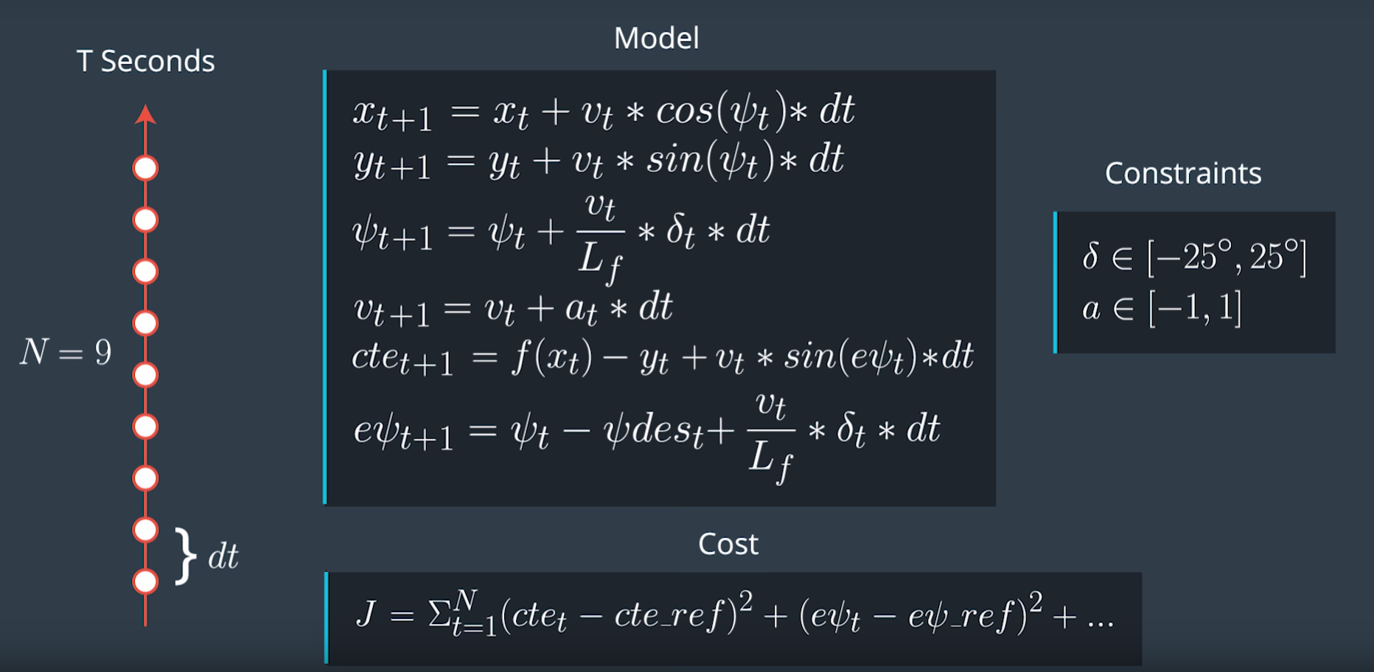

*Figure 1 Dynamic Model, Constraints and Cost Function*

The model includes four states, velocity ($v$), position ($x, y$), and the car rotation angle ($ψ$). With those four states given, the position of the vehicle can be transformed from the vehicle local frame into the global reference frame as shown in figure 2.

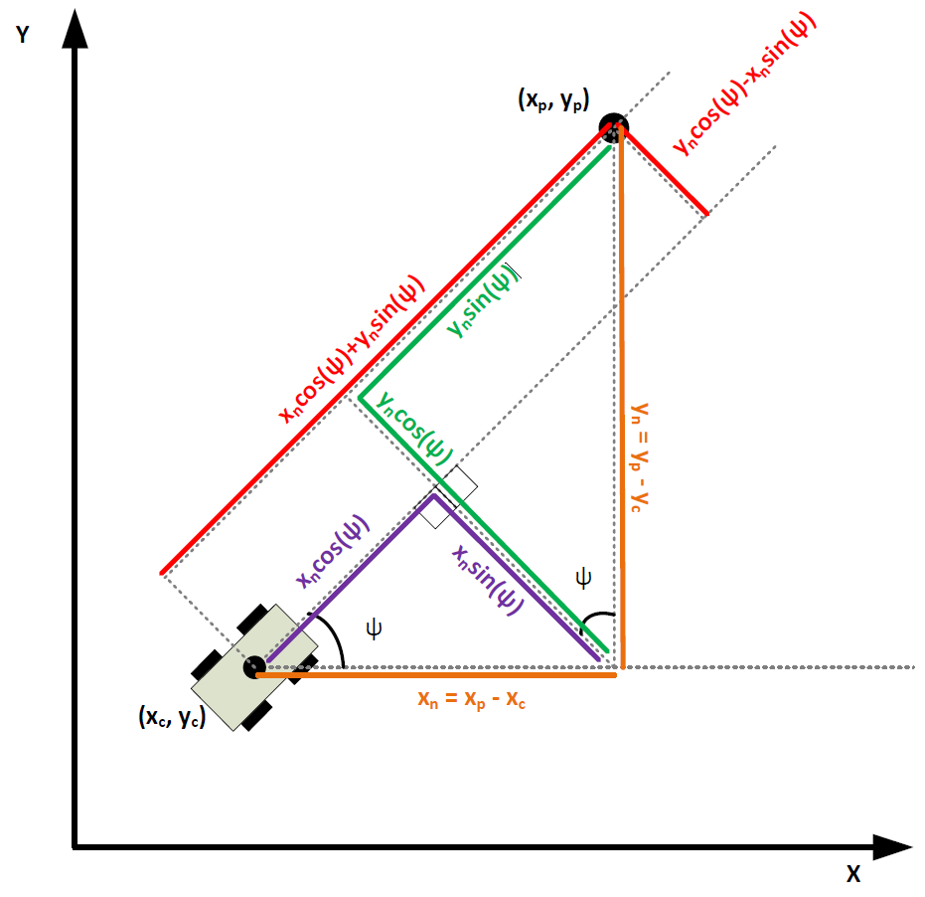

*Figure 2 Frame Transformation [1]*

With all the states in global frame, the motion of the model can be described with the dynamic model equations shown in figure 1. To generate the best actuators with the given constraints as given in figure 1. A cost function is constructed. The cost function includes cte and epsi which measures the how close the car is moving on the track and also the use of actuators and the gap between sequential actuations. The best parameters are generated when the cost function is minimized. To solve this minimization problem, the model is discretized with N prediction points and between each point the time difference is dt. As the minimization is performed in real time, calculation time is crucial, N cannot be too large, but at the same time, it needed to be large enough to calculate the path difference between the prediction and actual path and influence the cost function: The prediction path is generated with the dynamic model functions in figure 1, which the actual path is described by a third order polynomial. The number of N is manual adjusted to be 20 according to the vehicle performance in the simulator. Neglecting the calculation time, the smaller the time difference is, the closer the prediction is to be continuous. With the similar reason to limit the prediction point, the time difference is chosen to be 0.15s.

However, calculation time always exits and will cost latency. To address this issue, the actuator value for time t-1 is used for t.

[1] Udacity Student: jreyn121, <https://discussions.udacity.com/t/mpc-car-space-conversion-and-output-of-solve-intuition/249469/12>