GIT HUB

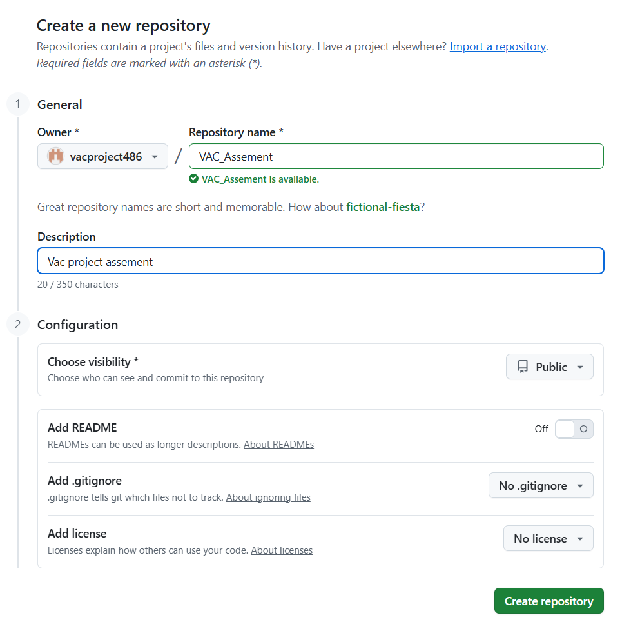

JENKINS:

Login and file items creation:

