# Bill Splitter App – Requirements Draft (v1)

## Vision

An Android app for organizers to quickly and transparently split group bills. The organizer alone uses the app—participants do not need to install anything. The app supports both receipt OCR and manual entry, and produces per-person totals with Thai PromptPay QR codes for easy payment.

## Core Features

### Event Creation

- Default name: auto-generated as DD Mon <time bucket> (e.g., '16 Aug evening').  
- Time buckets: Morning (05:00–11:59), Noon (12:00–13:59), Afternoon (14:00–17:59), Evening (18:00–21:59), Night (22:00–04:59).  
- Organizer can rename later; no upfront input required.

### Participants

- Free-text names, stored locally.  
- Auto-suggest: Recent groups (2–8 ppl), Frequent individuals, Co-occurrence suggestions.  
- Typing assistance: prefix + fuzzy match (Thai/English).  
- Auto-deduplication of names.

### Bill Input

Two modes:  
1. OCR capture – scan receipt, extract line items and amounts. Items editable.  
2. Manual entry – add items by typing amounts (labels optional). Simple list UI; no categories, no special tax/tip handling.

### Item Tagging

- Each item tagged to one, many, or 'All' participants.  
- Shared items divided equally across tagged participants.

### Calculation & Rounding

- Each participant’s share = sum of their item splits.  
- Rounding: 2 decimals, round-half-up.  
- Drift ≤0.02 THB adjusted to participant with largest total.

### Output

1. Overall summary sheet (PNG): table of item labels (if present), amount, assigned participants, totals row per participant.  
2. Per-person card (PNG): Event name + date, participant name + total (THB), PromptPay QR with embedded amount + reference, minimal design.

## Payments

- Organizer sets PromptPay ID (phone or citizen ID).  
- App generates dynamic QR codes for each participant.  
- On-screen multi-page view, one participant per page.  
- Each page can be shared as PNG (LINE/WhatsApp).  
- No paid/unpaid tracking in v1.

## Data & Storage

- All data stored on device; no cloud/account.  
- Receipt images not stored, only generated when exporting.  
- Fully offline; online only for optional cloud OCR.

## Localization & UX

- Languages: Thai and English.  
- Currency: THB only.  
- Focus on large, legible numbers.  
- No extra accessibility requirements for v1.

## Analytics (local only)

- OCR accuracy (proxy: % items edited).  
- Avg group size and bill size.  
- Time from bill capture/manual entry to QR gen.  
- 'Give-up' rate (events started but no output).

## Non-Goals (MVP)

- Participant apps/logins.  
- Paid/unpaid tracking.  
- Netting of payments.  
- Cloud backup/sync.  
- Special tax/tip logic.  
- CSV exports or per-person detailed statements.

## Risks & Mitigations

- OCR quality → manual mode is fallback.  
- PromptPay compatibility → test with major Thai banks early.  
- Offline constraint → ensure QR/exports run locally.

## Acceptance Criteria

- Organizer can add participants quickly via suggestions.  
- Event auto-named with date/time bucket.  
- Bill entered (OCR/manual) → items tagged → correct per-person totals.  
- Summary sheet shows clear split with optional labels.  
- Per-person card generates valid PromptPay QR.  
- Entire flow usable offline.

## UI Flow Idea

1. App opens directly to a calculator-style input pad for fast item entry.  
2. Organizer adds participants from suggested names shown at the top.  
3. Each expense item is entered and tagged with relevant participants. Items can be labeled by tapping the left side, or removed by swiping with an undo option.  
4. Once all items are entered, the app generates participant totals and PromptPay QR codes.  
5. Organizer swipes through QR codes per participant. The last page of this sequence automatically displays the full summary sheet.  
6. The summary sheet includes items, amounts, and participant allocations, with a share button.  
7. Events are added to history once the first item is entered. History can be accessed through a button without disrupting the main flow.

# Mockup of the UI

## Page1

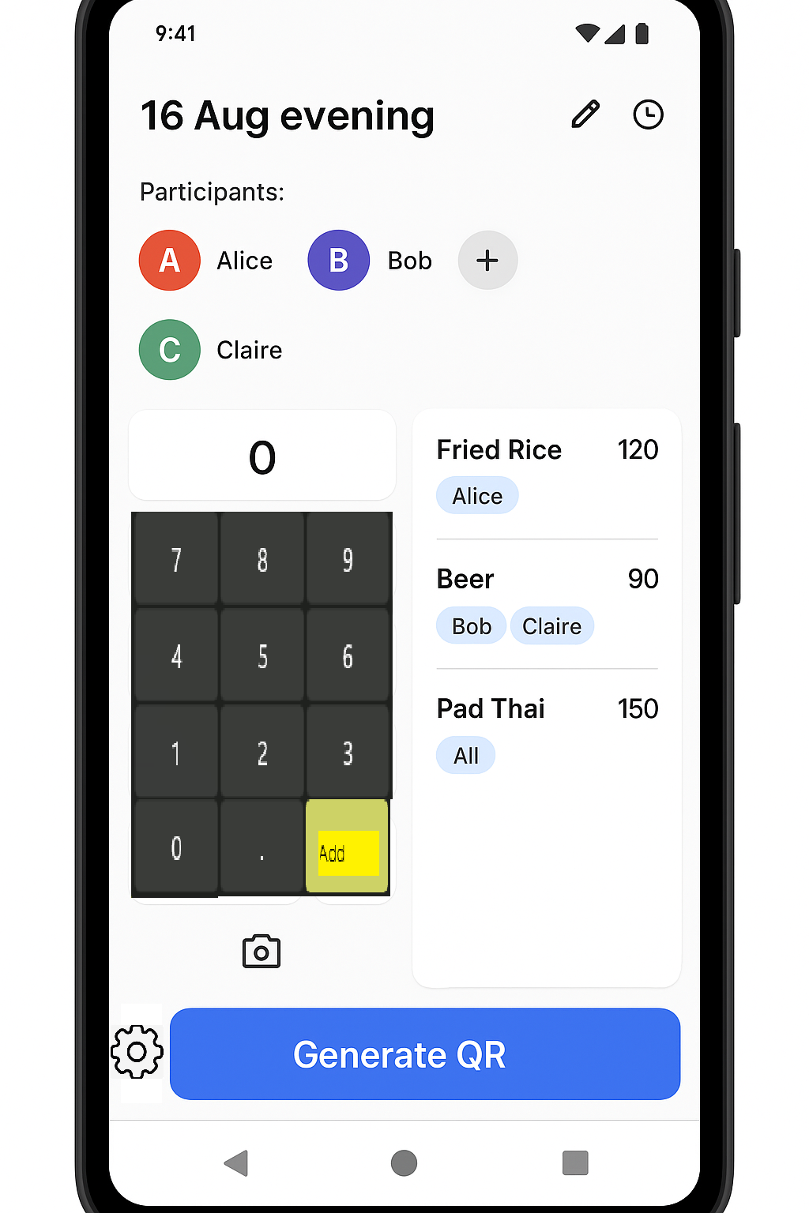

## Page2

---------------------------------------------------

Event: 16 Aug evening

[ Alice ]

Amount: ฿210.00

[ PromptPay QR here ]

[ Share QR ]

< Prev Next >

## Last Page

---------------------------------------------------

Event: 16 Aug evening

Summary Sheet

[Share Sheet]

< Prev

---------------------------------------------------

# Technical details

* Android studio already set up
* Project is created with Kotlin as language, shared on github already after project creation.
* Main package name is me.seta.vacset.kanjido
* Application name is Kanjido
* Put dependency on zxing and mlkit already