Boehringer Mannheim
Miditron® Junior Urine Analyzer
Host Interface Document
***Version 1.0a***

Boehringer Mannheim GmbH
Patient Care
Sandofer Straße 116
68305 Mannheim

Introduction

Document Purpose | This document provides the specifications for data transmission of results from a Boehringer Mannheim Miditron® Junior Urine Analyzer to an external laboratory host computer via an asynchronous serial connection. Questions concerning this document should be referred to the local Boehringer Mannheim Technical Support Group .

Document Conventions | All example data streams will be represented as follows:
 |  | STX | ; | A | ◊ | 1234567001 | ETX | 99 | CR

Space characters (ASCII 32) are represented by the ◊ symbol. All ASCII values are represented in decimal base. STX, ETX, and CR are the only control characters used, and will be represented by standard acronyms, as shown above. Each field is contained within a box.

Document Contents | This document is divided into sections. For further information about each section, please see:

Topic | See Page
Analyzer Overview | 2
Protocol | 3
Timing and Handshaking | 4
Results | 7
Enabling the Host | 10
Checksum Calculation | 12
Troubleshooting | 15
Appendix A - ASCII Chart | 16
Appendix B - Parameter Range Table | 17

Analyzer Overview

Analyzer Description | The Boehringer Mannheim Miditron® Junior Urine Analyzer is a semi-automated reflectance photometer intended for in-vitro semi-quantitative reading of urine test strips. The urine test strips are multiparameter strips used for the determination of specific gravity, pH, leukocytes, nitrite, glucose, ketone, urobilinogen, bilirubin, and blood in urine. The analyzer can store results for up to 150 strips in memory.

Analyzer Operation | Detailed operating instructions are beyond the scope of this document. The following specifications and operational overview are limited to information required for developing a host interface. For more information on the operation and maintenance of the Boehringer Mannheim Miditron® Junior Urine Analyzer see the Operator’s Manual delivered with the analyzer.

Operation Modes | Several different modes of operation are available, and are listed below.  - Operation without IDs  - Operation with IDs, Real Time  Enter Ids By Reading Tube Bar Codes  Enter Ids Manually Using A Bar Code Sheet  - Operation With IDs And An Internal Worklist  Enter IDs by reading tube bar codes  Enter IDs manually using a bar code sheet

Protocol

Overview | The interface is a simple bidirectional serial interface. All communications originate at the analyzer. The host need only:  - Send a packet (MOR) to tell the analyzer whether it is ready to receive when the analyzer requests attention.  - Send a packet (MOR) to tell the analyzer that the last result packet was good, and please send another.  - Send a packet (REP) to tell the analyzer that the last received packet had an error, so please send it again.

Packet Types | The Boehringer Mannheim Miditron® Junior Urine Analyzer uses different packets to determine the operation of the host interface and to transfer results. The types of packets are:

Packet | Sender | Description | Frame ID | Example
REP | Host or Analyzer | Repeat Request | ? (63₁₀) | STX?ETX3FCR
SPM | Analyzer | Start Communication | < (60₁₀) | STX<ETX3CCR
MOR | Host | Send next packet | > (62₁₀) | STX>ETX3ECR
SPE | Analyzer | Results Packet | ; (59₁₀) | STX;E…Data…ETX??CR
END | Analyzer | End Communication | : (58₁₀) | STX:ETX3ACR

All of the packets have a fixed format and content. The checksums will always be the same with the exception of the SPE, which will vary since SPEs contain different results.

Timing and Handshaking

Description | The Junior will always act as the ‘master’ in communicating with the host. As the master, the Junior always initiates conversations. The following diagrams and tables describe normal and abnormal communication exchanges.

Normal Operation | After a series of strips have been processed, the operator can send them to the host. The following diagram and table shows the sequence of events.

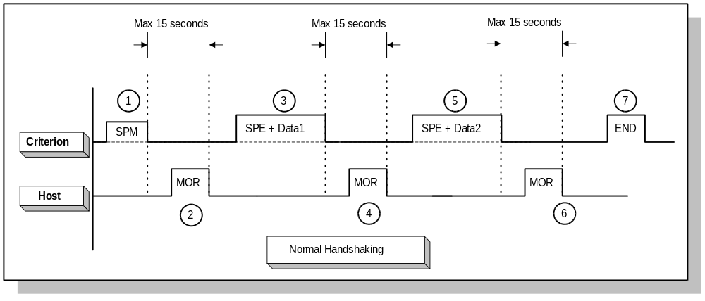
Junior

Event | Description
¬ | The operator presses the ‘reprint/send key’ on the Junior. The Junior sends the SPM message to the host, requesting permission to send results.
 | The host responds with the MOR message, giving the Junior permission to send a result.
® | The Junior sends the SPE message, which contains results for the first sample.
¯ | The host responds with the MOR message, giving the Junior permission to send the next result.
… | The Junior sends the SPE message, which contains results for the second sample.
† | The host responds with the MOR message, giving the Junior permission to send the next result.
‡ | The Junior sends the END message, telling the host it is finished sending results. The host does not reply to this message.

Timing and Handshaking, Continued

Abnormal Operation | After a series of strips have been processed, the operator can send them to the host. The following diagram and table shows the sequence of events when trouble occurs, and only one sample is being sent.
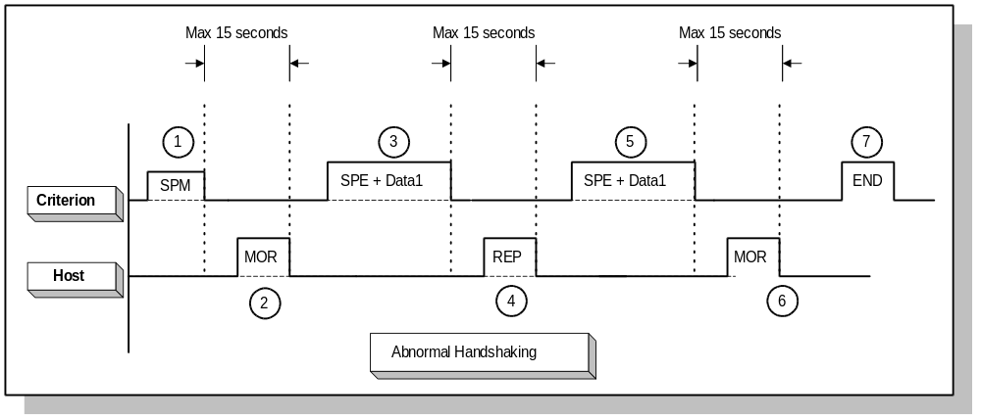
Junior

Event | Description
¬ | The operator presses the ‘reprint/send key’ on the Junior. The Junior sends the SPM message to the host, requesting permission to send results.
 | The host responds with the MOR message, giving the Junior permission to send a result. The host must respond within 15 seconds.
® | The Junior sends the SPE message, which contains results for the first sample.
¯ | The host responds with the MOR message, giving the Junior permission to send the next result.
… | The Junior sends the SPE message, which again contains results for the first sample.
† | The host responds with the MOR message, giving the Junior permission to send the next result.
‡ | The Junior sends the END message, telling the host it is finished sending results. The host does not reply to this message.

Special Notes | - The host should only send the MOR or REP messages, and in response to only the REP, SPE, or SPM packets from the analyzer.  - The analzyer will attempt to send it’s packets for a total of four times, terminate the communication cycle and post the ‘No host connect.’ message to the LCD.  - Upon receipt of four consecutive REP packets from the host, the analyzer will send the END packet, terminate the communication cycle and post the ‘No host connect.’ message to the LCD.

Timing and Handshaking, Continued

Status Transition Diagram | The diagram below may be helpful in understanding the operation of the host interface when the operator initiates transmission of results to the host.

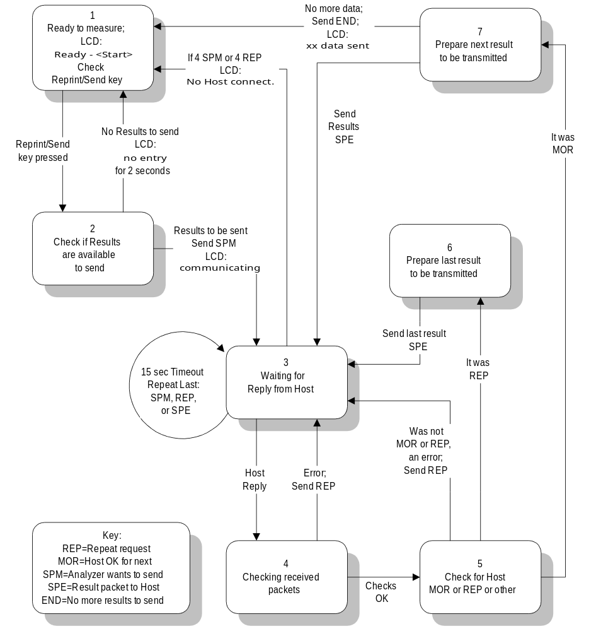

Results

Result Packet Structure | The results packet has a structure as shown below:

 |  |  |  |  |  | Units Settings
 |  |  |  |  |  | Conven-tional |  | Conven-tional & Arbitrary |  | Arbitrary |  | SI |  | SI &  Arbitrary
Start | Stop | Len | Content |  | Comment | Example 1 |  | Example 2 |  | Example 3 |  | Example 4 |  | Example 5
1 | 1 | 1 | STX |  | Start of Text (ASCII 02) | STX |  | STX |  | STX |  | STX |  | STX
2 | 2 | 1 | ; |  | Frame ID (ASCII 59) | ; |  | ; |  | ; |  | ; |  | ;
3 | 3 | 1 | E |  | Function Code (ASCII 69) | E |  | E |  | E |  | E |  | E
4 | 4 | 1 | Space |  |  | ◊ |  | ◊ |  | ◊ |  | ◊ |  | ◊
5 | 14 | 10 | Chars |  | Sample ID | 5462145698 |  | ◊◊◊◊◊◊◊◊◊◊ |  | ◊◊◊◊◊◊◊◊◊◊ |  | ◊◊◊◊◊◊◊◊◊◊ |  | ◊◊◊◊◊◊◊◊◊◊
15 | 15 | 1 | Space |  |  | ◊ |  | ◊ |  | ◊ |  | ◊ |  | ◊
16 | 20 | 5 | nnnnn |  | Sequence Number | ◊◊◊◊1 |  | ◊◊◊10 |  | ◊◊◊13 |  | ◊◊◊15 |  | ◊◊◊18
21 | 21 | 1 | Space |  |  | ◊ |  | ◊ |  | ◊ |  | ◊ |  | ◊
22 | 23 | 2 | nn |  | Day of Month | 12 |  | 12 |  | 12 |  | 12 |  | 12
24 | 24 | 1 | Separator |  | . (ASCII 46) | . |  | . |  | . |  | . |  | .
25 | 26 | 2 | nn |  | Month | 01 |  | 01 |  | 01 |  | 01 |  | 01
27 | 27 | 1 | Separator |  | . (ASCII 46) | . |  | . |  | . |  | . |  | .
28 | 29 | 2 | nn |  | Year | 96 |  | 96 |  | 96 |  | 96 |  | 96
30 | 30 | 1 | Space |  |  | ◊ |  | ◊ |  | ◊ |  | ◊ |  | ◊
31 | 32 | 2 | nn |  | Measurement Hour | 11 |  | 13 |  | 13 |  | 13 |  | 13
33 | 33 | 1 | Separator |  | : (ASCII 58) | : |  | : |  | : |  | : |  | :
34 | 35 | 2 | nn |  | Measurement Minute | 58 |  | 27 |  | 34 |  | 38 |  | 43
36 | 36 | 1 | Space |  |  | ◊ |  | ◊ |  | ◊ |  | ◊ |  | ◊
37 | 38 | 2 | SG |  | Specific Gravity Test Name | SG |  | SG |  | SG |  | SG |  | SG
39 | 43 | 5 | nnnnn |  | Specific Gravity Result |  | 1.020 |  | 1.020 |  | 1.020 |  | 1.025 |  | 1.025
44 | 48 | 5 | Chars |  | Specific Gravity Arbitrary | ◊◊◊◊◊ |  | ◊◊◊◊◊ |  | ◊◊◊◊◊ |  | ◊◊◊◊◊ |  | ◊◊◊◊◊
49 | 49 | 1 | Space |  |  | ◊ |  | ◊ |  | ◊ |  | ◊ |  | ◊
50 | 51 | 2 | PH |  | pH Test Name | PH |  | PH |  | PH |  | PH |  | PH
52 | 54 | 3 | nnn |  | pH Results | ◊◊6 |  | ◊◊5 |  | ◊◊6 |  | ◊◊5 |  | ◊◊5
55 | 59 | 5 | Chars |  | pH Arbitrary | ◊◊◊◊◊ |  | ◊◊◊◊◊ |  | ◊◊◊◊◊ |  | ◊◊◊◊◊ |  | ◊◊◊◊◊
60 | 60 | 1 | Space |  |  | ◊ |  | ◊ |  | ◊ |  | ◊ |  | ◊
61 | 63 | 3 | LEU |  | Leukocyte Test Name | LEU |  | LEU |  | LEU |  | LEU |  | LEU
64 | 74 | 11 | Chars |  | Leukocyte Result | ◊◊◊◊◊◊◊◊neg |  | ◊◊◊◊◊◊◊◊neg |  | ◊◊◊◊◊◊◊◊◊◊◊ |  | ◊◊◊◊◊◊◊◊neg |  | ◊◊◊◊◊◊◊◊neg
75 | 79 | 5 | Chars |  | Leukocyte Arbitrary | ◊◊◊◊◊ |  | ◊◊◊◊◊ |  | ◊◊neg |  | ◊◊◊◊◊ |  | ◊◊◊◊◊
80 | 80 | 1 | Space |  |  | ◊ |  | ◊ |  | ◊ |  | ◊ |  | ◊
81 | 83 | 3 | NIT |  | Nitrite Test Name | NIT |  | NIT |  | NIT |  | NIT |  | NIT
84 | 86 | 3 | Chars |  | Nitrite Result | pos |  | neg |  | ◊◊◊ |  | neg |  | neg
87 | 91 | 5 | Chars |  | Nitrite Arbitrary | ◊◊pos |  | ◊◊◊◊◊ |  | ◊◊neg |  | ◊◊◊◊◊ |  | ◊◊◊◊◊
92 | 92 | 1 | Space |  |  | ◊ |  | ◊ |  | ◊ |  | ◊ |  | ◊
93 | 95 | 3 | PRO |  | Protein Test Name | PRO |  | PRO |  | PRO |  | PRO |  | PRO
96 | 106 | 11 | Chars |  | Protein Result | ◊◊100◊mg/dl |  | ◊◊◊◊◊◊◊◊neg |  | ◊◊◊◊◊◊◊◊◊◊◊ |  | ◊◊◊0.15◊g/l |  | ◊◊◊◊◊◊◊◊neg
107 | 111 | 5 | Chars |  | Protein Arbitrary | ◊◊◊2+ |  | ◊◊◊◊◊ |  | ◊◊◊2+ |  | trace |  | ◊◊◊◊◊
112 | 112 | 1 | Space |  |  | ◊ |  | ◊ |  | ◊ |  | ◊ |  | ◊
113 | 115 | 3 | GLU |  | Glucose Test Name | GLU |  | GLU |  | GLU |  | GLU |  | GLU
116 | 126 | 11 | Chars |  | Glucose Result | ◊◊250◊mg/dl |  | ◊◊◊◊◊◊◊norm |  | ◊◊◊◊◊◊◊◊◊◊◊ |  | ◊◊◊◊◊◊◊norm |  | ◊◊◊◊◊◊◊norm
127 | 131 | 5 | Chars |  | Glucose Arbitrary | ◊◊◊2+ |  | ◊◊◊◊◊ |  | ◊◊◊2+ |  | ◊◊◊◊◊ |  | ◊◊◊◊◊
132 | 132 | 1 | Space |  |  | ◊ |  | ◊ |  | ◊ |  | ◊ |  | ◊

Results, Continued

Result Packet Structure (continued)

 |  |  |  |  |  |  |  |  | Units Settings
 |  |  |  |  |  |  |  |  | Conven-tional |  |  |  | Conven-tional & Arbitrary | Arbitrary |  | SI |  |  | SI &  Arbitrary
Start | Stop | Len |  | Content |  |  |  | Comment |  |  | Example 1 |  | Example 2 | Example 3 |  | Example 4 |  |  | Example 5
133 | 135 | 3 |  | KET |  | Ketone Test Name |  |  |  | KET |  | KET |  |  | KET |  | KET | KET
136 | 146 | 11 |  | Chars |  | Ketone Results |  |  |  | ◊◊◊◊◊◊◊◊neg |  | ◊◊◊◊◊◊◊◊neg |  |  | ◊◊◊◊◊◊◊◊◊◊◊ |  | ◊◊◊◊◊◊◊◊neg | ◊◊◊◊◊◊◊◊neg
147 | 151 | 5 |  | Chars |  | Ketone Arbitrary |  |  |  | ◊◊◊◊◊ |  | ◊◊◊◊◊ |  |  | ◊◊neg |  | ◊◊◊◊◊ | ◊◊◊◊◊
152 | 152 | 1 |  | Space |  |  |  |  |  | ◊ |  | ◊ |  |  | ◊ |  | ◊ | ◊
153 | 155 | 3 |  | UBG |  | Urobilinogen Test Name |  |  |  | UBG |  | UBG |  |  | UBG |  | UBG | UBG
156 | 166 | 11 |  | Chars |  | Urobilinogen Results |  |  |  | ◊◊◊◊◊◊◊norm |  | ◊◊◊◊◊◊◊norm |  |  | ◊◊◊◊◊◊◊◊◊◊◊ |  | ◊◊◊◊◊◊◊norm | ◊◊◊◊◊◊◊norm
167 | 171 | 5 |  | Chars |  | Urobilinogen Arbitrary |  |  |  | ◊◊◊◊◊ |  | ◊◊◊◊◊ |  |  | ◊◊◊◊◊ |  | ◊◊◊◊◊ | ◊◊◊◊◊
172 | 172 | 1 |  | Space |  |  |  |  |  | ◊ |  | ◊ |  |  | ◊ |  | ◊ | ◊
173 | 175 | 3 |  | BIL |  | Bilirubin Test Name |  |  |  | BIL |  | BIL |  |  | BIL |  | BIL | BIL
176 | 186 | 11 |  | Chars |  | Bilirubin Results |  |  |  | ◊◊◊◊◊◊◊◊neg |  | ◊◊◊◊◊◊◊◊neg |  |  | ◊◊◊◊◊◊◊◊◊◊◊ |  | ◊◊◊◊◊◊◊◊neg | ◊◊◊◊◊◊◊◊neg
187 | 191 | 5 |  | Chars |  | Bilirubin Arbitrary |  |  |  | ◊◊◊◊◊ |  | ◊◊◊◊◊ |  |  | ◊◊neg |  | ◊◊◊◊◊ | ◊◊◊◊◊
192 | 192 | 1 |  | Space |  |  |  |  |  | ◊ |  | ◊ |  |  | ◊ |  | ◊ | ◊
193 | 195 | 3 |  | BLD |  | Blood Test Name |  |  |  | BLD |  | BLD |  |  | BLD |  | BLD | BLD
196 | 206 | 11 |  | Chars |  | Blood Results |  |  |  | ◊◊◊◊◊150/ul |  | ◊◊◊◊◊◊50/ul |  |  | ◊◊◊◊◊◊◊◊◊◊◊ |  | ◊◊◊◊◊◊50/ul | ◊◊◊◊◊◊50/ul
207 | 211 | 5 |  | Chars |  | Blood Arbitrary |  |  |  | ◊◊◊3+ |  | ◊◊◊2+ |  |  | ◊◊◊4+ |  | ◊◊◊2+ | ◊◊◊2+
212 | 212 | 1 |  | Space |  |  |  |  |  | ◊ |  | ◊ |  |  | ◊ |  | ◊ | ◊
213 | 232 | 20 |  | Not Used |  | Not Used |  |  |  | NAG◊◊◊◊◊◊◊◊◊◊◊◊◊◊◊◊◊ |  | NAG◊◊◊◊◊◊◊◊◊◊◊◊◊◊◊◊◊ |  |  | NAG◊◊◊◊◊◊◊◊◊◊◊◊◊◊◊◊◊ |  | NAG◊◊◊◊◊◊◊◊◊◊◊◊◊◊◊◊◊ | NAG◊◊◊◊◊◊◊◊◊◊◊◊◊◊◊◊◊
233 | 233 | 1 |  | ETX |  | End of Text ETX |  |  |  | ETX |  | ETX |  |  | ETX |  | ETX | ETX
234 | 235 | 2 |  | Chars |  | Checksum |  |  |  | 59 |  | 86 |  |  | 9D |  | 0D | 91
236 | 236 | 1 |  | CR |  | Carriage Return (213) |  |  |  | CR |  | CR |  |  | CR |  | CR | CR

Results, Continued

Units Settings | The Junior system has flexible units settings that include the following:  (all examples are taken from the Result Packet Structure table on the previous pages, using the Blood test)

Setting | Result Example | Arbitrary Example
Conventional | ◊◊◊◊◊150/ul | ◊◊◊3+
Conventional & Arbitrary | ◊◊◊◊◊◊50/ul | ◊◊◊2+
Arbitrary | ◊◊◊◊◊◊◊◊◊◊◊ | ◊◊◊4+
SI | ◊◊◊◊◊◊50/ul | ◊◊◊2+
SI & Arbitrary | ◊◊◊◊◊◊50/ul | ◊◊◊2+

Important Notes | - The above examples represent different samples.  - If the setting is for only Arbitrary, then results are generally blank.  - If a particular test has no arbitrary settings for the generated result, then the result will be shown in the result column.  - The above settings are operator selectable, and affect both the host and the analyzer print settings.  - According to the used language the reported parameter name could be slightly different.

Enabling the Host

Overview | The Host interface is enabled using the touch keypad on the Junior system.  The following figure illustrates the key pad:

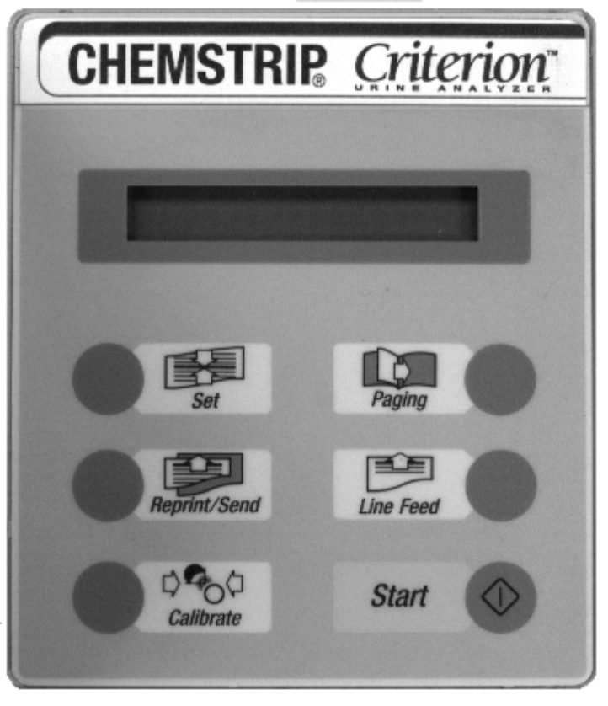

Enabling the Host, Continued

Procedure to Enable the Host | Use the following sequence to enable the host:

When the LCD Reads: | Press
READY - <START> | 
Setup | 
ENGLISH
24 hours
hh:mm
dd:mm:yy
Host/pc no
HOST/PC Yes | 
setup reprint
READY - <START> | Finished

Use of the Reprint/Send Button | Enabling the Host/PC does not automatically send results to the host. The operator must, after analyzing strips, press the Reprint/Send button to send results to the host. Only results that have not previously been sent to the host will be sent.

Cable Connections | The table below summarizes the connections needed for host communication. Do not hook to other pins, unless the optional bar code reader is present.

Junior |  |  |  | Host
DTE Signal | 9 Pin Female |  | Signal Direction | 9 Pin Male | 25 Pin Male | DCE Signal
RxD | 2 |  | ï | 3 | 2 | TxD
TxD | 3 |  | ð | 2 | 3 | RxD
GND | 5 |  | ó | 5 | 7 | GND

Communication Parameters | The required serial interface parameters are listed in the table below.

Parameter | Value
Baud Rate | 9600
Word Length | 8 bits
Parity | None
Stop Bits | 1
Checksum Calculation

Overview | All of the messages from the host are fixed, thus requiring no dynamic calculation of checksums. The host need only send the required packets along with the known checksums. The host can also check the REP, SPM, and END messages against stored messages to ensure integrity.  For the results packets (SPE) however, BM highly recommends that the host interface program uses the checksum to ensure data integrity of the result packets. This section describes how the checksum works.

Algorithm a | This check sum is a kind of longitudinal parity test (Longitudinal Redundancy Check ,LRC) of the bits contained in the data protocol. The protocol is linked bit by bit to XOR. The resulting byte is then split into two bytes (to avoid the occurrence of control characters) and attached to the protocol.  All bytes beginning with STX (inclusive) up to ETX (inclusive) are taken into account in the formation of the LRC. Some laboratory computers have a manufacturer-specific transmit/receive driver implemented which cuts off the STX in protocols and does not allow it to get into the usersoftware.In this case, the user must first switch off block testing in the Host.

LRC-Byte = Byte1 XOR Byte2 XOR Byte3 ........ XOR Bytelast
LRC1-Byte = high-Nibble (shifted by 4 bits) of the LRC-Byte OR 3016
LRC2-Byte = low-Nibble of the LRC-Byte OR 3016

Example:
Bit-No.
8 7 6 5 4 3 2 1
1 0 1 1 0 0 0 1 0
2 0 0 0 0 0 0 1 1
Byte-No. 3 0 0 1 1 0 1 1 0
4 0 0 1 1 1 0 1 0
5 0 0 1 1 1 1 1 0
----------------------------------
LRC-Byte 0 1 0 1 0 0 1 1
----------------------------------

high-Nibble 0 1 0 1
low-Nibble 0 0 1 1

LRC 1 - Byte = 0 0 1 1 0 0 0 0 /* 3016 */
OR 0 0 0 0 0 1 0 1 /* high-Nibble */
----------------------------
0 0 1 1 0 1 0 1
============================

Checksum Calculation, Continued

LRC 2 - Byte = 0 0 1 1 0 0 0 0 /* 3016 */
OR 0 0 0 0 0 0 1 1 /* low-Nibble */
----------------------------
0 0 1 1 0 0 1 1
============================

Further examples: MOR-Protocol: J>♥3?
REP-Protocol: J?♥3>
SPM-Protocol: J<♥3=

Algorithm b | This check sum is calculated by adding together the bytes to be transferred, the individual bytes being interpreted as positive, whole numbers. STX, the check sum, ETX and CR are not included in the addition. The result of the addition is taken as modulo 256. The resulting number can be represented by a single byte. The two half-bytes of this number are represented as hexadecimal figures (“0“..“9“, “A“..“F“). Leading zeros are included.

CS = (Byte2 + Byte3 + ... + ByteLength-4) modulo 256

If your software does not have a decimal-hexadecimal routine or function that can return a leading zero, the below algorithms may be helpful.

CS1-Byte = INT((CS / 16)) + 48 for INT((CS / 16)) ≤ 9
= INT((CS / 16)) + 55 for INT((CS / 16)) ≥ 10

CS2-Byte = (CS modulo 16) + 48 for (CS modulo 16) ≤ 9
= (CS modulo 16) + 55 for (CS modulo 16) ≥ 10

Example: MOR-Protocol

STX,'>',ETX,'3E',CR
0216 3E16 0316 3316 4516 0D16 with CS = 62 = 3E16

Further examples: MOR-Protocol: J>♥3E
REP-Protocol: J?♥3F
SPM-Protocol: J<♥3C

Checksum Calculation, Continued

Autoadaption Miditron Jr. is in a position to adapt itself automatically to the test procedure used by the host (checksum a,b). If an error is discovered when checking the test bytes of the receive protocol, the check will be continued using the algorithms of the alternative procedure. If, using the alternative test procedure, the test bytes are recognized as correct, this procedure will be used for all protocols in future. This new setting is retained even after the appliance has been switched off. If the alternative proceduredoes not recognize any correct test bytes either, an REP protocoll is transmitted and there is no chnge of test procedure.
If, upon startup (i.e. the first time Miditron Jr. is connected up to the host) , two different procedures are set, the host must reply to the SPM from Miditron Jr. with an REP or MOR and the relevant test bytes.

Example:

Miditron Jr. Host Remarks:
/SPM/ --------------> (checksum a)
<-------------- /MOR/ (checksum b)
/SPE/+data -------> (checksum b)
Hencefort, algorithm b permanently set as the test procedure in Miditron Jr.

<-------------- /MOR/ (checksum a)
or <-------------- /REP/ (checksum a)
/SPE/+data -------> (checksum a)
Hencefort, algorithm a permanently set as the test procedure in Miditron Jr.

<-------------- /MOR/ (checksum b)
or <-------------- /REP/ (checksum b)
/SPE/+data -------> (checksum b)
Henceforth, algorithm b permanently set as the test procedure in Miditron Jr.

Troubleshooting

Error Messages | If the Junior detects any abnormality during communication, it will display ‘No Host connect.’ on the LCD screen, and will cease the communication cycle. Refer to the table below for troubleshooting communication problems.

Description | Cause | Remedy
Results are not sent to the host, and ‘No Host connect.’ is displayed on the LCD. | If the host interface has worked before, but is not now, the host cable may be loose or damaged. | Check the cable to ensure that it is secure, both at the Junior, and at the host.
 | If the host has never worked, the cable connections might be incorrect. | Refer to Cable Connections in this document.
 | Communication parameters may be set incorrectly at the host side. | Refer to ‘Communication Parameters’ in this document.
Results are not sent to the host when the Reprint/Send key is pressed, the message ‘No Host connect.’ does not appear on the LCD, but the results print on the Junior printer | The Junior is not set up correctly for use with a host. | Refer to the ‘Procedure to Enable the Host’ in this document.
Results are printed when the Reprint/Send key is pressed, but no results are sent to the host, and ‘No Entry’ is displayed on the LCD. | No results are stored in the Junior that have not been previously sent to the host. | Process more strips.
Some of the results are sent to the host, then ‘No Host connect.’ is displayed on the LCD. | The host may not be responding in time, or the communications line might be noisy. | Call BM Technical Support

Appendix A - ASCII Chart
Char  Hex Dec | Char  Hex Dec | Char  Hex Dec | Char  Hex Dec | Char  Hex Dec | Char  Hex Dec | Char  Hex Dec | Char  Hex Dec
NULL  00 00 | DLE  10 16 | Space  20 32 | 0  30 48 | @  40 64 | P  50 80 | `  60 96 | p  70 112
SOH  01 01 | DC1  11 17 | !  21 33 | 1  31 49 | A  41 65 | Q  51 81 | a  61 97 | q  71 113
STX  02 02 | DC2  12 18 | "  22 34 | 2  32 50 | B  42 66 | R  52 82 | b  62 98 | r  72 114
ETX  03 03 | DC3  13 19 | #  23 35 | 3  33 51 | C  43 67 | S  53 83 | c  63 99 | s  73 115
EOT  04 04 | DC4  14 20 | $  24 36 | 4  34 52 | D  44 68 | T  54 84 | d  64 100 | t  74 116
ENQ  05 05 | NAK  15 21 | %  25 37 | 5  35 53 | E  45 69 | U  55 85 | e  65 101 | u  75 117
ACK  06 06 | SYN  16 22 | &  26 38 | 6  36 54 | F  46 70 | V  56 86 | f  66 102 | v  76 118
BEL  07 07 | ETB  17 23 | '  27 39 | 7  37 55 | G  47 71 | W  57 87 | g  67 103 | w  77 119
BS  08 08 | CAN  18 24 | (  28 40 | 8  38 56 | H  48 72 | X  58 88 | h  68 104 | x  78 120
HT  09 09 | EM  19 25 | )  29 41 | 9  39 57 | I  49 73 | Y  59 89 | i  69 105 | y  79 121
LF  0A 10 | SUB  1A 26 | *  2A 42 | :  3A 58 | J  4A 74 | Z  5A 90 | j  6A 106 | z  7A 122
VT  0B 11 | ESC  1B 27 | +  2B 43 | ;  3B 59 | K  4B 75 | [  5B 91 | k  6B 107 | {  7B 123
FF  0C 12 | FS  1C 28 | ,  2C 44 | <  3C 60 | L  4C 76 | \  5C 92 | l  6C 108 | |  7C 124
CR  0D 13 | GS  1D 29 | -  2D 45 | =  3D 61 | M  4D 77 | ]  5D 93 | m  6D 109 | }  7D 125
SO  0E 14 | RS  1E 30 | .  2E 46 | >  3E 62 | N  4E 78 | ^  5E 94 | n  6E 110 | ~  7E 126
SI  0F 15 | US  1F 31 | /  2F 47 | ?  3F 63 | O  4F 79 | _  5F 95 | o  6F 111 | DEL  7F 127

Appendix B - Parameter Range Table, Europe

Parameter | Conv. | SI | Arbitrary
Specific Gravity | 1.000 | 1.000 | 1.000
(SG) | 1.005 | 1.005 | 1.005
 | 1.010 | 1.010 | 1.010
 | 1.015 | 1.015 | 1.015
 | 1.020 | 1.020 | 1.020
 | 1.025 | 1.025 | 1.025
 | 1.030 | 1.030 | 1.030
pH | 5 | 5 | 5
 | 6 | 6 | 6
 | 6.5 | 6.5 | 6.5
 | 7 | 7 | 7
 | 8 | 8 | 8
 | 9 | 9 | 9
Leukocytes | neg | neg | neg
(LEU) | 25 /µl | 25 /µl | 1+
 | 100 /µl | 100 /µl | 2+
 | 500 /µl | 500 /µl | 3+
Nitrite | neg | neg | neg
(NIT) | pos | pos | pos
Protein | neg | neg | neg
(PRO) | 25 mg/dl | 0.25 g/l | 1+
 | 75 mg/dl | 0.75 g/l | 2+
 | 150 mg/dl | 1.5 g/l | 3+
 | 500 mg/dl | 5 g/l | 4+
Glucose | norm | norm | neg
(GLU) | 50 mg/dl | 3 mmol/l | 1+
 | 100 mg/dl | 6 mmol/l | 2+
 | 300 mg/dl | 17 mmol/l | 3+
 | 1000 mg/dl | 56 mmol/l | 4+
Keton | neg | neg | neg
(KET) | 5 mg/dl | 0.5 mmol/l | 1+
 | 15 mg/dl | 1.5 mmol/l | 2+
 | 50 mg/dl | 5 mmol/l | 3+
 | 150 mg/dl | 15 mmol/l | 4+
Urobilinogen | norm | norm | neg
(UBG) | 1 mg/dl | 17 µmol/l | 1+
 | 4 mg/dl | 68 µmol/l | 2+
 | 8 mg/dl | 135 µmol/l | 3+
 | 12 mg/dl | 203 µmol/l | 4+
Bilirubin | neg | neg | neg
(BIL) | 1 mg/dl | 17 µmol/l | 1+
 | 3 mg/dl | 50 µmol/l | 2+
 | 6 mg/dl | 100 µmol/l | 3+
Erythrocytes | neg | neg | neg
(ERY) | 10 /µl | 10 /µl | 1+
 | 25 /µl | 25 /µl | 2+
 | 50 /µl | 50 /µl | 3+
 | 150 /µl | 150 /µl | 4+
 | 250 /µl | 250 /µl | 5+

?? represents the checksum, which will vary depending on the Results Packet content. For more information, see the Checksum Calculation section.

