Boehringer Mannheim GmbH
BM/HITACHI 902 Automatic Analyzer
Host Interface Manual

System Interface - Functional Specifications

BM / ID.No. 1808974-001

Document Version 1.1

WARRANTY
Boehringer Mannheim GmbH makes no warranties for the BM Host Interface Manual beyond those set forth in the operations manual for BM/Hitachi 902 analyzer. Boehringer Mannheim GmbH disclaims all other warranties, express or implied, including but not limited to the implied warranties of merchantability and fitness for a particular purpose.
In no evant shall Boehringer Mannheim GmbH be liable for the incidental or consequential damages arising from the use of the interface.

VERSIONS

Version | Date | Modifications
1.0 | November 1996 | first version
1.1 | November 1997 | WARRANTY and VERSIONS added  format of sequence number within Sample Info of Control Results was changed from b1 to 01 (b = Space)

Contents:
1. Introduction
2. Interface Setup
2.1. Pin Arrangement
2.2. Interface Signal Level
2.3. Connection Cable
2.4. Specification of Communication
2.5. Setup of Communication Parameters
3. Basic Workflow
4. Software Protocol
4.1. Common text format
4.2. Start-of-data Code
4.3. Frame Identification
4.3.1. Frame Character
4.4. Data Field
4.4.1. Function Characters
4.4.2. Composition of Sample Information
4.4.3. Composition of Test Selection Information
4.4.4. Composition of Comment Information
4.4.5. Composition of Result Data for Routine, Rerun, STAT and Control samples
4.4.6. Absorbance Data
4.4.7. Photometry-assay Calibration Data
4.4.8. ISE Calibration Data
4.4.9. Data Alarm List
4.5. End-of-data Code
4.5.1. End-of-data Code Options
4.5.2. Checksum Calculation Methods
5. Data Transmission Control Procedure
5.1. Establishment of Data Link
5.2. Response to Information Message
5.2.1. No Information to be sent
5.2.2. Transfer of Communication Control Message
5.2.3. Transfer of Test Selection Information
5.2.4. Transfer of Result Data
5.2.5. Resending Request
5.2.6. Host sends SUS and REC frames
5.3. Termination and Restart of Communication
5.4. Retry of Communication
5.5. Result-Only mode
6. Communication Functions
6.1. Function List for Test Selection Data
6.2. Function List for Result Data
7. Communication Log
7.1. Overview
7.2. Trace Data
7.3. Reset and Printout of Trace Data
7.4. Trace Data Storing Capacity
7.5. Other
8. Example Traces
8.1. Test Selection Inquiry from AU to host incl. Result
8.2. Absorbance data from AU to host
8.3. Photometry-assay Calibration data from AU to host
8.4. ISE Calibration data from AU to host
8.5. Control data from AU to host
8.6. Specific Result Request from host to AU
9. Figures and Tables
Appendix A - ASCII Chart
Appendix B - Differences between HITACHI 911 and 902
Appendix C - Error Check Functions
Appendix D - Table of Communication Errors
Appendix E - Text Configuration Table

1 Introduction
This manual provides the specifications for bidirectional data transmission between an HITACHI Model 902 Automatic Analyzer by Boehringer Mannheim GmbH and an external laboratory host system via asynchronous serial connection. The hardware components required as well as the communication rules are described. They highlight the general considerations to be taken into account in any approach to realize the data communication between different computer systems.
This specification illustrates the fundamental considerations for the host link and contains information concerning the following:
– Hardware
• What interface hardware is required?
• How is the physical connection established?
– Use and control of the data transmission
• How to set the transfer and communication parameters?
• What is the formal structure of the strings and values to be transmitted and what influence can be taken on it?
• What kind of data or variables can be transmitted?
• How and by which system is the data transfer initiated?
– Software protocol
• What does the transmission protocol used for communication between the two systems look like?
• What does the host at the other end of the data link do and what rules has the program at the host link to follow?
Working with the host interface you will find that the data transfer from the host computer to the HITACHI Model 902 Automatic Analyzer can be done in a very easy, comfortable and reliable way.
If problems with the installation or questions about the transfer should arise please contact the responsible person of Boehringer Mannheim Service Department or directly the Service Management of the Central Marketing Department of Boehringer Mannheim GmbH (Germany):
Boehringer Mannheim GmbH
Technical Productmanagement
Data Technique
Sandhofer Straße 116
D-68305 Mannheim
Phone: (49) 621 / 759-2464
Telefax: (49) 621 / 759-4591

Figure 1 gives an general idea of the 902 interface data flow between the analyzer, the analyzer unit (AU) and the host system. More detailed description will be found in this document.

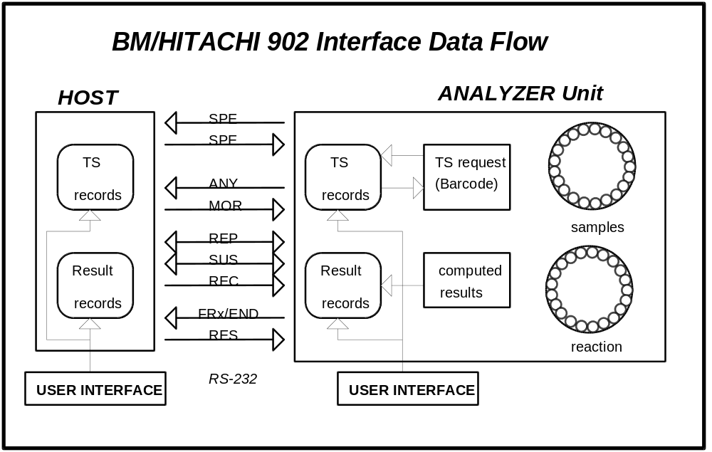
Figure 1: BM/HITACHI 902 Interface data flow
(1) Realtime test selection request is made for:
- Routine samples, if the record is not existing or the test selection is zero.
(2) Realtime result transmission is made for:
- Routine/ STAT/Control samples
- Calibration data
- Original Absorbance Data
(3) Batch result transmission can be initiated either by the operators request for
Routine/STAT results
Control data

2 Interface Setup
The 902 analyzer can select the RS-232C or the 20mA current loop interface and can monitor the sent data via each interface.
- RS-232C
Use the connector J402 on the RSDIST circuit board provided on the rear panel of the analyzer.
- 20 mA current loop
Use the same connector J402 as for RS-232C
- Communication Monitor
The data sent from the analyzer to the host can be monitored by using the connector J405 on the RSDIST board.

Figure 2 shows the settings of the DIP switch 1 (on the RSDIST PC board) for the selection of the RS232-C or current loop interface.
Switch one selects the interface: ON: current loop / OFF: RS-232C
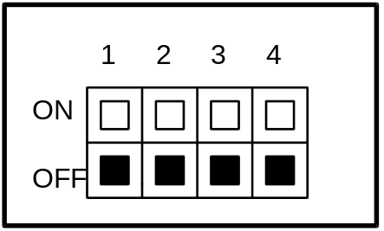
Figure 2: RSDIST Dip Switch 1 setting for RS-232C interface

3 Pin Arrangement
Table 1 shows the pin arrangement of the interface plug J402 (15-pin female) on the RSDIST board.

Pin no | Signal | Explanation | Direction
RS-232C (from Host)
1 | SG | Signal Ground | -
2 | Txd | Transmit Data | out
3 | Rxd | Receive Data | in
4 | RTS | Request to Send | out
5 | CTS | Clear to Send | in
Current loop (from Host)
6 | Txd+ | Transmit Data
7 | Txd-
8 | RTS+ | Request to Send
9 | RTS-
10 | CTS+ | Clear to Send
11 | CTS-
12 | Rxd+ | Receive Data
13 | Rxd-
14 | unused
15 | unused |  | -
Table 1: Pin arrangement for the J402 plug of the RSDIST board
Table 2 shows the pin arrangement of the communication monitor plug J405 (25-pin female) on the RSDIST board. (plug cannot be accessed on the backside of the analyzer, but only on the board)

Pin no | Signal | Explanation | Direction
RS-232C (from Host)
1 | unused |  | -
2 | Txd | Transmit Data | out
3 | unused |  | -
4 | RTS | Request to Send | out
5 | unused
6 | unused
7 | SG | Signal Ground | -
Current loop (from Host)
8 | Txd+ | Transmit Data
9 | Txd-
10 | RTS+ | Request to Send
11 | RTS-
12 | DTR+ | Data Terminal Ready
13 | DTR-
14 | unused
15 | unused |  | -
Table 2: Pin arrangement of the J405 plug of the RSDIST board

4 Interface Signal Level

 | Signal | Binary | Level | RS232 Voltage  Output / Input | Current Loop
negative | MARK (OFF) | ONE (1) | LOW | -12 V / -3 to -15 V | 20mA
positive | SPACE (ON) | ZERO (0) | HIGH | +12 V / +3 to 15 V | 0mA
Table 3: Signal Level

5 Connection Cable
Figure 3 shows the wiring diagram of the connection cable between the analyzer unit and the host.
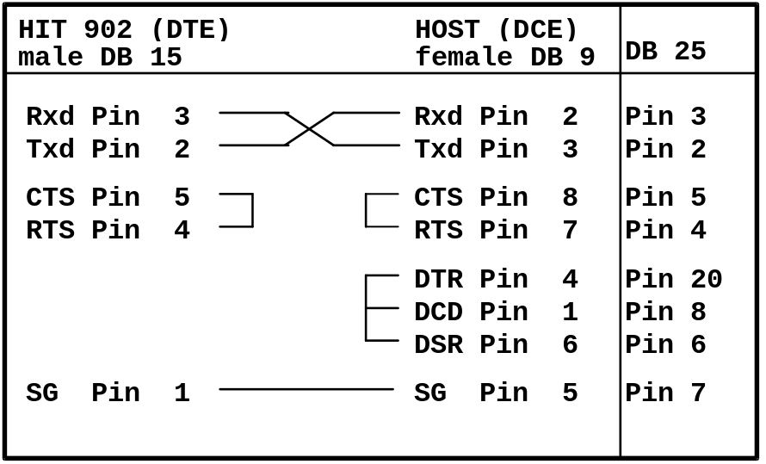
Figure 3: Host Interface connection cable

6 Specification of Communication
The table below shows the communication specifications of the host interface.

Item | Specification | Remarks
Interface | - Asynchronous serial interface RS-232C  - 20mA current loop | cable length max. 15m
Communication. method | Half duplex
Character code | JIS 7 bits, JIS 8 bits or ASCII
Text Mode | Non-transparent mode (ASCII)
Synchronization | Asynchronous system
Table 4: Specification of the host communication

7 Setup of Communication Parameters
All settings concerning the host interface are made on the Com. Parameters screen.
(menu path: Param è System è Com. Param)

[Parameters]
Status
[System Parameters]
Status
Test Param.
Carry Over
Date
Com. Param
Cal. Test
Serum Index
Orginal ABS
Options
Control Pos.
System
Rate As Chk
Init. Screen
Print Order
ISE Test
STAT Pos.
Check Digit

Profile
Home
P.Up

[Com. Parameters]
Status
Baud Rate
:9600
Parity
:No Parity

Data Bits
:7
Stop Bits
:2

End Code
:ETX+BCC
Text Length
:256
Retry
:2
Retry Time Out
:10

Com. Cycle
:2
Result Only
:Disable

Com. Trace
:Disable
Simul. Inquiry
:Disable

STAT Inquiry
:Disable

Figure 4: Com. Parameters screen

Serial interface parameters:
• Baud Rate 9600, 4800 baud
• Parity Check none, odd, even
• Data Bits 7, 8
• Stop Bits 1, 2

HIT 902 specific settings:
• Data-End Code 5 options (chapter 5.4)
• Maximum Text Length 256, 512 bytes (chapter 4.4.5 and 4.4.6)
• Retry Count 1 to 4 (chapter 5.4)
• Retry Time Out 1 to 4 seconds (chapter 5.4)
- Communication Cycle 2, 3, 5, 10 seconds (chapter 5.2.1)

Unidirectional communication mode:
• ‘Result Only’ mode (chapter 5.5)

Host Communication Trace:
• Option of recording the communication (the log can be printed and deleted on the Tools è Com. Trace screen)
(chapter 7)

Test selection Inquiry:
• ‘Simul. Inquiry’ option (chapter 4.4.3)
- STAT Inquiry (chapter 6.1)

These settings cannot be changed, if communication is running.
Communication is enabled on the Start Condition screen by selecting the ‘Host Com.’ option.

[Start Condition]
Status

Host Com.
Realtime Print
Calib. Print
S. End Buzzer

P.Up

Figure 5: Start Condition screen

To access the Start Condition screen press the [Batch Mode] or [Easy Mode] button and the button, then one of the arrow keys to move to the second page.
Ok
?

8 Basic Workflow
There are two ways of workflow on the BM/HITACHI 902 analyzer with a host connection:
- Test selection download in batch mode before starting the RUN
- Test selection download on request during the RUN. Download means sending information from the host to the analyzer.

Test Selection Download in Batch mode

 The operator places the samples on the instrument
 The operator initiates the download of all existing test selections from host side
 The operator starts the run

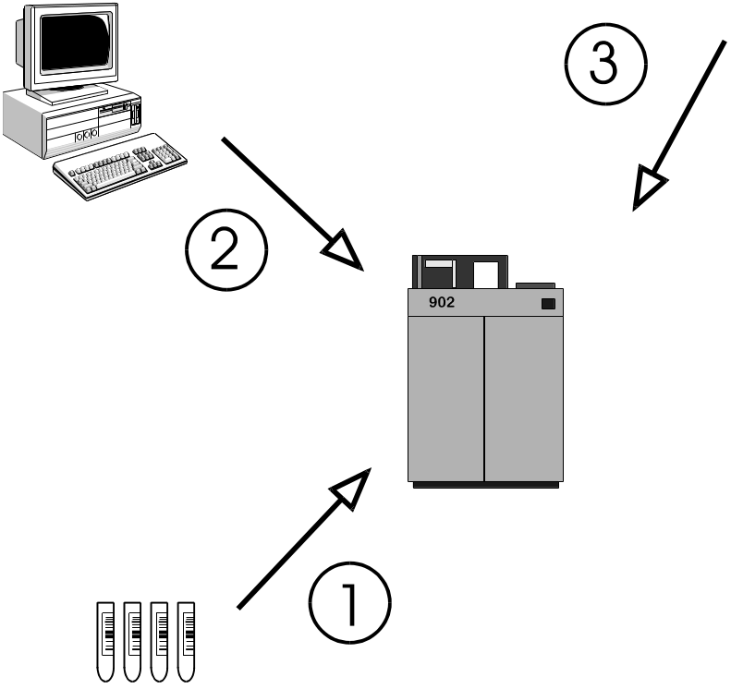
Figure 6: Test selection download in batch mode

Test Selection Download in Realtime mode

 The operator places the samples on the instrument
 The operator starts the run
 Upon reading the barcode of each sample the analyzer sends a request for each sample to the host
 The host sends back the corresponding test selection to the analyzer

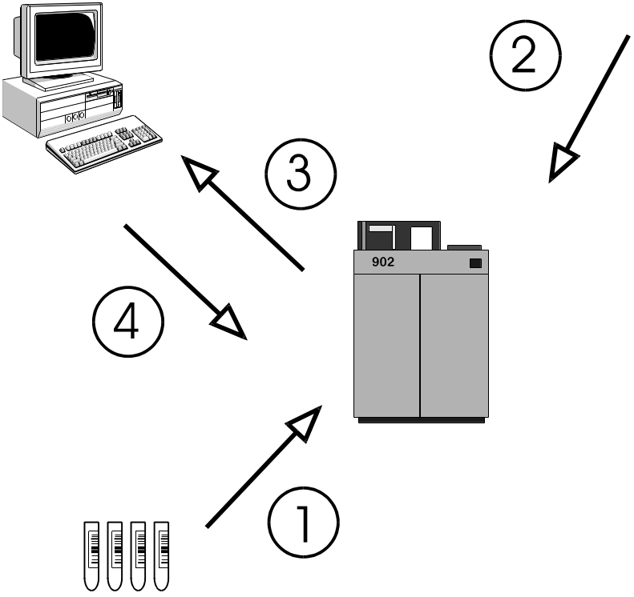
Figure 7: Test selection download in realtime mode

9 Software Protocol

10 Common text format
Each message that is sent to the AU (analyzer unit) or the HOST (laboratory computer system) consists of the following items:

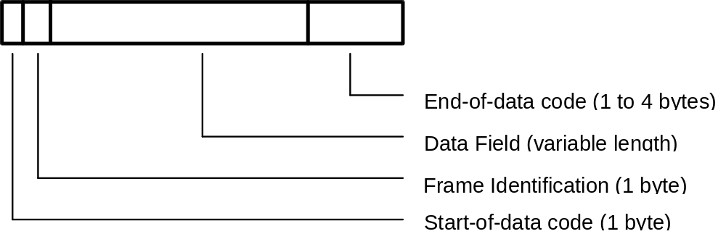

If you have a message without data (control frames ANY, REP, SUS, REC or MOR, see Table 6) then the Data Field is empty.

11 Start-of-data Code
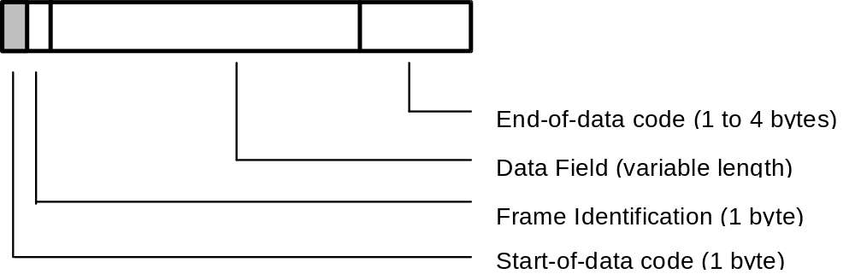

Each message sent from the AU or the host starts with the Start-of-Data Code (STX = 02H).

12 Frame Identification
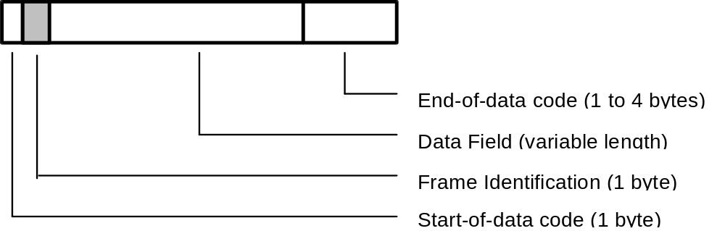

13 Frame Character
The frame character represents the purpose/ contents of the message.

Mnemonic | Name | Char. | ASCII Code | Sender | Note
FR1 | Frame 1 | 1 | 31H | AU | 1
FR2 | Frame 2 | 2 | 32H
END | End  Frame | : | 3AH |  | 2
SPE | Specific  Sample | ; | 3BH | AU  HOST | 3
RES | Results  Request | < | 3CH | HOST | 4
Table 5: Frame types having a Data Field

Note 1: The frame characters FR1 and FR2 are used, when the analytical data extends over more than one message. FR1 is used for the first message and END for the final message.
Note 2: END alone is used when analytical data for one sample can be sent in one single message.
Note 3: The AU uses the frame character SPE for the test selection inquiry of only one specific sample.
The host uses SPE for the test selection which is being sent in response to the inquiry from the AU.
Note 4: The specific result request RES is used to request analytical data of a specific sample from the host to the AU. (Depending on whether the ID is provided or not, only routine and STAT samples are taken as valid. The others are ignored.)

Mnemonic | Name | Char. | ASCII Code | Sender | Note
ANY | Any inquiry | > | 3EH | AU | 5
MOR | More | > | 3EH | HOST | 6
REP | Repeat | ? | 3FH | AU, HOST | 7
SUS | Suspend | @ | 40H | AU, HOST | 8
REC | Received | A | 41H | HOST | 9
Table 6: Frame types having no data field

Note 5: A positive response ANY is used by the AU to ask the host for the following items:
a) a test selection record for any sample that is available by the host.
b) RES, REC or MOR frame requests.
Note 6: MOR means that the host is ready to receive analytical data. (Analytical data can be transmitted from the AU to the host only when the host has sent this frame.)
Note 7: A negative response REP is used, when resending of the previous communication is requested. The host can send REP at any time. The AU, however, sends REP only when the response from the host is invalid or destroyed.
Note 8: The Data Bad and Suspend packet (SUS) is sent by the host to tell the analyzer that the last packet was bad, and that the host wants a delay before the packet is resent by the AU. The AU then resends the packet after another ANY/MOR cycle.
Note 9: With the Data Accepted but Suspend packet (REC) the host tells the analyzer that the last packet was okay and requests communication interruption for the duration of one communication cycle.

Frame Priorities
When two or more processings are carried out in response to a request from the host, the AU assigns priorities to them and returns a response to the host.
Batch communication is interrupted and suspended if the AU has a text with higher priority. This is restricted to the case where analytical data in the real-time mode is sent from AU and the transfer of analytical data is in response to a RES frame. After that the batch communication is restarted.
The table below shows the details of each frame and the priority.

Priority | Item
1 | SPE frame for STAT samples
2 | SPE frame for routine samples
3 | REP frame
4 | FRx,END frame for high-priority result data (real-time)
5 | FRx,END frame for specific result request (RES from host)
6 | FRx,END frame for batch results
Table 7: Frame priorities

14 Data Field
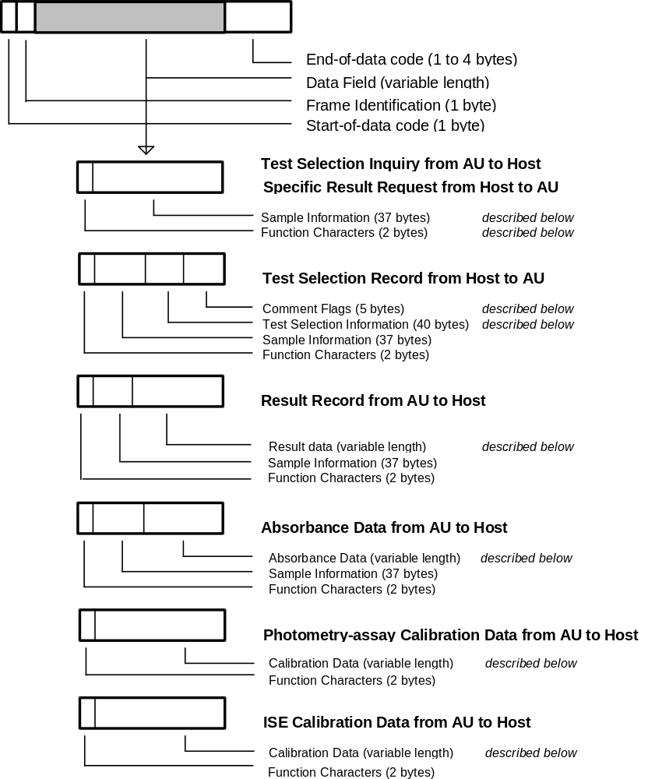

15 Function Characters
 |  |  | Test Selection Info. Inquiry |  | Result data
 |  | Direction of Communication | AU <-->HOST | AU <-- HOST | AU --> HOST |  | HOST --> AU
 |  | ID provided  / | Real-time  Communication | Batch  Communication | Real-time  Communication | Batch  Communication | Result  Request
 |  | not provided
 | Routine sample |  | A_ | A_ | A_ | a_ | a_
 | Stat sample |  | D_ | D_ | D_ | d_ | d_
 | Control sample |  |  |  | F_ | f_
 | Calibration  (Photometry) | Provided |  |  | G_
 | Calibration  (ISE) | / |  |  | H_
 | Absorbance data  (Routine) | not provided |  |  | I_
 | Absorbance data  (STAT) |  |  |  | K_
 | Routine sample |  | N_ | N_ | N_ | n_ | n_
 | STAT sample |  |  |  | Q_ | q_ | q_
Table 8: Function characters
Each character _ stands for a space (code 20hex)

16 Composition of Sample Information

(included in SPE, RES, FR1 to FR2, END frames)
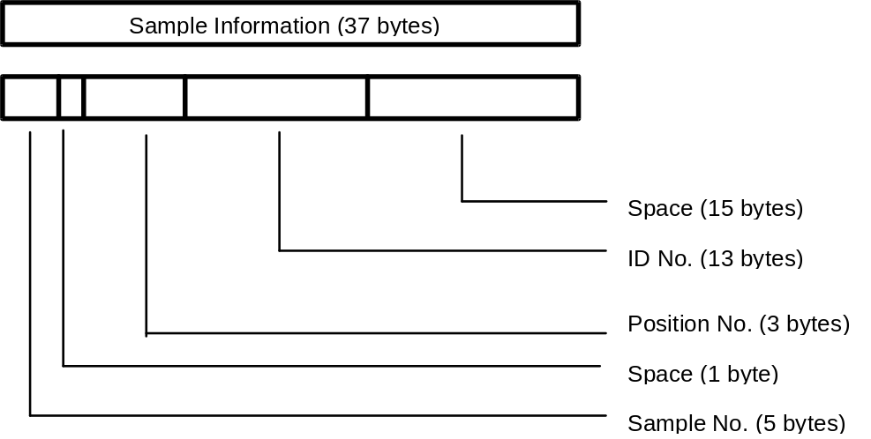

Item | L | Routine sample | Stat sample | Control sample | Note
Sample No. | 5 | Format: sssss  Range:  bbbb1-bb400 | Format: sssss  Range:  bbbb1-bbb50 | Format: cccss  c: control no.  Range: bb1 - bb5  ss: sequence no.  Range: 01 - 30 | 1
Space | 1
Position No. | 3 | Format: ppp  Range: bb1 - b35 | Format: ppp  Range: bb2 - b35 | Format: bbb  3 spaces | 2
Ident No. | 13 | Format: nnnnnnnnnnnnn  n = ident number |  | Format:  13 spaces | 3
Spaces | 15
Table 9: Format of sample information / b = space (20H)
Note 1: <AU to HOST>: For an inquiry in ID mode, spaces are given.
<HOST to AU>: In ID mode sample no is ignored.
Note 2: <AU to HOST>: Spaces are sent for control samples.
<HOST to AU>: If the information is not set, the 902 value is used.
Note 3: <AU to HOST>: For an inquiry in ID mode, spaces are given.
<HOST to AU>: In the non ID mode the Ident no. is treated as a comment.

See chapter 7 for examples.

17 Composition of Test Selection Information

(included in SPE frame)
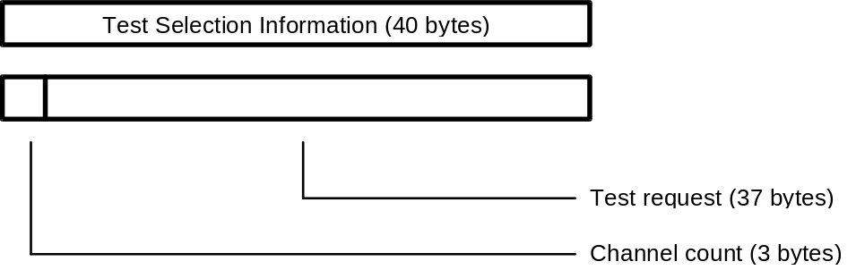

Item | Length | Range | Note
Channel count | 3 | Format: ccc  Range: bb0 to b37 | 1
Test request | 37 | Format: rrrr....rrrr  Range: 0 to 4 for each character:  0 = no request  1 = normal sample volume  2 = unused  3 = unused  4 = determined by AU (only for rerun) | 2
Table 10: Format of test selection information / b = space (20H)

Note 1: If the channel count is less than 37, the channels with higher count are ignored.
Note 2: The channels are listed in ascending order.
Channel 1..36: Photometry-assay tests.
Channel 37: ISE channel.
- request for electrolytes Na,K,Cl
- it is impossible to select request for any of Na, K and Cl from the host.
Note 3: When an isozyme test or a test that requires test-to-test compensation is requested and no test to compare is selected, the 902 automatically selects a test to perform the requested test.
Note 4: When a calculated test is requested, host must also request the tests that are necessary to perform the calculation. For example, if A/G ratio calculation is requested, TP and ALB channels must be included in the same T/S.
Note 5: TS request for serum indexes cannot be made for each sample. For request, specify serum index on the Parameter screen and serum indexes on the Start Condition screen.

Deleting a test selection entry:
A test selection with all 37 test positions set to '0' deletes an existing test selection for the specified sample and causes the analyzer to send another test selection inquiry if the corresponding barcode appears again at the barcode reader.
Simul. Inquiry option:
If the ‘Simul. Inquiry’ option is enabled on the Com. Parameters screen (see Figure 4 on page 13) the AU sends for each sample a test selection inquiry to the host even if there is already a test selection for that sample existing on the system.

18 Composition of Comment Information

(included in SPE frame)
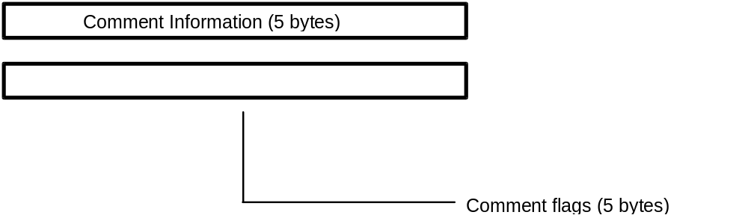

Item | Length | Range | Note
Comment flags | 5 | Format: ‘00000’
Table 11: Format of comment information

See chapter 7 for examples.

19 Composition of Result Data for Routine, Rerun, STAT and Control samples
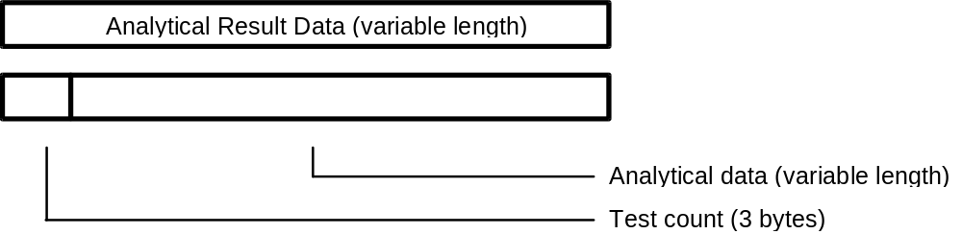

Item | Length | Range | Note
Test count | 3 | Format: ccc  Range: bb0 - b51 | 1
Result[n]  with n=1 to ‘Test count’ | 10 each | Format: cccvvvvvva  ccc: Test no.  Range:  bb1 - b36 Photometry assay  b38 - b40 Electrolyte  b41 - b43 Serum index  b44 - b51 Calculated tests  vvvvvv: Result value  a: Data alarm  Refer to the data alarm list  (see Table 20) | 2
Table 12: Format of analytical result data / b = space (20H)
Note 1: The AU transfers data for up to 36 tests respectively for simultaneous measurement in real-time and batch communication .
The results of the electrolytes (three tests of Na, K and Cl) are transfered with the test numbers 38 to 40, the results of serum indexes (three tests of lipemia, hemolysis and icterus) with the test numbers 41 to 43.
The results of the max. eight calculated tests are transfered with the test numbers 44 to 51.
Note 2: Format of the 6-character result value field:
Pos/Neg. | Decimal Point | Max.Digits | Example
Positive | absent | 6 | 123456
 | present | 5 | 123.45
Negative | absent | 5 | -12345  bb-123
 | present | 4 | -12.34  b-12.3
Table 13: Format of measured value / b = space (20H)

Text Size Limitation:
Since the maximum text size may be 256 or 512 bytes (selectable on Com. Parameters screen / see Figure 4 on page 13) it can happen that the analytical data text has to be divided into several (up to 3) frames depending on the text size and the number of test results.

 | Text Size | 256 bytes | 512 bytes
 | Max. no. of test results in one frame | 20 | 46
 | Tests in FR1 or END | 1 to 20 | 1 to 46
 | Tests in FR2 or END | 21 to 40 | 47 to 51
 | Tests in END | 41 to 51
Table 14: No. of test results per frame according to the text size.
The maximum number of transferable test results in one frame is calculated with the following expression:

max. no. of test results < (Text Size - 48) / 10 (Round off fractions)

20 Absorbance Data
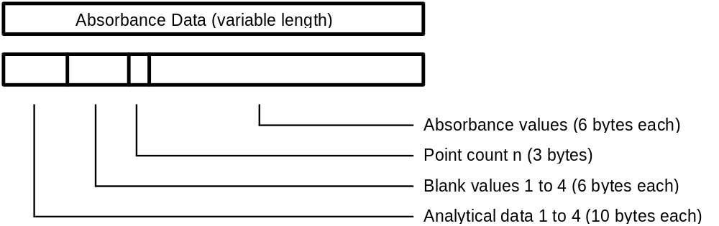

Item | Length | Range | Note
Analytical data [n]  with n=1 to 4 | 4 * 10 | Format: cccvvvvvva  ccc: Channel no.  vvvvvv: Result value  a: Data alarm  Refer to the data alarm list  (see Table 20) | 1
Blank data [n]  with n=1 to 4 | 4 * 6 | Format: cccccc | 2
Point count | 3 | Format: ppp  Range: n = bb0 - b35 | 3
Absorb. data [n]  with n=1 to ‘Point count’ | n * 6 | Format: aaaaaa /-aaaaa | 4
Table 15: Format of absorbance data / b = space (20H)
Note 1: If two-channel simultaneous measurement is specified, data for two channels is transfered. If serum index measurement is specified, data for up to four channels (1 channel + L, H, I) is transmitted.
If there is no relevant test for analytical data, 10 spaces are transmitted.
Note 2: The first value is the 'Stopped cell blank', the following three values are the 'Passed cell blanks'. The values are transmitted according to the analytical method of this test.
The unit for the cell blank data is 10-4 (10E-4) absolute. An integer is transmitted preceded by space with floating sign position.
Note 3: The point count is the number of photometric points which follow the point count information. The following values may occur:

 | Reaction time [min] | 3 | 4 | 5 | 10
 | Point Count | 11 | 14 | 17 | 35
Table 16: Reaction Times

Note 4: The absorbance data in the entire reaction monitoring system (data at each photometric point) is transmitted in the same format as for the above cell blank data. When the point count is less than 35, the data is closely transmitted in sequence starting from ABS 1.

Text Size Limitation:
Since the maximum text size may be 256 or 512 bytes (selectable on Com. Parameters screen / see Figure 4 on page 13) it can happen that the absorbance data text has to be divided into 2 frames depending on the text size and the number of absorbance values.

 | Text Size | 256 bytes | 512 bytes
 | ABS values in FR1 or END | 1 to 24 | 1 to 35
 | ABS values in END | 25 to 35
Table 17: No. of absorbance values per frame according to the text size.
The sample information is sent in each frame; the analytical data and blank values are only sent in the first frame.

See chapter 7 for examples.

Photometric Points

# | (sec) | Remarks | # | (sec) | Remarks
 | 0,00 | Sample pipetting  R1 pipetting and stirring
1 | 4,14 |  | 19 | 317,70
2 | 22,00 |  | 20 | 335,56
3 | 39,86 |  | 21 | 353,56
4 | 57,73 |  | 22 | 371,29
5 | 75,59 |  | 23 | 389,16
 |  | R2 pipetting and stirring | 24 | 407,02
6 | 93,46 |  | 25 | 424,88
7 | 111,32 |  | 26 | 439,40
8 | 129,18 |  | 27 | 457,13
9 | 142,53 |  | 28 | 492,99
10 | 160,39 |  | 29 | 510,86
11 | 178,26 | 3 min | 30 | 528,72
12 | 196,12 |  | 31 | 546,68
13 | 213,98 |  | 32 | 564,45
14 | 228,38 | 4 min | 33 | 582,31
15 | 246,24 |  | 34 | 600,18
16 | 264,11 |  | 35 |  | 10 min
17 | 281,97 | 5 min
 |  | R3 pipetting and stirring
18 | 299,84

21 Photometry-assay Calibration Data
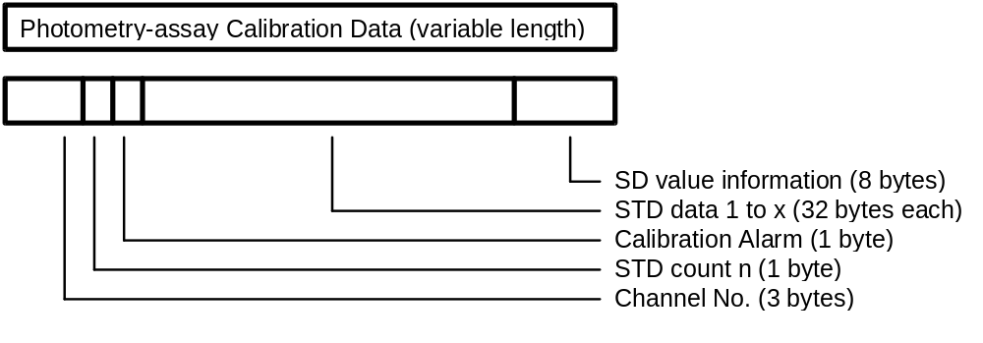

Item | Length | Range | Note
Channel no. | 3 | Format: ccc  Range: bb1 - b36 | 1
STD count | 1 | Format: n  No. of standards according to the calibration method  Range: n = 1 - 6 | 2
Calib. alarm | 1 | Format: a  Refer to the data alarm list  (see Table 20) | 3
STD[n]  with n=1 to ‘STD count’ | 32 each | Format: kaaaaaaddddddbbbbbb  eeeeeeupppppp  k: STD no.; Range: 1 - 6  aaaaaa 1st absorbance data  dddddd 1st initial absorbance data  bbbbbb 2nd absorbance data  eeeeee 2nd initial absorbance data  u data alarm  Refer to the data alarm list  (see Table 20)  pppppp Prozone value | 4  3
SD value | 8 | Format: pvvvvvvd  p 'Y' = SD value present  'N' = SD value absent  vvvvvv SD value  d decimal point position | 5
Table 18: Format of photometry-assay calibration data / b = space(20H)

Note 1: The test code in photometry-assay calibration which corresponds to the test code in the AU.
Note 2: When the STD count is 1, STD data 1 is followed by SD value information.
Note 3: Refer to the data alarm list (see
Note 4: Each standard is measured twice. (1st and 2nd abs. values). The 1st and 2nd absorbance values are the results of the bichromatic measurements at the corresponding measuring point; the initial absorbance values are the results of the monochromatic measurements with only the main wavelength. (Each standard is measured with two different wavelengths).
Each absorbance data is right-justified and preceded by space. The unit is 10-4 (10E-4) absolute. It is a 6-digit integer with sign.
Note 5: The SD value is only calculated for nonlinear and linear multi-point calibrations (3 to 6 standards). It is right-justified and preceded by space. It has no unit and the decimal point position can be set with the Test Parameters option on Param. è Test Param. screen. (SD limit is parameter no. 44)
If the SD value is absent, spaces are given instead of SD value and decimal point position.

See chapter 7 for examples.

22 ISE Calibration Data
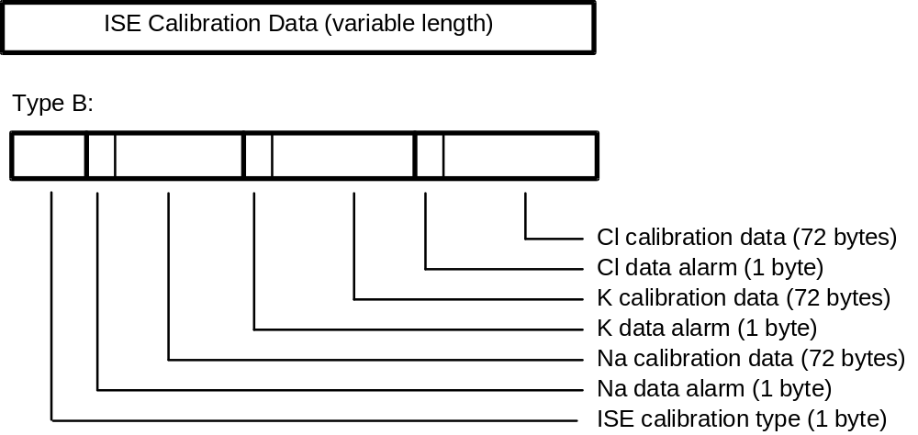

Item | Length | Range | Note
ISE type | 1 | Format: p  'B' : Tests Na, K, Cl (n = 3)
Data alarm[i]  +  Calib. data [i]  with i=1 to n | 1  8 * 9 each | Format: a  Refer to the data alarm list (see Table 20)  Format ddvvvvvva  dd: Data identification  Range: b1 - b8  vvvvvv: measured value  a: data alarm  Refer to the data alarm list  (see Table 20) | 1
Table 19: Format of ISE calibration data / b = space(20H)
Note 1: For each of the three tests NA, K, Cl, the following eight data items are transmitted:
- electromotive force of internal standard solution
- electromotive force of LOW solution
- electromotive force of HIGH solution
- electromotive force of M solution
- slope level for display
- concentration of internal standard solution
- concentration of M solution
- compensation factor
The unit for the measured value is mV. It has a sign and a decimal point. Spaces are given, when there is no relevant data.

See chapter 7 for examples.

23 Data Alarm List
No. | Data Alarm Name | Printer | CRT | I/F | Photometry Assay |  |  | ISE |  |  |  | Note
 |  |  |  |  | R/S | C | Std |  | R/S | C | Std |  | 1
1 | ADC abnormal | ADC? | A | A | o | o | o |  | o | o | o
2 | Cell blank abnormal | CELL? | Q | Q | o | o | o
3 | Sample short | SAMPLE | V | V | o | o | o |  | o | o | o |  | 2
4 | Reagent short | REAGN | T | T | o | o | o
5 | Absorbance over | ABS? | Z | Z | o | o | o
6 | PROZONE error | *****P | P | P | o | o | o
7 | Reac limit over at all points | LIMT0 | I | I | o | o | o
8 | Reaction limit over except at 1 point | LIMT1 | J | J | o | o | o
9 | Reaction limit over except at 2 or 3 points | LIMT2 | K | K | o | o | o
10 | Linearity abnormal for 9 points or more | LIM. | W | W | o | o | o
11 | Linearity abnormal for 8 points or less | LIM.8 | F | F | o | o | o
12 | Standard 1 absorbance abnormal | S1ABS? |  | H |  |  | o
13 | Duplicate error | DUP |  | U |  |  | o
14 | STD error | STD? |  | S |  |  | o |  |  |  | o
15 | Sensitivity error | SENS |  | Y |  |  | o
16 | Calibration error | CALIB |  | B |  |  | o |  |  |  | o
17 | SD error | SD? |  | G |  |  | o
18 | Noise error | NOISE | N | N |  |  |  |  | o | o | o
19 | Level error | LEVEL | L | L |  |  |  |  | o | o | o
20 | Slope error | SLOPE? |  | E |  |  |  |  |  |  | o
21 | Internal standard concentration error | I.STD |  | D |  |  |  |  |  |  | o
22 | Sample value abnormal | R.OVER | & | & |  |  |  |  | o | o
23 | Test-to-test comp. error | CMT.T | C | C | o | o |  |  | o | o
24 | Test-to-test compensation disabled | CMT.T! | M | M | o | o |  |  | o | o |  |  | 2
25 | Calculation test error | CALC? | % | % | o |  |  |  | o
26 | Overflow | OVER | O | O | o | o |  |  | o | o |  |  | 2
27 | Calculation disabled | ??? | X | X | o | o | o |  | o | o | o |  | 2
28 | Expected value high limit over | H |  |  | o | o |  |  | o | o |  |  | 3
29 | Expected value high limit over | L |  |  | o | o |  |  | o | o |  |  | 3
Table 20: Data alarm list

Note 1. R/S = Routine/STAT C = Control Std = Calibration
Note 2. Data is left blank
Note 3. May concur with other alarm
Note: When two or more data alarms are given for a single data item, the one registered first is output.

24 End-of-data Code
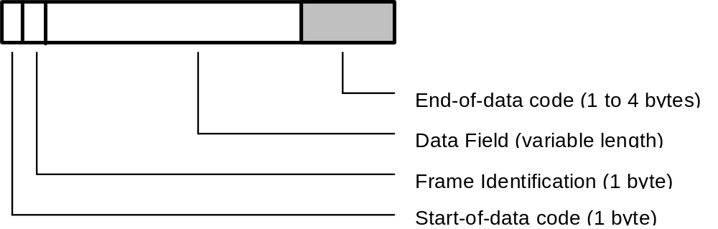

The End-of-data code represents the end of each text that is sent from the AU or the host.

25 End-of-data Code Options
There are five options which can be set on the Com. Parameters screen.

No | Code | ASCII | Bytes
1 | [ETX][BCC] | 03H [BCC] | 2
2 | [CR][LF][ETX] | 0DH 0AH 03H | 3
3 | [ETX] | 03H | 1
4 | [ETX][CR][LF] | 03H 0DH 0AH | 3
5 | [ETX][CKSH][CKSL][CR] | 03H [high][low] 0DH | 4
Table 21: End-of-data codes

26 Checksum Calculation Methods
[BCC] = Block Check Character
The calculation is made as follows:
All characters excluding [STX] and including [ETX] are XOR accumulated. This results in the BCC character (with code in the range 00H to FFH).
Example:
SPE from AU to HOST:
Routine Sample, with barcode reader
Position: 1, Ident No.: 000383

[STX];A·········1·······000383···············[ETX]’
BCC-calculation result = 60hex / check-string = "‘"

[CKSH][CKSL] = Checksum high/low
The calculation is made as follows:
The checksum is generated as the elementary sum of all data bytes excluding [STX] and [ETX]. The result of the calculation is a 4-digit hexadecimal value. The two low order digits of that number are converted to ASCII characters. These two characters build the checksum high/low.
Example:
SPE from AU to HOST:
[STX];A·········1·······000383···············[ETX]BB[CR]
Checksum-calculation result = BBhex / check-string = "BB"

Each character · in the above examples represents for a space (code 20hex)

27 Data Transmission Control Procedure

28 Establishment of Data Link
After activating the Host communication on the Start Condition screen, the AU transmits the ANY frame to the host. Communication is started from this point. The host has to answer within the communication cycle time, usually with a MOR frame.
x seconds after the receipt of the MOR frame, the AU sends the next ANY frame to the host. (x is the communication cycle time which can be set on the Com. Parameters screen)
In subsequent steps, the AU and the host continue transmission alternately.
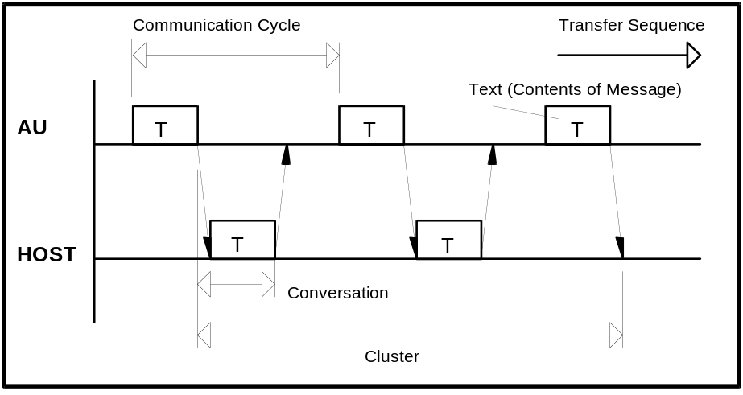
Figure 8: Common communication timing
Conversation One message sent from the host or the AU
Communication cycle One request from the AU with the corresponding answer
from the host
Cluster A group of conversations between the AU and the host

29 Response to Information Message
After receiving information, the receiver sends a response to inform the sender of the receiver status and the validity of received information.
The format of the various messages is described above. When the 256 or 512-byte mode is selected for the transmitted byte count, the analytical data text may exceed 256 or 512 bytes (including start-of-data code and end-of-data code) according to the sample. In this case, the analytical data text is divided. The frame character identifies each text part.
The AU continues replying as far as the host returns a response. Even when the text, corresponding to an optional frame character is transmitted and there is no more data to be sent between the AU and host, they continue sending the ANY frame and MOR frame respectively. However, the cluster is restarted immediately if analytical data transfer, test selection directive or any other transfer is requested.
After sending a text, the host should avoid sending until reception of a response or request to/for the next in a normal condition. Otherwise the AU will output an alarm.
In transfer from the host to the AU, a pause of at least 100 msec is required.
If no response is returned or an invalid response is received, the recovery procedure is executed. In case of sending from the host, the host must always be kept ready for receiving the response.
Described below are the typical procedure for returning a response to the information message and the procedure upon receiving the response.

30 No Information to be sent
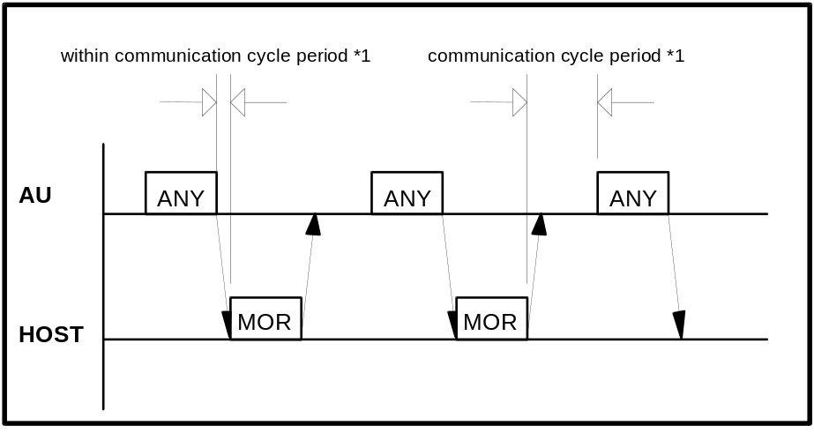
Figure 9: Communication timing without information exchange
*1: The communication cycle period can be adjusted (2 to 10 seconds / default = 2 seconds) on the Com. Parameters screen (see Figure 4 on page 13).

The AU continues returning the ANY frame in response to the MOR frame from the host. This procedure continues even when the AU and host have no information to be sent. Following conditions must be satisfied:
a) There is no test selection information to be sent to the host.
b) Analytical data is not output in the real time mode.
c) There is no request for the RES frame.
In this case, the AU sends the ANY frame one communication cycle time after receiving the MOR frame from the host (a point when the final end-of-data code is recognized).
After receiving a frame from the AU, the host should return a response as soon as possible. If it cannot respond within the communication cycle time, Host must transmit a SUS frame to the AU.

31 Transfer of Communication Control Message
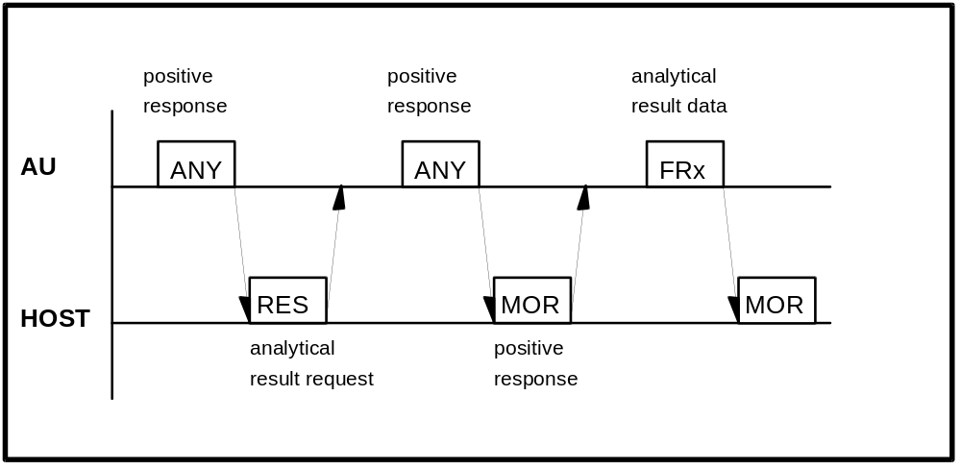
Figure 10: Transfer of communication control message

The RES, ANY, MOR, REP, SUS, REC frames are available for the communication control message.
For details, refer to the Frame types in Table 5 on page 19.

32 Transfer of Test Selection Information
(a) Test selection directive from the host to the AU (batch mode)
Usually the host will send test selections in advance of the sample's arrival on the analyzer. The host can send the test selection packet in response to the ANY frame from the AU.

(b) Test selection inquiry from the AU to the host (realtime mode)
If the test selection is not sent by the host, the AU can ask for specific test selections from the host. The test selection inquiries are sent to the host when samples are ready for processing and no test selections are available at the AU or the ‘Simul. Inquiry’ option is enabled on the Com. Parameters screen (see Figure 4 on page 13). This case is shown in Figure 11.

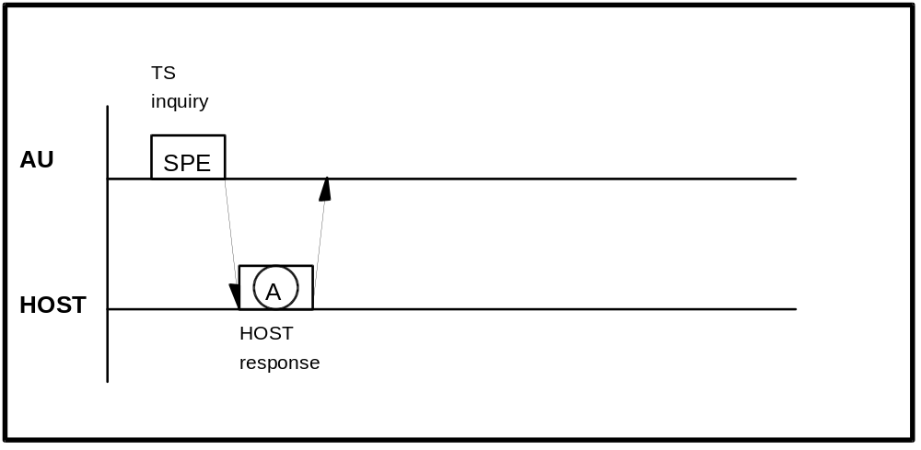
Figure 11: Test selection inquiry
The possible host responses to the specific test selection inquiry are listed in Table 22.

Frame A | Description
SPE | Respond with test selection for the sample requested. If the test selection is received correctly and in time, then this test selection will be used for the sample. If the test selection is not received, then the Default test selection will be used if one has been configured by the operator. If no Default test selection has been configured, then the sample will be skipped.
MOR | The host indicates that it cannot respond to test selection information inquiry but is ready to receive analytical data.
REC | The host indicates that it wants to suspend the communication with the AU for a specified time because it is neither possible to respond to test selection inquiry nor possible to receive analytical data.
Table 22: Host response to test selection inquiry

33 Transfer of Result Data
(a) Result request with the RES frame from the host to the AU
The host can make a request to the AU for the analytical data of a specific sample by use of the RES frame. The request could be for results which have not been received yet or for results which the AU has already sent.
The AU will respond with the ANY frame, to indicate that the request was received. The result will be returned to the host. If the AU cannot find the requested sample's result, no response will be given to the host to indicate this. The request was accepted by the AU, but this does not mean that the result is available to the AU.
The AU will store up to ten requests in an internal buffer. This buffer is periodically checked by the AU. The buffer will only hold ten requests, and subsequent requests are ignored. A request slot is cleared when the corresponding result is sent. All slots are cleared when the system is reset by switching off/on.
Because of the limit of ten slots, the host should be circumspect about using this feature. If requests are made for samples that do not exist, the request will never be fulfilled, and if all slots are used, this feature will become essentially disabled. This feature needs not to be implemented because the AU sends the result in realtime as soon as possible after completion.

(b) Result transfer from the AU to the host
The target is of course, getting results back to the host. For this the AU uses result frames.
There are three cases for result-sending:
- Real-time mode
the results are sent as soon as they are available at the AU side. This is the normal way.
- Batch mode
the results are transfered manually by the operator (see the [Monitor] screen)
- After result request
this method is described above (see (a)).

Figure 12 shows the result transmission procedure in normal case and in Table 24 the possible host responses to result frames are listed.
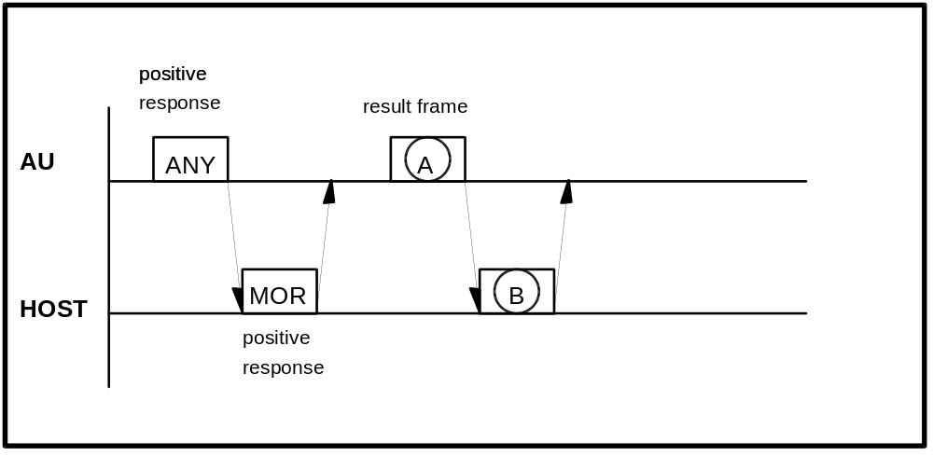
Figure 12: Result transmission

Frame A | Description
FR1, FR2, END | Analytical data (including calibration and absorbance result)
Table 23: AU result frames FR1, FR2, END

Frame B | Description
REP | when text in A is abnormal
MOR | to receive analytical data next time also
REC | to direct test selection
SUS | to suspend communication
SPE | to indicate test selection
RES | to request a specific sample
Table 24: Host response to FR1, FR2, END

Transmission Procedure in Special Case.
Results from a patient's sample can be sent in up to three result frame packets (depending on the number of results and the maximum text length). Each frame requires a MOR from the host before the next frame will be sent. Ideally, the AU will try to transfer all packets for a sample without sending any other type of packet. There are instances, such as the analyzer needing test selection information, in which the AU can afford to wait for the current sample's result frames to transfer. One effect of this system is, that there is no delay for SPE frames. This case is shown in Figure 13.
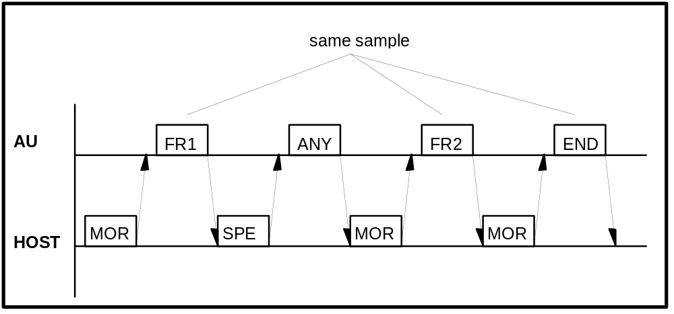
Figure 13: Result transmission with three frames and SPE interrupt

34 Resending Request
If there is any abnormality in the contents of the text received from the AU or the host, resending is requested with the REP frame. Figure 14 shows this procedure if the AU sends the REP frame; in Figure 15 the host sends the REP frame.
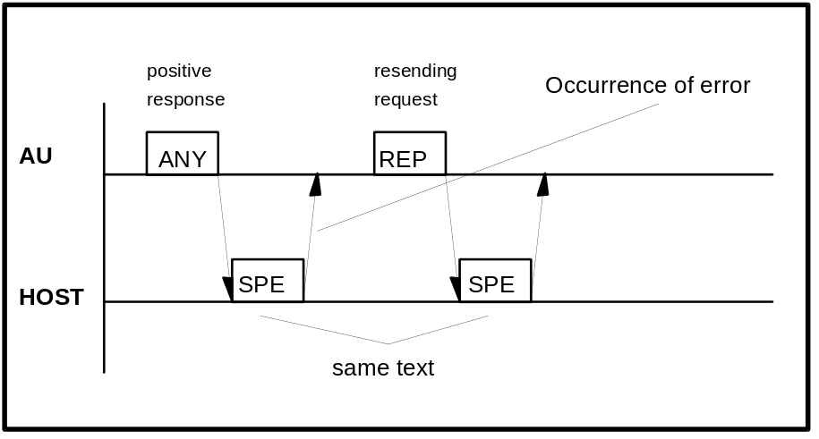
Figure 14: Resending request with REP frame from AU to host
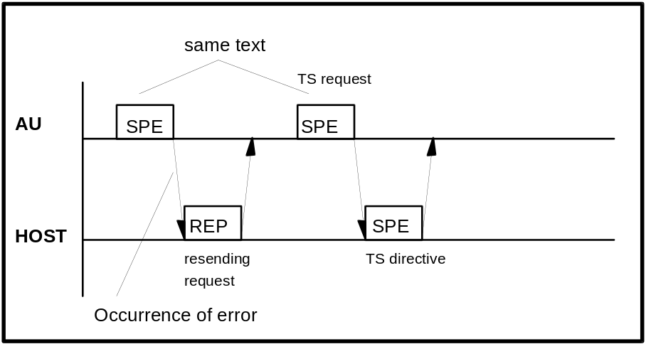
Figure 15: Resending request with REP frame from host to AU

35 Host sends SUS and REC frames
The SUS frame is sent to the AU to request a communication interruption within regular communication session. The AU detects failure of transmission to Host and when communication is resumed by Host sending MOR and the last transmitted text was an analytical data text, the AU retransmits the same text to resume the communication.
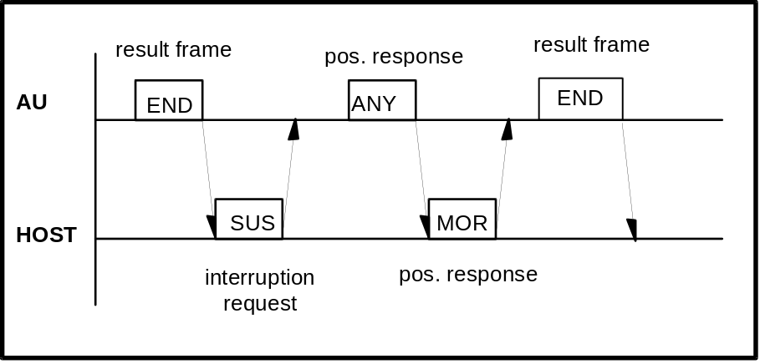
Figure 16: Host sends the SUS frame
The REC frame is sent to the AU to request a communication interruption within regular communication session. The AU detects successful transmission of the last transmitted analytical data and does not resend the text upon the reception of the MOR frame from the Host.
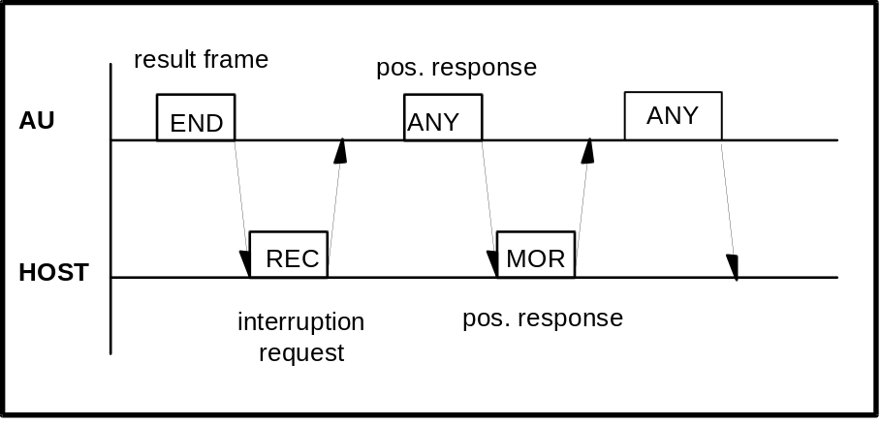
Figure 17: Host sends the REC frame

36 Termination and Restart of Communication

Condition of Termination | Real-time  Communication | Batch  Communication | Restart of Communication
Change from YES to NO for  ‘Host Communication’ on the Start Condition screen | STOP | STOP | Change from NO to YES for ‘Host Communication’  Previous contents of com-munication are all canceled.
Occurrence of send/receive time-out error  Host did not respond within specified time | STOP | STOP | Same as above
Occurrence of hardware error alarm related to communication | STOP | STOP | Same as above
Occurrence of FD read error during sending of analytical data to the host |  | STOP | Remaining samples in specified range are not sent.  Upon restart, samples in newly specified range are sent.
Stop directive through screen during sending of analytical data to the host |  | STOP * | Same as above
Occurrence of FD read error during transfer of analytical data for specific sample to the host |  |  | Relevant sample alone is canceled.
Detection of abnormality in text (discrepancy in end-of-data code between AU and host for example) |  |  | ----------
Occurrence of E. STOP-Level alarm at AU side  AU shifts to sleep mode |  |  | ----------
Table 25: Termination and restart of communication
Note*:
Transfer of analytical data is stopped regardless of sample type (Routine or control sample).

37 Retry of Communication
If the host does not respond to a frame within the communication cycle time, the AU continues sending the last frame that was not acknowledged by the host. On the Com. Parameters screen (see on page 13) the number of these retries to re-establish the data link (‘Retry’ option) can be set from ‘1’ to ‘4’. Also the time between these retries (‘Retry Time’ option) can be set from ‘1’ to ‘4’ seconds on this screen.
After the last retry without host answer the AU issues the warning 126-01 (“A reception timeout has occurred“) and switches off the communication.

38 Result-Only mode
In this mode, analytical data alone is transmitted to the host and resending request (REP frame) from the AU or host or response to specific sample request is not made.
If the ‘Result Only’ option is selected on the Com. Parameters screen (see Figure 4 on page 13), the AU does not send test selection inquiries or accept test selection directive. The AU waits for one second or more after sending ETX in the analytical data text and proceeds to transfer to the host regardless of the communication procedure (realtime or batch result transmission).
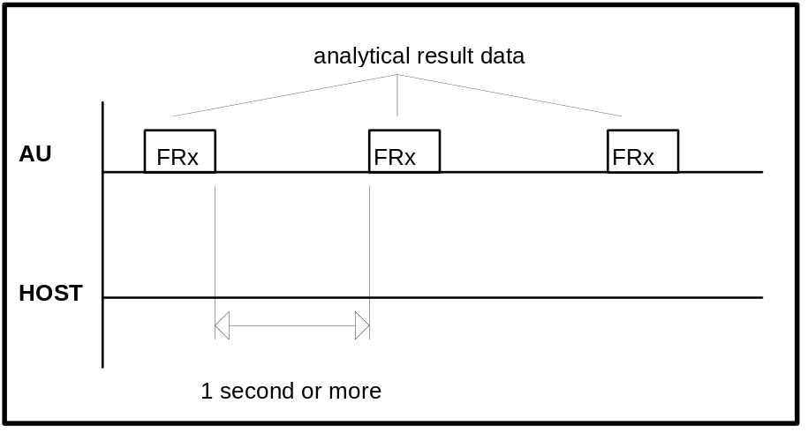
Figure 18: Timing in case of ‘Result Only’ option selected

39 Communication Functions

40 Function List for Test Selection Data
Function |  | Inquiry | Directive | Conditions
Routine sample |  |  |  | Invalid when ‘Result Only’ mode is selected on Com. Parameters screen (see Figure 4 on page 13)
STAT  sample | with ID |  |  | Valid when ‘STAT Inquiry’ option is selected on Com. Parameters screen
 | without ID |  |  | Invalid when ‘Result Only’ mode is selected on Com. Parameters screen
Table 26: Function list for test selection data

41 Function List for Result Data
Function | Real-time  Communication | Batch  Communication | Specific  Sample  Request  from host | Conditions
Routine sample |  |  |  | Specific sample request is invalid when ‘Result Only’
STAT sample |  |  |  | mode is selected on Com. Parameters screen
Control sample |  |  |  | (see Figure 4 on page 13)
Calibration
Original absorbance |  |  |  | Available only if ‘Original ABS’ is enabled on Param. -> System > Original ABS screen
Table 27: Function list for result data
Comments:
- If ‘Original ABS’ is enabled there is no test selection inquiry sent from analyzer to host.
- The above real-time communication indicates a communication carried out while the instrument is busy in analysis, and the batch communication indicates a communication when specified through the screen.
- Batch result communication is initiated on the following screens ...
Monitor è Routine samples è Send for Routine results (no. 1 to 400)
Monitor è STAT samples è Send for STAT results (no. 1 to 50)
Monitor è Control samples è Send for Control results (no. 101 to 530)

42 Communication Log

43 Overview
If enabled on the Com. Parameters screen (option ‘Com. Trace’ / see Figure 4 on page 13) the contents of the communication between the AU and host is stored on the system disk. To check the contents of communication, the stored data can be output onto the printer.

44 Trace Data
The time of communication execution, the direction of communication and the contents of the message are stored.
The data to be stored differs between the following two cases:
a) In normal communication.
The frame and function character and the sample information are stored.
Storage is made according to the following rule:
1) Text without function character
Frame character and one character after it (2 characters)
2) Photometry-assay calibration text
Frame and function char., channel and STD count and calib. alarm (8 characters)
3) ISE calibration text
Frame and function character, ISE type (4 characters)

b) Upon Occurrence of any error during communication.
The details of the error and all characters up to occurrence of the error are stored.
Note, however, that only the frame character, function character and sample information are stored the same as in normal communication if send time-out occurs during sending from the AU to the system.

45 Reset and Printout of Trace Data
To print or delete the trace data file, select the ‘Com. Trace’ option on the Tools screen and select [Print] or [Delete] mode; then press the [Start] button.

46 Trace Data Storing Capacity
Data of up to 1200 cycles (conversation) can be stored.

47 Other
Communication trace data is not stored under the following conditions:
- During printout of communication data
- During deletion of communication trace data

48 Example Traces

Example 1: Test Selection inquiry / Test selection / Result
Example 2: Absorbance data from AU to host
Example 3: Photometry assay Calibration data from AU to host
Example 4: ISE Calibration data from AU to host
Example 5: Control data from AU to host
Example 6: Specific Result Request from host to AU

Common explanations for the following HIT 902 trace lists:
Format
1st column Sender of text (AU=Analyzer Unit)
2nd column Sending time
3rd column Trace data

Replacement of Control charcters
Mnemonic meaning replaced ASCII code
[STX] start of text 02H
[ETX] end of text 03H
[CR] carriage return 0DH
· space 20H

Table 28: Communication trace details
The communication trace was aquired with the Interface Testprogram 'HOST902.EXE' (developed by the Technical Productmanagement / Data Technique department)

49 Test Selection Inquiry from AU to host incl. Result

AU 14:44:00,39 [STX]>[ETX]{3Dh}
Host 14:44:00,39 [STX]>[ETX]{3Dh}

AU 14:44:02,03 [STX];A·········3·······000456···············[ETX]{6Dh}
Host 14:44:02,08 [STX];A·········3·······000456················37100000000
011000000000000000000000000000000[ETX]{48h}

AU 14:44:02,26 [STX]>[ETX]{3Dh}
Host 14:44:02,30 [STX]>[ETX]{3Dh}

...

AU 14:58:11,07 [STX]>[ETX]{3Dh}
Host 14:58:11,07 [STX]>[ETX]{3Dh}

AU 14:58:12,50 [STX]:A·····3···3·······000456·················3··1···0.2
··11·-0.04··12·-0.25·[ETX]{51h}
Host 14:58:12,55 [STX]>[ETX]{3Dh}

AU 14:58:14,37 [STX]>[ETX]{3Dh}
Host 14:58:14,37 [STX]>[ETX]{3Dh}

Text format of example 1a: Test Selection Inquiry from the AU

The AU sends a test selection inquiry in realtime mode.
(each character · stands for a space - ASCII code 20h)

AU 14:44:02,03 [STX];A·········3·······000456···············[ETX]{6Dh}

 | [STX]  ;  A  ·  ·····  ·  ··3  ·······000456  ···············  [ETX]  {6Dh} | Start of text (ASCII code 02H)  Frame character : ; for TS inquiry  Function character: A for  - routine sample  - with barcode reader  - realtime communication  1 space  Sample number :  1 space  Position : 3  Ident-No : 000456  15 spaces  End of text (ASCII code 03H)  Hex. character code of block check character

Text format of example 1b: Test Selection information from host to AU

The host sends test selection information as answer to the request from the AU.
(each character · stands for a space - ASCII code 20h)

Host 14:44:02,08 [STX];A·········3·······000456················37100000000
011000000000000000000000000000000[ETX]{48h}

 | [STX]  ;  A  ·  ·····  ·  ··3  ·······000456  ···············  ·37  1000000000  1100000000  0000000000  0000000  00000  [ETX]  {48h} | Start of text (ASCII code 02H)  Frame character : ; for TS information  Function character: A for  - routine sample  - without barcode reader  - realtime communication  1 space  Sample number :  1 space  Position : 3  Ident-No : 000456  15 spaces  Test count : 37  Test flags : test no. 1, 11, 12 selected  Comment flags : all 0 (=> no comments)  End of text (ASCII code 03H)  Hex. character code of block check character

Text format of example 1c: Routine results from AU to host

The AU sends test results in realtime mode.
(each character · stands for a space - ASCII code 20h)

AU 14:58:12,50 [STX]:A·····3···3·······000456·················3··1···0.2
··11·-0.04··12·-0.25·[ETX]{51h}

 | [STX]  :  A  ·  ····3  ·  ··3  ·······000456  ···············  ··3  ··1  ···0.2  ·  ·11  ·-0.04  ·  ·12  ·-0.25  ·  [ETX]  {51h} | Start of text (ASCII code 02H)  Frame character : : for result  Function character: A for  - routine sample  - with barcode reader  - realtime communication  1 space  Sample number : 3  1 space  Position : 3  Ident-No : 000456  15 spaces  Result count : 3  1. Result  Test no. : 1  Result : 0.2  Alarm : no alarm  2. Result  Test no. : 11  Result : -0.04  Alarm : no alarm  3. Result  Test no. : 12  Result : -0.25  Alarm : no alarm  End of text (ASCII code 03H)  Hex. character code of block check character

50 Absorbance data from AU to host

AU 15:59:58,32 [STX]>[ETX]{3Dh}
Host 15:59:58,32 [STX]>[ETX]{3Dh}

AU 15:59:59,37 [STX]1I·····6···1·······000383·················1···0.0···
······························7144··7158··7164··7172·24··
·188···160····50····46····73··5309··5240··5240··5248··524
9··5255··5253··5253··5252··5252··5249··5254··5253··5254··
5254··5253··5253··5254··5254[ETX]{46h}
Host 15:59:59,48 [STX]>[ETX]{3Dh}

AU 15:59:59,64 [STX]:I·····6···1·······000383················11··5250··5
249··5253··5253··5253··5255··5257··5255··5257··5253··5252
[ETX]{57h}
Host 15:59:59,69 [STX]>[ETX]{3Dh}

AU 16:00:04,69 [STX]>[ETX]{3Dh}
Host 16:00:04,69 [STX]>[ETX]{3Dh}

Text format of example 2: Original absorbance data from AU to host (1. frame)
Since max. text length was set to 256 characters, the absorbance data was transfered in two frames.

The AU sends absorbance data in realtime mode.
(each character · stands for a space - ASCII code 20h)

AU 15:59:59,37 [STX]1I·····6···1·······000383·················1···0.0···
······························7144··7158··7164··7172·24··
·188···160····50····46····73··5309··5240··5240··5248··524
9··5255··5253··5253··5252··5252··5249··5254··5253··5254··
5254··5253··5253··5254··5254[ETX]{46h}

 | [STX]  1  I  ·  ····6  ·  ··1  ·······000383  ···············  ··1  ···0.0  ·  ··········  ··········  ··········  ··7144  ··7158  ··7164  ··7172  ·24  ···188  ···160  ····50  ····46  ····73  ··5309  ··5240  ··5240  ··5252  ··5249  ··5254  ··5253  ··5253  ··5252  ··5252  ··5249  ··5254  ··5253  ··5254  ··5254  ··5253  ··5253  ··5254  ··5254  [ETX]  {46h} | Start of text (ASCII code 02H)  Frame character : 1 for 1. result frame  Function character: I for  - Absorbance data (Routine)  1 space  Sample number : 6  1 space  Position : 1  Ident-No : 000383  15 spaces  Analytical data 1  Test no. : 1  Result : 0.0  Alarm : no alarm  no 2. Result  no 3. Result  no 4. Result  Blank value 1  Blank value 2  Blank value 3  Blank value 4  Point count : 24  ABS value 1 : 188  ABS value 2 : 160  ABS value 3 : 50  ABS value 4 : 46  ABS value 5 : 73  ABS value 6 : 5309  ABS value 7 : 5240  ABS value 8 : 5240  ABS value 9 : 5252  ABS value 10 : 5249  ABS value 11 : 5254  ABS value 12 : 5253  ABS value 13 : 5253  ABS value 14 : 5252  ABS value 15 : 5252  ABS value 16 : 5249  ABS value 17 : 5254  ABS value 18 : 5253  ABS value 19 : 5254  ABS value 20 : 5254  ABS value 21 : 5253  ABS value 22 : 5253  ABS value 23 : 5254  ABS value 24 : 5254  End of text (ASCII code 03H)  Hex. character code of block check character
Text format of example 2: Original absorbance data from AU to host (2. frame)
Since max. text length was set to 256 characters, the absorbance data was transfered in two frames.

The AU sends absorbance data in realtime mode.
(each character · stands for a space - ASCII code 20h)

AU 15:59:59,64 [STX]:I·····6···1·······000383················11··5250··5
249··5253··5253··5253··5255··5257··5255··5257··5253··5252
[ETX]{57h}

 | [STX]  :  I  ·  ····6  ·  ··1  ·······000383  ···············  ·11  ··5250  ··5249  ··5253  ··5253  ··5253  ··5255  ··5257  ··5255  ··5257  ··5253  ··5252  [ETX]  {57h} | Start of text (ASCII code 02H)  Frame character : : for final result frame  Function character: I for  - Absorbance data (Routine)  1 space  Sample number : 6  1 space  Position : 1  Ident-No : 000383  15 spaces  Point count : 11  ABS value 25 : 5250  ABS value 26 : 5249  ABS value 27 : 5253  ABS value 28 : 5253  ABS value 29 : 5253  ABS value 30 : 5255  ABS value 31 : 5257  ABS value 32 : 5255  ABS value 33 : 5257  ABS value 34 : 5253  ABS value 35 : 5252  End of text (ASCII code 03H)  Hex. character code of block check character

51 Photometry-assay Calibration data from AU to host

AU 10:21:25,55 [STX]>[ETX]3E[CR]
Host 10:21:25,55 [STX]>[ETX]3E[CR]

AU 10:21:26,66 [STX]:G··122·1·-1043···628·-1039···618······02···757··250
6···759··2513······0N·······[ETX]35[CR]
Host 10:21:26,71 [STX]>[ETX]3E[CR]

Text format of example 3:

AU sends Photometry assay Calibration data in realtime mode.

AU 10:21:26,66 [STX]:G··122·1·-1043···628·-1039···618······02···757··250
6···759··2513······0N·······[ETX]35[CR]

 | [STX]  :  G  ·  ·12  2  ·  1  ·-1043  ···628  ·-1039  ···618  ·  ·····0  2  ···757  ··2506  ···759  ··2513  ·  ·····0  N  ······  ·  [ETX]  35  [CR] | Start of text (ASCII code 02H)  Frame character: data frame  Function character: Photom. cal data  Space  Channel : 12  No. of standards : 2  Calibration alarm  STD No. 1  1st absorbance data  1st initial absorbance data  2nd absorbance data  2nd initial absorbance data  data alarm  Prozone value  STD No. 2  1st absorbance data  1st initial absorbance data  2nd absorbance data  2nd initial absorbance data  data alarm  Prozone value  N for 'no SD value'  value  decimal point position  End of text (ASCII code 03H)  Checksum  Carriage return (ASCII code 0DH)

52 ISE Calibration data from AU to host

AU 10:16:01,78 [STX]>[ETX]3E[CR]
Host 10:16:01,78 [STX]>[ETX]3E[CR]

AU 10:16:06,60 [STX]:H·BS·1·-51.7··2······V·3······V·4······V·5······E·6
······D·7······X·8······XS·1·-53.6··2······V·3······V·4··
····V·5······E·6······D·7······X·8······XS·1·111.0··2····
··V·3······V·4······V·5······E·6······X·7······X·8······X
[ETX]F0[CR]
Host 10:16:06,71 [STX]>[ETX]3E[CR]

Text format of example 4:

Analyzer sends ISE Calibration data in realtime mode.

AU 10:16:06,60 [STX]:H·BS·1·-51.7··2······V·3······V·4······V·5······E·6
······D·7······X·8······XS·1·-53.6··2······V·3······V·4··
····V·5······E·6······D·7······X·8······XS·1·111.0··2····
··V·3······V·4······V·5······E·6······X·7······X·8······X
[ETX]F0[CR]

 | [STX]  :  H  ·  B  S  ·1  ·-51.7  ·  ·2  ······  V  ·3  ······  V  ·4  ······  V  ·5  ······  E  ·6  ······  D  ·7  ······  X  ·8  ······  X | Start of text (ASCII code 02H)  Frame character: data frame  Function character: ISE cal data  Space  Typ B = Tests Na, K, Cl  Na data alarm  Cal. data 1  value = -51.7  data alarm 1  Cal. data 2  no value  data alarm 2  Cal. data 3  no value  data alarm 3  Cal. data 4  no value  data alarm 4  Cal. data 5  no value  data alarm 5  Cal. data 6  no value  data alarm 6  Cal. data 7  no value  data alarm 7  Cal. data 8  no value  data alarm 8
Photometric calibration data (cont.)

 | S  ·1  ·-53.6  ·  ·2  ······  V  ·3  ······  V  ·4  ······  V  ·5  ······  E  ·6  ······  D  ·7  ······  X  ·8  ······  X | K data alarm  Cal. data 1  value = -53.6  data alarm 1  Cal. data 2  no value  data alarm 2  Cal. data 3  no value  data alarm 3  Cal. data 4  no value  data alarm 4  Cal. data 5  no value  data alarm 5  Cal. data 6  no value  data alarm 6  Cal. data 7  no value  data alarm 7  Cal. data 8  no value  data alarm 8
 | S  ·1  ·111.0  ·  ·2  ······  V  ·3  ······  V  ·4  ······  V  ·5  ······  E  ·6  ······  X  ·7  ······  X  ·8  ······  X  [ETX]  F0  [CR] | Cl data alarm (STD error)  Cal. data 1  value = 111  data alarm 1 (Level error)  Cal. data 2  no value  data alarm 2  Cal. data 3  no value  data alarm 3  Cal. data 4  no value  data alarm 4  Cal. data 5  no value  data alarm 5  Cal. data 6  no value  data alarm 6  Cal. data 7  no value  data alarm 7  Cal. data 8  no value  data alarm 8  End of text (ASCII code 03H)  Checksum  Carriage return (ASCII code 0DH)

53 Control data from AU to host

AU 10:28:09,80 [STX]>[ETX]3E[CR]
Host 10:28:09,80 [STX]>[ETX]3E[CR]

AU 10:28:12,28 [STX]:F···106··································5·11··3.74
··12··5.44··38·111.0··39··4.46··40··80.7·[ETX]6D[CR]
Host 10:28:12,33 [STX]>[ETX]3E[CR]

AU 10:28:17,23 [STX]>[ETX]3E[CR]
Host 10:28:17,23 [STX]>[ETX]3E[CR]

Text format of example 5:

The AU sends control results in realtime.
(each character · stands for a space - ASCII code 20h)

AU 10:28:12,28 [STX]:F···106··································5·11··3.74
··12··5.44··38·111.0··39··4.46··40··80.7·[ETX]6D[CR]

 | [STX]  :  F  ·  ··1  06  ················  ················  ··5  ·11  ··3.74  ·  ·12  ··5.44  ·  ·38  ·111.0  ·  ·39  ··4.46  ·  ·40  ··80.7  ·  [ETX]  6D  [CR] | Start of text (ASCII code 02H)  Frame character : : for result  Function character: F for  - control sample  - realtime communication  1 space  Control number : 1  Sequence number : 6  32 spaces  Result count : 5  1. Result  Test no. : 11  Result : 3.74  Alarm : no alarm  2. Result  Test no. : 12  Result : 5.44  Alarm : no alarm  3. Result  Test no. : 38  Result : 111  Alarm : no alarm  4. Result  Test no. : 39  Result : 4.46  Alarm : no alarm  5. Result  Test no. : 40  Result : 80.7  Alarm : no alarm  End of text (ASCII code 03H)  Checksum  Carriage return

54 Specific Result Request from host to AU

AU 15:27:36,44 [STX]>[ETX]{3Dh}
Host 15:27:36,44 [STX]>[ETX]{3Dh}

AU 15:27:41,37 [STX]>[ETX]{3Dh}
Host 15:27:41,37 [STX]<a·················000391···············[ETX]{55h}

AU 15:27:41,64 [STX]>[ETX]{3Dh}
Host 15:27:41,64 [STX]>[ETX]{3Dh}

AU 15:27:46,37 [STX]:a·····2···2·······000391·················5··1···0.0
··11·-0.04··38·134.3··39··5.35··40··94.9·[ETX]{67h}
Host 15:27:46,42 [STX]>[ETX]{3Dh}

AU 15:27:51,53 [STX]>[ETX]{3Dh}
Host 15:27:51,53 [STX]>[ETX]{3Dh}

Text format of example 6

The host sends a specific result request.
(each character · stands for a space - ASCII code 20h)

Host 15:27:41,37 [STX]<a·················000391···············[ETX]{55h}

 | [STX]  <  a  ·  ·····  ·  ···  ·······000391  ···············  [ETX]  {55h} | Start of text (ASCII code 02H)  Frame character : < for result request  Function character: a for  - routine sample  - with barcode reader  - batch communication  1 space  Sample number :  1 space  Position :  Ident-No : 000391  15 spaces  End of text (ASCII code 03H)  Hex. character code of block check character

55 Figures and Tables
Figure 1: BM/HITACHI 902 Interface data flow
Figure 2: RSDIST Dip Switch 1 setting for RS-232C interface
Figure 3: Host Interface connection cable
Figure 4: Com. Parameters screen
Figure 5: Start Condition screen
Figure 6: Test selection download in batch mode
Figure 7: Test selection download in realtime mode
Figure 8: Common communication timing
Figure 9: Communication timing without information exchange
Figure 10: Transfer of communication control message
Figure 11: Test selection inquiry
Figure 12: Result transmission
Figure 13: Result transmission with three frames and SPE interrupt
Figure 14: Resending request with REP frame from AU to host
Figure 15: Resending request with REP frame from host to AU
Figure 16: Host sends the SUS frame
Figure 17: Host sends the REC frame
Figure 18: Timing in case of ‘Result Only’ option selected

Table 1: Pin arrangement for the J402 plug of the RSDIST board
Table 2: Pin arrangement of the J405 plug of the RSDIST board
Table 3: Signal Level
Table 4: Specification of the host communication
Table 5: Frame types having a Data Field
Table 6: Frame types having no data field
Table 7: Frame priorities
Table 8: Function characters
Table 9: Format of sample information / b = space (20H)
Table 10: Format of test selection information / b = space (20H)
Table 11: Format of comment information
Table 12: Format of analytical result data / b = space (20H)
Table 13: Format of measured value / b = space (20H)
Table 14: No. of test results per frame according to the text size.
Table 15: Format of absorbance data / b = space (20H)
Table 16: Reaction Times
Table 17: No. of absorbance values per frame according to the text size.
Table 18: Format of photometry-assay calibration data / b = space(20H)
Table 19: Format of ISE calibration data / b = space(20H)
Table 20: Data alarm list
Table 21: End-of-data codes
Table 22: Host response to test selection inquiry
Table 23: AU result frames FR1, FR2, END
Table 24: Host response to FR1, FR2, END
Table 25: Termination and restart of communication
Table 26: Function list for test selection data
Table 27: Function list for result data
Table 28: Communication trace details

Appendix A - ASCII Chart

Char  Hex Dez | Char  Hex Dez | Char  Hex Dez | Char  Hex Dez | Char  Hex Dez | Char  Hex Dez | Char  Hex Dez | Char  Hex Dez
NUL  00 0 | DLE  10 16 | Space  20 32 | 0  30 48 | @  40 64 | P  50 80 | `  60 96 | p  70 112
SOH  01 1 | DC1  11 17 | !  21 33 | 1  31 49 | A  41 65 | Q  51 81 | a  61 97 | q  71 113
STX  02 2 | DC2  12 18 | "  22 34 | 2  32 50 | B  42 66 | R  52 82 | b  62 98 | r  72 114
ETX  03 3 | DC3  13 19 | #  23 35 | 3  33 51 | C  43 67 | S  53 83 | c  63 99 | s  73 115
EOT  04 4 | DC4  14 20 | $  24 36 | 4  34 52 | D  44 68 | T  54 84 | d  64 100 | t  74 116
ENQ  05 5 | NAK  15 21 | %  25 37 | 5  35 53 | E  45 69 | U  55 85 | e  65 101 | u  75 117
ACK  06 6 | SYN  16 22 | &  26 38 | 6  36 54 | F  46 70 | V  56 86 | f  66 102 | v  76 118
BEL  07 7 | ETB  17 23 | '  27 39 | 7  37 55 | G  47 71 | W  57 87 | g  67 103 | w  77 119
BS  08 8 | CAN  18 24 | (  28 40 | 8  38 56 | H  48 72 | X  58 88 | h  68 104 | x  78 120
HT  09 9 | EM  19 25 | )  29 41 | 9  39 57 | I  49 73 | Y  59 89 | i  69 105 | y  79 121
LF  0A 10 | SUB  1A 26 | *  2A 42 | :  3A 58 | J  4A 74 | Z  5A 90 | j  6A 106 | z  7A 122
VT  0B 11 | ESC  1B 27 | +  2B 43 | ;  3B 59 | K  4B 75 | [  5B 91 | k  6B 107 | {  7B 123
FF  0C 12 | FS  1C 28 | ,  2C 44 | <  3C 60 | L  4C 76 | \  5C 92 | l  6C 108 | |  7C 124
CR  0D 13 | GS  1D 29 | -  2D 45 | =  3D 61 | M  4D 77 | ]  5D 93 | m  6D 109 | }  7D 125
SO  0E 14 | RS  1E 30 | .  2E 46 | >  3E 62 | N  4E 78 | ^  5E 94 | n  6E 110 | ~  7E 126
SI  0F 15 | US  1F 31 | /  2F 47 | ?  3F 63 | O  4F 79 | _  5F 95 | o  6F 111 | DEL  7F 127

Appendix B - Differences between HITACHI 911 and 902
Transmission of Calculated Test Results:
HIT 911: No
HIT 902: Yes
Maximum Size of Transfered Data:
HIT 911: 256, 512 bytes (selectable on System Parameter screen)
HIT 902: 256, 512, 1280 bytes (selectable on Com. Parameters screen)
Retry Count/Time:
HIT 911: 1 to 99 retries with 1 to 99 seconds delay each in case of no host answer (selectable on System Parameter screen)
HIT 902: 1 to 4 retries with 1 to 4 seconds delay each (selectable on Com. Parameters screen)
Host can send comments within test selection:
HIT 911: Yes
HIT 902: No
Function characters:
Completely different (see manual)
Frame format:
Completely different (see manual)

Appendix C - Error Check Functions
If the contents of the received text falls under any condition shown in the table below the AU judges that there is an abnormal character and outputs an alarm:

Attribute | Item | Error Condition | Remarks
Text Information | Frame character | if there is an unrelevant frame character
 | Function character | if there is an unrelevant function character received
Sample Information | Sample no.  Position no. | if a number is out of the specified range | no alarm is output if the items consist of spaces (in the ID mode)
 | ID no. | In the ID mode, the ID number must be right-justified.  Character range $20 to $FE | if the ID consists of spaces in the ID mode, an alarm is output.
Inquiry Information | Test Selection | if the test flags are not ‘0’ ,’1’ or ‘4’  if the channel count is out of the specified range

Appendix D - Table of Communication Errors

 | Contents | Alarm Code
 | A reception timeout has occurred | 126-01
 | A transmission timeout has occurred | 126-02
 | BCC error found in received text | 126-03
 | Parity error occurred during data reception. | 126-04
 | Framing error occurred during data reception. | 126-05
 | Overrun error occurred during data reception. | 126-06
 | Frame error | 126-07
 | Text length error | 126-08
 | Function character error | 126-09
 | Sample information error | 126-10
 | Test selection information error | 126-11
 | Comment information error | 126-12
 | Reception cannot continue up to the end code because an illegal character was received from the host. | 126-13

The alarm level for all the above listetd alarms is WARNING.

Appendix E - Text Configuration Table
The columns and rows of the following tables have the following contents:

Frame type | Frame |  | Frame items
Sender |  |  | Item length in bytes

Positive response | ANY |  | STX | > | End-code
AU |  |  | 1 | 1 | 1 to 4

Positive response | MOR |  | STX | > | End-code
Host |  |  | 1 | 1 | 1 to 4

Negative response | REP |  | STX | ? | End-code
AU / Host |  |  | 1 | 1 | 1 to 4

Bad and suspend | SUS |  | STX | @ | End-code
AU / Host |  |  | 1 | 1 | 1 to 4

Ok and suspend | REC |  | STX | A | End-code
Host |  |  | 1 | 1 | 1 to 4

TS Request | SPE |  | STX | ; | Fu | Sample Information | End-code
AU |  |  | 1 | 1 | 2 | 37 | 1 to 4

Result Request | RES |  | STX | ; | Fu | Sample Information | End-code
AU |  |  | 1 | 1 | 2 | 37 | 1 to 4

Test selection | SPE |  | STX | ; | Fu | Sample Information | Channel  Count | Test selection | Comment flags | End-code
Host |  |  | 1 | 1 | 2 | 37 | 3 | 37 | 5 | 1 to 4

Analytical data | FR1 to END |  | STX | : | Fu | Sample Information | Channel count | Analytical data  1 to 51 | End-code
AU |  |  | 1 | 1 | 2 | 37 | 3 | 510 | 1 to 4

Absorbance data | FR1 to END |  | STX | : | Fu | Sample Information | Analytical data 1 to 4 | Blank data 1 to 4 | Point count | ABS values  1 to 35 | End-code
AU |  |  | 1 | 1 | 2 | 37 | 40 | 24 | 3 | 210 | 1 to 4

Photometry assay Calib | END |  | STX | : | G_ | Test no. | STD count | Calib alarm | STD data  1 to 6 | SD value | End-code
AU |  |  | 1 | 1 | 2 | 3 | 1 | 1 | 192 | 8 | 1 to 4

ISE Calib | END |  | STX | : | H_ | ISE type | ISE calibration data  1 to 3 | End-code
AU |  |  | 1 | 1 | 2 | 1 | 219 | 1 to 4

The above tables show the text configuration when the maximum text length is set to 512 bytes.
For details about the format of the data items refer to the corresponding chapter in this document.

