Boehringer Mannheim / Hitachi
Clinical Laboratory Automation System (CLAS™)
Host Interface Document
Edition for University Hospital Leiden

Version 1.2L

Order Part No. 000000000-0000

Boehringer Mannheim GmbH
Lab Diagnostics
Sandhofer Straße 116
D- 68305 Mannheim

DISCLAIMER

BoEHRINGER MANNHEIM GmbH makes no representations or warranties with respect to the contents of this document and specifically disclaims any implied warranties, including the implied warranties of merchantability and fitness for a particular purpose. in no case shall boehringer mannheim GmbH be liable for incidental or consequential damages.

copyright

copyright 1997, by boehringer mannheim GMBH. all right reserved. no part of this publication may be reproduced without the express written permission of boehringer mannheim GMBH.

Chapter 1 - Overview
Document Purpose
System Overview
Version Control
Chapter 2 - Main Controller
- Interface Configuration
- Software Protocol
Overview of Frame Structure
Data Control Frames
Data Frames
Test Selection Frame
Test Selection Frame Structure
Description of Test Selection Fields
Adding/Deleting Test Selections
Rerun / Repeat / Reflex Test Selections
Test Selection Frame Example
Test Selection Frame Example
Test Selection Frame Example
Aliquot Sorter Results Frame
Aliquot Results Frame Structure
Description of Aliquot Results Fields
Aliquot Results Frame Example
Aliquot Results Frame Example
Test Results Frame
Test Results Frame Structure
Description of Test Results Fields
Test Results Frame Example
Test Results Frame Example
Online Aliquot Results Frame
Aliquot Results Frame Structure
Description of Aliquot Results Fields
Aliquot Results Frame Example
Aliquot Results Frame Example
- Transmission Control Protocol
Protocol Overview
Sending a Data Frame
Communication Time-Out
Resending a Data Frame
Terminating a Data Frame Transmission
Idle Communications
Main Controller Unavailable

Overview

Document Purpose | This document details the specifications for the Boehringer Mannheim/Hitachi Clinical Laboratory Automation System. Questions concerning this document should be referred to the Boehringer Mannheim Technical Product Management, +49 (621) 759-4204.

System Overview | The Clinical Laboratory Automation System (CLAS™) is a series of interlinked specimen processing and transport modules designed to receive serum and plasma primary tubes pre-loaded in standard racks, perform operations such as centrifugation, tube decapping, aliquotting to cups and secondary tubes, secondary tube bar code labeling and recapping, cup/tube transport to integrated chemistry analyzers and hematology, and sorting and stocking of aliquot tubes and primary tubes in racks for distribution to off-line workstations or storage.  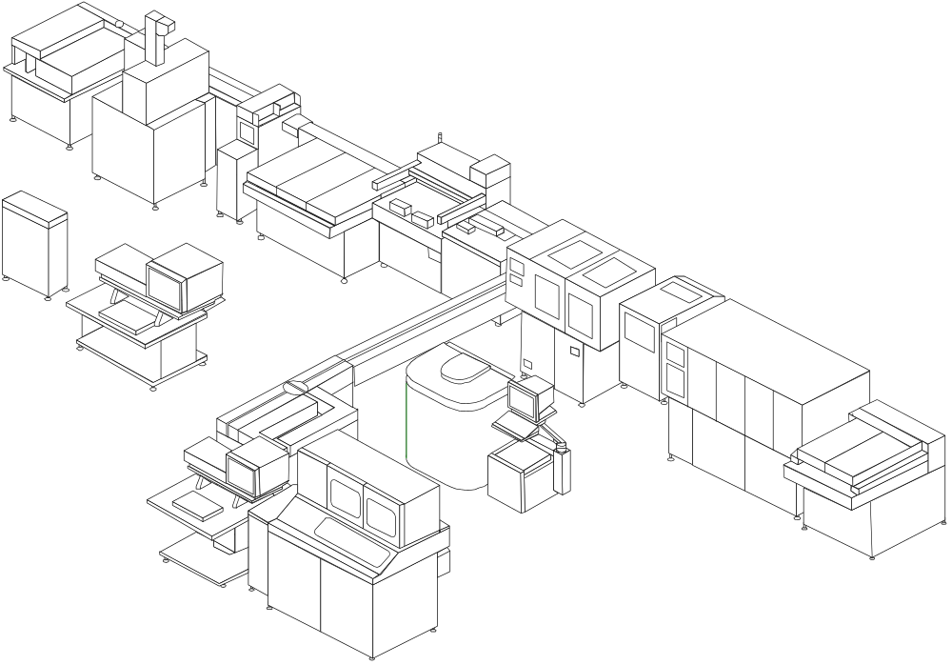

Continued on next page
Overview

Version Control | Version | Date | Comment
 | 1.0 | 6/15/97 | Original Document
 | 1.1 | 6/26/97 | Test Selections Frame  Description of Test Selections Fields  - Modified Figure 1 - Aliquot Bar Code Label example diagram in the Comments 1 to 4 field description section.  Rerun / Repeat / Reflex Test Selections  - Created the text for this section.  Aliquot Results Frame  Aliquot Results Frame Structure  - Modified Aliquot Sorter Tray Position range from 01 - FF to 01 - FA (250).  Description of Aliquot Results Fields  - Modified Aliquot Sorter Tray Position range from 01 - FF to 01 - FA (250).  Test Result Frame  Test Result Frame  - Modified the overview or opening description to provide more detail about the Test Result Frame.  Test Results Frame Example  - Modified the first Test Results Frame example to include a sample type code in the Sample Type field.  - Created a two frame example of a Test Results frame to indicate the break points.

Continued on next page

 | 1.1L | 7/7/97 | Special Edition for University Hospital Leiden (AZL)  Removed Chapters for Units not available at Leiden System  - Original Sample Sorter - Interface Box  - Hematology Module.  - Appendix - Original Sample Sorter  Test Selections Frame  Frame Identification  - Change type information for use in Leiden (remove 6, add 8)  Comment Fields  - Change all length to 20  Example  - New example with details  Aliquot Results  Example  - New example with details
 | 1.2L | 7/24/97 | Some formal and wording corrections  Additional trace examples

Main Controller

Introduction | This chapter contains information about the Main Controller interface.

In This Chapter | This chapter describes the following topics:

Topic | See Page
Interface Configuration | 2
Software Protocol | 4
Overview of Frame Structure | 4
Test Selection Frame | 7
Aliquot Sort Results Frame | 15
Test Results Frame | 23
Online Aliquot Results Frame | 32
Transmission Control Protocol | 41
Protocol Overview | 41
Sending a Data Frame | 42
Communication Time-out | 43
Resending a Data Frame | 44
Terminating a Data Transmission | 45
Idle Communications | 45
Main Controller Unavailable | 46

Interface Configuration

Interface Configuration Overview | There are three physical interface ports for the Main Controller. All interfaces are unidirectional and have the same communication settings. The role of each interface will be discussed further in Software Protocol and Transmission Control Protocol sections in this chapter. The physical location of these ports are discussed in the Cable Configuration section in this chapter.

Item | Specification
Interface | Asynchronous serial interface (RS-232C)
Communication Method | Half-Duplex
Character Code | ASCII
Communication Settings:  Baud Rate:  Data Bits:  Parity:  Stop Bits: | 4800  7  Even  2
Terminating Characters | <ETB> + BCC or <ETX> + BCC  See End of Data section on page 6.

Continued on next page
Interface Configuration, Continued

Cable Configuration | The host communication ports for the Main Controller are located on a multi-terminal server called PCOM 1 device. The PCOM 1 device is found behind the front access panel of Sample I/O module. The PCOM device is a serial-to-Ethernet protocol converter with eight physical ports.  - Port One will be for communications from the host system to the Main Controller of test selections (batch).  - Port Two will be for communications from the Main Controller to the host system for results (real-time) and off-line aliquot sort results (manual batch).  - Port Three will be for communications from the Main Controller to the host system for on-line aliquot information (real-time or manual batch).  All cables have the same pin-outs as shown in the table below and conform to the RS-232 standard.
 |  | Main Controller Cable Side  DB-25 Male Connector | Host Cable Side
 |  | 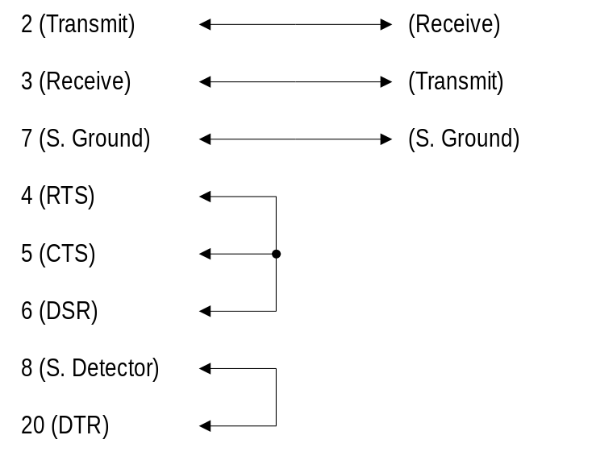
 |  | Note: The cable hood connectors need to be M2.5 (metric) screws rather than the traditional SAE threaded screws.

Software Protocol

Overview of Frame Structure | All data between the Main Controller and the host system is transferred in frames. There are two basic frame types.  - Data control frames that influence how the interface behaves, and  - Data frames that contain data.

Data Control Frames | The following are possible data control frames and their use:
 |  | Control Frame | Use
 |  | <ENQ> | - Used to initiate communications with the other device.
 |  | <EOT> | - Used to inform the receiving device that the sending device has no further information to send.  - Used to terminate communications due to an error.
 |  | <ACK> | - Used to acknowledge that the receiving device is ready to communicate in response to an <ENQ> packet.  - Used to acknowledge that data was received and the BCC matched the data transferred.
 |  | <NAK> | - Used to acknowledge that data was received but an error has occurred.

Data Frames | Below is an illustration of the general frame structure for data frames being sent to and from the Main Controller:
 |  | Start of Data  Page 5 | Frame Identification  Page 5 | Frame  Information  Page 6 ff | End of Data  Page 6
 |  | 1 Byte | 3 Bytes | < 500 Bytes |  | 2 Bytes

Continued on next page
Software Protocol, Continued

Start of Data | All data frames start with an <STX> (ASCII Decimal 02) character.

Frame Identification | The frame identification bytes identify:  - The type of frame - Function Code,  - The number of the frame - Frame Number, and  - The total number of frames being sent - Total Frames.  The Function Code assists the Main Controller and the host system identify what type of information is being sent.  If the information to be sent in the frame information section exceeds 500 bytes then the information must be divided into blocks of 500 bytes or less each. Because of this, the Frame Number and Total Frames information are needed to assist the Main Controller and the host system to determine how many frames are being sent and to ensure each frame was received in order.

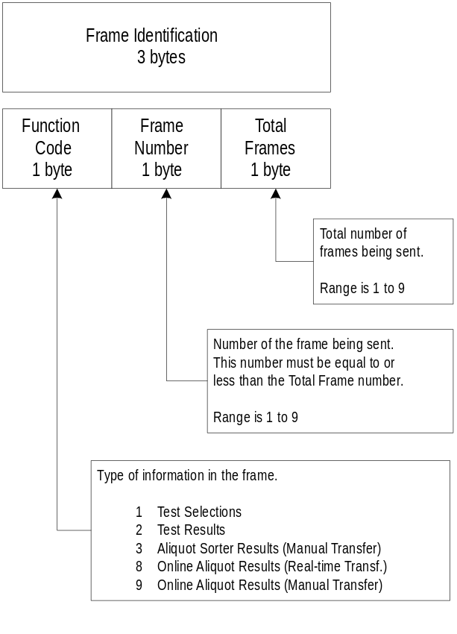

Continued on next page
Software Protocol, Continued

Frame Information | There are various types of information which can be transferred between the Main Controller and the host system using data frames. Use the table below to determine the different types of data frames, which direction they are transmitted, and what section in this document provides more details:
 |  | Data Frame Type | Direction | Refer to Page
 |  | Test Selections | Host ⇒ MC | 7
 |  | Off-line Aliquot Sort Results | MC ⇒ Host | 15
 |  | Test Results | MC ⇒ Host | 23
 |  | On-line Aliquot Results | MC ⇒ Host | 32

End of Data | All data frames end with End of Data bytes as shown below:
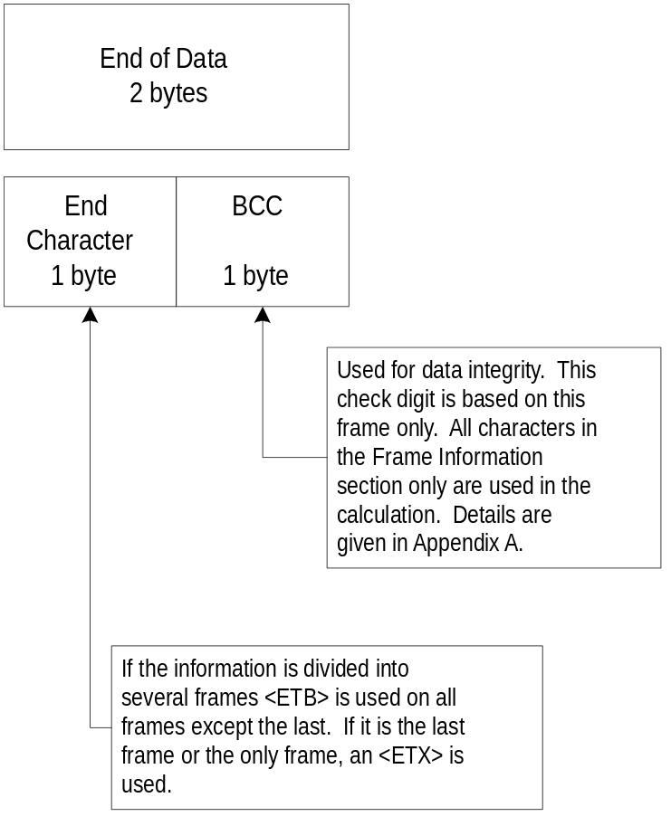

Continued on next page
Software Protocol, Continued

Test Selection Frame | The test selection frame is used by the host system to communicate test selection information and patient demographics for a sample.  This is a variable length frame because the number of test selections differ for each patient and demographics may or may not be sent.

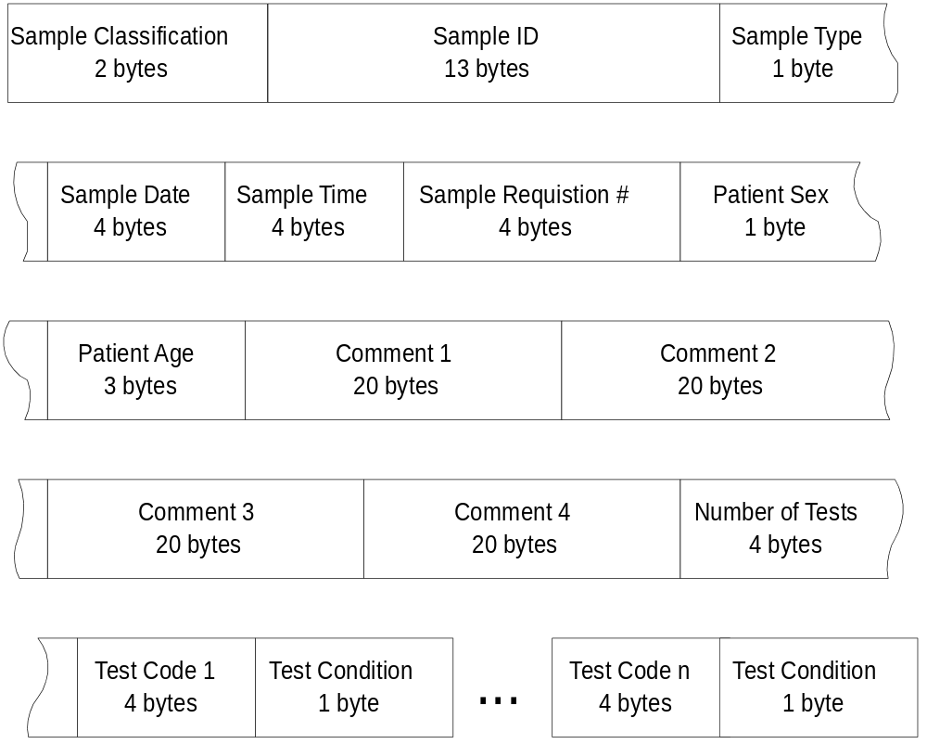

Continued on next page
Software Protocol, Continued

Test Selection Frame Structure | Use the table below to understand the structure of the test selection frame:
 |  | # |  | Field |  |  |  | Bytes |  | Comment
 |  | 1 |  | Start of Data |  |  |  | 1 |  | <STX> - ASCII 02
 |  | 2 |  | Function Code |  |  |  | 1 |  | 1 - Test Selection Frame (ASCII 49)
 |  | 3 |  | Frame Number |  |  |  | 1
 |  | 4 |  | Total Frames |  |  |  | 1
 |  | 5 |  | Sample Classification |  |  |  |  | 2 |  |  | Left Justified, Spaced Filled
 |  | 6 |  | Sample ID |  |  |  |  | 13 |  |  | Right Justified, Zero Filled
 |  | 7 |  | Sample Type |  |  |  |  | 1 |  |  | Range is 1 to 5
 |  | 8 |  | Sample Date |  |  |  |  | 4 |  |  | Zero Filled, Format is MMDD
 |  | 9 |  | Sample Time |  |  |  |  | 4 |  |  | Zero Filled, Format is HHMM
 |  | 10 |  | Sample Requisition Number |  |  |  |  | 4 |  |  | Right Justified Zero Filled
 |  | 11 |  | Patient Sex |  |  |  |  | 1 |  |  | Range is M, F, or <SP>
 |  | 12 |  | Patient Age |  |  |  |  | 3 |  |  | Right Justified, Zero Filled format
 |  | 13 |  | Comment 1 |  |  |  |  | 20 |  |  | Left Justified, Space Filled
 |  | 14 |  | Comment 2 |  |  |  |  | 20 |  |  | Left Justified, Space Filled
 |  | 15 |  | Comment 3 |  |  |  |  | 20 |  |  | Left Justified, Space Filled
 |  | 16 |  | Comment 4 |  |  |  |  | 20 |  |  | Left Justified, Space Filled
 |  | 17 |  | Number of Tests |  |  |  |  | 4 |  |  | Right Justified, Zero Filled, Range 0-512
 |  | 18-N |  | Test Selections 1 - N (This section repeats as many times as the number in the ”Number of Tests” field)
 |  |  |  |  | A |  | Test Selection |  |  |  |  | 4 |  | Right Justified, Zero Filled, Range 1-3000
 |  |  |  | B |  | Test Condition |  |  |  |  | 1 |  | Range is 1, 2, 3, or 4
 |  | N+1 |  | End Character |  |  |  | 1 |  | <ETX> or <ETB>
 |  | N+2 |  | BCC |  |  |  | 1 |  | See Appendix A

Continued on next page
Software Protocol, Continued

Description of Test Selection Fields | Sample Classification | Specifies the type of sample. Only the following sample classifications are allowed for this frame type:
 |  | Code | Definition
 |  | N<SP> | Routine Chemistry Sample
 |  | Rn | Repeat/rerun/reflex sample test selections where n can be from 1 or 2. The main controller has two separate databases (R1 & R2) to store these test selections for these types of samples. See Rerun / Repeat / Reflex Test Selections section on page 13.

Sample ID | Specifies the bar code number for each sample. At least four consecutive digits should be numeric in the bar code id.

Sample Type | Specifies the type of sample material.
 | Code | Definition
 | 1 | Serum / Plasma
 | 2 | Urine
 | 3 | Cerebral Spinal Fluid
 | 4 | Supernatant
 | 5 | Other

Continued on next page
Software Protocol, Continued

Description of | Sample Date | A date associated with the sample.
Test Selection Fields  (Continued) |  | Format: MMDD
 |  | Field | Meaning | Range
 |  | MM | Month | 01 - 12
 |  | DD | Day | 01 - 31
 |  | Example: May 3rd would be “0503”.

Sample Time | A time associated with the sample.
 | Format: HHMM
 | Field | Meaning | Range
 | HH | Hour | 00 - 23
 | MM | Minute | 00 - 59
 | Example: 8:31pm would be “2031”.

Sample Requisition Number | Use of the information in this field is optional. The host could use this field in conjunction with the Sample Date as an alternative method of sample identification.

Patient Sex | Sex of patient.  See Aliquot Bar Code Label example on page 11.
 | Range | Definition
 | F | Female
 | M | Male
 | <SP> | Unknown

Patient Age | Age of patient in years. This is a numeric field only and decimals are not allowed.  See Aliquot Bar Code Label example on page 11.

Continued on next page
Software Protocol, Continued

Description of Test Selection Fields  (Continued) | Comments 1 to 4 | Four comment fields exist and have field names that can be defined at the CLAS Main Controller and on the chemistry analyzer(s) such as Name, Location, Physician, Test Selections, etc.  Each of the four comment fields has the fixed length of 20 characters and should be padded with space characters (ASCII 32). If the comments are not of the right length or contain illegal characters then the entire test selections frame will not be used.  Note: For 100 mm aliquot tubes, all four comment fields are printed on the label 20 characters in length. For 75 mm only 13 characters will be printed for comment fields two and four.
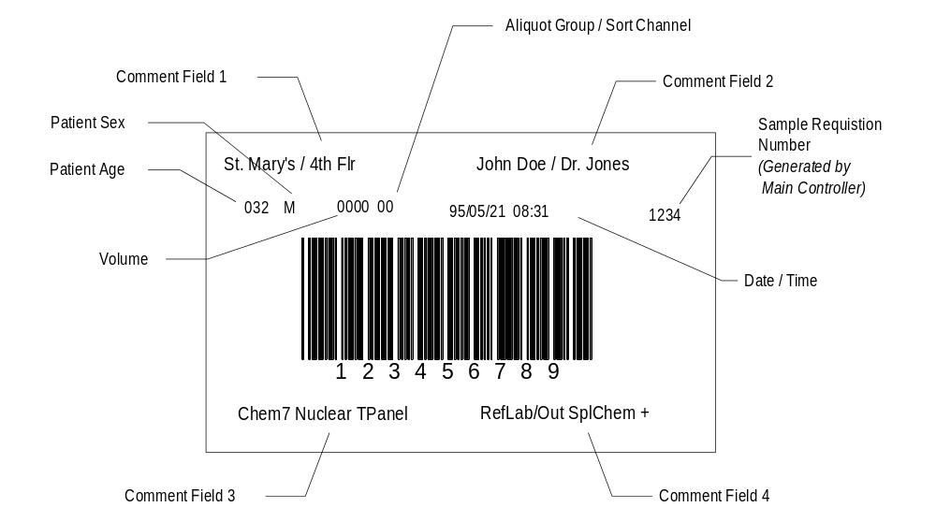
Figure 1 - Aliquot Bar Code Label Example

Continued on next page
Software Protocol, Continued

Description of Test Selection Fields  (Continued) | Number of Tests | The total number of tests ordered for this sample should equal the number of test codes and selections that follow in the next field(s).  Range: 0000 to 0512

Test Selection | This field indicates which test(s) are needed to be performed on the sample. This number is assigned in a user-definable table on the Main Controller and host side.  Range: 0001-3000  Example: Glucose 0001  LDH 0012

Test Condition | This field indicates what sample instructions are sent used to perform the test(s) on the sample.  Note: Option 2 and 3 are only supported by on-line Boehringer Mannheim instruments. Option 4 can be used when updating other test selections for a sample and did not want to effect the status of this selection.
 | Range | Definition
 | 1 | Normal volume
 | 2 | Reduce volume
 | 3 | Increase volume
 | 4 | Leave test condition as previously selected

Continued on next page
Software Protocol, Continued

Adding and Deleting of Test Selections | When the host downloads a test selection frame the main controller makes a determination if the sample test selections exist in the main controller database. If the record does not exist, the main controller adds this record. If the sample already exists, the subsequent downloads overwrite the record in the main controller. In order to add test(s) for a sample, all of the sample’s test(s) must be downloaded including the additional test(s). In order to delete test(s) for a given sample, all of the sample’s test(s) must be downloaded minus the test(s) to be omitted.

Rerun / Repeat / Reflex Test Selections | A routine sample’s test selections are downloaded with an “N” in the Sample Classification field of the Test Selection Frame. These test instructions are stored in the routine or normal database and when these samples are placed on CLAS™ they are processed accordingly.  If the host wants to generate a rerun/repeat/reflex test selection for a sample, the host will place a “R1” or “R2” in the Sample Classification field of the Test Selection Frame and download this along with the test selections to the main controller. These test instructions are stored in a separate database from the routine database and when the samples are placed in a “R1” or “R2” rack these samples are process based on test selections stored in their respective databases.

Test Selection Frame Example | - HOST 07:57:50,10 [ENQ]  - MC 07:57:50,26 [ACK]  - HOST 07:57:50,27 [STX]111N·00000029609841071214011234M046Westera  - ,·Jan········Gruenstadt··········Neugasse······  - ······Boehringer·Mannheim·004900011000210003100  - 04100051000610007100081000910010100111001210013  - 10014100151001610017100181001910020100211002210  - 02310024100251002610027100281002910030100311003  - 21003310034100351003610037100531005410055100561  - 0057100591006010061100621006310064100651[ETX][D  - C2]  - MC 07:57:52,54 [ACK]  - HOST 07:57:52,63 [EOT]  - HOST 07:57:52,64 [ENQ]  - MC 07:57:52,86 [ACK]  - HOST 07:57:52,93 [STX]111N·00000029609731071214022345M039Centner  - ,·Peter······Neustadt············Lilientahlstr.  - ······Boehringer·Mannheim·004900011000210003100  - 04100051000610007100081000910010100111001210013  - 10014100151001610017100181001910020100211002210  - 02310024100251002610027100281002910030100311003  - 21003310034100351003610037100531005410055100561  - 0057100591006010061100621006310064100651[ETX]I  - MC 07:57:55,21 [ACK]  - HOST 07:57:55,29 [EOT]

Continued on next page
Software Protocol, Continued
Test Selection Frame Example  (Continued) | - HOST 07:57:55,31 [ENQ]  - MC 07:57:55,59 [ACK]  - HOST 07:57:55,67 [STX]111N·00000029609161071214033456M036Yano,·S  - higeru·······Mito················Design·Departm  - ent···HID·················004900011000210003100  - 04100051000610007100081000910010100111001210013  - 10014100151001610017100181001910020100211002210  - 02310024100251002610027100281002910030100311003  - 21003310034100351003610037100531005410055100561  - 0057100591006010061100621006310064100651[ETX][C  - AN]  - MC 07:57:57,94 [ACK]  - HOST 07:57:58,02 [EOT]  - HOST 07:57:58,04 [ENQ]  - MC 07:57:58,25 [ACK]  - HOST 07:57:58,33 [STX]111N·00000029609351071214044567F036Bos,·Ja  - n·Leen·······Almere··············Netherlands···  - ······Boehringer·Mannheim·004900011000210003100  - 04100051000610007100081000910010100111001210013  - 10014100151001610017100181001910020100211002210  - 02310024100251002610027100281002910030100311003  - 21003310034100351003610037100531005410055100561  - 0057100591006010061100621006310064100651[ETX]l  - MC 07:58:00,61 [ACK]  - HOST 07:58:00,69 [EOT]  - HOST 07:58:00,71 [ENQ]  - MC 07:58:00,99 [ACK]  - HOST 07:58:01,08 [STX]111N·00000029609991071214056789F037Boor,·J  - an·Willem····Leiden··············Netherlands···  - ······Boehringer·Mannheim·004900011000210003100  - 04100051000610007100081000910010100111001210013  - 10014100151001610017100181001910020100211002210  - 02310024100251002610027100281002910030100311003  - 21003310034100351003610037100531005410055100561  - 0057100591006010061100621006310064100651[ETX]-  - MC 07:58:03,37 [ACK]  - HOST 07:58:03,45 [EOT]
Details | - Function Code: 1  - Frame Number: 1  - Total Frames: 1  - Sample Classification: N·  - Sample ID: 0000002960984  - Sample Type: 1  - Sample Date: 0712  - Sample Time: 1401  - Sample Requisition Number: 1234  - Patient Sex: M  - Patient Age. 046  - Comment 1: Westera,·Jan········  - Comment 2: Gruenstadt··········  - Comment 3: Neugasse············  - Comment 4: Boehringer·Mannheim·  - Number of Tests: 0049  - Test# Cond. Test# Cond. Test# Cond. Test# Cond.  - Test Selection 1- 4: 0001 1 0002 1 0003 1 0004 1  - Test Selection 5- 8: 0005 1 0006 1 0007 1 0008 1  - Test Selection 9-12: 0009 1 0010 1 0011 1 0012 1  - Test Selection 13-16: 0013 1 0014 1 0015 1 0016 1  - Test Selection 17-20: 0017 1 0018 1 0019 1 0020 1  - Test Selection 21-24: 0021 1 0022 1 0023 1 0024 1  - Test Selection 25-28: 0025 1 0026 1 0027 1 0028 1  - Test Selection 29-32: 0029 1 0030 1 0031 1 0032 1  - Test Selection 33-36: 0033 1 0034 1 0035 1 0036 1  - Test Selection 37-40: 0037 1 0053 1 0054 1 0055 1  - Test Selection 41-44: 0056 1 0057 1 0059 1 0060 1  - Test Selection 45-48: 0061 1 0062 1 0063 1 0064 1  - Test Selection 49: 0065 1

Software Protocol, Continued

Aliquot Sorter Results Frame | The Main Controller sends aliquot and sort information for the aliquot tubes/cups to the host system. This information can be used for a sample tracking system or floor notification by the host system if so desired.  The frame is a fixed length of 499 bytes (including Start of Data, Frame Identification and End of Data information). If any of the rack sample positions are empty, then that sample position’s information will be zero filled.

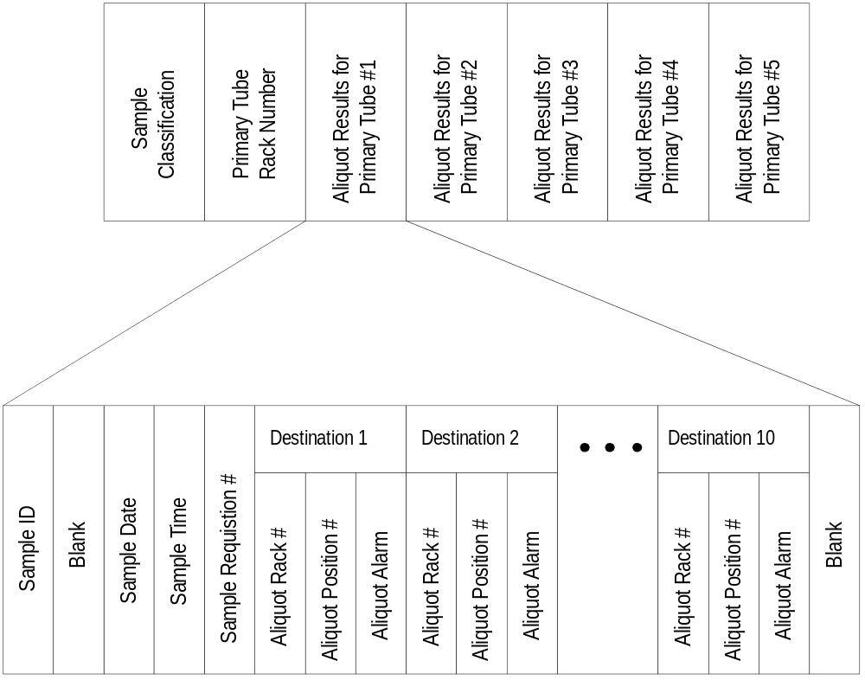

Continued on next page
Software Protocol, Continued

Aliquot Results Frame Structure | Use the table below to determine the structure of the aliquot result frame:
 |  | # | Field |  |  |  | Bytes | Comment
 |  | 1 | Start of Data |  |  |  | 1 | <STX> (ASCII 02)
 |  | 2 | Function Code |  |  |  | 1 | 3 - Operator initiated (batch) transfer (ASCII 51)
 |  | 3 | Frame Number |  |  |  | 1 | 1 (ASCII 49)
 |  | 4 | Total Frames |  |  |  | 1 | 1 (ASCII 49)
 |  | 5 | Sample Classification |  |  |  | 2 | Left Justified, Spaced Filled
 |  | 6 | Primary Tube Rack Number |  |  |  | 4
 |  | 7-11 |  | Sample Position 1 - 5 (This section repeats for a total of 5 times)
 |  |  |  | A | Sample ID |  |  |  | 13 |  | Right Justified, Zero filled
 |  |  |  | B | Blank |  |  |  | 1 |  | Space Filled
 |  |  |  | C | Sample Date |  |  |  | 4 |  | MMDD, Zero Filled
 |  |  |  | D | Sample Time |  |  |  | 4 |  | HHMM, Zero Filled
 |  |  |  | E | Sample Requisition Number |  |  |  | 4 |  | Right Justified, Zero Filled
 |  |  |  | F-O | Destination 1 - 10 (This section repeats for a total of 10 times)
 |  |  |  |  | a | Aliquot Sorter Tray Number |  |  | 4 | Right Justified, Zero Filled
 |  |  |  |  | b | Aliquot Sorter Tray Position |  |  | 2 | Range: 01 to FA
 |  |  |  |  | c | Aliquot Alarm |  |  | 1 | <SP>, A-G, or O
 |  |  |  | P | Blank |  |  |  | 1 | Space Filled
 |  | 12 | End Character |  |  |  | 1 | <ETX> or <ETB>
 |  | 13 | BCC |  |  |  | 1 | See Appendix A

Note: If there is no sample ID because no primary sample then fields A up to P are filled with 0 (ASCII 48).
The frame has always 10 destinations. If there is no destination in the appropriate system layout the fields for this destination is zero filled.

Continued on next page
Software Protocol, Continued

Description of Aliquot Results Fields | Sample Classification | Specifies the type of sample. Only the following sample(s) are allowed for this frame:
 |  | Code | Definition
 |  | N | Routine Chemistry Sample

Primary Tube Rack Number | The number of the rack where the primary tube sample is located.

Sample ID | Specifies the bar code number for each sample.

Blank | Reserved for future use.

Sample Date | A date associated with the sample.
 | Format: MMDD
 | Field | Meaning | Range
 | MM | Month | 01 - 12
 | DD | Day | 01 - 31
 | Example: May 3rd would be “0503”.

Sample Time | A time associated with the sample.
 | Format: HHMM
 | Field | Meaning | Range
 | HH | Hour | 00 - 23
 | MM | Minute | 00 - 59
 | Example: 8:31pm would be “2031”.

Continued on next page
Software Protocol, Continued

Description of Aliquot Results Fields  (Continued) | Sample Requisition Number | Use of the information in this field is optional. The host could use this field in conjunction with the Sample Date as an alternative method of sample identification.

Aliquot Sorter (AQS) Tray Number | The tray number the aliquot tube is placed.  Note: At the AQS the tray number is read via bar-code reader when an empty tray is placed. If the tray bar code is not used then the default tray number is 0001.

Aliquot Sorter (AQS) Tray Position Number | The position number (hexadecimal) in the rack that the aliquot tube is placed.  Range: 01 to FA

Aliquot Alarm | Shows any alarms that occurred for this sample during the aliquotting process.
 | Alarm | Definition
 | <SP> | Successful Aliquot
 | A | Not aliquoted due to primary sample liquid level could not be identified.
 | B | Not aliquoted due to insufficient sample volume (i.e. sample short).
 | C | Not aliquoted due to a dispensing nozzle was clogged (i.e. Possible sample fibrin or serum separator).
 | D | Not Used
 | E | Not aliquoted due to nozzle jam.
 | F | Not aliquoted due to mechanical problem on the aliquot unit during the process.

Continued on next page
Software Protocol, Continued

Description of Aliquot Results Fields  (Continued) | Aliquot Alarm  (Continued) | Shows any alarms that occurred for this sample during the aliquotting process.
 |  | Alarm | Definition
 |  | G | Not aliquoted due to unmatched order.
 |  | O | Not aliquoted due to no aliquot information or primary sample tube in the sample rack.  Note: The alarm is the letter O (ASCII 79).

Blank | Reserved for future use.

Aliquot Results Frame Example | - ..  - ..  - MC 03:04:24,80 [ENQ]  - HOST 03:04:24,83 [ACK]  - MC 03:04:26,00 [STX]311N·61310000002961331·062511351322000000·  - 000000·000000·000000·000000·000118·000117·00000  - 0000000000000000·0000002961398·0625113513890001  - 19·000118·000118·000118·000116·000119·000118·00  - 0000000000000000000·0000002961442·0625113514330  - 0011A·000119·000119·000119·000117·00011A·000119  - ·000000000000000000000·0000002961407·0625113513  - 9800011B·00011A·00011A·00011A·000118·00011B·000  - 11A·000000000000000000000·0000002961220·0625113  - 5121100011C·00011B·00011B·00011B·000119·00011C·  - 00011B·000000000000000000000·[ETX]y  - HOST 03:04:26,20 [ACK]  - MC 03:04:27,22 [EOT]  - MC 03:04:27,41 [ENQ]  - HOST 03:04:27,44 [ACK]  - MC 03:04:28,61 [STX]311N·61120000002960633·06251135062400011D·  - 00011C·00011C·00011C·00011A·00011D·00011C·00000  - 0000000000000000·0000002961076·0625113510670001  - 1E·00011D·00011D·00011D·00011B·00011E·00011D·00  - 0000000000000000000·0000002961061·0625113510520  - 0011F·00011E·00011E·00011E·00011C·00011F·00011E  - ·000000000000000000000·0000002961080·0625113510  - 71000120·00011F·00011F·00011F·000000·000000·000  - 000·000000000000000000000·0000002961310·0625113  - 51301000000·000000·000000·000000·000000·000000·  - 000000·000000000000000000000·[ETX]}  - HOST 03:04:28,81 [ACK]  - MC 03:04:29,83 [EOT]

Continued on next page
Software Protocol, Continued
Aliquot Results Frame Example  (Continued) | - MC 03:04:30,00 [ENQ]  - HOST 03:04:30,04 [ACK]  - MC 03:04:31,20 [STX]311N·61430000002963904·062511353895000000·  - 000000·000000·000000·000000·000000·000000·00000  - 0000000000000000·0000002963911·0625113539020000  - 00·000000·000000·000000·000000·000000·000000·00  - 0000000000000000000·0000002963876·0625113538670  - 00000·000000·000000·000000·000000·000000·00011F  - ·000000000000000000000·0000002963897·0625113538  - 88000121·000120·000120·000120·00011D·000120·000  - 120·000000000000000000000·0000002963880·0625113  - 53871000122·000121·000121·000121·00011E·000121·  - 000121·000000000000000000000·[ETX][LF]  - HOST 03:04:31,41 [ACK]  - MC 03:04:32,43 [EOT]  - ..  - ..
Details | - Function Code: 3  - Frame Number: 1  - Total Frames: 1  - Sample Classification: N·  - Primary Tube Rack Number: 6131  - 1. Position Sample ID: 0000002961331  - Blank: ·  - Sample Date: 0625  - Sample Time: 1135  - Sample Requisition Number: 1322  - Tray# Pos Alarm  - Destination 1: 0000 00 ·  - Destination 2: 0000 00 ·  - Destination 3: 0000 00 ·  - Destination 4: 0000 00 ·  - Destination 5: 0000 00 ·  - Destination 6: 0001 18 ·  - Destination 7: 0001 17 ·  - Destination 8: 0000 00 0  - Destination 9: 0000 00 0  - Destination 10: 0000 00 0  - Blank: ·  - 2. Position Sample ID: 0000002961398  - Blank: ·  - Sample Date: 0625  - Sample Time: 1135  - Sample Requisition Number: 1389  - Tray# Pos Alarm  - Destination 1: 0001 19 ·  - Destination 2: 0001 18 ·  - Destination 3: 0001 18 ·  - Destination 4: 0001 18 ·  - Destination 5: 0001 16 ·  - Destination 6: 0001 19 ·  - Destination 7: 0001 18 ·  - Destination 8: 0000 00 0  - Destination 9: 0000 00 0  - Destination 10: 0000 00 0  - Blank: ·

Continued on next page

Software Protocol, Continued
Details  (Continued) | - 3. Position Sample ID: 0000002961442  - Blank: ·  - Sample Date: 0625  - Sample Time: 1135  - Sample Requisition Number: 1433  - Tray# Pos Alarm  - Destination 1: 0001 1A ·  - Destination 2: 0001 19 ·  - Destination 3: 0001 19 ·  - Destination 4: 0001 19 ·  - Destination 5: 0001 17 ·  - Destination 6: 0001 1A ·  - Destination 7: 0001 19 ·  - Destination 8: 0000 00 0  - Destination 9: 0000 00 0  - Destination 10: 0000 00 0  - Blank: ·  - 4. Position Sample ID: 0000002961407  - Blank: ·  - Sample Date: 0625  - Sample Time: 1135  - Sample Requisition Number: 1398  - Tray# Pos Alarm  - Destination 1: 0001 1B ·  - Destination 2: 0001 1A ·  - Destination 3: 0001 1A ·  - Destination 4: 0001 1A ·  - Destination 5: 0001 18 ·  - Destination 6: 0001 1B ·  - Destination 7: 0001 1A ·  - Destination 8: 0000 00 0  - Destination 9: 0000 00 0  - Destination 10: 0000 00 0  - Blank: ·  - 5. Position Sample ID: 0000002961220  - Blank: ·  - Sample Date: 0625  - Sample Time: 1135  - Sample Requisition Number: 1211  - Tray# Pos Alarm  - Destination 1: 0001 1C ·  - Destination 1: 0001 1B ·  - Destination 3: 0001 1B ·  - Destination 4: 0001 1B ·  - Destination 5: 0001 19 ·  - Destination 6: 0001 1C ·  - Destination 7: 0001 1B ·  - Destination 8: 0000 00 0  - Destination 9: 0000 00 0  - Destination 10: 0000 00 0  - Blank: ·

Continued on next page

Software Protocol, Continued

Test Results Frame | The Main Controller uses test result frames to transfer sample’s results to the host system.  Each frame contains only one analyzer’s results for a sample. If a sample has results information greater than 500 bytes from one analyzer the results information will be sent in more than one frame (See Sending a Data Frame in the Transmission Control Protocol section on page 42. In addition, if a sample has tests being performed on multiple analyzers there could be multiple results frame for one sample. Each sample has an identifier (analyzer code) to indicate which analyzer sent the information and if the transmission is a real-time or operator initiated (batch) transmission. This is a variable length frame since the number of tests performed on each sample may vary.

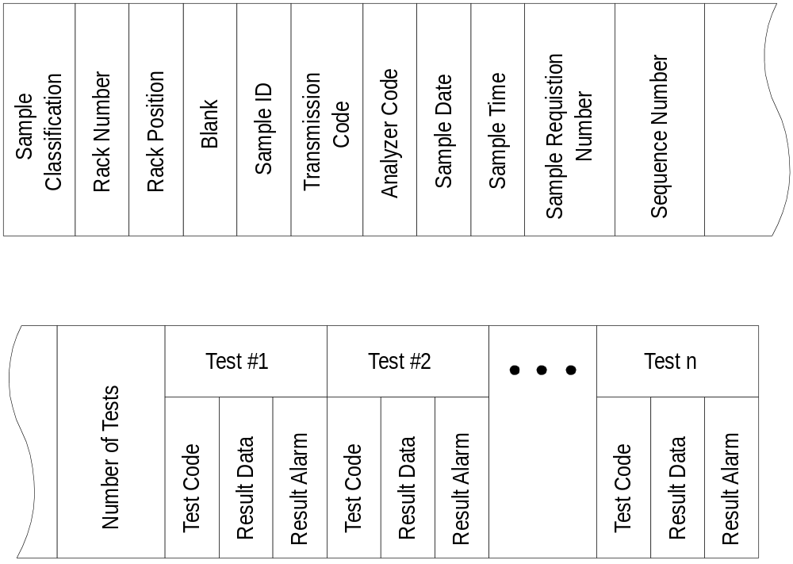

Continued on next page
Software Protocol, Continued

Test Results Frame Structure | Use the table below to determine the structure of the test results frame:

# | Field |  | Bytes |  | Comment
1 | Start of Data |  | 1 |  | <STX> - ASCII 02
2 | Function Code |  | 1 |  | 2 (ASCII 50)
3 | Frame Number |  | 1
4 | Total Frames |  | 1
5 | Sample Classification |  | 2 |  | Left Justified, Spaced Filled
6 | Rack Number |  | 4
7 | Rack Position |  | 1 |  | Range: 1 to 5
8 | Sample Type |  | 1 |  | Range : 1 to 5
9 | Sample ID |  | 13 |  | Right Justified, Zero Filled
10 | Transmission Code |  | 1 |  | 1 (Real-time) or 2 (Manual / Batch)
11 | Analyzer Code |  | 1 |  | Range is 1 to n
12 | Sample Date |  | 4 |  | MMDD, Zero Filled
13 | Sample Time |  | 4 |  | HHMM, Zero Filled
14 | Sample Requisition Number |  | 4 |  | Right Justified, Zero Filled
15 | Sequence Number |  | 4 |  | Right Justified, Zero Filled
16 | Number of Tests |  | 2 |  | Right Justified, Zero Filled, Range 01-99
17-N | Test Result 1 - N (This section repeats as many times as the number in the “Number of Tests” field)
 | A | Test Code |  |  |  |  | 4 | Right Justified, Zero Filled
 | B | Result Data |  |  |  |  | 8 | Right Justified
 | C | Result Alarm |  |  |  |  | 1
N+1 | End Character |  |  | 1 |  | <ETX> or <ETB>
N+2 | BCC |  |  | 1 |  | See Appendix A

Continued on next page
Software Protocol, Continued

Description of Test Results Fields | Sample Classification | Specifies the type of sample. Only the following sample(s) are allowed for this frame type:
 |  | Code | Definition
 |  | N<SP> | Routine Chemistry Sample
 |  | En | STAT sample from analyzer n where n can be 1, 2, or 3.
 |  | Cn | 911 Control results (1 to 8) where n can be from C1 to C8.
 |  | Cn | 747 Control results (1 to 10) where n can be from C1 to CA.
 |  | A1 to DA | 917 Control results (1 to 40).
 |  | R0 | Automatic Rerun results.
 |  | R1 | Rerun / Repeat/ Reflex results for the primary sample.
 |  | R2 | Rerun / Repeat/ Reflex results for the primary sample.

Sample Rack Number | The number of the rack where the sample is located.  Note: Depending on system layout this can be primary rack ID or aliquot rack ID.

Sample Rack Position | The position number in the sample rack where the sample is located.  Range: 1 to 5  Note: For STAT samples the Sample Rack Position will be zero filled.

Continued on next page
Software Protocol, Continued

Description of Test Results | Sample Type | Specifies the type of sample material.
Fields |  | Code | Definition
(Continued) |  | 1 | Serum / Plasma
 |  | 2 | Urine
 |  | 3 | Cerebral Spinal Fluid
 |  | 4 | Supernatant
 |  | 5 | Other

Sample ID | Specifies the bar code number for each sample.  Important: An instrument specified ID will be placed in the Sequence Number field for a control.

Transmission Code | The mode of transmission (real-time or batch) the results are being transmitted.  Note: If the real-time results transmission from the main controller fail then the results will need to be re-transmitted.  - If re-transmitted from the analyzers the Transmission Code will be 1 and the Analyzer Code will be the corresponding instrument number.  - If re-transmitted from the main controller the Transmission Code will be 2 and the Analyzer Code will be the corresponding instrument number. The main controller will send a separate Test Results Frame for each analyzer.
 | Code | Definition
 | 1 | Real-time transmission of results.
 | 2 | Batch transmission of results.

Continued on next page
Software Protocol, Continued

Description of Test Results | Analyzer Code
Fields |  | Code | Definition
(Continued) |  | 1 | Results from analyzer one.
 |  | 2 | Results from analyzer two.
 |  | n | Results from analyzer n.

Sample Date | A date associated with the sample.  Note: If sample is a STAT (Sample Classification is En) or a control then the Sample Date field is zero-filled.
 | Format: MMDD
 | Field | Meaning | Range
 | MM | Month | 01 - 12
 | DD | Day | 01 - 31
 | Example: May 3rd would be “0503”.

Sample Time | A time associated with the sample.  Note: If sample is a STAT (Sample Classification is En) or a control then the Sample Time field is zero-filled.
 | Format: HHMM
 | Field | Meaning | Range
 | HH | Hour | 00 - 23
 | MM | Minute | 00 - 59
 | Example: 8:31pm would be “2031”.

Continued on next page
Software Protocol, Continued

Description of Test Results Fields  (Continued) | Sample Requisition Number | Use of the information in this field is optional. The host could define this field in the test selection frame.

Sequence Number | A number assigned by the CLAS™ system to each sample as the test selections are downloaded from the host system.  Important: For control and STAT samples the sequence number will be the analyzer sequence number.

Number of Tests | Indicates the number of test results that will be transferred.

Test Code | This is a number that is assigned to a test taken from a user-definable table on the Main Controller and host side.  Range: 0001-3000  Example: Glucose 0001  LDH 0012

Continued on next page
Software Protocol, Continued

Description of Test Results Fields  (Continued) | Result Data |  | The positive or negative analytical results data for the test. This field is space filled and has a non-floating sign. Positive results will have a <SP> (ASCII 32; replaced by ◊ in the table below) in the most-significant-digit and a - (ASCII 45) for a negative result. The decimal, if present, counts as one byte.
 |  |  | Decimal | Max. Digit | Example
 |  | Positive | Absent | 7 | ◊1234567
 |  |  | Present | 6 | ◊1234.56
 |  | Negative | Absent | 7 | -◊◊◊3456
 |  |  | Present | 6 | -◊◊◊◊1.4
Important: If a “?” (ASCII 63) is present in the most-significant-digit then the results was greater than the allowable result size and the results data for this test should not be used.
If a “C” (ASCII 67) is present in the most-significant-digit then the results was canceled and the results data for this test should not be used.

Result Alarm | The analyzer alarm code for the result is transmitted in this field. If there is no alarm, then it will be filled with a <SP> (ASCII 32).  Note: For a list of analyzer alarm codes, please call our Technical Product Management at +49 621 759-4204 to order individual analyzer host interface document(s).

Continued on next page
Software Protocol, Continued

Test Results Frame Example 1 | - The example below are test results sent in one result frame.
- MC 04:37:55,06 [ENQ]
- HOST 04:37:55,13 [ACK]
- MC 04:37:56,70 [STX]211N·6225110000002961442130612155500003752
- 240001······21·0002·····225·0003······26·0004··
- ···1.5·0005······15·0006······15·0007·····3.1·0
- 008·····6.9·0009·····8.2·0010······89·0011·····
- 141·0012·····3.4·0013·····5.6·0014·····0.4·0015
- ·····0.1·0016·····173·0018·····104·0019······72
- ·0028·····125·0029·····4.4·0030······89·0031···
- ····5·0032·······0·0033·······0·[ETX]
- HOST 04:37:57,04 [ACK]
- MC 04:37:57,49 [EOT]

Details 1 | - Function Code: 2  - Frame Number: 1  - Total Frames: 1  - Sample Classification: N·  - Rack Number : 6225  - Rack Position: 1  - Sample Type: 1  - Sample ID: 0000002961442  - Transmission Code: 1  - Analyzer Code: 3  - Sample Date: 0612  - Sample Time: 1555  - Sample Requisition Number: 0000  - Sequence Number: 3752  - Number of Tests: 24  - Code -Result— Alarm  - 1. Test Result: 0001 ······21 ·  - 2. Test Result: 0002 ·····225 ·  - 3. Test Result: 0003 ······26 ·  - 4. Test Result: 0004 ·····1.5 ·  - 5. Test Result: 0005 ······15 ·  - 6. Test Result: 0006 ······15 ·  - 7. Test Result: 0007 ·····3.1 ·  - 8. Test Result: 0008 ·····6.9 ·  - 9. Test Result: 0009 ·····8.2 ·  - 10. Test Result: 0010 ······89 ·  - 11. Test Result: 0011 ·····141 ·  - 12. Test Result: 0012 ·····3.4 ·  - 13. Test Result: 0013 ·····5.6 ·  - 14. Test Result: 0014 ·····0.4 ·  - 15. Test Result: 0015 ·····0.1 ·  - 16. Test Result: 0016 ·····173 ·  - 17. Test Result: 0018 ·····104 ·  - 18. Test Result: 0019 ······72 ·  - 19. Test Result: 0028 ·····125 ·  - 20. Test Result: 0029 ·····4.4 ·  - 21. Test Result: 0030 ······89 ·  - 22. Test Result: 0031 ·······5 ·  - 23. Test Result: 0032 ·······0 ·  - 24. Test Result: 0033 ·······0 ·

Continued on next page
Software Protocol, Continued
Test Results Frame Example 2 | - The example below are test results sent in two result frames.
- MC 08:26:21,82 [ENQ]
- HOST 08:26:21,83 [ACK]
- MC 08:26:23,03 [STX]212N·6139110000002960999120712140567890990
- 490001·····251·0002···210.2·0003····3018·0004··
- ·294.2R0005·····8.5·0006···12.68V0007····14.1I0
- 008···220.9A0009····2106·0010···276.4·0011···11
- 3.9·0012····3955·0013···41.63·0014···337.5F0015
- ·····539Q0016-····1.9·0017······43·0018····1533
- ·0019···152.6·0020···50.11J0021·····911·0022···
- ··365·0023···233.5H0024····1242·0025···345.8·00
- 26···273.9F0027···15.24P0028···391.6·0029····53
- .6·0030····6027·0031·····354K0032·····451·0033·
- ···3191·0034···15.88·0035···163.1A0036[ETB]_
- HOST 08:26:23,42 [ACK]
- MC 08:26:23,88 [STX]222····2624·0037···103.6·0053···180.3·0054
- ····1169Q0055···374.6·0056···57.36·0057····4646
- ·0059···156.1·0060····74.3·0061-······2·0062···
- 528.7·0063···676.7·0064···35.15·0065···117.4X[E
- TX]0
- HOST 08:26:24,09 [ACK]
- MC 08:26:25,12 [EOT]

Details 2 | - Function Code: 2  - Frame Number: 1  - Total Frames: 2  - Sample Classification: N·  - Primary Tube Rack Number: 6139  - Rack Position: 1  - Sample Type: 1  Sample ID: 0000002960999  - Transmission Code: 1  - Analyzer Code: 2  - Sample Date: 0712  - Sample Time: 1405  - Sample Requisition Number: 6789  - Sequence Number: 0990  - Number Of Tests: 49  - Code -Result— Alarm  - 1. Test Result: 0001 ·····251 ·  - 2. Test Result: 0002 ···210.2 ·  - 3. Test Result: 0003 ····3018 ·  - 4. Test Result: 0004 ···294.2 R  - 5. Test Result: 0005 ·····8.5 ·  - 6. Test Result: 0006 ···12.68 V  - 7. Test Result: 0007 ····14.1 I  - 8. Test Result: 0008 ···220.9 A  - 9. Test Result: 0009 ····2106 ·  - 10. Test Result: 0010 ···276.4 ·  - 11. Test Result: 0011 ···113.9 ·  - 12. Test Result: 0012 ····3955 ·  - 13. Test Result: 0013 ···41.63 ·  - 14. Test Result: 0014 ···337.5 F  - 15. Test Result: 0015 ·····539 Q  - 16. Test Result: 0016 -····1.9 ·  - 17. Test Result: 0017 ······43 ·  - 18. Test Result: 0018 ····1533 ·  - 19. Test Result: 0019 ···152.6 ·  - 20. Test Result: 0020 ···50.11 J  - 21. Test Result: 0021 ·····911 ·  - 22. Test Result: 0022 ·····365 ·  - 23. Test Result: 0023 ···233.5 H  - 24. Test Result: 0024 ····1242 ·  - 25. Test Result: 0025 ···345.8 ·  - 26. Test Result: 0026 ···273.9 F  - 27. Test Result: 0027 ···15.24 P

Continued on next page
Software Protocol, Continued
Details 2  (Continued) | - 28. Test Result: 0028 ···391.6 ·  - 29. Test Result: 0029 ····53.6 ·  - 30. Test Result: 0030 ····6027 ·  - 31. Test Result: 0031 ·····354 K  - 32. Test Result: 0032 ·····451 ·  - 33. Test Result: 0033 ····3191 ·  - 34. Test Result: 0034 ···15.88 ·  - 35. Test Result: 0035 ···163.1 A  - 36. Test Result: 0036  - 2. Frame:  - Function Code: 2  - Frame Number: 2  - Total Frames: 2  - 36. Test Result: ····2624 ·  - 37. Test Result: 0037 ···103.6 ·  - 38. Test Result: 0053 ···180.3 ·  - 39. Test Result: 0054 ····1169 Q  - 40. Test Result: 0055 ···374.6 ·  - 41. Test Result: 0056 ···57.36 ·  - 42. Test Result: 0057 ····4646 ·  - 43. Test Result: 0059 ···156.1 ·  - 44. Test Result: 0060 ····74.3 ·  - 45. Test Result: 0061 -······2 ·  - 46. Test Result: 0062 ···528.7 ·  - 47. Test Result: 0063 ···676.7 ·  - 48. Test Result: 0064 ···35.15 ·  - 49. Test Result: 0065 ···117.4 X

Continued on next page
Software Protocol, Continued
Online Aliquot Results Frame | The Main Controller sends real-time aliquot information to the host system. This information can be used to provide aliquot / sample information to assist in connecting additional instruments to the CLAS™ system if so desired. The frame is a fixed length of 446 bytes(including Start of Data, Frame Identification and End of Data information).  Note: If any of the positions of the sample rack are empty, then that position’s sample information will be zero filled.

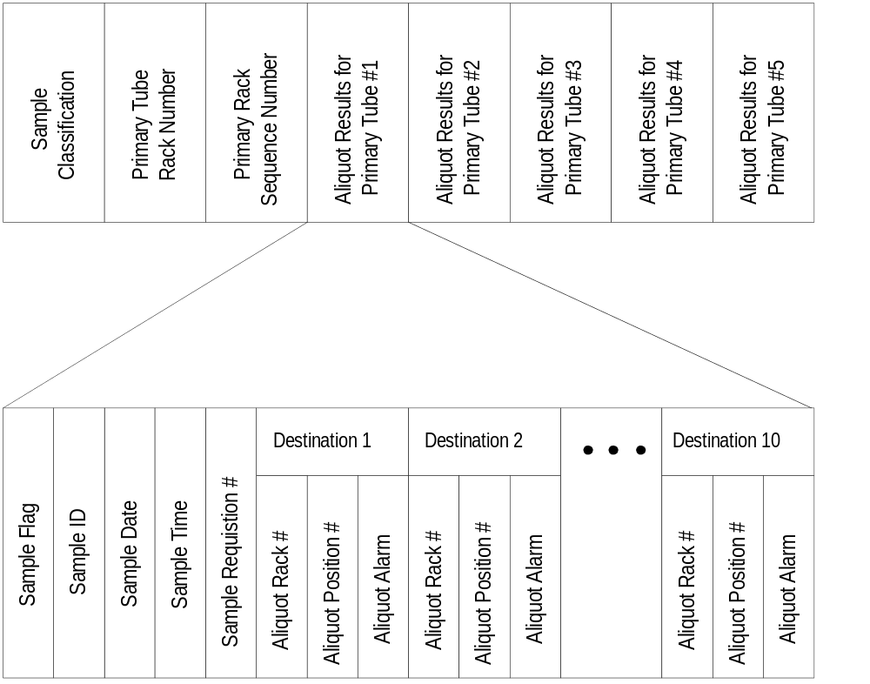

Continued on next page
Software Protocol, Continued

Aliquot Results Frame Structure | Use the table below to determine the structure of the aliquot result frame:
 |  | # |  | Field |  |  |  | Bytes | Comment
 |  | 1 |  | Start of Data |  |  |  | 1 | <STX> (ASCII 02)
 |  | 2 |  | Function Code |  |  |  | 1 | 8 (ASCII 56)
 |  | 3 |  | Frame Number |  |  |  | 1 | 1 (ASCII 49)
 |  | 4 |  | Total Frames |  |  |  | 1 | 1 (ASCII 49)
 |  | 5 |  | Sample Classification |  |  |  | 2 | Left Justified, Spaced Filled
 |  | 6 |  | Primary Tube Rack Number |  |  |  | 4
 |  | 7 |  | Primary Rack Seq. Number |  |  |  | 4 | Left Justified, Zero-Filled
 |  |  | 8-12 |  | Sample Position 1 - 5 (This section repeats for a total of 5 times)
 |  |  |  |  | A | Sample Flag |  |  |  | 1 |  | 0 or 1 (ASCII 48 or 49)
 |  |  |  |  | B | Sample ID |  |  |  | 13 |  | Right Justified, Zero filled
 |  |  |  |  | C | Sample Date |  |  |  | 4 |  | MMDD, Zero Filled
 |  |  |  |  | D | Sample Time |  |  |  | 4 |  | HHMM, Zero Filled
 |  |  |  |  | E | Sample Requisition Number |  |  |  | 4 |  | Right Justified, Zero Filled
 |  |  |  |  | F-O | Aliquot Results 1 - 10 (This section repeats for a total of 10 times)
 |  |  |  |  |  | a | Aliquot Rack Number |  |  |  | 4 |  | Right Justified, Zero Filled
 |  |  |  |  |  | b | Aliquot Position Number |  |  |  | 1
 |  |  |  |  |  | c | Aliquot Alarm |  |  |  | 1 |  | <SP>, A-G
 |  | 13 |  | End Character |  |  |  | 1 | <ETX> or <ETB>
 |  | 14 |  | BCC |  |  |  | 1 | See Appendix A
Notes:
- If primary sample(s) are re-loaded after normal aliquotting and the R-ALIQ function is not used in the main controller then the aliquot rack, position and alarm fields will be zero filled for that sample.
- If the instrumentation uses:
- Primary sample, then Primary Tube Rack Number (6), and Primary Rack Sequence Number are the key index information.
- A-Line aliquots, then aliquot information (F-Aliquot Results 1, a-Aliquot Rack Number, b-Aliquot Position) are key index information.

Continued on next page
Software Protocol, Continued

Description of Aliquot Results Fields | Sample Classification | Specifies the type of sample. Only the following sample(s) are allowed for this frame:
 |  | Code | Definition
 |  | N<SP> | Routine Chemistry Sample

Primary Tube Rack Number | The number of the rack where the primary tube sample is located.  Important: Since a primary tube rack may be re-used several times, it is important not to use this number as the unique identifier.

Primary Rack Sequence Number | A unique sequence number assigned to the primary rack by the Aliquoter.  Range: 0001 to 2000

Sample Flag | It indicates if a sample was present during aliquotting and if sample information is to follow for that sample.
 | Flag | Definition
 | 0 | Sample is not present
 | 1 | Sample is present
 | Note: If any of the positions of the sample rack are empty, then that position’s sample information will be zero filled.

Sample ID | Specifies the bar code number for each sample.

Continued on next page
Software Protocol, Continued

Description of Aliquot Results Fields  (Continued) | Sample Date | A date associated with the sample.
 |  | Format: MMDD
 |  | Field | Meaning | Range
 |  | MM | Month | 01 - 12
 |  | DD | Day | 01 - 31
 |  | Example: May 3rd would be “0503”.

Sample Time | A time associated with the sample.
 | Format: HHMM
 | Field | Meaning | Range
 | HH | Hour | 00 - 23
 | MM | Minute | 00 - 59
 | Example: 8:31pm would be “2031”.

Sample Requisition Number | Use of the information in this field is optional. The host could define this field in the test selection frame.

Aliquot Rack Number | The rack number the aliquot cup is placed.  Range: 5001 to 8999

Aliquot Position Number | The position number in the rack that the aliquot cup is placed.  Range: 1 to 5

Continued on next page
Software Protocol, Continued

Description of Aliquot Results Fields  (Continued) | Aliquot Alarm | Shows any alarms that occurred for this sample during the aliquotting process.
 |  | Alarm | Definition
 |  | <SP> | Successful Aliquot
 |  | A | Not aliquoted due to primary sample liquid level could not be identified.
 |  | B | Not aliquoted due to insufficient sample volume (i.e. sample short).
 |  | C | Not aliquoted due to a dispensing nozzle was clogged (i.e. Possible sample fibrin or serum separator).
 |  | D | Not Used
 |  | E | Not aliquoted due to nozzle jam.
 |  | F | Not aliquoted due to mechanical problem on the aliquot unit during the process.
 |  | G | Not aliquoted due to unmatched order.
Note:
Do not process a sample that has an aliquot alarm associated with it.

Online Aliquot Results Frame Example 1 | - MC 07:23:09,35 [ENQ]  - HOST 07:23:09,43 [ACK]  - MC 07:23:10,49 [STX]811N·7818000110000002962329062511352320586  - 11·80731·80732·80733·80734·80735·80681·80682·00  - 00000000001000000296231106251135230258612·80683  - ·80684·80685·81001·81002·81003·81004·0000000000  - 001000000296224206251135223358613·81005·81181·8  - 1182·81183·81184F81185F000000000000000000100000  - 0296223506251135222658614·000000000000000000000  - 00000000000000000000000000000000010000002962221  - 06251135221258615F00000000000000000000000000000  - 0000000000000000000000000[ETX](  - HOST 07:23:10,81 [ACK]  - MC 07:23:11,83 [EOT]

Continued on next page

Software Protocol, Continued
Details 1 | - Function Code: 8  - Frame Number. 1  - Total Frames: 1  - Sample Classification: N·  - Primary Tube Rack Number: 6158  - Prim.Rack Sequence Number: 0001  - Position 1:  - Sample Flag: 1  - Sample ID: 0000002964377  - Sample Date: 0625  - Sample Time: 1135  - Sample Requisition Number: 4368  - RackID Pos Alarm  - 1. Aliquot: 0000 0 0 (no aliquot for A-line Elecsys)  - 2. Aliquot: 8079 1 ·  - 3. Aliquot: 8079 2 ·  - 4. Aliquot: 8079 3 ·  - 5. Aliquot: 8079 4 ·  - 6. Aliquot: 8079 5 ·  - 7. Aliquot: 8092 1 ·  - 8. Aliquot: 8092 2 ·  - 9. Aliquot: 0000 0 0  - 10. Aliquot: 0000 0 0  - Position 2:  - Sample Flag: 1  - Sample ID: 0000002964408  - Sample Date: 0625  - Sample Time: 1135  - Sample Requisition Number: 4399  - RackID Pos Alarm  - 1. Aliquot: 0000 0 0  - 2. Aliquot: 8092 3 ·  - 3. Aliquot: 8092 4 ·  - 4. Aliquot: 8092 5 ·  - 5. Aliquot: 8073 1 ·  - 6. Aliquot: 8073 2 ·  - 7. Aliquot: 8073 3 ·  - 8. Aliquot: 8073 4 ·  - 9. Aliquot: 0000 0 0  - 10. Aliquot: 0000 0 0  - Position 3:  - Sample Flag: 1  - Sample ID: 0000002964869  - Sample Date: 0625  - Sample Time: 1135  - Sample Requisition Number: 4860  - RackID Pos Alarm  - 1. Aliquot: 0000 0 0  - 2. Aliquot: 8073 5 ·  - 3. Aliquot: 0000 0 0  - 4. Aliquot: 0000 0 0  - 5. Aliquot: 0000 0 0  - 6. Aliquot: 0000 0 0  - 7. Aliquot: 0000 0 0  - 8. Aliquot: 0000 0 0  - 9. Aliquot: 0000 0 0  - 10. Aliquot: 0000 0 0

Continued on next page

Software Protocol, Continued
Details 1  (Continued) | - Position 4:  - Sample Flag: 1  - Sample ID: 0000002964528  - Sample Date: 0625  - Sample Time: 1135  - Sample Requisition Number: 4519  - RackID Pos Alarm  - 1. Aliquot: 0000 0 0  - 2. Aliquot: 0000 0 0  - 3. Aliquot: 0000 0 0  - 4. Aliquot: 0000 0 0  - 5. Aliquot: 0000 0 0  - 6. Aliquot: 0000 0 0  - 7. Aliquot: 0000 0 0  - 8. Aliquot: 0000 0 0  - 9. Aliquot: 0000 0 0  - 10. Aliquot: 0000 0 0  - Position 5:  - Sample Flag: 1  - Sample ID: 0000002964580  - Sample Date: 0625  - Sample Time: 1135  - Sample Requisition Number: 4571  - RackID Pos Alarm  - 1. Aliquot: 0000 0 0  - 2. Aliquot: 0000 0 0  - 3. Aliquot: 0000 0 0  - 4. Aliquot: 0000 0 0  - 5. Aliquot: 0000 0 0  - 6. Aliquot: 0000 0 0  - 7. Aliquot: 0000 0 0  - 8. Aliquot: 0000 0 0  - 9. Aliquot: 0000 0 0  - 10. Aliquot: 0000 0 0

Online Aliquot Results Frame Example 2 | - MC 07:23:09,35 [ENQ]  - HOST 07:23:09,43 [ACK]  - MC 07:23:10,49 [STX]811N·7818000110000002962329062511352320586  - 11·80731·80732·80733·80734·80735·80681·80682·00  - 00000000001000000296231106251135230258612·80683  - ·80684·80685·81001·81002·81003·81004·0000000000  - 001000000296224206251135223358613·81005·81181·8  - 1182·81183·81184F81185F000000000000000000100000  - 0296223506251135222658614·000000000000000000000  - 00000000000000000000000000000000010000002962221  - 06251135221258615F00000000000000000000000000000  - 0000000000000000000000000[ETX](  - HOST 07:23:10,81 [ACK]  - MC 07:23:11,83 [EOT]
Details 2 | - Function Code: 8  - Frame Number. 1  - Total Frames: 1  - Sample Classification: N·  - Primary Tube Rack Number: 7818  - Prim.Rack Sequence Number: 0001  - Position 1:  - Sample Flag: 1  - Sample ID: 0000002962329  - Sample Date: 0625  - Sample Time: 1135  - Sample Requisition Number: 2320

Continued on next page

Software Protocol, Continued
Details 2  (Continued) | - RackID Pos Alarm  - 1. Aliquot: 5861 1 · (aliquot for A-line Elecsys)  - 2. Aliquot: 8073 1 · (aliquot for AQS destination 1)  - 3. Aliquot: 8073 2 · (aliquot for AQS destination 2)  - 4. Aliquot: 8073 3 · (aliquot for AQS destination 3)  - 5. Aliquot: 8073 4 · (aliquot for AQS destination 4)  - 6. Aliquot: 8073 5 · (aliquot for AQS destination 5)  - 7. Aliquot: 8068 1 · (aliquot for AQS destination 6)  - 8. Aliquot: 8068 2 · (aliquot for AQS destination 7)  - 9. Aliquot: 0000 0 0 (no destination in the layout)  - 10. Aliquot: 0000 0 0 (no destination in the layout)  - Position 2:  - Sample Flag: 1  - Sample ID: 0000002962311  - Sample Date: 0625  - Sample Time: 1135  - Sample Requisition Number: 2302  - RackID Pos Alarm  - 1. Aliquot: 5861 2 · (aliquot for A-line Elecsys)  - 2. Aliquot: 8068 3 ·  - 3. Aliquot: 8068 4 ·  - 4. Aliquot: 8068 5 ·  - 5. Aliquot: 8100 1 ·  - 6. Aliquot: 8100 2 ·  - 7. Aliquot: 8100 3 ·  - 8. Aliquot: 8100 4 ·  - 9. Aliquot: 0000 0 0  - 10. Aliquot: 0000 0 0  - Position 3:  - Sample Flag: 1  - Sample ID: 0000002962242  - Sample Date: 0625  - Sample Time: 1135  - Sample Requisition Number: 2233  - RackID Pos Alarm  - 1. Aliquot: 5861 3 · (aliquot for A-line Elecsys)  - 2. Aliquot: 8100 5 ·  - 3. Aliquot: 8118 1 ·  - 4. Aliquot: 8118 2 ·  - 5. Aliquot: 8118 3 ·  - 6. Aliquot: 8118 4 F  - 7. Aliquot: 8118 5 F  - 8. Aliquot: 0000 0 0  - 9. Aliquot: 0000 0 0  - 10. Aliquot: 0000 0 0  - Position 4:  - Sample Flag: 1  - Sample ID: 0000002962235  - Sample Date: 0625  - Sample Time: 1135  - Sample Requisition Number: 2226  - RackID Pos Alarm  - 1. Aliquot: 5861 4 · (aliquot for A-line Elecsys)  - 2. Aliquot: 0000 0 0  - 3. Aliquot: 0000 0 0  - 4. Aliquot: 0000 0 0  - 5. Aliquot: 0000 0 0  - 6. Aliquot: 0000 0 0  - 7. Aliquot: 0000 0 0  - 8. Aliquot: 0000 0 0  - 9. Aliquot: 0000 0 0  - 10. Aliquot: 0000 0 0

Continued on next page

Software Protocol, Continued
Details 2  (Continued) | - Position 5:  - Sample Flag: 1  - Sample ID: 0000002962221  - Sample Date: 0625  - Sample Time: 1135  - Sample Requisition Number: 2212  - RackID Pos Alarm  - 1. Aliquot: 5861 5 F (aliquot for A-line Elecsys)  - 2. Aliquot: 0000 0 0  - 3. Aliquot: 0000 0 0  - 4. Aliquot: 0000 0 0  - 5. Aliquot: 0000 0 0  - 6. Aliquot: 0000 0 0  - 7. Aliquot: 0000 0 0  - 8. Aliquot: 0000 0 0  - 9. Aliquot: 0000 0 0  - 10. Aliquot: 0000 0 0

Continued on next page

Transmission Control Protocol

Protocol Overview | The Main Controller has three physical communication ports which must be linked to the host.  - Port One is used for communications from the host system to the Main Controller for test selections.  - Port Two will be for communications from the Main Controller to the host system for results and off-line aliquot sort results.  - Port Three will be for communications from the Main Controller to the host system for on-line aliquot information.  Each communication line has the following master and slave roles:  - The master will initiate communication with a data control frame and send the data frames to the slave.  - The slave role will acknowledge the receipt of the data frames.  Use the table below to identify the types of data frames transmitted between the Main Controller/host and the master/slave role each system plays:

Port | Master | Slave | Data Transmitted
1 | Host System | Main Controller | Test Selections
2 | Main Controller | Host System | Test Results  Aliquot Sort Results
3 | Main Controller | Host System | On-line Aliquot Results

Continued on next page
Transmission Control Protocol, Continued

Sending a Data Frame | This section describes the data flow for transmission of a data frame from the master to the slave.  Use the table below to understand what role the master and slave have in the transmission of data frames.  Note: In this example, the master device has an information section < 506 bytes (1 byte Start Data Character + 3 byte Frame Identification Section + 2 byte End Data Characters + < 500 byte Frame Information).

Step | Action | Who Performs
1 | Initiates with an <ENQ> (ASCII 05). | Master
2 | Acknowledges the receipt of the <ENQ> with an <ACK> (ASCII 06). | Slave
3 | Sends a data frame of 506 bytes or less. | Master
4 | Acknowledges receipt of the data frame with an <ACK> (ASCII 06). | Slave
5 | Terminates communications with an <EOT> (ASCII 04). | Master
6 | Go to Step #1 if additional data frames are to be sent at this time. | Master

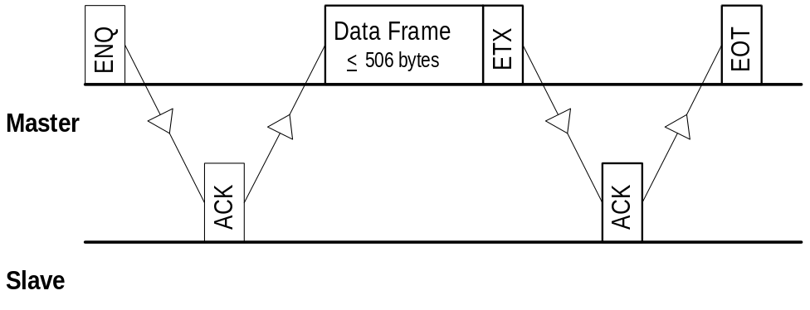

Continued on next page
Transmission Control Protocol, Continued

Sending a Data Frame  (Continued) | In this example the master will send a data frame greater than 506 bytes. The data is divided into multiple frames so that no one information section exceeds the 500 byte limit.  Note: If one block of information is being sent in multiple frames, the End Character for the frame(s) are an <ETB> (ASCII 23) with the exception of the final data frame that has an <ETX> (ASCII 03).
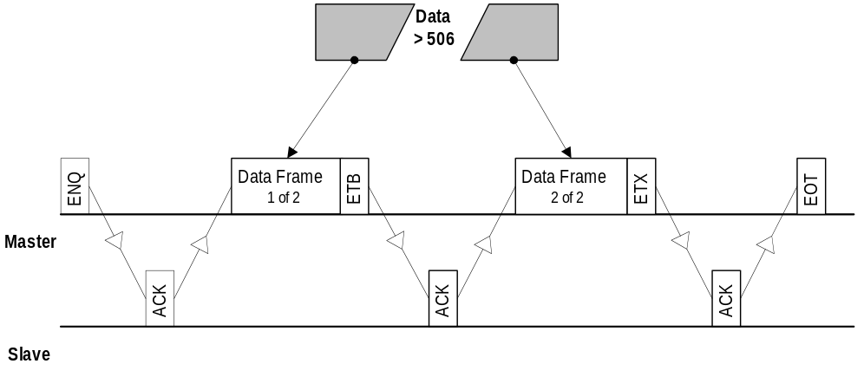

Communication Time-Out | This section describes the data flow for when the master initiates communications and an acknowledgment is not received from the slave.  The master waits 7 seconds for the acknowledgment from the slave and then tries to initiate communications again by sending another <ENQ>. If the master fails to receive an <ACK> to acknowledge the receipt of the packet after a total of 10 of these cycles, it will terminate the communications by sending an <EOT>.  Note: The main controller will turn off host communications after the <EOT> is sent.
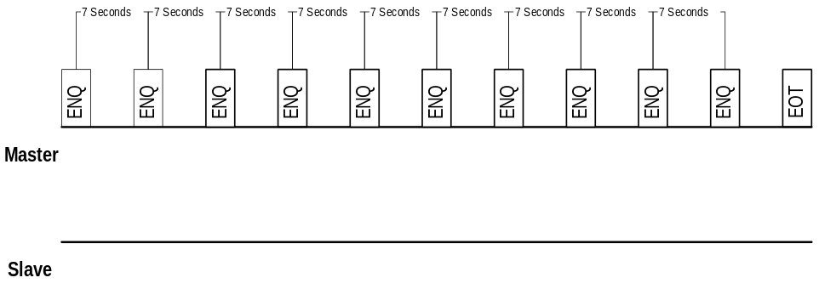

Continued on next page
Transmission Control Protocol, Continued

Resending a Data Frame | This section describes the data flow for when the master has initiated communications and sent a data frame that was not accepted by the slave.  If the slave detects an error in the receipt of a data frame (i.e. BCC does not match the data frame) the slave will send a <NAK> (ASCII 21) to the master. The master will retransmit the last data frame once more. If the slave sends an <ACK> to the retransmission, the communication cycle continues

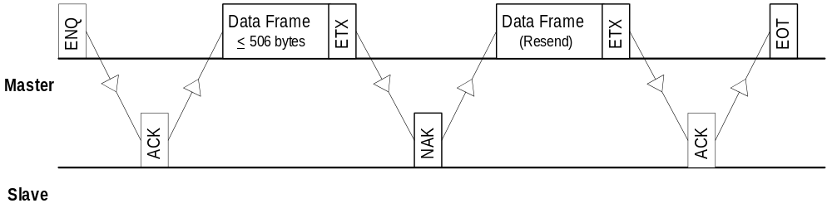

If the slave sends an <NAK> to the retransmission, the master will terminate communications by sending an <EOT>. This is considered a failed transmission and any partial information that was successfully received will not be used.

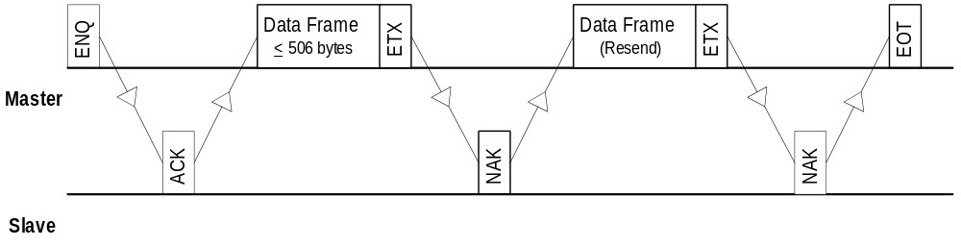

Continued on next page
Transmission Control Protocol, Continued

Terminating a Data Frame Transmission | This section describes the data flow for when the master has initiated communications and is sending a data frame and the slave fails to respond with an <ACK> or a <NAK>.  The master will wait 10 seconds for the slave to respond and then send an <EOT> to terminate the communications cycle.

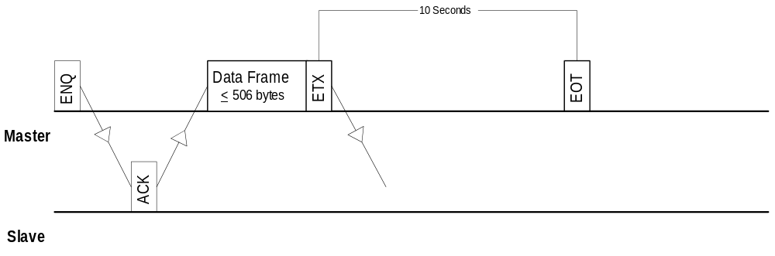

Idle Communications | This section describes the data flow for when the master does not have any information to send. This idle state will remain until the master has information to send and initiates communication cycle with an <ENQ>.

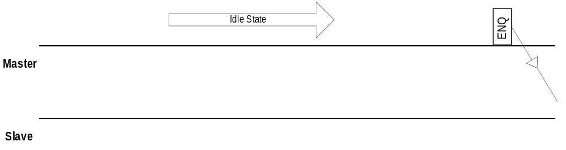

Continued on next page
Transmission Control Protocol, Continued

Main Controller Unavailable | This section describes the data flow for when the main controller is unavailable due to daily operator initiated database maintenance. This state will remain until the main controller completes its maintenance tasks.

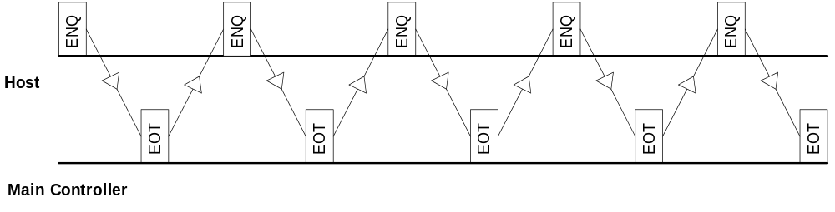

Appendix A - BCC Calculation

Introduction | The BCC calculation uses a "bitwise exclusive OR" of all the characters in the received or transmitted data stream, with the exception of the start code (STX) and the BCC character itself. The end character (either ETX or ETB) is included. Please note that it is possible for the BCC to be any ASCII character including control codes.  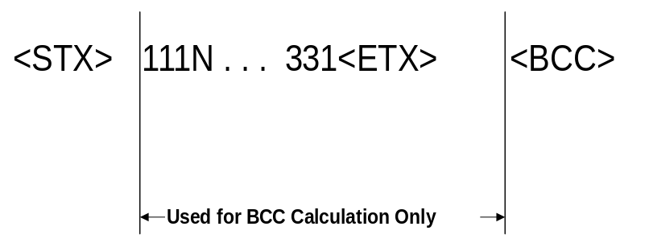

Appendix B - ASCII Chart
Char  Hex Dec | Char  Hex Dec | Char  Hex Dec | Char  Hex Dec | Char  Hex Dec | Char  Hex Dec | Char  Hex Dec | Char  Hex Dec
NUL  00 0 | DLE  10 16 | Space  20 32 | 0  30 48 | @  40 64 | P  50 80 | `  60 96 | p  70 112
SOH  01 1 | DC1  11 17 | !  21 33 | 1  31 49 | A  41 65 | Q  51 81 | a  61 97 | q  71 113
STX  02 2 | DC2  12 18 | "  22 34 | 2  32 50 | B  42 66 | R  52 82 | b  62 98 | r  72 114
ETX  03 3 | DC3  13 19 | #  23 35 | 3  33 51 | C  43 67 | S  53 83 | c  63 99 | s  73 115
EOT  04 4 | DC4  14 20 | $  24 36 | 4  34 52 | D  44 68 | T  54 84 | d  64 100 | t  74 116
ENQ  05 5 | NAK  15 21 | %  25 37 | 5  35 53 | E  45 69 | U  55 85 | e  65 101 | u  75 117
ACK  06 6 | SYN  16 22 | &  26 38 | 6  36 54 | F  46 70 | V  56 86 | f  66 102 | v  76 118
BEL  07 7 | ETB  17 23 | ’  27 39 | 7  37 55 | G  47 71 | W  57 87 | g  67 103 | w  77 119
BS  08 8 | CAN  18 24 | (  28 40 | 8  38 56 | H  48 72 | X  58 88 | h  68 104 | x  78 120
HT  09 9 | EM  19 25 | )  29 41 | 9  39 57 | I  49 73 | Y  59 89 | i  69 105 | y  79 121
LF  0A 10 | SUB  1A 26 | *  2A 42 | :  3A 58 | J  4A 74 | Z  5A 90 | j  6A 106 | z  7A 122
VT  0B 11 | ESC  1B 27 | +  2B 43 | ;  3B 59 | K  4B 75 | [  5B 91 | k  6B 107 | {  7B 123
FF  0C 12 | FS  1C 28 | ,  2C 44 | <  3C 60 | L  4C 76 | \  5C 92 | l  6C 108 | |  7C 124
CR  0D 13 | GS  1D 29 | -  2D 45 | =  3D 61 | M  4D 77 | ]  5D 93 | m  6D 109 | }  7D 125
SO  0E 14 | RS  1E 30 | .  2E 46 | >  3E 62 | N  4E 78 | ^  5E 94 | n  6E 110 | ~  7E 126
SI  0F 15 | US  1F 31 | /  2F 47 | ?  3F 63 | O  4F 79 | _  5F 95 | o  6F 111 | DEL  7F 127

Unidirectional as referred to in this manual will be two-way communications for data control frames and one-way communications for data frames.
Actual number of bytes is the Number of Tests ordered x 4 bytes.

