Boehringer Mannheim GmbH
BM/HITACHI 912 Automatic Analyzer
Host Interface Manual

System Interface - Functional Specifications
Including features of the BM/Hitachi 912 Version 1-09
BM / ID.No. 1901176-001

Document Version 1.1

1. Introduction
2. Interface Setup
2.1. Connection Cable
2.2. Specification of Communication
2.3. Setup of Communication Parameters
3. Basic Workflow
4. Software Protocol
4.1. Common text format
4.2. Start-of-data Code
4.3. Frame Identification
4.3.1. Frame Character
4.4. Data Field
4.4.1. Function Characters
4.4.2. Composition of Sample Information
4.4.3. Composition of Test Selection Information
4.4.4. Composition of Comment Information
4.4.5. Composition of Result Data for Routine, Rerun, STAT and Control samples
4.4.6. Absorbance Data
4.4.7. Photometry-assay Calibration Data
4.4.8. ISE Calibration Data
4.4.9. Data Alarm List
4.5. End-of-data Code
4.5.1. End-of-data Code Options
4.5.2. Checksum Calculation Methods
5. Data Transmission Control Procedure
5.1. Establishment of Data Link
5.2. Response to Information Message
5.2.1. No Information to be sent
5.2.2. Transfer of Communication Control Message
5.2.3. Transfer of Test Selection Information
5.2.4. Transfer of Result Data
5.2.5. Resending Request
5.2.6. Host sends SUS and REC frames
5.3. Termination and Restart of Communication
5.4. Retry and Repeat of Communication
5.5. Results-Only mode
6. Communication Functions
6.1. Function List for Test Selection Data
6.2. Function List for Result Data
7. Communication Log
7.1. Overview
7.2. Trace Data
7.3. Display, Printout and Reset of Communication Log data
7.4. Trace Data Storing Performance
8. Example Traces
8.1. Test Selection inquiry from CU to host incl. Result
8.2. Absorbance data from CU to host
8.3. Photometry-assay Calibration data from CU to host
8.4. ISE Calibration data from CU to host
8.5. Control data from CU to host
8.6. Specific Result Request from host to CU
9. Figures and Tables
Appendix A - ASCII Chart
Appendix B - Differences between HITACHI 911 and 912 Host
Appendix C - Error Check Functions
Appendix D - Table of Communication Alarms
Appendix E - Text Configuration Table

Versions

Version | Date | Modification
1.0 | January 1997
1.1 | July 1997 | Chapter 5.4 - ‘Repeat of Communication’ removed  Chapter 8.3 - Correction of example trace (photom.-assay calibration)

1 Introduction
This manual provides the specifications for bidirectional data transmission between an HITACHI Model 912 Automatic Analyzer by Boehringer Mannheim GmbH and an external laboratory host system via asynchronous serial connection. The hardware components required as well as the communication rules are described. They highlight the general considerations to be taken into account in any approach to realize the data communication between different computer systems.
This specification illustrates the fundamental considerations for the host link and contains information concerning the following:
– Hardware
• What interface hardware is required?
• How is the physical connection established?
– Use and control of the data transmission
• How to set the transfer and communication parameters?
• What is the formal structure of the strings and values to be transmitted and what influence can be taken on it?
• What kind of data or variables can be transmitted?
• How and by which system is the data transfer initiated?
– Software protocol
• What does the transmission protocol used for communication between the two systems look like?
• What does the host at the other end of the data link do and what rules has the program at the host link to follow?
Working with the host interface you will find that the data transfer from the host computer to the HITACHI Model 912 Automatic Analyzer can be done in a very easy, comfortable and reliable way.
If problems with the installation or questions about the transfer should arise please contact the responsible person of Boehringer Mannheim Service Department:
Boehringer Mannheim GmbH
Laboratory Instrumentation
Instrumentation Services
System Support
Sandhofer Straße 116
D-68305 Mannheim
Phone: (49) 621 / 759-2464
Telefax: (49) 621 / 759-4394
Figure 1 gives an general idea of the 912 interface data flow between the analyzer, the control unit (CU) and the host system. More detailed description will be found in this document.

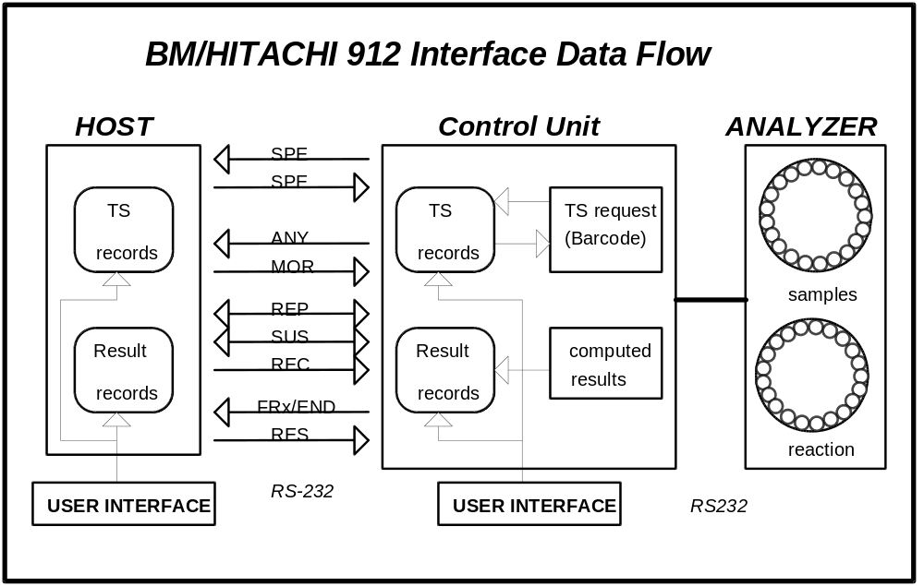
Figure 1: BM/HITACHI 912 Interface data flow
(1) Realtime test selection request is made for:
- Routine samples, if the record is not existing or the test selection is zero.
- Manual Rerun/Auto Rerun samples, if inquiry is enabled (Host Communication screen)
- STAT samples, if inquiry is enabled (Host Communication screen) and bar code reader is on.
(2) Realtime result transmission is made for:
- Routine/Rerun/STAT/Control samples
- Calibration data
- Original Absorbance Data
(3) Batch result transmission can be initiated either by
- the host, sending a result request frame for Routine or STAT results
- the operators request for Routine, STAT or Control results
The Host Communication screen is shown in Figure 3 on page 9.

2 Interface Setup

3 Connection Cable
Figure 2 shows the wiring diagram of the connection cable between the control unit of the 912 and the host.
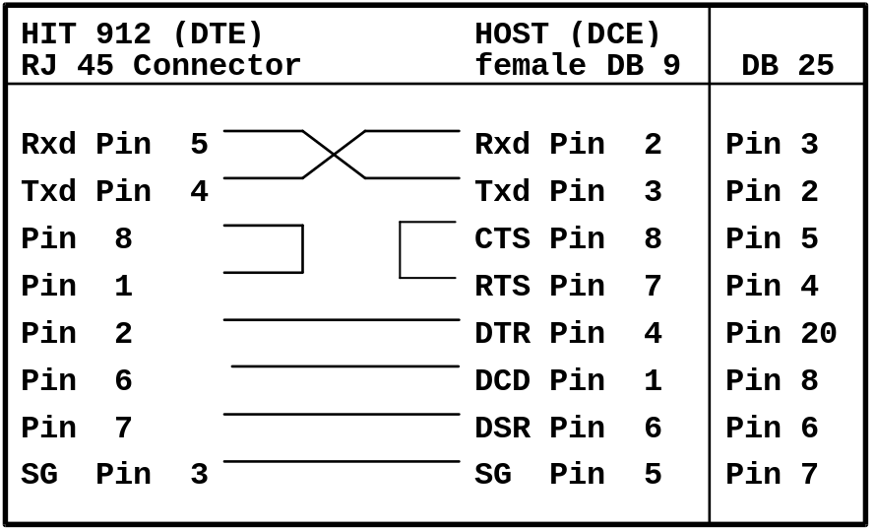
Figure 2: Connection cable
Connect the cable with the RJ 45 connector to the first (on the left side) of the four connectors of the interface card on the backside of the HP Vectra computer.

4 Specification of Communication
The table below shows the communication specifications of the host interface.

Item | Specification | Remarks
Interface | Asynchronous serial interface RS-232C | cable length max. 15m
Communication. method | Half duplex
Character code | ASCII
Text Mode | Non-transparent Mode (ASCII)
Synchronization | Asynchronous system
Table 1: Specification of the host communication

5 Setup of Communication Parameters
All settings concerning the host interface are made on the Host Communication screen.
(menu path: Utility è System è Host Comm)

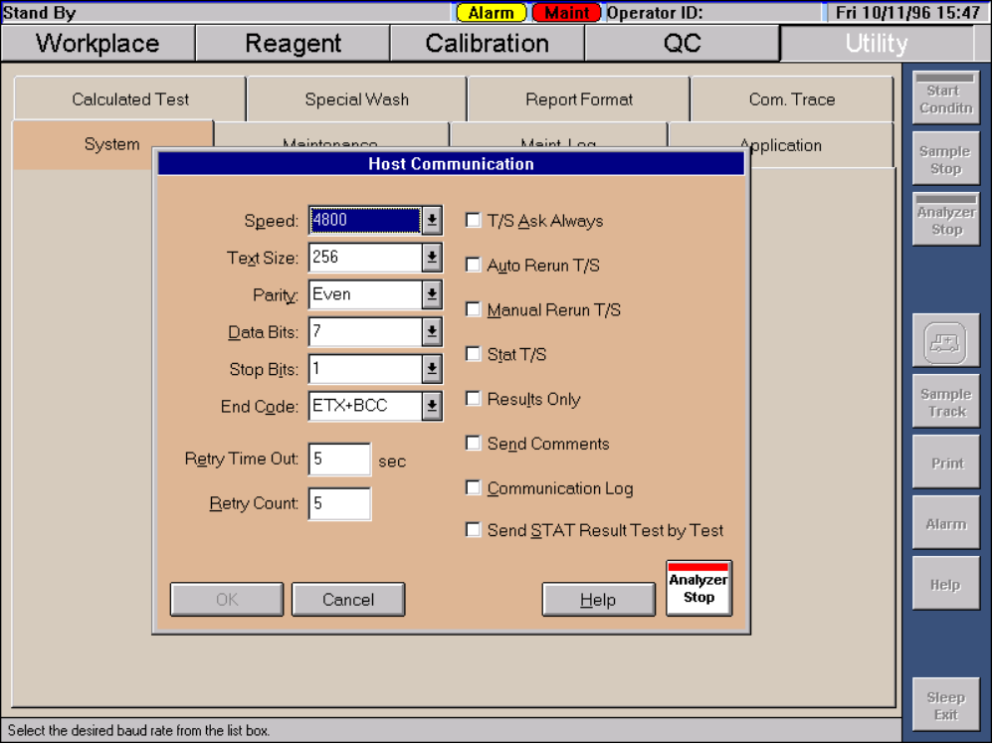
Figure 3: Host Communication screen

Serial interface parameters:
• Communication Speed 9600, 4800 baud
• Parity Check none, odd, even
• Data Bits 7, 8
• Stop Bits 1, 2

HIT 912 specific settings:
• Maximum Text Length 256, 512, 1024 bytes (chapter 4.4.5 and 4.4.6)
• Retry Count 1 to 99 / 0 = unlimited (chapter 5.4)
• Retry Time 1 to 99 seconds (chapter 5.4)
• Data-End Code 5 options (chapter 5.4)

• Option of sending comments within the result message (chapter 4.4.4 and 4.4.5)
• Option of sending STAT results test by test (chapter 4.4.5)

Test selection handling:
• ‘T/S Ask Always’ option (chapter 4.4.3)

Optional test selection inquiry for
• Auto Rerun (chapter 6.1)
• Manual Rerun (chapter 6.1)
• STAT (chapter 6.1)

Unidirectional communication mode:
• ‘Result Only’ mode (chapter 5.5)

Host Communication Log:
• Option of recording the communication (the communication log can be displayed on the screen, printed, stored on a diskette as text file and deleted)
(chapter 7)

Communication is enabled on the Start Condition screen by selecting the ‘On Line’ option in the ‘Host Communication’ frame.

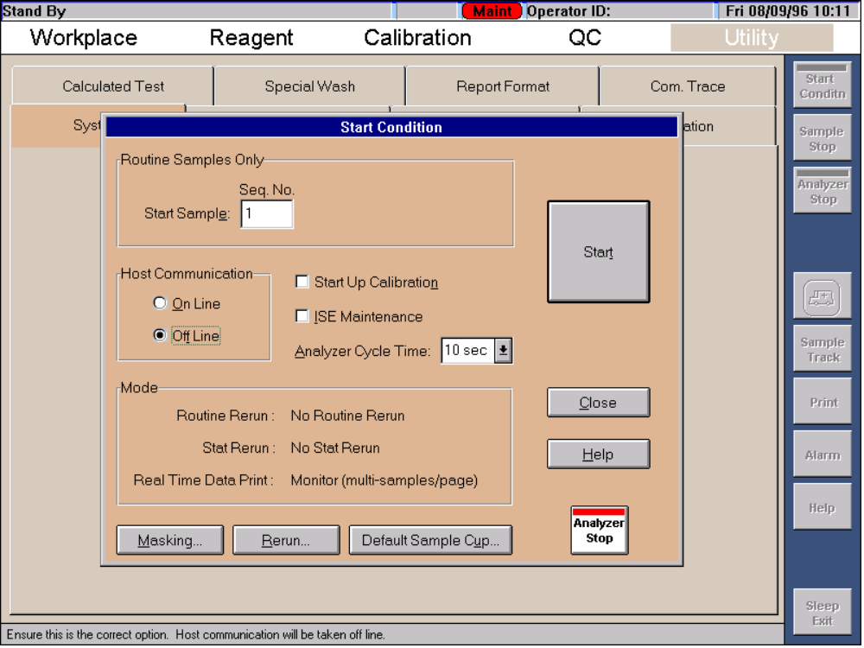
Figure 4: Start Condition screen

6 Basic Workflow
There are two ways of workflow on the BM/HITACHI 912 analyzer with a host connection:
- Test selection download in batch mode before starting the RUN
- Test selection download on request during the RUN. Download means sending information from the host to the analyzer.

Test Selection Download in Batch mode

 The operator places the samples on the instrument
 The operator initiates the download of all existing test selections from host side
 The operator starts the run

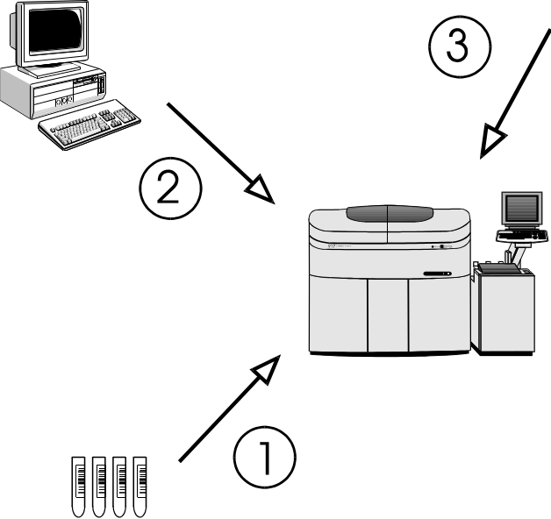
Figure 5: Test selection download in batch mode

Test Selection Download in Realtime mode

 The operator places the samples on the instrument
 The operator starts the run
 Upon reading the barcode of each sample the analyzer sends a request for each sample to the host
 The host sends back the corresponding test selection to the analyzer

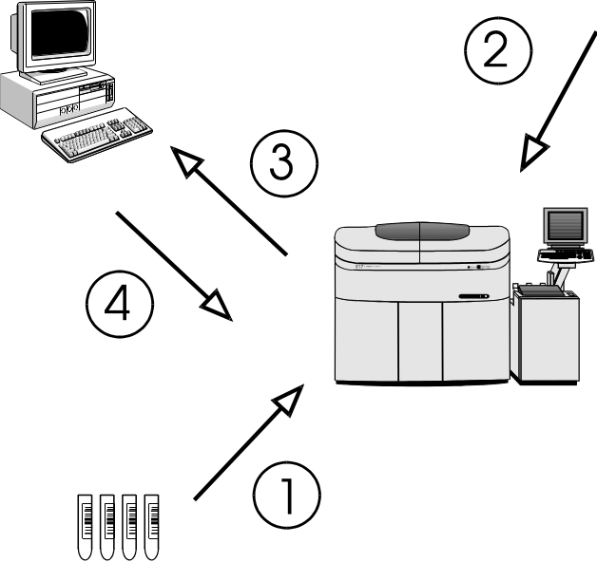
Figure 6: Test selection download in realtime mode

7 Software Protocol

8 Common text format
Each message that is sent to the CU (control unit) or the HOST (laboratory computer system) consists of the following items:

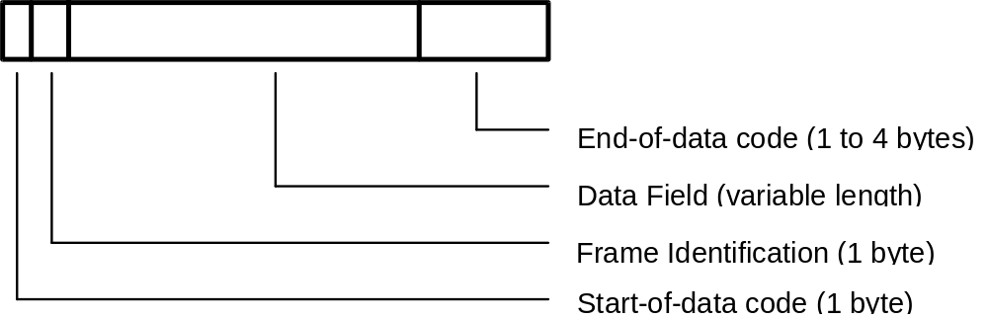

If you have a message without data (control frames ANY, REP, SUS, REC or MOR, see Table 3) then the Data Field is empty.

9 Start-of-data Code
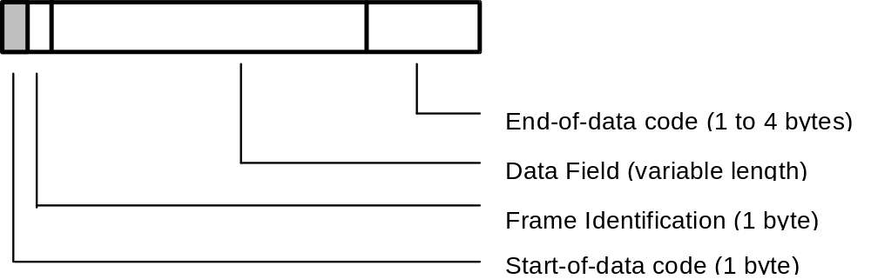

Each message sent from the CU or the host starts with the Start-of-Data Code (STX = 02H).

10 Frame Identification
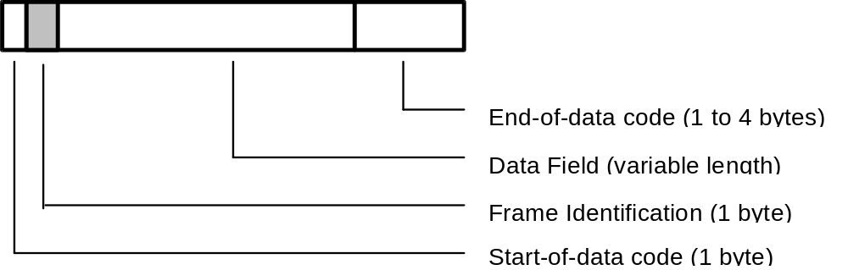

11 Frame Character
The frame character represents the purpose/ contents of the message.

Mnemonic | Name | Char. | ASCII Code | Sender | Note
FR1 | Frame 1 | 1 | 31H | CU | 1
FR2 | Frame 2 | 2 | 32H
END | End  Frame | : | 3AH |  | 2
SPE | Specific  Sample | ; | 3BH | CU  HOST | 3
RES | Results  Request | < | 3CH | HOST | 4
Table 2: Frame types having a Data Field

Note 1: The frame characters FR1 and FR2 are used, when the analytical data extends over more than one message. FR1 is used for the first message and END for the final message.
Note 2: END alone is used when analytical data for one sample can be sent in one single message.
Note 3: The CU uses the frame character SPE for the test selection inquiry of only one specific sample.
The host uses SPE for the test selection which is being sent in response to the inquiry from the CU.
Note 4: The specific result request RES is used to request analytical data of a specific sample from the host to the CU. (Depending on whether the ID is provided or not, only routine and STAT samples are taken as valid. The others are ignored.)

Mnemonic | Name | Char. | ASCII Code | Sender | Note
ANY | Any inquiry | > | 3EH | CU | 5
MOR | More | > | 3EH | HOST | 6
REP | Repeat | ? | 3FH | CU, HOST | 7
SUS | Suspend | @ | 40H | CU, HOST | 8
REC | Received | A | 41H | HOST | 9
Table 3: Frame types having no data field

Note 5: A positive response ANY is used by the CU to ask the host for the following items:
a) a test selection record for any sample that is available by the host.
b) RES, REC or MOR frame requests.
Note 6: MOR means that the host is ready to receive analytical data. (Analytical data can be transmitted from the CU to the host only when the host has sent this frame.)
Note 7: A negative response REP is used, when resending of the previous communication is requested. The host can send REP at any time. The CU, however, sends REP only when the response from the host is invalid or destroyed.
Note 8: The Data Bad and Suspend packet (SUS) is sent by the host to tell the analyzer that the last packet was bad, and that the host wants a delay before the packet is resent by the CU. The CU then resends the packet after another ANY/MOR cycle.
Note 9: With the Data Accepted but Suspend packet (REC) the host tells the analyzer that the last packet was okay and requests a 5-second communication interruption.

Frame Priorities
When two or more processings are carried out in response to a request from the host, the CU assigns priorities to them and returns a response to the host.
Batch communication is interrupted and suspended if the CU has a text with higher priority. This is restricted to the case where analytical data in the real-time mode is sent from CU and the transfer of analytical data is in response to a RES frame. After that the batch communication is restarted.
The table below shows the details of each frame and the priority.

Priority | Item
1 | SPE frame for STAT samples
2 | SPE frame for routine samples
3 | REP frame
4 | FRx,END frame for high-priority result data (real-time)
5 | FRx,END frame for specific result request (RES from host)
6 | FRx,END frame for batch results
Table 4: Frame priorities

12 Data Field
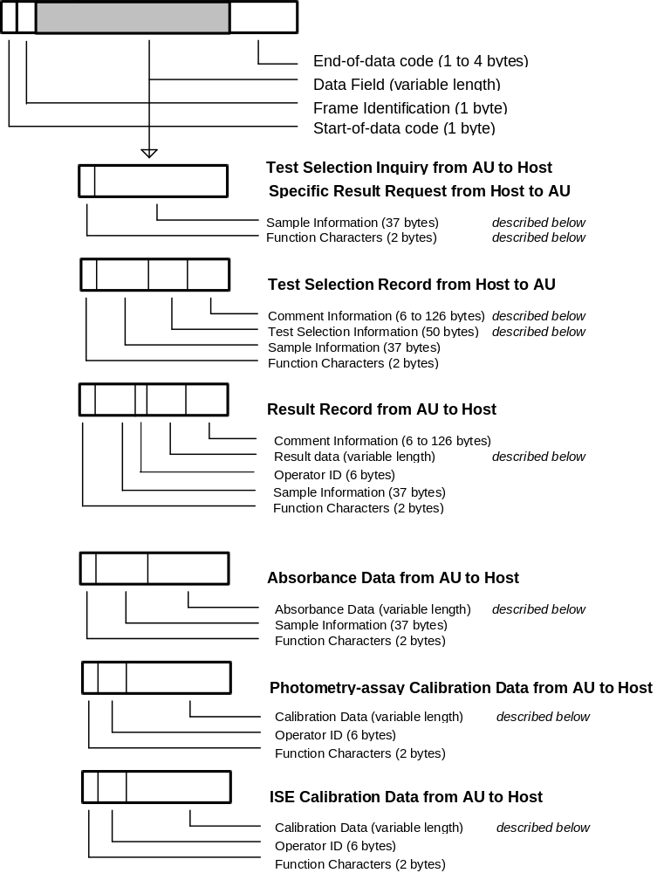

13 Function Characters
 |  |  | Test Selection Info. Inquiry |  | Result data
 |  | Direction of Communication | CU <-->HOST | CU <-- HOST | CU --> HOST |  | HOST --> CU
 |  | ID provided  / | Real-time  Communication | Batch  Communication | Real-time  Communication | Batch  Communication | Result  Request
 |  | not provided | Sample  Class x (1-5) | Sample  Class x (1-5) | Sample  Class x (1-5) | Sample  Class x (1-5) | Sample  Class x (1-5)
 | Routine sample |  | Ax | Ax | Ax | ax | ax
 | Routine sample  (automatic rerun) | Provided | Bx | Bx | Bx
 | Routine sample  (manual rerun) |  | Cx | Cx | Cx
 | Stat sample |  | Dx |  | Dx | dx | dx
 | Stat sample  (automatic rerun) |  |  |  | Ex
 | Control sample |  |  |  | F_ | f_
 | Calibration  (Photometry) | Provided |  |  | G_
 | Calibration  (ISE) | / |  |  | H_
 | Absorbance data  (Routine) | not provided |  |  | Ix
 | Absorbance data  (STAT) |  |  |  | Kx
 | Routine sample |  | Nx | Nx | Nx | nx | nx
 | Routine sample  (Automatic Rerun) |  | Ox | Ox | Ox
 | Routine sample  (Manual Rerun) | Not provided | Px | Px | Px
 | STAT sample |  |  |  | Qx | qx | qx
 | STAT sample  (Automatic Rerun) |  |  |  | Rx
Table 5: Function character table
(CU = Hit 912 Control Unit)
The character _ represents a space (code 20h).
The character x stands for the class or sample type number 1 to 5
Class 1 = Ser/Pl
Class 2 = Urine
Class 3 = CSF
Class 4 = Suprnt
Class 5 = Other

14 Composition of Sample Information

(included in SPE, RES, FR1 to FR2, END frames)
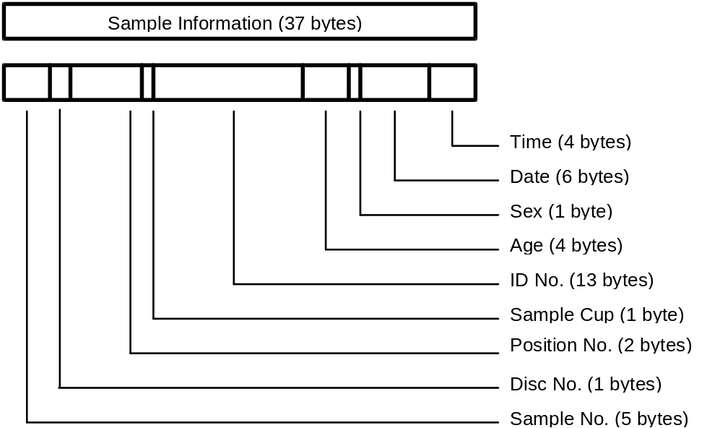

Item | L | Routine sample | Stat sample | Control sample | Note
Sample No. | 5 | Format: sssss  Range:  bbbb1-10000 | Format: sssss  Range:  bbbb1-10000 | Format: ccsss  c: control no.  Range: b1 - 60  sss: sequence no.  Range: bb1 - 150 | 1
Disk No. | 1 | Format: d  Range: 0 - 9 | Format: d  Range: 0 - 9 | Format: d  Range:  inner: b  outer: 0 - 9 | 2
Position No. | 2 | Format: pp  Range: b1 - 110 | Format: pp  Range: b1 - 70 | Format: pp  Range:  inner: b1 - b8  outer: b1 - 50 | 3
Sample Cup | 1 | Format: c  Range: 1 - 5  1 = Standard Cup  2 = Micro Cup  3 = Standard Cup on Tube  4 = Micro Cup on Tube  5 = Tube |  | Format: b | 4
Ident No. | 13 | Format: nnnnnnnnnnnnn  n = ident number |  | Format:  bbbbbnnnnnnnn  n = control name | 5
Age | 4 | Format: aaac  aaa: age no.  Range: bb0 - 200  c: age unit  1 day  2 month  3 year |  | Format: bbbb | 6
Sex | 1 | Format: s  s: sex no.  0 other  1 male  2 female |  | Format: b | 7
Date | 6 | Format: mmddyy  mm: month 01 to 12  dd: day 01 to 31  yy: year 00 to 99 |  | Format: bbbbbb | 8
Time | 4 | Format: hhmm  hh: hour 00 to 23  mm: minute 00 to 59 |  | Format: bbbb | 8
Table 6: Format of sample information / b = space (20H)
Note 1: <CU to HOST>: For an inquiry in ID mode, spaces are given.
Note 2: <CU to HOST>: For an inquiry in ID mode, spaces are given.
<HOST to CU>: If the information is not set, the 912 value is used.
Note 3: <CU to HOST>: For an inquiry in ID mode, spaces are given.
<HOST to CU>: If the information is not set, the 912 value is used.
Note 4: <CU to HOST>: Always transmitted as blank.
<HOST to CU>: If the information is not set, the 912 setting is used. If there is no 912 setting the default cup info is used.
Note 5: When the ID-No. is within 13 digits, it is right justified and preceded by spaces.
In case of no ID-mode the CU treats the ID-No. as a comment.
Note 6: <CU to HOST>: If the info. is not set, spaces are sent.
<HOST to CU>: Set age information that is sent from the CU.
Note 7: <CU to HOST>: If the info. is not set, a space is sent.
<HOST to CU>: Set sex information that is sent from the CU.
Note 8: <CU to HOST>: The blood collection date/time which the CU has is transmitted. If the date/time is not set, the sent one is set.
<HOST to CU>: Set the date/time sent from the host. Note, however, that the date/time at the CU side is set if spaces are included in each date/time field.

See chapter 7 for examples.

15 Composition of Test Selection Information

(included in SPE frame)
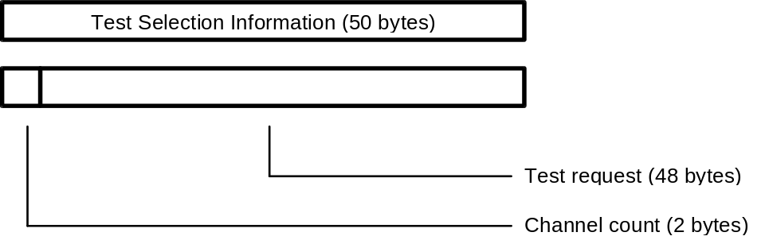

Item | Length | Range | Note
Channel count | 2 | Format: cc  Range: b0 to 48 | 1
Test request | 48 | Format: rrrr....rrrr  Range: 0 to 4 for each character:  0 = no request  1 = normal sample volume  2 = decreased volume  3 = increased volume  4 = determined by CU (only for rerun) | 2
Table 7: Format of test selection information / b = space (20H)

Note 1: If the channel count is less than 48, the channels with higher count are ignored.
Note 2: The channels are listed in ascending order.
Channels 1..46: Photometry-assay tests
Channel 47: ISE channel
- request for electrolytes (2 or 3 tests, depending on the data setting on the Application Parameter screen:
On Board - Na,K,Cl / Inactive - Na,K).
- it is not possible to select request for any of Na, K and Cl from the host.
Channel 48: Serum index channel
- Request for serum indices (for 3 tests of L, H and I)
Note 3: When an isozyme test or a test that requires test-to-test compensation is requested and no test to compare is selected, the 912 automatically selects a test to perform the requested test, but will not transmit the data.
Note 4: When a calculated test is requested, Host must also request the tests that are necessary to perform the calculation. For example, if A/G ratio calculation is requested, TP and ALB channels must be included in the same T/S.
Note 5: The 912 has a function to perform reruns with rerun sample volumes and output the data correcting the data by sample-volume ratio (not available with ISE).

Deleting a test selection entry:
A test selection with all 48 test positions set to '0' deletes an existing test selection for the specified sample and causes the analyzer to send another test selection inquiry if the corresponding barcode appears again at the barcode reader.
T/S Ask Always mode:
If the ‘T/S Ask Always’ mode is enabled on the Host Communication screen (see Figure 3 on page 9) the CU sends for each sample a test selection inquiry to the host even if there is already a test selection for that sample existing on the system.

16 Composition of Comment Information

(included in SPE, END frame)
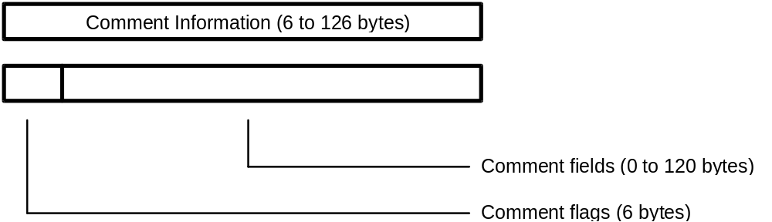

Item | Length | Range | Note
Comment flags | 6 | Format: FFFFFF  F: comment switch/flag  0 absence of corr. comment  1 presence of corr. comment | 1
Comment 1 | 30 | Format: cccc....cccc  c: comment corresponding to flag 1 | 2
Comment 2 | 25 | Format: cccc....cccc  c: comment corresponding to flag 2
Comment 3 | 20 | Format: cccc....cccc  c: comment corresponding to flag 3
Comment 4 | 15 | Format: cccc....cccc  c: comment corresponding to flag 4
Comment 5 | 15 | Format: cccc....cccc  c: comment corresponding to flag 5
Comment 6 | 20 | Format: cccc....cccc  c: comment corresponding to flag 6
Table 8: Format of comment information

Note 1: For each comment flag that is set to ‘1’, the corresponding comment text follows.
Comment info within test selection from host to CU:
If all comment flags are ‘0’, the [ETX] code follows directly after the last comment flags.
For those comment fields that are not sent to the CU, an already existing comment text remains valid.
Comment info within result transmission
If enabled on the Host Communication screen (option ‘Send Comments’ / see Figure 3 on page 9) the comment information is sent at the end of each result transmission to the host. (Control results do not have that comment info).
Note 2: Within the comment data fields, the character range is valid from code 20H to FEH. (see Appendix A - ASCII Chart)

See chapter 7 for examples.

17 Composition of Result Data for Routine, Rerun, STAT and Control samples
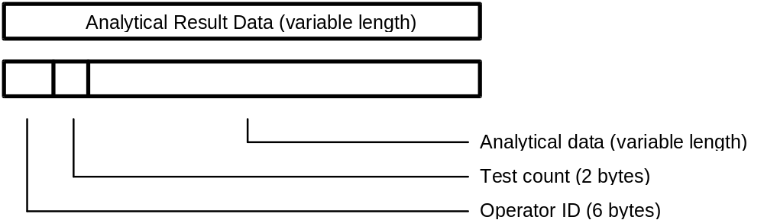

Item | Length | Range | Note
Operator ID | 6 | Format: oooooo
Test count | 2 | Format: cc  Range: b0 - 60 | 1
Result[n]  with n=1 to ‘Test count’ | 9 each | Format: ccvvvvvva  cc: Test no.  Range:  b1 - 46 Photometry assay  47 - 49 Electrolyte  50 - 52 Serum index  53 - 60 Calculated tests  vvvvvv: Result value  a: Data alarm  Refer to the data alarm list  (see Table 17 on page 37) | 2  3
Table 9: Format of analytical result data / b = space (20H)

Note 1: The CU transfers data for up to 46 tests respectively for simultaneous measurement in real-time and batch communication .
The results of the electrolytes (three tests of Na, K and Cl) are transmitted with the test numbers 47 to 49, the results of serum indexes (three tests of lipemia, hemolysis and icterus) with the test numbers 50 to 52 and the calculated test results with the test numbers 53 to 60.
Note 2a: Format of the 6-character result value field:

Pos/Neg. | Decimal Point | Max.Digits | Example
Positive | absent | 6 | 123456
 | present | 5 | 123.45
Negative | absent | 5 | -12345  bb-123
 | present | 4 | -12.34  b-12.3
Table 10: Format of measured value / b = space (20H)
Note 2b: Qualitative Result Transmission
On the Utility è Application è Range screen, it is possible to enter six-character long expressions for definable result ranges. If activated, the corresponding expression is transmitted left justified and space filled instead of the result value.
This option is not available for control results.
If the qualitative data to be transmitted is left blank, the original analytical data is transmitted.
Note 3a: Edited Results Transmission
Results that have been modified on the Workplace è Data Review è Edit screen get the following marks attached if the option 'Edited Flag' was enabled on Utility è System è Alarm Setting screen.
'*' (code 2AH) is displayed on the Data Review screen and sent to the host as alarm character.
'EDITED' is printed on the monitor printout.

See chapter 7 for examples.

STAT result transfer Test by Test:
If this option on the Host Communication screen (see Figure 3 on page 9), is enabled, single STAT test results are sent to the host as soon as available. When the result of the last test of a sample is available, all test results of that sample are sent in one result result transmission.

Text Size Limitation:
Since the maximum text size may be 256, 512 or 1024 bytes (selectable on Host Communication screen / see Figure 3 on page 9) it can happen that the analytical data text has to be divided into several (up to 3) frames depending on the text size and the number of test results.

 | Text Size | 256 bytes | 512 bytes | 1024 bytes
 | Max. no. of test results in one frame | 22 | 51 | 60
 | Tests in FR1 or END | 1 to 22 | 1 to 51 | 1 to 60
 | Tests in FR2 or END | 23 to 44 | 52 to 60
 | Tests in END | 45 to 60
Table 11: No. of test results per frame according to the text size.
The maximum number of transferable test results in one frame is calculated with the following expression:

max. no. of test results < (Text Size - 47) / 9 (Round off fractions)

If the ‘Send Comments’ option is enabled on the Host Communication screen (see Figure 3 on page 9), the six comment fields are sent after the last result value. If there are more than one result frame necessary the comments are only sent in the END frame. Since the whole comment information is 120 characters long, the maximum number of test results in the END frame is less than described in the table above.

18 Absorbance Data
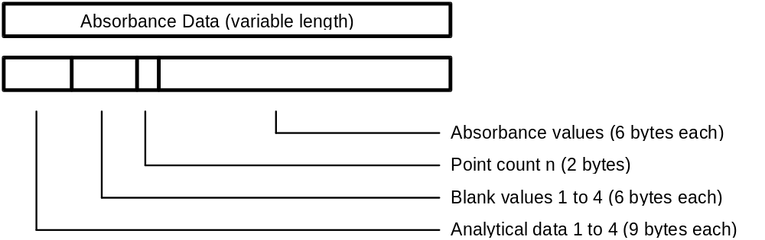

Item | Length | Range | Note
Analytical data [n]  with n=1 to 4 | 4 * 9 | Format: ccvvvvvva  cc: Channel no.  vvvvvv: Result value  a: Data alarm  Refer to the data alarm list  (see Table 17 on page 37) | 1
Blank data [n]  with n=1 to 4 | 4 * 6 | Format: cccccc | 2
Point count | 2 | Format: pp  Range: n = b0 - 49 | 3
Absorb. data [n]  with n=1 to ‘Point count’ | n * 6 | Format: aaaaaa /-aaaaa | 4
Table 12: Format of absorbance data / b = space (20H)
Note 1: If two-channel simultaneous measurement is specified, data for two channels is transfered. If serum index measurement is specified, data for up to four channels (1 channel + L, H, I) is transmitted.
If there is no relevant test for analytical data, 9 spaces are transfered.
Note 2: The first value is the 'Stopped cell blank', the following three values are the 'Passed cell blanks'. The values are transmitted according to the analytical method of this test.
The unit for the cell blank data is 10-4 (10E-4) absolute. An integer is transmitted preceded by space with floating sign position.
Note 3: The point count is the number of photometric points which follow the point count information. The following values may occur:

 | Reaction time [sec] | 3 | 4 | 5 | 10 | 15
 | Point Count | 10 | 13 | 15 | 31 | 49
Table 13: Reaction Times

Note 4: The absorbance data in the entire reaction monitoring system (data at each photometric point) is transmitted in the same format as for the above cell blank data. When the point count is less than 49, the data is closely transmitted in sequence starting from ABS 1.
Text Size Limitation:
Since the maximum text size may be 256, 512 or 1024 bytes (selectable on Host Communication screen / see Figure 3 on page 9) it can happen that the absorbance data text has to be divided into 2 frames depending on the text size and the number of absorbance values.

 | Text Size | 256 bytes | 512/1024 bytes
 | ABS values in FR1 or END | 1 to 24 | 1 to 49
 | ABS values in END | 25 to 49
Table 14: No. of absorbance values per frame according to the text size.
The sample information is sent in each frame; the analytical data and blank values are only sent in the first frame.

See chapter 7 for examples.

Photometric Points

# | (sec) | Remarks | # | (sec) | Remarks
Sample pipetting
R1 pipetting
R1 stirring
1 | 0,00 |  | 26 | 490,43
2 | 19,92 |  | 27 | 510,35
3 | 39,84 |  | 28 | 530,27
4 | 59,76 |  | 29 | 550,20
5 | 79,69 | R2 pipetting | 30 | 570,12
6 | 99,61 | R2 stirring | 31 | 590,04
7 | 119,53 |  | 32 | 609,96 | R4 pipetting and stirring
8 | 139,45 |  | 33 | 629,88
9 | 159,37 |  | 34 | 649,80
10 | 179,29 |  | 35 | 669,73
11 | 199,21 |  | 36 | 689,65
12 | 219,14 |  | 37 | 709,57
13 | 239,06 |  | 38 | 729,49
14 | 255,74 |  | 39 | 749,41
15 | 275,66 |  | 40 | 769,33
16 | 295,59 |  | 41 | 789,25
17 | 325,51 | R3 pipetting and stirring | 42 | 809,18
18 | 335,43 |  | 43 | 829,10
19 | 355,35 |  | 44 | 865,70
20 | 375,27 |  | 45 | 885,63
21 | 395,19 |  | 46 | 905,55
22 | 415,11 |  | 47 | 925,47
23 | 435,04 |  | 48 | 945,39
24 | 454,96 |  | 49 | 965,31
25 | 472,16

19 Photometry-assay Calibration Data
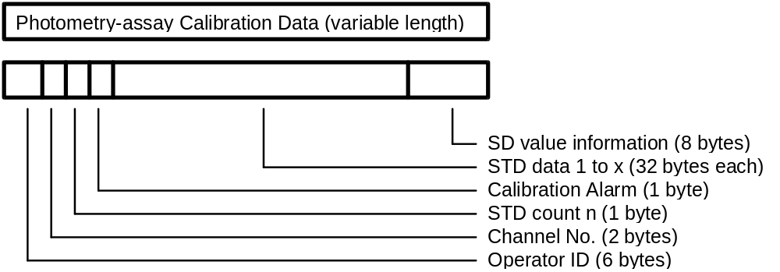

Item | Length | Range | Note
Operator ID | 6 | Format: oooooo
Channel no. | 2 | Format: cc  Range: b1 - 46 | 1
STD count | 1 | Format: n  No. of standards according to the calibration method  Range: n = 1 - 6 | 2
Calib. alarm | 1 | Format: a  Refer to the data alarm list  (see Table 17 on page 37) | 3
STD[n]  with n=1 to ‘STD count’ | 32 each | Format: kaaaaaaddddddbbbbbb  eeeeeeupppppp  k: STD no.; Range: 1 - 6  aaaaaa 1st absorbance data  dddddd 1st initial absorbance data  bbbbbb 2nd absorbance data  eeeeee 2nd initial absorbance data  u data alarm  Refer to the data alarm list  (see Table 17 on page 37)  pppppp Prozone value | 4  3
SD value | 8 | Format: pvvvvvvd  p 'Y' = SD value present  'N' = SD value absent  vvvvvv SD value  d decimal point position | 5
Table 15: Format of photometry-assay calibration data / b = space(20H)
Note 1: The test code in photometry-assay calibration which corresponds to the test code in the CU.
Note 2: When the STD count is 1, STD data 1 is followed by SD value information.
Note 3: Refer to the data alarm list (see Table 17 on page 37)
Note 4: Each standard is measured twice. (1st and 2nd abs. values). The 1st and 2nd absorbance values are the results of the bichromatic measurements at the corresponding measuring point; the initial absorbance values are the results of the monochromatic measurements with only the main wavelength. (Each standard is measured with two different wavelengths).
Each absorbance data is right-justified and preceded by space. The unit is 10-4 (10E-4) absolute. It is a 6-digit integer with sign.
Note 5: The SD value is only calculated for nonlinear and linear multi-point calibrations (3 to 6 standards). It is right-justified and preceded by space. It has no unit and the decimal point position can be set on the Utility è Application è Calib screen in the text field ‘SD Limit’.
If the SD value is absent, spaces are given instead of SD value and decimal point position.

See chapter 7 for examples.

20 ISE Calibration Data
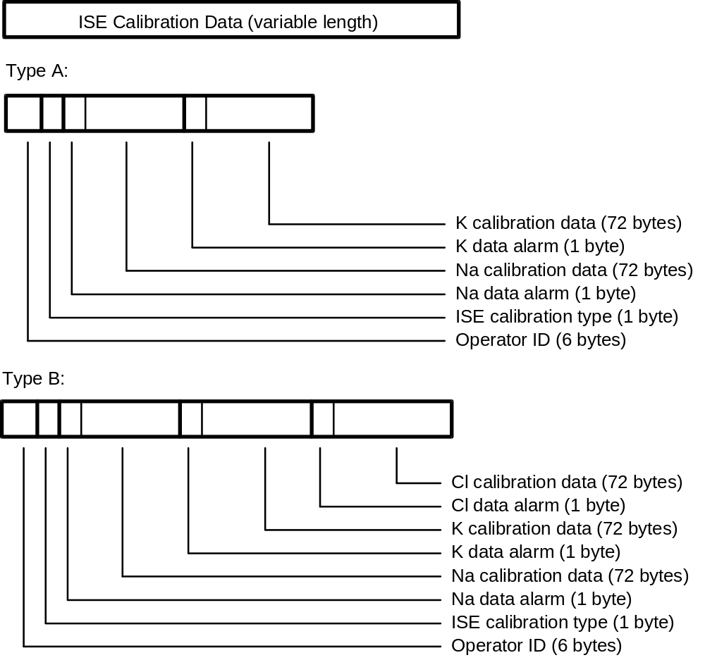

Item | Length | Range | Note
Operator ID | 6 | Format: oooooo
ISE type | 1 | Format: p  ‘A’ : Tests Na, K (n = 2)  'B' : Tests Na, K, Cl (n = 3)
Data alarm[i]  +  Calib. data [i]  with i=1 to n | 1  8 * 9 each | Format: a  Refer to the data alarm list (seeTable 17 on page 37)  Format ddvvvvvva  dd: Data identification  Range: b1 - b8  vvvvvv: measured value  a: data alarm  Refer to the data alarm list  (see Table 17 on page 37) | 1
Table 16: Format of ISE calibration data / b = space(20H)
Note 1: For each of the three tests NA, K, Cl, the following eight data items are transmitted:
- electromotive force of internal standard solution
- electromotive force of LOW solution
- electromotive force of HIGH solution
- electromotive force of M solution
- slope level for display
- concentration of internal standard solution
- concentration of M solution
- compensation factor
The unit for the measured value is mV. It has a sign and a decimal point. Spaces are given, when there is no relevant data.

See chapter 7 for examples.

21 Data Alarm List

No. | Data Alarm Name | Printer | CRT | I/F | Photometry Assay |  |  | ISE |  |  |  | Note
 |  |  |  |  | R/S | C | Std |  | R/S | C | Std |  | 1
1 | ADC abnormal | ADC? | A | A | o | o | o |  | o | o | o
2 | Cell blank abnormal | CELL? | Q | Q | o | o | o
3 | Sample short | SAMPL. | V | V | o | o | o |  | o | o | o |  | 2
4 | Reagent short | REAGN. | T | T | o | o | o |  | o | o | o
5 | Absorbance over | ABS? | Z | Z | o | o | o
6 | PROZONE error | *****P | P | P | o | o | o |  |  |  |  |  | 3
7 | Reac limit over at all points | LIMT.0 | I | I | o | o | o
8 | Reaction limit over except at 1 point | LIMT.1 | J | J | o | o | o
9 | Reaction limit over except at 2 or 3 points | LIMT.2 | K | K | o | o | o
10 | Linearity abnormal for 9 points or more | LIN. | W | W | o | o | o
11 | Linearity abnormal for 8 points or less | LIN.8 | F | F | o | o | o
12 | Standard 1 absorbance abnormal | S1ABS? | H | H |  |  | o
13 | Duplicate error | DUP | U | U |  |  | o
14 | STD error | STD? | S | S |  |  | o |  |  |  | o
15 | Sensitivity error | SENS | Y | Y |  |  | o
16 | Calibration error | CALIB | B | B |  |  | o |  |  |  | o
17 | SD error | SD? | G | G |  |  | o
18 | Noise error | NOISE | N | N |  |  |  |  | o | o | o
19 | Level error | LEVEL | L | L |  |  |  |  | o | o | o
20 | Slope error | SLOPE? |  | E |  |  |  |  |  |  | o
21 | Preparation error | PREP. |  | R |  |  |  |  |  |  | o
22 | Internal standard concentration error | I.STD |  | D |  |  |  |  |  |  | o
23 | Sample value abnormal | R.OVER | & | & |  |  |  |  | o | o
24 | Test-to-test comp. error | CMP.T | C | C | o | o |  |  | o | o
25 | Test-to-test compensation disabled | CMP.T! | M | M | o | o |  |  | o | o |  |  | 2
26 | Technical upper limit over | LIMTH | $ | $ | o |  |  |  | o
27 | Technical lower limit over | LIMTL | $ | $ | o |  |  |  | o
Table 17: Data alarm list (part 1)

No | Data Alarm Name | Printer | CRT | I/F | Photometry Assay |  |  | ISE |  |  |  | Note
 |  |  |  |  | R/S | C | Std |  | R/S | C | Std |  | 1
28 | Random error (R-4s) | RANDOM | @ | @ |  | o |  |  |  | o
29 | Systematic error 1 (2-2sA) | SYSTM1 | # | # |  | o |  |  |  | o
30 | Systematic error 2 (2-2sW) | SYSTM 2 | # | # |  | o |  |  |  | o
31 | Systematic error 3 (4-1sA) | SYSTM 3 | # | # |  | o |  |  |  | o
32 | Systematic error 4 (4-1sW) | SYSTM 4 | # | # |  | o |  |  |  | o
33 | Systematic error 5 (10xA) | SYSTM 5 | # | # |  | o |  |  |  | o
34 | Systematic error 6 (10xW) | SYSTM 6 | # | # |  | o |  |  |  | o
35 | QC error 1 | QCERR1 | + | + |  | o |  |  |  | o
36 | QC error 2 | QCERR2 | + | + |  | o |  |  |  | o
37 | Calculation test error | CALC? | % | % | o |  |  |  | o
38 | Overflow | OVER | O | O | o | o |  |  | o | o |  |  | 2
39 | Calculation disabled | ??? | X | X | o | o | o |  | o | o | o
40 | Expected value upper limit over | H |  |  | o | o |  |  | o | o |  |  | 4
41 | Expected value lower limit over | L |  |  | o | o |  |  | o | o | o |  | 4
42 | Edited Results | EDITED | * | * | o |  |  |  | o
43 | Calibration failure | CalErr | ! | ! | o | o |  |  | o | o
44 | Convergence absorbance over | >AMAX | > | > | o | o
45 | Repeat upper limit over | REPH | = | = | o |  |  |  | o
46 | Repeat lower limit over | REPL | = | = | o |  |  |  | o |  |  |  | 2
47 | Masking data |  | ? |  | o |  |  |  | o
Table 18: Data alarm list (part 2)
Note 1. R/S = Routine/STAT C = Control Std = Calibration
Note 2. Data is left blank
Note 3. Prozone value is output on printer only in real-time monitor mode.
(***** = prozon value, 5 digits)
Note 4. Can exist with any other alarm.

When two or more data alarms are given for a single data item, the one registered first is output.
Random errors, systematic errors and QC errors that are generated during realtime QC are attached to the second control sample only. When outputting batch data, the program outputs these errors with all control samples. However, if the printing of the second-control-sample data has been delayed during realtime QC, the program outputs the above alarms with both control samples upon realtime output.

22 End-of-data Code
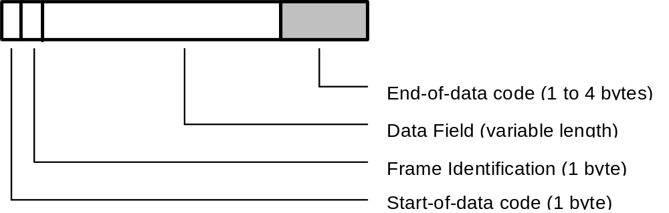

The End-of-data code represents the end of each text that is sent from the CU or the host.

23 End-of-data Code Options
There are five options which can be set on the Host Communication screen.

No | Code | ASCII | Bytes
1 | [ETX][BCC] | 03H [BCC] | 2
2 | [CR][LF][ETX] | 0DH 0AH 03H | 3
3 | [ETX] | 03H | 1
4 | [ETX][CR][LF] | 03H 0DH 0AH | 3
5 | [ETX][CKSH][CKSL][CR] | 03H [high][low] 0DH | 4
Table 19: End-of-data codes

24 Checksum Calculation Methods
[BCC] = Block Check Character
The calculation is made as follows:
All characters excluding [STX] and including [ETX] are XOR accumulated. This results in the BCC character (with code in the range 00H to FFH).
Example:
SPE from CU to HOST:
Routine Sample, Class 1, with barcode reader
Sample No.: 1, Disk No.: 0 , Position: 1
Ident No.: 100001, Age: 36 years, Sex: male
Date: September, 23th, 1991, Time 9:30

[STX];A1····10·11·······100001·36312309910930[ETX]check-string
BCC-calculation: result = 64hex / check-string = "d"

[CKSH][CKSL] = Checksum high/low
The calculation is made as follows:
The checksum is generated as the elementary sum of all data bytes excluding [STX] and [ETX]. The result of the calculation is a 4-digit hexadecimal value. The two low order digits of that number are converted to ASCII characters. These two characters build the checksum high/low.
Example:
SPE from CU to HOST:
[STX] ;A1····10·11·······100001·36312309910930[ETX]check-string[CR]
Checksum-calculation: result = 03hex / check-string = "03"

25 Data Transmission Control Procedure

26 Establishment of Data Link
After selecting the On-Line option on the Start Condition screen, the CU transmits the ANY frame to the host. Communication is started from this point. The host has to answer within 5 seconds, usually with a MOR frame.
5 seconds after the receipt of the MOR frame, the CU sends the next ANY frame to the host.
In subsequent steps, the CU and the host continue transmission alternately.
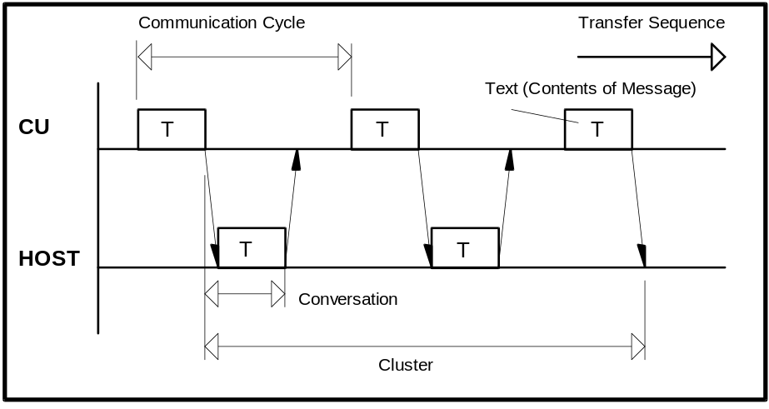
Figure 7: Common communication timing
Conversation One message sent from the host or the CU
Communication cycle One request from the CU with the corresponding answer
from the host
Cluster A group of conversations between the CU and the host

27 Response to Information Message
After receiving information, the receiver sends a response to inform the sender of the receiver status and the validity of received information.
The format of the various messages is described above. When the 256 or 512-byte mode is selected for the transmitted byte count, the analytical data text may exceed 256 or 512 bytes (including start-of-data code and end-of-data code) according to the sample. In this case, the analytical data text is divided. The frame character identifies each text part.
The CU continues replying as far as the host returns a response. Even when the text, corresponding to an optional frame character is transmitted and there is no more data to be sent between the CU and host, they continue sending the ANY frame and MOR frame respectively. However, the cluster is restarted immediately if analytical data transfer, test selection directive or any other transfer is requested.
After sending a text, the host should avoid sending until reception of a response or request to/for the next in a normal condition. Otherwise the CU will output an alarm.
In transfer from the host to the CU, a pause of at least 100 msec is required.
If no response is returned or an invalid response is received, the recovery procedure is executed. In case of sending from the host, the host must always be kept ready for receiving the response.
Described below are the typical procedure for returning a response to the information message and the procedure upon receiving the response.

28 No Information to be sent
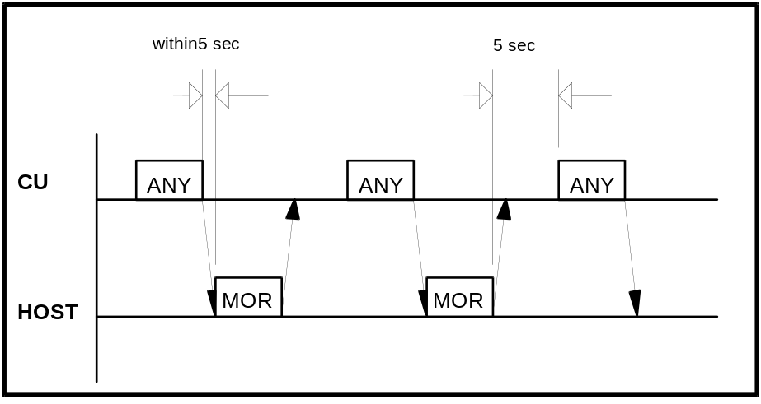
Figure 8: Communication timing without information exchange

The CU continues returning the ANY frame in response to the MOR frame from the host. This procedure continues even when the CU and host have no information to be sent. Following conditions must be satisfied:
a) There is no test selection information to be sent to the host.
b) Analytical data is not output in the real time mode.
c) There is no request for the RES frame.
In this case, the CU sends the ANY frame in the lapse of 5 seconds after receiving the MOR frame from the host (a point when the final end-of-data code is recognized).
After receiving a frame from the CU, the host should return a response as soon as possible. If it cannot respond within 5 seconds, Host must transmit a SUS frame to the CU.

29 Transfer of Communication Control Message
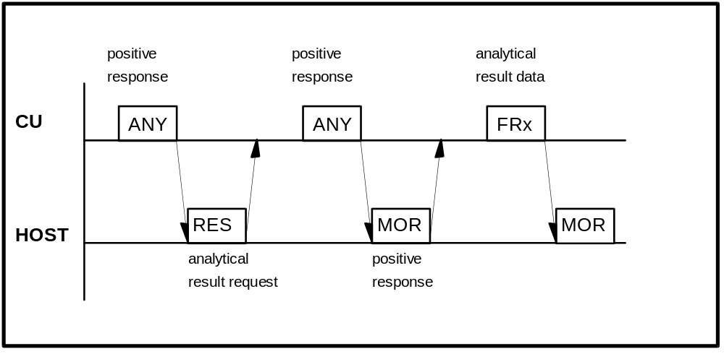
Figure 9: Transfer of communication control message

The RES, ANY, MOR, REP, SUS, REC frames are available for the communication control message.
For details, refer to the Frame types in Table 2 on page 15.

30 Transfer of Test Selection Information
(a) Test selection directive from the host to the CU (batch mode)
Usually the host will send test selections in advance of the sample's arrival on the analyzer. The host can send the test selection packet in response to the ANY frame from the CU.

(b) Test selection inquiry from the CU to the host (realtime mode)
If the test selection is not sent by the host, the CU can ask for specific test selections from the host. The test selection inquiries are sent to the host when samples are ready for processing and no test selections are available at the CU or the ‘T/S Ask Always’ option is enabled on the Host Communication screen (see Figure 3 on page 9). This case is shown in Figure 10.
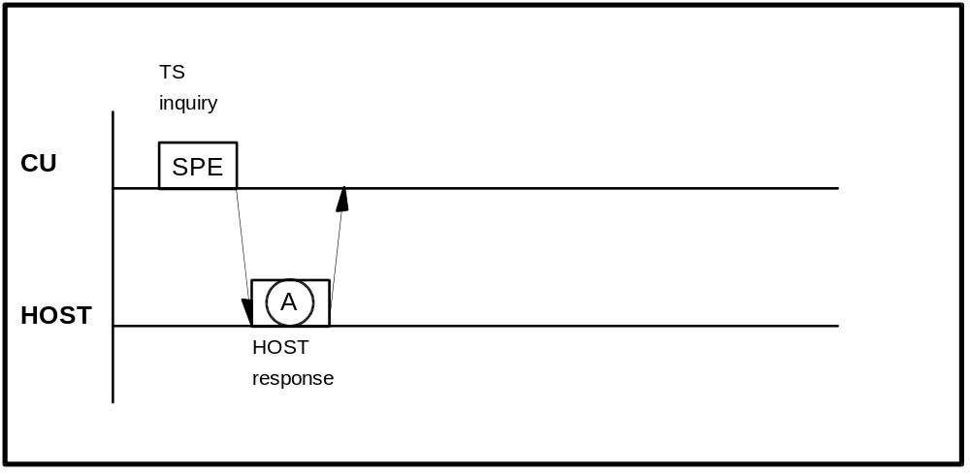
Figure 10: Test selection inquiry
The possible host responses to the specific test selection inquiry are listed in Table 20.

Frame A | Description
SPE | Respond with test selection for the sample requested. If the test selection is received correctly and in time, then this test selection will be used for the sample. If the test selection is not received, then the Default test selection will be used if one has been configured by the operator. If no Default test selection has been configured, then the sample will be skipped.
MOR | The host indicates that it cannot respond to test selection information inquiry but is ready to receive analytical data.  In this case the alarm message 'T/S Availability Error' is displayed on the screen.
REC | The host indicates that it wants to suspend the communication with the CU for a specified time because it is neither possible to respond to test selection inquiry nor possible to receive analytical data.
Table 20: Host response to test selection inquiry

31 Transfer of Result Data
(a) Result request with the RES frame from the host to the CU
The host can make a request to the CU for the analytical data of a specific sample by use of the RES frame. The request could be for results which have not been received yet or for results which the CU has already sent.
The CU will respond with the ANY frame, to indicate that the request was received. The result will be returned to the host. If the CU cannot find the requested sample's result, no response will be given to the host to indicate this. The request was accepted by the CU, but this does not mean that the result is available to the CU.
The CU will store up to ten requests in an internal buffer. This buffer is periodically checked by the CU. The buffer will only hold ten requests, and subsequent requests are ignored. A request slot is cleared when the corresponding result is sent. All slots are cleared when the system is reset by switching off/on.
Because of the limit of ten slots, the host should be circumspect about using this feature. If requests are made for samples that do not exist, the request will never be fulfilled, and if all slots are used, this feature will become essentially disabled. This feature needs not to be implemented because the CU sends the result in realtime as soon as possible after completion.

(b) Result transfer from the CU to the host
The target is of course, getting results back to the host. For this the CU uses result frames.
There are three cases for result-sending:
- Real-time mode; the results are sent as soon as they are available at the CU side. This is the normal way.
- Batch mode; the results are transfered manually by the operator (see the Data Review screen)
- After result request; this method is described above (see (a)).

Figure 11 shows the result transmission procedure in normal case and in Table 22 the possible host responses to result frames are listed.
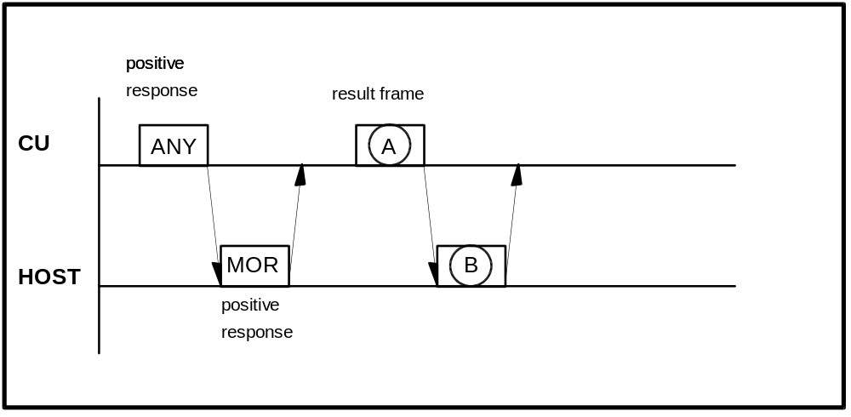
Figure 11: Result transmission

Frame A | Description
FR1 to END | Analytical data (including calibration and absorbance result)
Table 21: CU result frames FR1 to FR2 / END

Frame B | Description
REP | when text in A is abnormal
MOR | to receive analytical data next time also
REC | to direct test selection
SUS | to suspend communication
SPE | to indicate test selection
RES | to request a specific sample
Table 22: Host response to FR1 to FR2 / END
Transmission Procedure in Special Case.
Results from a patient's sample can be sent in up to three result frame packets (depending on the number of results and the maximum text length). Each frame requires a MOR from the host before the next frame will be sent. Ideally, the CU will try to transfer all packets for a sample without sending any other type of packet. There are instances, such as the analyzer needing test selection information, in which the CU can afford to wait for the current sample's result frames to transfer. One effect of this system is, that there is no delay for SPE frames. This case is shown in Figure 12.
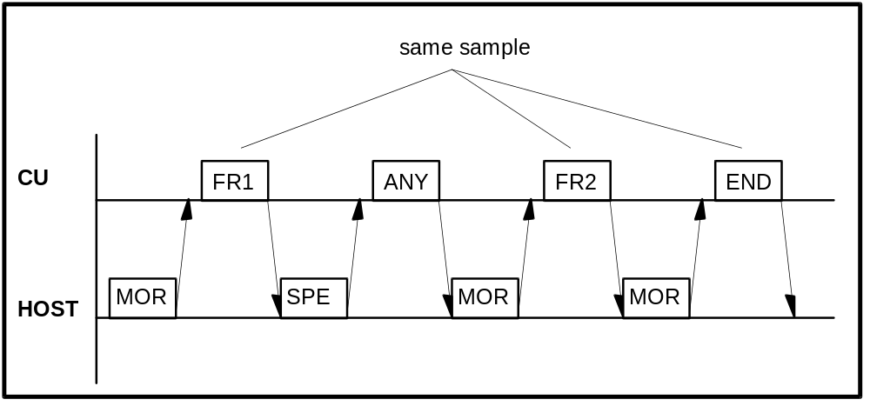
Figure 12: Result transmission with three frames and SPE interrupt

32 Resending Request
If there is any abnormality in the contents of the text received from the CU or the host, resending is requested with the REP frame. Figure 13 shows this procedure if the CU sends the REP frame; in Figure 14 the host sends the REP frame.
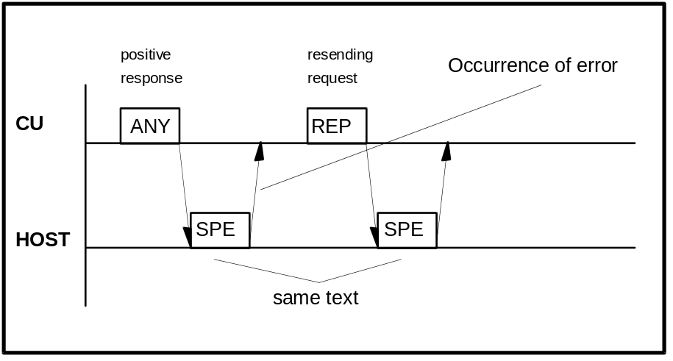
Figure 13: Resending request with REP frame from CU to host
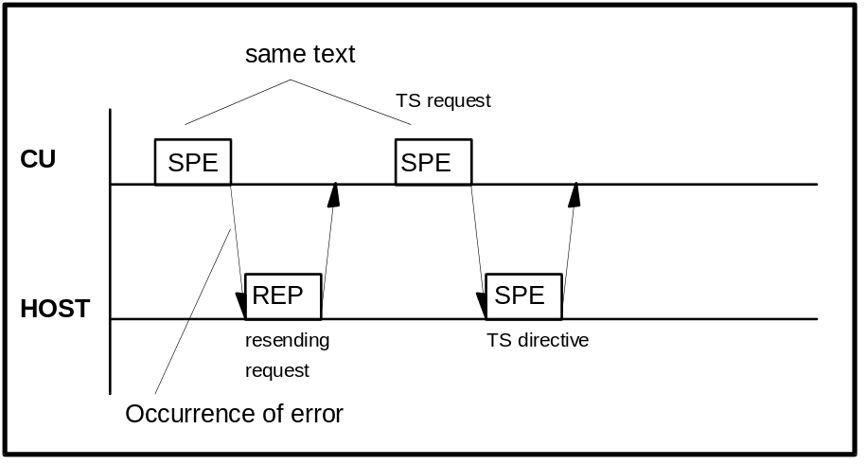
Figure 14: Resending request with REP frame from host to CU

33 Host sends SUS and REC frames
The SUS frame is sent to the CU to request a communication interruption within regular communication session. The CU detects failure of transmission to Host and when communication is resumed by Host sending MOR and the last transmitted text was an analytical data text, the CU retransmits the same text to resume the communication.
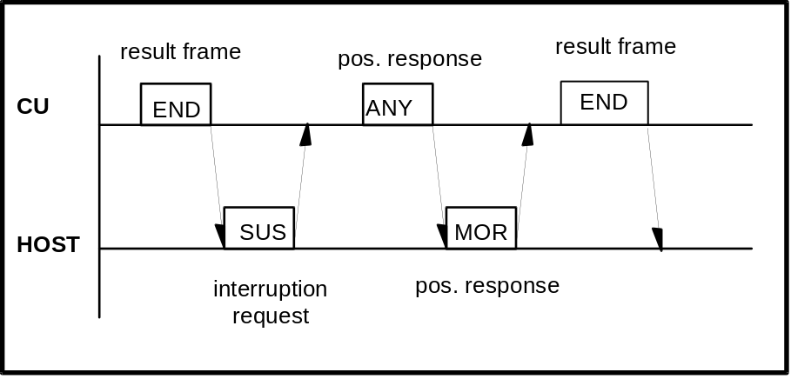
Figure 15: Host sends the SUS frame
The REC frame is sent to the CU to request a communication interruption within regular communication session. The CU detects successful transmission of the last transmitted analytical data and does not resend the text upon the reception of the MOR frame from the Host.
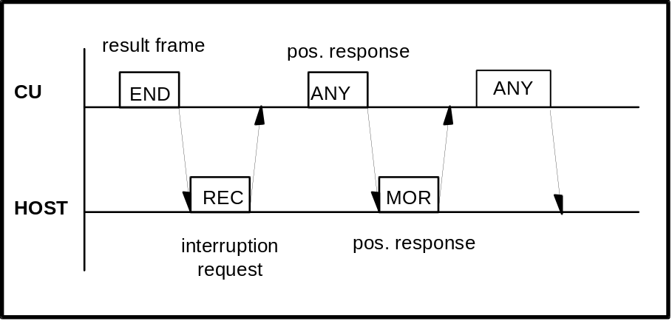
Figure 16: Host sends the REC frame

34 Termination and Restart of Communication

Condition of Termination | Real-time  Communication | Batch  Communication | Restart of Communication
Selection of [Off Line] for  ‘Host Communication’ on the Start Condition screen | STOP | STOP | Selection of [On Line] for ‘Host Communication’  Previous contents of com-munication are all canceled.
Occurrence of send/receive time-out error  Host did not respond within specified time | STOP | STOP | Same as above
Occurrence of hardware error alarm related to communication | STOP | STOP | Same as above
Occurrence of HD read error during sending of analytical data to the host |  | STOP | Remaining samples in specified range are not sent.  Upon restart, samples in newly specified range are sent.
Stop directive through screen during sending of analytical data to the host |  | STOP * | Same as above
Occurrence of HD read error during transfer of analytical data for specific sample to the host |  |  | Relevant sample alone is canceled.
Detection of abnormality in text (discrepancy in end-of-data code between CU and host for example) |  |  | ----------
Occurrence of E. STOP-Level alarm at CU side  CU shifts to sleep mode |  |  | ----------
Table 23: Termination and restart of communication
Note*:
Transfer of analytical data is stopped regardless of sample type (Routine, STAT or control sample).

35 Retry of Communication
If the host does not respond to a frame within 5 seconds, the CU continues sending the ANY frame. On the Host Communication screen (see Figure 3 on page 9) the number of these retries to re-establish the data link (‘Retry Count’ option) can be set from ‘1’ to ‘99’. (or ‘0’, which stands for an infinite number of retries). Also the time between these retries (‘Retry Time’ option) can be set from ‘1’ to ‘99’ seconds on this screen.
After the last retry without host answer the CU issues the warning 130-001 (“LIS? - Reception time-out error occurred“) and switches off the communication.

36 Results-Only mode
In this mode, analytical data alone is transmitted to the host and resending request (REP frame) from the CU or host or response to specific sample request is not made.
If the ‘Result Only’ option is selected on the Host Communication screen (see Figure 3 on page 9), the CU does not send test selection inquiries or accept test selection directive. The CU waits for one second or more after sending ETX in the analytical data text and proceeds to transfer to the host regardless of the communication procedure (realtime or batch result transmission).
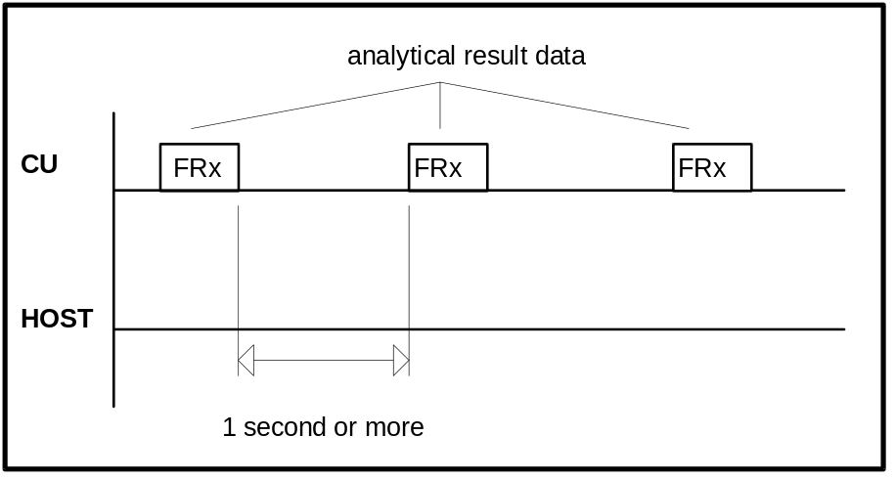
Figure 17: Timing in case of ‘Result Only’ option selected

37 Communication Functions

38 Function List for Test Selection Data

Function |  | Inquiry | Directive | Conditions | Note
Routine sample |  |  |  | Invalid when ‘Results Only’ mode is selected on Host Comm. screen (see Figure 3 on page 9)
STAT  sample | with ID |  |  | Valid when ‘STAT T/S’ option is selected on Host Comm. screen
 | without ID |  |  | Invalid when ‘Results Only’ mode is selected on Host Comm. screen
Manual  Rerun  sample | Routine  sample |  |  | Valid when ‘Manual Rerun T/S’ option is selected on Host Comm. screen.  Invalid when ‘Results Only’ mode is selected on Host Comm. screen | 1
Automatic  Rerun  sample | Routine  sample |  |  | Valid when ‘Auto Rerun T/S’ option is selected on Host Comm. screen.  Invalid when ‘Results Only’ mode is selected on Host Comm. screen | 2
Table 24: Function list for test selection data
Note 1: When ‘Manual Rerun T/S’ option is not selected, an inquiry is not sent from the CU to the host. However, for any sample that has been measured at least once in the analyzer, the test selection directive from the host can be accepted.
Note 2: When ‘Auto Rerun T/S’ option is not selected, an inquiry is not sent from the CU to the host. However, for any sample that has been measured at least once in the analyzer, the test selection directive from the host can be accepted.

39 Function List for Result Data
Function |  | Real-time  Communication | Batch  Communication | Specific  Sample  Request  from host | Conditions
Routine sample |  |  |  |  | Specific sample request is invalid when
STAT sample |  |  |  |  | ‘Result Only’ mode is selected
Control sample |  |  |  |  | on Host Comm. screen  (see Figure 3 on page 9)
Automatic/  Manual | Routine  sample
Rerun  sample | STAT  sample
Calibration
Original absorbance |  |  |  |  | Available only if ‘Original ABS’ is selected the Utility -> System screen
Table 25: Function list for result data
Comments:
- The above real-time communication indicates a communication carried out while the instrument is busy in analysis, and the batch communication indicates a communication when specified through the screen.
- Batch result communication is initiated on ...
Workplace è Data Review è Send to Host screen
for Routine, STAT and Control results

40 Communication Log

41 Overview
If enabled on the Host Communication screen (option ‘Host Comm Trace’ / see Figure 3 on page 9) the contents of the communication between the CU and host is stored on the hard disk.
To check the contents of communication, the stored data is displayed on the screen, output to the printer or copied to a diskette as a text file.

42 Trace Data
The time of communication execution, the direction of communication and the contents of the message are stored.
Example of communication log:

HOST COMMUNICATION TRACE (LIS TRACE) 28/08/96 09:54 BMSERV

09:40:49 912->Host
>
ETX

09:40:44 Host->912
;A2 000999 363107306012344800000000000010000000000000000000000000
0000000010111111Comm1 Comm2 Comm3
Comm4 Comm5 Comm6
ETX

09:40:43 912->Host
>
ETX

09:40:38 Host->912
>
ETX

43 Display, Printout and Reset of Communication Log data
The communication log data may be displayed on the screen with the option Utility è Comm. Trace. On this screen there is also a button [Refresh] to refresh the contents of the trace window if recording is still enabled and a [Delete All] button to delete the communication log file.
On the Print è Utility screen ‘Host Comm Trace’ option allows to print the log data, to store it on a diskette as text file or to delete it.

44 Trace Data Storing Performance
Data of up to 2000 cycles (conversation) can be stored.

45 Example Traces

Example 1: Test Selection inquiry / Test selection / Result
Example 2: Absorbance data from CU to host
Example 3: Photometry assay Calibration data from CU to host
Example 4: ISE Calibration data from CU to host
Example 5: Control data from CU to host
Example 6: Specific Result Request from host to CU

Common explanations for the following HIT 912 trace lists:
Format
1st column Sender of text (CU=Control Unit)
2nd column Sending time
3rd column Trace data

Replacement of Control charcters
Mnemonic meaning replaced ASCII code
[STX] start of text 02H
[ETX] end of text 03H
[CR] carriage return 0DH
· space 20H

{xxh} xx is the hexadecimal code of the character that is sent

Table 26: Communication trace details
The communication trace was aquired with the Interface Testprogram 'HOST912.EXE' (developed by the Technical Productmanagement / Data Technique department)

46 Test Selection inquiry from CU to host incl. Result
CU 10:14:52,57 [STX]>[ETX]{3Dh}
Host 10:14:52,57 [STX]>[ETX]{3Dh}

CU 10:14:57,23 [STX];A1·····0·4········000319····00828961020[ETX]{79h}
Host 10:14:57,28 [STX];A1·····0·4········000319····00828961020480000000000
00100000000000000000000000000000000010111111Comm1········
·················Comm2····················Comm3··········
·····Comm4··········Comm5·····Comm6···············[ETX]{7
2h}

CU 10:15:02,73 [STX]>[ETX]{3Dh}
Host 10:15:02,73 [STX]>[ETX]{3Dh}

...

CU 10:16:21,73 [STX]>[ETX]{3Dh}
Host 10:16:21,73 [STX]>[ETX]{3Dh}

CU 10:16:26,67 [STX]:A1·····0·4········000319····00828960921BMSERV·413··
·4.2·47···179·48·····9·49···147·[ETX]{64h}
Host 10:16:26,73 [STX]>[ETX]{3Dh}

CU 10:16:32,17 [STX]>[ETX]{3Dh}
Host 10:16:32,17 [STX]>[ETX]{3Dh}

Text format of example 1a: Test Selection Inquiry from the CU

Inquiry: The CU sends a test selection inquiry.
(each character · stands for a blank - ASCII code 20h)

CU 10:14:57,23 [STX];A1·····0·4········000319····00828961020[ETX]{79h}

 | [STX]  ;  A  1  [Sample information]  ·····  0  ·4  ·  ·······000319  ····  0  082896  1020  [ETX]  {79h} | Start of text (ASCII code 02H)  Frame character : ; for TS inquiry  Function character: A for  - routine sample  - with barcode reader  - realtime communication  Class : 1  Sample number : (undefined)  Disk number : 0  Position : 4  Cup : (undefined)  Ident-No : 000319  Age : (undefined)  Sex : (undefined)  Date : 28th of August 1996  Time : 10:20  End of text (ASCII code 03H)  Hex code of the Block check character  (the character ‘y’ is sent)

Text format of example 1b: Test Selection from Host

TS: The Host sends the test selection.
(each character · stands for a blank - ASCII code 20h)

Host 10:14:57,28 [STX];A1·····0·4········000319····00828961020480000000000
00100000000000000000000000000000000010111111Comm1········
·················Comm2····················Comm3··········
·····Comm4··········Comm5·····Comm6···············[ETX]{7
2h}
 | [STX]  ;  A  1  [Sample information]  ·····  0  ·4  ·  ·······000319  ····  0  082896  1020  [Test Selection]  48  0000000000001000  0000000000000000  0000000000000010  [Comments]  111111  Comm1·························  Comm2····················  Comm3···············  Comm4··········  Comm5·····  Comm6···············  [ETX]  {72h} | Start of text (ASCII code 02H)  Frame character : ; for TS  Function character: A for  - routine sample  - with barcode reader  - realtime communication  Class : 1  Sample number : (undefined)  Disk number : 0  Position : 4  Cup : (undefined)  Ident-No : 000319  Age : (undefined)  Sex : (undefined)  Date : 28th of August 1996  Time : 10:20  Test Counter : 48  Selected tests : 13, 47  Comment Flags : 1 to 6 set  Comment 1 : Comm1  Comment 2 : Comm2  Comment 3 : Comm3  Comment 4 : Comm4  Comment 5 : Comm5  Comment 6 : Comm6  End of text (ASCII code 03H)  Hex code of the Block check character  (the character ‘r’ is sent)

Text format of example 1c: Test Result from CU

The CU sends analytical results in realtime mode.
(each character · stands for a blank - ASCII code 20h)

CU 10:16:26,67 [STX]:A1·····0·4········000319····00828960921BMSERV·413··
·4.2·47···179·48·····9·49···147·[ETX]{64h}

 | [STX]  :  A  1  [Sample information]  ·····  0  ·4  ·  ·······000319  ····  0  082896  0921  [Operator ID]  BMSERV  [Results]  ·4  13  ···4.2  ·  47  ···179  ·  48  ·····9  ·  49  ···147  ·  [ETX]  {64h} | Start of text (ASCII code 02H)  Frame character : : for Result  Function character: A for  - routine sample  - with barcode reader  - realtime communication  Class : 1  Sample number : (undefined)  Disk number : 0  Position : 4  Cup : (undefined)  Ident-No : 000319  Age : (undefined)  Sex : (undefined)  Date : 28th of August 1996  Time : 09:21  Operator ID : BMSERV  No. of results : 4  1. Res - test No. : 13  1. Res - value : 4.2  1. Res - alarm : none  2. Res - test No. : 47  2. Res - value : 179  2. Res - alarm : none  3. Res - test No. : 48  3. Res - value : 9  3. Res - alarm : none  4. Res - test No. : 49  4. Res - value : 147  4. Res - alarm : none  End of text (ASCII code 03H)  Hex code of the Block check character  (the character ‘d’ is sent)

47 Absorbance data from CU to host
CU 10:20:05,58 [STX]>[ETX]{3Dh}
Host 10:20:05,64 [STX]>[ETX]{3Dh}

CU 10:20:06,57 [STX]:I1·····0·4········000319····0082896102013···4.3····
·································147···147···14710··5913·
·6060··6147··6210··6265··6311··6347··6376··6398··6421[ETX
]{62h}
Host 10:20:06,69 [STX]>[ETX]{3Dh}

CU 10:20:12,17 [STX]>[ETX]{3Dh}
Host 10:20:12,23 [STX]>[ETX]{3Dh}

Text format of example 2: Absorbance data

The CU sends original absorbance data in realtime mode.
(each character · stands for a blank - ASCII code 20h)

CU 10:20:06,57 [STX]:I1·····0·4········000319····0082896102013···4.3····
·································147···147···14710··5913·
·6060··6147··6210··6265··6311··6347··6376··6398··6421[ETX
]{62h}

 | [STX]  :  I  1  [Sample information]  ·····  0  ·4  ·  ·······000319  ····  0  082896  1020  [Analytical results]  13  ···4.3  ·  ·········  ·········  ·········  [Blank data]  ······  ···147  ···147  ···147  [Absorbanve values]  10  ··5913  ··6060  ··6147  ··6210  ··6265  ··6311  ··6347  ··6376  ··6398  ··6421  [ETX]  {62h} | Start of text (ASCII code 02H)  Frame character : : for Result  Function character: I for Absorbance  - routine sample  - with barcode reader  - realtime communication  Class : 1  Sample number : (undefined)  Disk number : 0  Position : 4  Cup : (undefined)  Ident-No : 000319  Age : (undefined)  Sex : (undefined)  Date : 28th of August 1996  Time : 10:20  Test No. : 13  Result : 4.3  Data alarm : none  2. Result : none  3. Result : none  4. Result : none  Poin count : 10  Abs value 1 : 5913  Abs value 2 : 6060  Abs value 3 : 6147  Abs value 4 : 6210  Abs value 5 : 6265  Abs value 6 : 6311  Abs value 7 : 6347  Abs value 8 : 6376  Abs value 9 : 6398  Abs value 10 : 6421  End of text (ASCII code 03H)  Hex code of the Block check character  (the character ‘b’ is sent)

48 Photometry-assay Calibration data from CU to host

CU 09:20:41,26 [STX]>[ETX]{3Dh}
Host 09:20:41,30 [STX]>[ETX]{3Dh}

CU 09:14:35,51 [STX]:G·BMSERV132·1··1451··1549··1453··1551······02··5738
··6203··5779··6258······0N······0[ETX]{2Eh}
Host 09:20:42,41 [STX]>[ETX]{3Dh}

CU 09:20:47,85 [STX]>[ETX]{3Dh}
Host 09:20:47,89 [STX]>[ETX]{3Dh}

Text format of example 3: Photometry assay calibration data

The CU sends photometry assay calibration data in reltime mode.
(each character · stands for a blank - ASCII code 20h)

CU 09:14:35,51 [STX]:G·BMSERV132·1··1451··1549··1453··1551······02··5738
··6203··5779··6258······0N······0[ETX]{2Eh}

[STX]  :  G  ·  BMSERV  13  2  ·  1  ··1451  ··1549  ··1453  ··1551  ·  ·····0  2  ··5738  ··6203  ··5779  ··6258  ·  ·····0  N  ······  0  [ETX]  {2Eh} | Start of text (ASCII code 02H)  Frame character : : for Result  Function character: G for Photometric Calibration  Space  Operator ID  Channel no. : 13  No. of standards : 2  Calibration alarm  STD No. 1  1st absorbance data  1st initial absorbance data  2nd absorbance data  2nd initial absorbance data  data alarm  Prozone value  STD No. 2  1st absorbance data  1st initial absorbance data  2nd absorbance data  2nd initial absorbance data  data alarm  Prozone value  N for 'no SD value'  value  decimal point position  End of text (ASCII code 03H)  Hex code of the Block check character  (the character ‘.’ is sent)

49 ISE Calibration data from CU to host

CU 14:40:38,69 [STX]>[ETX]3E[CR]
Host 14:40:38,69 [STX]>[ETX]3E[CR]

CU 14:40:39,96 [STX]:H·······B··1·-29.7··2·-33.5··3·-26.0··4·-30.8··5··6
0.0··6···139··7···133··8····-2···1·-32.2··2·-45.4··3·-24.
1··4·-34.2··5··57.9··6·····5··7·····5··8·····0···1·124.3·
·2·130.1··3·122.2··4·126.3··5·-44.9··6···108··7····98··8·
···-3·[ETX]40[CR]
Host 14:40:40,01 [STX]>[ETX]3E[CR]

CU 14:40:45,62 [STX]>[ETX]3E[CR]
Host 14:40:45,62 [STX]>[ETX]3E[CR]

Text format of example 4: ISE calibration data

The CU sends ISE calibration data in reltime mode.
(each character · stands for a blank - ASCII code 20h)

CU 14:40:39,96 [STX]:H·······B··1·-29.7··2·-33.5··3·-26.0··4·-30.8··5··6
0.0··6···139··7···133··8····-2···1·-32.2··2·-45.4··3·-24.
1··4·-34.2··5··57.9··6·····5··7·····5··8·····0···1·124.3·
·2·130.1··3·122.2··4·126.3··5·-44.9··6···108··7····98··8·
···-3·[ETX]40[CR]
[STX]  :  H  ·  ······  B  ·  ·1  ·-29.7  ·  ·2  ·-33.5  ·  ·3  ·-26.0  ·  ·4  ·-30.8  ·  ·5  ··60.0  ·  ·6  ···139  ·  ·7  ···133  ·  ·8  ····-2  ·  ·  ·1·-32.2·  ·2·-45.4·  ·3·-24.1·  ·4·-34.2·  ·5··57.9·  ·6·····5·  ·7·····5·  ·8·····0·  ·  ·1·124.3·  ·2·130.1·  ·3·122.2·  ·4·126.3·  ·5·-44.9·  ·6···108·  ·7····98·  ·8····-3·  [ETX]  40  [CR] | Start of text (ASCII code 02H)  Frame character : : for Result  Function character: H for ISE Calibration  Space  Operator ID  ISE type : B (Na, K, Cl)  Na Data Alarm :  Na Data item 1  Na meas. value 1 : -29.7  Na data alarm 1 :  Na Data item 2  Na meas. value 2 : -33.5  Na data alarm 2 :  Na Data item 3  Na meas. value 3 : -26.0  Na data alarm 3 :  Na Data item 4  Na meas. value 4 : -30.8  Na data alarm 4 :  Na Data item 5  Na meas. value 5 : -60.0  Na data alarm 5 :  Na Data item 6  Na meas. value 6 : 139  Na data alarm 6 :  Na Data item 7  Na meas. value 7 : 133  Na data alarm 7 :  Na Data item 8  Na meas. value 8 : -2  Na data alarm 8 :  K Data Alarm : none  K Data item 1/measured value/data alarm  K Data item 2/measured value/data alarm  K Data item 3/measured value/data alarm  K Data item 4/measured value/data alarm  K Data item 5/measured value/data alarm  K Data item 6/measured value/data alarm  K Data item 7/measured value/data alarm  K Data item 8/measured value/data alarm  Cl Data Alarm : none  Cl Data item 1/measured value/data alarm  Cl Data item 2/measured value/data alarm  Cl Data item 3/measured value/data alarm  Cl Data item 4/measured value/data alarm  Cl Data item 5/measured value/data alarm  Cl Data item 6/measured value/data alarm  Cl Data item 7/measured value/data alarm  Cl Data item 8/measured value/data alarm  End of text (ASCII code 03H)  Checksum  Carriage Return (ASCII code 0DH)

50 Control data from CU to host
CU 09:21:37,28 [STX]>[ETX]{3Dh}
Host 09:21:37,28 [STX]>[ETX]{3Dh}

CU 09:21:42,50 [STX]:F·02004··1······PNU····················BMSERV·512··
0.77·13···3.7·47···125·48·····5·49····93·[ETX]{25h}
Host 09:21:42,55 [STX]>[ETX]{3Dh}

CU 09:21:47,98 [STX]>[ETX]{3Dh}
Host 09:21:48,03 [STX]>[ETX]{3Dh}

Text format of example 5: Control Result

The CU sends control results in realtime mode.
(each character · stands for a blank - ASCII code 20h)

CU 09:21:42,50 [STX]:F·02004··1······PNU····················BMSERV·512··
0.77·13···3.7·47···125·48·····5·49····93·[ETX]{25h}
 | [STX]  :  F  ·  [Sample information]  02  004  ·  ·1  ·  ·····PNU·····  ···············  [Operator ID]  BMSERV  [Results]  ·5  12  ··0.77  ·  13  ···3.7  ·  47  ···125  ·  48  ·····5  ·  49  ····93  ·  [ETX]  {25h} | Start of text (ASCII code 02H)  Frame character : : for Result  Function character: F for  - Control sample  - realtime communication  Space  Control No. : 2  Sequence No. : 4  Disk number : Space for inner ring  Position : 1  Cup : (undefined)  Control Name : PNU  15 Spaces  Operator ID : BMSERV  No. of results : 5  1. Res - test No. : 12  1. Res - value : 0.77  1. Res - alarm :  2. Res - test No. : 13  2. Res - value : 3.7  2. Res - alarm :  3. Res - test No. : 47  3. Res - value : 125  3. Res - alarm :  4. Res - test No. : 48  4. Res - value : 5  4. Res - alarm :  5. Res - test No. : 49  5. Res - value : 93  5. Res - alarm :  End of text (ASCII code 03H)  Hex code of the Block check character  (the character ‘%’ is sent)

51 Specific Result Request from host to CU
CU 09:25:09,57 [STX]>[ETX]{3Dh}
Host 09:25:09,57 [STX]<a1················000323···············[ETX]{4Dh}

CU 09:25:15,87 [STX]>[ETX]{3Dh}
Host 09:25:15,87 [STX]>[ETX]{3Dh}

CU 09:25:16,42 [STX]:a1····80·8········000323····00828960930BMSERV·413··
·4.4·47···150·48·····6·49···113·[ETX]{5Ah}
Host 09:25:16,48 [STX]>[ETX]{3Dh}

Text format of example 6: Specific result request from the Host

The host sends the specific result request.
(each character · stands for a blank - ASCII code 20h)

Host 09:25:09,57 [STX]<a1················000323···············[ETX]{4Dh}

 | [STX]  <  a  1  [Sample Information]  ·····  ·  ··  ·  ·······000323  ····  ·  ······  ····  [ETX]  {4Dh} | Start of text (ASCII code 02H)  Frame character : < for result request  Function character: a for  - routine sample  - with barcode reader  - batch communication  Class : 1  Sample number : (undefined)  Disk number : (undefined)  Position : (undefined)  Cup : (undefined)  Ident-No : 000323  Age : (undefined)  Sex : (undefined)  Date : (undefined)  Time : (undefined)  End of text (ASCII code 03H)  Hex code of the Block check character  (the character ‘M’ is sent)

52 Figures and Tables
Figure 1: BM/HITACHI 912 Interface data flow
Figure 2: Connection cable
Figure 3: Host Communication screen
Figure 4: Start Condition screen
Figure 5: Test selection download in batch mode
Figure 6: Test selection download in realtime mode
Figure 7: Common communication timing
Figure 8: Communication timing without information exchange
Figure 9: Transfer of communication control message
Figure 10: Test selection inquiry
Figure 11: Result transmission
Figure 12: Result transmission with three frames and SPE interrupt
Figure 13: Resending request with REP frame from CU to host
Figure 14: Resending request with REP frame from host to CU
Figure 15: Host sends the SUS frame
Figure 16: Host sends the REC frame
Figure 17: Timing in case of ‘Result Only’ option selected

Table 1: Specification of the host communication
Table 2: Frame types having a Data Field
Table 3: Frame types having no data field
Table 4: Frame priorities
Table 5: Function character table
Table 6: Format of sample information / b = space (20H)
Table 7: Format of test selection information / b = space (20H)
Table 8: Format of comment information
Table 9: Format of analytical result data / b = space (20H)
Table 10: Format of measured value / b = space (20H)
Table 11: No. of test results per frame according to the text size.
Table 12: Format of absorbance data / b = space (20H)
Table 13: Reaction Times
Table 14: No. of absorbance values per frame according to the text size.
Table 15: Format of photometry-assay calibration data / b = space(20H)
Table 16: Format of ISE calibration data / b = space(20H)
Table 17: Data alarm list (part 1)
Table 18: Data alarm list (part 2)
Table 19: End-of-data codes
Table 20: Host response to test selection inquiry
Table 21: CU result frames FR1 to FR2 / END
Table 22: Host response to FR1 to FR2 / END
Table 23: Termination and restart of communication
Table 24: Function list for test selection data
Table 25: Function list for result data
Table 26: Communication trace details

Appendix A - ASCII Chart

Char  Hex Dez | Char  Hex Dez | Char  Hex Dez | Char  Hex Dez | Char  Hex Dez | Char  Hex Dez | Char  Hex Dez | Char  Hex Dez
NUL  00 0 | DLE  10 16 | Space  20 32 | 0  30 48 | @  40 64 | P  50 80 | `  60 96 | p  70 112
SOH  01 1 | DC1  11 17 | !  21 33 | 1  31 49 | A  41 65 | Q  51 81 | a  61 97 | q  71 113
STX  02 2 | DC2  12 18 | "  22 34 | 2  32 50 | B  42 66 | R  52 82 | b  62 98 | r  72 114
ETX  03 3 | DC3  13 19 | #  23 35 | 3  33 51 | C  43 67 | S  53 83 | c  63 99 | s  73 115
EOT  04 4 | DC4  14 20 | $  24 36 | 4  34 52 | D  44 68 | T  54 84 | d  64 100 | t  74 116
ENQ  05 5 | NAK  15 21 | %  25 37 | 5  35 53 | E  45 69 | U  55 85 | e  65 101 | u  75 117
ACK  06 6 | SYN  16 22 | &  26 38 | 6  36 54 | F  46 70 | V  56 86 | f  66 102 | v  76 118
BEL  07 7 | ETB  17 23 | '  27 39 | 7  37 55 | G  47 71 | W  57 87 | g  67 103 | w  77 119
BS  08 8 | CAN  18 24 | (  28 40 | 8  38 56 | H  48 72 | X  58 88 | h  68 104 | x  78 120
HT  09 9 | EM  19 25 | )  29 41 | 9  39 57 | I  49 73 | Y  59 89 | i  69 105 | y  79 121
LF  0A 10 | SUB  1A 26 | *  2A 42 | :  3A 58 | J  4A 74 | Z  5A 90 | j  6A 106 | z  7A 122
VT  0B 11 | ESC  1B 27 | +  2B 43 | ;  3B 59 | K  4B 75 | [  5B 91 | k  6B 107 | {  7B 123
FF  0C 12 | FS  1C 28 | ,  2C 44 | <  3C 60 | L  4C 76 | \  5C 92 | l  6C 108 | |  7C 124
CR  0D 13 | GS  1D 29 | -  2D 45 | =  3D 61 | M  4D 77 | ]  5D 93 | m  6D 109 | }  7D 125
SO  0E 14 | RS  1E 30 | .  2E 46 | >  3E 62 | N  4E 78 | ^  5E 94 | n  6E 110 | ~  7E 126
SI  0F 15 | US  1F 31 | /  2F 47 | ?  3F 63 | O  4F 79 | _  5F 95 | o  6F 111 | DEL  7F 127

Appendix B - Differences between HITACHI 911 and 912 Host
Cable
Host Interface connector:
HIT 911: DB 25-pin male connector on the backside of the analyzer
HIT 912: RJ-45 connector on the interface card in the HP computer
Settings
Retry Count:
HIT 911: 1 to 99 retries in case of no host answer (selectable on System Parameter screen)
HIT 912: 1 to 99 retries and 0 for unlimited (selectable on Host Communication screen)
Maximum Size of Transferred Data:
HIT 911: 256, 512 bytes (selectable on System Parameter screen)
HIT 912: 256, 512, 1024 bytes (selectable on Host Communication screen)
STAT results are optionally sent test by test:
HIT 911: No
HIT 912: Yes
Function characters
Completely different (like 917 - see manual)
Frame Format
Sample Information:
HIT 911: 3-digit sample no.
HIT 912: 5-digit sample no. and 1-digit sample cup type

No. of comment fields:
HIT 911: 5 - 30, 25, 20, 15, 10 characters
HIT 912: 6 - 30, 25, 20, 15, 10, 20 characters
Result Transmission
Transmission of Calculated Test Results:
HIT 911: No
HIT 912: Yes
CU send comments within result transmission:
HIT 911: No
HIT 912: Yes
6-character operator ID within result transmission (Analytical and calibration results):
HIT 911: No
HIT 912: Yes

Appendix C - Error Check Functions
If the contents of the received text falls under any condition shown in the table below the CU judges that there is an abnormal character and outputs an alarm:

Attribute | Item | Error Condition | Remarks
Text Information | Frame character | if there is an unrelevant frame character
 | Function character | if there is an unrelevant function character received | if 912 requests with A1 the Host may answer with A1 to A5
Sample Information | Sample no.  disk no.  position no.  sample cup | if a number is out of the specified range | no alarm is output if the items consist of spaces (in the ID mode)
 | ID no. | In the ID mode, the ID number must be right-justified.  Character range 20hex to FEhex | if the ID consists of spaces in the ID mode, an alarm is output.
 | Age, Sex, Date, Time | if the contents of each item is out of the specified range
Inquiry Information | Test Selection | if the test flags are not within ‘0’ to ‘4’  if the channel count is out of the specified range
 | Comment Information | Character range 20hex to FEhex

Appendix D - Table of Communication Alarms
All communication alarms are ‘LIS?’ alarms with main alarm code 130.
The alarm level for all the above listed alarms is WARNING.

Sub Code | Description
1 | Reception time-out error is generated.
2 | Due to one of the following conditions, the CU cannot send text to the Host:  1) CTS signal has been off for 10 sec. or longer.  2) Communication cable is malfunctioning.  3) Host has not been initialized.
3 | Check sum error is generated.
4 | Text length error is generated.
5 | Function character error is generated.
6 | Sample information error is generated.
7 | T/S error is generated.
8 | Comment error is generated.
9 | Framing error is detected in the received text.
10 | Overrun error is detected in the received text.
11 | Parity error is detected in the received text.
12 | Communication port error is generated.
13 | STX/ETX characters contained in the received text are unrecognizable.
14 | In response to a frame sent from the 912, Host has transmitted a REP frame more than the allowable number of times.
15 | LIS queue buffer is full. The number of texts that were not transmittable to Host has reached 200.

Appendix E - Text Configuration Table
The columns and rows of the following tables have the following contents:

Frame type | Frame |  | Frame items
Sender | bytes |  | Item length in bytes

Positive response | ANY |  | STX | > | End-code
CU | 3 to 6 |  | 1 | 1 | 1 to 4

Positive response | MOR |  | STX | > | End-code
Host | 3 to 6 |  | 1 | 1 | 1 to 4

Negative response | REP |  | STX | ? | End-code
CU / Host | 3 to 6 |  | 1 | 1 | 1 to 4

Bad and suspend | SUS |  | STX | @ | End-code
CU / Host | 3 to 6 |  | 1 | 1 | 1 to 4

Ok and suspend | REC |  | STX | A | End-code
Host | 3 to 6 |  | 1 | 1 | 1 to 4

TS Request | SPE |  | STX | ; | Fu | Sample Information | End-code
CU | 42 - 45 |  | 1 | 1 | 2 | 37 | 1 to 4

Result Request | RES |  | STX | ; | Fu | Sample Information | End-code
CU | 42 - 45 |  | 1 | 1 | 2 | 37 | 1 to 4

Test selection | SPE |  | STX | ; | Fu | Sample Information | Channel  Count | Test selection | Comments | End-code
Host | vari. |  | 1 | 1 | 2 | 37 | 2 | 48 | 6 to 126 | 1 to 4

Analytical data | FR1 to END |  | STX | : | Fu | Sample Information | Operator ID | Channel count | Analytical data  1 to 60 | Comments | End-code
AU | vari. |  | 1 | 1 | 2 | 37 | 6 | 2 | 540 | 6 to 126 | 1 to 4

Absorbance data | FR1 to END |  | STX | : | Fu | Sample Information | Analytical data 1 to 4 | Blank data 1 to 4 | Point count | ABS values  1 to 49 | End-code
AU | vari. |  | 1 | 1 | 2 | 37 | 36 | 24 | 2 | 438 | 1 to 4

Photometry assay Calib | END |  | STX | : | G_ | Operator ID | Test no. | STD count | Calib alarm | STD data  1 to STD count (6) | SD value | End-code
AU | vari. |  | 1 | 1 | 2 | 6 | 2 | 1 | 1 | STD count * 32 (192) | 8 | 1 to 4

ISE Calib | END |  | STX | : | H_ | Operator ID | ISE type | ISE calibration data  1 to 2/3 | End-code
AU |  |  | 1 | 1 | 2 | 6 | 1 | 146/219 | 1 to 4

The character _ represents a space (code 20h).
The above tables show the text configuration when the maximum text length is set to 1024 bytes.
For details about the format of the data items refer to the corresponding chapter in this document.

