Laboratory Accreditation
Specification Validation Procedure
CAL 747.32 Part 8, ISE Unit Temperature
BM/Hitachi 747
Version: 3.2

Date: December 1997
Written by: | Mr. Heesch, LI-E
Authorized by: | Mr. Ringsleben, LI-T
Checked by: | Mr. Nakatani, HID QA
Released by: | Mr. De Caluwé, LI-E

This sheet provides a Validation procedure to comply with the requirements of laboratory accreditation standards.

This sheet is an uncontrolled copy.

Laboratory Accreditation Spec. Validation Proc.
on ISE Unit Temperature
BM/Hitachi 747

Content:

1. Purpose page 3
2. General Description page 3
3. Operating Conditions page 3
4. Traceability of the Validation Standards page 4
5. Test Procedure page 4
6. Documentation page 5
7. Requirements to the Digital-Multimeter (DMM) page 5
8. Error Budget page 6
9. Use of new Thermistors page 6
10. Validation Form page 7
11. Drawings page 8

1. Purpose

This validation procedure describes the validation of the temperature in the ISE chamber of the HITACHI 747 Analyser.
The meaning of "validation" is to determine the difference between the "true temperature" and the "set-temperature".

2. General description & measuring theory

The Temperature is measured with a selected thermistor, mounted to a prepared dummy electrode.
The thermistors is fixed with thermally conductive silicone to a metal-plate, which is glued to the dummy electrode.
The thermistors are supplied by THERMOMETRICS, USA. The certified tolerance of these thermistors is ± 0.05 ° C.
The temperature-resistance is measured by a Digital MultiMeter (DMM, requirements see chapter 7). The measured resistance has to be calculated to the according temperature by a individual resistance/temperature function.

3. Operating conditions

The validation should be performed under normal operating conditions, i.e.

• room temperature : 15 to 30 ° C
• relative humidity: 40 to 80 %
• no ventilation or draught

Note, that the variation of the room temperature should not exceed ± 2°C during the validation process.

4. Traceability of the Validation Standards

Refer to Procedure „Traceability of Sensors for Temperature Check“

5. Test Procedure

1. Switch on the DMM

2. Insert the dummy electrode (prepared with the thermistor) into the ISE chamber. (Place the electrode between the Cl and Ca electrodes).

3. Connect a 2 wire lead to the connection-block of the dummy electrode and close the ISE chamber.
Caution: Avoid touching, bending or drawing the thermistor or its leads

4. Switch on the Hitachi 747 and the computer. Wait until initialisation is done: The message ´Standby´ occurs .

5. Connect the thermistor to the 2-wire resistance input of the DMM.

6. Wait for at least 1 hour

7. Choose the 2 wire-RESISTANCE-function and an appropriate range

8. Read the displayed resistance-value of the DMM, and enter it to the
Validation-Protocol.

9. Wait 5 minutes

10. Repeat the resistance measurements, described in steps 8-9, 4 further times.

11. Calculate the temperature-values as described in the validation protocol.
Caution: ensure that the thermistor-specific coefficients TA, TB, and TC are still applicable. If you are in a doubt, use a new dummy electrode and the corresponding coefficients. Section 8 describes how to recalculate this coefficients. It is recommended to use a programmable pocket-calculator for the resistance/temperature conversions. In order to avoid rounding errors, do not round any intermediate-results !

6. Documentation

For documentation of the validation result use the attached forms (validation-protocols).

7. Requirements to the Digital-Multimeter (DMM)

The DMM for the resistance-measurements has to fulfill the following requirements:

• 12 or 24 month accuracy of resistance,
measurements in the 0-200kOhms range : <= 2000 ppm (of reading)
• Current for resistance measurements: <= 10 µA
• Latest validation certificate:
not older than 12 or 24 months (24 months if the according specs are <= 2000 ppm)

8. Error Budget

Refer to Procedure „Traceability of Sensors for Temperature Check“

9. Use of a new Thermistor:

If you use a new thermistor, and the new resistance/temperature-table differs from the old one, the coefficients TA, TB, and TC must be recalculated as follows:

R1 = resistance at 0° C T1 = 273.15 K + 0 K = 273.15 K X1 = ln(R1)
R2 = resistance at 30° C T2 = 273.15 K + 30 K = 303.15 K X2 = ln(R2)
R3 = resistance at 50° C T3 = 273.15 K + 50 K = 323.15 K X3 = ln(R3)

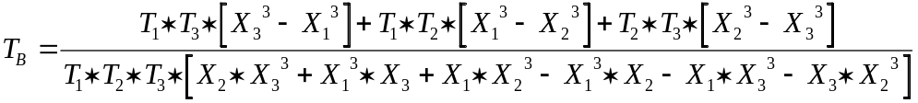

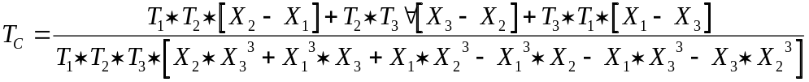

10. Validation Form for Cal 747.32 P8

10.1 Analyser Parameters

Validation ID | HIT 747 ser. no.

10.2 DMM / Thermometer Parameters

Producer / Type | Serial Number | Last Validation Date

10.3 Thermistor Parameters and Results

Thermistor-Curve No. |  | Supply-Date |  | Lot No.
UT443 SX1
Coefficient TA |  | Coefficient TB |  | Coefficient TC
4.61235 * 10-4 |  | 2.41852 * 10-4 |  | 9.64321 * 10-8
n | Measured Resistance n [Ohms] |  | X = ln(Resistance n) |  | 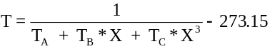
1
2
3
4
5
* depending on the  actual Thermistor-Lot |  | Average Temp. 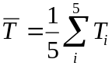 |  | = [° C]
 |  | Range = T max -T min |  | Range = [° C]

Average Temperature = 34.8 ° ± G_{total} ? (..........) yes r no r
T max -T min <= 0.1 ° C ? yes r no r

11. Drawings

Figure 1, location of thermistor in the dummy electrode

dummy electrode for HIT 747

