Laboratory Accreditation
Specification Validation Procedure
CAL 747.32 Part 9, Reaction Bath Temperature
BM/Hitachi 747
Version: 3.2

Date: December 1997
Written by: | Mr. Heesch, LI-E
Authorized by: | Mr. Ringsleben, LI-T
Checked by: | Mr. Nakatani, HID QA
Released by: | Mr. De Caluwé, LI-E

This sheet provides a Validation procedure to comply with the requirements of laboratory accreditation standards.

This sheet is an uncontrolled copy.

Laboratory Accreditation Spec. Validation Proc.
on Reaction Bath Temperature
BM/Hitachi 747

Content:

1. Purpose page 3
2. General Description page 3
3. Operating Conditions page 3
4. Traceability of the Validation Standards page 4
5. Test Procedure page 4-5
6. Documentation page 5
7. Requirements to the Digital-Multimeter (DMM) page 5
8. Error Budget page 6
9. Use of new Thermistors page 6
10. Validation Form (for the inner cuvette ring) page 7
11. Validation Form (for the outer cuvette ring) page 8
12. Drawings page 9
13. Example page 10

1. Purpose

This validation procedure describes the validation of the reaction bath temperature of the HITACHI 747 Analyser.
The meaning of "validation" is to determine the difference between the "true temperature" and the "set-temperature".

2. General description & measuring theory

The Temperature is measured with selected thermistors, mounted to a prepared cuvette segment. The thermistors are supplied by THERMOMETRICS, USA. The certified tolerance of this thermistor is ±0.05 °C
The thermistor probe must be mounted to a cuvette with a hole in its bottom. The tip of the thermistor must rise about 5mm deeper than the bottom line of the cuvette segment (see chapter 11, figure 1).The temperature-resistance is measured by a Digital MultiMeter (DMM, requirements see chapter 7)
The measured resistance has to be calculated to the according temperature by a individual resistance/temperature function.

Note: If an alternative mercury or digital thermometer with an accuracy of <= 0.06°C and an appropriate traceability evidence is available, you can use it instead of the described thermistor probe. In this case use the same validation forms by filling out the temperature column only.

3. Operating conditions

The validation should be performed under normal operating conditions, i.e.

• room temperature : 15 to 30 °C
• relative humidity: 40 to 80 %
• no ventilation or draft

Note, that the variation of the room temperature should not exceed ± 2 ° C during the validation process.

4. Traceability of the Validation Standards

Refer to Procedure „Traceability of Sensors for Temperature Check“

5. Test Procedure

1. Switch on the DMM

2. Insert the thermistor probe to the outer cuvette with the hole in its bottom. The thermistor tip must immerse about 5mm deeper than the cuvette bottom line
(see chapter 11, figure 1)

3. Switch on the Hitachi 747 and select the temperature which is normally used by the customer

4. Wait until the temperature is established. The actual temperature can be seen on the ´Operation Monitor´.

5. Connect the thermistor lead to the 2-wire resistance input of the DMM.
Caution: Handle the thermistor with care ! Avoid touching, bending or drawing the thermistor leads

6. Choose the 2 wire-RESISTANCE-function and an appropriate Ohms range

7. Read the displayed resistance-value of the DMM, and enter it to the
Validation-Form for the outer (inner) cuvette ring.

8. Wait 1 minute

9. Repeat the resistance measurements, described in steps 7-8, 4 further times.

10. Insert the thermistor probe to the inner cuvette with the hole in its bottom

11. Repeat steps 7-9 for the inner cuvette-ring measurements.

12. Calculate the temperature-values as described in the Validation-Forms.
Caution: ensure that the thermistor-specific coefficients TA, TB, and TC are still applicable. If you are in a doubt, use new thermistors and the corresponding coefficients. Chapter 8 describes how to recalculate these coefficients. Chapter 9 gives an example, how the protocol has to be filled out. It is recommended to use a programmable pocket-calculator or a spreadsheet program for the resistance/ temperature conversions. In order to avoid rounding errors, do not round any intermediate-results !

13. If necessary, repeat the whole validation procedure for further set-temperatures (25°, 30°, 37° C). In this case use further Validation Forms

6. Documentation

For documentation of the validation result use the attached Validation-Forms.
Use 2 Forms (outer/inner cuvette-ring) for each temperature

7. Requirements to the Digital-Multimeter (DMM)

The DMM for the resistance-measurements has to fulfill the following requirements:

• 12 or 24 month accuracy of resistance,
measurements in the 0-200kOhms range : <= 2000 ppm (of reading)
• Current for resistance measurements: <= 10 µA
• Latest validation certificate:
not older than 12 or 24 months (24 months if the according specs are <= 2000 ppm)

8. Error Budget

Refer to Procedure „Traceability of Sensors for Temperature Check“

9. Use of a new Thermistor:

If you use a new thermistor, and the new resistance/temperature-table differs from the old one, the coefficients TA, TB, and TC must be recalculated as follows:

R1 = resistance at 0° C T1 = 273.15 K + 0 K = 273.15 K X1 = ln(R1)
R2 = resistance at 30° C T2 = 273.15 K + 30 K = 303.15 K X2 = ln(R2)
R3 = resistance at 50° C T3 = 273.15 K + 50 K = 323.15 K X3 = ln(R3)

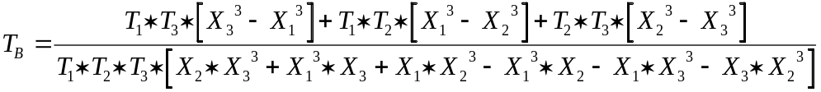

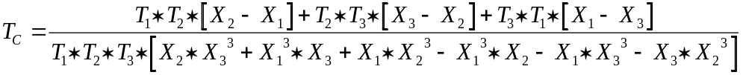

10. Validation Form for Cal 747.32 P9

10.1 Analyser Parameters

Validation ID | HIT 747 ser. no. | set - temp. | cuvette ring
 |  |  | inner

10.2 DMM / Thermometer Parameters

Producer / Type | Serial Number | Last Validation Date

10.3 Thermistor Parameters and Results

Thermistor-Curve No. |  | Supply-Date |  | Lot No.
UT443 SX1
Coefficient TA |  | Coefficient TB |  | Coefficient TC
4.61235 * 10-4 |  | 2.41852 * 10-4 |  | 9.64321 * 10-8
n | Measured Resistance n [Ohms] |  | X = ln(Resistance n) |  | 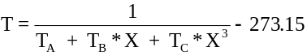
1
2
3
4
5
* depending on the  actual Thermistor-Lot |  | Average Temp. 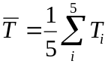 |  | = [° C]
 |  | Range = T max -T min |  | Range = [° C]

Average Temperature = Set-Temperature ± G_{total} ? (..........) yes r no r
Range <= 0.2 ° C ? yes r no r

11. Validation Form for Cal 747.32 P9

11.1 Analyser Parameters

Validation ID | HIT 747 ser. no. | set - temp. | cuvette ring
 |  |  | outer

11.2 DMM / Thermometer Parameters

Producer / Type | Serial Number | Last Validation Date

11.3 Thermistor Parameters and Results

Thermistor-Curve No. |  | Supply-Date |  | Lot No.
UT443 SX1
Coefficient TA |  | Coefficient TB |  | Coefficient TC
4.61235 * 10-4 |  | 2.41852 * 10-4 |  | 9.64321 * 10-8
n | Measured Resistance n [Ohms] |  | X = ln(Resistance n)
1
2
3
4
5
* depending on the  actualThermistor-Lot |  | Average Temp. |  | = [° C]
 |  | Range = T max -T min |  | Range = [° C]

Average Temperature = Set-Temperature ± G_{total} ? (..........) yes r no r
Range <= 0.2 ° C ? yes r no r

12. Drawings

Figure 1, location of the temperature probe

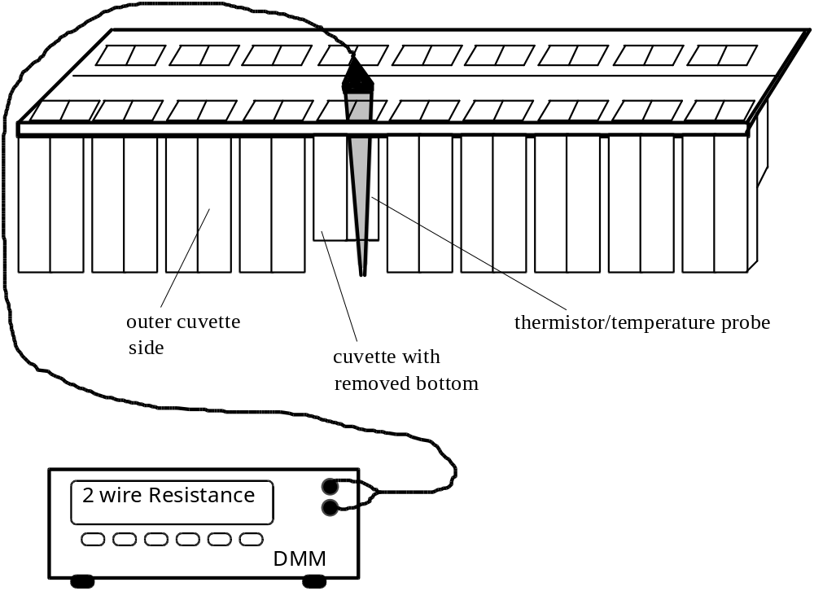

cuvette segment HIT 747

13. Validation Form for Cal 747.32 P9 EXAMPLE !

13.1 Validation ID/Analyser Parameters

Validation ID | HIT 747 ser. no. | set - temp. | cuvette ring
123456 |  | 37 ° C | outer

13.2 DMM / Thermometer Parameters

Producer / Type | Serial Number | Last Validation Date
KEITHLEY 2001 | 0546072 | 07.11.1992

13.3 Thermistor Parameters and Results

Thermistor-Curve No. |  | Supply-Date |  | Lot No.
UT443 SX1
Coefficient TA |  | Coefficient TB |  | Coefficient TC
4.61235 * 10-4 |  | 2.41852 * 10-4 |  | 9.64321 * 10-8
1 | 54502 Ohm |  | 10.90599268 |  | 37.0117
2 | 54518 Ohm |  | 10.90628620 |  | 37.0039
3 | 54510 Ohm |  | 10.90613945 |  | 37.0078
4 | 54512 Ohm |  | 10.90617614 |  | 37.0069
5 | 54523 Ohm |  | 10.90637791 |  | 37.0015
* depending on the actual  Thermistor-Lot |  | Average Temp. |  | = 37.006 [° C]
 |  | Range = T max -T min |  | Range = 0.01 [° C]

Average Temperature = Set Temperature ± G_{total} ? (..0.2°C.) yes x no r
Range <= 0.2 ° C ? yes x no r

