Laboratory Accreditation
Specification Validation Procedure
Traceability of dye solutions for
Pipetting volume check
Version 1.1

Date: December 1997
Written by: | Mr. Mathew, LI-E1
Authorized by: | Mr. Kolsch, LI-TG
Checked by: | Mr. Bamberg, LI-E1
Released by: | Mr. De Caluwé, LI-E

This sheet provides a Validation procedure to comply with the requirements of laboratory accreditation standards.

This sheet is an uncontrolled copy.
Laboratory Accreditation Spec. Validation Procedure
on Traceability of dye solutions for
Pipetting volume check

Content:

1 Purpose
2 Validity
3 General description & measuring theory
4 Traceability of the Validation Standards
4.1 Calibration hierarchy of volume standards
4.1.1 Used scales for production of BMS and its subdilutions
5 Error Budget
5.1 Hierarchy of Stock- and Subdilutions
5.2 Solution BMS (stock-solution)
5.3 Solution BMR
5.4 Solution BMPR
5.4.1 Tolerance Zone
6 Literature
7 History of Changes

Purpose
This validation procedure describes the traceability chain and the error budgets for the dilution series BMS, BMR and BMPR used for the pipetting volume check. Since the quantity of each production-lot can change, some contents of this procedure are lot-dependent (due to the usage of different scales related to the production quantity).

Validity
This procedure is valid for validation kits with lot no. 06 or higher.

Solutions | Analyser
BMS, BMR, BMPR (KBMPR*) | HITACHI, ES300, ES600, ES700, KEYSYS
table 1 * = identical with BMPR

General description & measuring theory
The dilution series used for the photometer linearity check consists from 2 subdilutions which were produced from the stock solution BMS. The absolute value of BMS and its subdilutions is not critical, but the dilution ratio between each subdilution. The volume check is performed by comparing the dilution’s made by the AUT (Analyser under test) pipetting system with the target dilution’s of the BMS/BMR and BMPR solutions. Due to the fact that the BMPR as well as the AUT-made subdilution’s are measured by the same photometer, the photometer absorbence-inaccuracy is compensated. All measurements are performed at wavelengths where the nigrosine-solutions have absorbence-plateaus. Therefore the impact of wavelength-uncertainties to the absorbence are reduced.

Traceability of the Validation Standards
All solutions are produced in a production environment where all equipment and production personnel is submitted to the requirements of GMP, FDA and ISO9001.
Due to the usage of very precise scales which are calibrated regularly, the traceability to national weight standards is guaranteed. All scales are calibrated either by the internal calibration facility or directly by the „Eichamt Mannheim“ which is the local representation of the PTB (Physikalisch Technische Bundesanstalt).The dilution ratios between all dyes is checked by a „SWEDISH NATIONAL LABORA-TORY“ (SP-Sveriges Provnings- och Forskningsinstitut, 15 Boras). The reference no’s. of the calibration certificates are listed in the packing inserts of each validation kit. The transmittance standard as well as the wavelength standard at SP are traceable to the „National Physical Laboratory, Great Britain“.

Calibration hierarchy of volume standards

National Physical Laboratory
Great Britain

NBS Transmittance-Standard

HOLMIUM Wavelength-Standard

SP
Swedish National Testing
and Research Institute

Boehringer Mannheim GmbH

Liquid Volume Standards
BMS/BMR/BMPR

AUT

Analyzer under Test

fig. 1

Used scales for production of BMS and its subdilutions
scale | type | cal. ID | inaccuracy | calibration interval | calibration  standard | used for dyes
W1 | SARTORIUS 2022 |  | 0.1mg | daily &  3 months | weight set 7035, class E2 | nigrosine, BMS
W2 | METTLER PK 4800 |  | 0.1g | daily &  3 months
W3 | METTLER PK 36 |  | 0.1g | daily &  3 months |  | BMS
W4 | METTLER ID5 MultiRange 60kg |  | 1.0g | daily &  3 months |  | BMR  BMPR
W5 | METTLER PM 4000 |  |  | daily &  3 months
W6 | METTLER ID5 MultiRange 1500kg |  |  | daily &  3 months

table 2
Absorbence spectrum of nigrosine
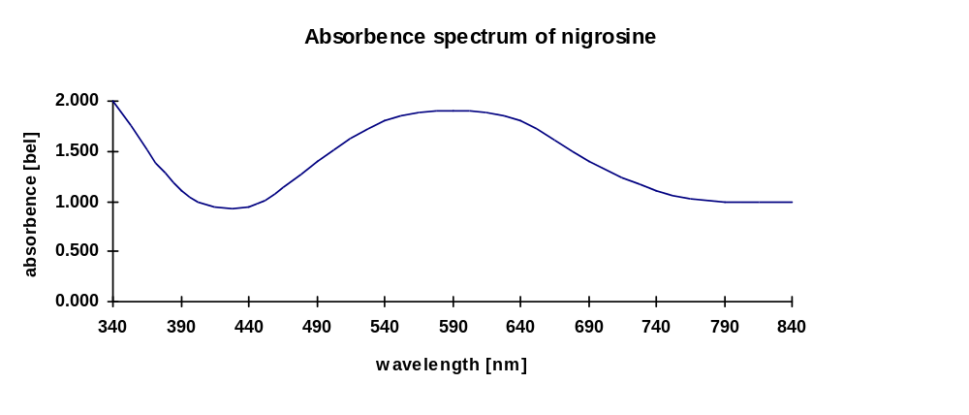
fig. 2

Error Budget

Hierarchy of Stock- and Subdilutions

Stock Solution BMS

METTLER ID5
MultiRange
W4

BMR
= 1 : 3.125 of BMS
BMPR
= 1 : 25 of BMS
( = 1 : 8 of BMR )

fig. 3

Solution BMS (stock-solution)

The accuracy of pipetting volume is checked by comparing the absorbence of BMPR with the absorbence of the dilution’s made by AUT-pipettors. Due to the known dilution-ratio between BMS, BMR and BMPR the dilution error can be determined. The absolute absorbence of BMS respectively its subdilutions has none impact to the results. Therefore the dye stability has to be taken into consideration only.

Total amount [Total]: 4000.00g
Nigrosine amount [NIG]: 6.40g
Water (BS) amount [BS ] 3993.60g

Used scale W1 (for nigrosine): Sartorius 2022
Used scale W3: METTLER PK36
Scale calibration interval: daily and 3 month
Scale Inaccuracy W1 u_{scaleW1} ±0.1mg
Scale Inaccuracy W3 u_{scaleW3} ±100mg

Instability of dye u_{instable} ±1%

Inaccuracy caused by dye-instability ± 1.000%

Total inaccuracy: ≈ ± 1 %

Solution BMR

Total amount [Total]: 53.00kg
BMS amount [BMS]: 16.96kg
Water (BS) amount [BS ] 36.04kg

Used scale: METTLER ID5 MultiRange
Scale calibration interval: daily and 3 month
Scale Inaccuracy u_{scale} ±1.000g
Instability of dye u_{instable} ±1%

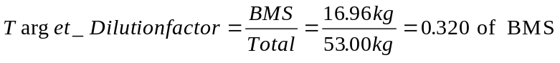

Inaccuracy caused by scale expressed dilution error: ± 0.0025% (neglect)
Inaccuracy caused by dye-instability ± 1.000%

Total inaccuracy: ≈ ± 1 %

Solution BMPR

Total amount [Total]: 47.00kg
BMS amount [BMS]: 1.88kg
Water (BS) amount [BS ] 45.12kg

Used scale: METTLER ID5 MultiRange
Scale calibration interval: daily and 3 month
Scale Inaccuracy u_{scale} ±1.000g
Instability of dye u_{instable} ±1%

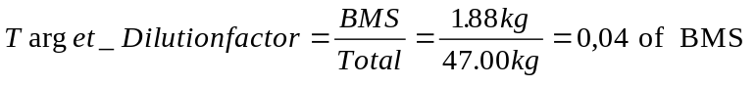

Inaccuracy caused by scale expressed dilution error: ± 0.0022% (neglect)
Inaccuracy caused by dye-instability ± 1.000%

Total inaccuracy: ≈ ± 1 %

Tolerance Zone
The tolerance zone consists from the uncertainty of the validation method itself and the analysers uncertainty. The table below shows the total uncertainty for all analysers which can be checked by the dilution series BMS, BMR and BMPR.

For the check of pipetting volumes, the solutions to be measured are prepared by both, the sample- and the reagentpipettor. Therefore cross effect by reagentpipettor while samplepipettor check and cross effect by samplepipettor while reagentpipettor check have to be taken into consideration. The inaccuracy caused by these cross effects is expressed by u_{method1.} Other errors like solution instability, cuvette and temperature impacts are summarised under u_{method2}.

For all analysers the medians of the measurements for each dilution step are used for the calculations.

The tolerance zones are symmetrical. The total uncertainty G_{total} is specified as follows:
G_{total} = G_{analyser} + u_{method1} + u_{method2}

G_{total} = Total uncertainty
G_{analyser} = specified analyser pipetting uncertainty
u_{method1} = cross effects by other pipettors
u_{method2} = uncertainty of method caused by instability of solutions and analyser
specific uncert. (e.g. impact of cuvettes, temperature effects, etc.)

Analyser  type | G_{analyser}  _{sample}  _{pipettor} | u_{method1}  _{sample}  _{pipettor} | u_{method2}  _{sample}  _{pipettor} | G_{total SPIP}  _{sample pipettor} | G_{analyzer}  _{reagent}  _{pipettor} | u_{method1}  _{reagent}  _{pipettor} | u_{method2}  _{reagent}  _{pipettor} | G_{total RPIP}  _{reagent pipettor}
HIT 917 | 0.5µl | 0.5µl | 0.2µl | 1.2µl | 2.5µl | 2.5µl | 0.2µl | 5.2µl
HIT 912 | 0.5µl | 0.5µl | 0.2µl | 1.2µl | 2.5µl | 2.5µl | 0.2µl | 5.2µl
HIT 911 | 0.5µl | 0.5µl | 0.2µl | 1.2µl | 2.5µl | 2.5µl | 0.2µl | 5.2µl
HIT 904 | 0.5µl | 0.5µl | 0.2µl | 1.2µl | 2.5µl | 2.5µl | 0.2µl | 5.2µl
HIT 902 | 0.5µl | 0.5µl | 0.2µl | 1.2µl | 2.5µl | 2.5µl | 0.2µl | 5.2µl
HIT 747-100 | 0.5µl | 0.5µl | 1µl | 1.2µl | 2.5µl | 2.5µl | 1µl | 6.0µl
HIT 747-200 | 0.5µl | 0.5µl | 1µl | 1.2µl | 2.5µl | 2.5µl | 1µl | 6.0µl
HIT 747-400 | 0.5µl | 0.5µl | 1µl | 1.2µl | 2.5µl | 2.5µl | 1µl | 6.0µl
HIT 737
HIT 717 | 0.5µl | 0.5µl | 0.2µl | 1.2µl | 2.5µl | 2.5µl | 0.2µl | 5.2µl
HIT 705
HIT 704 | 0.5µl | 0.5µl | 0.2µl | 1.2µl | 2.5µl | 2.5µl | 0.2µl | 5.2µl
KEYSYS | 0.2µl | 0.2µl | 0.51µl | 0.91µl | 1.5µl | 0.59µl | 1.20µl | 3.29µl
table 3.0

Analyser  type | Dilution  (sample/reagent) | G_{analyzer}  _{sample/reagent dilution} | u_{method2}  _{sample/reagent dilution} | G_{total}  _{sample/reagent dilution}
ES 300 | 20µl/1020µl = 1/51 | 5.60% | 2% | 7.60%
 | 100/1000µl = 1/11 | 2.10% | 2% | 4.10%
 | 200µl/1200µl = 1/6 | 1.80% | 2% | 3.90%
ES 600 / ES 700 | 20µl/1020µl = 1/51 | 5.60% | 2% | 7.60%
 | 100/1000µl = 1/11 | 2.10% | 2% | 4.10%
 | 500µl/1000µl = 1/2 | 1.80% | 2% | 3.90%
table 3.1

Literature
- DIN 1319
„Grundbegriffe der Meßtechnik“
Basic concepts of measurements; concepts for uncertainty of measurement and evaluation of measuring instruments

- Absorbence Standard Nigrosine (BMS)
Standards in absorption spectrometry-Techniques in visible and UV spectrometry; Vol I, UV spectrometry group (1981), Chapman and Hall Ltd.

- Vocabulary and symbols
ISO 3534-1977(E/F)
Statistics - Vocabulary and symbols, first edition - 1977-07-01
Statistique - Vocabulaire et symboles, Première édition - 1977-07-01

- Photometer specifications
DIN 5030 Teil 1, Juni 1985
DIN 5030 Teil 2, Sept. 1982
DIN 5030 Teil 3, Dez. 1984
Spektrale Strahlungsmessung

- Guidelines for the Expression of Uncertainty of Measurement in Calibrations
Western European Calibration Co-operation, WECC Doc. 19-1990

History of Changes
Version | Date | Changes, Amendments
V 0.1 | March ‘97 | 1. Edition
V 1.1 | Dec. ‘97 | Adapted to ref. determin. at SP, Sweden
table 4

