Laboratory Accreditation
Specification Validation Procedure
CAL 917.32 Part 9, Temperature of Reaction Bath
BM/Hitachi 917
Version: 3.2

Date: December 1997
Written by: | Mr. Mathew, LI-E
Authorized by: | Mr. Ringsleben, LI-TS
Checked by: | Mr. Yabe, HID
Released by: | Mr. De Caluwé, LI-E

This sheet provides a validation procedure to comply with the requirements of laboratory accreditation standards.

This sheet is an uncontrolled copy.
Laboratory Accreditation Spec. Validation Procedure
on Reaction Bath Temperature
BM/Hitachi 917

Content:

1. Purpose page 3
2. General Description page 3
3. Operating Conditions page 3
4. Traceability of the validation standards page 4
5. Test Procedure page 4-5
6. Documentation page 5
7. Error Budget page 5
8. Requirements to the Digital-Multimeter (DMM) page 6
9. Use of new Thermistors page 6
10. Validation Form, General Form page 7
11. Validation Form, Example page 8
12. Drawings page 9

1. Purpose

This validation procedure describes the validation of the reaction bath temperature of the HITACHI 917 Analyser.
The meaning of "validation" is to determine the difference between the "true temperature" and the "set-temperature".

2. General description & measuring theory

The temperature is measured with a thermistor probe, mounted to a prepared cuvette segment. The selected thermistor is supplied by THERMOMETRICS, USA. The certified tolerance is ± 0.05 ° C.
The thermistor probe is mounted to a cuvette with a hole in its bottom. The tip of the thermistor tip must rise about 5mm deeper than the bottom line of the cuvette segment. (see chapter 11, figure 1).
The temperature resistance is measured by a DMM (requirements see chap.7)
The measured resistance has to be calculated to the according temperature by a individual resistance/temperature function.

Note: If an alternative mercury or digital thermometer with an inaccuracy of <= 0.10°C and an appropriate traceability evidence is available, you can use it instead of the described thermistor probe. In this case use the same validation forms by filling out the temperature column only.

3. Operating conditions

The validation should be performed under normal operating conditions, i.e.

• room temperature : 15 to 30 °C
• relative humidity: 40 to 80 %
• no ventilation or draft

Note, that the variation of the room temperature should not exceed ± 2 °C during the validation process.
4. Traceability to National Standard

Refer to Procedure „Traceability of Sensors for Temperature Check“

5. Test Procedure

1. Switch on the DMM

2. Insert the thermistor probe to the cuvette with the hole in its bottom. The tip of the thermistor probe must immerse about 5mm deeper than the edge of the cuvette bottom line(see chapter 11, figure 1)

3. Switch on the Hitachi 917. Wait until initialisation is done: The message ´Standby´ occurs .

4. Wait until the temperature is established. The actual temperature is displayed in Sample Tracking Screen

5. Connect the thermistor lead to the 2-wire resistance input of the DMM.

6. Caution: Handle the thermistor with care ! Avoid bending or drawing the thermistor leads

7. Choose the 2 wire-RESISTANCE-function and an appropriate Ohms-range

8. Read the displayed resistance-value of the DMM and enter it to the validation protocol.

9. Wait 1 minute

10. Repeat the resistance measurements, described in steps 8-9, four further times.

11. Calculate the temperature-values as described in the validation Protocol.Caution: ensure that the thermistor-specific coefficients TA, TB, and TC are still applicable. If you are in a doubt, use new thermistors and the corresponding coefficients.
Chapter 8 describes how to recalculate this coefficients.
Chapter 9 gives an example, how the protocol has to be filled out.
It is recommended to use a programmable pocket-calculator for the resistance/temperature conversations. In order to avoid rounding errors, do not round any intermediate-results !

6. Documentation

For documentation of the validation results use the attached validation form.

7. Error Budget

Refer to Procedure „Traceability of Sensors for Temperature Check“,
8. Requirements to the Digital-Multimeter (DMM)

The DMM for the resistance-measurements has to fulfill the following requirements:

• 12 or 24 month accuracy of resistance,
measurements in the 0-200kOhms range : <= 2000 ppm (of reading)
• Current for resistance measurements: <= 10 µA
• Latest validation certificate:
not older than 12 or 24 months (24 months if the according specs are <= 2000 ppm)

9. Use of a new Thermistor:

If you use a new thermistor and the new resistance/temperature-table differs from the old one, the coefficients TA, TB, and TC must be recalculated as follows:

R1 = resistance at 0° C T1 = 273.15 K + 0 K = 273.15 K X1 = ln(R1)
R2 = resistance at 30° C T2 = 273.15 K + 30 K = 303.15 K X2 = ln(R2)
R3 = resistance at 50° C T3 = 273.15 K + 50 K = 323.15 K X3 = ln(R3)

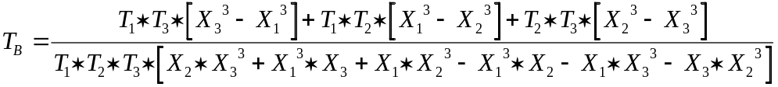

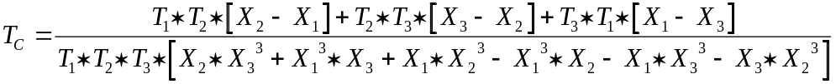
10. Validation Form for Cal 917.32 P9

10.1 Validation ID/Analyser Set Temperature

Validation ID | HIT 917 set temp.
 | 37 °C

10.2 DMM / Thermometer Parameters

Producer / Type | Serial Number | Last Validation Date

10.3 Thermistor Parameters and Results

Thermistor-Curve No. |  | Supply-Date |  | Lot No.
UT 443 SX1
Coefficient TA |  | Coefficient TB |  | Coefficient TC
4.61235 * 10-4 |  | 2.41852 * 10-4 |  | 9.64321 * 10-8
n | Measured Resistance [Ohms] |  | X = ln(Resistance n) |  | 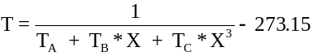
1
2
3
4
5
* depending on the  actual Thermistor-Lot |  | Average Temp. 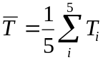 |  | = [° C]

Average Temperature = Set Temperature ± G_{total} ? (..........) yes r no r

11. Validation Form for Cal 917.32 P9 (Example)

11.1 Validation ID/Analyser Parameters


Validation ID | HIT 917 set temp.
123456 | 37 ° C

11.2 DMM / Thermometer Parameters

Producer / Type | Serial Number | Last Validation Date
KEITHLEY 2001 | 0546072 | 07.11.1992

11.3 Thermistor Parameters and Results

Thermistor-Curve No. |  | Supply-Date |  | Lot No.
UT 443 SX1 |  | June 1993 * |  | A 9149 *
Coefficient TA |  | Coefficient TB |  | Coefficient TC
4.61235 * 10-4 |  | 2.41852 * 10-4 |  | 9.64321 * 10-8
n | Measured Resistance n [Ohms] |  | X = ln(Resistance n)
1 | 54502 Ohm |  | 10.90599268 |  | 37.0117
2 | 54518 Ohm |  | 10.90628620 |  | 37.0039
3 | 54510 Ohm |  | 10.90613945 |  | 37.0078
4 | 54512 Ohm |  | 10.90617614 |  | 37.0069
5 | 54523 Ohm |  | 10.90637791 |  | 37.0015
* depending on the  actual Thermistor-Lot |  | Average Temp. |  | = 37.006 [° C]

Average Temperature = Set Temperature ± G_{total} ? (...0.2°C .) yes r no r
12. Drawings

Figure 1, location of the thermistor

cuvette segment HIT 917

