Boehringer Mannheim GmbH

MONITOR Program

Operator Manual

Program Version: 6.2

Contents:

1. Introduction
2. Installation
3. MONITOR Program
3.1. Autostart Option
3.2. Main Screen
3.3. Menu Options
3.3.1. ‘Trace-File/Start Recording’
3.3.2. ‘Trace-File/Display’
3.3.3. ‘Trace-File/Delete’
3.3.4. ‘Trace-File/Copy Trace File’
3.3.5. ‘Trace-File/Write Trace Backup’
3.3.6. ‘Trace-File/Read Trace Backup’
3.3.7. ‘Options/RS232 Parameter’
3.3.8. ‘Options/Desktop’
3.3.9. ‘Options/Monitor Setting’
3.3.10. ‘Options/Host Interface test program’
3.3.11. ‘?’
4. HOSTTEST Program
4.1. Main Screen
4.2. Menu System
4.2.1. ‘File/Test Selections’
4.2.2. ‘File/Results’
4.2.3. ‘File/Terminal’
4.2.4. ‘Trace/Open’
4.2.5. ‘Trace/Close’
4.2.6. ‘Trace/Display’
4.2.7. ‘Trace/Erase Window’
4.2.8. ‘Options/HOST ON/OFF’
4.2.9. ‘Options/RS 232-Parameter’
4.2.10. ‘Options/Desktop’
4.2.11. ‘Options/Instrument’
4.2.12. ‘Options/MONITOR program
4.2.13. ‘?’
4.2.14. ‘Selected-Length’
Appendix A - Error messages of the trace interpreter
Appendix B - Message format and checksum calculation
Appendix C - Wiring schemes of the Host Interface cables
Appendix D - Connection schemes for MONITOR and HOSTTEST
MONITOR with one T-Connector in half duplex mode
MONITOR with two T-Connectors in full duplex mode
MONITOR with up to four T-Connectors in Multi-port Recording mode
HOSTTEST in direct connection
Appendix E - Wiring diagram of the T-Connector
Appendix F - List of Files
Appendix G - Contents of MONITOR.INI file
Appendix H - Software-Updates

1 Introduction
The MONITOR program packet consists of two programs (MONITOR and HOSTTEST), which use the same adjustments. They can also run independently from each other. In both programs, there is a menu option to start the other program.

The MONITOR program has to be installed on a computer whose serial port is connected to the so called T-Connector. This T-connector is inserted into an existing serial Host<->Analyzer connection (see chapter ‘Connection schemes). After activating the recording option of the program, the complete communication between the two partners (e.g. host and analyzer) is stored in a trace file.
With the display option, this file can be displayed on the screen, printed, copied to disk and searched for keywords.
When displaying such a trace file, it is possible to display additional information like timing between messages, the message in hexadecimal format and the instrument specific interpretation of the message if the instrument is supported by the program.

The HOSTTEST program serves as simple ‘Host’ and directly communicates with the connected analyzer.
After selecting the connected analyzer in the list of supported instruments the communication can be established or tested.
According to the host functions of the instruments, test selection can be sent in real-time and batch mode and results are received and stored in a file for later analysis.

The actual software version the following instruments/host protocols are supported by MONITOR and HOSTTEST:

BM/HITACHI 917, 912, 911/904, 902, 747-100/200, 747-400, 717, 704, 705
STA - Std. bi. Protocol
STA, STA Compact - ASTM Protocol
KEYSYS
COASYS
ES 300/600/700
VS250/PPV
Miditron, Miditron Junior
Elecsys 2010/1010

2 Installation
For installing the software packet on your hard disk just insert the distribution diskette and run A:\INSTALL.EXE
A dialogue appears on the screen where only the MONITOR program is displayed in the list field. After entering the target path on the hard disk both programs are copied to the hard disk.
The start command for the MONITOR program is: MONITOR.EXE
The start command for the HOSTTEST program is: HOSTTEST.EXE

3 MONITOR Program

4 Autostart Option

The MONITOR program may be started with an additional command line parameter:

MONITOR /AUTO

The program is started and directly initiates the actually selected communication mode.
This mode and the serial parameters are taken from the RS232 dialogue and must therefore be set before using the Autostart option.
In additon, the trace file name and path as well as the file mode (APPEND or OVERWRITE) may be specified by configuration file AUTO.INI which can be modified with any text editor tool. This file looks like this:

' Autostart Configuration File for the MONITOR Tool V 6.2
' =======================================================
'
' The file has three entries:
'
' TRACE FILE NAME:
' ----------------
' The file name of the trace file e.g. TRACE.TRC
' If the file name is invalid, an error message is displayed.
' If no file name was entered, TRACE.TRC is taken
' as default name.
'
' TRACE FILE PATH:
' ----------------
' The path of the trace file e.g. C:\MONITOR\DATA\
' If the path does not exist, an error message is displayed.
' If no path was entered, the current path is
' taken as default.
'
' FILE MODE:
' ----------
' Supported options: APPEND and OVERWRITE
' Any other expression displays an error message.
'
' All other parameters are taken from the Options
' screen

TRACE FILE NAME = TR_NAME.TRC
TRACE FILE PATH = C:\MONITOR\DATA
FILE MODE = OVERWRITE

5 Main Screen

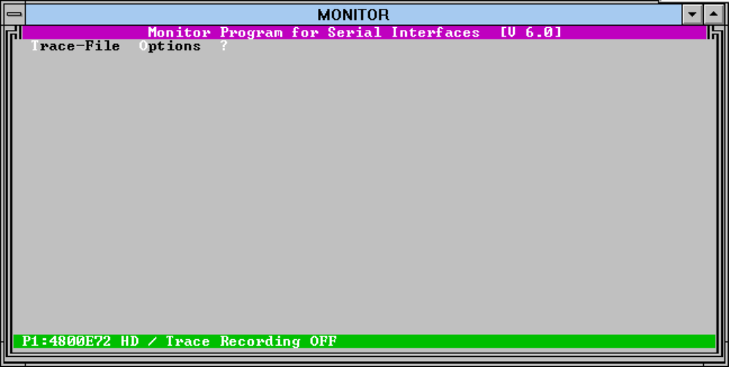

The main screen of the MONITOR program contains the following items:

- the pull-down menu system with the menu options ‘Trace-File’, ‘Options’ and ‘?’

- the Trace window (still empty)

- the status line with the serial parameters and common information

6 Menu Options

7 ‘Trace-File/Start Recording’
A file selection dialogue appears where the trace file name can be entered. A new name as well as the name of an already existing trace file can be entered. In the latter case the operator is prompted whether the existing file shall be overwritten or whether the new data shall be appended.
After confirming the file name, the data reception routine is started (the trace window gets black) and waits for data. This is the recording phase.
Received messages are displayed with time and sender information.
The recording phase is left with the <Esc> key.
During the recording phase the actual trace file size and the remaining free space on the hard disk can be displayed with the key combination <Shift> + <F1>.
The actually selected communication mode together with the parameters of the activated ports is displayed if the key combination <Shift> + <F2> is pressed.
In Multi-port Recording communication mode the channel to display the trace info may be selected with the corresponding number key (e.g. <1> for port 1, <2> for port 2, ...)
Below the screen during the recording phase is displayed; the menu system is disabled, as additional information the name of the trace file and the starting time are displayed.

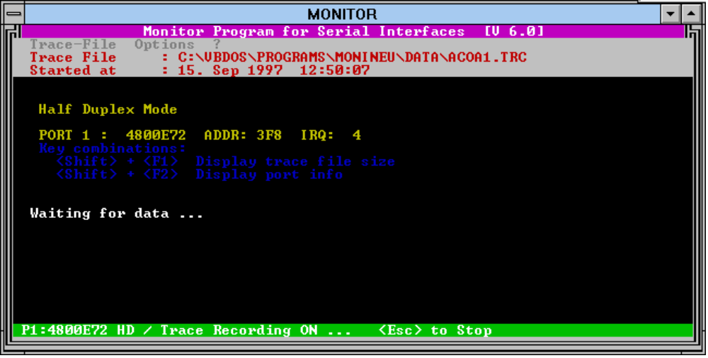

8 ‘Trace-File/Display’
With this option already recorded trace files can be displayed.
The file selection dialogue offers all existing trace files. After the file selection an option box with additional information items is displayed. The following information can be selected for each message:

- Trace in ASCII Format (STANDARD)
this is the standard format which is always displayed. In this format the control characters (character codes 00hex to 1Fhex) are replaced by mnemonics for a better readability of the message (e.g. [STX] for code 02hex or [ACK] for code 06hex).

- Timing Information (OPTION)
If the sender of the messages can be distinguished, the duration of the message as well as the delay between the messages are displayed in tenth of a second.

- Trace in hexadecimal Format (OPTION)
The message is displayed in hexadecimal format.

- Instrument-specific Interpretation (OPTION)
Each message is interpreted as long as the correct instrument is selected and the program supports that instrument. If only a part of the message is interpreted this is indicated by three points.
The interpretation is always in english.

- Character Timing (OPTION)
The complete trace file is displayed character by character with receiving time and sender identification (0 or 1) for each single character.
If this option is selected, all other above listed display options are automatically deselected because of the expected large size of the text file.

An example trace with header info and three messages:

MONITOR Trace File

Operators Name : Claus Mahlmann
Trace started : 05. Feb 1996 16:08:37
Trace stopped : 05. Feb 1996 16:14:51
Parameters : 9600 Baud, 8 Data-, 1 Stopbits, no parity
Message Info : - ASCII Format
- Timing Info
- Hexadecimal Format
- Interpretation for HITACHI 911/904
--------------------------------------------------------------------------

Host 16:08:41,72 [STX]>[ETX]=
Trans. Duration: 00:00:00,00 Time between this and next: 00:00:03,84
HEX 0 : 02 3E 03 3D
HITACHI 911/904
Acknowledgement (ANY/MOR)

AU 16:08:45,56 [STX]>[ETX]=
Trans. Duration: 00:00:00,00 Time between this and next: 00:00:05,27
HEX 0 : 02 3E 03 3D
HITACHI 911/904
Acknowledgement (ANY/MOR)

...

AU 16:09:52,57 [STX];A···10·1ident12345678·35120730961245[ETX][US]
Trans. Duration: 00:00:00,05 Time between this and next: 00:00:03,24
HEX 0 : 02 3B 41 20 20 20 31 30 20 31 69 64 65 6E 74 31
HEX 16 : 32 33 34 35 36 37 38 20 33 35 31 32 30 37 33 30
HEX 32 : 39 36 31 32 34 35 03 1F
HITACHI 911/904
Test Selection Request: Routine / with barcode / Realtime / Class 1
Cup: SampleNo: 1 DiskNo: 0 PosNo: 1 Id: ident12345678
Age: 35 Fact: 1 Sex: 2 Date: 073096 Time: 1245

After selecting the additional information options the binary trace file is read, prepared and stored in the temporary text file ‘TEMP.TMP’. The contents of this text file is displayed with a trace editor on the screen.
The Trace Editor has the following menu options:

9 ‘File/Display Trace Info’
This menu option displays a window with the following trace file specific information:

- File size in Bytes
- Number of characters (there are six bytes of information stored for each character)
- Number of messages
- Date and time of the recording start
- Date and time of the reception of the first character
- Date and time of the reception of the last character
- Date and time of the recording end
- Recording duration in hours, minutes, seconds
- Name of the operator

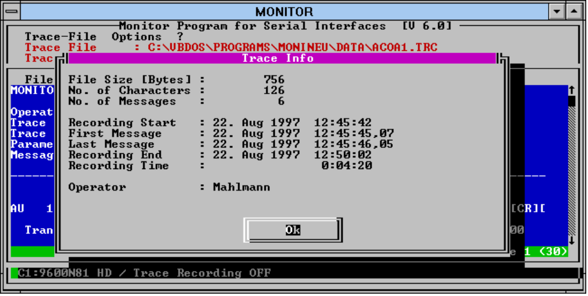

10 ‘File/Print’
It is possible to print the whole file or only a selected part of the text. The available parallel ports of the computer or a text file can be specified as print target.
A 43-character string can be entered as comment which appears in each head line of the printout.
According to the connected printer and adjustment, the number of lines per page and the width of the left margin in characters may be specified.

11 ‘File/Close’
This option closes the trace editor. This can also be done by pressing the <ESC> key.

12 ‘Search/Search Text’
A dialogue box appears where any text/keyword can be entered. Following additional search options can be specified:

Origin:
- Start searching at the first line of the displayed screen
- Start searching at the beginning of the file

Direction:
- Forward
- Backward

- Case sensitive
- Replace the spaces in the search text by the actual space replacement character (see chapter ‘Options/Monitor Setting’)

This dialogue box can also be accessed with the function key <F2>.
A message box appears if no text to search was entered.

13 ‘Search/Search Text’
If the first search action was successful, it can be repeated with this option. This is also possible with the function key <F3>.

14 ‘Search/Search Selected Text’
If there is a part of the text selected, this option jumps to the first selected line.

15 ‘?’
This option lists all key combinations for browsing or selecting text within the trace editor:
<Up> Scroll up one line
<Down> Scroll down one line
<Pg Up> Scroll up one page
<Pg Down> Scroll down one page
<Ctrl Home> Start of Text
<Ctrl End> End of Text
<Ctrl A> The first visible line of the actually displayed text is marked as the start of the selected text part
<Ctrl B> The last visible line of the actually displayed text is marked as the end of the selected text part
<Ctrl C> The text is deselected
<F2> Search Text Dialogue
<F3> Search again
<Esc> Close Trace Editor

16 ‘Selected-Length’
After selecting a text part, press this main menu option to get the length of the text part displayed in the menu line.

17 ‘Trace-File/Delete’
Trace files which are not longer used can be deleted from the hard disk with this menu option.

18 ‘Trace-File/Copy Trace File’
After selecting a trace file and the target drive, the selected file is copied if there is enough free space on the target drive.

19 ‘Trace-File/Write Trace Backup’
This option allows to copy trace files which do not fit on one single diskette to as much diskettes as are necessary.
The trace file is copies in binary format; that means that the receiver of the diskettes can do his own analysis of the trace file (if he also has the MONITOR program)
The available disk drives and formats are displayed in a dialogue box; the number of needed diskettes is calculated and displayed. After starting the copy procedure the program asks for inserting the next diskette.
The diskettes need to be formatted and empty !
It is recommended to label the diskettes so that the receiver of the diskettes can read in the trace file correctly.

20 ‘Trace-File/Read Trace Backup’
The trace files which are copied to several diskettes with the above described option can be read in with this option.
Just select the source drive and insert the first diskette of the set.
The program asks for the next diskette. The trace file is built together on the hard disk and can be displayed with the ‘Trace-File/Display’ option of the MONITOR program.

21 ‘Options/RS232 Parameter’
This dialogue box contains all settings concerning the serial interface for up to four serial ports (Port 1 to Port 4). The serial parameters may be different for the different ports:

Baud-Rate: 300, 600, 1200, 2400, 4800, 9600, 19200 baud

No. of Databits: 6, 7, 8

No. of Stopbits: 1, 2

Parity check: no, odd, even parity

Port No.: According to the selected Communication mode, one or more ports are needed. The characters -> in front of the port option indicate the needed port/s for the actually selected communication mode (one port for half duplex mode, ports 1 and 2 for full duplex mode and all selected ports for Multi-port recording.

Port Address: The default addresses for the ports 1 to 4 are:
Port 1 | 3F8
Port 2 | 2F8
Port 3 | 3E8
Port 4 | 2E8

Port Interrupt: The default interrupt for ports 1 and 2 are:
Port 1 | Interrupt 4
Port 2 | Interrupt 3
for the other ports any interrupt up to 7 may be entered.

Use: If Multi-port Recording is selected, the ports to activate may be selected with these controls.

Communication Mode:
Half duplex mode In the half duplex mode the computer with the MONITOR program is connected to one T-Connector which records the communication in both directions. Ports 1 to 4 may be selected, but if the corresponding port is not available, a message is displayed.

Full duplex mode In the full duplex mode two T-Connectors are put together where each T-Connector is connected to one serial port. (COM1 and COM2 must be available). Each port records the data in one direction. Even if both communication partners send at the same time, the complete information is recorded.
(see Appendix D - Connection schemes)
For this communication mode, ports 1 and 2 must be available. If one of them is not available, a message is displayed.

Multi-port Recording If this mode is selected, the received data of all selected ports is saved in a separate trace file. The trace files have fix names (PORT1.TRC to PORT4.TRC).
With this options, up to four serial connections may be recorded.

With the [Param Synchro x] button the parameters of the selected port (x) are copied to all other existing ports.

The [Default Addr.] button enters the following addresses and Interrupts into the text fields:

Port 1 | Addr. 3F8 | IRQ 4
Port 2 | Addr. 2F8 | IRQ 3
Port 3 | Addr. 3E8 | IRQ 5
Port 4 | Addr. 2E8 | IRQ 7

The actually selected serial parameters are displayed in the status line.
Examples:
P1:9600N81 HD
Port 1 is selected with 9600 baud, no parity, 8 data- 1 stopbit in Half-duplex mode

P1:4800E72 P2:4800E72 FD
Ports 1 and 2 are activated with 4800 baud, even parity, 7 data-, 2 stopbits in Full-duplex mode

P1:4800E72 P2:4800E72 P3:9600N81 P4:1200O71 MP
Ports 1 to 4 are activated with different port parameters for Multi-port Recording

22 ‘Options/Desktop’
The desktop language and the display mode can be selected with this option.

Language: All text lines of the program are stored in one text file. As basic languages the german and english text files are available. It is however possible to create text files for the other languages in the option box with any text editor program. The language is coded in the file name. When starting the program it detects the existing text files and offers them in the option box.

Display Mode: If there is only a monochrome monitor available the colors can be disabled for better contrast.

23 ‘Options/Monitor Setting’
The following settings are available on this screen:

Device Names: Two device names can be entered. These names are used in the trace file to identify the sender. It depends on the cable connection to and from the T-Connector which message is combined with which device name. If they are just exchanged the button [Swap Names] changes them back.

Sender Detection: The complete communication between the two devices is received from the T-Connector via one data line (Receive data). To detect the sender of each single received character the software has to check the signal on pin 8 (DCD handshake line). Therefore this pin must be connected in the used cable from the T-Connector to the MONITOR computer. This pin is set if device 1 sends and not set if device 2 sends data.
This is the default mode of detecting the sender of a message.
If there is not such a cable available where pin 8 is connected the second mode (Detection of SOH, STX, ACK, NAK, DLE, ...) can be used to get sender changes. In this mode a sender change is assumed whenever one of the listed control characters is received. The DCD line is not checked in this mode.

Space Replacement: The space character (code 20hex) within messages can be replaced by another readable character. The code of this character can be entered here.

Operator name: An 18-character operator name can be entered. This name appears in the head of the trace file.

Max. Trace Size: The max. size of the trace file may be limited to a value between 1 MB and the available free space on the drive of the actual datapath.
During recording phase the actual trace file size as well as the remaining free space on the hard disk can be checked with the key combination <Shift> + <F1>.
If during the recording the defined trace file size is reached, the trace file is overwritten from the beginning.
It is not possible to express the recording capacity in time because that depends on the amount of data that is sent.
Since there are 6 bytes of binary information stored for each received character it is possible to store 166.666 characters with the 1 MB max. file size option. If a BM/HITACHI 917 with 2 seconds as cycle time is connected you can record 2,5 hours ANY/MOR communication (without data frames !).

24 ‘Options/Host Interface test program’
This menu option starts the Host Interface test program HOSTTEST.

25 ‘?’
In a window the programs name, version number and the developers address are displayed.

26 HOSTTEST Program

27 Main Screen
The main screen of the HOSTTEST program contains the following items:

- the pull-down menu system with the menu options ‘File’, ‘Trace’, ‘Options’ and ‘?’.

- the trace window for displaying the communication

- the status line for displaying the actual serial parameters and the selected instrument

28 Menu System

29 ‘File/Test Selections’
This data input mask serves for creating test selections which are sent to the analyzer in real-time (on request from the analyzer) or batch (as long as the analyzer supports that mode) mode.
For a batch transmission, the start sample ID and the number of test selections can be specified. In this case the sample ID needs to be numerical because it is incremented.
There are 16 test positions where the test name and the test number can be entered. Each single test is activated by activating the control box left to the test name field. Changes in the test list need to be stored with the [Save] button. The [Reset] button writes default values to the sample ID, test name and test number fields.
After pressing [Send Batch] the specified test selections are sent to the analyzer.
The real-time mode is always active, i.e. whenever a request from the analyzer is received, a test selection for that sample with the specified tests selected is sent back.

30 ‘File/Results’
All result from the analyzer are stored in the file RESULTS.DAT.
In addition the results are entered into the text file RESULTS.TXT. This file can be imported into a spreadsheet application for further processing. (no spaces included; the data fields ‘Ident number’, ‘Test number’, ‘Test names’, ‘Result’, ‘Alarm-Flag’ are delimited by semicolon).

On the result screen there is a list box which contains all sample Ids. When selecting a sample ID, all existing results for that sample are displayed in the text box below the sample list. Together with each single result value the test number, test name and alarm flag is displayed. If the test names are not transferred, they are taken from the test selection input mask. If a result for a test number is received for which there is no entry in the test selection mask an interrogation mark is written in the test name position.

31 ‘File/Terminal’
This option activates a terminal mode where manually created messages may be sent to the other device, where the received character are displayed without any protocol-specific formatting.
A text field appears above the trace window for manually created messages.
Any message can be entered into that field and sent to the other device with the [Send] button. Control characters (01 hex to 1E hex) can be entered via function key.

1. Level | F1 to F10 | control codes 01 hex to 10 hex
2. Level | Shift+F1 to Shift+F10 | control codes 11 hex to 20 hex
3. Level | Ctrl+F1 to Ctrl+F10 | control codes 21 hex to 30 hex

The corresponding mnemonics are inserted into the text field at the cursor position.
The [Add Checksum] button adds the protocol- and instrument-specific frame to the message.
Each character of the message can also be replaced by its hexadecimal character code. The hexadecimal code (00 to FF) needs to be enclosed in brackets.

Example: | If the text field contains the following sequence: {02}1234{35}{36}{03}
 | the string: 123456 enclosed in STX and ETX is sent to the analyzer.

The last ten messages that are send with the [Send] button are stored in a ring buffer. The [Previous] button brings those messages back to the text field.

32 ‘Trace/Open’
The communication between host test program and analyzer can be stored in a trace file.
Just enter the trace file name. An open trace file is indicated by the trace file name above the trace window. The trace file has the same file structure than the trace file of the MONITOR program, i.e. they can only be displayed with the MONITOR program. (see menu option ‘Trace/Display’)

33 ‘Trace/Close’
The recording of the communication is terminated.

34 ‘Trace/Display’
For displaying the contents of a trace file the MONITOR program is loaded. So you have the complete choice of additional information for displaying the trace file.

35 ‘Trace/Erase Window’
This options clears the trace window.

36 ‘Options/HOST ON/OFF’
For testing purpose the host answer can be disabled. When starting the program this option is always enabled. The actual status is displayed in the status line.

37 ‘Options/RS 232-Parameter’
This dialogue box contains all settings concerning the serial interface:

Baud-Rate: 300, 600, 1200, 2400, 4800, 9600, 19200 baud

No. of Databits: 6, 7, 8

No. of Stopbits: 1, 2

Parity check: no, odd, even parity

Port No.: While the MONITOR program supports up to four serial ports, the HOSTTEST only supports COM1 and COM2

Port Address: The default addresses for the ports 1 to 2 are:
Port 1 | 3F8
Port 2 | 2F8
The default addresses may not be changed !

Port Interrupt: The default interrupt for ports 1 and 2 are:
Port 1 | Interrupt 4
Port 2 | Interrupt 3
The default interrupts may not be changed !

The actually selected serial parameters are displayed in the status line.

38 ‘Options/Desktop’
The desktop language and the display mode can be selected with this option.

Language: All text lines of the program are stored in one text file. As basic languages the german and english text files are available. It is however possible to create text files for the other languages in the option box with any text editor program. The language is coded in the file name. When starting the program it detects the existing text files and offers them in the option box.

Display Mode: If there is only a monochrome monitor available the colours can be disabled for better contrast.

39 ‘Options/Instrument’
This dialogue serves for selecting the connected instrument.
According to the selected instrument, additional adjustments like end code or type of checksum calculation are enabled or disabled.
The adjustments are stored in the configuration data file. The actually selected instrument is displayed in the status line.

40 ‘Options/MONITOR program
This menu option starts the communication recording program MONITOR.

41 ‘?’
In a window the programs name, version number and the developers address are displayed.

42 ‘Selected-Length’
This menu option is only visible if the Terminal mode is activated (see 4.2.3 File/Terminal).
When pressing this main menu option the length of the selected text part in the Terminal text window is displayed in the menu line.

Appendix A - Error messages of the trace interpreter
The following errors are discovered by the interpreter function and indicated by a corresponding message:

BM/HITACHI 917, 912, 911/904, 747-100/200, 747-400, 717, 704, 705:

 | Message | if ...
 | [STX] missing | first character of the message is not a [STX]
 | Invalid End-Code | invalid end code
 | Wrong Checksum | wrong checksum
 | Invalid Message Length | - TS has wrong no. of characters  - Result has wrong no. of characters
 | Unknown Frame Character | wrong/unknown frame character
 | Invalid Control Character | Message consists of a single character other than ACK, NAK or EOT  (only Hit 747-400, 717, 704)

STA - Std bi-directional

 | Message | if ...
 | Invalid Control Character | Message consists of a single character other than SOH, ACK or NAK
 | [STX] missing | first character of the message is not a [STX]
 | Invalid End-Code | invalid end code
 | Wrong Checksum | wrong checksum
 | Unknown Frame Character | wrong/unknown frame character
 | Invalid Message Length | - Request has wrong no. of characters  - Worklist has wrong no. of characters  - Result has wrong no. of characters
 | Invalid Method Format | the method list has wrong no. of characters

STA - ASTM

 | Message | if ...
 | Invalid Control Character | Message consists of a single character other than ACK, ENQ, EOT or NAK
 | Invalid Message Length | message shorter than 6 characters
 | [STX] missing | first character of the message is not a [STX]
 | Invalid End-Code | invalid end code
 | Wrong Checksum | wrong checksum
 | Unknown Record Type | wrong/unknown record character

KeySys

 | Message | if ...
 | Invalid Message Length | - Message is shorter than 6 characters  - Control Frames have wrong no. of characters
 | [STX] missing | first character of the message is not a [STX]
 | Invalid End-Code | invalid end code
 | Wrong Checksum | wrong checksum
 | Unknown Frame Character | wrong/unknown frame character

ES 300/600/700

 | Message | if ...
 | Invalid Control Character | Message consists of a single character other than ACK, ENQ, EOT, DLE or NAK
 | [STX] missing | first character of the message is not a [STX]
 | Invalid End-Code | invalid end code
 | Wrong Checksum | wrong checksum
 | Invalid Data Set | Data set is not EP or ED
 | Invalid Data Set Type | Type of data set is not RQ, HD or MD

VS250/PPV

 | Message | if ...
 | Invalid Control Character | Message consists of a single character other than ACK or NAK
 | [STX] missing | first character of the message is not a [STX]
 | Invalid End-Code | invalid end code
 | Wrong Checksum | wrong checksum
 | Unknown Packet Identifier | Packet identifier is not E, I, D or S
 | Invalid Message Length | - Enquiry has wrong length  - Initialisation has wrong length  - TS request has wrong length  - TS has wrong length  - Result has wrong length  - Pipettor list has wrong length  - End has wrong length

CoaSys

 | Message | if ...
 | Invalid Control Character | Message consists of a single character other than ACK or NAK
 | Wrong Start Sequence | Start sequence is not [STX][CR][LF]
 | Wrong Checksum | wrong checksum
 | Invalid Message Length | Message has wrong length

Miditron

 | Message | if ...
 | [STX] missing | first character of the message is not a [STX]
 | Invalid End-Code | invalid end code
 | Wrong Checksum | wrong checksum
 | Invalid Message Length | message shorter than 6 characters
 | Unknown Frame Character | wrong/unknown frame character
 | Invalid OPC Function Code | Invalid function code for OPC frames

Appendix B - Message format and checksum calculation
All characters in the grey sections are taken for the checksum calculation !

HITACHI 917, 747-100/200, KeySys

 | STX | Data | ETX | CSH | CSL | CR

Method: Sum of all character codes in hexadecimal format. CSH and CSL are the two least significant digits of that sum.

HITACHI 912, 911/904, 902

1 | STX | Data | ETX | BCC

Method: The character code of the BCC results from the exclusive OR sum of all character codes.

2 | STX | Data | CR | LF | ETX

3 | STX | Data | ETX

4 | STX | Data | ETX | CR | LF

5 | STX | Data | ETX | CSH | CSL | CR

Method: Sum of all character codes in hexadecimal format. CSH and CSL are the two least significant digits of that sum.

HITACHI 747-400

1 | STX | Data | ETX/ETB | BCC

Method: The character code of the BCC results from the exclusive OR sum of all character codes.

2 | STX | Data | CR | LF | ETX

3 | STX | Data | ETX

4 | STX | Data | ETX | CR | LF

HITACHI 717

1 | STX | Data | ETX/ETB | BCC

Method: The character code of the BCC results from the exclusive OR sum of all character codes.

2 | STX | Data | CR | LF | ETX

3 | STX | Data | ETX

4 | STX | Data | ETX | CR | LF

HITACHI 704

1 | STX | Data | ETX/ETB | BCC

Method: The character code of the BCC results from the exclusive OR sum of all character codes.

2 | STX | Data | CR | LF | ETX

3 | STX | Data | ETX

HITACHI 705

 | STX | Data | CR | LF | ETX

STA - Standard bi-directional

 | STX | Data | BCC | ETX

Method: The character code of the BCC results from the exclusive OR sum of all character codes.
7Fh: If the sum is 03h, it is replaced by 7Fh.
or 40h: The sum is increased by 40h.

STA, STA Compact, Elecsys 2010/1010 - ASTM Protocol

 | STX | Data | ETX | CSH | CSL | CR | LF

Method: Sum of all character codes in hexadecimal format. CSH and CSL are the two least significant digits of that sum.

CoaSys

 | STX | CR | LF
 | RS (1Eh) | Data | CR | LF
...
 | GS (1Dh) | CSH | CSL | CR | LF
 | ETX | CR | LF

Method: Sum of all character codes in hexadecimal format. CSH and CSL are the two least significant digits of that sum.

ES 300/600/700

 | Control character | TC 1 | TC 2
or
 | STX | Data | ETX | CSH | CSL | TC 1 | TC 2

Method: Sum of all character codes in hexadecimal format. CSH and CSL are the two least significant digits of that sum.

VS250/PPV

 | STX | Data | CSH | CSL | ETX

Method: The remainder of the division between the sum of all character codes and 256 is calculated.
The code of the CSH character is results from the OR operation of the high nibble (most significant 4 bits) of the above calculated sum with 30h.
The code of the CSL character is results from the OR operation of the low nibble (least significant 4 bits) of the above calculated sum with 30h.

Miditron

1 | STX | Data | ETX | 20h | 20h | CR

2 | STX | Data | ETX | CSH | CSL | CR

Method: The XOR sum of all character codes is calculated.
The code of the CSH character is results from the OR operation of the high nibble (most significant 4 bits) of the above calculated sum with 30h.
The code of the CSL character is results from the OR operation of the low nibble (least significant 4 bits) of the above calculated sum with 30h.

Appendix C - Wiring schemes of the Host Interface cables

BM/HITACHI 917
BM/HITACHI 747-100/200
ES 300, 600, 700
STA, STA Compact
Elecsys 1010

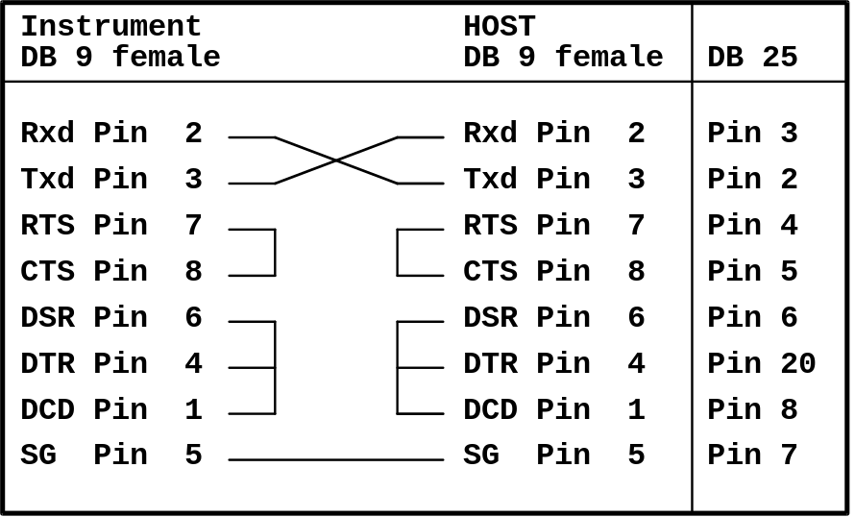

Elecsys 2010

BM/HITACHI 912
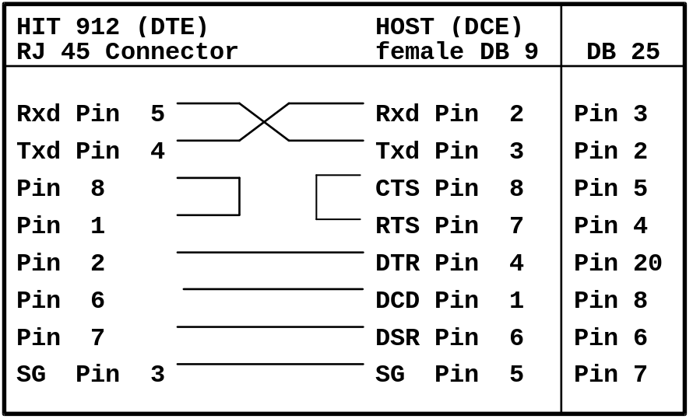

BM/HITACHI 902
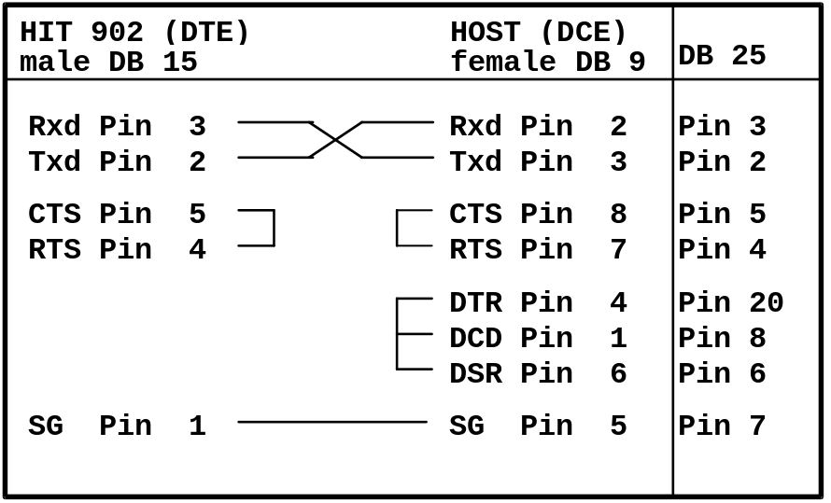

BM/HITACHI 911/904
BM/HITACHI 747-400

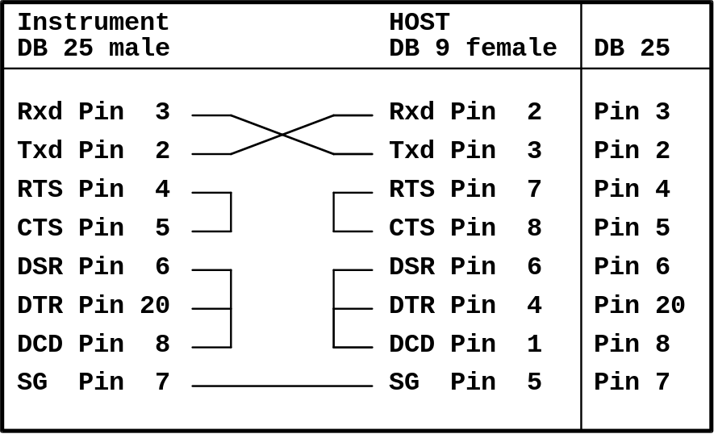

BM/HITACHI 717
BM/HITACHI 704
BM/HITACHI 705

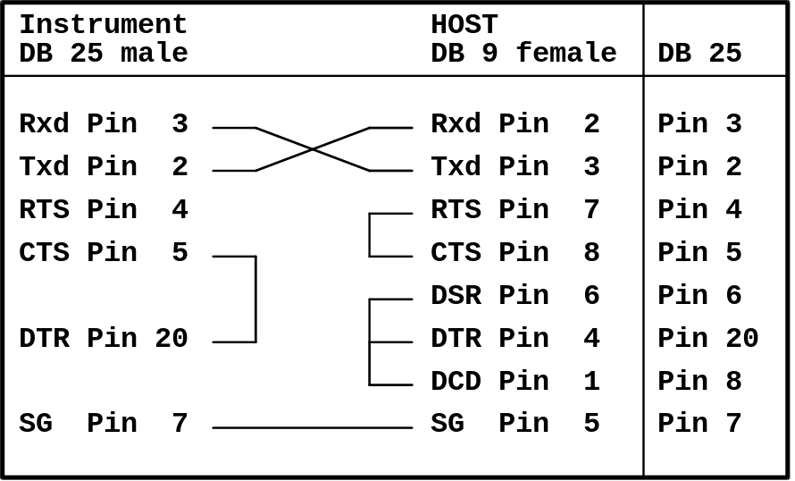

VS 250
KeySys

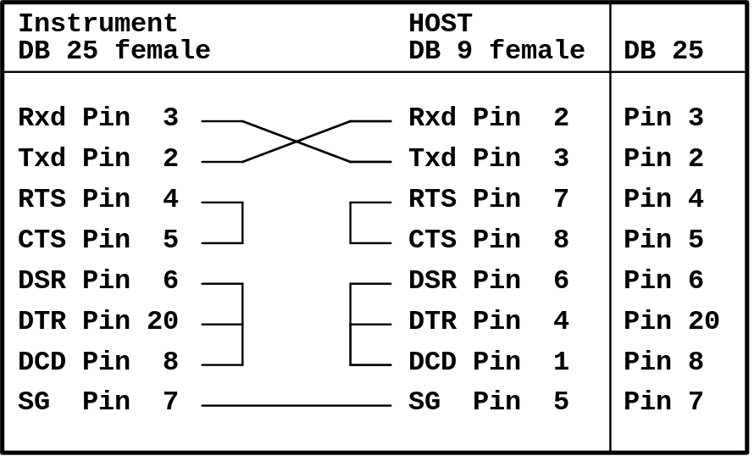

Appendix D - Connection schemes for MONITOR and HOSTTEST

MONITOR with one T-Connector in half duplex mode

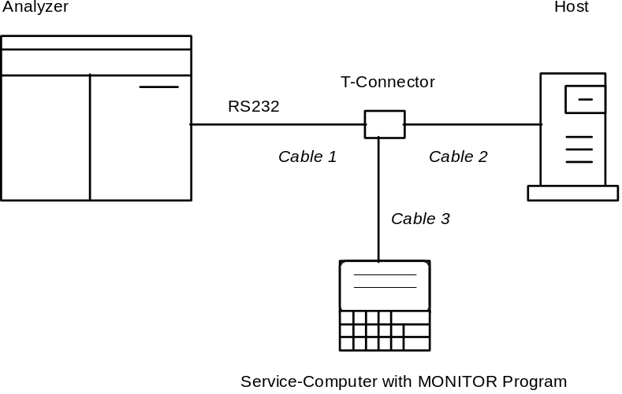

The T-Connector pins from cable 1 to 2 are directly connected, that means that cable 1 needs to be a null-modem cable (crossed data lines) and cable 2 needs to be a modem-cable (non-crossed data lines) or vice versa.
Cable 3 has the following wiring:

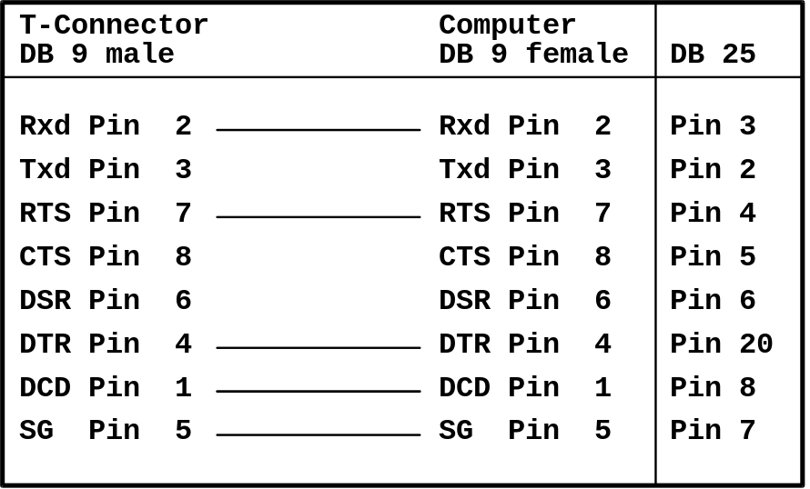

MONITOR with two T-Connectors in full duplex mode

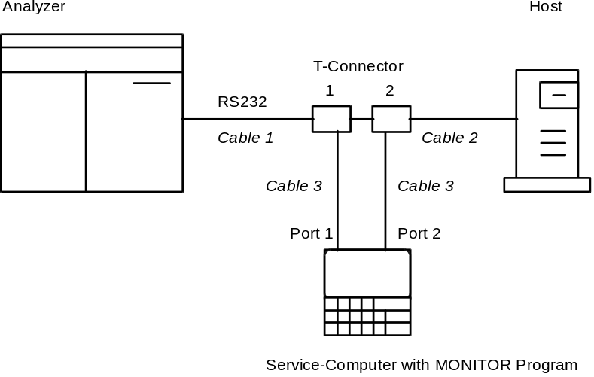

Cables like above.

MONITOR with up to four T-Connectors in Multi-port Recording mode

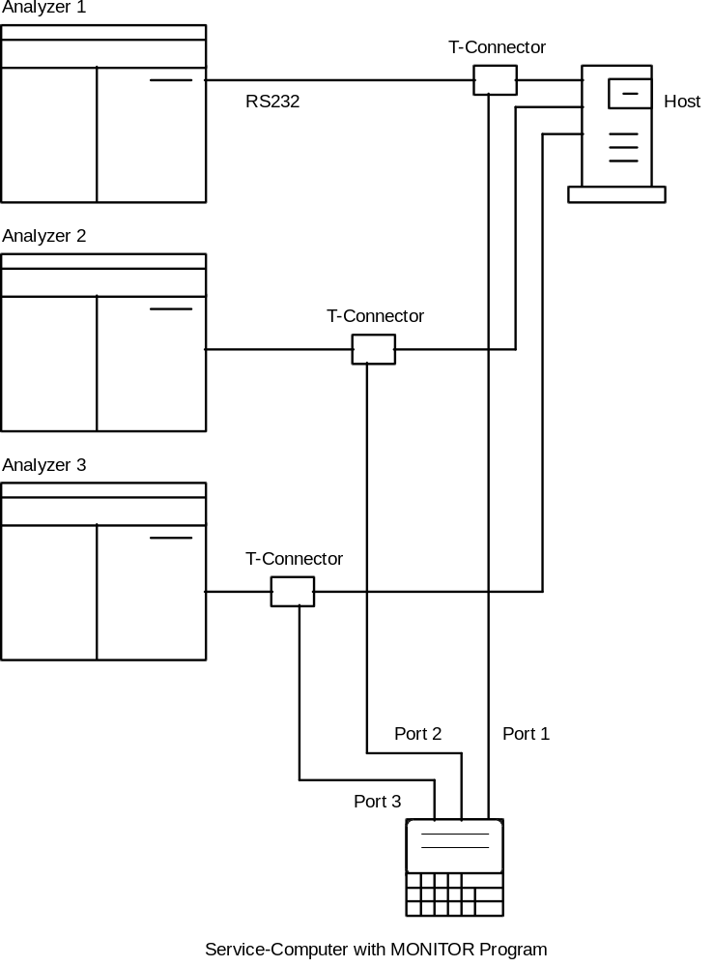

Cables like above.

HOSTTEST in direct connection

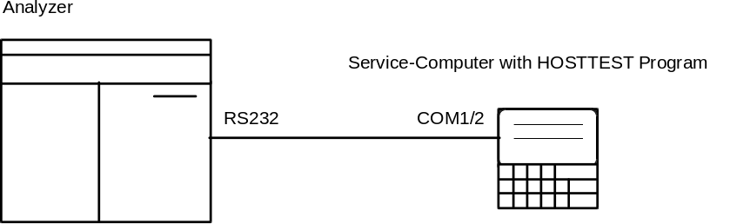

Concerning wiring scheme of the cables see chapter 5.2

Appendix E - Wiring diagram of the T-Connector

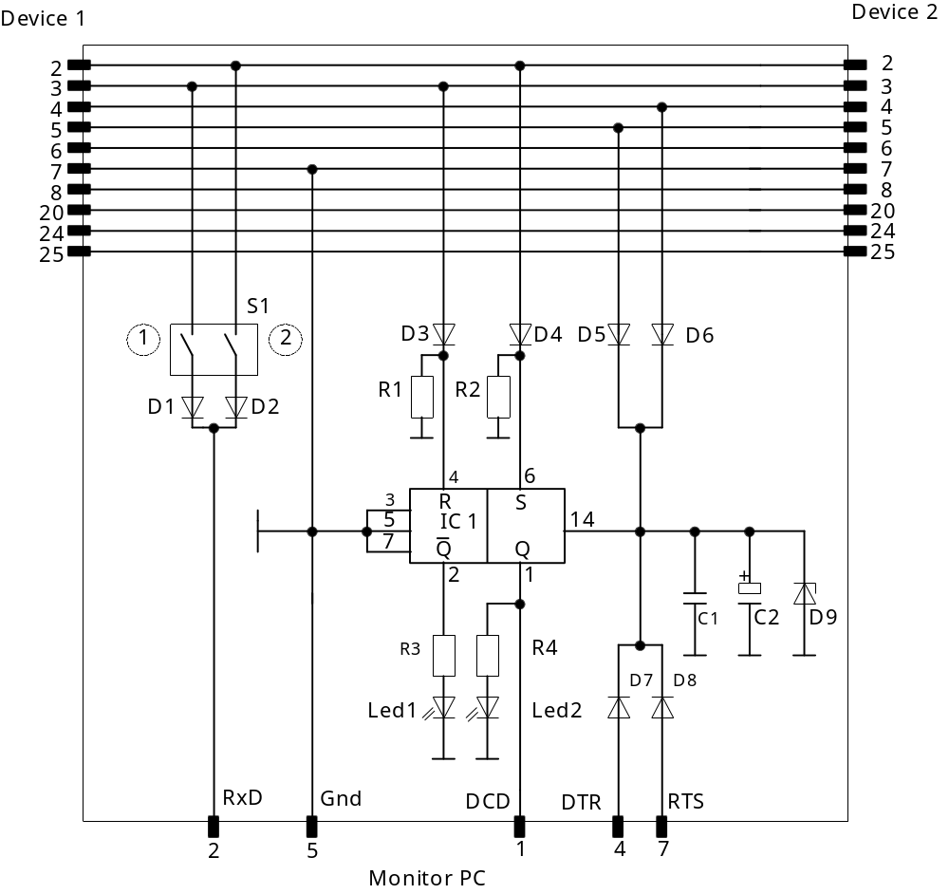

Appendix F - List of Files

File | Contents
MONITOR
MONITOR.EXE | Monitor program
MONITOR.ICO | Windows program icon
MONI_EN.TXT | English text lines
MONI_GE.TXT | German text lines
MONIREAD.EXE | Turbo Pascal routine for recording the trace files
MONIWRIT.EXE | Turbo Pascal routine for creating the text file
MONI.INI | Parameters from MONITOR.EXE for MONIREAD.EXE and MONIWRIT.EXE
AUTO.INI | Configuration data for Autostart Mode
temporary files

TEMP.TMP | temporary text file for prepared trace files
BACK.TXT | Information from MONI.EXE to MONITOR.EXE
INDEX.DAT | Index file for the text editor
PRINTER.BUF | Contains the text lines for the printout option
MELD.TXT | Contains the error message after calling a DOS routine
*.TRC | Trace files
HOSTTEST
HOSTTEST.EXE | Host Interface test program
HOSTTEST.ICO | Windows program icon
HOST_EN.TXT | English text lines
HOST_GE.TXT | German text lines
TESTSEL.DAT | test selection data
RESULTS.DAT | Received results in binary format
RESULTS.TXT | Received results in text format
temporary files

ASTMBUFF.TXT | Record buffer for the ASTM protocol
ESBUFF.TXT | Message buffer for the ES protocol
TERMBUFF.DAT | Buffer for the last ten sent messages
Used by both programs
MONITOR.INI | Configuration data; created when MONITOR is started for the first time
INST.DAT | List of supported Instruments/protocols

Appendix G - Contents of MONITOR.INI file

The configuration data for MONITOR and HOSTTEST is stored in MONITOR.INI

[Monitor Program]
[Desktop]
Language = ENGLISH
Desktop language; Options: ENGLISH or GERMAN
Display = COLOR
Color mode; Options: MONO or Color
[RS232 Parameter]
Port 1 Parameters = 9600N813F8 41
Port 2 Parameters = 300E622F8 31
Port 3 Parameters = 19200N813E8 51
Port 4 Parameters = 9600N812E8 70
Serial parameters for 4 ports, Format: bbbbbpdsaaaiic
bbbbb = Baud rate (300 to 19200), p = Parity (N,O,E), d =Data bits (6,7,8)
s = Stop bits (1,2), aaa = Port Address (hex), ii = Interrupt, c = Selected (1) or not selected (0)
Com-Port = 1
Port number for half duplex mode (recording one channel)
Communication Mode = 1
Options: -1 = Multi-port Recording, 0 = Full-duplex mode, 1 = half-duplex mode
[Port Comments]
Port 1 Comment = Port 1 Comment
Port 2 Comment = Port 2 Comment
Port 3 Comment = Port 3 Comment
Port 4 Comment = Port 4 Comment
Comments for the max. four port. May be edited only here with any text editor; they are displayed only in recording mode
[Trace File]
Trace File = ACOA2.TRC
Last used trace file name
Datapath = C:\MONITOR\DATA1\
Last used trace file path
[Printer]
Printer-Port = 1
Printer port number
Lines per Page = 60
Number of lines per page
Left Margin = 3
number of characters as left margin
[Settings]
Device 1 = AU
Name of device 1 within trace file
Device 2 = Host
Name of device 2 within trace file
Space Substitute = 250
Code of the character that represents a space within the messages
Sender Change Detection by = STX
Sender detection method; Options: DCD = hardware or STX = software
Max. Trace Size = 1
Max. trace file size; Options: 0 = unlimited, 1,2,3 = 1 to 3 MB
Operator = Mahlmann
Operator name; apears in header of each trace file
[Host Testprogram]
Instrument = ES3
Actually selected instrument
End-Code = 1
End-code option for Hit 911, 912, 902; Options 1 to 5
No. of Term = 2
No. of termination characters for ES protocol
ES Mode = SLAVE
ES mode; Options: MASTER or SLAVE
Termination Char 1 = 13
Code of the first termination character for ES protocol
Termination Char 2 = 10
Code of the second termination character for ES protocol
Std. bi. Checksum = 7F
Checksum calculation method for the STA std.bi. protocol; Options: 7F or OR 40h
STA Station No. = 99
Station number for the STA protocol
Miditron Checksum = EURO
Checksum calculation method for the Miditron protocol; Options: EURO, USA or NONE

Appendix H - Software-Updates

Version 4.7 - August 1996

MONITOR Program
- The detection of the available serial ports is no longer done by interrupt.
- Implementation of the Interpretation of the Elecsys 2010 protocol.

HOSTTEST Program
- For STA Std.bi and STA-ASTM there is another input field for the STA station no. in the Options screen.
Normally the station no. of the received worklist request is stored and used within worklists to the instrument. But if you want to send worklists from host without request you have to know the station no.
- Test selection sending in realtime and batch mode as well as storage of received results for the Elecsys 2010 instrument.

Version 4.8 - October 1996

MONITOR Program
- Within the recording routine (black window) the serial parameters, odd and even parity were used in a wrong way.
- There is an Error Window when the trace recording cannot be started because of too less working memory.
- Sometimes the recording routine (black window) did not start, when ‘Overwrite’ mode for the trace file was selected.
- There were invalid start and end dates displayed in the header of the trace window when the month was greater than 7.
- It is now possible to enter the print data mask and store the trace into a text file in case that the printer is not ready.

HOSTTEST Program
- There are two more End-of-data codes selectable for the Hit 717.
- There is an additional option on the ‘Instrument Selection’ screen for the Miditron (Checksum calculation method: american, european, none)

Version 4.9 - November 1996

MONITOR Program
- If program was started from DOS level the printout of a trace file caused an ‘Invalid SHARE operation’ error and did not print the correct trace data.
- When using the ‘Copy Trace’ menu option the trace file was stored under the sources file name instead of the entered target file name.
- When displaying a trace file with one message being longre than 1300 characters (because of missing sender direction info) the program may crash.

HOSTTEST Program
- In Terminal mode the control character with code 0 may be generated with function key.

Version 5.0 - December 1996

MONITOR Program
- If ‘Read Trace Backup’ function was run with A: or B: as actual datapath the program aborted because there was not enought free space on the target drive.
The actual datapath is now displayed and the free space on the target drive is checked.

Version 5.1 - May 1997

HOSTTEST Program
- The software crashed, if no test was selected for the answer to a realtime request for ELECSYS 2010.
- The patient record P within the test selection message of the ELECSYS is empty.
- The error message from the ELECSYS (Header + Termination record) is no longer answered by the test program by an invalid test selection message.
- The sequence number within the request record from the ELECSYS is sent back within the order record of the test selection message.
- For ES systems, the software answers also TN requests. That means, IN (identnumber), TC (test code) and TN (test number) variables are sent.

Version 5.3 - July 1997

HOSTTEST Program
- From the Test Selection screen it is possible to send multiple Orders to the Elecsys systems.
- The complete sample info of the Request record Q (seq. no., carrier no., pos no., carrier type and container type) is echoed within the Order record O for the Elecsys 2010.

Version 5.4 - August 1997

HOSTTEST Program
- Correction of the Hit 704 BCC calculation.

Version 6.0 - November 1997

MONITOR Program
- Completely new trace editor
- Trace Info, Print and Search options move from main menu to editor menu
- up to four ports are supported
- Multi-port Recording as new communication mode
- In Multi-port recording the channel to display is selected with the corresponding number key <1> to <4>
- Communication mode is displayed during recording with <Shift>+<F2>
- The Monitor program may be started with the command line parameter /AUTO. This causes the program to directly start the recording mode with the selected serial parameters and trace file name and path which are saved in the file AUTO.INI
- When the option ‘Print to File’ is selected for trace file output, the actual path is displayed and the actual trace file name with extension TRC is entered to the text filed as proposal for the text file name.

HOSTTEST Program
- Terminal mode for manually created messages and received messages is instrument-independant
- Software crashed, if [Batch] button was pressed on the ‘Test Selection’ screen with an empty ID text field

Version 6.1 - January 1998

MONITOR Program
- The program may be directly closed with the key combination <Ctrl> + <C>
- Comments for the four serial ports may be entered with any text editor in the MONITOR.INI file. These comments are displayed during the recording within the trace window, if in Multiport-Recording a channel key (<1> to <4>) is pressed to switch the trace display.

HOSTTEST Program
- BCC calculation for test selections from HOSTTEST to Hit 717 and Hit 704 were wrong.
- Wrong serial parameters (9600,N,8,1) were entered into the trace file header when activating a trace file.

Version 6.2 - January 1998

MONITOR Program
- It was possible to generate trace files with invalid file names (e.g. spaces within the file name)
- When starting the Monitor tool for the first time and creating the configuration file MONITOR.INI, ‘Full duplex’ was set as default communication mode instead of ‘Half duplex’.
- The max. trace file size may be set from 1 MB to the available free space on the drive of the actaul datapath.

HOSTTEST Program
- It was possible to generate trace files with invalid file names (e.g. spaces within the file name)

