Boehringer Mannheim GmbH
BM/HITACHI 911 / 904 Automatic Analyzers
Host Interface Manual

System Interface - Functional Specifications

BM / ID.No. 1563173-001

Document Version 2.2

1. Introduction
2. Interface Setup
2.1. Pin Description and Signal Control
2.2. Connection Cable
2.3. DIP switch Setting
2.4. Signal Discrimination
2.5. Specification of Communication
2.6. Setup of Communication Parameters
3. Basic Workflow
4. Software Protocol
4.1. Common text format
4.2. Start-of-data Code
4.3. Frame Character
4.3.1. Frame Types
4.3.2. Frame Priorities
4.4. Data Field
4.4.1. Function Characters
4.4.2. Sample Container Information
4.4.3. Composition of Sample Information
4.4.4. Composition of Test Selection Information
4.4.5. Composition of Result Data for Routine, Rerun, STAT, and Control samples
4.4.6. Absorbance Data
4.4.7. Photometry-assay Calibration Data
4.4.8. ISE Calibration Data
4.4.9. Data Alarm List
4.5. End-of-data Code
4.5.1. Options
5. Data Transmission Control Procedure
5.1. Establishment of Data Link
5.2. Response to Information Message
5.2.1. No Information to be sent
5.2.2. Transfer of Communication Control Message
5.2.3. Transfer of Test Selection Information
5.2.4. Transfer of Result Data
5.2.5. Resending Request
5.3. Termination and Restart of Communication
5.4. RESULT-ONLY mode
6. Communication Functions
6.1. Function List for Test Selection Data
6.2. Function List for Result Data
7. Communication Trace
7.1. Overview
7.2. Trace Data
7.3. Reset and Printout of Trace Data
7.4. Trace Data Storing Performance
8. Examples for Traces
8.1. Test Selection record from HOST to AU (batchmode)
8.2. Test Selection inquiry from AU to HOST (realtimemode)
8.3. Result data from AU to HOST
8.4. Absorbance data from AU to HOST
8.5. Photometry-assay Calibration data from AU to HOST
8.6. ISE Calibration data from AU to HOST
8.7. Control data from AU to HOST
8.8. Specific Result Request from HOST to AU
9. Figures and Tables
Appendix A - ASCII Chart
Appendix B - Differences between the HIT 747 and 911
Appendix C - Tabel of System I/F Alarms (Category 111)
Appendix D - Text Configuration Table

1 Introduction
This manual provides the specifications for bidirectional data transmission between an HITACHI Model 911/904 Automatic Analyzer by Boehringer Mannheim GmbH and an external laboratory host system via asynchronous serial connection. The hardware components required as well as the communication rules are described. They highlight the general considerations to be taken into account in any approach to realize the data communication between different computer systems.
This specification illustrates the fundamental considerations for the host link and contains information concerning the following:
– Hardware
• What interface hardware is required?
• How is the physical connection established?
– Use and control of the data transmission
• How to set the transfer and communication parameters?
• What is the formal structure of the strings and values to be transmitted and what influence can be taken on it?
• What kind of data or variables can be transmitted?
• How and by which system is the data transfer initiated?
– Software protocol
• What does the transmission protocol used for communication between the two systems look like?
• What does the host at the other end of the data link do and what rules has the program at the host link to follow?
Working with the host interface you will find that the data transfer from the host computer to the HITACHI Model 911/904 Automatic Analyzer can be done in a very easy, comfortable and reliable way.
If problems with the installation or questions about the transfer should arise please contact the responsible person of Boehringer Mannheim Service Department or directly the Service Management of the Central Marketing Department of Boehringer Mannheim GmbH (Germany):
Boehringer Mannheim GmbH
Technical Productmanagement
Data Technique
Sandhofer Straße 116
D-68305 Mannheim
Phone: (49) 621 / 759-2464
Telefax: (49) 621 / 759-4394
Figure 1 gives an overview about the 911 Interface Data Flow between the Analyzer and the HOST.

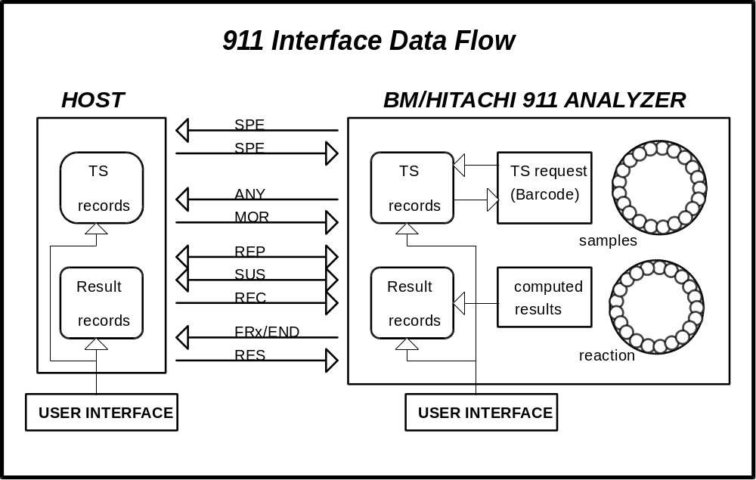
Figure 1: HIT 911 Interface Data Flow
(1) Realtime test selection request is made for:
- Routine samples, if the record is not existing or the test selection is zero.
- Rerun/Autorerun samples, if inquiry is enabled (System Parameters screen 4-09)
- STAT samples, if inquiry is enabled (System Parameters screen 4-09) and bar code reader is on.
(2) Realtime result transmission is made for:
- Routine/STAT/Control samples
- Calibration data
- Original absorbance, if requested (System Parameters screen 4-09)
(3) Batch result transmission can be initiated either by
- the HOST, sending a RES frame
- the operators request for
- Routine or STAT results (Data Review screen 1-06) or
- Control data (Individual QC List screen 2-03)
The System Parameters screen 4-09 is shown in Figure 6.

2 Interface Setup

3 Pin Description and Signal Control

Pin no | Signal | Explanation | Direction
2 | Txd | Transmit Data | out
3 | Rxd | Receive Data | in
4 | RTS | Request to Send | out
5 | CTS | Clear to Send | in
6 | DSR | Data Set Ready | in
8 | DCD | Data Carrier Detect | in
20 | DTR | Data Terminal Ready | out
1 | FG | Frame Ground | -
7 | SG | Signal Ground | -
Table 1: Pin Description for the 25-pin plug of the Model 911
If the wires for hardware handshake (refer to Figure 2) are used and connected to the host the following behaviour must be taken into account:
a) After the selection of Host Communication (Start Conditions screen 1-05) the signals RTS and DTR are active (SPACE: refer to Table 2) from the analyzer side. This condition is also found after an interrupt of the communication due to an input or an error.
The only use of this signal at the host computer is to check if a physical connection is established.
b) After the selection of Host Communication the Hitachi analyzer expects an active signal (SPACE) on the CTS-pin. Otherwise an error 111-002 occurs. With the CTS-signal the Hitachi analyzer recognizes whether the host computer is ready to receive.
c) The Hitachi analyzer expects an active signal (SPACE) on the DCD-pin. This signal activates the receive function of the analyzer. If the signal is missing the error 111-001 occurs, even if the Host Communication is enabled and the host is sending.

4 Connection Cable
Figure 2 and Figure 3 show two different possibilities to establish the hardware connection. Both connections can be used.
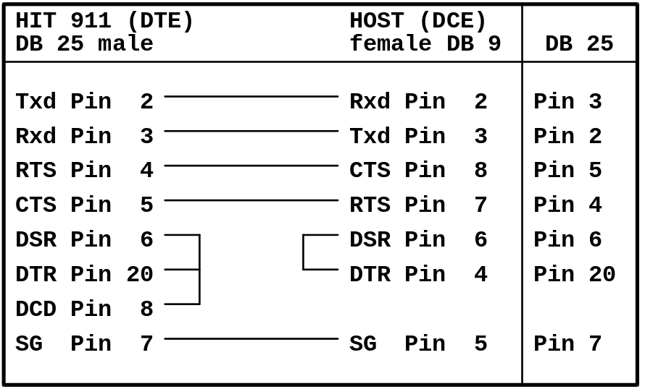
Figure 2: Cable Recommendation from Hitachi
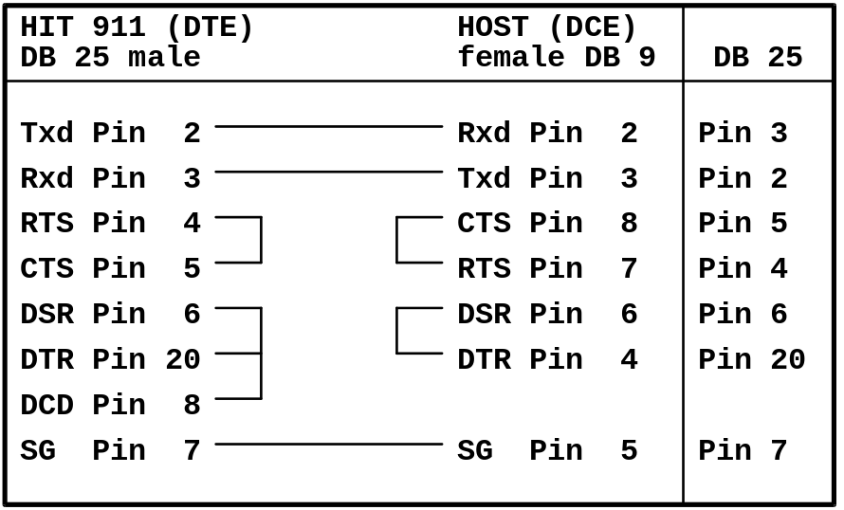
Figure 3: Connection without hardware handshake
Connect the cable to the connector 'H.CPU' on the backside of the analyzer.
Via the connector 'H.MON' it is possible to listen to the data transferred from the analyzer to the host while the host system is connected.

5 DIP switch Setting
Figure 4 and Figure 5 show the settings of the DIP switch 3 (on the ADC-SIF board) for the interfaces RS232-C or current loop.
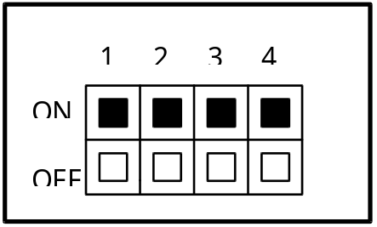
Figure 4: ADC-SIF Dip Switch 3 setting for RS232-C
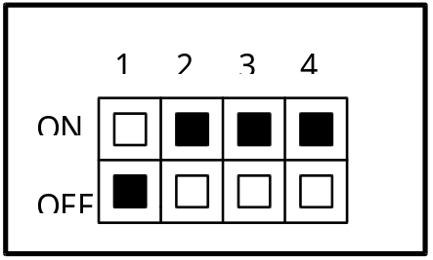
Figure 5: ADC-SIF Dip Switch 3 setting for current loop

6 Signal Discrimination

Signal | Binary | Level | RS232 Voltage | Current Loop
MARK (OFF) | ONE (1) | LOW | <= -3V | 20mA
SPACE (ON) | ZERO (0) | HIGH | > 3V | 0mA
Table 2: Signal discrimination

7 Specification of Communication
The table below shows the communication specifications of the host interface.

Item | Specification | Remarks
Interface | RS232C or | Cable max. 15m
 | current loop | Cable max. 50m
Communication. method | Half duplex
Code | ASCII/JIS 7bit/JIS 8bit
Table 3: Parameters not to be adjusted

8 Setup of Communication Parameters
All settings concerning the host interface are made on the System Parameters screen 4-09 (see Figure 6 and Figure 7) of the AU program.
On selection of this screen, the currently set information is displayed. The display can be changed over by the GUIDANCE key.

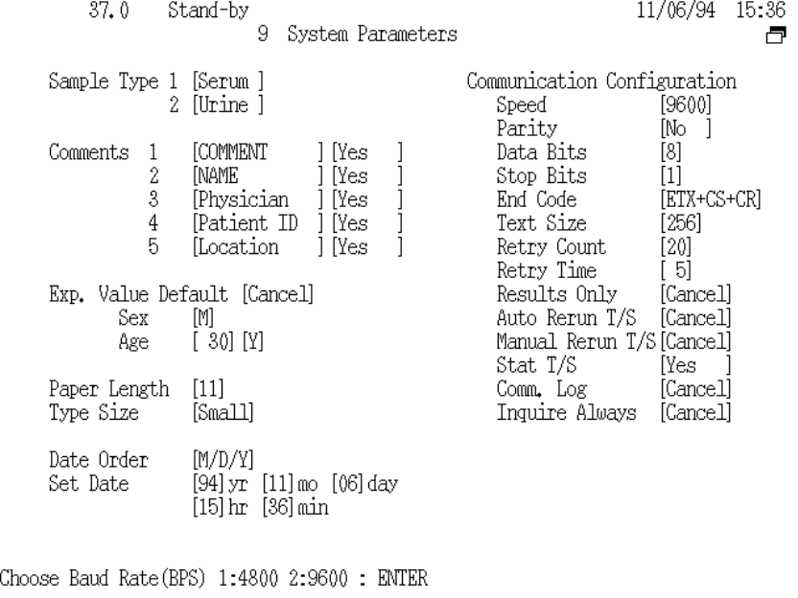
Figure 6: System Parameters screen 4-09 / part 1

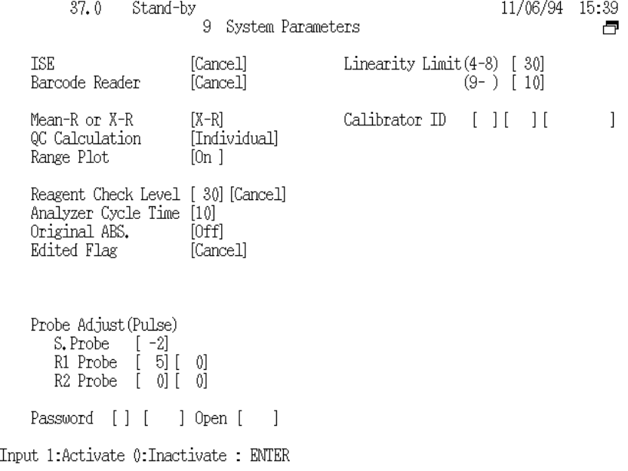
Figure 7: System Parameters screen 4-09 / part 2
Serial interface parameters:
• Communication Speed 9600, 4800 baud
• Paritycheck none, odd, even
• Data Bits 7, 8
• Stop Bits 1, 2

HIT 911 specific settings:
• Maximum Text Length 256, 512 bytes (chapter 4.4.5 and 4.4.6)
• End-of-data Code 5 options (chapter 4.5)
• Retry Count 1 to 99 (chapter 5.1)
• Retry Time 1 to 99 seconds (chapter 5.1)

Test selection handling:
• ‘Inquire Always’ option (chapter 4.4.4)

Optional test selection inquiry for
• Auto Rerun (chapter 6.1)
• Manual Rerun (chapter 6.1)
• STAT (chapter 6.1)

Unidirectional communication mode:
• ‘Result Only’ mode (chapter 5.4)

Host Communication Trace:
• Option of recording the communication
(the log is printed and cleared on the Mechanism Check screen 5-02)
(chapter 7)

Communication is switched on/off on the Start Conditions screen 1-04.
since Version 4-26:
If the instrument is in ‘Sample number mode’ (Barcode: Cancel) the ‘Host Communication’ field on the Start Conditions screen is protected during operation and probe washing. It is then possible to switch off communication, but it is not possible to switch on again the communication.

9 Basic Workflow
There are two possible ways of workflow on the BM/HITACHI 911 analyzer with a host connection:
- Test selection download in batch mode before starting the RUN
- Test selection download on request during the RUN

Test Selection Download in Batch mode

 The operator places the samples on the instrument
 The operator initiates the download of all existing test selections from host side
 The operator starts the run

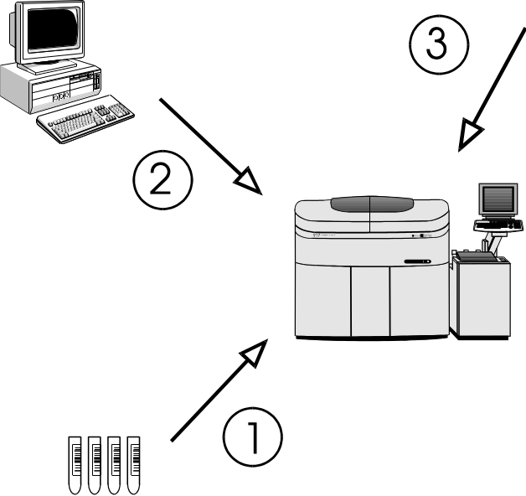
Figure 8: Test selection download in batch mode

Test Selection Download in Realtime mode

 The operator places the samples on the instrument
 The operator starts the run
 Upon reading the barcode of each sample the analyzer sends a request for each sample to the host
 The host sends back the corresponding test selection to the analyzer

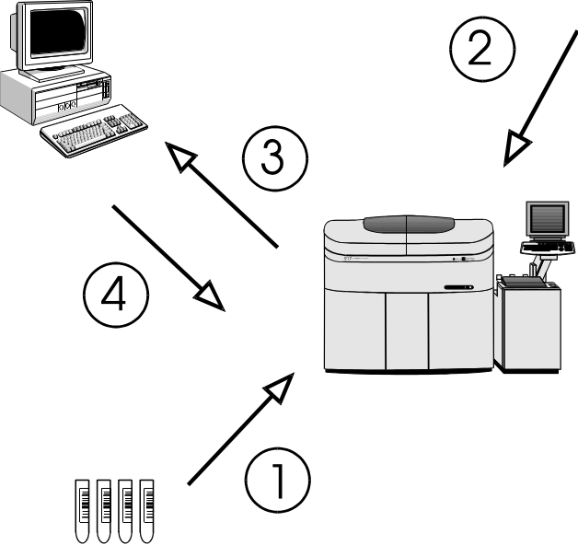
Figure 9: Test selection download in realtime mode

10 Software Protocol

11 Common text format
Each message that is sent to the AU (analytical unit) or the HOST (laboratory computer system) consists of the following items:

Start-of-data code | Frame character | Data field | End-of-data code

If you have a message without data (control frames ANY, REP or MOR, see Table 5) then the field Data Field is empty.

12 Start-of-data Code

Start-of-data code |  |  |  | Frame character |  |  | Data field |  | End-of-data code
 | Start-of-data code |  |  |  | : | STX (02H) |  | 1 Byte length

Each message sent from the AU or the HOST starts with the Start-of-Data Code (STX = 02H).

13 Frame Character

Start-of-data code |  |  | Frame character |  |  |  | Data Field |  | End-of-data code
 | Frame character |  |  |  | : | refer to Table 4 and Table 5 |  | 1 Byte length

The Frame Character represents the purpose/ contents of the message.

14 Frame Types

No | Mnemonic | Name | Char. | ASCII Code | Sender | Note
1 | FR1 | Frame 1 | 1 | 31H | AU | 1
2 | FR2 | Frame 2 | 2 | 32H
3 | END | End  Frame | : | 3AH |  | 2
4 | SPE | Specific  Sample | ; | 3BH | AU  HOST | 3
5 | RES | Results  Request | < | 3CH | HOST | 4
Table 4: Frame types having a Data Field
Note 1: The frame characters FR1 and FR2 are used, when the analytical data extends over more than one message. FR1 is used for the first message and END for the final message.
Note 2: END alone is used when analytical data for one sample can be sent in one single message.
Note 3: The AU uses the frame character SPE for the test selection inquiry of only one specific sample.
The HOST uses SPE for the test selection which is being sent in response to the inquiry from the AU.
Note 4: The specific result request RES is used to request analytical data of a specific sample from the HOST to the AU. (depending on whether the ID is provided or not, only routine and STAT samples are taken as valid. The others are ignored.)

No | Mnemonic | Name | Char. | ASCII Code | Sender | Note
6 | ANY | Any inquiry | > | 3EH | AU | 5
7 | MOR | More | > | 3EH | HOST | 6
8 | REP | Repeat | ? | 3FH | AU, HOST | 7
9 | SUS | Suspend | @ | 40H | AU, HOST | 8
10 | REC | Received | A | 41H | HOST | 9
Table 5: Frame types having no data field
Note 5: A positive response ANY is used by the AU to ask the HOST for the following items:
a) a test selection record for any sample that is available by the HOST.
b) rerun samples initiated by the HOST.
c) RES or MOR frame requests.
Note 6: MOR means that the HOST is ready to receive analytical data. (Analytical data can be transferred from the AU to the HOST only when the HOST has sent this frame.)
Note 7: A negative response REP is used, when resending of the previous communication is requested. The HOST can send REP at any time. The AU, however, sends REP only when the response text to ANY is destroyed and resends the same text in any other case.
Note 8: The Data Bad and Suspend packet (SUS) is sent by the HOST to tell the analyzer that the last packet was bad, and that the host does not want to continue at this time. However at the HITACHI 911 analyzer there is no additional delay. This packet only exists because of backward compatibility to previous analyzers. You can also use the REP packet (see Note 7)
Note 9: With the Data Accepted but Suspend packet (REC) the Host tells the analyzer that the last packet was okay and that the HOST needs a break. However at the HITACHI 911 analyzer there is no additional delay. This packet only exists because of backward compatibility to previous analyzers. You can also use the MOR frame (see Note 6)

15 Frame Priorities
When two or more processings are carried out in response to a request from the HOST, the AU assigns priorities to them and returns a response to the HOST.
Batch communication is interrupted and suspended if the AU has a text with higher priority. This is restricted to the case where analytical data in the real-time mode is sent from AU and the transfer of analytical data is in response to a RES frame. After that the batch communication is restarted.
The table below shows the details of each frame and the priority.

Priority | Item
1 | SPE frame for STAT samples
2 | SPE frame for routine samples
3 | REP frame
4 | FRx,END frame for realtime results
5 | FRx,END frame for specific result request (RES from HOST)
6 | FRx,END frame for batch result transmission
Table 6: Frame priorities

16 Data Field

Start-of-data code |  |  | Frame character |  |  | Data Field |  | End-of-data code
 | Data field |  |  | : | refer to the lists a) to g) |  |  |  | variable length

The field Data Field can be defined differently and contains any information:
a) Test selection inquiry from AU to HOST (SPE frame)
Function character | Space (20H) | Sample information
1 byte length | 1 byte length | 34 bytes length

b) Specific result request from HOST to AU (RES frame)
Function character | Space (20H) | Sample information

c) Test selection record from HOST to AU (SPE frame )
Function character | Sample Contain. | Sample information | Test selection info.
 |  |  | variable length

d) Result transfer from AU to HOST (FRx/END frame)
Function character | Space (20H) | Sample information | Result data
 |  |  | variable length

e) Absorbance data from AU to HOST (END frame)
Function character | Space (20H) | Sample information | Absorbance data
 |  |  | variable length

f) Photometry-assay calibration data from AU to HOST (END frame)
Function character | Photometry-assay calibration data
 | variable length

g) ISE calibration data from AU to HOST (END frame)
Function character | ISE calibration data
 | variable length

17 Function Characters
In the function character form for result data, the upper case letters are used for real-time and the lower case letters for batch communication.

 | Form | Test Selection Info. Inquiry |  |  |  |  |  | Result data
 | Direction of Communication | AU <-->HOST |  |  | AU <-- HOST |  |  | AU --> HOST
 | ID Provided  / | Real-time  Communication |  |  | Batch  Communication |  |  | Real-time  Communication |  |  |  | Batch  Communication
 | Not Provided | Sample  Class 1 | Sample  Class 2 | Sample  Class 1 |  | Sample  Class 2 | Sample  Class 1 |  | Sample  Class 2 | Sample  Class 1 |  |  | Sample  Class 2
Routine sample |  | A | B | A |  | B | A |  | B | a |  |  | b
Routine sample  (automatic rerun) | Provided | C | D | C |  | D | C |  | D
Routine sample  (manual rerun) |  | E | F | E |  | F | E |  | F
Stat sample |  | G | H |  |  |  | G |  | H | g |  |  | h
Stat sample  (automatic rerun) |  |  |  |  |  |  | I |  | J
Control sample | Provided |  |  |  |  |  | K |  | L | k |  |  | l
Calibration sample | / |  |  |  |  |  | M (Photometry-assay), N (ISE)
Absorbance data  (routine) | Not Provided |  |  |  |  |  | O |  | P
Absorbance data  (Stat) |  |  |  |  |  |  | Q |  | R
Routine sample |  | S | T | S |  | T | S |  | T | s |  |  | t
Routine sample  (automatic rerun) |  | U | V | U |  | V | U |  | V
Routine sample  (manual rerun) | Not Provided | W | X | W |  | X | W |  | X
Stat sample |  |  |  |  |  |  | G |  | H | g |  |  | h
Stat sample  (automatic rerun) |  |  |  |  |  |  | I |  | J
Table 7: Function characters

18 Sample Container Information
The sample container information for a specific sample can be sent within the test selection (SPE frame) from the HOST by assigning the second function character as follows.

2. Function Character | Container
1 | STD Cup
2 | Micro Cup
3 | STD Cup on Tube
4 | Micro Cup on Tube
5 | Tube
Space (20H) | container information specified on the instrument (on Start Conditions screen 1-04
Table 8: Sample Container Selection

19 Composition of Sample Information

Sample information
34 bytes length
(included in SPE, RES, FR1, FR2, END frames)

Sample No | Disk No | Position No | Ident No | Age | Sex | Date | Time

Item | L | Routine sample | Stat sample | Control sample | Note
Sample No. | 3 | Format: sss  Range: bb1-800* | Format: sss  Range: bb1-200 | Format: css  c: control no.  Range: 1 - 8  ss: sequence no.  Range: 1 -30 | 1
Disk No. | 1 | Format: d  Range: 0 - 9 | Format: d  Range: 0 - 9 | Format: b
Position No. | 2 | Format: pp  Range: b1 - 50 | Format: pp  Range: 51 - 70 | Format: bb | 2
Ident No. | 13 | Format: nnnnnnnnnnnnn  n = ident number |  | Format:  bbbbbnnnnnnnn  n = control name | 3  7
Age | 4 | Format: aaac  aaa: age no.  Range: bb0 - 200  c: age unit  1 day  2 month  3 year |  | Format: bbbb | 4
Sex | 1 | Format: s  s: sex no.  0 neutral  1 male  2 female |  | Format: b | 5
Date | 6 | Format: mmddyy  mm: month  dd: day  yy: year |  | Format: bbbbbb | 6
Time | 4 | Format: hhmm  hh: hour  mm: minute |  | Format: bbbb | 6
Table 9: Format of Sample Information / b = space (20H)
Note 1: When the sample number is within 3 digits, it is right justified and preceded by spaces.
Note 2: In case of ID mode, the position number for the STAT sample is within the range 1 - 70.
Note 3: When the ID-No. is within 13 digits, it is right justified and preceded by spaces.
In case of no ID-mode the AU treats the ID-No. as a comment.
Note 4: <AU to HOST>: If the info. is not set, spaces are sent.
<HOST to AU>: Set age information that is sent from the AU.
Note 5: <AU to HOST>: If the info. is not set, a space is sent.
<HOST to AU>: Set sex information that is sent from the AU.
Note 6: <AU to HOST>: The blood collection date/time which the AU has is transferred. If the date/time is not set, the sent one is set.
<HOST to AU>: Set the date/time sent from the HOST. Note, however, that the date/time at the AU side is set if spaces are included in each date/time field.
Note 7: In CLAS mode the ID field contains: bbbbbbbbRRRRP
b = Space (20H)
R = Rack No.
P = Position (1 to 5)

See chapter 7 for examples.

20 Composition of Test Selection Information

Test selection information
variable length
(included in SPE frame)

Channel count | Test request | Comment flags | Comments

Item | Length | Range | Note
Channel count | 2 | 'b0' to '48' | 1
Test request | 48 | Format: rrrr....rrrr  r: range for each character:  0 no request  1 normal sample volume  2 decreased volume  3 increased volume  4 volume determined by AU | 2
Comment flags | 5 | Format: ccccc  c: comment switch/flag  0 absence of corr. comment  1 presence of corr. comment | 3
Comment 1 | 30 | Format: cccc....cccc  c: comment corresponding to flag 1 | 4
Comment 2 | 25 | Format: cccc....cccc  c: comment corresponding to flag 2 | 4
Comment 3 | 20 | Format: cccc....cccc  c: comment corresponding to flag 3 | 4
Comment 4 | 15 | Format: cccc....cccc  c: comment corresponding to flag 4 | 4
Comment 5 | 10 | Format: cccc....cccc  c: comment corresponding to flag 5 | 4
Table 10: Format of Test Selection Information / b = space (20H)
Note 1: If the channel count is less than 48, the channels with higher count are ignored.
Note 2: The channels are listed in ascending order.
Channel 1..46: Photometry-assay tests.
Channel 47: ISE channel.
- Request for electrolytes (2 or 3 tests).
- Na/K/Cl is selected when 'ON BOARD' is specified for DATA MODE of the Cl test on the Chemistry Parameter screen 4-01.
- Na/K is selected when 'MANUAL' is specified for DATA MODE of the Cl test on the Chemistry Parameter screen 4-01.
- It is impossible to select request for any of Na, K and Cl from the HOST.
Channel 48: Serum index channel:
- Request for serum indices (for 3 tests of L, H and I).

Note 3: Only in case other than '0', the comment name is reflected on the AU. In case of '0', the AU ignores the comment name (previously specified comment is given priority).
Within the comment data fields, the allowed character range is from code 20H to 7EH. (See Appendix A - ASCII Chart)
Note 4: Depending on comment flags. When one or more comments are not used, send the relevant comment names closely.

Deleting a test selection entry:
A test selection with all 48 test positions set to '0' deletes an existing test selection for the specified sample and causes the analyzer to send another test selection inquiry if the corresponding barcode appears again at the barcode reader.
In request for the isozyme test or compensation test, the other test necessary for isozyme calculation or test-to-test calculation is automatically supplied for analysis and analytical data is transfered when the other test is not requested. The additional test data for serum indexes is transfered also.
since Version 4-26:
Inquire Always mode:
If the ‘Inquire Always’ mode is enabled on the System Parameters screen 4-09 (see Figure 6 on page 10) the CU sends for each sample a test selection inquiry to the host even if there is already a test selection for that sample existing on the system.

See chapter 7 for examples.

21 Composition of Result Data for Routine, Rerun, STAT, and Control samples

Result data
variable length
(included in FR1, FR2, END frames)

Test count | Result[i]
with i = 1 to ‘Test count’

Item | Length | Range | Note
Test count | 2 | Format: cc  Range: b0 - 52 | 1
Result[i]  with i=1 to ‘Test count’ | 9 each | Format: ccvvvvvva  cc: Test no.  Range:  b1 - 46 Photometry assay  47 - 49 Electrolyte  50 - 52 Serum index  vvvvvv: Result value  a: Data alarm  Refer to the data alarm list  (Table 18 ) | 2  3
Table 11: Format of result data / b = space (20H)
Note 1: The AU transfers data for up to 46 tests respectively for simultaneous measurement in real-time and batch communication .
The results of the electrolytes (three tests of Na, K and Cl) are transfered with the test numbers 47 to 49, the results of serum indexes (three tests of lipemia, hemolysis and icterus) with the test numbers 50 to 52.
For the sample, for which all tests are deleted with the edited data on the Data Review screen 1-06, sample information followed by test count ' 0' is transferred. At that time result data is not transferred.
Note 2a: Format of the result value:
The position of the negative sign is selectable by dip switch setting on ADC-SIF board as follows:
SW 2-3 ON: bb-123
SW 2-3 OFF: -bb123

Pos/Neg. | Decimal Point | Max.Digits | Example
Positive | absent | 6 | 123456
 | present | 5 | 123.45
Negative | absent | 5 | -12345  -bb123
 | present | 4 | -12.34  -b12.3
Table 12: Format of measured value / b = space (20H)
Note 2b: Qualitative Result Transmission
On the Chemistry Parameters screen 4-01 it is possible to enter six-character long expressions for definable result ranges. If activated for Class 1, Class 2 or both, the corresponding expression is transferred instead of the result value.
Note 3a: Results that have been modified on the Data Review screen 1-06 get the following marks attached if the option 'EDITED FLAG' was activated on System Parameters screen 4-09.
'*' (code 2AH) is displayed on the Data Review screen 1-06 and sent to the HOST as alarm character.
'EDITED' is printed on the monitor printout.
Note 3b: Whenever the calibration of the corresponding test failed, the following marks are attached if the Dip switch 2 (No. 4) is OFF:
'!' (code 31H) is displayed on the Data Review screen 1-06 and sent to the HOST as alarm character.
'CALIB!' is printed on the monitor printout.

Text Size:
Since the text size may be 256 or 512 bytes (selectable on System Parameters screen 4-09 / see Figure 6 on page 10) it can happen that the analytical data text has to be divided into several (up to 3) frames depending on the text size and the number of test results.

Text Size | 256 bytes | 512 bytes
Max. no. of test results in one frame | 23 | 52
Tests in FR1 or END | 1 to 23
Tests in FR2 or END | 24 to 46
Tests in END | 47 to 52 | 1 to 52
Table 13: No. of test results per frame according to the text size.

See chapter 7 for examples.

Comments:
- Since the text size may be 256 or 512 bytes (settable on System Parameters screen 4-09 / see Figure 6 on page 10) and the end-code-character is settable up to four characters, calculate the maximum number of transferable channels within one text according to the following expression:
max number < (Text size - 44) / 9
- When running batch communication in the 256-byte mode, data is sent in up to three texts for each sample. In this case, the AU sends the first text (FR1) and then the following (FR2 / END) within 5 seconds after receiving the MOR frame.

22 Absorbance Data

Absorbance data
variable length
(included in FR1, FR2, END frames)

Analyt. data [i] | BLANK[i] | Point count | ABS[k]
with i = 1 to 4 and k = 1 to Point count

Item | Length | Range | Note
Analytical data [i]  with i=1 to 4 | 9 each | Format: ccvvvvvva  cc: Channel no.  vvvvvv: Result value  a: Data alarm  Refer to the data alarm list  (see Table 18 ) | 1
Blank data [i]  with i=1 to 4 | 6 each | Format: cccccc | 2
Point count | 2 | Format: pp  Range: 0 - 49 | 3
Absorb. data [k]  with k=1 to ‘Point count’ | 6 each | Format: aaaaaa /-aaaaa | 4
Table 14: Format of Absorbance Data
Note 1: If two-channel simultaneous measurement is specified, data for two channels is transferred. If serum index measurement is specified, data for up to four channels (1 channel + L, H, I) is transferred.
If there is no relevant test for analytical data, 9 spaces are transferred.
Note 2: The first value is the 'Stopped cell blank', the following three values are the 'Passed cell blanks'. The values are transferred according to the analytical method of this test.
The Unit for the cell blank data is 10-4 (10E-4) absolute. An integer is transferred preceded by space with fixed sign position.
Note 3: The point count is the number of photometric points which follow the point count information. The following values may occur:

Reaction time [min] | 3 | 4 | 5 | 10 | 15
Point Count | 10 | 13 | 15 | 31 | 49

Note 4: The absorbance data in the entire reaction monitoring system (data at each photometric point) is transferred in the same format as for the above cell blank data. When the point count is less than 49, the data is closely transferred in sequence starting from ABS 1.

Text Size:
Since the text size may be 256 or 512 bytes (selectable on System Parameters screen 4-09 / see Figure 6 on page 10) it can happen that the absorbance data text has to be divided into several (up to 2) frames depending on the text size and the number of absorbance values.

Text Size | 256 bytes | 512 bytes
ABS values in FR1 or END | 1 to 25 | 1 to 49
ABS values in END | 26 to 49
Table 15: No. of absorbance values per frame according to the text size.
The sample information is sent in each frame; the analytical data and blank values are only sent in the first frame.

See chapter 7 for examples.

Photometric Points
1 cycle = 10 sec

# | Time (sec) | Remarks | # | Time (sec) | Remarks
1 | 0,00 | R1 stirring | 26 | 490,43
2 | 19,92 |  | 27 | 510,35
3 | 39,94 |  | 28 | 530,27
4 | 59,76 | R2 discharge | 29 | 550,20
5 | 79,69 | R2 stirring | 30 | 570,12
6 | 99,61 |  | 31 | 590,04 | R4 discharge
7 | 119,53 |  | 32 | 609,96
8 | 159,37 |  | 33 | 629,88
9 | 179,29 |  | 34 | 649,80
10 | 199,21 |  | 35 | 669,73
11 | 219,14 |  | 36 | 689,65
12 | 239,06 |  | 37 | 709,57
13 | 255,74 |  | 38 | 729,49
14 | 275,66 |  | 39 | 749,41
15 | 295,59 | R3 discharge | 40 | 769,33
16 | 315,51 |  | 41 | 789,25
17 | 335,43 |  | 42 | 809,18
18 | 355,35 |  | 43 | 829,10
19 | 375,27 |  | 44 | 865,70
20 | 395,19 |  | 45 | 885,63
21 | 415,11 |  | 46 | 905,55
22 | 435,04 |  | 47 | 925,47
23 | 454,96 |  | 48 | 945,39
24 | 472,16 |  | 49 | 965,31
25 | 490,43

23 Photometry-assay Calibration Data

Photometry-assay Calibration data
variable length
(included in frame)

Channel no. | STD count | Calib. alarm | STD data [k] | SD value
with k = 1 to STD count

Item | Length | Range | Note
Channel no. | 2 | Format: cc  Range: b1 - 46 | 1
STD count | 1 | Format: s  No. of standards according to the calibration method  Range: 1 - 6 | 2
Calib. alarm | 1 | Format: a  Refer to the data alarm list  (see Table 18) | 3
STD[k] | 32 each | Format: kaaaaaaddddddbbbbbb  eeeeeeupppppp  k: STD no.; Range: 1 - 6  aaaaaa 1st absorbance data  dddddd 1st initial absorbance data  bbbbbb 2nd absorbance data  eeeeee 2nd initial absorbance data  u data alarm  Refer to the data alarm list  (see Table 18 )  pppppp Prozone value | 4  3
SD value | 8 | Format: pvvvvvvd  p 'Y' = SD value present  'N' = SD value absent  vvvvvv SD value  d decimal point position | 5
Table 16: Format of Photometry-assay Calib. Data / b = space (20H)
Note 1: The test code in photometry-assay calibration which corresponds to the test code in the AU.
Note 2: When the STD count is 1, STD data 1 is followed by SD value information.
Note 3: Refer to the data alarm list ( see Table 18 on page 34 )
Note 4: Each standard is measured twice. (1st and 2nd abs. values). The 1st and 2nd absorbance values are the results of the bichromatic measurements at the corresponding measuring point; the initial absorbance values are the results of the monochromatic measurements with only the main wavelength. (Each standard is measured with two different wavelengths).
Each absorbance data is right-justified and preceded by space. The unit is 10-4 (10E-4) absolute. It is a 6-digit integer with sign.
Note 5: The SD value is only calculated for nonlinear and linear multi-point calibrations (3 to 6 standards). It is right-justified and preceded by space. It has no unit and the decimal point position is settable on Chemistry Parameters screen 4-01.

See chapter 7 for examples.

24 ISE Calibration Data

ISE Calibration data
(included in END frame)

Type A: Tests Na, K (152 bytes)
ISE type | Space | Na alarm | Na data | K alarm | K data

Type B: Tests Na, K, Cl (225 bytes)
ISE type | Space | Na alarm | Na data | K alarm | K data | Cl alarm | Cl data

Item | Length | Range | Note
ISE type | 1 | Format: p  'A' : Tests Na, K ( n = 2 )  'B' : Tests Na, K, Cl ( n = 3 )
Data alarm  +  Calib. data [i]  with i=1 to n | 1  +  8 * 9 each | Format: a  Refer to the data alarm list  (see Table 18)  Format: ddvvvvvva  dd: Data identification.  Range: b1 - b8  vvvvvv: measured value  a: Data alarm  Refer to the data alarm list (Table 18) | 1  2
Table 17: Format of ISE Calibration Data / b = space (20H)
Note 1: Refer to the data alarm list (see Table 18 on page 34 ).
Note 2: Each data field consists of the following eight data items:
- electromotive force of internal standard solution
- electromotive force of LOW solution
- electromotive force of HIGH solution
- electromotive force of M solution
- slope level for display
- concentration of internal standard solution
- concentration of M solution
- compensation factor
The unit for the measured value is mV. It has a sign and a decimal point. Spaces are given, when there is no relevant data.

See chapter 7 for examples.

25 Data Alarm List

No. | Data Alarm Name | Printer | CRT | I/F | Photometry Assay |  |  | ISE |  |  |  | Note
 |  |  |  |  | R/S | C | Std |  | R/S | C | Std |  | 1
1 | ADC abnormal | ADC? | A | A | o | o | o |  | o | o | o
2 | Cell blank abnormal | CELL? | Q | Q | o | o | o
3 | Sample short | SAMPL | V | V | o | o | o |  | o | o | o |  | 2
4 | Reagent short | REAGN | T | T | o | o | o |  |  |  |  |  | 2
5 | Absorbance over | ABS? | Z | Z | o | o | o
6 | PROZONE error | .....P | P | P | o | o | o |  |  |  |  |  | 3
7 | Reac limit over at all points | LIMT0 | I | I | o | o | o
8 | Reaction limit over except at 1 point | LIMT1 | J | J | o | o | o
9 | Reaction limit over except at 2 or 3 points | LIMT2 | K | K | o | o | o
10 | Linearity abnormal for 9 points or more | LIN. | W | W | o | o | o
11 | Linearity abnormal for 8 points or less | LIN.8 | F | F | o | o | o
12 | Standard 1 absorbance abnormal | S1ABS? |  | H |  |  | o
13 | Duplicate error | DUP |  | U |  |  | o
14 | STD error | STD? |  | S |  |  | o
15 | Sensitivity error | SENS |  | Y |  |  | o
16 | Calibration error | CALIB |  | B |  |  | o
17 | SD error | SD? |  | G |  |  | o
18 | Noise error | NOISE | N | N |  |  |  |  | o | o | o
19 | Level error | LEVEL | L | L |  |  |  |  | o | o | o
20 | Slope abnormal | SLOPE? |  | E |  |  |  |  |  |  | o
21 | Preparation abnormal | PREP. |  | R |  |  |  |  |  |  | o
22 | Internal standard concentration abnormal | I.STD |  | D |  |  |  |  |  |  | o
Table 18: Data alarm list (part 1)

No | Data Alarm Name | Printer | CRT | I/F | Photometry Assay |  |  | ISE |  |  |  | Note
 |  |  |  |  | R/S | C | Std |  | R/S | C | Std |  | 1
23 | Sample value abnormal | R.OVER | & | & |  |  |  |  | o | o
24 | Test-to-test comp. error | CMP.T | C | C | o | o |  |  | o | o
25 | Test-to-test compensation disabled | CMP.T! | M | M | o | o |  |  | o | o |  |  | 4
26 | Panic value upper limit over | LIMTH | $ | $ | o |  |  |  | o
27 | Panic value lower limit over | LIMTL | $ | $ | o |  |  |  | o
28 | Random error (R-4s) | RANDOM | @ | @ |  | o |  |  |  | o
29 | Systematic error 1 (2-2sA) | SYSTM1 | # | # |  | o |  |  |  | o
30 | Systematic error 2 (2-2sW) | SYSTM2 | # | # |  | o |  |  |  | o
31 | Systematic error 3 (4-1sA) | SYSTM3 | # | # |  | o |  |  |  | o
32 | Systematic error 4 (4-1sW) | SYSTM4 | # | # |  | o |  |  |  | o
33 | Systematic error 5 (10xA) | SYSTM5 | # | # |  | o |  |  |  | o
34 | Systematic error 6 (10xW) | SYSTM6 | # | # |  | o |  |  |  | o
35 | QC error 1 | QCERR1 | + | + |  | o |  |  |  | o
36 | QC error 2 | QCERR2 | + | + |  | o |  |  |  | o
37 | Calculation test error | CALC? |  |  | o | o |  |  | o | o
38 | Overflow | OVER | O | O | o | o |  |  | o | o |  |  | 4
39 | Calculation disabled | ??? | X | X | o | o | o |  | o | o |  |  | 4
40 | Expected value upper limit over | H |  |  | o |  |  |  | o |  |  |  | 5
41 | Expected value lower limit over | L |  |  | o |  |  |  | o |  | o |  | 5
42 | Edited Results | EDITED | * | * | o | o |  |  | o | o
43 | Calibration failed | CALIB! | ! | ! | o | o |  |  | o | o
Table 19: Data alarm list (part 2)
Note 1. R/S = Routine/STAT C = Control Std = Calibration
Note 2. Data may be blanked.
Note 3. Prozone value is output on printer only in real-time monitor mode.
Note 4. Data is blanked.
Note 5. Can exist with any other alarm.

Note: When two or more data alarms are given for a single data item, the one registered first is output.

26 End-of-data Code

Start-of-data code |  |  | Frame character |  |  | Data Field |  | End-of-data code
 | End-of-data code |  |  | : | refer to Table 4 and Table 5 |  | variable length

The End-of-data code represents the end of each text that is sent from the AU or the HOST. Its format is selectable in the System Parameters screen 4-09 (see Figure 6 on page 10).

27 Options

No | Code | ASCII | Bytes
1 | [ETX][BCC] | 03H [BCC] | 2
2 | [CR][LF][ETX] | 0DH 0AH 03H | 3
3 | [ETX] | 03H | 1
4 | [ETX][CR][LF] | 03H 0DH 0AH | 3
5 | [ETX][CKSH][CKSL][CR] | 03H [high][low] 0DH | 4
Table 20: End-of-data codes
[BCC] = Block Check Character
The calculation is made as follows:
All characters excluding [STX] and including [ETX] are XOR accumulated. This results in the BCC character (with code in the range 00H to FFH).
Example:
SPE from HOST to AU:
Routine Sample, Class 1, with barcode reader
Sample No.: 123, Disk No.: 0 , Position: 1
Ident No.: 0123456789123, Age: 36 years, Sex: male
Date: September, 23th, 1991, Time 9:30

[STX];A_1230_50123456789123_36310923910930[ETX]check-string
BCC-calculation: result = 50H / transferred: "P"

[CKSH][CKSL] = Checksum high/low
The calculation is made as follows:
The checksum is generated as the elementary sum of all data bytes excluding [STX] and [ETX]. The result of the calculation is a 4-digit hexadecimal value. The two low order digits of that number are converted to ASCII characters. These two characters build the checksum high/low.
Example:
SPE from HOST to AU:
[STX];A_1230_50123456789123_36310923910930[ETX]check-string[CR]
Checksum-calculation: result = 4BH / transferred: "4B"

28 Data Transmission Control Procedure

29 Establishment of Data Link
After activating Host Communication on the Start Conditions screen 1-04, the AU transfers the ANY frame to the HOST. Communication is started from this point. The HOST has to answer within 5 seconds, usually with a MOR frame.
If the host does not answer, the AU sends another ANY frame (even if the host does not answer to a result transmission the AU does not repeat the result but sends the ANY frame). On the system parameters screen 4-09 (see Figure 6) the number of attempts to establish the data link (RETRY COUNT) can be set from 1 to 99. Also the time between these retries (RETRY TIME) can be set from 1 to 99 seconds on this screen.
In subsequent steps, the AU and HOST continue transmission alternately.
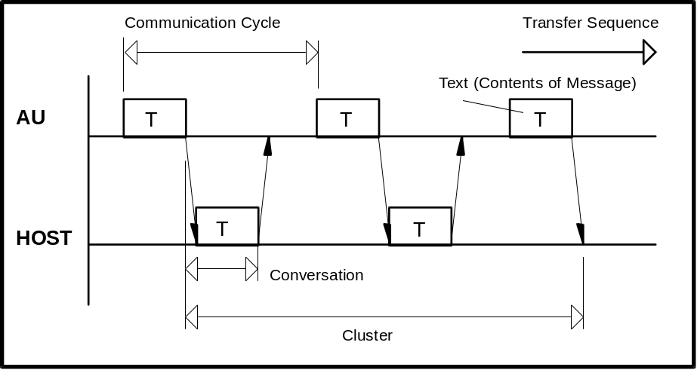
Figure 10: Common communication timing
Conversation One message sent from the HOST or the AU
Communication cycle One request from the AU with the corresponding answer
from the HOST
Cluster A group of conversations between the AU and the HOST

30 Response to Information Message
After receiving information, the receiver sends a response or message in its place to inform the sender of the receiver status and the validity of received information.
The format of the various messages is described above. When the 256-byte mode is selected for the transferred byte count, the analytical data text may exceed 256 bytes (including start-of-data code and end-of-data code) according to the sample. In this case, the frame character identifies the number of transmission which is sent in the text.
The AU continues replying as far as the HOST returns a response. Even when the text, corresponding to an optional frame character is transferred and there is no more data to be sent between the AU and HOST, they continue sending the ANY frame and MOR frame respectively. However, the cluster is restarted immediately if analytical data transfer, test selection directive or any other transfer is requested.
After sending a text, the HOST should avoid sending until reception of a response or request to/for the next in a normal condition. Otherwise the AU will output an alarm.
If no response is returned or an invalid response is received, the recovery procedure is executed. In case of sending from the HOST, the HOST must always be kept ready for receiving the response.
Described below are the typical procedure for returning a response to the information message and the procedure upon receiving the response.

31 No Information to be sent
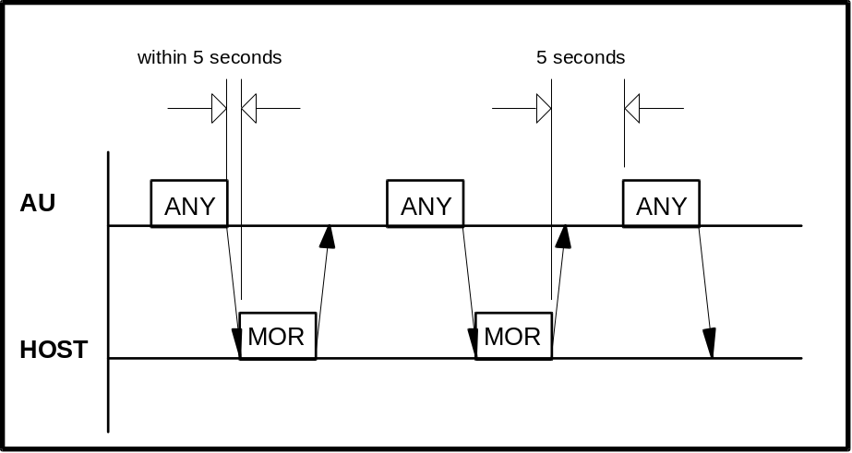
Figure 11: Communication timing without information exchange

The AU continues returning the ANY frame in response to the MOR frame from the HOST. This procedure continues even when the AU and HOST have no information to be sent. Following conditions must be satisfied:
a) There is no test selection information to be sent to the HOST.
b) Analytical data is not output in the real time mode.
c) There is no request for the RES frame.
d) Specification through the screen is not made.
In this case, the AU sends the ANY frame in the lapse of five seconds after receiving the MOR frame from the HOST (a point when the final end-of-data code is recognized).
After receiving from the AU, the HOST should return a response as soon as possible within the following 5 seconds.

32 Transfer of Communication Control Message
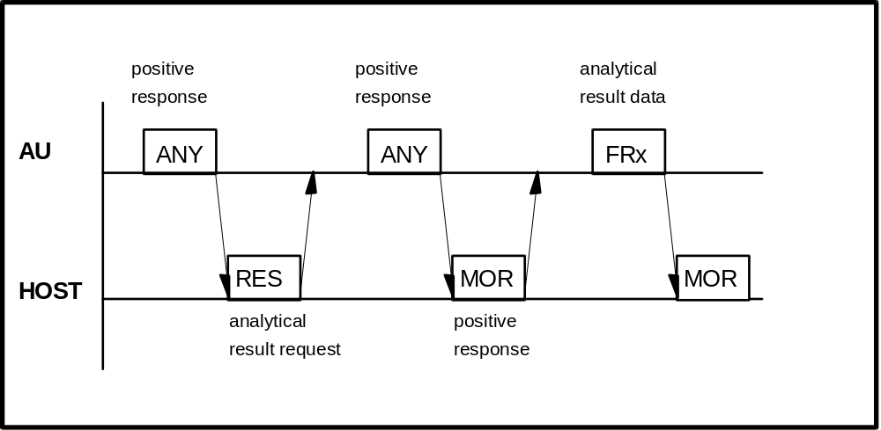
Figure 12: Transfer of communication control message

The RES, ANY, MOR, REP frames are available for the communication control message.
For details, refer to the Frame types in Table 4 and Table 5.

33 Transfer of Test Selection Information

(a) Test selection directive from the HOST to the AU
Usually the HOST will send test selections in advance of the sample's arrival on the analyzer. The HOST can send the test selection packet in response to the ANY frame from the AU.

(b) Test selection inquiry from the AU to the HOST
If the test selection is not sent by the HOST, the AU can ask for specific test selections from the HOST. The test selection inquiries are sent to the HOST when samples are ready for processing and no test selections are available at the AU. This case is shown in Figure 13.
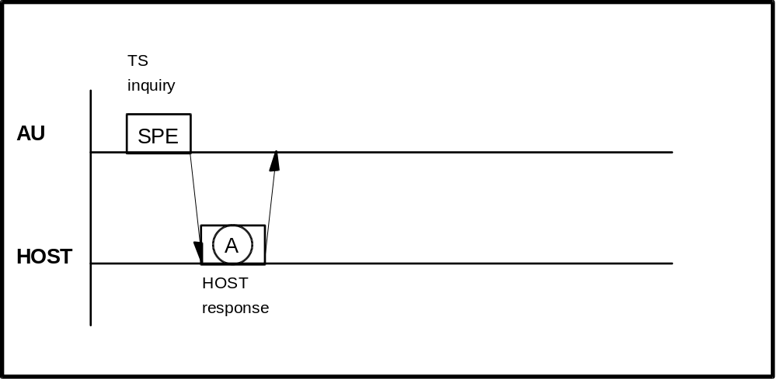
Figure 13: Test selection inquiry
The possible HOST responses to the specific test selection inquiry are listed in Table 21.

Frame A | Description
SPE | Respond with test selection for the sample requested. If the test selection is received correctly and in time, then this test selection will be used for the sample. If the test selection is not received, then the Default test selection will be used if one has been configured by the operator. If no Default test selection has been configured, then no tests will be selected.
MOR | The HOST indicates that it cannot respond to test selection information inquiry but is ready to receive analytical data.  In this case the alarm message 'T/S Availability Error' is displayed on the screen.
Table 21: HOST response to test selection inquiry

34 Transfer of Result Data

(a) Result request with the RES frame from the HOST to the AU
The HOST can make a request to the AU for the analytical data of a specific sample by use of the RES frame. The request could be for results which have not been received yet or for results which the AU has already sent.
The AU will respond with the ANY frame, to indicate that the request was received. The result will be returned to the HOST. If the AU cannot find the requested sample's result, no response will be given to the HOST to indicate this. The request was accepted by the AU, but this does not mean that the result is available to the AU.
The AU will store up to ten requests in an internal buffer. This buffer is periodically checked by the AU. The buffer will only hold ten requests, and subsequent requests are ignored. A request slot is cleared when a result is sent. All slots are cleared when the system is reset by switching off/on.
Because of the limit of ten slots, the HOST should be circumspect about using this feature. If requests are made for samples that do not exist, the request will never be fulfilled, and if all slots are used, this feature will become essentially disabled. This feature need not be implemented because the AU sends the result in realtime as soon as possible after completion.

(b) Result transfer from the AU to the HOST
The target is of course, getting results back to the HOST. For this the AU uses result frames.
There are three cases for result-sending:
- Real-time mode; the results are sent as soon as they are available at the AU side. This is the normal way.
- Batch mode; the results are transferred manually by the operator (see the Data Review screen 1-06)
- After result request; this method is described above (see (a)).

Figure 14 shows the result transmission procedure in normal case and in Table 23 the possible HOST responses to result frames are listed.
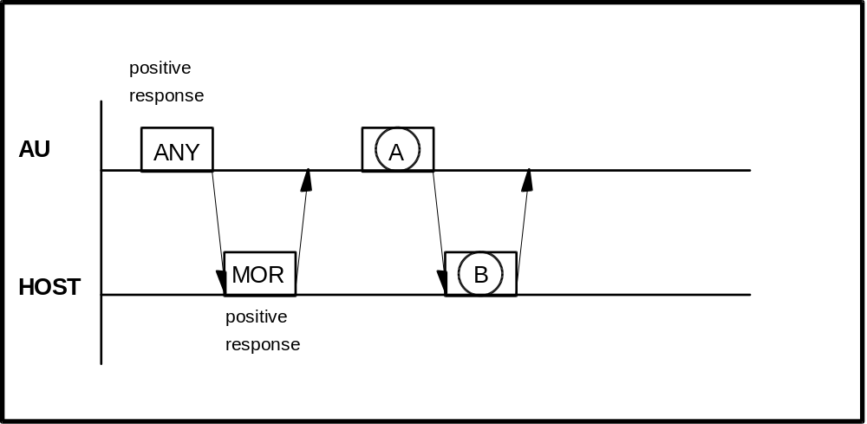
Figure 14: Result transmission

Frame A | Description
FR1 to END | Analytical data (including calibration result and absorbance data in entire reaction monitoring system)
Table 22: AU result frames

Frame B | Description
REP | when text in A is abnormal
MOR | to receive analytical data next time also
SPE | to indicate test selection
RES | to request a specific sample
Table 23: HOST response to FR1/END
Transmission Procedure in Special Case.
Results from a patient's sample can be sent in up to three result frame packets (depending on the number of results and the maximum message length). Each frame requires a MOR from the HOST before the next frame will be sent. Ideally, the AU will try to transfer all packets for a sample without sending any other type of packet. There are instances, such as the analyzer needing test selection information, in which the AU can afford to wait for the current sample's result frames to transfer. One effect of this system is, that there is no delay for SPE frames. This case is shown in Figure 15.
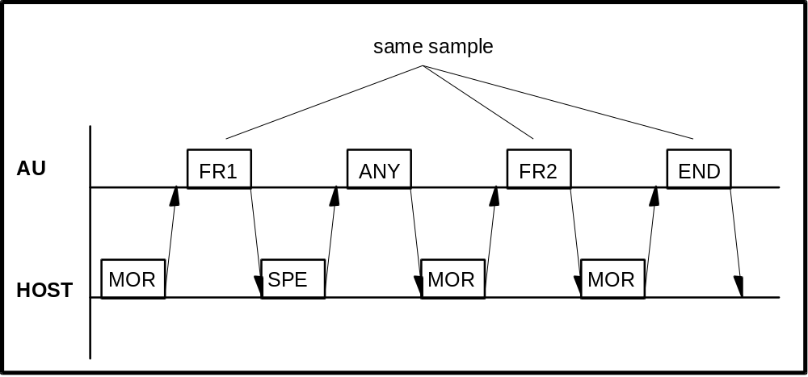
Figure 15: Result transmission with three frames and SPE interrupt

35 Resending Request
If there is any abnormality in the contents of the text received from the AU or the HOST, resending is requested with the REP frame. Figure 16 shows this procedure if the AU sends the REP frame; in Figure 17 the HOST sends the REP frame.
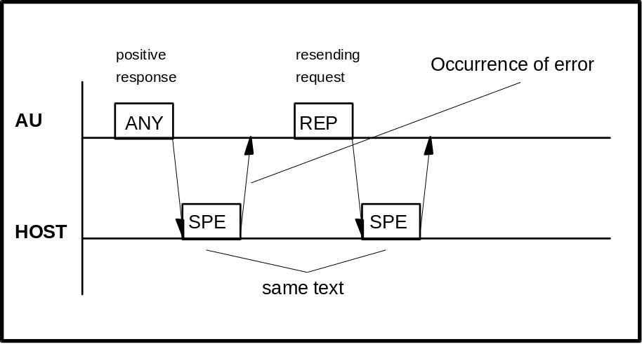
Figure 16: Resending request with REP frame from AU to HOST
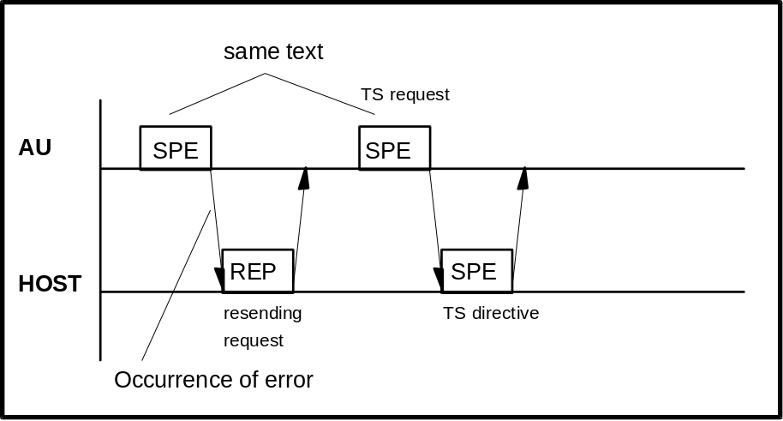
Figure 17: Resending request with REP frame from HOST to AU

36 Termination and Restart of Communication

Condition of Termination | Real-time  Communication | Batch  Communication | Restart of Communication
Specification of (OFF) for  Host Comm. on Start Conditions screen 1-04 | STOP | STOP | Change from (OFF) to (ON) for Host Comm.  Previous contents of com-munication are all canceled.
Occurrence of send/receive time-out error | STOP | STOP | Same as above
Occurrence of hardware error alarm related to communication | STOP | STOP | Same as above
Occurrence of FD read error during sending of analytical data to HOST |  | STOP | Remaining samples in specified range are not sent.  Upon restart, samples in newly specified range are sent.
Stop directive through screen during sending of analytical data to HOST |  | STOP * | Same as above
Occurrence of FD read error during transfer of analytical data for specific sample to HOST |  |  | Relevant sample alone is canceled.
Detection of abnormality in text (BCC error or discrepancy in end-of-data code between AU and HOST for example) |  |  | ----------
Occurrence of E. STOP-Level alarm at AU side |  |  | ----------
Table 24: Termination and Restart of Communication
Note*:
Transfer of analytical data is stopped regardless of sample type (routine, STAT or control sample).
Example: Cancellation during batch transfer of analytical data for the control sample is possible through the Data Review screen 1-06 as well as the Individual QC List screen 2-03.

37 RESULT-ONLY mode
In this mode, analytical data alone is transferred to the HOST and resending request (REP frame) from the AU or HOST or response to specific sample request is not made.
With (YES) specified for RESULT ONLY on the System Parameters screen 4-09 (see Figure 6 on page 10), the AU returns no response to test selection inquiry or test selection directive even when (YES) is specified for the test selection inquiry. The AU waits for two seconds or more after sending ETX in the analytical data text and proceeds to transfer to the HOST regardless of the communication procedure.

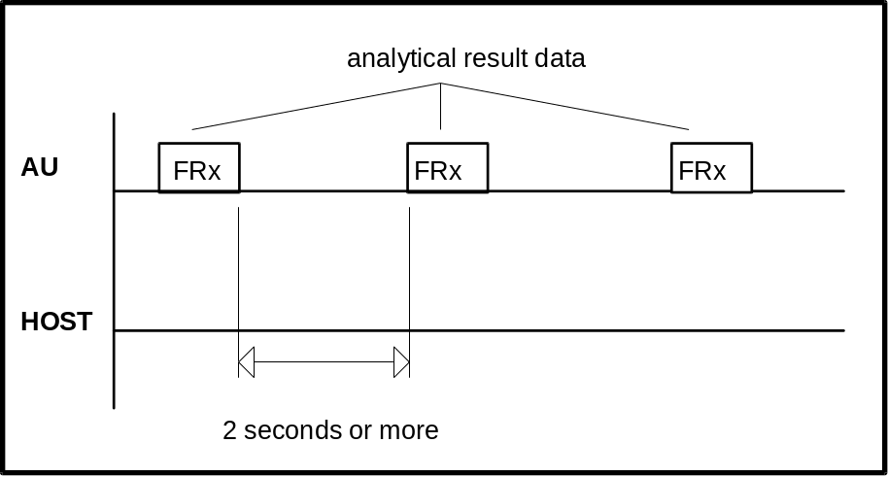
Figure 18: Timing in RESULT ONLY mode

38 Communication Functions

39 Function List for Test Selection Data

Function |  | Inquiry | Directive | Conditions
Routine sample |  |  |  | Invalid when (YES) is specified for RESULT ONLY on Screen 4-09 (see Figure 6)
STAT  sample | with ID |  |  | Valid when (YES) is specified for STAT T/S on Screen 4-09
 | without ID |  |  | Invalid when (YES) is specified for RESULT ONLY
Manual  Rerun  sample | Routine  sample |  |  | Valid when (YES) is specified for RERUN ONLY T/S on Screen 4-09.  Invalid when (YES) is specified for RESULT ONLY
Automatic  Rerun  sample | Routine  sample |  |  | Valid when (YES) is specified for AUTO RERUN T/S on Screen 4-09  Invalid when (YES) is specified for RESULT ONLY
Table 25: Function list for test selection data

40 Function List for Result Data

Function |  | Real-time  Communication | Batch  Communication | Specific  Sample  Request  from HOST | Conditions
Routine sample |  |  |  |  | Specific sample re-quest is invalid when
STAT sample |  |  |  |  | (YES) is specified for  RESULT ONLY
Control sample |  |  |  |  | on Screen 4-09  (see Figure 6)
Automatic/  Manual | Routine  sample
Rerun  sample | STAT  sample
Calibration
Original absorbance |  |  |  |  | Valid when (YES) is specified for ORIGINAL ABS.on Screen 4-09
Table 26: Function list for result data
Comments:
- The above real-time communication indicates a communication carried out while the instrument is busy in analysis, and the batch communication indicates a communication when specified through the screen.
(Note, however, that test selection information inquiry is not specified through the screen and specification through the HOST is accepted.)
- To stop communication between the AU and HOST, change (ON) to (OFF) for Host Communication on the Start Conditions screen 1-04. In this case, however, note that all communication processing is stopped.

41 Communication Trace

42 Overview
The contents of communication between the AU and HOST are stored in the I/O RAM provided with backup battery (hereafter referred to as I/O RAM). To check the contents of communication, the stored data is output onto the printer as a report. This function is selectable on the System Parameters screen 4-09 (see Figure 6).

43 Trace Data
The time of communication execution, the direction of communication and the contents of the message are stored.
The data to be stored differs between the following two cases.
a) In normal communication.
The frame character, function character and sample information (sample no., disk no., position no. and ID no. alone) are stored.
Note, however, that only the frame character and function character are stored for the text which does not contain sample information.
b) Upon Occurrence of any error during communication.
The details of the error and all characters up to occurrence of the error are stored.
Note, however, that only the frame character, function character and sample information (same as in a) above) are stored the same as in normal communication if send time-out occurs during sending from the AU to the system.

44 Reset and Printout of Trace Data
The trace data is printed out and reset with the Host Communication Log function on the Mechanism Check screen 5-02. Not actual trace data but storing pointers and cyclic information are cleared to zero with the reset function.

45 Trace Data Storing Performance

 | Max. Storing Cycle Count  (conversation) | Max. Storage Time  (min)
in normal case | 256 | Approx. 40
if error occurs every cycle | 128 | Approx. 20
Table 27: Trace data storage performance

46 Examples for Traces

Example 1: Test Selection record from HOST to AU
Example 2: Test Selection inquiry from AU to HOST
Example 3: Result data from AU to HOST
Example 4: Absorbance data from AU to HOST
Example 5: Photometry assay Calibration data from AU to HOST
Example 6: ISE Calibration data from AU to HOST
Example 7: Control data from AU to HOST
Example 8: Specific Result Request from HOST to AU

Common explanations for the following HIT911 trace lists:
Format
1st column Sender of text (AU=Analyzer Unit)
2nd column Sending time
3rd column Trace data

Control charcters
Mnemonic meaning ASCII code
[STX] start of text 02H
[ETX] end of text 03H
[CR] carriage return 0DH
[LF] line feed 0AH
^ space 20H
<$..> Block check character

Table 28: Communication trace details
The communication trace was aquired with the Host Interface Testprogram 'HOST911.EXE' (from Technical Productmanagement / Data Technique)

47 Test Selection record from HOST to AU (batchmode)

(Detailed format of first conversation on the next page)

AU 10:23:25 [STX]>[ETX]3E[CR]
HOST 10:23:25 [STX];A^^^^^^^^^^^^^^000042^30310319920833480010001100000000
0000000000000000000000000000001011111Test^1^mit^Identnummer^
^^^^^^^Hugo^^^^^^^^^^^^^^^^^^^^^Arzt^^^^^^^^^^^^^^^^Patient^
1^^^^^^Station^1^[ETX]C4[CR]

AU 10:23:30 [STX]>[ETX]3E[CR]
HOST 10:23:30 [STX];A^^^^^^^^^^^^^^000043^24320319920834480010001100000000
0000000000000000000000000000001011111Test^1^mit^Identnummer^
^^^^^^^Brigitte^^^^^^^^^^^^^^^^^Arzt^^^^^^^^^^^^^^^^Patient^
2^^^^^^Station^1^[ETX]F2[CR]

AU 10:23:36 [STX]>[ETX]3E[CR]
HOST 10:23:36 [STX];A^^^^^^^^^^^^^^000044^66310319920835480010001100000000
0000000000000000000000000000001011111Test^1^mit^Identnummer^
^^^^^^^Opa^Fritz^^^^^^^^^^^^^^^^Arzt^^^^^^^^^^^^^^^^Patient^
3^^^^^^Station^1^[ETX]EF[CR]

AU 10:23:41 [STX]>[ETX]3E[CR]
HOST 10:23:41 [STX];A^^^^^^^^^^^^^^000022^^^^^^^^^^^^^^^480010001100000000
0000000000000000000000000000001011111Test^1^mit^Identnummer^
^^^^^^^Der^Unbekannte^^^^^^^^^^^Arzt^^^^^^^^^^^^^^^^Patient^
4^^^^^^Station^1^[ETX]2B[CR]

AU 10:23:46 [STX]>[ETX]3E[CR]
HOST 10:23:46 [STX];A^^^^^^^^^^^^^^000046^28110319920836480010001100000000
0000000000000000000000000000001011111Test^1^mit^Identnummer^
^^^^^^^Baby^^^^^^^^^^^^^^^^^^^^^Arzt^^^^^^^^^^^^^^^^Patient^
5^^^^^^Station^1^[ETX]BF[CR]

AU 10:23:51 [STX]>[ETX]3E[CR]
HOST 10:23:51 [STX]>[ETX]3E[CR]

.......
Text format of example 1:

Inquiry: Analyzer sends ANY frame.

AU 10:23:25 [STX]>[ETX]3E[CR]
[STX]  >  [ETX]  3E  [CR] | Start of text (ASCII code 02H)  Frame character: ANY inquiry  End of text (ASCII code 03H)  Checksum  Carriage return (ASCII code 0DH)
Answer: HOST sends the next available Test selection to the AU.

HOST 10:23:25 [STX];A^^^^^^^^^^^^^^000042^30310319920833480010001100000000
0000000000000000000000000000001011111Test^1^mit^Identnummer^
^^^^^^^Hugo^^^^^^^^^^^^^^^^^^^^^Arzt^^^^^^^^^^^^^^^^Patient^
1^^^^^^Station^1^[ETX]C4[CR]

[STX]  ;  A  ^  [Sample information]  ^^^  ^  ^^  ^^^^^^^000042  ^303  1  031992  0833  [Test selection information]  48  001000110000000000000000  000000000000000000000010  11111  Test 1 mit Identnummer  Hugo  Arzt  Patient 1  Station 1  [ETX]  C4  [CR] | Start of text (ASCII code 02H)  Frame character: TS inquiry  Function character: Class1 / Routine sample /  Batch communication / Barcode mode  Space  Sample number (3 spaces)  Disk number (space)  Position (2 spaces)  Identnumber  Age 30 = Years  Sex = male  Date = March, 19th 1992  Time = 8:33  Channel count  Test request with normal volume for tests 3,7,  8 and 47.  Comment flags 1 to 5 set  Comment 1 with max. 30 char.  Comment 2 with max. 25 char.  Comment 3 with max. 20 char.  Comment 4 with max. 15 char.  Comment 5 with max. 10 char.  End of text (ASCII code 03H)  Checksum  Carriage return (ASCII code 0DH)

48 Test Selection inquiry from AU to HOST (realtimemode)

(Detailed format of first conversation on the next page)

AU 11:46:36 [STX];A^^^11^1^^^^^^^000042^^^3^0319921147[ETX]4D[CR]
HOST 11:46:37 [STX];A^^^11^1^^^^^^^000042^^^3^0319921147480010001100000000
0000000000000000000000000000001011111Test^1^mit^Identnummer^
^^^^^^^Hugo^^^^^^^^^^^^^^^^^^^^^Arzt^^^^^^^^^^^^^^^^Patient^
1^^^^^^Station^1^[ETX]C2[CR]

AU 11:46:42 [STX];A^^^21^2^^^^^^^000043^^^3^0319921147[ETX]50[CR]
HOST 11:46:42 [STX];A^^^21^2^^^^^^^000043^^^3^0319921147480010001100000000
0000000000000000000000000000001011111Test^1^mit^Identnummer^
^^^^^^^Brigitte^^^^^^^^^^^^^^^^^Arzt^^^^^^^^^^^^^^^^Patient^
2^^^^^^Station^1^[ETX]ED[CR]

AU 11:46:47 [STX]>[ETX]3E[CR]
HOST 11:46:47 [STX]>[ETX]3E[CR]

AU 11:46:53 [STX];A^^^31^3^^^^^^^000044^^^3^0319921147[ETX]53[CR]
HOST 11:46:53 [STX];A^^^31^3^^^^^^^000044^^^3^0319921147480010001100000000
0000000000000000000000000000001011111Test^1^mit^Identnummer^
^^^^^^^Opa^Fritz^^^^^^^^^^^^^^^^Arzt^^^^^^^^^^^^^^^^Patient^
3^^^^^^Station^1^[ETX]E6[CR]

AU 11:46:58 [STX]>[ETX]3E[CR]
HOST 11:46:58 [STX]>[ETX]3E[CR]
Text format of example 2:

Inquiry: Analyzer sends Test selection inquiry.

AU 11:46:36 [STX];A^^^11^1^^^^^^^000042^^^3^0319921147[ETX]4D[CR]

[STX]  ;  A  ^  [Sample information]  ^^1  1  ^1  ^^^^^000042  ^^^3  ^  031992  1147  [ETX]  4D  [CR] | Start of text (ASCII code 02H)  Frame character: TS inquiry  Function character: Class1 / Routine sample /  Realtime communication / Barcode mode  Space  Sample number 1  Disk number 1  Position 1  Identnumber  Age factor = Years  Sex = undefined  Date = March, 19th 1992  Time = 11:47  End of text (ASCII code 03H)  Checksum  Carriage return (ASCII code 0DH)
Answer: If available, the HOST sends the according Test selection to the AU.

HOST 11:46:37 [STX];A^^^11^1^^^^^^^000042^^^3^0319921147480010001100000000
0000000000000000000000000000001011111Test^1^mit^Identnummer^
^^^^^^^Hugo^^^^^^^^^^^^^^^^^^^^^Arzt^^^^^^^^^^^^^^^^Patient^
1^^^^^^Station^1^[ETX]C2[CR]

Format see Example 1

49 Result data from AU to HOST

(Detailed format of first conversation on the next page)

AU 12:05:52 [STX]:A^^^11^1^^^^^^^000042^^^3^0319921147^6^3^^5.10^^7-
^^^^2I^8^^^0.5I47^288.4&48^^5.40^49^^96.8L[ETX]42[CR]
HOST 12:05:53 [STX]>[ETX]3E[CR]

AU 12:05:58 [STX]>[ETX]3E[CR]
HOST 12:05:58 [STX]>[ETX]3E[CR]

...

AU 12:06:28 [STX]>[ETX]3E[CR]
HOST 12:06:28 [STX]>[ETX]3E[CR]

AU 12:06:28 [STX]:A^^^21^2^^^^^^^000043^^^3^0319921147^6^3^^5.01^^7-
^^^^2I^8^^^0.7I47^287.1&48^^5.35^49^^96.8L[ETX]47[CR]
HOST 12:06:29 [STX]>[ETX]3E[CR]

AU 12:06:34 [STX]>[ETX]3E[CR]
HOST 12:06:34 [STX]>[ETX]3E[CR]
Text format of example 3:

Analyzer sends Result data in Realtime mode.

AU 12:05:52 [STX]:A^^^11^1^^^^^^^000042^^^3^0319921147^6^3^^5.10^^7-
^^^^2I^8^^^0.5I47^288.4&48^^5.40^49^^96.8L[ETX]42[CR]

[STX]  :  A  ^  [Sample information]  ^^1  1  ^1  ^^^^^^^000042  ^^^3  ^  031992  1147  [Result data]  ^6  ^3  ^^5.10  ^  ^7  ^^^^^2  I  ^8  ^^^0.5  I  47  ^288.4  &  48  ^^5.40  ^  49  ^^96.8  L  [ETX]  42  [CR] | Start of text (ASCII code 02H)  Frame character: data frame  Function character: Class1 / Routine sample /  Realtime communication / Barcode mode  Space  Sample number 1  Disk number 1  Position 1  Identnumber  Age factor = Years  Sex = undefined  Date = March, 19th 1992  Time = 11:47  Test count (6 results follow)  Test No. 3  value = 5,10  data alarm  Test No. 7  value = 2  data alarm (Reac. limit over at all points)  Test No. 8  value = 0,5  data alarm (Reac. limit over at all points)  Test No. 47  value = 288,4  data alarm (Sample value abnormal)  Test No. 48  value = 5,4  data alarm  Test No. 49  value = 96,8  data alarm (Level error)  End of text (ASCII code 03H)  Checksum  Carriage return (ASCII code 0DH)

50 Absorbance data from AU to HOST

(Detailed format of first conversation on the next page)

AU 12:56:36 [STX]:O^^^11^1^^^^^^^000042^^^3^0319921250^7-^^^^1I^^^^^^^^^
^^^^^^^^^^^^^^^^^^^^^432^^^^^^^^^^^^^^^^^^13^^1341^^^^41^^^^
47^^^648^^3818^^3986^^3985^^3985^^3987^^3988^^3987^^3987^^39
90[ETX]8D[CR]
HOST 12:56:36 [STX]>[ETX]3E[CR]

AU 12:56:41 [STX]>[ETX]3E[CR]
HOST 12:56:41 [STX]>[ETX]3E[CR]

...

AU 12:56:56 [STX]>[ETX]3E[CR]
HOST 12:56:56 [STX]>[ETX]3E[CR]

AU 12:56:57 [STX]:O^^^21^2^^^^^^^000043^^^3^0319921251^7^^^^^0I^^^^^^^^^
^^^^^^^^^^^^^^^^^^^^^400^^^^^^^^^^^^^^^^^^13^^1354^^^^44^^^^
47^^^658^^3866^^4013^^4014^^4013^^4015^^4014^^4014^^4016^^40
14[ETX]04[CR]
HOST 12:56:57 [STX]>[ETX]3E[CR]

AU 12:57:02 [STX]>[ETX]3E[CR]
HOST 12:57:02 [STX]>[ETX]3E[CR]

AU 12:57:07 [STX]>[ETX]3E[CR]
HOST 12:57:07 [STX]>[ETX]3E[CR]

AU 12:57:08 [STX]:O^^^11^1^^^^^^^000042^^^3^0319921250^3^^5.12^^^^^^^^^^
^^^^^^^^^^^^^^^^^^^^^^70^^^^^^^^^^^^^^^^^^15^^^^73^^^^69^^^^
68^^^^67-^^280^^^^45^^^194^^^285^^^348^^^394^^^429^^^459^^^4
81^^^495^^^511[ETX]52[CR]
HOST 12:57:08 [STX]>[ETX]3E[CR]

AU 12:57:13 [STX]>[ETX]3E[CR]
HOST 12:57:13 [STX]>[ETX]3E[CR]

AU 12:57:18 [STX]>[ETX]3E[CR]
HOST 12:57:18 [STX]>[ETX]3E[CR]

AU 12:57:23 [STX]>[ETX]3E[CR]
HOST 12:57:23 [STX]>[ETX]3E[CR]

AU 12:57:24 [STX]:O^^^21^2^^^^^^^000043^^^3^0319921251^3^^5.11^^^^^^^^^^
^^^^^^^^^^^^^^^^^^^^^^51^^^^^^^^^^^^^^^^^^15^^^161^^^^74^^^^
72^^^^69-^^253^^^^53^^^199^^^289^^^349^^^396^^^430^^^459^^^4
80^^^495^^^510[ETX]5C[CR]
HOST 12:57:24 [STX]>[ETX]3E[CR]

Text format of example 4:

Analyzer sends Absorbance data in realtime mode.

AU 12:56:36 [STX]:O^^^11^1^^^^^^^000042^^^3^0319921250^7-^^^^1I^^^^^^^^^
^^^^^^^^^^^^^^^^^^^^^432^^^^^^^^^^^^^^^^^^13^^1341^^^^41^^^^
47^^^648^^3818^^3986^^3985^^3985^^3987^^3988^^3987^^3987^^39
90[ETX]8D[CR]

[STX]  :  O  ^  [Sample information]  ^^1  1  ^1  ^^^^^^^000042  ^^^3  ^  031992  1250  [Analytical data 1 to 4]  ^7  -^^^^1  I  ^^  ^^^^^^  ^  ^^  ^^^^^^  ^  ^^  ^^^^^^  ^  [Blank values 1 to 4]  ^^^432  ^^^^^^  ^^^^^^  ^^^^^^  [Absorbance values]  13  ^^1341  ^^^^41  ^^^^47  ^^^648  ^^3818  ^^3986  ^^3985  ^^3985  ^^3987  ^^3988  ^^3987  ^^3987  ^^3990  [ETX]  8D  [CR] | Start of text (ASCII code 02H)  Frame character: data frame  Function character: Class1 / Routine sample /  Realtime communication / Barcode mode  Space  Sample number 1  Disk number 1  Position 1  Identnumber  Age factor = Years  Sex = undefined  Date = March, 19th 1992  Time = 12:50  Channel No.  value = -1  data alarm (React. limit over at all points)  Channel No.  no value  data alarm  Channel No.  no value  data alarm  Channel No.  no value  data alarm  Stopped cell blank 1  Passed cell blank 1  Passed cell blank 2  Passed cell blank 3  Point count = 13  Abs. data 1  Abs. data 2  Abs. data 3  Abs. data 4  Abs. data 5  Abs. data 6  Abs. data 7  Abs. data 8  Abs. data 9  Abs. data 10  Abs. data 11  Abs. data 12  Abs. data 13  End of text (ASCII code 03H)  Checksum  Carriage return (ASCII code 0DH)

51 Photometry-assay Calibration data from AU to HOST

(Detailed format of first conversation on the next page)

AU 11:59:18 [STX]:M^42S1-^^111^^6406-^^102^^6345I^^^^^^2-^^102^^6201-^^102
^^6284I^^^^^^N^^^^^^^[ETX]42[CR]
HOST 11:59:19 [STX]>[ETX]3E[CR]

AU 11:59:24 [STX]:M192S1^^^^^1^^^106^^^^^0^^^101^^^^^^^2^^^^21^^^724-^^^^2
^^^105V^^^^^^N^^^^^^^[ETX]3C[CR]
HOST 11:59:24 [STX]>[ETX]3E[CR]

AU 11:59:29 [STX]>[ETX]3E[CR]
HOST 11:59:29 [STX]>[ETX]3E[CR]

AU 11:59:34 [STX]>[ETX]3E[CR]
HOST 11:59:34 [STX]>[ETX]3E[CR]

AU 11:59:39 [STX]>[ETX]3E[CR]
HOST 11:59:39 [STX]>[ETX]3E[CR]

AU 11:59:39 [STX]:M^71S1^^^^^3^^3605^^^^^0^^3634I^^^^^^N^^^^^^^[ETX]8B[CR]
HOST 11:59:40 [STX]>[ETX]3E[CR]

AU 11:59:45 [STX]>[ETX]3E[CR]
HOST 11:59:45 [STX]>[ETX]3E[CR]

...

AU 12:01:30 [STX]>[ETX]3E[CR]
HOST 12:01:30 [STX]>[ETX]3E[CR]

AU 12:01:30 [STX]:M^81S1^^^^^0^^5403^^^^15^^5427I^^^^^^N^^^^^^^[ETX]9F[CR]
HOST 12:01:30 [STX]>[ETX]3E[CR]
Text format of example 5:

Analyzer sends Photometry assay Calibration data to the HOST.

AU 11:59:18 [STX]:M^42S1-^^111^^6406-^^102^^6345I^^^^^^2-^^102^^6201
-^^102^^6284I^^^^^^N^^^^^^^[ETX]42[CR]

[STX]  :  M  ^4  2  S  1  -^^111  ^^6406  -^^102  ^^6345  I  ^^^^^^  2  -^^102  ^^6201  -^^102  ^^6284  I  ^^^^^^  N  ^^^^^^  ^  [ETX]  42  [CR] | Start of text (ASCII code 02H)  Frame character: data frame  Function character: Photom. cal data  Channel 4  No. of standards  Calibration alarm  STD No. 1  1st absorbance data  1st initial absorbance data  2nd absorbance data  2nd initial absorbance data  data alarm  Prozone value  STD No. 2  1st absorbance data  1st initial absorbance data  2nd absorbance data  2nd initial absorbance data  data alarm  Prozone value  N for 'no SD value'  value  decimal point position  End of text (ASCII code 03H)  Checksum  Carriage return (ASCII code 0DH)

52 ISE Calibration data from AU to HOST

AU 11:51:25 [STX]:NB^^^1-^32.8^^2-^38.7^^3-^32.2^^4-^35.8^^5^^52.0^^6^15
6.0^^7^136.6^^8^^^7.4^^^1-^33.5^^2-^49.7^^3-^30.7^^4-^41.0^^
5^^51.6^^6^^6.20^^7^^4.43^^8^^0.27^S^1-343.0L^2-343.0^^3-343
.0^^4-^76.1L^5^^^^^^E^6^^^^^^D^7^^^^^^X^8^^^^^^^[ETX]DC[CR]
HOST 11:51:25 [STX]>[ETX]3E[CR]

AU 11:51:30 [STX]>[ETX]3E[CR]
HOST 11:51:30 [STX]>[ETX]3E[CR]

...

Text format of example 6:

Analyzer sends ISE Calibration data to the HOST.

AU 11:51:25 [STX]:NB^^^1-^32.8^^2-^38.7^^3-^32.2^^4-^35.8^^5^^52.0^^6^15
6.0^^7^136.6^^8^^^7.4^^^1-^33.5^^2-^49.7^^3-^30.7^^4-^41.0^^
5^^51.6^^6^^6.20^^7^^4.43^^8^^0.27^S^1-343.0L^2-343.0^^3-343
.0^^4-^76.1L^5^^^^^^E^6^^^^^^D^7^^^^^^X^8^^^^^^^[ETX]DC[CR]
[STX]  :  N  B  ^  ^  ^1  -^32.8  ^  ^2  -^38.7  ^  ^3  -^32.2  ^  ^4  -^35.8  ^  ^5  ^^52.0  ^  ^6  ^156.0  ^  ^7  ^136.6  ^  ^8  ^^^7.4  ^ | Start of text (ASCII code 02H)  Frame character: data frame  Function character: ISE cal data  Typ B = Tests Na, K, Cl  Space  Na data alarm  Cal. data 1  value = -32,8  data alarm 1  Cal. data 2  value = -38,7  data alarm 2  Cal. data 3  value = -32,2  data alarm 3  Cal. data 4  value = -35,8  data alarm 4  Cal. data 5  value = 52,0  data alarm 5  Cal. data 6  value = 156,0  data alarm 6  Cal. data 7  value = 136,6  data alarm 7  Cal. data 8  value = 7,4  data alarm 8

^  ^1  -^33.5  ^  ^2  -^49.7  ^  ^3  -^30.7  ^  ^4  -^41.0  ^  ^5  ^^51.6  ^  ^6  ^^6.20  ^  ^7  ^^4.43  ^  ^8  ^^0.27  ^ | K data alarm  Cal. data 1  value = -33,5  data alarm 1  Cal. data 2  value = -49,7  data alarm 2  Cal. data 3  value = -30,7  data alarm 3  Cal. data 4  value = -41,0  data alarm 4  Cal. data 5  value = 51,6  data alarm 5  Cal. data 6  value = 6,2  data alarm 6  Cal. data 7  value = 4,43  data alarm 7  Cal. data 8  value = 0,27  data alarm 8
S  ^1  -343.0  L  ^2  -343.0  ^  ^3  -343.0  ^  ^4  -^76.1  L  ^5  ^^^^^^  E  ^6  ^^^^^^  D  ^7  ^^^^^^  X  ^8  ^^^^^^  ^  [ETX]  DC  [CR] | Cl data alarm (STD error)  Cal. data 1  value = -343,0  data alarm 1 (Level error)  Cal. data 2  value = -343,0  data alarm 2  Cal. data 3  value = -343,0  data alarm 3  Cal. data 4  value = -76,1  data alarm 4 (Level error)  Cal. data 5  no value  data alarm 5 (Slope abnormal)  Cal. data 6  no value  data alarm 6 (Int. std. concentr. abnormal)  Cal. data 7  no value  data alarm 7 (Calculation disable)  Cal. data 8  no value  data alarm 8  End of text (ASCII code 03H)  Checksum  Carriage return (ASCII code 0DH)

53 Control data from AU to HOST

AU 13:44:55 [STX]:K^101^^^^^^^^PNU^^^^^^^^^^^^^^^^^^^^^1^8^^^0.5I[ETX]8F[CR]
HOST 13:44:55 [STX]>[ETX]3E[CR]

AU 13:45:05 [STX]:K^201^^^^^^^^PNP^^^^^^^^^^^^^^^^^^^^^1^8^^^0.2I[ETX]88[CR]
HOST 13:45:05 [STX]>[ETX]3E[CR]

AU 13:45:07 [STX]:K^102^^^^^^^^PNU^^^^^^^^^^^^^^^^^^^^^1^3^^5.08^[ETX]7A[CR]
HOST 13:45:08 [STX]>[ETX]3E[CR]

AU 13:45:10 [STX]:K^202^^^^^^^^PNP^^^^^^^^^^^^^^^^^^^^^1^3^^4.43^[ETX]74[CR]
HOST 13:45:10 [STX]>[ETX]3E[CR]
Text format of example 7:

Analyzer sends Control data to the HOST.

AU 13:44:55 [STX]:K^101^^^^^^^^PNU^^^^^^^^^^^^^^^^^^^^^1^8^^^0.5I[ETX]
8F[CR]

[STX]  :  K  ^  [Sample Information]  1  01  ^  ^^  ^^^^^PNU^^^^^  ^^^^  ^  ^^^^^^  ^^^^  [Result data]  ^1  ^8  ^^^0.5  I  [ETX]  8F  [CR] | Start of text (ASCII code 02H)  Frame character: data frame  Function character: Control sample  Space  Control No. 1  Sequence No. 1  Disk No (space)  Position (2 spaces)  Control name  Age (4 spaces)  Sex (space)  Date (6 spaces)  Time (4 spaces)  Test count (one result follows)  Test No. 8  value = 0,5  data alarm (Reac. limit over at all points)  End of text (ASCII code 03H)  Checksum  Carriage return (ASCII code 0DH)

54 Specific Result Request from HOST to AU

Manuell communication Starttime: 12:13:05

AU 12:13:20 [STX]>[ETX]
HOST 12:13:20 [STX]>[ETX]

AU 12:13:25 [STX]>[ETX]
HOST 12:13:25 [STX]>[ETX]

AU 12:13:30 [STX]>[ETX]
HOST 12:13:30 [STX]<a^^^^^^^^^^^^^^000043^^^^^^^^^^^^^^^[ETX]64[CR]

AU 12:13:31 [STX]>[ETX]
HOST 12:13:31 [STX]>[ETX]

AU 12:13:32 [STX]>[ETX]
HOST 12:13:32 [STX]>[ETX]

AU 12:13:33 [STX]>[ETX]
HOST 12:13:33 [STX]>[ETX]

AU 12:13:34 [STX]>[ETX]
HOST 12:13:34 [STX]>[ETX]

AU 12:13:35 [STX]>[ETX]
HOST 12:13:35 [STX]>[ETX]

AU 12:13:36 [STX]:a^^^20^2^^^^^^^000043^15310410920955^1^7-^^^^4I[ET
X]75[CR]
HOST 12:13:36 [STX]>[ETX]

AU 12:13:41 [STX]>[ETX]
HOST 12:13:41 [STX]>[ETX]

AU 12:13:46 [STX]>[ETX]
HOST 12:13:46 [STX]>[ETX]

.......

Text format of example 8:

HOST sends specific result request / AU sends the result

HOST 12:13:30 [STX]<a^^^^^^^^^^^^^^000043^^^^^^^^^^^^^^^[ETX]64[CR]

[STX]  <  a  ^  [Sample Information]  ^^^  ^  ^^  ^^^^^^^000043  ^^^^  ^  ^^^^^^  ^^^^  [ETX]  64  [CR] | Start of text (ASCII code 02H)  Frame character: Result Request  Function character: Class1 / Routine sample /  Batchmode / Barcode mode  Space  Sample No. undefined  Disk No undefined  Position No undefined  Ident No.  Age undefined  Sex undefined  Date undefined  Time undefined  End of text (ASCII code 03H)  Checksum  Carriage return (ASCII code 0DH)

55 Figures and Tables
Figure 1: HIT 911 Interface Data Flow
Figure 2: Cable Recommendation from Hitachi
Figure 3: Connection without hardware handshake
Figure 4: ADC-SIF Dip Switch 3 setting for RS232-C
Figure 5: ADC-SIF Dip Switch 3 setting for current loop
Figure 6: System Parameters screen 4-09 / part 1
Figure 7: System Parameters screen 4-09 / part 2
Figure 8: Test selection download in batch mode
Figure 9: Test selection download in realtime mode
Figure 10: Common communication timing
Figure 11: Communication timing without information exchange
Figure 12: Transfer of communication control message
Figure 13: Test selection inquiry
Figure 14: Result transmission
Figure 15: Result transmission with three frames and SPE interrupt
Figure 16: Resending request with REP frame from AU to HOST
Figure 17: Resending request with REP frame from HOST to AU
Figure 18: Timing in RESULT ONLY mode

Table 1: Pin Description for the 25-pin plug of the Model 911
Table 2: Signal discrimination
Table 3: Parameters not to be adjusted
Table 4: Frame types having a Data Field
Table 5: Frame types having no data field
Table 6: Frame priorities
Table 7: Function characters
Table 8: Sample Container Selection
Table 9: Format of Sample Information / b = space (20H)
Table 10: Format of Test Selection Information / b = space (20H)
Table 11: Format of result data / b = space (20H)
Table 12: Format of measured value / b = space (20H)
Table 13: No. of test results per frame according to the text size.
Table 14: Format of Absorbance Data
Table 15: No. of absorbance values per frame according to the text size.
Table 16: Format of Photometry-assay Calib. Data / b = space (20H)
Table 17: Format of ISE Calibration Data / b = space (20H)
Table 18: Data alarm list (part 1)
Table 19: Data alarm list (part 2)
Table 20: End-of-data codes
Table 21: HOST response to test selection inquiry
Table 22: AU result frames
Table 23: HOST response to FR1/END
Table 24: Termination and Restart of Communication
Table 25: Function list for test selection data
Table 26: Function list for result data
Table 27: Trace data storage performance
Table 28: Communication trace details

Appendix A - ASCII Chart

Char  Hex Dez | Char  Hex Dez | Char  Hex Dez | Char  Hex Dez | Char  Hex Dez | Char  Hex Dez | Char  Hex Dez | Char  Hex Dez
NUL  00 0 | DLE  10 16 | Space  20 32 | 0  30 48 | @  40 64 | P  50 80 | `  60 96 | p  70 112
SOH  01 1 | DC1  11 17 | !  21 33 | 1  31 49 | A  41 65 | Q  51 81 | a  61 97 | q  71 113
STX  02 2 | DC2  12 18 | "  22 34 | 2  32 50 | B  42 66 | R  52 82 | b  62 98 | r  72 114
ETX  03 3 | DC3  13 19 | #  23 35 | 3  33 51 | C  43 67 | S  53 83 | c  63 99 | s  73 115
EOT  04 4 | DC4  14 20 | $  24 36 | 4  34 52 | D  44 68 | T  54 84 | d  64 100 | t  74 116
ENQ  05 5 | NAK  15 21 | %  25 37 | 5  35 53 | E  45 69 | U  55 85 | e  65 101 | u  75 117
ACK  06 6 | SYN  16 22 | &  26 38 | 6  36 54 | F  46 70 | V  56 86 | f  66 102 | v  76 118
BEL  07 7 | ETB  17 23 | '  27 39 | 7  37 55 | G  47 71 | W  57 87 | g  67 103 | w  77 119
BS  08 8 | CAN  18 24 | (  28 40 | 8  38 56 | H  48 72 | X  58 88 | h  68 104 | x  78 120
HT  09 9 | EM  19 25 | )  29 41 | 9  39 57 | I  49 73 | Y  59 89 | i  69 105 | y  79 121
LF  0A 10 | SUB  1A 26 | *  2A 42 | :  3A 58 | J  4A 74 | Z  5A 90 | j  6A 106 | z  7A 122
VT  0B 11 | ESC  1B 27 | +  2B 43 | ;  3B 59 | K  4B 75 | [  5B 91 | k  6B 107 | {  7B 123
FF  0C 12 | FS  1C 28 | ,  2C 44 | <  3C 60 | L  4C 76 | \  5C 92 | l  6C 108 | |  7C 124
CR  0D 13 | GS  1D 29 | -  2D 45 | =  3D 61 | M  4D 77 | ]  5D 93 | m  6D 109 | }  7D 125
SO  0E 14 | RS  1E 30 | .  2E 46 | >  3E 62 | N  4E 78 | ^  5E 94 | n  6E 110 | ~  7E 126
SI  0F 15 | US  1F 31 | /  2F 47 | ?  3F 63 | O  4F 79 | _  5F 95 | o  6F 111 | DEL  7F 127

Appendix B - Differences between the HIT 747 and 911

Item | HIT 747 | HIT 911
Cable connection | No handshake connection necessary | Pins DSR, DCD, DTR have to be connected on analyser side
Communication status after CU power off/on while host communication on | Communication still ON;  CU starts with REP frame | Communication ON if system parameters were stored
Communication cycle time | 3 sec | 5 sec
Delay after receiving REC/SUS frame from Host | 8 sec | no effect
Delay of ANY frame from analyser after receiving a test selection in batch mode | ~0 | 5 sec
Frame types | OPC and SPM frames available | No OPC and SPM frames
End-of-data type | Only one fixed type: [ETX]<CKSH><CKSL>[CR] | One of five options selectable on system parameters screen  1. [ETX] <BCC>  2. [CR] [LF] [ETX]  3. [ETX]  4. [ETX] [CR] [LF]  5. [ETX]<CKSH><CKSL>[CR]
Result transmission of calculated tests | Results of calculated tests are sent with the test counts 53 to 60 | Results of calculated tests are not sent to the host
Transmission of test assignment information | The TNNA array contains the 60 names for the 60 tests.  It is sent when program is started or testnames are changed or testcode to channel relation is changed by operator.  The TCA array contains up to 4 test codes for each of the 32 channels.  It is sent when program is started or testcode to channel relation is changed by the operator. | No transmission of test assignment information
Data alarm characters | different - refer to the corresponding interface manual
Function characters | different - refer to the corresponding interface manual

Item | HIT 747 | HIT 911
Identification of transmission mode for result transmission | seperate character following the function character instead of space:  realtime transmission A  batch transmission B  high priority transm. C | transmission mode information is included in function character
Format of sample information | different - refer to the corresponding interface manual
Format of test selection information | different - refer to the corresponding interface manual
Test request values for rerun samples | reduced volume 2  analyser decided vol 3 | reduced volume 2  increased volume 3  analyser decided vol 4
Format of ISE calibration results | different - refer to the corresponding interface manual
Format of photometry-assay calibration results | different - refer to the corresponding interface manual

Appendix C - Tabel of System I/F Alarms (Category 111)

Sub code | Description | Possible cause | Comm.  stopped
1 | The text cannot be received from the Host within the specified period of time | (HOST > 911)  timeout error | X
2 | The data cannot be transmitted to the system within the specified period of time | (911 > HOST)  timeout error | X
3 | Communication is attempted when the buffered controller has not been initialized properly. |  | X
4 | A command cannot be issued to the buffered controller. |  | X
5 | The end-of-command interrupt is not returned from the buffered controller. |  | X
6 | An illegal command or invalid data has been written to the buffered controller. |  | X
7 | An error has occured in accessing the FIFO buffer (buffered controller) |  | X
8 | The serial interface LSI circuit of the buffered controller is defective. |  | X
9 | An illegal interrupt has been attempted from the buffered controller. |  | X
10 | In response to frame-by-frame transmission request from the analyser, REP frames have been transmitted from the Host in succession beyond the specified limit. |  | X
11 | An illegal character has been found in the received text. | (HOST > 911)  character error
12 | The character count between STX and ETX in the received text is out of the predetermined allowable range. | (HOST > 911)  format error
13 | The transmission protocol procedure has been ignored in text transmission from the Host. | (HOST > 911)  format error
14 | A vertical parity error has been found in the received data. | (HOST > 911)  receiving error
15 | An overrun error has been found in the received data. | (HOST > 911)  receiving error
16 | A framing error has been found in the received data. | (HOST > 911)  receiving error
17 | The BCC value of the received text does not agree with the counted by the analyser. | (HOST > 911)  BCC error
18 | The check sum value of the received text does not agree with the counted by the analyzer. | (HOST > 911)  check sum error

Appendix D - Text Configuration Table
The columns and rows of the following tables have the following contents:

Frame type | Frame |  | Frame items
Sender | bytes |  | Item length in bytes

Positive response | ANY |  | STX | > | End-of-data code
CU | 9 |  | 1 | 1 | 1 to 4

Positive response | MOR |  | STX | > | End-of-data code
Host | 2+end |  | 1 | 1 | 1 to 4

Negative response | REP |  | STX | ? | End-of-data code
CU / Host | 2+end |  | 1 | 1 | 1 to 4

Bad and suspend | SUS |  | STX | @ | End-of-data code
CU / Host | 2+end |  | 1 | 1 | 1 to 4

Ok and suspend | REC |  | STX | A | End-of-data code
Host | 2+end |  | 1 | 1 | 1 to 4

TS Request | SPE |  | STX | ; | Fu | Sample Information | End-of-data code
CU | 38+end |  | 1 | 1 | 2 | 34 | 1 to 4

Result Request | RES |  | STX | < | Fu | Sample Information | End-of-data code
Host | 38+end |  | 1 | 1 | 2 | 34 | 1 to 4

Test selection | SPE |  | STX | ; | Fu | Sample Information | Channel  Count | Test selection | Comments | End-of-data code
Host | 193+end |  | 1 | 1 | 2 | 34 | 2 | 48 | 105 | 1 to 4

Analytical data | FR1 to END |  | STX | : | Fu | Sample Information | Channel count | Analytical data  1 to 52 | End-of-data code
AU | 508+end |  | 1 | 1 | 2 | 34 | 2 | 468 | 1 to 4

Absorbance data | FR1 to END |  | STX | : | Fu | Sample Information | Analytical data 1 to 4 | Blank data 1 to 4 | Point count | ABS values  1 to 49 | End-of-data code
AU | 394+end |  | 1 | 1 | 2 | 34 | 36 | 24 | 2 | 294 | 1 to 4

Photometry assay Calib | END |  | STX | : | M | Test no. | STD count | Calib alarm | STD data  1 to 6 | SD value | End-of-data code
AU | 207+end |  | 1 | 1 | 1 | 2 | 1 | 1 | 192 | 8 | 1 to 4

ISE Calib | END |  | STX | : | N | ISE type | ISE calibration data  1 to 3 | ETX | CSH | CSL | CR
AU | 224+end |  | 1 | 1 | 2 | 1 | 219 | 1 | 1 | 1 | 1

The above tables show the text configuration when the maximum text length is set to 512 bytes.
For details about the format of the data items refer to the corresponding chapter in this document.

