Boehringer Mannheim GmbH
BM/HITACHI 917 Automatic Analyzer
Host Interface Manual

System Interface - Functional Specifications
Including features of the BM/Hitachi 917 Version 2
and Appendix for BM/Hitachi 917 Rack Version
BM / ID.No. 1804928-001

Document Version 2.1

1. Introduction
2. Interface Setup
2.1. Connection Cable
2.2. Pin Description
2.3. Specification of Communication
2.4. Setup of Communication Parameters
3. Basic Workflow
4. Software Protocol
4.1. Common text format
4.2. Start-of-data Code
4.3. Frame Identification
4.3.1. Host Identification
4.3.2. Instrument Identification
4.3.3. Packet Number
4.3.4. Frame Character
4.4. Data Field
4.4.1. Function Characters
4.4.2. Composition of Sample Information
4.4.3. Composition of Test Selection Information
4.4.4. Composition of Comment Information
4.4.5. Composition of Result Data for Routine, Rerun, STAT and Control samples
4.4.6. Absorbance Data
4.4.7. Photometry-assay Calibration Data
4.4.8. ISE Calibration Data
4.4.9. Channel Assignment Information
4.4.10. Data Alarm List
4.5. End-of-data Code
5. Data Transmission Control Procedure
5.1. Establishment of Data Link
5.2. Response to Information Message
5.2.1. No Information to be sent
5.2.2. Transfer of Communication Control Message
5.2.3. Transfer of Test Selection Information
5.2.4. Transfer of Result Data
5.2.5. Resending Request
5.3. Termination and Restart of Communication
5.4. Retry and Repeat of Communication
5.5. RESULT-ONLY mode
6. Communication Functions
6.1. Function List for Test Selection Data
6.2. Function List for Result Data
6.3. Function List for Analyzer Information Transfer
7. Communication Trace
7.1. Overview
7.2. Trace Data
7.3. Reset and Printout of Trace Data
7.4. Trace Data Storing Performance
8. Example Traces
8.1. Test Selection inquiry from CU to host incl. Result
8.2. Absorbance data from CU to host
8.3. Photometry-assay Calibration data from CU to host
8.4. ISE Calibration data from CU to host
8.5. Control data from CU to host
8.6. Specific Result Request from host to CU
8.7. Channel Assignment Information from host to CU
9. Figures and Tables
Appendix A - ASCII Chart
Appendix B - Differences between HITACHI 911 and 917
Appendix C - Differences between V2 Disk and Rack Version
Appendix D - Error Check Functions
Appendix E - Table of Communication Errors
Appendix F - Text Configuration Table

1 Introduction
This manual provides the specifications for bidirectional data transmission between an HITACHI Model 917 Automatic Analyzer by Boehringer Mannheim GmbH and an external laboratory host system via asynchronous serial connection. The hardware components required as well as the communication rules are described. They highlight the general considerations to be taken into account in any approach to realize the data communication between different computer systems.
This specification illustrates the fundamental considerations for the host link and contains information concerning the following:
– Hardware
• What interface hardware is required?
• How is the physical connection established?
– Use and control of the data transmission
• How to set the transfer and communication parameters?
• What is the formal structure of the strings and values to be transmitted and what influence can be taken on it?
• What kind of data or variables can be transmitted?
• How and by which system is the data transfer initiated?
– Software protocol
• What does the transmission protocol used for communication between the two systems look like?
• What does the host at the other end of the data link do and what rules has the program at the host link to follow?
Working with the host interface you will find that the data transfer from the host computer to the HITACHI Model 917 Automatic Analyzer can be done in a very easy, comfortable and reliable way.
If problems with the installation or questions about the transfer should arise please contact the responsible person of Boehringer Mannheim Service Department or directly the Service Management of the Central Marketing Department of Boehringer Mannheim GmbH (Germany):
Boehringer Mannheim GmbH
Technical Productmanagement
Data Technique
Sandhofer Straße 116
D-68305 Mannheim
Phone: (49) 621 / 759-2464
Telefax: (49) 621 / 759-4591
Figure 1 gives an general idea of the 917 interface data flow between the analyzer, the control unit (CU) and the host system. More detailed description will be found in this document.

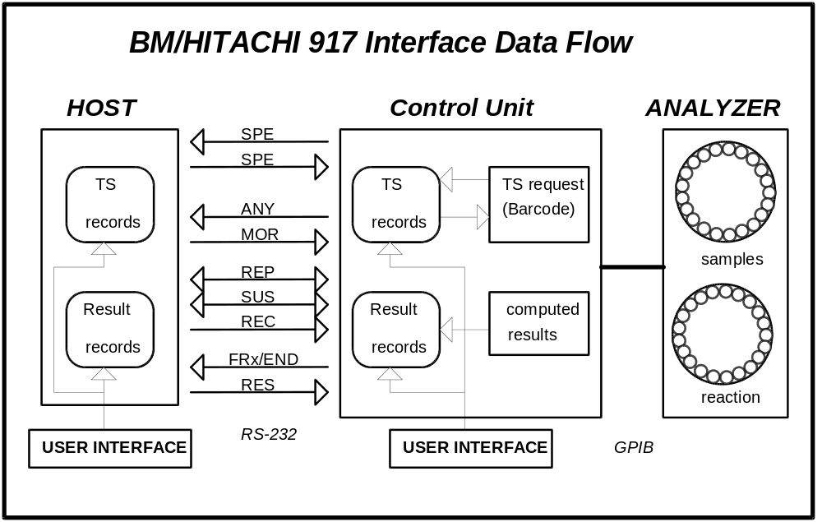
Figure 1: BM/HITACHI 917 Interface data flow
(1) Realtime test selection request is made for:
- Routine samples, if the record is not existing or the test selection is zero.
- Rerun/Autorerun samples, if inquiry is enabled (Host Setting screen)
- STAT samples, if inquiry is enabled (Host Setting screen) and bar code reader is on.
(2) Realtime result transmission is made for:
- Routine/STAT/Control samples
- Calibration data
(3) Batch result transmission can be initiated either by
- the host, sending a RES frame
- the operators request for
Routine or STAT results or
Control data or
Original Absorbance Data
The Host Setting screen is shown in Figure 4 on page 9.

2 Interface Setup

3 Connection Cable
Figure 2 and Figure 3 show two different possibilities to establish the hardware connection. Both can be used.
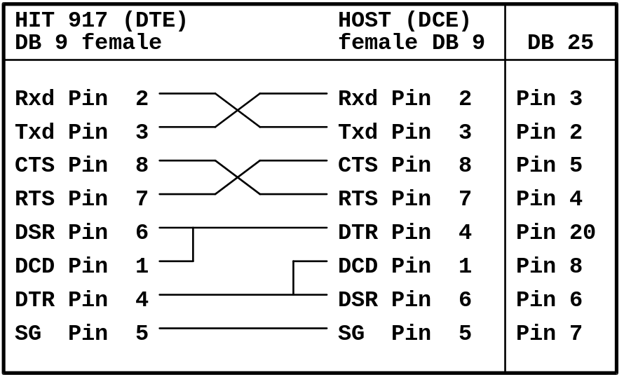
Figure 2: Connection with hardware handshake
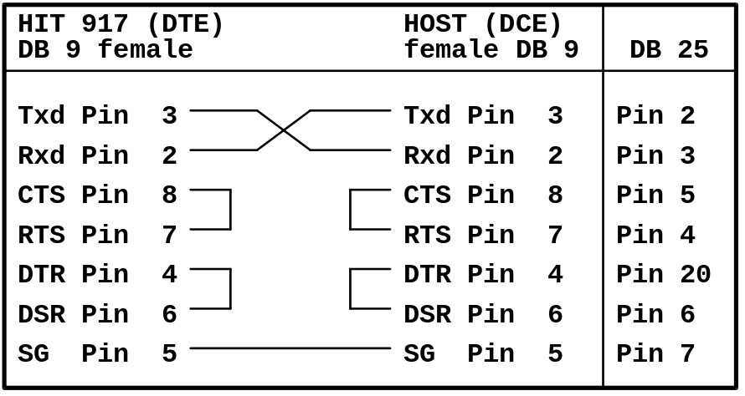
Figure 3: Connection without hardware handshake
Connect the cable to the connector 'Serial A' on the backside of the HP Vectra computer.

4 Pin Description
Table 1 shows the pin description of the RS232 serial interface.

Pin no | Signal | Explanation | Direction
3 | Txd | Transmit Data | out
2 | Rxd | Receive Data | in
7 | RTS | Request to Send | out
8 | CTS | Clear to Send | in
6 | DSR | Data Set Ready | in
1 | DCD | Data Carrier Detect | in
4 | DTR | Data Terminal Ready | out
5 | SG | Signal Ground | -
Table 1: Pin description for the 9-pin plug ‘Serial A’ of the HP Vectra

5 Specification of Communication
The table below shows the communication specifications of the host interface.

Item | Specification | Remarks
Interface | Asynchronous serial interface RS-232C | cable length max. 15m
Communication. method | Half duplex
Character code | ASCII
End-of-data code | [ETX] CHSH CHSL [CR] | see Table 20
Table 2: Specification of the host communication

6 Setup of Communication Parameters
All settings concerning the host interface are made on the Host Setting screen.
(menu path: Maint/Utility è System è Host)

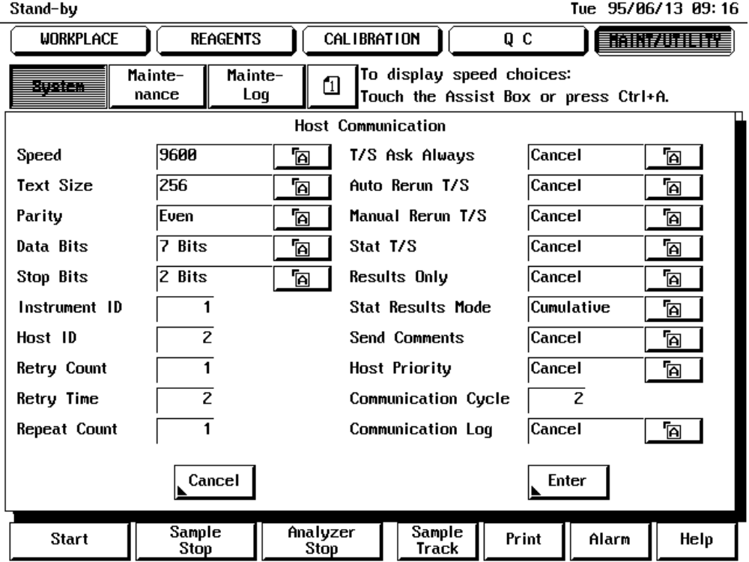
Figure 4: Host Setting screen
Serial interface parameters:
• Communication Speed 9600, 4800 baud
• Paritycheck none, odd, even
• Data Bits 7, 8
• Stop Bits 1, 2

HIT 917 specific settings:
• Maximum Text Length 256, 512, 1280 bytes (chapter 4.4.5 and 4.4.6)
• Retry Count 1 to 99 / 0 = unlimited (chapter 5.4)
• Retry Time 1 to 99 seconds (chapter 5.4)
• Repeat Count 1 to 99 / 0 = unlimited (chapter 5.4)
• Communication Cycle 2 to 10 seconds (chapter 5.1)

• Instrument Identification 1 to 9 (chapter 4.3)
• Host Identification 1 to 9 (chapter 4.3)

• Option of sending comments within the result message (chapter 4.4.4 and 4.4.5)
• Option of sending STAT results ‘as soon as cooked’ (chapter 4.4.5)

Test selection handling:
• ‘TS Ask Always’ option (chapter 4.4.3)
• ‘Host Priority’ (chapter 4.4.3)

Optional test selection inquiry for
• Auto Rerun (chapter 6.1)
• Manual Rerun (chapter 6.1)
• STAT (chapter 6.1)

Unidirectional communication mode:
• ‘Result Only’ mode (chapter 5.5)

Host Communication Trace:
• Option of recording the communication (the log is printed and cleared with the menu option Print è Maint/Utility è System Communication Trace)
(chapter 7)

Communication is switched on on Start è Print Host è Mode Set screen by pressing the Host Comm [Enable] button.

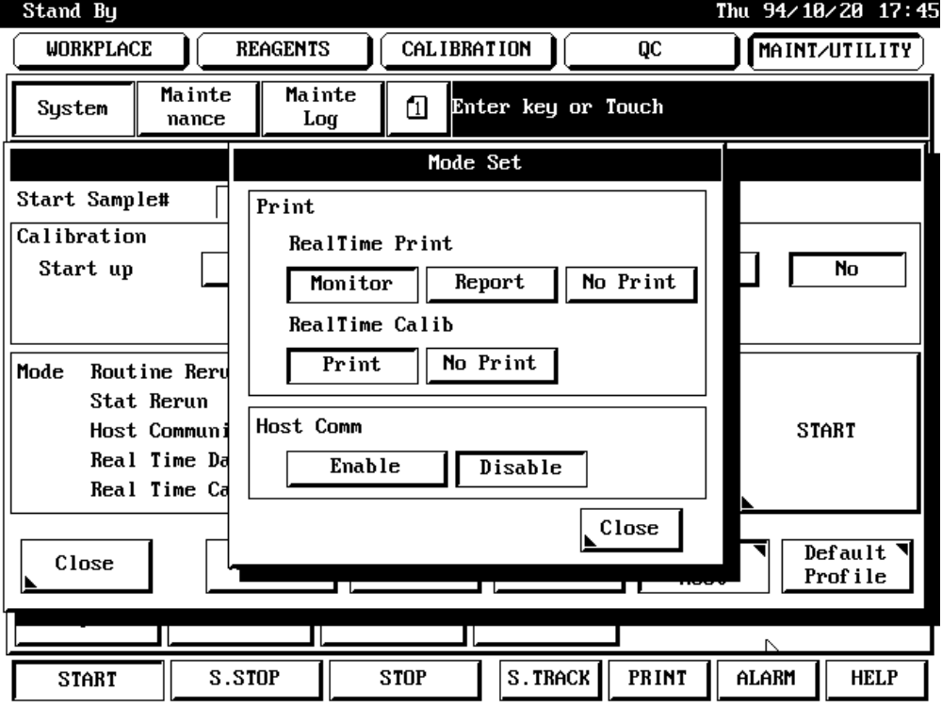
Figure 5: Start Conditions screen

7 Basic Workflow
There are two ways of workflow on the BM/HITACHI 917 analyzer with a host connection:
- Test selection download in batch mode before starting the RUN
- Test selection download on request during the RUN. Download means sending information from the host to the analyzer.

Test Selection Download in Batch mode

 The operator places the samples on the instrument
 The operator initiates the download of all existing test selections from host side
 The operator starts the run

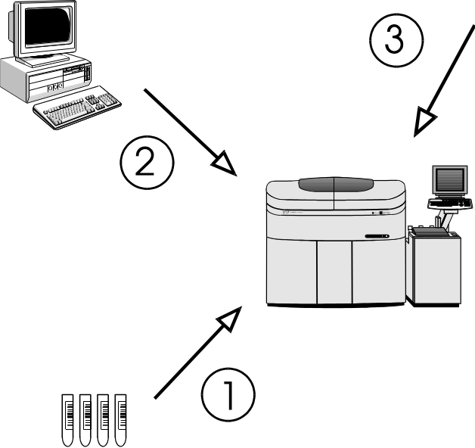
Figure 6: Test selection download in batch mode

Test Selection Download in Realtime mode

 The operator places the samples on the instrument
 The operator starts the run
 Upon reading the barcode of each sample the analyzer sends a request for each sample to the host
 The host sends back the corresponding test selection to the analyzer

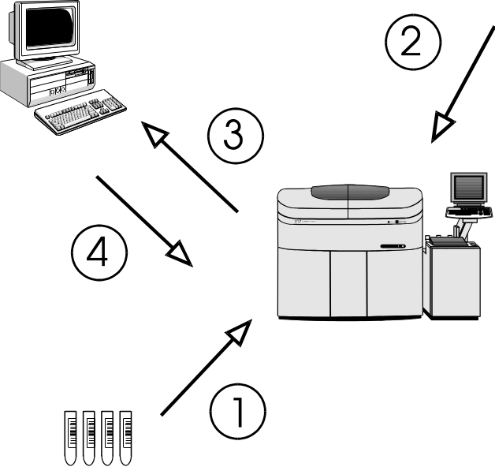
Figure 7: Test selection download in realtime mode

8 Software Protocol

9 Common text format
Each message that is sent to the CU (control unit) or the HOST (laboratory computer system) consists of the following items:

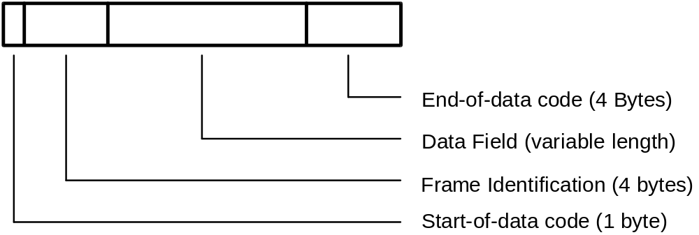

If you have a message without data (control frames ANY, REP or MOR, see Table 4) then the Data Field is empty.

10 Start-of-data Code
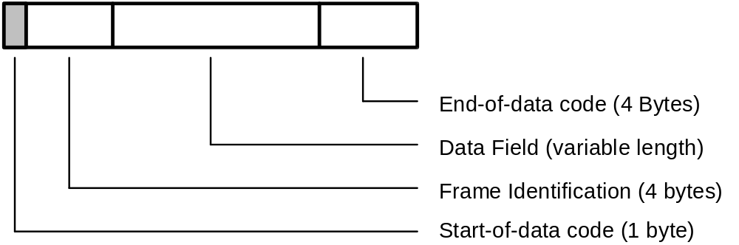

Each message sent from the CU or the host starts with the Start-of-Data Code (STX = 02H).

11 Frame Identification
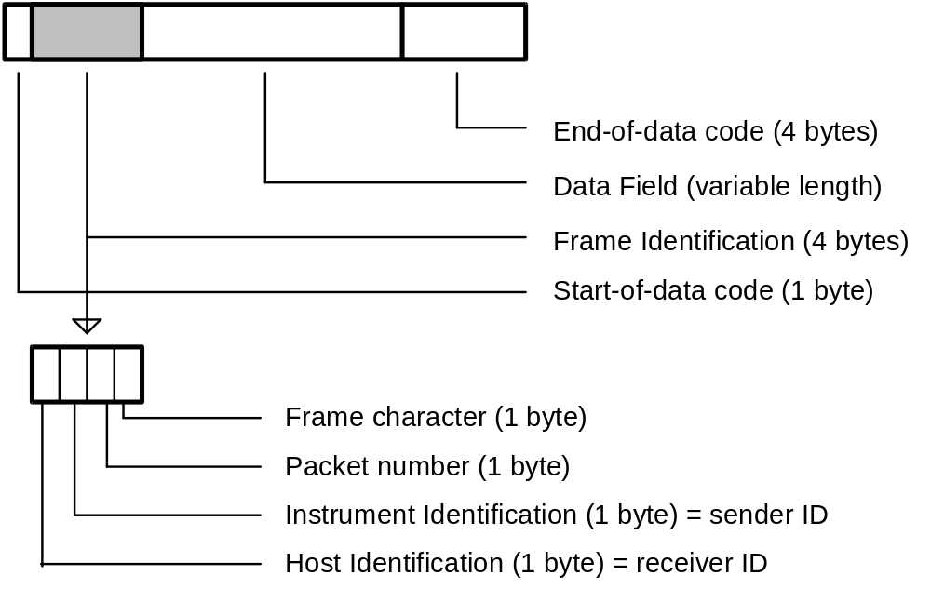

The frame identification consists of the following four items:

12 Host Identification
A numeric character (‘1’ to ‘9’) is selectable on the Host Setting screen (see Figure 4 on page 9) as host identification. Host is receiver from instruments point of view.

13 Instrument Identification
A numeric character (‘1’ to ‘9’) is selectable on the Host Setting screen (see Figure 4 on page 9) as instrument identification. Instrument is sender from instruments point of view.

NOTE
Sender/ receiver identification must be vice versa from the host side. The 917 ignores sender/ receiver ID.

14 Packet Number
The packet number is incremented with each packet that is sent to the host (characters ‘1’ to ‘8’ are used). After the frame with the packet number ‘8’ the next frame contains the packet number ‘1’.

15 Frame Character
The frame character represents the purpose/ contents of the message.

No | Mnemonic | Name | Char. | ASCII Code | Sender | Note
1 | FR1 | Frame 1 | 1 | 31H | CU | 1
2 | FR2 | Frame 2 | 2 | 32H
3 | FR3 | Frame 3 | 3 | 33H
4 | FR4 | Frame 4 | 4 | 34H
5 | FR5 | Frame 5 | 5 | 35H
6 | END | End  Frame | : | 3AH |  | 2
7 | SPE | Specific  Sample | ; | 3BH | CU  HOST | 3
8 | RES | Results  Request | < | 3CH | HOST | 4
Table 3: Frame types having a Data Field

Note 1: The frame characters FR1 to FR5 are used, when the analytical data extends over more than one message. FR1 is used for the first message and END for the final message.
Note 2: END alone is used when analytical data for one sample can be sent in one single message.
Note 3: The CU uses the frame character SPE for the test selection inquiry of only one specific sample.
The host uses SPE for the test selection which is being sent in response to the inquiry from the CU.
Note 4: The specific result request RES is used to request analytical data of a specific sample from the host to the CU. (Depending on whether the ID is provided or not, only routine and STAT samples are taken as valid. The others are ignored.)

No | Mnemonic | Name | Char. | ASCII Code | Sender | Note
9 | ANY | Any inquiry | > | 3EH | CU | 5
10 | MOR | More | > | 3EH | HOST | 6
11 | REP | Repeat | ? | 3FH | CU, HOST | 7
12 | SUS | Suspend | @ | 40H | CU, HOST | 8
13 | REC | Received | A | 41H | HOST | 9
Table 4: Frame types having no data field

Note 5: A positive response ANY is used by the CU to ask the host for the following items:
a) a test selection record for any sample that is available by the host.
b) RES, REC or MOR frame requests.
Note 6: MOR means that the host is ready to receive analytical data. (Analytical data can be transfered from the CU to the host only when the host has sent this frame.)
Note 7: A negative response REP is used, when resending of the previous communication is requested. The host can send REP at any time. The CU, however, sends REP only when the response text to ANY is destroyed.
Note 8: The Data Bad and Suspend packet (SUS) is sent by the host to tell the analyzer that the last packet was bad, and that the host wants a delay before the packet is resent by the CU. The CU then resends the packet after another ANY/MOR cycle.
Note 9: With the Data Accepted but Suspend packet (REC) the host tells the analyzer that the last packet was okay. (but there is no additional delay in the communication like we know from Hitachi 747)

Frame Priorities
When two or more processings are carried out in response to a request from the host, the CU assigns priorities to them and returns a response to the host.
Batch communication is interrupted and suspended if the CU has a text with higher priority. This is restricted to the case where analytical data in the real-time mode is sent from CU and the transfer of analytical data is in response to a RES frame. After that the batch communication is restarted.
The table below shows the details of each frame and the priority.

Priority | Item
1 | SPE frame for STAT samples
2 | SPE frame for routine samples
3 | REP frame
4 | FRx,END frame for specific result request (RES from host)  Sending of Channel Assignment Information
5 | FRx,END frame for batch result transmission
6 | FRx,END frame for realtime results
Table 5: Frame priorities

16 Data Field
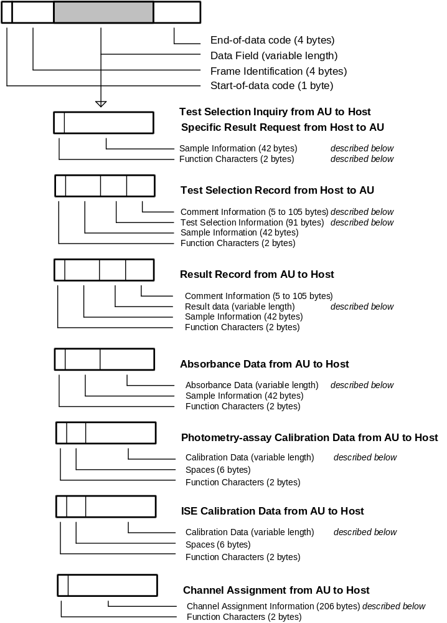

17 Function Characters
 |  |  | Test Selection Info. Inquiry |  | Result data
 |  | Direction of Communication | CU <-->HOST | CU <-- HOST | CU --> HOST |  | HOST --> CU
 |  | ID Provided  / | Real-time  Communication | Batch  Communication | Real-time  Communication | Batch  Communication | Result  Request
 |  | Not Provided | Sample  Class i (1-5) | Sample  Class i (1-5) | Sample  Class i (1-5) | Sample  Class i (1-5) | Sample  Class i (1-5)
 | Routine sample |  | Ai | Ai | Ai | ai | ai
 | Routine sample  (automatic rerun) | Provided | Bi | Bi | Bi
 | Routine sample  (manual rerun) |  | Ci | Ci | Ci
 | Stat sample |  | Di |  | Di | di | di
 | Stat sample  (automatic rerun) |  |  |  | Ei
 | Control sample | Provided |  |  | F_ | f_
 | Calibration  (Photometry) | / |  |  | G_
 | Calibration  (ISE) | not provided |  |  | H_
 | Routine sample |  | Ni | Ni | Ni | ni | ni
 | Routine sample  (Automatic Rerun) |  | Oi | Oi | Oi
 | Routine sample  (Manual Rerun) | Not Provided | Pi | Pi | Pi
 | STAT sample |  |  |  | Qi | qi | qi
 | STAT sample  (Automatic Rerun) |  |  |  | Ri
 | Absorbance data  (Routine) |  |  |  |  | ii
 | Absorbance data  (Routine Rerun) | provided |  |  |  | ji
 | Absorbance data  (STAT) | / |  |  |  | ki
 | Absorbance data  (STAT Rerun) | Not Provided |  |  |  | li
 | Absorbance data  (Control) |  |  |  |  | m_
 | Channel Assignment Information |  |  |  | XA
Table 6: Function characters

18 Composition of Sample Information

(included in SPE, RES, FR1 to FR5, END frames)
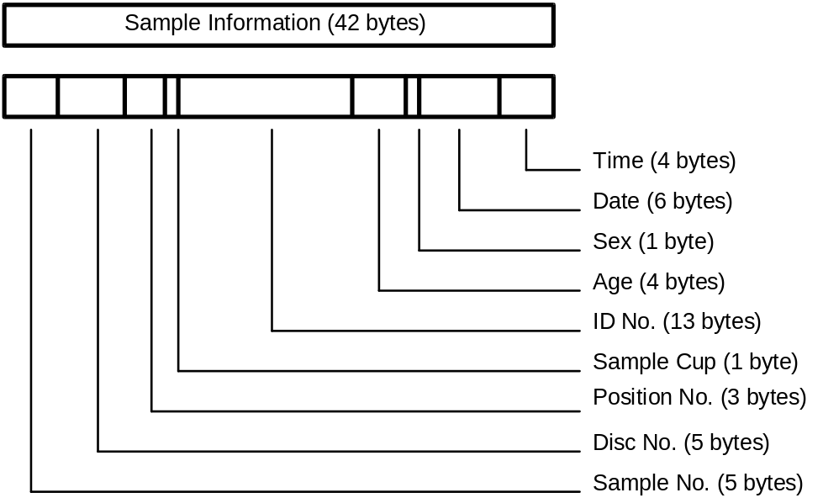

Item | L | Routine sample | Stat sample | Control sample | Note
Sample No. | 5 | Format: sssss  Range:  bbbb1-10000 | Format: sssss  Range:  bbbb1-bb400 | Format: ccsss  c: control no.  Range: b1 - 40  sss: sequence no.  Range: bb1 - 150 | 1
Disk No. | 5 | Format: ddddd  Range:  bbbb0 - bbbb9 | Format: ddddd  Range:  bbbb0 - bbbb9 | Format: bbbbd  Range: d = 0 - 9  for sample disk 1  d = b for sample disk 2 | 2
Position No. | 3 | Format: ppp  Range:  bb1 - 110 | Format: ppp  Range:  bb1 - 110 | Format: ppp  Range: bb1 - 110  for sample disk 1  Range: bb1 - b57  for sample disk 2 | 3
Sample Cup | 1 | Format: c  Range: 1 - 2  1 = Standard Cup  2 = Micro Cup | Format: c  Range: 1 - 2  1 = Standard Cup  2 = Micro Cup | Format: b | 4
Ident No. | 13 | Format: nnnnnnnnnnnnn  n = ident number |  | Format:  bbbbbnnnnnnnn  n = control name | 5
Age | 4 | Format: aaac  aaa: age no.  Range: bb0 - 200  c: age unit  1 day  2 month  3 year |  | Format: bbbb | 6
Sex | 1 | Format: s  s: sex no.  0 other  1 male  2 female |  | Format: b | 7
Date | 6 | Format: mmddyy  mm: month  dd: day  yy: year |  | Format: LLLLLL  L = Control Lot no.  (first 6 digits) | 8
Time | 4 | Format: hhmm  hh: hour  mm: minute |  | Format: LLbb  L = Control lot no.  (last 2 digits) | 8
Table 7: Format of sample information / b = space (20H)
Note 1: <CU to HOST>: For an inquiry in ID mode, spaces are given.
Note 2: <CU to HOST>: For an inquiry in ID mode, spaces are given.
Note 3: <CU to HOST>: For an inquiry in ID mode, spaces are given.
Note 4: <CU to HOST>: Sample cup information which the CU has is sent.
<HOST to CU>: If the information is not set, ‘1’ is set for it.
Note 5: When the ID-No. is within 13 digits, it is right justified and preceded by spaces.
In case of no ID-mode the CU treats the ID-No. as a comment.
Note 6: <CU to HOST>: If the info. is not set, spaces are sent.
<HOST to CU>: Set age information that is sent from the CU.
Note 7: <CU to HOST>: If the info. is not set, a space is sent.
<HOST to CU>: Set sex information that is sent from the CU.
Note 8: <CU to HOST>: The blood collection date/time which the CU has is transfered. If the date/time is not set, the sent one is set.
<HOST to CU>: Set the date/time sent from the host. Note, however, that the date/time at the CU side is set if spaces are included in each date/time field.

See chapter 7 for examples.

19 Composition of Test Selection Information

(included in SPE frame)
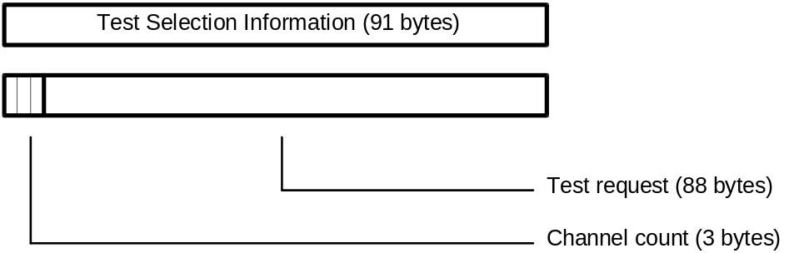

Item | Length | Range | Note
Channel count | 3 | 'bb0' to 'b88' | 1
Test request | 88 | Format: rrrr....rrrr  Range: 0 to 4 for each character:  0 = no request  1 = normal sample volume  2 = decreased volume  3 = increased volume  4 = determined by CU (only for rerun) | 2
Table 8: Format of test selection information / b = space (20H)

Note 1: If the channel count is less than 88, the channels with higher count are ignored.
Note 2: The channels are listed in ascending order.
Channel 1..86: Photometry-assay tests.
Channel 87: ISE channel.
- request for electrolytes (3 tests).
- all three tests Na/K/Cl are selected
- it is impossible to select request for any of Na, K and Cl from the host.
new in version 2
- for the rerun of class 2 samples, decreased volume (flag 2) can be selected.
Channel 88: Serum index channel:
- Request for serum indices (for 3 tests of L, H and I).

Deleting a test selection entry:
A test selection with all 88 test positions set to '0' deletes an existing test selection for the specified sample and causes the analyzer to send another test selection inquiry if the corresponding barcode appears again at the barcode reader.
In request for the isozyme test or compensation test, the other test necessary for isozyme calculation or test-to-test calculation is automatically supplied for analysis and analytical data is transfered when the other test is not requested. The additional test data for serum indexes is transfered also.
TS Ask Always mode:
If the ‘TS Ask Always’ mode is enabled on the Host Setting screen (see Figure 4 on page 9) the CU sends for each sample a test selection inquiry to the host even if there is already a test selection for that sample existing on the system.
Host Priority:
With this setting on the Host Setting screen (see Figure 4 on page 9) the mastership of communication can be given either to the CU (default / ‘Host Priority’ disabled) or to the host.
If given to the host the CU suspends the analysis of the subsequent samples until the host responds to a sample inquiry. When a response from the host is received, the analytical sequence is resumed. It is therefore necessary to respond to any inquired sample. Even if the analysis of a sample is not required, a response to its inquiry must be made.

20 Composition of Comment Information

(included in SPE, FR1 to FR5, END frame)
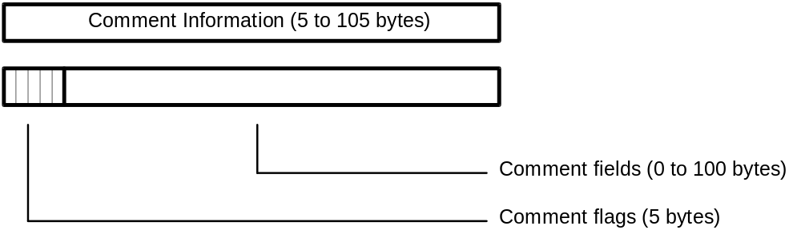

Item | Length | Range | Note
Comment flags | 5 | Format: FFFFF  F: comment switch/flag  0 absence of corr. comment  1 presence of corr. comment | 1
Comment 1 | 30 | Format: cccc....cccc  c: comment corresponding to flag 1 | 2
Comment 2 | 25 | Format: cccc....cccc  c: comment corresponding to flag 2
Comment 3 | 20 | Format: cccc....cccc  c: comment corresponding to flag 3
Comment 4 | 15 | Format: cccc....cccc  c: comment corresponding to flag 4
Comment 5 | 10 | Format: cccc....cccc  c: comment corresponding to flag 5
Table 9: Format of comment information

Note 1: For each comment flag that is set to ‘1’, the corresponding comment text follows.
Comment info within test selection from host to CU:
If all comment flags are ‘0’, the [ETX] code follows directly after the last comment flags.
For those comment fields that are not sent to the CU, an already existing comment text remains valid.
Comment info within result transmission
If enabled on the Host Setting screen (option ‘Send Comments’ / see Figure 4 on page 9) the comment information is sent at the end of each result transmission to the host. (Control results do not have that comment info). In this case, all five comment fields are sent (flag setting ‘11111’ even if some comment fields are empty.
Note 2: Within the comment data fields, the character range is valid from code 20H to 7EH. (see Appendix A - ASCII Chart)

See chapter 7 for examples.

21 Composition of Result Data for Routine, Rerun, STAT and Control samples
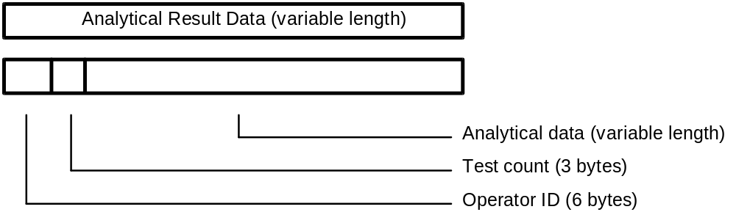

Item | Length | Range | Note
Operator ID | 6 | Format: oooooo
Test count | 3 | Format: ccc  Range: bb0 - 100 | 1
Result[n]  with n=1 to ‘Test count’ | 10 each | Format: cccvvvvvva  ccc: Test no.  Range:  bb1 - b86 Photometry assay  b87 - b89 Electrolyte  b90 - b92 Serum index  b93 - 100 Calculated tests  vvvvvv: Result value  a: Data alarm  Refer to the data alarm list  (see Table 18 ) | 2  3
Table 10: Format of analytical result data / b = space (20H)

Note 1: The CU transfers data for up to 86 tests respectively for simultaneous measurement in real-time and batch communication .
The results of the electrolytes (three tests of Na, K and Cl) are transfered with the test numbers 87 to 89, the results of serum indexes (three tests of lipemia, hemolysis and icterus) with the test numbers 90 to 92.
For the sample, for which all tests are deleted with the edited data on the Data Review screen, sample information followed by test count 'bb0' is transfered. In that case, no result data is transfered.
Note 2a: Format of the 6-character result value field:

Pos/Neg. | Decimal Point | Max.Digits | Example
Positive | absent | 6 | 123456
 | present | 5 | 123.45
Negative | absent | 5 | -12345  bb-123
 | present | 4 | -12.34  b-12.3
Table 11: Format of measured value / b = space (20H)
Note 2b: Qualitative Result Transmission
On the Maint/Utility è Application è Range screen, it is possible to enter six-character long expressions for definable result ranges. If activated, the corresponding expression is transfered instead of the result value.
Note 3a: Results that have been modified on the Workplace è Data Review è Edit screen get the following marks attached if the option 'Edited Flag' was enabled on Maint/Utility è System è Alarm screen.
'*' (code 2AH) is displayed on the Data Review screen and sent to the host as alarm character.
'EDITED' is printed on the monitor printout.
Note 3b: The Maint/Utility è System è Exeption function offers the possibility to select alarm flags. All results which are flagged with those selected alarms are not sent to the host.

See chapter 7 for examples.

Text Size:
Since the text size may be 256, 512 or 1280 bytes (selectable on Host Setting screen / see Figure 4 on page 9) it can happen that the analytical data text has to be divided into several (up to 6) frames depending on the text size and the number of test results.

Text Size | 256 bytes | 512 bytes | 1280 bytes
Max. no. of test results in one frame | 19 | 45 | 100
Tests in FR1 or END | 1 to 19 | 1 to 45 | 1 to 100
Tests in FR2 or END | 20 to 38 | 46 to 90
Tests in FR3 or END | 39 to 57 | 91 to 100
Tests in FR4 or END | 58 to 76
Tests in FR5 or END | 77 to 95
Tests in END | 95 to 100
Table 12: No. of test results per frame according to the text size.
The maximum number of transferable test results in one frame is calculated with the following expression:

max. no. of test results < (Text Size - 62) / 10 (Round off fractions)

If the ‘Send Comments’ option is enabled on the Host Setting screen (see Figure 4 on page 9), the five comment fields are sent after the last result value. If there are more than one result frame necessary the comments are only sent in the END frame. Since the whole comment information is 105 characters long, the maximum number of test results in the END frame is less than described in the table above.

STAT result trasfer ‘as soon as cooked’:
If the option Stat Results Mode on the Host Setting screen (see Figure 4 on page 9), is set to Incremental, single STAT test results are sent to the host as soon as available

22 Absorbance Data
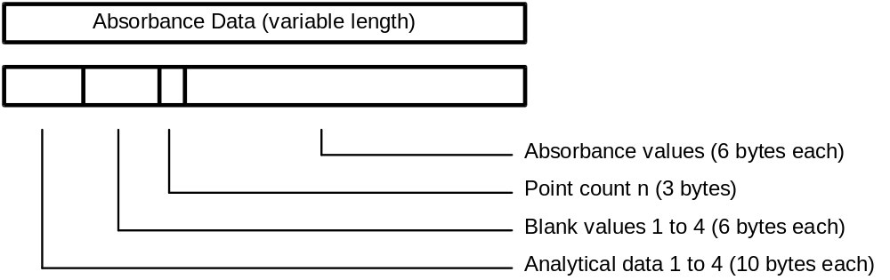

Item | Length | Range | Note
Analytical data [n]  with n=1 to 4 | 4 * 10 | Format: cccvvvvvva  ccc: Channel no.  vvvvvv: Result value  a: Data alarm  Refer to the data alarm list  (see Table 18) | 1
Blank data [n]  with n=1 to 4 | 4 * 6 | Format: cccccc | 2
Point count | 3 | Format: ppp  Range: n = bb0 - b73 | 3
Absorb. data [n]  with n=1 to ‘Point count’ | n * 6 | Format: aaaaaa /-aaaaa | 4
Table 13: Format of absorbance data / b = space (20H)
Note 1: If two-channel simultaneous measurement is specified, data for two channels is transfered. If serum index measurement is specified, data for up to four channels (1 channel + L, H, I) is transfered.
If there is no relevant test for analytical data, 10 spaces are transfered.
Note 2: The first value is the 'Stopped cell blank', the following three values are the 'Passed cell blanks'. The values are transfered according to the analytical method of this test.
The unit for the cell blank data is 10-4 (10E-4) absolute. An integer is transfered preceded by space with floating sign position.
Note 3: The point count is the number of photometric points which follow the point count information. The following values may occur:

Reaction time [sec] | 1 | 2 | 3 | 4 | 5 | 6 | 7 | 8 | 9 | 10 | 15 | 22
Point Count | 4 | 8 | 11 | 14 | 17 | 21 | 25 | 28 | 31 | 34 | 50 | 73

Note 4: The absorbance data in the entire reaction monitoring system (data at each photometric point) is transfered in the same format as for the above cell blank data. When the point count is less than 73, the data is closely transfered in sequence starting from ABS 1.
Text Size:
Since the text size may be 256, 512 or 1280 bytes (selectable on Host Setting screen / see Figure 4 on page 9) it can happen that the absorbance data text has to be divided into several (up to 3) frames depending on the text size and the number of absorbance values.

Text Size | 256 bytes | 512 bytes | 1280 bytes
ABS values in FR1 or END | 1 to 23 | 1 to 65 | 1 to 73
ABS values in FR2 or END | 24 to 56 | 66 to 73
ABS values in END | 57 to 73
Table 14: No. of absorbance values per frame according to the text size.
The sample information is sent in each frame; the analytical data and blank values are only sent in the first frame.

See chapter 7 for examples.

Photometric Points
# | (sec) | total | # | (sec) | total
S |  | Sample | 36 | 655.899
R1 | 0 |  | 37 | 673.744
1 | 7.267 |  | 38 | 691.588
2 | 25.121 |  | 39 | 709.432
3 | 42.965 |  | 40 | 727.267
4 | 60.809 | 1 min | 41 | 745.121
5 | 78.654 |  | 42 | 762.965
R2 | 85.500 |  | 43 | 780.809
6 | 94.593 |  | 44 | 798.654
7 | 111.438 |  | 45 | 814.593
8 | 129.282 | 2 min | 46 | 831.438
9 | 147.126 |  | 47 | 849.282
10 | 164.971 |  | 48 | 867.126
11 | 182.815 | 3 min | 49 | 884.971
12 | 200.659 |  | 50 | 902.815 | 15 min
13 | 218.504 |  | 51 | 920.659
14 | 236.348 | 4 min | 52 | 938.504
15 | 254.193 |  | 53 | 956.348
16 | 270.093 |  | 54 | 974.193
R3 | 279.000 |  | 55 | 990.093
17 | 286.977 | 5 min | 56 | 1006.977
18 | 304.821 |  | 57 | 1024.821
19 | 322.665 |  | 58 | 1042.665
20 | 340.510 |  | 59 | 1060.510
21 | 358.354 | 6 min | 60 | 1078.654
22 | 376.199 |  | 61 | 1096.199
23 | 394.043 |  | 62 | 1114.043
24 | 411.887 |  | 63 | 1131.887
25 | 429.732 | 7 min | 64 | 1149.732
26 | 445.632 |  | 65 | 1165.632
27 | 462.516 |  | 66 | 1182.516
28 | 480.360 | 8 min | 67 | 1200.360
29 | 498.204 |  | 68 | 1218.204
30 | 516.049 |  | 69 | 1236.049
31 | 533.893 | 9 min | 70 | 1253.893
32 | 551.737 |  | 71 | 1271.737
33 | 569.582 |  | 72 | 1289.582
R4 | 580.500 |  | 73 | 1307.426 | 22 min
34 | 587.426 | 10 min
35 | 605.271

23 Photometry-assay Calibration Data
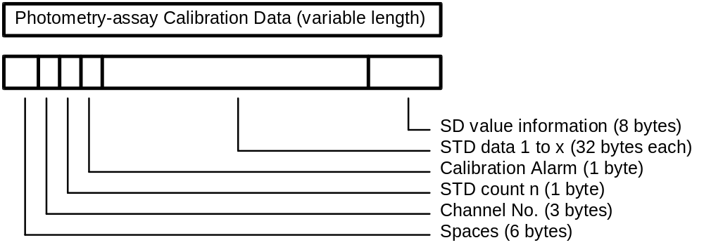

Item | Length | Range | Note
Operator ID | 6 | Format: oooooo
Channel no. | 3 | Format: ccc  Range: bb1 - b86 | 1
STD count | 1 | Format: n  No. of standards according to the calibration method  Range: n = 1 - 6 | 2
Calib. alarm | 1 | Format: a  Refer to the data alarm list  (see Table 18) | 3
STD[n]  with n=1 to ‘STD count’ | 32 each | Format: kaaaaaaddddddbbbbbb  eeeeeeupppppp  k: STD no.; Range: 1 - 6  aaaaaa 1st absorbance data  dddddd 1st initial absorbance data  bbbbbb 2nd absorbance data  eeeeee 2nd initial absorbance data  u data alarm  Refer to the data alarm list  (see Table 18)  pppppp Prozone value | 4  3
SD value | 8 | Format: pvvvvvvd  p 'Y' = SD value present  'N' = SD value absent  vvvvvv SD value  d decimal point position | 5
Table 15: Format of photometry-assay calibration data / b = space(20H)
Note 1: The test code in photometry-assay calibration which corresponds to the test code in the CU.
Note 2: When the STD count is 1, STD data 1 is followed by SD value information.
Note 3: Refer to the data alarm list (see Table 18)
Note 4: Each standard is measured twice. (1st and 2nd abs. values). The 1st and 2nd absorbance values are the results of the bichromatic measurements at the corresponding measuring point; the initial absorbance values are the results of the monochromatic measurements with only the main wavelength. (Each standard is measured with two different wavelengths).
Each absorbance data is right-justified and preceded by space. The unit is 10-4 (10E-4) absolute. It is a 6-digit integer with sign.
Note 5: The SD value is only calculated for nonlinear and linear multi-point calibrations (3 to 6 standards). It is right-justified and preceded by space. It has no unit and the decimal point position can be set at Maint/Utility è Application è Calib screen.
If the SD value is absent, spaces are given instead of SD value and decimal point position.

See chapter 7 for examples.

24 ISE Calibration Data
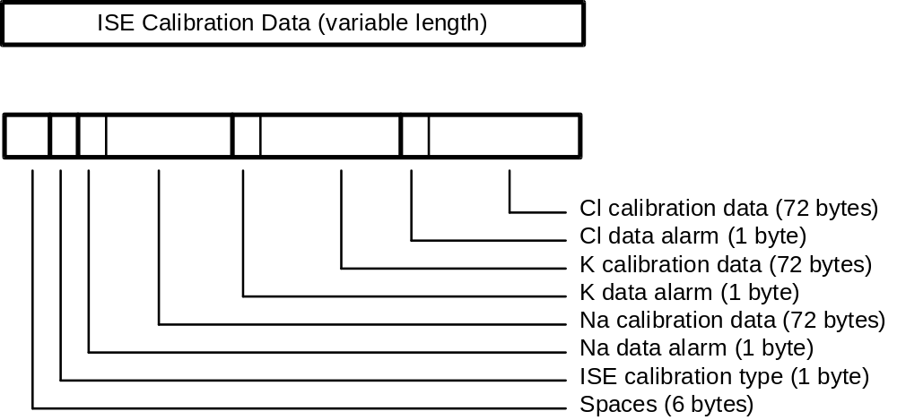

Item | Length | Range | Note
Operator ID | 6 | Format: oooooo
ISE type | 1 | Format: p  'B' : Tests Na, K, Cl ( n = 1 to 3 )
Data alarm[n]  +  Calib. data [n]  with n=1 to 3 | 1  8 * 9 each | Format: a  Refer to the data alarm list (see Table 18)  Format ddvvvvvva  dd: Data identification  Range: b1 - b8  vvvvvv: measured value  a: data alarm  Refer to the data alarm list  (see Table 18) | 1
Table 16: Format of ISE calibration data / b = space(20H)
Note 1: For each of the three tests NA, K, Cl, the following eight data items are transfered:
- electromotive force of internal standard solution
- electromotive force of LOW solution
- electromotive force of HIGH solution
- electromotive force of M solution
- slope level for display
- concentration of internal standard solution
- concentration of M solution
- compensation factor
The unit for the measured value is mV. It has a sign and a decimal point. Spaces are given, when there is no relevant data.

See chapter 7 for examples.

25 Channel Assignment Information
The channel assignment information for the maximum of 100 channels is transfered in two frames (FR1 and END). Each frame has the following format.
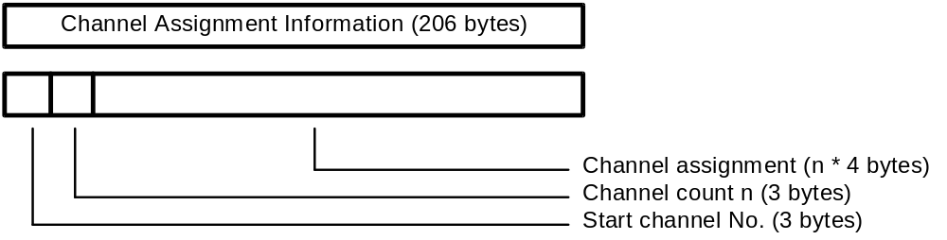

Item | Length | Range | Note
Start channel | 3 | Format: sss  Range: bb1 (first frame)  b51 (second frame) | 1
Channel count | 3 | Format: ccc  Range: n = b50 | 1
Application code [n]  with n= 1 to 50 | n * 4 | Format: aaaa  Range: bbb1 - b910 Photometry assay  b961 - b980 Calculated item  b989 - b991 Electrolyte  b992 - b994 Serum Index | 2
Table 17: Format of channel assignment information / b = space(20H)
Note 1: The channel values are right justified and preceeded by space.
Note 2: The application code for each channel is transfered. If a channel has no application code assigned, four spaces are sent.

26 Data Alarm List

No. | Data Alarm Name | Printer | CRT | I/F | Photometry Assay |  |  | ISE |  |  |  | Note
 |  |  |  |  | R/S | C | Std |  | R/S | C | Std |  | 1
1 | ADC abnormal | ADC? | A | A | o | o | o |  | o | o | o
2 | Cell blank abnormal | Cell? | Q | Q | o | o | o
3 | Sample short | Sampl | V | V | o | o | o |  | o | o | o |  | 2
4 | Reagent short | Reagn | T | T | o | o | o |  |  |  |  |  | 2
5 | Absorbance over | ABS? | Z | Z | o | o | o
6 | PROZONE error | Prozon | P | P | o | o | o |  |  |  |  |  | 3
7 | Reac limit over at all points | Limt0 | I | I | o | o | o
8 | Reaction limit over except at 1 point | Limt1 | J | J | o | o | o
9 | Reaction limit over except at 2 or 3 points | Limt2 | K | K | o | o | o
10 | Linearity abnormal for 9 points or more | Lin. | W | W | o | o | o
11 | Linearity abnormal for 8 points or less | Lin.8 | F | F | o | o | o
12 | Standard 1 absorbance abnormal | S1Abs? |  | H |  |  | o
13 | Duplicate error | Dup |  | U |  |  | o
14 | STD error | Std? |  | S |  |  | o
15 | Sensitivity error | Sens |  | Y |  |  | o
16 | Calibration error | Calib |  | B |  |  | o
17 | SD error | SD! |  | G |  |  | o
18 | Noise error | Noise | N | N |  |  |  |  | o | o | o
19 | Level error | Level | L | L |  |  |  |  | o | o | o
20 | Slope abnormal | Slope? |  | E |  |  |  |  |  |  | o
21 | Preparation abnormal | Margin |  | R |  |  |  |  |  |  | o
22 | Internal standard concentration abnormal | I.Std |  | D |  |  |  |  |  |  | o
Table 18: Data alarm list (part 1)

No | Data Alarm Name | Printer | CRT | I/F | Photometry Assay |  |  | ISE |  |  |  | Note
 |  |  |  |  | R/S | C | Std |  | R/S | C | Std |  | 1
23 | Sample value abnormal | R.Over | & | & |  |  |  |  | o | o
24 | Test-to-test comp. error | Cmp.T | C | C | o | o |  |  | o | o
25 | Test-to-test compensation disabled | Cmp.T! | M | M | o | o |  |  | o | o |  |  | 4
26 | Panic value upper limit over | LIMTH | $ | $ | o |  |  |  | o
27 | Panic value lower limit over | LIMTL | $ | $ | o |  |  |  | o
28 | Random error (R-4s) | Random | @ | @ |  | o |  |  |  | o
29 | Systematic error 1 (2-2sA) | Systm1 | # | # |  | o |  |  |  | o
30 | Systematic error 2 (2-2sW) | Systm2 | # | # |  | o |  |  |  | o
31 | Systematic error 3 (4-1sA) | Systm3 | # | # |  | o |  |  |  | o
32 | Systematic error 4 (4-1sW) | Systm4 | # | # |  | o |  |  |  | o
33 | Systematic error 5 (10xA) | Systm5 | # | # |  | o |  |  |  | o
34 | Systematic error 6 (10xW) | Systm6 | # | # |  | o |  |  |  | o
35 | QC error 1 | QcErr1 | + | + |  | o |  |  |  | o
36 | QC error 2 | QcErr2 | + | + |  | o |  |  |  | o
37 | Calculation test error | Calc? | % | % | o | o |  |  | o | o
38 | Overflow | Over | O | O | o | o |  |  | o | o |  |  | 4
39 | Calculation disabled | ??? | X | X | o | o | o |  | o | o |  |  | 4
40 | Expected value upper limit over | H |  |  | o |  |  |  | o |  |  |  | 5
41 | Expected value lower limit over | L |  |  | o |  |  |  | o |  | o |  | 5
42 | Edited Results | Edited | * | * | o | o |  |  | o | o
43 | Calibration failure | CalErr | ! | ! | o | o |  |  | o | o
44 | Convergence absorbance over | >AMAX | > | > | o
45 | Repeat upper limit over | ReptH | = | = | o |  |  |  | o
46 | Repeat lower limit over | ReptL | = | = | o |  |  |  | o
Table 19: Data alarm list (part 2)
Note 1. R/S = Routine/STAT C = Control Std = Calibration
Note 2. Data may be blanked.
Note 3. Prozone value is output on printer only in real-time monitor mode.
Note 4. Data is blanked.
Note 5. Can exist with any other alarm.

Note: When two or more data alarms are given for a single data item, the one registered first is output.

27 End-of-data Code
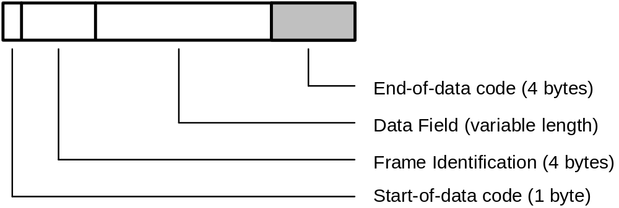

The End-of-data code represents the end of each text that is sent from the CU or the host. Its format is shown below:

Code | ASCII | Bytes
[ETX][CKSH][CKSL][CR] | 03H [high][low] 0DH | 4
Table 20: Format of the end-of-data code
Checksum Calculation:
[CKSH][CKSL] = Checksum high/low
The calculation is made as follows:
The checksum is generated as the elementary sum of all data bytes excluding [STX] and [ETX]. The result of the calculation is a 4-digit hexadecimal value. The two low order digits of that number are converted to ASCII characters. These two characters build the checksum high/low.
Example:
Test selection Inquiry from host to CU:

[STX]216;N1^^^^1^^^^0^^1^^^^^^^^^^^^^^^^^^^0712941225[ETX]86[CR]
(the character ^ represents a space - 20 hex)

Checksum decimal 134
Checksum hexadecimal 86
Checksum high 8
Checksum low 6
End-of-data code [ETX]86[CR]

28 Data Transmission Control Procedure

29 Establishment of Data Link
After pressing the Host Communication [Enable] button on the START è Print Host è Mode Set screen, the CU transfers the ANY frame to the host. Communication is started from this point. The host has to answer within x seconds, usually with a MOR frame.
x is the communication cycle time which can be set from 2 to 10 seconds on the Host Setting screen (see Figure 4 on page 9)
x seconds after the receipt of the MOR frame the CU sends the next ANY frame to the host
In subsequent steps, the CU and host continue transmission alternately.
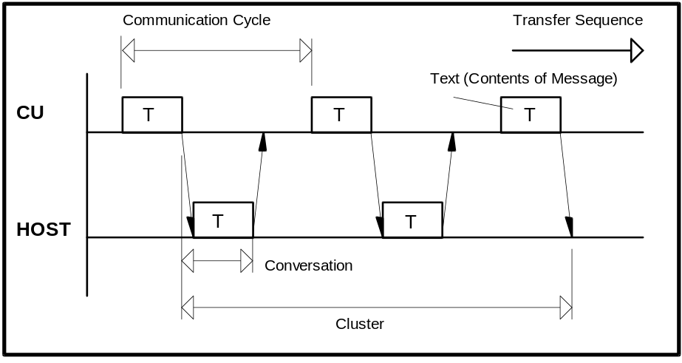
Figure 8: Common communication timing
Conversation One message sent from the host or the CU
Communication cycle One request from the CU with the corresponding answer
from the host
Cluster A group of conversations between the CU and the host

30 Response to Information Message
After receiving information, the receiver sends a response to inform the sender of the receiver status and the validity of received information.
The format of the various messages is described above. When the 256 or 512-byte mode is selected for the transfered byte count, the analytical data text may exceed 256 or 512 bytes (including start-of-data code and end-of-data code) according to the sample. In this case, the analytical data text is divided. The frame character identifies each text part.
The CU continues replying as far as the host returns a response. Even when the text, corresponding to an optional frame character is transfered and there is no more data to be sent between the CU and host, they continue sending the ANY frame and MOR frame respectively. However, the cluster is restarted immediately if analytical data transfer, test selection directive or any other transfer is requested.
After sending a text, the host should avoid sending until reception of a response or request to/for the next in a normal condition. Otherwise the CU will output an alarm.
In transfer from the host to the CU, a pause of at least 100 msec is required.
If no response is returned or an invalid response is received, the recovery procedure is executed. In case of sending from the host, the host must always be kept ready for receiving the response.
Described below are the typical procedure for returning a response to the information message and the procedure upon receiving the response.

31 No Information to be sent
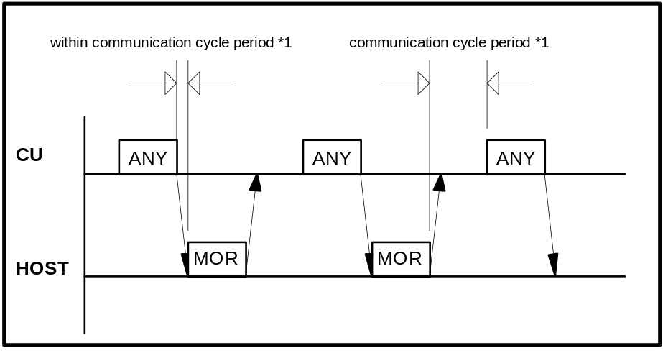
Figure 9: Communication timing without information exchange
*1: The communication cycle period can be adjusted (2 to 10 seconds / default = 2 seconds) on the Host Setting screen (see Figure 4 on page 9).

The CU continues returning the ANY frame in response to the MOR frame from the host. This procedure continues even when the CU and host have no information to be sent. Following conditions must be satisfied:
a) There is no test selection information to be sent to the host.
b) Analytical data is not output in the real time mode.
c) There is no request for the RES frame.
d) Specification through the screen is not made.
In this case, the CU sends the ANY frame in the lapse of the communication cycle period after receiving the MOR frame from the host (a point when the final end-of-data code is recognized).
After receiving from the CU, the host should return a response as soon as possible within the following communication cycle period.

32 Transfer of Communication Control Message
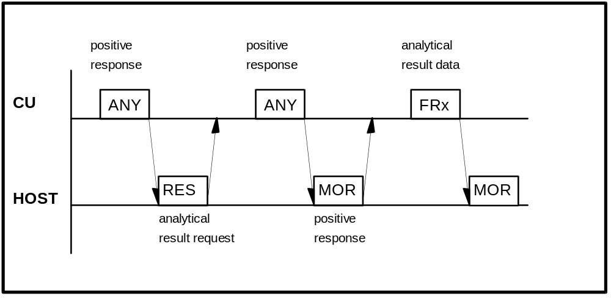
Figure 10: Transfer of communication control message

The RES, ANY, MOR, REP, SUS, REC frames are available for the communication control message.
For details, refer to the Frame types in Table 3 on page 16.

33 Transfer of Test Selection Information
(a) Test selection directive from the host to the CU (batch mode)
Usually the host will send test selections in advance of the sample's arrival on the analyzer. The host can send the test selection packet in response to the ANY frame from the CU.

(b) Test selection inquiry from the CU to the host (realtime mode)
If the test selection is not sent by the host, the CU can ask for specific test selections from the host. The test selection inquiries are sent to the host when samples are ready for processing and no test selections are available at the CU or the ‘TS Ask always’ option is enabled on the Host Setting screen (see Figure 4 on page 9). This case is shown in Figure 11.
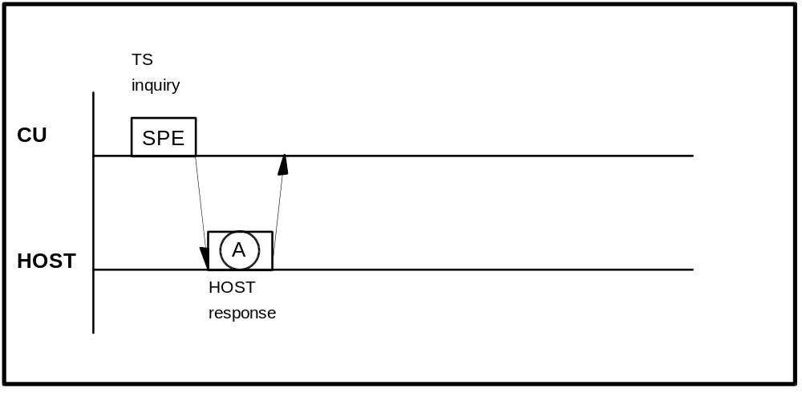
Figure 11: Test selection inquiry
The possible host responses to the specific test selection inquiry are listed in Table 21.

Frame A | Description
SPE | Respond with test selection for the sample requested. If the test selection is received correctly and in time, then this test selection will be used for the sample. If the test selection is not received, then the Default test selection will be used if one has been configured by the operator. If no Default test selection has been configured, then the sample will be skipped.
MOR | The host indicates that it cannot respond to test selection information inquiry but is ready to receive analytical data.  In this case the alarm message 'T/S Availability Error' is displayed on the screen.
REC | The host indicates that it wants to suspend the communication with the CU for a specified time because it is neither possible to respond to test selection inquiry nor possible to receive analytical data.
Table 21: Host response to test selection inquiry

34 Transfer of Result Data
(a) Result request with the RES frame from the host to the CU
The host can make a request to the CU for the analytical data of a specific sample by use of the RES frame. The request could be for results which have not been received yet or for results which the CU has already sent.
The CU will respond with the ANY frame, to indicate that the request was received. The result will be returned to the host. If the CU cannot find the requested sample's result, no response will be given to the host to indicate this. The request was accepted by the CU, but this does not mean that the result is available to the CU.
The CU will store up to ten requests in an internal buffer. This buffer is periodically checked by the CU. The buffer will only hold ten requests, and subsequent requests are ignored. A request slot is cleared when a result is sent. All slots are cleared when the system is reset by switching off/on.
Because of the limit of ten slots, the host should be circumspect about using this feature. If requests are made for samples that do not exist, the request will never be fulfilled, and if all slots are used, this feature will become essentially disabled. This feature needs not to be implemented because the CU sends the result in realtime as soon as possible after completion.

(b) Result transfer from the CU to the host
The target is of course, getting results back to the host. For this the CU uses result frames.
There are three cases for result-sending:
- Real-time mode; the results are sent as soon as they are available at the CU side. This is the normal way.
- Batch mode; the results are transfered manually by the operator (see the Data Review screen)
- After result request; this method is described above (see (a)).

Figure 12 shows the result transmission procedure in normal case and in Table 23 the possible host responses to result frames are listed.
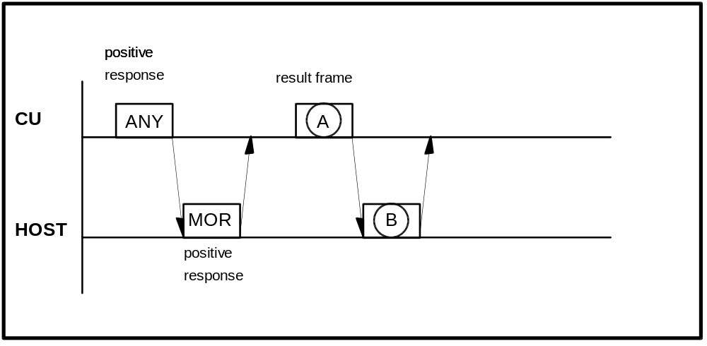
Figure 12: Result transmission

Frame A | Description
FR1 to END | Analytical data (including calibration and absorbance result)
Table 22: CU result frames FR1 to FR5 / END

Frame B | Description
REP | when text in A is abnormal
MOR | to receive analytical data next time also
REC | to direct test selection
SUS | to suspend communication
SPE | to indicate test selection
RES | to request a specific sample
Table 23: Host response to FR1 to FR5 / END
Transmission Procedure in Special Case.
Results from a patient's sample can be sent in up to six result frame packets (depending on the number of results and the maximum message length). Each frame requires a MOR from the host before the next frame will be sent. Ideally, the CU will try to transfer all packets for a sample without sending any other type of packet. There are instances, such as the analyzer needing test selection information, in which the CU can afford to wait for the current sample's result frames to transfer. One effect of this system is, that there is no delay for SPE frames. This case is shown in Figure 13.
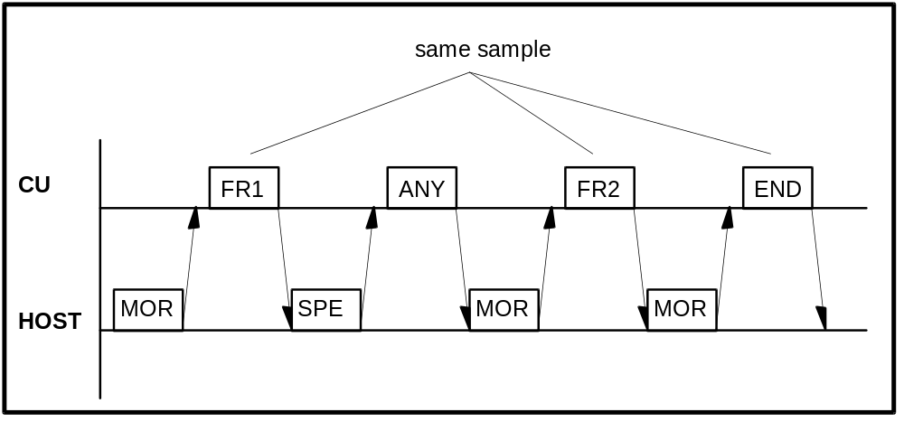
Figure 13: Result transmission with three frames and SPE interrupt

35 Resending Request
If there is any abnormality in the contents of the text received from the CU or the host, resending is requested with the REP frame. Figure 14 shows this procedure if the CU sends the REP frame; in Figure 15 the host sends the REP frame.
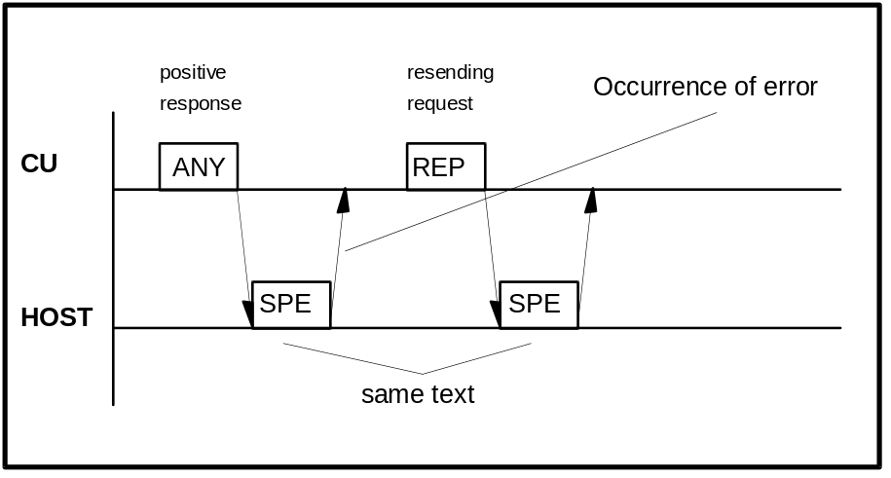
Figure 14: Resending request with REP frame from CU to host
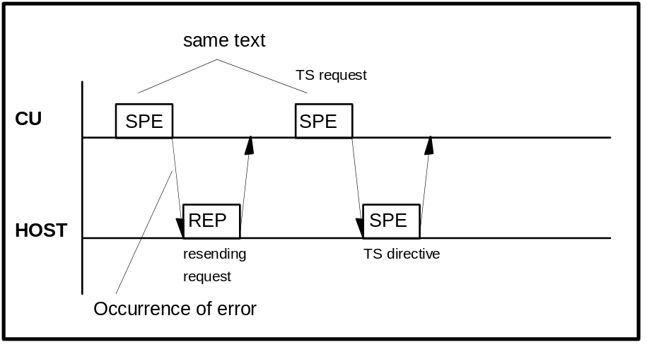
Figure 15: Resending request with REP frame from host to CU

36 Termination and Restart of Communication

Condition of Termination | Real-time  Communication | Batch  Communication | Restart of Communication
Specification of [Disable] for  ‘Host Comm’ | STOP | STOP | Change from [Disable] to [Enable] for ‘Host Comm’  Previous contents of com-munication are all canceled.
Occurrence of send/receive time-out error | STOP | STOP | Same as above
Occurrence of hardware error alarm related to communication |  |  | Same as above
Occurrence of HD read error during sending of analytical data to the host |  | STOP | Remaining samples in specified range are not sent.  Upon restart, samples in newly specified range are sent.
Stop directive through screen during sending of analytical data to the host |  | STOP * | Same as above
Occurrence of HD read error during transfer of analytical data for specific sample to the host |  |  | Relevant sample alone is canceled.
Detection of abnormality in text (discrepancy in end-of-data code between CU and host for example) |  |  | ----------
Occurrence of E. STOP-Level alarm at CU side |  |  | ----------
Table 24: Termination and restart of communication
Note*:
Transfer of analytical data is stopped regardless of sample type (routine, STAT or control sample).
Example: Cancellation during batch transfer of analytical data is possible with the ‘Flush’ buttons on the Send Host windows

37 Retry and Repeat of Communication
(1) Retry of Communication
If the host does not respond to an ANY frame within the communication cycle time (2 to 10 seconds), the CU issues the warning 126-001 (“timeout error on receiption“) and continues sending the last frame that was not acknowledged by the host (if the last frame was the ANY frame, then a REP frame is sent). On the Host Setting screen (see Figure 4 on page 9) the number of these retries to reestablish the data link (‘Retry Count’ option) can be set from ‘1’ to ‘99’. (or ‘0’, which stands for an infinite number of retries). Also the time between these retries (‘Retry Time’ option) can be set from ‘1’ to ‘99’ seconds on this screen.
After the last retry without host answer the CU issues the warning 126-014 (“communication was disabled after the specified number of retries“) the communication is switched off.
(2) Repeat Communication
On the occurrence of a communication error, a repeat is requested immediately (with REP frame). If the number of repeat frames (‘Repeat Count’ option on the Host Setting screen can be set from ‘1’ to ‘99’) is reached, the CU cancels sending the current text and transfers the next text.

38 RESULT-ONLY mode
In this mode, analytical data alone is transfered to the host and resending request (REP frame) from the CU or host or response to specific sample request is not made.
If [Enable] is specified for ‘Result Only’ on the Host Setting screen (see Figure 4 on page 9), the CU returns no response to test selection inquiry or test selection directive even when [Enable] is specified for the test selection inquiry. The CU waits for two seconds or more after sending ETX in the analytical data text and proceeds to transfer to the host regardless of the communication procedure (realtime or batch result transmission).
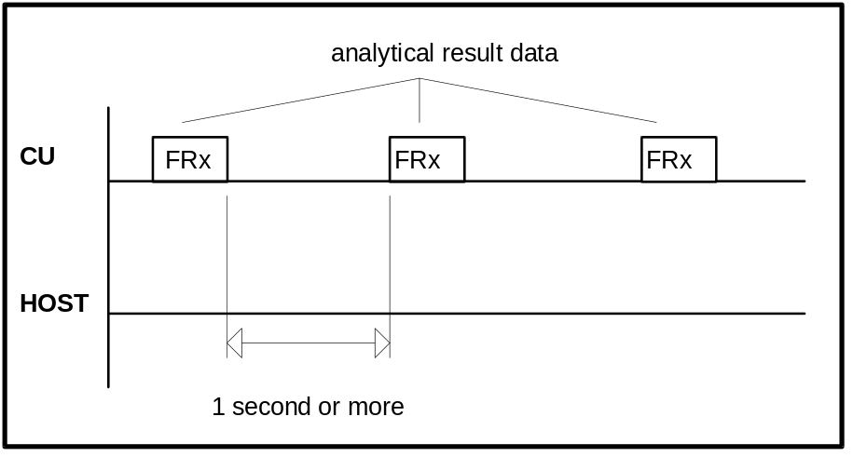
Figure 16: Timing in case of ‘Result Only’ option enabled

39 Communication Functions

40 Function List for Test Selection Data

Function |  | Inquiry | Directive | Conditions | Note
Routine sample |  |  |  | Invalid when [Enable] is specified for ‘Result Only’ on Host Setting screen (see Figure 4 on page 9)
STAT  sample | with ID |  |  | Valid when [Enable] is specified for ‘STAT TS Inq’ on Host Setting screen
 | without ID |  |  | Invalid when [Enable] is specified for ‘Result Only’
Manual  Rerun  sample | Routine  sample |  |  | Valid when [Enable] is specified for ‘Manual Rerun Inq’ on Host Setting screen (Note 1)  Invalid when [Enable] is specified for ‘Result Only’ | 1
Automatic  Rerun  sample | Routine  sample |  |  | Valid when [Enable] is specified for ‘Auto Rerun Inq’ on Host Setting screen (Note 2)  Invalid when [Enable] is specified for ‘Result Only’ | 2
Table 25: Function list for test selection data
Note 1: When [Disable] is specified for ‘Rerun Only Inq’, an inquiry is not sent from the analyzer to the host. However, for any sample that has been measured at least once in the analyzer, the test selection directive can be accepted from the host.
Note 2: When [Disable] is specified for ‘Auto Rerun Inq’, an inquiry is not sent from the analyzer to the host. However, for any sample that has been measured at least once in the analyzer, the test selection directive can be accepted from the host.

41 Function List for Result Data
Function |  | Real-time  Communication | Batch  Communication | Specific  Sample  Request  from host | Conditions
Routine sample |  |  |  |  | Specific sample request is invalid when
STAT sample |  |  |  |  | [Enable] is specified for ‘Result Only’
Control sample |  |  |  |  | on Host Setting screen  (see Figure 4 on page 9)
Automatic/  Manual | Routine  sample
Rerun  sample | STAT  sample
Calibration
Original absorbance
Table 26: Function list for result data
Comments:
- The above real-time communication indicates a communication carried out while the instrument is busy in analysis, and the batch communication indicates a communication when specified through the screen.
- Batch result communication is initiated on ...
Workplace è Data Review è Send Host screen
for Routine and STAT results
Workplace è Data Review è Reaction Monitor è Send Host screen
for Routine, STAT and Rerun Absorbance data
QC è Individual è Send Host screen
for Control results
QC è Individual è Data List è Reaction Monitor è Send Host screen
for Control Absorbance data

With the [Flush] button on the corresponding screens a running transmission can be aborted.

42 Function List for Analyzer Information Transfer
Function | Conditions
Channel Assignment Information | sent to the host when communication is started for the first time after power on.
Table 27: Function list for analyzer information

43 Communication Trace

44 Overview
If enabled on the Host Setting screen (option ‘Comm Trace’ / see Figure 4 on page 9) the contents of the communication between the CU and host is stored on the hard disk. To check the contents of communication, the stored data is output onto the printer as a report.

45 Trace Data
The time of communication execution, the direction of communication and the contents of the message are stored.
The data to be stored differs between the following two cases.
a) In normal communication.
The host ID, Instrument ID, packet no., frame character, function character and sample information (sample no., disk no., position no. and ID no. alone) are stored.
Note, however, that only the host ID, Instrument ID, packet no., frame character and function character are stored for the text which does not contain sample information.
b) Upon Occurrence of any error during communication.
The details of the error and all characters up to occurrence of the error are stored.
Note, however, that only the host ID, Instrument ID, packet no., frame character, function character and sample information (same as in a) above) are stored the same as in normal communication if send time-out occurs during sending from the CU to the system.

46 Reset and Printout of Trace Data
To printout and/or delete the trace data file, proceed Print è Maint/Utility è System Communication Trace.

47 Trace Data Storing Performance
Data of up to 2000 cycles (conversation) can be stored.

48 Example Traces

Example 1: Test Selection inquiry / Test selection / Result
Example 2: Absorbance data from CU to host
Example 3: Photometry assay Calibration data from CU to host
Example 4: ISE Calibration data from CU to host
Example 5: Control data from CU to host
Example 6: Specific Result Request from host to CU
Example 7: Channel Assignment Information from CU to host

Common explanations for the following HIT 917 trace lists:
Format
1st column Sender of text (CU=Control Unit)
2nd column Sending time
3rd column Trace data

Replacement of Control charcters
Mnemonic meaning replaced ASCII code
[STX] start of text 02H
[ETX] end of text 03H
[CR] carriage return 0DH
^ space 20H

Table 28: Communication trace details
The communication trace was aquired with the Interface Testprogram 'HOST917.EXE' (developed by the Technical Productmanagement / Data Technique department)

49 Test Selection inquiry from CU to host incl. Result

CU 12:32:01,73 [STX]215>[ETX]D6[CR]
Host 12:32:01,83 [STX]215>[ETX]D6[CR]

CU 12:32:05,89 [STX]216;N1^^^^1^^^^0^^1^^^^^^^^^^^^^^^^^^^0712941225<ETX
>86[CR]
Host 12:32:06,17 [STX]216;N1^^^^1^^^^0^^11only^comment1^3531^^^^^^^^^^^881
100000000000000000000000000000000000000000000000000000000
00000000000000000000000000001011111Smith^^^^^^^^^^^^^^^^^
^^^^^^^^John^^^^^^^^^^^^^^^^^^^^^Comm^3^^^^^^^^^^^^^^Comm
^4^^^^^^^^^Comm^5^^^^[ETX]E4[CR]

CU 12:32:06,67 [STX]217>[ETX]D8[CR]
Host 12:32:06,83 [STX]217>[ETX]D8[CR]

...

CU 12:43:25,00 [STX]212>[ETX]D3[CR]
Host 12:43:25,10 [STX]212>[ETX]D3[CR]

CU 12:43:29,60 [STX]213:N1^^^^1^^^^0^^11only^comment1^35310712941225^^^^
^^^^5^^1^^^3.5$^^2^^^331^^87^113.1^^88^^4.81^^89^^84.2^11
111Smith^^^^^^^^^^^^^^^^^^^^^^^^^John^^^^^^^^^^^^^^^^^^^^
^Comm^3^^^^^^^^^^^^^^Comm^4^^^^^^^^^Comm^5^^^^[ETX]12[CR]
Host 12:43:29,94 [STX]213>[ETX]D4[CR]

CU 12:43:34,05 [STX]214>[ETX]D5[CR]
Host 12:43:34,17 [STX]214>[ETX]D5[CR]

Text format of example 1a: Test Selection Inquiry from the CU

Inquiry: The CU sends a test selection inquiry.
(each character ^ stands for a blank - ASCII code 20h)

CU 12:32:05,89 [STX]216;N1^^^^1^^^^0^^1^^^^^^^^^^^^^^^^^^^0712941225[ETX
]86[CR]

 | [STX]  2  1  6  ;  N  1  [Sample information]  ^^^^1  ^^^^0  ^^1  1  ^^^^^^^^^^^^^  ^^^^  ^  071294  1225  [ETX]  86  [CR] | Start of text (ASCII code 02H)  Host-ID : 2  Instrument-ID : 1  Packet number : 6  Frame character : ; for TS inquiry  Function character: N for  - routine sample  - without barcode reader  - realtime communication  Class : 1  Sample number : 1  Disk number : 0  Position : 1  Cup : Standard  Ident-No : (undefined)  Age : (undefined)  Sex : (undefined)  Date : 12th of July 1994  Time : 12:25  End of text (ASCII code 03H)  Checksum  Carriage return (ASCII code 0DH)
Text format of example 1b: Test Selection from the Host

The host sends the according test selection to the CU.
(each character ^ stands for a blank - ASCII code 20h)

Host 12:32:06,17 [STX]216;N1^^^^1^^^^0^^11only^comment1^3531^^^^^^^^^^^881
100000000000000000000000000000000000000000000000000000000
00000000000000000000000000001011111Smith^^^^^^^^^^^^^^^^^
^^^^^^^^John^^^^^^^^^^^^^^^^^^^^^Comm^3^^^^^^^^^^^^^^Comm
^4^^^^^^^^^Comm^5^^^^[ETX]E4[CR]
 | [STX]  2  1  6  ;  N  1  [Sample information]  ^^^^1  ^^^^0  ^^1  1  only comment1  ^353  1  ^^^^^^  ^^^^  [Test Selection Information]  ^88  11000000...010  [Comments]  11111  Smith^^^^^^^^^^^^^^^^^^^^^^^^^  John^^^^^^^^^^^^^^^^^^^^^  Comm^3^^^^^^^^^^^^^^  Comm^4^^^^^^^^^  Comm^5^^^^  [ETX]  E4  [CR] | Start of text (ASCII code 02H)  Host-ID : 2  Instrument-ID : 1  Packet number : 6  Frame character : ; for Test Selection  Function character: N for  - routine  - without barcode reader  - realtime communication  Class : 1  Sample number : 1  Disk number : 0  Position : 1  Cup : Standard  Ident-No : (treated as comment)  Age : 35 Years  Sex : male  Date : undefined  Time : undefined  No. of test flags : 88  Selected tests : 1, 2, 87  Selected Comments : 1 to 5  Comment field 1  Comment field 2  Comment field 3  Comment field 4  Comment field 5  End of text (ASCII code 03H)  Checksum  Carriage return (ASCII code 0DH)
Text format of example 1c: Result Transmission from the CU

The CU sends the result to the host.
(each character ^ stands for a blank - ASCII code 20h)

CU 12:43:29,60 [STX]213:N1^^^^1^^^^0^^11only^comment1^35310712941225^^^^
^^^^5^^1^^^3.5$^^2^^^331^^87^113.1^^88^^4.81^^89^^84.2^11
111Smith^^^^^^^^^^^^^^^^^^^^^^^^^John^^^^^^^^^^^^^^^^^^^^
^Comm^3^^^^^^^^^^^^^^Comm^4^^^^^^^^^Comm^5^^^^[ETX]12[CR]
 | [STX]  2  1  3  :  N  1  [Sample information]  ^^^^1  ^^^^0  ^^1  1  only comment1  ^353  1  071294  1225  [Result Information]  ^^^^^^  ^^5  ^^1  ^^^3.5  $  ^^2  ^^^331  ^  ^87  ^113.1  ^  ^88  ^^4.81  ^  ^89  ^^84.2  ^  [Comments]  11111  Smith^^^^^^^^^^^^^^^^^^^^^^^^^  John^^^^^^^^^^^^^^^^^^^^^  Comm^3^^^^^^^^^^^^^^  Comm^4^^^^^^^^^  Comm^5^^^^  [ETX]  12  [CR] | Start of text (ASCII code 02H)  Host-ID : 2  Instrument-ID : 1  Packet number : 3  Frame character : : for Result  Function character: N for  - routine  - without barcode reader  - realtime communication  Class : 1  Sample number : 1  Disk number : 0  Position : 1  Cup : Standard  Ident-No : (treated as comment)  Age : 35 Years  Sex : male  Date : 12th of July 1994  Time : 12:25  Operator ID  No. of results : 5  1. Result  Test no. : 1  Result : 3.5  Alarm : $ for LIMIT high  2. Result  Test no. : 2  Result : 331  Alarm : no alarm  3. Result  Test no. : 87 (ISE Na)  Result : 113.1  Alarm : no alarm  4. Result  Test no. : 88 (ISE K )  Result : 4.81  Alarm : no alarm  5. Result  Test no. : 89 (ISE Cl)  Result : 84.2  Alarm : no alarm  Comment fields 1 to 5 are selected  Comment field 1  Comment field 2  Comment field 3  Comment field 4  Comment field 5  End of text (ASCII code 03H)  Checksum  Carriage return (ASCII code 0DH)

50 Absorbance data from CU to host
CU 17:08:46,08 [STX]217>[ETX]D8[CR]
Host 17:08:46,19 [STX]217>[ETX]D8[CR]

CU 17:08:51,57 [STX]218:i1^^^^1^^^^0^^1^^^^^^^^^^^^^^^^^3^0712941408^^1^
^^3.7$^^^^^^^^^^^^^^^^^^^^^^^^^^^^^^^^^^^^^^^236^^^238^^^
237^11^^6205^^6377^^6444^^6486^^6525^^6553^^6576^^6597^^6
613^^6624^^6639[ETX]1B[CR]
Host 17:08:51,96 [STX]218>[ETX]D9[CR]

CU 17:08:57,12 [STX]211>[ETX]D2[CR]
Host 17:08:57,23 [STX]211>[ETX]D2[CR]

Text format of example 2: Absorbance data from the CU

The CU sends original absorbance data to the host.
(each character ^ stands for a blank - ASCII code 20h)

CU 17:08:51,57 [STX]218:i1^^^^1^^^^0^^1^^^^^^^^^^^^^^^^^3^0712941408^^1^
^^3.7$^^^^^^^^^^^^^^^^^^^^^^^^^^^^^^^^^^^^^^^236^^^238^^^
237^11^^6205^^6377^^6444^^6486^^6525^^6553^^6576^^6597^^6
613^^6624^^6639[ETX]1B[CR]
 | [STX]  2  1  8  :  i  1  ^^^^1  ^^^^0  ^^1  ^  ^^^^^^^^^^^^^  ^^^3  ^  071294  1408  ^^1  ^^^3.7  $  ^^^  ^^^^^^  ^  ^^^  ^^^^^^  ^  ^^^  ^^^^^^  ^  ^^^^^^  ^^^236  ^^^238  ^^^237  ^11  ^^6205  ^^6377  ^^6444  ^^6486  ^^6525  ^^6553  ^^6576  ^^6597  ^^6613  ^^6624  ^^6639  [ETX]  1B  [CR] | Start of text (ASCII code 02H)  Host-ID : 2  Instrument-ID : 1  Packet number : 8  Frame character : : for Result  Function character: i for  - routine  - absorbance data  Class : 1  Sample number : 1  Disk number : 0  Position : 1  Cup : Standard  Ident-No : (treated as comment)  Age : in Years  Sex : male  Date : 12th of July 1994  Time : 14:08  1. Test no. : 1  Result : 3,7  Alarm : $  2. Test no.  2. Result  2. Alarm  3. Test no.  3. Result  3. Alarm  4. Test no.  4. Result  4. Alarm  1. blank value  2. blank value  3. blank value  4. blank value  No. of Abs. values : 11  Absorbance value 1 : 6205  Absorbance value 2 : 6377  Absorbance value 3 : 6444  Absorbance value 4 : 6486  Absorbance value 5 : 6525  Absorbance value 6 : 6553  Absorbance value 7 : 6576  Absorbance value 8 : 6597  Absorbance value 9 : 6613  Absorbance value 10 : 6624  Absorbance value 11 : 6639  End of text (ASCII code 03H)  Checksum  Carriage return (ASCII code 0DH)

51 Photometry-assay Calibration data from CU to host

CU 15:44:58,80 [STX]211>[ETX]D2[CR]
Host 15:44:58,87 [STX]211>[ETX]D2[CR]

CU 15:45:01,05 [STX]212:G^^^^^^^^^12^1^^1316^^1396^^1312^^1383^^^^^^02^^
6726^^7385^^6671^^7321^^^^^^0N^^^^^^^[ETX]AB[CR]
Host 15:45:01,17 [STX]212>[ETX]D3[CR]

CU 15:45:03,21 [STX]213>[ETX]D4[CR]
Host 15:45:03,26 [STX]213>[ETX]D4[CR]
Text format of example 3:

The CU sends photometry assay calibration data to the host.
(each character ^ stands for a blank - ASCII code 20h)

CU 15:45:01,05 [STX]212:G^^^^^^^^^12^1^^1316^^1396^^1312^^1383^^^^^^02^^
6726^^7385^^6671^^7321^^^^^^0N^^^^^^^[ETX]AB[CR]

[STX]  2  1  2  :  G^  ^^^^^^  ^^1  2  ^  1  ^^1316  ^^1396  ^^1312  ^^1383  ^  ^^^^^0  2  ^^6726  ^^7385  ^^6671  ^^7321  ^  ^^^^^0  N  ^^^^^^  ^  [ETX]  AB  [CR] | Start of text (ASCII code 02H)  Host-ID : 2  Instrument-ID : 1  Packet number : 2  Frame character : : for Result  Function character: G for Photometric Calibration  Operator ID  Channel no. : 1  No. of standards : 2  Calibration alarm  STD No. 1  1st absorbance data  1st initial absorbance data  2nd absorbance data  2nd initial absorbance data  data alarm  Prozone value  STD No. 2  1st absorbance data  1st initial absorbance data  2nd absorbance data  2nd initial absorbance data  data alarm  Prozone value  N for 'no SD value'  value  decimal point position  End of text (ASCII code 03H)  Checksum  Carriage return (ASCII code 0DH)

52 ISE Calibration data from CU to host

CU 15:41:10,05 [STX]212>[ETX]D3[CR]
Host 15:41:10,10 [STX]212>[ETX]D3[CR]

CU 15:41:12,41 [STX]213:H^^^^^^^B^^1^-32.0^^2^-34.8^^3^-27.3^^4^-26.8^^5
^^60.0^^6^133.6^^7^^^163^^8^^^^-4^^^1^-38.0^^2^-50.6^^3^-
29.0^^4^-31.7^^5^^58.7^^6^^4.92^^7^^6.31^^8^-0.02^^^1^111
.6^^2^113.5^^3^106.5^^4^107.3^^5^-39.8R^6^^89.5^^7^^^115^
^8^^^^^1^[ETX]F7[CR]
Host 15:41:12,73 [STX]213>[ETX]D4[CR]

Text format of example 4:
The CU sends ISE calibration data to the host.
(each character ^ stands for a blank - ASCII code 20h)

CU 15:41:12,41 [STX]213:H^^^^^^^B^^1^-32.0^^2^-34.8^^3^-27.3^^4^-26.8^^5
^^60.0^^6^133.6^^7^^^163^^8^^^^-4^^^1^-38.0^^2^-50.6^^3^-
29.0^^4^-31.7^^5^^58.7^^6^^4.92^^7^^6.31^^8^-0.02^^^1^111
.6^^2^113.5^^3^106.5^^4^107.3^^5^-39.8R^6^^89.5^^7^^^115^
^8^^^^^1^[ETX]F7[CR]

[STX]  2  1  3  :  H^  ^^^^^^  B  ^  ^1  ^-32.0  ^  ^2  ^-34.8  ^  ^3  ^-27.3  ^  ^4  ^-26.8  ^  ^5  ^^60.0  ^  ^6  ^133.6  ^  ^7  ^^^163  ^  ^8  ^^^^-4  ^ | Start of text (ASCII code 02H)  Host-ID : 2  Instrument-ID : 1  Packet number : 2  Frame character : : for Result  Function character: G for Photometric Calibration  Operator ID  ISE Type B = Tests Na, K, Cl  Na data alarm  Cal. data 1  value = -32  data alarm 1  Cal. data 2  value = -34,8  data alarm 2  Cal. data 3  value = -27,3  data alarm 3  Cal. data 4  value = -26,8  data alarm 4  Cal. data 5  value = 60  data alarm 5  Cal. data 6  value = 133,6  data alarm 6  Cal. data 7  value = 163  data alarm 7  Cal. data 8  value = -4  data alarm 8
Text format of Example 4 cont.
^  ^1  ^-38.0  ^  ^2  ^-50.6  ^  ^3  ^-29.0  ^  ^4  ^-31.7  ^  ^5  ^^58.7  ^  ^6  ^^4.92  ^  ^7  ^^6.31  ^  ^8  ^-0.02  ^ | K data alarm  Cal. data 1  value = -38  data alarm 1  Cal. data 2  value = -50,6  data alarm 2  Cal. data 3  value = -29  data alarm 3  Cal. data 4  value = -31,7  data alarm 4  Cal. data 5  value = 58,7  data alarm 5  Cal. data 6  value = 4,92  data alarm 6  Cal. data 7  value = 6,31  data alarm 7  Cal. data 8  value = -0,02  data alarm 8
^  ^1  ^111.6  ^  ^2  ^113.5  ^  ^3  ^106.5  ^  ^4  ^107.3  ^  ^5  ^-39.8  R  ^6  ^^89.5  ^  ^7  ^^^115  ^  ^8  ^^^^^1  ^  [ETX]  F7  [CR] | Cl data alarm  Cal. data 1  value = 111,6  data alarm 1  Cal. data 2  value = 113,5  data alarm 2  Cal. data 3  value = 106,5  data alarm 3  Cal. data 4  value = 107,3  data alarm 4  Cal. data 5  value = -39,8  data alarm 5  Cal. data 6  value = 89,5  data alarm 6  Cal. data 7  value = 115  data alarm 7  Cal. data 8  value = 1  data alarm 8  End of text (ASCII code 03H)  Checksum  Carriage return (ASCII code 0DH)

53 Control data from CU to host
CU 15:52:21,51 [STX]218>[ETX]D9[CR]
Host 15:52:21,57 [STX]218>[ETX]D9[CR]

CU 15:52:23,82 [STX]211:F1^^117^^^^^^^^^^^^^^PNU^^^^^^^^^^^^^^^^^^^^^^^^
^^^^7^^1^^^3.5^^^2^^^340^^^3^^1.69^^^5^^^5.1^^87^116.4^^8
8^^4.80^^89^^85.4^[ETX]05[CR]
Host 15:52:23,98 [STX]211>[ETX]D2[CR]

CU 15:52:26,17 [STX]212>[ETX]D3[CR]
Host 15:52:26,23 [STX]212>[ETX]D3[CR]

Text format of example 5:

The CU sends control data to the host.
(each character ^ stands for a blank - ASCII code 20h)

CU 15:52:23,82 [STX]211:F1^^117^^^^^^^^^^^^^^PNU^^^^^^^^^^12345678^^^^^^
^^^^7^^1^^^3.5^^^2^^^340^^^3^^1.69^^^5^^^5.1^^87^116.4^^8
8^^4.80^^89^^85.4^[ETX]05[CR]

[STX]  2  1  1  :  F  1  ^^1  17  ^^^^^  ^^^  ^  ^^^^^PNU^^^^^  ^^^^  ^  12345678  ^^  ^^^^^^  ^^7  ^^1  ^^^3.5  ^  ^^2  ^^^340  ^  ^^3  ^^1.69  ^  ^^5  ^^^5.1  ^  ^87  ^116.4  ^  ^88  ^^4.80  ^  ^89  ^^85.4  ^  [ETX]  05  [CR] | Start of text (ASCII code 02H)  Host-ID : 2  Instrument-ID : 1  Packet number : 1  Frame character : : for Result  Function character: F for Control / realtime  Class : 1  Control No. : 1  Sequence No. : 17  Disk No : 5 spaces  Position : 3 spaces  Cup : 1 space  ID containing Control name  Age : 4 spaces  Sex : 1 space  Control Lot no. : 12345678  2 spaces  Operator ID  No. of results : 7  Test No. : 1  value : 3,5  Alarm : no alarm  Test No. : 2  value : 340  Alarm : no alarm  Test No. : 3  value : 1,69  Alarm : no alarm  Test No. : 5  value : 5,1  Alarm : no alarm  Test No. : 87  value : 116,4  Alarm : no alarm  Test No. : 88  value : 4,8  Alarm : no alarm  Test No. : 89  value : 85,4  Alarm : no alarm  End of text (ASCII code 03H)  Checksum  Carriage return (ASCII code 0DH)

54 Specific Result Request from host to CU
CU 17:08:08,19 [STX]217>[ETX]D8[CR]
Host 17:08:08,30 [STX]217>[ETX]D8[CR]

CU 17:08:13,46 [STX]218>[ETX]D9[CR]
Host 17:08:13,57 [STX]218<n1^^^^1^^^^0^^1^^^^^^^^^^^^^^^^^^^^^^^^^^^^^<ETX
>E8[CR]

CU 17:08:13,78 [STX]211>[ETX]D2[CR]
Host 17:08:13,89 [STX]211>[ETX]D2[CR]

CU 17:08:19,28 [STX]212:n1^^^^1^^^^0^^11^^^^^^^^^^^^^^^^3^0628940914^^^^
^^^^7^^1^^^3.6^^^2^^^343^^^3^^1.99^^^5^^^5.1^^87^107.1^^8
8^^4.08^^89^^77.8^11111Kommentar^1^^^^^^^^^^^^^^^^^^^^^^^
^^^^^^^^^^^^^^^^^^^^^^^^^^^^^^^^^^^^^^^^^^^^^^^^^^^^^^^^^
^^^^^^^^^[ETX]A0[CR]
Host 17:08:19,67 [STX]212>[ETX]D3[CR]

Text format of example 6:

The host sends a specific result request / the CU sends back the corresponding result, if available
(each character ^ stands for a blank - ASCII code 20h)

Host 17:08:13,57 [STX]218<n1^^^^1^^^^0^^1^^^^^^^^^^^^^^^^^^^^^^^^^^^^^[ETX
]E8[CR]

[STX]  2  1  8  <  n  1  ^^^^1  ^^^^0  ^^1  ^  ^^^^^^^^^^^^^  ^^^^  ^  ^^^^^^  ^^^^  [ETX]  E8  [CR] | Start of text (ASCII code 02H)  Host-ID : 2  Instrument-ID : 1  Packet number : 8  Frame character : < for Result request  Function character: n for  - routine sample  - without barcode reader  - batch communication  Class : 1  Sample number : 1  Disk number : 0  Position : 1  Cup : (undefined)  Ident-No : (undefined)  Age : (undefined)  Sex : (undefined)  Date : 12th of July 1994  Time : 12:25  End of text (ASCII code 03H)  Checksum  Carriage return (ASCII code 0DH)

55 Channel Assignment Information from host to CU
CU 15:24:22,98 [STX]214>[ETX]D5[CR]
Host 15:24:23,03 [STX]214>[ETX]D5[CR]

CU 15:24:25,35 [STX]2151XA^^1^50^^^4^^^7^288^104^166^^^^^^^^^^^^^^^^^^^^
^^^^^^^^^^^^^^^^^^^^^^^^^^^^^^^^^^^^^^^^^^^^^^^^^^^^^^^^^
^^^^^^^^^^^^^^^^^^^^^^^^^^^^^^^^^^^^^^^^^^^^^^^^^^^^^^^^^
^^^^^^^^^^^^^^^^^^^^^^^^^^^^^^^^^^^^^^^^^^^^^^[ETX]37[CR]
Host 15:24:25,57 [STX]215>[ETX]D6[CR]

CU 15:24:27,82 [STX]216:XA^51^50^^^^^^^^^^^^^^^^^^^^^^^^^^^^^^^^^^^^^^^^
^^^^^^^^^^^^^^^^^^^^^^^^^^^^^^^^^^^^^^^^^^^^^^^^^^^^^^^^^
^^^^^^^^^^^^^^^^^^^^^^^^^^^^^^^^^^^^^^^^^^^^^^^^989^990^9
91^992^993^994^^^^^^^^^^^^^^^^^^^^^^^^^^^^^^^^[ETX]15[CR]
Host 15:24:28,03 [STX]216>[ETX]D7[CR]

CU 15:24:30,12 [STX]217>[ETX]D8[CR]
Host 15:24:30,17 [STX]217>[ETX]D8[CR]

Text format of example 7a:

The CU sends the channel assignment to the host (first frame)
(each character ^ stands for a blank - ASCII code 20h)

CU 15:24:25,35 [STX]2151XA^^1^50^^^4^^^7^288^104^166^^^^^^^^^^^^^^^^^^^^
^^^^^^^^^^^^^^^^^^^^^^^^^^^^^^^^^^^^^^^^^^^^^^^^^^^^^^^^^
^^^^^^^^^^^^^^^^^^^^^^^^^^^^^^^^^^^^^^^^^^^^^^^^^^^^^^^^^
^^^^^^^^^^^^^^^^^^^^^^^^^^^^^^^^^^^^^^^^^^^^^^[ETX]37[CR]
[STX]  2  1  5  1  XA  ^^1  ^50  ^^^4  ^^^7  ^288  ^104  ^166  ^^^^  [ETX]  37  [CR] | Start of text (ASCII code 02H)  Host-ID : 2  Instrument-ID : 1  Packet number : 5  Frame character : 1 for 1. Result frame  Function character: XA for Channel Assignment  Start channel no. : 1  No. of channels : 50  Application code 1: 4  Application code 2: 7  Application code 3: 288  Application code 4: 104  Application code 5: 166  Channels 6 to 50 are not set  4 spcaes each  End of text (ASCII code 03H)  Checksum  Carriage return (ASCII code 0DH)

Text format of example 7b:

The CU sends the channel assignment to the host (2. frame)
(each character ^ stands for a blank - ASCII code 20h)

CU 15:24:27,82 [STX]216:XA^51^50^^^^^^^^^^^^^^^^^^^^^^^^^^^^^^^^^^^^^^^^
^^^^^^^^^^^^^^^^^^^^^^^^^^^^^^^^^^^^^^^^^^^^^^^^^^^^^^^^^
^^^^^^^^^^^^^^^^^^^^^^^^^^^^^^^^^^^^^^^^^^^^^^^^989^990^9
91^992^993^994^^^^^^^^^^^^^^^^^^^^^^^^^^^^^^^^[ETX]15[CR]
[STX]  2  1  6  :  XA  ^51  ^50  ^^^^  ....  ^989  ^990  ^991  ^992  ^993  ^994  ....  ^^^^  [ETX]  37  [CR] | Start of text (ASCII code 02H)  Host-ID : 2  Instrument-ID : 1  Packet number : 6  Frame character : : for last Result frame  Function character: XA for Channel Assignment  Start channel no. : 51  No. of channels : 50  Channels 51 to 86 are not set => 4 spcaes each  Application code 87: 989  Application code 88: 990  Application code 89: 991  Application code 90: 992  Application code 91: 993  Application code 92: 994  Channels 93 to 100 are not set => 4 spcaes each  End of text (ASCII code 03H)  Checksum  Carriage return (ASCII code 0DH)

56 Figures and Tables
Figure 1: BM/HITACHI 917 Interface data flow
Figure 2: Connection with hardware handshake
Figure 3: Connection without hardware handshake
Figure 4: Host Setting screen
Figure 5: Start Conditions screen
Figure 6: Test selection download in batch mode
Figure 7: Test selection download in realtime mode
Figure 8: Common communication timing
Figure 9: Communication timing without information exchange
Figure 10: Transfer of communication control message
Figure 11: Test selection inquiry
Figure 12: Result transmission
Figure 13: Result transmission with three frames and SPE interrupt
Figure 14: Resending request with REP frame from CU to host
Figure 15: Resending request with REP frame from host to CU
Figure 16: Timing in case of ‘Result Only’ option enabled

Table 1: Pin description for the 9-pin plug ‘Serial A’ of the HP Vectra
Table 2: Specification of the host communication
Table 3: Frame types having a Data Field
Table 4: Frame types having no data field
Table 5: Frame priorities
Table 6: Function characters
Table 7: Format of sample information / b = space (20H)
Table 8: Format of test selection information / b = space (20H)
Table 9: Format of comment information
Table 10: Format of analytical result data / b = space (20H)
Table 11: Format of measured value / b = space (20H)
Table 12: No. of test results per frame according to the text size.
Table 13: Format of absorbance data / b = space (20H)
Table 14: No. of absorbance values per frame according to the text size.
Table 15: Format of photometry-assay calibration data / b = space(20H)
Table 16: Format of ISE calibration data / b = space(20H)
Table 17: Format of channel assignment information / b = space(20H)
Table 18: Data alarm list (part 1)
Table 19: Data alarm list (part 2)
Table 20: Format of the end-of-data code
Table 21: Host response to test selection inquiry
Table 22: CU result frames FR1 to FR5 / END
Table 23: Host response to FR1 to FR5 / END
Table 24: Termination and restart of communication
Table 25: Function list for test selection data
Table 26: Function list for result data
Table 27: Function list for analyzer information
Table 28: Communication trace details

Appendix A - ASCII Chart

Char  Hex Dez | Char  Hex Dez | Char  Hex Dez | Char  Hex Dez | Char  Hex Dez | Char  Hex Dez | Char  Hex Dez | Char  Hex Dez
NUL  00 0 | DLE  10 16 | Space  20 32 | 0  30 48 | @  40 64 | P  50 80 | `  60 96 | p  70 112
SOH  01 1 | DC1  11 17 | !  21 33 | 1  31 49 | A  41 65 | Q  51 81 | a  61 97 | q  71 113
STX  02 2 | DC2  12 18 | "  22 34 | 2  32 50 | B  42 66 | R  52 82 | b  62 98 | r  72 114
ETX  03 3 | DC3  13 19 | #  23 35 | 3  33 51 | C  43 67 | S  53 83 | c  63 99 | s  73 115
EOT  04 4 | DC4  14 20 | $  24 36 | 4  34 52 | D  44 68 | T  54 84 | d  64 100 | t  74 116
ENQ  05 5 | NAK  15 21 | %  25 37 | 5  35 53 | E  45 69 | U  55 85 | e  65 101 | u  75 117
ACK  06 6 | SYN  16 22 | &  26 38 | 6  36 54 | F  46 70 | V  56 86 | f  66 102 | v  76 118
BEL  07 7 | ETB  17 23 | '  27 39 | 7  37 55 | G  47 71 | W  57 87 | g  67 103 | w  77 119
BS  08 8 | CAN  18 24 | (  28 40 | 8  38 56 | H  48 72 | X  58 88 | h  68 104 | x  78 120
HT  09 9 | EM  19 25 | )  29 41 | 9  39 57 | I  49 73 | Y  59 89 | i  69 105 | y  79 121
LF  0A 10 | SUB  1A 26 | *  2A 42 | :  3A 58 | J  4A 74 | Z  5A 90 | j  6A 106 | z  7A 122
VT  0B 11 | ESC  1B 27 | +  2B 43 | ;  3B 59 | K  4B 75 | [  5B 91 | k  6B 107 | {  7B 123
FF  0C 12 | FS  1C 28 | ,  2C 44 | <  3C 60 | L  4C 76 | \  5C 92 | l  6C 108 | |  7C 124
CR  0D 13 | GS  1D 29 | -  2D 45 | =  3D 61 | M  4D 77 | ]  5D 93 | m  6D 109 | }  7D 125
SO  0E 14 | RS  1E 30 | .  2E 46 | >  3E 62 | N  4E 78 | ^  5E 94 | n  6E 110 | ~  7E 126
SI  0F 15 | US  1F 31 | /  2F 47 | ?  3F 63 | O  4F 79 | _  5F 95 | o  6F 111 | DEL  7F 127

Appendix B - Differences between HITACHI 911 and 917
Communication Cycle Period:
HIT 911: 5 sec
HIT 917: selectable on the Host Setting screen (2 to 10 sec / default 2 sec)
Mastership of Test Selection Inquiry Communication:
HIT 911: Mastership is given to the AU: if the host does not respond to the inquiry from the AU within the specified time the sample is skipped.
HIT 917: Mastership selectable on the Host Setting screen to CU or host.
If mastership is given to the host, the CU waits analyzing the subsequent samples until the test selection of the actual sample is received.
Transmission of Absorbance Data:
HIT 911: only in realtime mode
HIT 917: only in batch mode
Transmission of Calculated Test Results:
HIT 911: No
HIT 917: Yes (like 747)
Transmission of Channel Assignment Information:
HIT 911: No
HIT 917: After power on or change of channel assignment (the application codes of all channels are sent to the host)
Maximum Size of Transfered Data:
HIT 911: 256, 512 bytes (selectable on System Parameter screen)
HIT 917: 256, 512, 1280 bytes (selectable on Host Setting screen)
Sample Cup Selection within Test Selection Info
HIT 911: Default or one of five different sample cups can be specified from host
HIT 917: Standard or Micro Cup can be specified from host
End-of-data Codes:
HIT 911: 5 different end-codes (selectable on System Parameter screen)
HIT 917: only one end-of-data code with checksum (like 747)
Retry Count:
HIT 911: 1 to 99 retries in case of no host answer (selectable on System Parameter screen)
HIT 917: 1 to 99 retries and 0 for unlimited (selectable on Host Setting screen)
Function characters:
Completely different (see manual)
Frame format:
Completely different (see manual)

New features of HIT 917 V1:

Instrument ID (sender), Host ID (receiver), Packet No. in each message
(ID`s for sending are selectable on the Host Setting screen. Received ID`s will be ignored)

‘TS Ask Always’ mode selectable on Host Setting screen (like 747)

Option of sending the comment fields within the result message selectable on Host Setting screen.

Repeat Counter: Number of REP frames can be set from ‘1’ to ‘99’ or ‘0’ for unlimited (selectable on Host Setting screen)

New features of HIT 917 V2:

Class numbers 3, 4 and 5 can be sent within the test selection for a specific sample.

The Control Lot Number is sent within the sample information section of the control result frame.

The six-character Operator ID is sent within the result frame.

STAT results can be sent ‘As soon as cooked’.

Data alarms can be selected where results with those selected alarms are not sent to the host (Exception).

Appendix C - Differences between V2 Disk and Rack Version
1. Automatic Rerun
The automatic rerun is not supported by the Rack version:
That means; the instrument does not send requests for the auto rerun to the host and also does not accept test selections for the auto rerun from the host.
2. Manual Rerun
To perform a manual rerun the rerun samples have to be placed in a pink rerun rack which has to be placed on the supply trays L or R or the additional gate.
If the barcode mode is disabled the operator has to enter the rack and position number for the manual rerun on the Data Review screen.
3. Sample Information
3.1. Sample Number
Within the Sample Information section of the corresponding messages, the 5-digit sample number field has the following format:

 | Routine/Rerun | STAT | Controls
 | bbbb1-10000 | bbbb1-bb400 | ccsss  cc = b1-40 / sss = bb1-150
(b = space)

3.2. Disk/Rack Number
The 5-digit disk/rack number field has the following format:

 | Routine | Routine Rerun | STAT | Control
 | b4001-b8999 | bA001-bA200 | bbbbb | bbbbb
 | rack types  red 4001-4999  gray 5000-6999  yellow 7000-8999 | rack type  pink A001-A200
(b = space)

3.3. Position Number
The 3-digit position number field has the following format:

 | Routine/Rerun | STAT | Control
 | bb1-bb5 | bb1-b10 | b11-b57
(b = space)

4. Additional Gate
When starting operation in either Barcode or Sample Number mode, the Rack system checks whether host communication is enabled or disabled. The additional gate will become active or inactive according to this setting as follows:

 | Mode | Host Communication | Status of the  Additional gate
 | Barcode | ON/OFF | active
 | S. No. | ON with TS inquiry | active
 |  | ON without TS inquiry  (result only) | inactive
 |  | OFF | inactive

Although the host communication status can be changed manually during operation, the status of the additional gate should be protected not to be changed during operation.

Appendix D - Error Check Functions
If the contents of the received text falls under any condition shown in the table below the CU judges that there is an abnormal character and outputs an alarm:

Attribute | Item | Error Condition | Remarks
Text Information | Host ID, Instrument ID | if the character is not within ‘0’ to ‘9’
 | Packet No. | if the character is not within ‘1’ to ‘8’
 | Frame character | if there is an unrelevant frame character
Sample Information | Sample no.  disk no.  position no.  sample cup | if a number is out of the specified range | no alarm is output if the items consist of spaces (in the ID mode)
 | ID no. | In the ID mode, the ID number must be right-justified.  Character range $20 to $FE | if the ID consists of spaces in the ID mode, an alarm is output.
 | Age, Sex, Date, Time | if the contents of each item is out of the specified range
Inquiry Information | Test Selection | if the test flags are not within ‘0’ to ‘4’  if the channel count is out of the specified range
 | Comment Information | Character range 20h to FEh

Appendix E - Table of Communication Errors

 | Contents | Alarm Code
 | A receiving timeout has occurred | 126-001
 | A transmission timeout has occurred | 126-002
 | A checksum error has occurred | 126-003
 | A parity error has occurred | 126-004
 | A framing error has occurred | 126-005
 | An overrun error has occurred | 126-006
 | A frame error has occurred | 126-007
 | A text length error has occurred | 126-008
 | A function character error has occurred | 126-009
 | A sample information data error has occurred | 126-010
 | A test selection data error has occurred | 126-011
 | A comment error has occurred | 126-012
 | A host ID, instrument ID or packet no. error has occurred | 126-013
 | Communication disabled after the specified number of retries | 126-014

Appendix F - Text Configuration Table
The columns and rows of the following tables have the following contents:

Frame type | Frame |  | Frame items
Sender | bytes |  | Item length in bytes

The following abbrevations are used: HID: Host Identification / AID: Analyzer Identification / PN: Packet number

Positive response | ANY |  | STX | HID | AID | PN | > | ETX | CSH | CSL | CR
CU | 9 |  | 1 | 1 | 1 | 1 | 1 | 1 | 1 | 1 | 1

Positive response | MOR |  | STX | HID | AID | PN | > | ETX | CSH | CSL | CR
Host | 9 |  | 1 | 1 | 1 | 1 | 1 | 1 | 1 | 1 | 1

Negative response | REP |  | STX | HID | AID | PN | ? | ETX | CSH | CSL | CR
CU / Host | 9 |  | 1 | 1 | 1 | 1 | 1 | 1 | 1 | 1 | 1

Bad and suspend | SUS |  | STX | HID | AID | PN | @ | ETX | CSH | CSL | CR
CU / Host | 9 |  | 1 | 1 | 1 | 1 | 1 | 1 | 1 | 1 | 1

Ok and suspend | REC |  | STX | HID | AID | PN | A | ETX | CSH | CSL | CR
Host | 9 |  | 1 | 1 | 1 | 1 | 1 | 1 | 1 | 1 | 1

TS Request | SPE |  | STX | HID | AID | PN | ; | Fu | Sample Information | ETX | CSH | CSL | CR
CU | 53 |  | 1 | 1 | 1 | 1 | 1 | 2 | 42 | 1 | 1 | 1 | 1

Result Request | RES |  | STX | HID | AID | PN | < | Fu | Sample Information | ETX | CSH | CSL | CR
Host | 53 |  | 1 | 1 | 1 | 1 | 1 | 2 | 42 | 1 | 1 | 1 | 1

Test selection | SPE |  | STX | HID | AID | PN | ; | Fu | Sample Information | Channel  Count | Test selection | Comments | ETX | CSH | CSL | CR
Host | 249 |  | 1 | 1 | 1 | 1 | 1 | 2 | 42 | 3 | 88 | 105 | 1 | 1 | 1 | 1

Analytical data | FR1 to END |  | STX | HID | AID | PN | : | Fu | Sample Information | Operator | Channel count | Analytical data  1 to 100 | Comments | ETX | CSH | CSL | CR
AU | 1167 |  | 1 | 1 | 1 | 1 | 1 | 2 | 42 | 6 | 3 | 1000 | 105 | 1 | 1 | 1 | 1

Absorbance data | FR1 to END |  | STX | HID | AID | PN | : | Fu | Sample Information | Analytical data 1 to 4 | Blank data 1 to 4 | Point count | ABS values  1 to 73 | ETX | CSH | CSL | CR
AU | 558 |  | 1 | 1 | 1 | 1 | 1 | 2 | 42 | 40 | 24 | 3 | 438 | 1 | 1 | 1 | 1

Photometry assay Calib | END |  | STX | HID | AID | PN | : | G_ | Operator | Test no. | STD count | Calib alarm | STD data  1 to 6 | SD value | ETX | CSH | CSL | CR
AU | 222 |  | 1 | 1 | 1 | 1 | 1 | 2 | 6 | 3 | 1 | 1 | 192 | 8 | 1 | 1 | 1 | 1

ISE Calib | END |  | STX | HID | AID | PN | : | H_ | Operator | ISE type | ISE calibration data  1 to 3 | ETX | CSH | CSL | CR
AU | 237 |  | 1 | 1 | 1 | 1 | 1 | 2 | 6 | 1 | 219 | 1 | 1 | 1 | 1

Channel Assignment | FR1 / END |  | STX | HID | AID | PN | : | XA | Start  channel | Channel  count | Application codes  1 to 50 | ETX | CSH | CSL | CR
AU | 217 |  | 1 | 1 | 1 | 1 | 1 | 2 | 3 | 3 | 200 | 1 | 1 | 1 | 1

The above tables show the text configuration when the maximum text length is set to 1280 bytes.
For details about the format of the data items refer to the corresponding chapter in this document.

