Application Tool for BM/Hitachi 902

Product Information

Version 2.1

November 1997

Contents:
1. Background
2. Setup of the Tool
2.1. Hard- and Software Requirements
2.2. Installation of the Tool
2.3. Initialization of the Application Database
3. Software Changes
3.1. Version 2.1 - November 1997
3.2. Version 2.0 - October 1997
3.2.1. Three-digit Application Code as additional data item
3.2.2. Application Update Disk Comparison
3.2.3. Application Update Disk Maintenance
3.2.4. Edit Carry-Over Evasion Information
3.2.5. Make Default Parameter Disk
4. How the Application Tool works
4.1. Application database concept
4.2. Main screen of the tool
4.3. How to move within the application database
5. How to update/create a Parameter Disk
6. Menu System of the Application Tool
Appendix A: Printouts of the Application Tool
1. Application Data - Screen Format (one application/page)
2. Application Data - List (one application/page)
3. Application Data - Table (multiple applications, only text file)
4. Application Database Index
5. Application Update Disk Index
6. Key Setting (part 1)
7. Reagent Load List (part 1)
8. Calibrator Load List
9. ISE Parameters
10. Serum Index Information
11. Carry Over Evasion Information
12. Application Update Disk Comparison

Filename: 0000.doc

1 Background
For each photometric application, which shall be measured at the BM/Hitachi 902 analyzer, the corresponding application data must be programmed. The application data for maximum 36 applications can be entered via the internal keypad or loaded from the Parameter Disk in drive 1 on the analyzer.
Since the data input via keypad is very inconvenient and each analyzer needs a customer-specific combination of applications, it is necessary to have a tool with which the applications can be modified and combined on an external computer. This individually combined application data can be written back to the Parameter Disk and then loaded into the analyzer.
This will be the main purpose of the Application Tool.

2 Setup of the Tool

3 Hard- and Software Requirements
To run the Application Tool, your computers hard and software must meet the following requirements:

any IBM compatible machine with 80486 processor or higher
a hard disk (with about 4 MB free space)
a 3.5 inch floppy drive
a VGA compatible display (resolution 640 * 480 or more)
at least four megabyte of memory
a mouse

MS-DOS version 3.1 or later
Windows version 3.0 or later

4 Installation of the Tool
The Application Tool is to be installed on the hard disk by the SETUP routine on the distribution diskette 1.
The SETUP routine creates a new directory, copies the program files, the help and library files from the distribution diskettes to the hard disk.
Be sure that no other application is open during setup !

To start Setup:
Insert the distribution diskette 1 into drive A:
From the file menu of the Program Manager or File Manager, choose Run.
Type A:\SETUP
Follow the setup instructions on the screen.

5 Initialization of the Application Database
After the first installation of the Application Tool there is neither the configuration data file (APP902.INI) nor the application database file (APP902.DB) present.
When starting the Tool for the first time by double-clicking the newly created program icon the software creates a default configuration file and an ‘empty’ application database.
Now please insert the Application Update Disk which is also included in the software packet and perform the menu option ‘Update Disk / Read Application Update Disk’.
All application entries which are stored on the disk may be copied to the application database on your harddisk.
Now you can start configuring applications and creating Parameter Disks for the BM/Hitachi 902.
Read the following chapters to find out how to do that.

6 Software Changes

7 Version 2.1 - November 1997
- The ‘Assay Code’ information was missing within the ‘Application Data Table’
Bug fixed
- If the first Carry Over Evasion entry was displayed and the [Reset] button was pressed, the first entry was not deleted.
Bug fixed

- The application comment was inserted between the channel number and the application code in the ‘Chemistry Parameter’ list.
- The caption of the Evasion Enabled/Disabled checkbox toggles for better understanding of the actual status.
- The character range for the test name text field is limited to the range that is available at the 902 analyzer (0 to 9, A to Z, -/.)
- If you try to start the tool while it is already running, a warning is displayed
- The following default values have been changed, if an application entry is deleted in the Work or Database Area:
Standard position 1: 0
Expected Value Range: -99999 to 999999
SD Limit: 0.1
- The ‘Reagent Load List’ gets the following two fix entries appended:
Pos 39: Multiclean
Pos 40: Hitergent
If there are no photometric tests entered for positions 37 and 38, the following is printed:
Pos 37: Int. Std.
Pos 38: Diluent

8 Version 2.0 - October 1997

9 Three-digit Application Code as additional data item
When updating the version 1.0 Application Tool to version 2.0, the existing database files are not overwritten. However the structure of the application database, the Application Update Disk and the Application Set files has changed in version 2.0.
- Conversion of the Application database
When starting the tool after installation of version 2.0, it recognizes the version 1.0 application database and converts it automatically to the new structure by adding the default application code ‘000’ to each application record.
- Conversion of the Application Set file
If you try to open an Application Set file which was saved with version 1.0 of the Application Tool, the tool converts the 36 application records in the same way than described above. In addition the actual ISE, Serum Index and Carry-Over Evasion parameters are appended to the Application Set file.
- Conversion of the Application Update Disk
If you try to perform the menu option ‘Update Disk / Read Application Update Disk’, the application records on the disk are automatically converted to the new version 2.0 structure by adding the default application code ‘000’ to each application record.
If you try to access a version 1.0 Application Update Disk with any other menu option of the Application Tool, a message is displayed which asks you to use the above mentioned menu option to convert the disk.

10 Application Update Disk Comparison
The version 2.0 got a new main menu option ‘Update Disk’ where the ‘Read’ and ‘Write Application Update Disk’ options moved from the ‘File’ menu.
An additional option in this menu is the comparison of two Application Update Disks.
The application code as new data item is used to compare the parameters of an application that is saved on both Update Disks. With this report as enclosed documentation, the user who receives a new Application Update Disk may find out, which application are new or if single parameters of specific applications have been changed.

11 Application Update Disk Maintenance
This option within the ‘Update Disk’ menu is hidden. It may only be used by evaluation personal who create the Update Disks.
The option allows to write a disk identifikation to the disk. It also allows to assign the 3-digit application code to the applications on the disk. Search options may be used to find applications without code (default code is 000) or applications which have the same code assigned. The above described Update Disk Comparison only works, if all applications have the correct application code assigned.
A further maintenance option is the sorting of the applications on the Update Disk by test name or application code.

12 Edit Carry-Over Evasion Information
In additon to the edit options for the ISE and Serum Index parameters the ‘Extras’ menu got the option to edit the Carry-Over Evasion information.
This info is read from the Parameter Disk together with the other information and saved in a separate database file. It may be modified, printed and optionally written back to the Parameter Disk.
It is also saved in the Application Set file together with the Work Area applications, the Key Setting, the ISE and Serum Index information.

13 Make Default Parameter Disk
All files of a default Parameter Disk are installed on the hard disk during the installation of the version 2.0 Application Tool. This new option within the ‘Options’ menu allows to create a BM/Hitachi 902 Parameter Disk by copying the corresponding files to an empty 3,5 inch diskette.

14 How the Application Tool works

15 Application database concept
The tool has access to an application database with 436 records. The first 36 records represent the Work Area, the remaining 400 records represent the Database Area.
The Database Area includes all existing applications for the analyzer. The operator selects the needed applications out of the Database Area and copies them to the 36 positions of the Work Area, which is afterwards written to the BM/Hitachi 902 Parameter Disk.

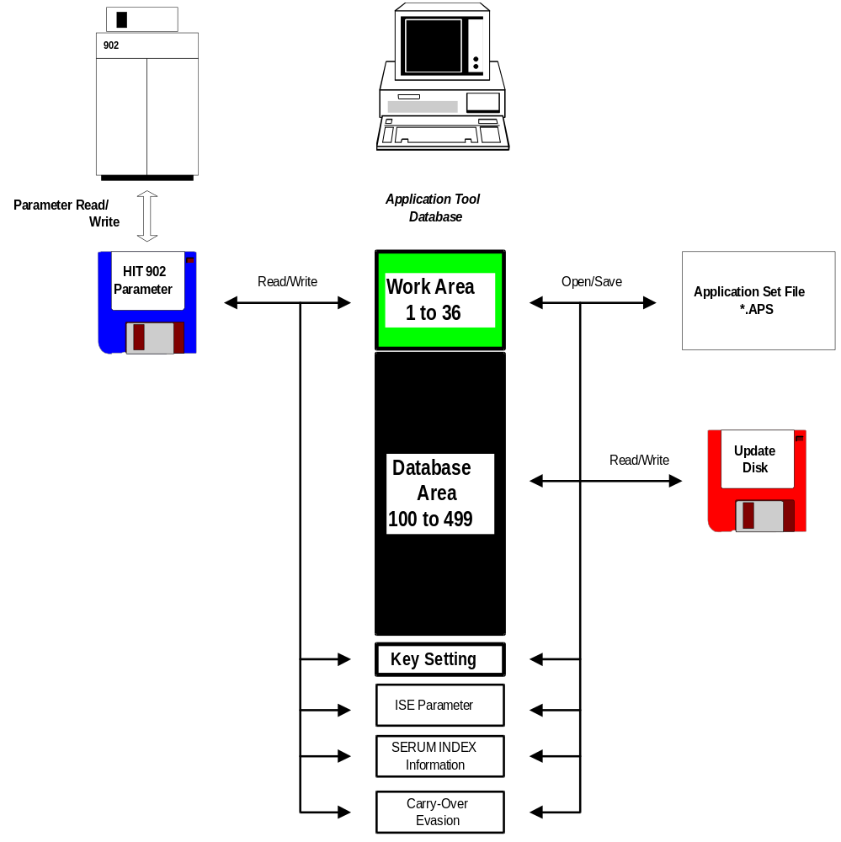

16 Main screen of the tool
After starting the tool, all data items including a comment of the first application record of the Work Area are displayed on the screen. Each data item may be modified.
The main screen includes a pull-down menu system and a status line where date and time as well as a short hint regarding the object which has the focus are displayed.

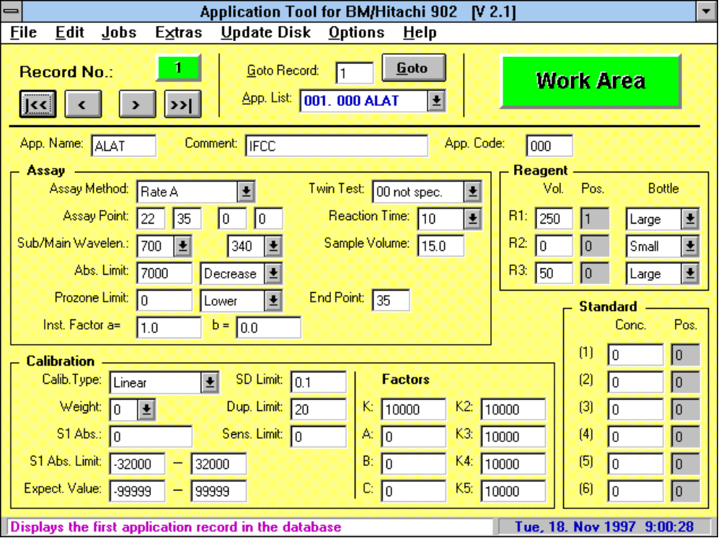

17 How to move within the application database
For moving through the application database the following means are available:
- Buttons for moving to the next/previous application record
- Buttons for moving to the first/last application record
- Combination of ‘Goto’ button and text field to enter the number of the record which shall be displayed
- Test list for selecting the wished application record by test name

18 How to update/create a Parameter Disk
For updating an already existing or creating an initial Parameter Disk, do the following steps:

If you want to update an already existing Parameter Disk, perform first the ...
... Menu option: Read Hit 902 Parameter Disk in the ‘File’ menu.
This option reads the application data from the Parameter Disk and enters it into the Work Area.

Now go on with the ...
... Menu option: Configure Work Area in the ‘Jobs’ menu.
Here you copy the needed application records from the Database Area to the Work Area

The next will be the ...
... Menu option: Edit Key Setting in the ‘Jobs’ menu.
The Key Setting may be done for the above configured applications and can be printed as additional documentation enclosed to the Parameter Disk

A first check can be done with the ...
... Menu option: Reagent Load List in the ‘Jobs’ menu.
The entered reagent positions are displayed; multiple assignment may be recognized. The Reagent Load List may be printed as additional documentation enclosed to the Parameter Disk.

A further check can be done with the ...
... Menu option: Calibration Load List in the ‘Jobs’ menu.
The entered Standard positions are displayed. The Calibration Load List may be printed as additional documentation enclosed to the Parameter Disk.

After having done all these jobs, insert the Parameter Disk again and perform the ...
... Menu option: Write Hit 902 Parameter Disk in the ‘File’ menu.
The application and key setting data is written to the Parameter Disk. After inserting the disk into drive 1 of the BM/Hitachi 902, perform the Parameter Write function to load the data into memory.

When reading the application data from the Parameter Disk, the ISE parameters, Serum Index and Carry-Over Evasion information are also read and stored on the hard disk.
As an additional option, they may be edited and written back to Parameter Disk.

The following workflow chart shows includes the above described steps:

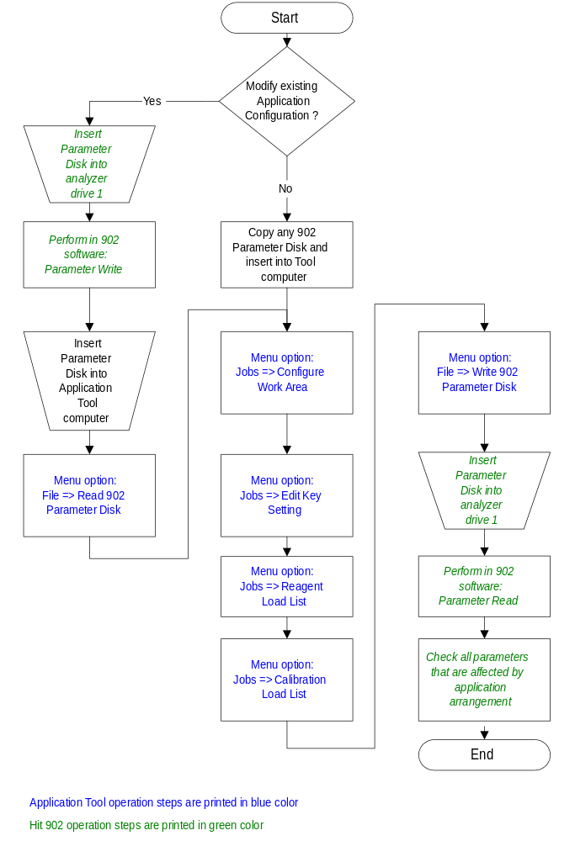

19 Menu System of the Application Tool
The pull-down menu system includes all options for reading, writing, modifying, saving, printing the application data:

 | File Menu
 | Read Hit 902 Parameter Disk | ... reads the 36 application records, the Key Setting, the ISE parameters, the Serum Index and Carry-Over Evasion information from the Hit 902 Parameter Disk into the database files
 | Write Hit 902 Parameter Disk | ... writes the 36 application records of the Work Area, the Key Setting, the ISE parameters, the Serum Index and Carry-Over Evasion information to the Hit 902 Parameter Disk
 | Open Application Set | ... opens an already created Application Set (see next option) and loads it into the Work Area.
 | Save Application Set | ... saves the 36 records of the Work Area, the actual Key Setting, the ISE parameters, the Serum Index and Carry-Over Evasion information into an Application Set file.  Different combinations of applications for different instruments or customers can be stored for later processing.
 | Delete Application Set | ... deletes an Application Set file which is no longer needed.
 | Print | ... prints the application data in different formats to different output targets.  Any subset of applications out of Work and Database Area may be selected for the output. The output formats are:  - Screen Copy (one Application per page)  - Parameter list (one Application per page)  - Parameter table  The output targets are ...  - the standard printer  - a text file  - a text file where the data items are delimited by a character which can be specified. This file may be imported into any spreadsheet application for further processing  - a bitmap graphics file (only for screen copy) This file may be used for import into word processor, for documentation purpose.
 | Exit | ... quits the program

 | Edit Menu
 | Save actual Record | ... saves the actual application record into the database.  As soon as any data item is changed, it is displayed in red forecolor. If the record shall be left or a menu option is selected, there is a prompt, whether the record shall be saved. If the record shall be saved, all data items are checked for valid values.
 | Copy, Move, Delete, Compare Records | ... allows copying, moving, deleting and comparing data records within the complete application database.  The records are displayed in two list boxes, a source and a target list box. Any subset of application records may be selected in the source list and copied or moved to the position selected in the target list. When moving records, the source positions are deleted (= overwritten with a default record).  The Compare option allows comparing the data items of two records where the different data fields are displayed with different background color.
 | Delete Application Database | ... deletes the complete application database

 | Jobs Menu
 | Configure Work Area | ... allows to configure the Work Area according to the requirements for a specific instrument.  The needed applications may be copied from the Database to the Work Area.
 | Edit Key Setting | ... modifies the actual Key Setting.  When reading the application data from the Parameter Disk, the Key Setting is also read and stored in the application database. This Key Setting can be modified according to the actual application arrangement in the Work Area. The Key Setting is written back to the Parameter Disk together with the application data.  The Key Setting may also be output to the printer or a text file for documentation purpose.
 | Reagent Load List | ... displays the actual reagent positions according to the position values in the application records of the Work Area.  The reagent position table may be output to the printer or a text file for documentation purpose.
 | Calibration Load List | ... displays the actual Standard positions according to the position values in the application records of the Work Area.  The Calibration Load List may be output to the printer or a text file for documentation purpose.

 | Extras Menu
 | Edit ISE parameters | ... allows editing the ISE parameters which are read from the Parameter Disk together with the application data.  The info may be printed and written back to the Parameter Disk.
 | Edit Serum Index Information | ... allows editing the Serum Index information which is read from the Parameter Disk together with the application data.  The info may be printed and written back to the Parameter Disk.
 | Edit Carry-Over Evasion | ... allows editing the Carry-Over Evasion information which is read from the Parameter Disk together with the application data.  The info may be printed and written back to the Parameter Disk.

 | Update Disk Menu
 | Read Application Update Disk | ... reads all records from the Hit 902 Application Update Disk (see next option) and displays them in a list.  Any subsets of this list may be selected and loaded to any position of the Database Area.
 | Write Application Update Disk | ... allows to write up to 400 records of the Database Area to an Application Update Disk.  Updated and new applications for the Hitachi 902 may be distributed in this way.
 | Check, Sort, Modify Application Update Disk | ... allows to write an ID to the Update Disk. Application codes may be assigned to the application records on the disk. The applications on the disk may be sorted by test name or application code. The Update Disk may be searched for missing of multiple used application codes.  This menu option is enabled only for evaluation staff !
 | Compare Application Update Disks | ... allows to compare the contents of two Update diskettes. The key field for the comparison is the application code. Different items may be selected for the comparison report

 | Options Menu
 | Desktop Language | ... offers several different languages for the desktop of the Application Tool.  All text lines for one language are stored in separate text file. The english and german text files are included, further language versions may be created with any text editor. A software change is not necessary.
 | Database Path | ... allows to set a path for the database files (Application, ISE and Serum Index). The database files may also be stored on a network drive, where they are available for different workstations.
 | Make Default Parameter Disk | ... allows to create a default BM/Hitachi 902 Parameter Disk by copying the corresponding files from hard disk to an empty floppy disk.

 | Help Menu
 | Contents | ... opens the Windows-based help system for the Application Tool.  In each form there is a help button with which the operator gets context-sensitive help.
 | Info | ... displays information about the Application Tool, the developer and the system

Appendix A: Printouts of the Application Tool

1. Application Data - Screen Format (one application/page)

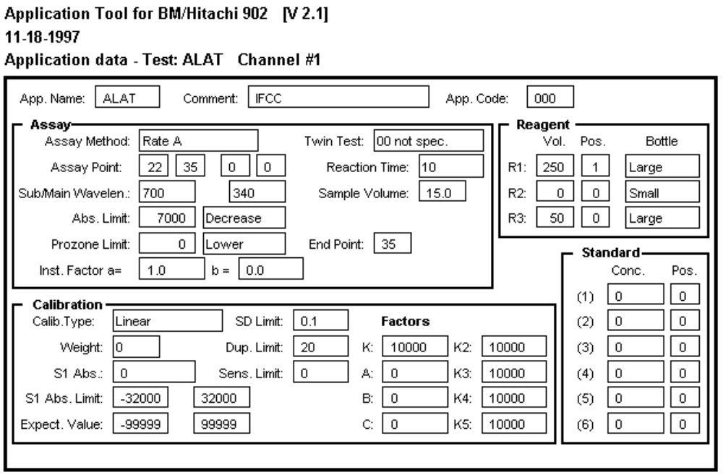

2. Application Data - List (one application/page)
Application Tool for BM/Hitachi 902 [V 2.1]
10-08-1997

Chemistry Parameters
--------------------

Channel : 102
Comment : Albumin
Application Code : 067

No 1. Test Name ALB
No 2. Assay Code (Mthd) 1 Point
No 3. Assay Code (2.Test) 0
No 4. Reaction Time 3
No 5. Assay Point 1 6
No 6. Assay Point 2 0
No 7. Assay Point 3 0
No 8. Assay Point 4 0
No 9. Wavelength (SUB) 700
No 10. Wavelength (MAIN) 600
No 11. Sample Volume 2.0
No 12. R1 Volume 350
No 13. R1 Position 0
No 14. R1 Bottle Size Large
No 15. R2 Volume 0
No 16. R2 Position 0
No 17. R2 Bottle Size Small
No 18. R3 Volume 0
No 19. R3 Position 0
No 20. R3 Bottle Size Small
No 21. Calib. Type (Type) Linear
No 22. Calib. Type (Wght) 0
No 23. Calib. Conc. 1 0.00
No 24. Calib. Pos. 1 0
No 25. Calib. Conc. 2 0
No 26. Calib. Pos. 2 0
No 27. Calib. Conc. 3 0
No 28. Calib. Pos. 3 0
No 29. Calib. Conc. 4 0
No 30. Calib. Pos. 4 0
No 31. Calib. Conc. 5 0
No 32. Calib. Pos. 5 0
No 33. Calib. Conc. 6 0
No 34. Calib. Pos. 6 0
No 35. S1 ABS. 0
No 36. K Factor 10000
No 37. K2 Factor 10000
No 38. K3 Factor 10000
No 39. K4 Factor 10000
No 40. K5 Factor 10000
No 41. A Factor 0
No 42. B Factor 0
No 43. C Factor 0
No 44. SD Limit 0.1
No 45. Duplicate Limit 270
No 46. Sens. Limit 2700
No 47. S1ABS. Limit (L) -32000
No 48. S1ABS. Limit (H) 32000
No 49. ABS Limit 0
No 50. ABS Limit (D/I) Decrease
No 51. Prozone Limit 0
No 52. Proz Limit (Upp/Low) Lower
No 53. Prozone (End Point) 35
No 54. Expect. Value (L) -9999
No 55. Expect. Value (H) 9999
No 56. Instr. Factor (a) 1.0
No 57. Instr. Factor (b) 0.0
No 58. Key Setting -

3. Application Data - Table (multiple applications, only text file)

Chemistry Parameters

;Channel#;100;101;102
;Comment;AMP;OCPC;BCG
;Application Code;043;055;067
1;Test Name;ALP;Ca;ALB
2;Assay Code (Mthd);Rate A;2 Point End;1 Point
3;Assay Code (2.Test);0;0;0
4;Reaction Time;10;5;3
5;Assay Point 1;26;5;6
6;Assay Point 2;35;17;0
7;Assay Point 3;0;0;0
8;Assay Point 4;0;0;0
9;Wavelength (SUB);700;700;700
10;Wavelength (MAIN);415;600;600
11;Sample Volume;11,0;10,0;2,0
12;R1 Volume;250;250;350
13;R1 Position;0;0;0
14;R1 Bottle Size;Large;Large;Large
15;R2 Volume;0;100;0
16;R2 Position;0;0;0
17;R2 Bottle Size;Small;Large;Small
18;R3 Volume;50;0;0
19;R3 Position;0;0;0
20;R3 Bottle Size;Small;Large;Small
21;Calib. Type (Type);Linear;Linear;Linear
22;Calib. Type (Wght);0;0;0
23;Calib. Conc. 1;0;0,00;0,00
24;Calib. Pos. 1;0;0;0
25;Calib. Conc. 2;0;0;0
26;Calib. Pos. 2;0;0;0
27;Calib. Conc. 3;0;0;0
28;Calib. Pos. 3;0;0;0
29;Calib. Conc. 4;0;0;0
30;Calib. Pos. 4;0;0;0
31;Calib. Conc. 5;0;0;0
32;Calib. Pos. 5;0;0;0
33;Calib. Conc. 6;0;0;0
34;Calib. Pos. 6;0;0;0
35;S1 ABS.;0;0;0
36;K Factor;10000;10000;10000
37;K2 Factor;10000;10000;10000
38;K3 Factor;10000;10000;10000
39;K4 Factor;10000;10000;10000
40;K5 Factor;10000;10000;10000
41;A Factor;0;0;0
42;B Factor;0;0;0
43;C Factor;0;0;0
44;SD Limit;0,1;0,1;0,1
45;Duplicate Limit;110;350;270
46;Sens. Limit;1000;0;2700
47;S1ABS. Limit (L);-32000;-32000;-32000
48;S1ABS. Limit (H);32000;32000;32000
49;ABS Limit;15000;0;0
50;ABS Limit (D/I);Increase;Increase;Decrease
51;Prozone Limit;0;32000;0
52;Proz Limit (Upp/Low);Lower;Upper;Lower
53;Prozone (End Point);35;35;35
54;Expect. Value (L);-9999;-99999;-9999
55;Expect. Value (H);9999;99999;9999
56;Instr. Factor (a);1,0;1,0;1,0
57;Instr. Factor (b);0,0;0,0;0,0
58;Key Setting;-;-;-

4. Application Database Index

Application Tool for BM/Hitachi 902 [V 2.1]
10-08-1997

Application Database Index
--------------------------

Channel 100: 043 ALP AMP
Channel 101: 055 Ca OCPC
Channel 102: 067 ALB BCG
Channel 103: 003 ALT IFCC
Channel 104: 123 ALP AMP
Channel 105: 005 ALP opt.
Channel 106: 002 P-AMY liquid
Channel 107: 000 P-AMY EPS
Channel 108: 000 AMYL liquid
Channel 109: 000 AMYL EPS
Channel 110: 000 BIL-T DPD
Channel 111: 000 D-BIL Jendr. Direct
Channel 112: 000 BIL-T Jendr.
Channel 113: 000 CK NAC Lyo
Channel 114: 000 Ca OCPC

Channel 116: 002 Chol PAP Liquid with SMS
Channel 117: 000 Chol PAP liquid
Channel 118: 000 CHE But.
Channel 119: 000 ALP AMP
Channel 120: 000 CK NAC Lyo

Channel 123: 000 CREJ Jaffe with blank
Channel 124: 000 CRE Jaffe STAT Meth.
Channel 125: 000 CRE PAP plus

Channel 127: 000 GGT Szasz

Channel 129: 000 GGT Std. Meth. 94

Channel 131: 000 GLU PAP
Channel 132: 000 GLU HK

Channel 134: 000 AST IFCC
Channel 135: 789 ASAT IFCC with Pyp
Channel 136: 000 GOT opt.
Channel 137: 000 ALT IFCC
Channel 138: 000 ALAT IFCC with Pyp
Channel 139: 000 GPT opt.
Channel 140: 000 HBDH opt

Channel 143: 000 FE Ferroz.

Channel 145: 000 LDH SFBC
Channel 146: 000 LDH opt
Channel 147: 000 LIP turb.

Channel 150: 000 PHOS UV

Channel 154: 000 TP Biuret
Channel 155: 000 TG PAP liquid
Channel 156: 000 TG PAP liquid with SMS

Channel 158: 000 UREA liquid UV

Channel 160: 000 UA PAP plus

...

5. Application Update Disk Index

Application Tool for BM/Hitachi 902 [V 2.1]
10-08-1997

Application Update Disk Index
Disk ID: Version 2.0
-----------------------------

Channel 100: 888 ALB BCG
Channel 101: 005 ALP opt.
Channel 102: 043 ALP AMP
Channel 103: 123 ALP AMP
Channel 104: 003 ALT IFCC
Channel 105: 000 AMYL liquid

Channel 107: 055 Ca OCPC

Channel 109: 999 P-AMY liquid

6. Key Setting (part 1)

Application Tool for BM/Hitachi 902 [V 2.1]
10-08-1997

Key Setting (sorted by Key no.)
-------------------------------

Key 01: 011 HDL-C Channel 001
Key 02: 014 TG Channel 002
Key 03: 123 CHOL Channel 003
Key 04: 456 Ca Channel 004
Key 05: 000 ACP Channel 005
Key 06: 000 NPP Channel 006
Key 07: 000 K Channel 008
Key 08: 000 GLDH Channel 009
Key 09: 000 Mg Channel 010
Key 10: 000 LIP Channel 007
Key 11: 000 TG Channel 011
Key 12:

Key 13:
Key 14:
Key 15:
Key 16:
Key 17:
Key 18:
Key 19:
Key 20:
Key 21:
Key 22:
Key 23:
Key 24:

Key 25:
Key 26:
Key 27:
Key 28:
Key 29:
Key 30:
Key 31:
Key 32:
Key 33:
Key 34:
Key 35:
Key 36:

Key 37:
Key 38: 000 ISE Channel 037
Key Setting (part 2)

Application Tool for BM/Hitachi 902 [V 2.1]
10-08-1997

Key Setting (sorted by Channel no. = Host channel)
--------------------------------------------------

Channel 001. 011 HDL-C on Key 1
Channel 002. 014 TG on Key 2
Channel 003. 123 CHOL on Key 3
Channel 004. 456 Ca on Key 4
Channel 005. 000 ACP on Key 5
Channel 006. 000 NPP on Key 6
Channel 007. 000 LIP on Key 10
Channel 008. 000 K on Key 7
Channel 009. 000 GLDH on Key 8
Channel 010. 000 Mg on Key 9
Channel 011. 000 TG on Key 11
Channel 012. 000 APOA1
Channel 013. 000 Na
Channel 014. 000 GENT
Channel 015. 000
Channel 016. 000
Channel 017. 000
Channel 018. 000
Channel 019. 000
Channel 020. 000
Channel 021. 000
Channel 022. 000
Channel 023. 000
Channel 024. 000
Channel 025. 000
Channel 026. 000
Channel 027. 000
Channel 028. 000
Channel 029. 000
Channel 030. 000
Channel 031. 000
Channel 032. 000
Channel 033. 000
Channel 034. 000
Channel 035. 000
Channel 036. 000

Channel 037. ISE on Key 38

7. Reagent Load List (part 1)

Application Tool for BM/Hitachi 902 [V 2.1]
04-22-1997

Reagent Load List (sorted by Position no.)
------------------------------------------

Pos. 01: ALB R1 (#01) /
Pos. 02: P-AMY R1 (#02) /
Pos. 03: P-AMY R3 (#02) /
Pos. 04: AMYL R1 (#03) /
Pos. 05: AMYL R3 (#03) /
Pos. 06: BIL-T R1 (#04) /
Pos. 07: BIL-T R3 (#04) /
Pos. 08: Ca R1 (#05) /
Pos. 09: Ca R2 (#05) /
Pos. 10: Chol R1 (#06) /
Pos. 11: CREJ R1 (#07) /
Pos. 12: CREJ R3 (#07) /
Pos. 13: GGT R1 (#08) /
Pos. 14: GLU R1 (#09) /
Pos. 15: GLU R2 (#09) /
Pos. 16:
Pos. 17:
Pos. 18:
Pos. 19:
Pos. 20:
Pos. 21:
Pos. 22:
Pos. 23:
Pos. 24:
Pos. 25:
Pos. 26:
Pos. 27:
Pos. 28:
Pos. 29:
Pos. 30:
Pos. 31:
Pos. 32:
Pos. 33:
Pos. 34:
Pos. 35:
Pos. 36:

Pos. 37: (Int. Std.)
Pos. 38: (Diluent)

Pos. 39: Multiclean
Pos. 40: Hitergent
Reagent Load List (part 2)

Application Tool for BM/Hitachi 902 [V 2.1]
04-22-1997

Reagent Load List (sorted by Channel no.)
-----------------------------------------

Channel 1: ALB R1 1
Channel 2: P-AMY R1 2
R3 3
Channel 3: AMYL R1 4
R3 5
Channel 4: BIL-T R1 6
R3 7
Channel 5: Ca R1 8
R2 9
Channel 6: Chol R1 10
Channel 7: CREJ R1 11
R3 12
Channel 8: GGT R1 13
Channel 9: GLU R1 14
R2 15

8. Calibrator Load List

Application Tool for BM/Hitachi 902 [V 2.1]
04-22-1997

Calibration Load List (sorted by Position no.)
----------------------------------------------

Pos. 36: ALB (#01-S1) P-AMY (#02-S1) AMYL (#03-S1) BIL-T (#04-S1)
Ca (#05-S1) Chol (#06-S1) CREJ (#07-S1) GGT (#08-S1)
GLU (#09-S1)
Pos. 37: ALB (#01-S2) P-AMY (#02-S2) AMYL (#03-S2) BIL-T (#04-S2)
Ca (#05-S2) Chol (#06-S2) CREJ (#07-S2) GGT (#08-S2)
GLU (#09-S2)
Pos. 38:
Pos. 39:
Pos. 40:
Pos. 41:
Pos. 42:
Pos. 43:
Pos. 44:
Pos. 45:
Pos. 46:
Pos. 47:
Pos. 48:
Pos. 49:
Pos. 50:
Pos. 51:
Pos. 52:
Pos. 53:
Pos. 54:
Pos. 55:
Pos. 56:
Pos. 57:

9. ISE Parameters

Application Tool for BM/Hitachi 902 [V 2.1]
04-22-1997

ISE Parameters
--------------

Na K Cl

No 1. Low Liquid Conc. 120.0 3.00 80.0
No 2. High Liquid Conc. 160.0 7.00 120.0
No 3. Calibrator Conc. 134.0 4.42 99.6

No 5. Expected Low 0 0 0
No 6. Expected High 9999 9999 9999

No 7. Instr. Factor A 1.00 1.0 1.0
No 8. Instr. Factor B 0.0 0.0 0.0

No 9. Comp. Tolerance Range 200.0 200.0 200.0
No 10. Correction Coefficient -2 -0.11 0

10. Serum Index Information

Application Tool for BM/Hitachi 902 [V 2.1]
04-22-1997

Serum Index Information
-----------------------

Channel No :000

Factor A : 25
Factor B : 122000
Factor C : 10
Factor D : 1600
Factor E : 19000
Factor F : 180000

11. Carry Over Evasion Information

Application Tool for BM/Hitachi 902 [V 2.1]
10-08-1997

Carry-Over Evasion Parameters
-----------------------------

* Reagent Probe Evasion *

Channel 004: 456 Ca R1 to Channel 005: 000 ACP R1 Pos. 36 250ul
Channel 004: 456 Ca R1 to Channel 005: 000 ACP R1 Pos. 39 250ul
Channel 002: 014 TG R3 to ALL R2 Pos. W1 100ul
Channel 008: 000 K R2 to ISE R3 Pos. 7 60ul
Channel 001: 011 HDL-C R1 to Channel 010: 000 Mg R1 Pos. 10 100ul

* Reaction Cell Evasion *

Channel 004: 456 Ca Pos. 39 500ul
Channel 001: 011 HDL-C Pos. 1 50ul

* Sample Probe Evasion *

Channel 005: 000 ACP Pos. W3

12. Application Update Disk Comparison

Part 1
Application Tool for BM/Hitachi 902 [V 2.1]
10-08-1997

Application Update Disk Comparison
----------------------------------

* Applications on Disk 1 and Disk 2 *

Disk 1: Version 1.0
Disk 2: Version 2.0

Channel 101: 005 ALP opt.
Channel 102: 043 ALP AMP
Channel 103: 123 ALP AMP DIFFERENT !

Different Data Items Version 1.0 Version 2.0
1. Test Name ALP AMYL
5. Assay Point 1 26 28
11. Sample Volume 11.0 10.0
14. R1 Bottle Size Large Small
45. Duplicate Limit 110 100
46. Sens. Limit 1000 510
49. ABS Limit 15000 20000
54. Expect. Value (L) -9999 -99999
55. Expect. Value (H) 9999 99999

Channel 104: 003 ALT IFCC
Channel 107: 055 Ca OCPC

Part 2 (Option)

Application Tool for BM/Hitachi 902 [V 2.1]
10-08-1997

Application Update Disk Comparison
----------------------------------

* New Applications on Disk 2 *

Disk 1: Version 1.0
Disk 2: Version 2.0

Channel 100: 888 ALB BCG
Channel 109: 999 P-AMY liquid

Part 3 (Option)

Application Tool for BM/Hitachi 902 [V 2.1]
10-08-1997

Application Update Disk Comparison
----------------------------------

* Applications on Disk 2 without Application Code !!! *

Disk 1: Version 1.0
Disk 2: Version 2.0

Channel 105: 000 AMYL liquid

