Data Input Tool
for the
‘Laboratory Accreditation Specification Validation Procedure’
for BM/HITACHI instruments

Version 2.0

November 1997

Contents:
1. Introduction
1.1. Purpose of the ‘Data Input Tool’
1.2. Requirements
2. Installation of the ‘Data Input Tool’
3. Setting up the 'Data Input Tool'
3.1. User Registration
3.2. Instrument Selection / EXCEL Settings
4. Validation Procedure
APPENDIX A: List of installed files:
APPENDIX B: Software Updates

1 Introduction

2 Purpose of the ‘Data Input Tool’
This software shall support the ‘Laboratory Accreditation Specification Validation Procedure’ for BM/HITACHI instruments.
All the data necessary for the Validation procedure which had to be entered directly into the EXCEL spreadsheets prepared by the Boehringer Mannheim Instrument Evaluation department can now be entered into data input masks. Even the cell blank values which are transferred from the instrument to the computer via the serial interface are read, reformatted and entered into the spreadsheet which is loaded in the background.
Since all validation steps are displayed on the main screen, you can always see whether all tests are done, or which one is still missing.
The printout of the validation result can also be initiated by a button on the main screen.
Each screen includes a [Help] button with which you get context sensitive help.

This tool will make the validation procedure easier, mistakes will be avoided and of course time will be saved.

3 Requirements
Before you install the software, make sure that your computer meets the minimum requirements.
To run the Data Input Tool, you must have certain hardware and software installed on your computer:

Computer requirements:

: any IBM compatible machine with 80286 processor or higher
a hard disk
a 3.5 inch floppy drive
a VGA compatible display
four megabyte of memory
8 a mouse

ÿ MS-DOS version 3.1 or later
ÿ Windows version 3.0 or later
ÿ Microsoft EXCEL 4.0 or 5.0

Necessary hard and software for the validation procedure:

ð Calibration kit for BM/HITACHI analyzers

ð BM Temperature sensor for Calibration S.No.: UNI-A 10262-011

ð Digital multimeter with an accuracy of at least 0,06 V for lamp voltage measurement and max. 350 ppm within the 200k Ohm range for the resistance (temperature) measurement

ð Parallel/serial converter incl. cable for cell blank transmission

ð Host Interface cable for test selection and result transmission

4 EXCEL spreadsheets created by the Boehringer Mannheim Instrument Evaluation department for the instrument types that you want to validate.
The following spreadsheets are available:
917_20.XLS for BM/HITACHI 917
912_30.XLS for BM/HITACHI 912
911_20.XLS for BM/HITACHI 911
902_30.XLS for BM/HITACHI 902
747_20.XLS for BM/HITACHI 747
717_20.XLS for BM/HITACHI 717
704_20.XLS for BM/HITACHI 704
The spreadsheet files must already be installed on the hard disk of your computer.

< For the BM/HITACHI instruments 704, 717, 911 there are special 'System Disks' available, which contain the pre-programmed parameters SPIP, RPIP and PREF for the 'Pipettor Accuracy and Precision' test.
For BM/HITACHI 917 there is a 'Parameter Disk' which contains the above mentioned tests.

Documentation requirements:
Printout of the 'Specification Validation Procedure' for the instrument types that you want to validate.

4 Installation of the ‘Data Input Tool’
The setup routine copies the program files, the help and library files from the distribution diskettes 1 and 2 to your hard disk.

To install the Data Input Tool on your harddisk do the following:

è Insert the distribution diskette 1 in drive A:

è From the file menu of the Program or File Manager, choose Run

è Type a:\setup

è Follow the instructions on the screen.

As soon as you have completed the setup procedure, you can start the Data Input Tool by double-clicking the icon in the new program group.

5 Setting up the 'Data Input Tool'

6 User Registration
When starting the software for the first time, you are prompted for your and your companys name. Enter the names and confirm by pressing the [Ok] button.

7 Instrument Selection / EXCEL Settings
When starting the software for the first time, the configuration file CERT_HIT.INI is created with default values. A corresponding message on the screen is displayed.
After that, the Instrument Selection / EXCEL Setting screen is opened and you are asked to adapt all the settings in that screen to your local environment.

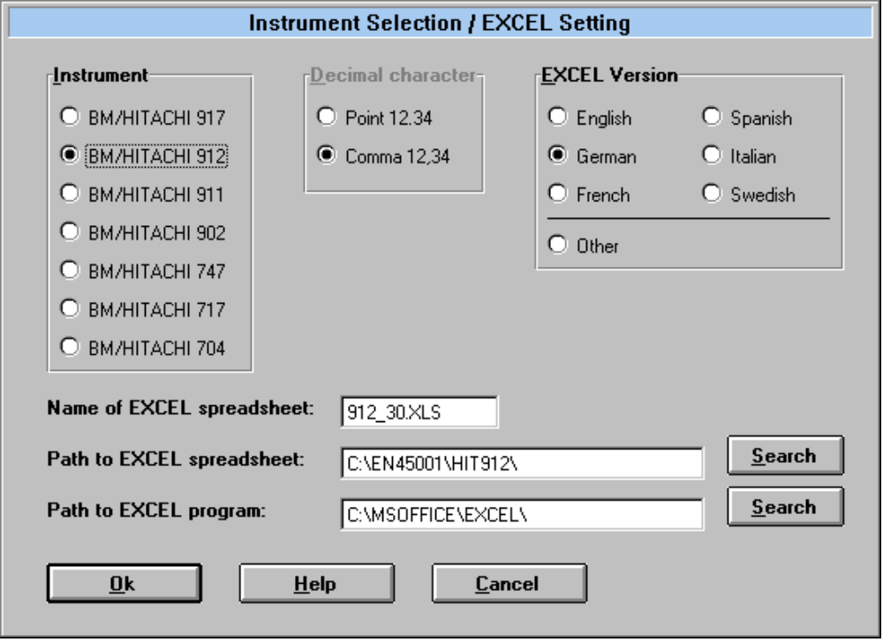

This screen can later be accessed via the Options menu.
The following settings need to be done:

Instrument:
Select the instrument you want to work with.

Name of EXCEL spreadsheet / Path to EXCEL spreadsheet:
The results of each measurement of the validation procedure are entered automatically into the corresponding EXCEL spreadsheet. There is one individual spreadsheet for each of the five supported HITACHI analyzers. These spreadsheets must be installed on your hard disk.
In this screen you have to enter the name and path of the spreadsheet.

Path to EXCEL program:
The EXCEL application must also be installed on your computer.
Enter the path where the EXCEL application is installed.
For this and the setting above there are [Search] buttons which make it easy to search the harddisk.

Decimal character:
Select the kind of decimal character. Point or comma can be selected; the decimal character depends on the country setting in your computers operating system. If the wrong sign is selected the transferred decimal values are mis-interpreted in the spreadsheet.
This setting needs only to be done if the automatical detection fails. When started, the software tries to find this setting in the Windows configuration file ‘WIN.INI’ !

EXCEL language version:
Select the language version of the installed EXCEL program.
The language version of your EXCEL application is important for the data transfer and the spreadsheet printout option. If the setting is wrong, both features fail.
If you use an EXCEL version which is not listed in this box, use the option Other. Therefore you have to specify the cell identification (e.g. ‘C’ for cell and ‘R’ for row in the english version; check on EXCEL’s General Options screen) and the hotkeys to initiate the printout of the actual spreadsheet (e.g. Alt+ ‘F’ to open the File menu and ‘P’ for the print menu option.

8 Validation Procedure
This is the main screen of the ‘Data Input Tool’:

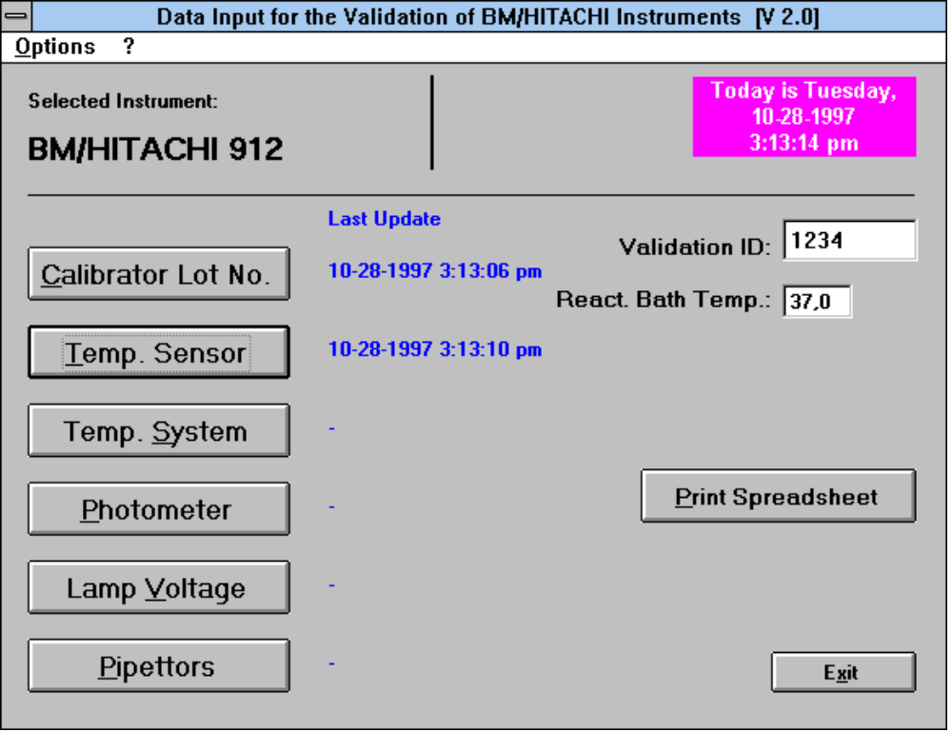

There are six data input screens, which can be accessed via the corresponding button on the main screen after entering the Validation ID. The data is entered manually or via data transfer from the instrument. After entering all data in one screen, they are transferred to the selected EXCEL spreadsheet by pressing the [Data Ok] button.
If EXCEL is not yet loaded, this is done now.

The Validation Procedure consists of the following parts:

Before starting the measurements:

Calibrator Lot No.
... to check or modify calibrator lot numbers and reference values.

Temp. Sensor
... to check or to modify the calibration values of the temperature sensor.

Measurements:

Temp. System
... to validate the temperature of the reaction bath.
refer to Specification Part 9

Photometer
... to validate linearity, precision and wavelength accuracy of the photometer.
refer to Specification Part 2

Lamp Voltage
... to validate the photometer lamp voltage.
refer to Specification Part 1

Pipettors
... to validate accuracy and precision of the pipetting system.
refer to Specification Part 7

When all measurements are done and the data items are transferred to the EXCEL spreadsheet, the documentation is generated by pressing ...

Print Spreadsheet
this function generates a printout of the entered values according to EN 45001.

For more detailed information please refer to the comments in each input screen and the context sesitive help !

APPENDIX A: List of installed files
The following files are installed into the application directory:

CERT_HIT.EXE Main program
CERT_EN.TXT English text file
CERT_GE.TXT German text file
CERT_ENH.HLP English help file
CERT_GEH.HLP German help file
CERT_HIT.DAT Sensor and calibrator lot data

These files are created when the program is running:

CERT_HIT.INI Configuration data
TRACE.TXT Host communication trace file
CELL.TXT Received Cell Blank data from the analyzer

This is a list of the DLLs which Visual Basic 4.0 needs for running the software. They are installed into your Windows system directory:

VB40016.DLL
OC25.DLL
OC25DEU.DLL
OLE2.DLL
TYPELIB.DLL
OLE2DISP.DLL
OLE2PROX.DLL
OLE2CONV.DLL
STORAGE.DLL
COMPOBJ.DLL
OLE2.REG
OLE2NLS.DLL
STDOLE.TLB
SCP.DLL
VAEN21.OLB
CTL3DV2.DLL
VB4DE16.DLL
MSCOMM16.OCX

APPENDIX B: Software Updates
The following midifications have been done to the Data Input Tool ...

Version 1.1
Additional option box for setting the kind of handshake for the serial transmission of Cell Blank data via the parallel/serial converter.

Version 1.2 - Feb 1997
When BM/Hitachi 747 is selected, there are data input fields for 4 channels displayed on the ‘Pipettor’ screen. Host transmission is no longer supported for this instrument.

Version 1.3 - March 1997
The two beeps at the beginning of the cell blank data transfer have been removed. They caused data loss at some older computer types.

Version 2.0 - November 1997
The validation procedure may also be performed for the 912 and 902 BM/Hitachi analyzers.

