Laboratory Accreditation
Specification Validation Procedure
CAL 704.32 Part 5, Wavelength deviation
BM/Hitachi 704
Version: 3.2

Date: December 1997
Written by: | Mr. Mathew, LI-E
Authorized by: | Mr. Ringsleben, LI-T
Checked by: | Mr. Nakatani, HID QA
Released by: | Mr. De Caluwé, LI-E

This sheet provides a Validation procedure to comply with the requirements of laboratory accreditation standards.

This sheet is an uncontrolled copy.
Laboratory Accreditation Spec. Validation Procedure
on
Wavelength deviation
BM/Hitachi 704
Content:
1 Purpose
2 General Description
3 Test Procedure
4 Traceability to National Standard
5 Handling of the validation standards
6 Evaluation and Documentation
7 Error Budget
8 Literature
9 Appendix: Validation Form

Purpose
The purpose of this Validation procedure is to determine the wavelength deviation of the automatic analyzer BM/Hitachi 704.

General Description
The principle of this validation procedure works as follows: A Validation standard with a known absorbance spectrum is measured out with the HITACHI 704 at two certain wavelengths. Because the absorbance is a function of the wavelength a deviation from the measuring wavelength will also cause a deviation of the measure absorbance from the expected value.

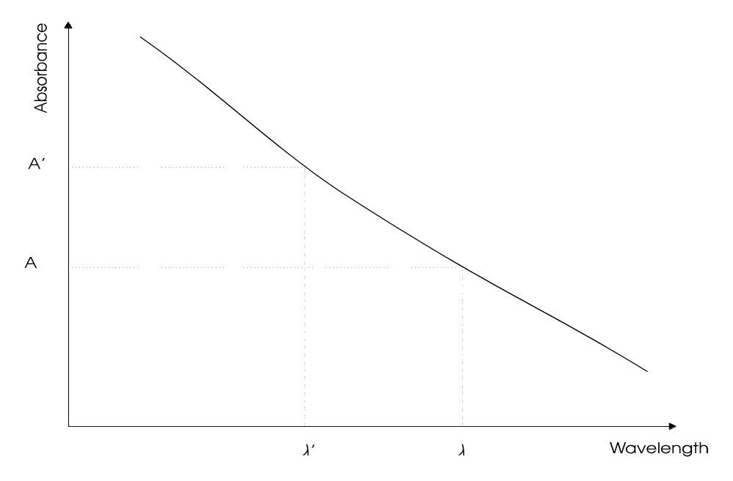

The wavelengths checked in this Validation procedure are λ1=480 nm and λ2= 570 nm. For each wavelength a series of 5 measurements is to be performed.

Because of the photometer construction a deviation of the wavelengths will affect all measurement wavelengths in the same way. So it is sufficient to check only two wavelengths.

Test Procedure
The results of part 2, »photometric linearity«, can be used for evaluation. No extra procedure exits.

The evalution of the data must be performed by trained service personnel only.

Traceability to National Standard
Refer to Procedure „Traceability of dye solutions for Wavelength Check“

Handling of the validation standards
The validation standards have to be handled carefully. Take care of the following items:
- Store the validation solutions in a dark and cold place (refrigerator)
- In order to minimise formation of air-bubbles take care that the validation solutions have at least room temperature before usage
- Before usage homogenise the validation solutions by carefully turning the bottles (do not shake the bottles !)
- Avoid contamination while distribution of samples (by dust or dirty pipette-tips)
- If the bottles once have been opened, use them up within one week
- Close the bottles tightly, immediately after distribution of samples (to avoid contamination and/or evaporation)
- Don’t expose the solutions directly to sunlight (UV-light)

Evaluation and Documentation
For evaluation and documentation use the enclosed Validation form or the Excel-spreadsheet for Validation of the BM/Hitachi 704.

With the reference values Xref and mref the wavelength deviation is calculated out of the median xm of the measured absorbances.

• Wavelength deviation 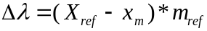

The reference values Xref are delivered together with the Validation kit containing the dye.
The wavelength check is passed if all calculated wavelength errors are within the tolerance zone (G_{total}) described in procedure „Traceability of dye solutions for Wavelength Check“

Error Budget
Refer to Procedure „Traceability of dye solutions for Wavelength Check“

Literature
- Photometer specifications
- DIN 5030 Teil 1, Juni 1985
DIN 5030 Teil 2, Sept. 1982
DIN 5030 Teil 3, Dez. 1984
Spektrale Strahlungsmessung
- Validation procedure „Traceability of dye solutions for Wavelength Check“
Description of traceability and error budget for wavelength check

Appendix: Validation Form
Validation ID

Validation Form for Cal 704.32P5

Measurement No. | Absorbance at 480 nm [Bel] | Absorbance at 570 nm [Bel]
1
2
3
4
5

Calculation | λ = 480 nm | λ = 570 nm
Median xm
Δλ [nm]
Gtotal [nm]
u [nm]

Passed /Failed

o Wavelength check is passed.
o Wavelength check has failed.

