Laboratory Accreditation
Specification Validation Procedure
CAL 704.32 Part 9, Temperature of Reaction Bath
BM/Hitachi 704
Version: 3.2

Date: December 1997
Written by: | Mr. Mathew, LI-E
Authorized by: | Mr. Ringsleben, LI-TS
Checked by: | Mr. Yabe, HID
Released by: | Mr. De Caluwé, LI-E

This sheet provides a validation procedure to comply with the requirements of laboratory accreditation standards.

This sheet is an uncontrolled copy.
Laboratory Accreditation Spec. Validation Procedure
on Reaction Bath Temperature
BM/Hitachi 704

Content:

1. Purpose page 3
2. General Description page 3
3. Operating Conditions page 3
4. Traceability of the validation standards page 4
5. Test Procedure page 4-5
6. Documentation page 5
7. Error Budget page 5
8. Requirements to the Digital-Multimeter (DMM) page 6
9. Use of new Thermistors page 6
10. Validation Form, General Form page 7
11. Validation Form, Example page 8
12. Drawings page 9

1. Purpose

This validation procedure describes the validation of the reaction bath temperature of the HITACHI 704 Analyser.
The meaning of "validation" is to determine the difference between the "true temperature" and the "set-temperature".

2. General description & measuring theory

The temperature is measured with a thermistor probe, mounted to a prepared cuvette segment. The selected thermistor is supplied by THERMOMETRICS, USA. The certified tolerance is ± 0.05 ° C.
The thermistor probe is mounted to a cuvette with a hole in its bottom. The tip of the thermistor tip must rise about 5mm deeper than the bottom line of the cuvette segment. (see chapter 11, figure 1).
The temperature resistance is measured by a DMM (requirements see chap.7)
The measured resistance has to be calculated to the according temperature by a individual resistance/temperature function.

Note: If an alternative mercury or digital thermometer with an inaccuracy of <= 0.10°C and an appropriate traceability evidence is available, you can use it instead of the described thermistor probe. In this case use the same validation forms by filling out the temperature column only.

3. Operating conditions

The validation should be performed under normal operating conditions, i.e.

• room temperature : 15 to 30 °C
• relative humidity: 40 to 80 %
• no ventilation or draft

Note, that the variation of the room temperature should not exceed ± 2 °C during the validation process.
4. Traceability to National Standard

Refer to Procedure „Traceability of Sensors for Temperature Check“

5. Test Procedure

1. Switch on the DMM

2. Insert the thermistor probe to the cuvette with the hole in its bottom. The tip of the thermistor probe must immerse about 5mm deeper than the edge of the cuvette bottom line (see chapter 11, figure 1).

3. Select the incubation-temperature, which is normally used by the customer. To do this, set the temperature switch to the desired temperature and proceed with the following steps:

3.1. Open the left side cover of the instrument
3.2. Set the temperature switch in the upper left corner to the demanded temperature.
3.3. Open the back cover.
3.4. Remove the fan which is located at the back side of the cooling unit
3.5. Remove the fixing plate of temperature adjusting pins by loosening the knurled nut, and get the adjusting pin for the demanded temperature (the temperature is engraved to the top of the pin).
3.6. Exchange the temperature adjusting pin corresponding to the setting temperature

Caution: The temperature adjusting pin is placed in the reaction bath flow path. Therefore the adjusting pin exchange must be quick to prevent loosing of too much water.

4. Switch on the Hitachi 704. Wait until initialisation is done: The message ´Standby´ occurs .

5. Wait until the demanded temperature is established. The actual temperature can be seen on the monitor.

6. Connect the thermistor lead to the 2-wire resistance input of the DMM.
Caution: Avoid touching, bending or drawing the thermistor-leads

7. Connect the thermistor with the 2-wire resistance input of the DMM.

8. Choose the 2 wire-RESISTANCE-function and an appropriate range.

9. Read the displayed resistance-value of the DMM, and enter it to the
Validation-Protocol.

10. Wait 1 minute.

11. Repeat the resistance measurements, described in steps 9-10, 4 further times.

12. Calculate the temperature-values as described in the validation protocol.
Caution: ensure that the thermistor-specific coefficients TA, TB, and TC are still applicable. If you are in a doubt, use a new thermistor probe and the corresponding coefficients.
Section 8 describes how to recalculate this coefficients.
It is recommended to use a programmable pocket-calculator for the resistance/temperature conversions. In order to avoid rounding errors, do not round any intermediate results !

13. If necessary, repeat the whole validation procedure for the remaining set temperatures

6. Documentation

For documentation of the validation results use the attached validation form.

7. Error Budget

Refer to Procedure „Traceability of Sensors for Temperature Check“
8. Requirements to the Digital-Multimeter (DMM)

The DMM for the resistance-measurements has to fulfill the following requirements:

• 12 or 24 month accuracy of resistance,
measurements in the 0-200kOhms range : <= 2000 ppm (of reading)
• Current for resistance measurements: <= 10 µA
• Latest validation certificate:
not older than 12 or 24 months (24 months if the according specs are <= 2000 ppm)

9. Use of a new Thermistor:

If you use a new thermistor and the new resistance/temperature-table differs from the old one, the coefficients TA, TB, and TC must be recalculated as follows:

R1 = resistance at 0° C T1 = 273.15 K + 0 K = 273.15 K X1 = ln(R1)
R2 = resistance at 30° C T2 = 273.15 K + 30 K = 303.15 K X2 = ln(R2)
R3 = resistance at 50° C T3 = 273.15 K + 50 K = 323.15 K X3 = ln(R3)

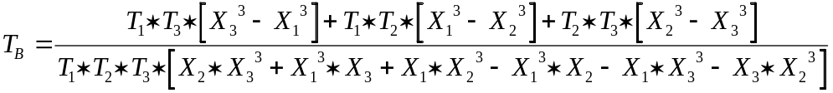

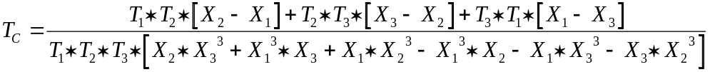
10. Validation Form for Cal 704.32 P9

10.1 Validation ID/Analyser Set Temperature

Validation ID | HIT 704 set temp.
 | 37 °C

10.2 DMM / Thermometer Parameters

Producer / Type | Serial Number | Last Validation Date

10.3 Thermistor Parameters and Results

Thermistor-Curve No. |  | Supply-Date |  | Lot No.
UT 443 SX1
Coefficient TA |  | Coefficient TB |  | Coefficient TC
4.61235 * 10-4 |  | 2.41852 * 10-4 |  | 9.64321 * 10-8
n | Measured Resistance [Ohms] |  | X = ln(Resistance n) |  | 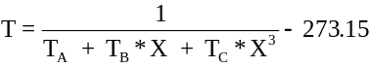
1
2
3
4
5
* depending on the  actual Thermistor-Lot |  | Average Temp. 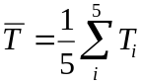 |  | = [° C]

Average Temperature = Set Temperature ± G_{total} ? (..........) yes r no r
11. Validation Form for Cal 704.32 P9 (Example)

11.1 Validation ID/Analyser Parameters


Validation ID | HIT 704 set temp.
123456 | 37 ° C

11.2 DMM / Thermometer Parameters

Producer / Type | Serial Number | Last Validation Date
KEITHLEY 2001 | 0546072 | 07.11.1992

11.3 Thermistor Parameters and Results

Thermistor-Curve No. |  | Supply-Date |  | Lot No.
UT 443 SX1 |  | June 1993 * |  | A 9149 *
Coefficient TA |  | Coefficient TB |  | Coefficient TC
4.61235 * 10-4 |  | 2.41852 * 10-4 |  | 9.64321 * 10-8
n | Measured Resistance n [Ohms] |  | X = ln(Resistance n)
1 | 54502 Ohm |  | 10.90599268 |  | 37.0117
2 | 54518 Ohm |  | 10.90628620 |  | 37.0039
3 | 54510 Ohm |  | 10.90613945 |  | 37.0078
4 | 54512 Ohm |  | 10.90617614 |  | 37.0069
5 | 54523 Ohm |  | 10.90637791 |  | 37.0015
* depending on the  actual Thermistor-Lot |  | Average Temp. |  | = 37.006 [° C]

Average Temperature = Set Temperature ± G_{total} ? (..........) yes r no r
12. Drawings

Figure 1, location of the thermistor

cuvette segment HITACHI

cuvette, bottom removed
HITACHI 704 cuvette segment
approx. 5mm
DMM

