Laboratory Accreditation
Specification Validation Procedure
Traceability of dye solutions for
Absorbence check
Version 1.1

Date: November 1997
Written by: | Mr. Mathew, LI-E1
Authorized by: | Mr. Kolsch, LI-TG
Checked by: | Mr. Bamberg, LI-E1
Released by: | Mr. De Caluwé, LI-E

This sheet provides a Validation procedure to comply with the requirements of laboratory accreditation standards.

This sheet is an uncontrolled copy.

Laboratory Accreditation Spec. Validation Procedure
on Traceability of dye solutions for
absorbence check

Content:

1 Purpose
2 Validity
3 General description & measuring theory
4 Traceability of the Validation Standards
4.1 Calibration hierarchy of photometer and photometric standards
5 Absorbence spectrum of nigrosine standards S40 and S100
6 Error Budget / Tolerance Zone
6.1 List of uncertainties:
6.2 Calculation of G_{total}
6.3 Analyser, wavelength and method-specific uncertainty’s of absorbence
7 Literature
8 History of Changes
9 Appendices (Example for validation kit packing-list)

Purpose
This validation procedure describes the traceability chain and the error budgets for the dyes which are used for the validation of absorbence inaccuracy.

Validity
This procedure is valid for validation kits with lot no. 06 or higher.

Solutions | Analyser
S100 | all HITACHI analysers & KEYSYS
S40 | ES300, ES600, ES700
Table 1

General description & measuring theory
The absorbence inaccuracy of the AUT (Analyser Under Test) is determined by measuring of nigrosine based dyes. The dyes for the absorbence check belong to the dilution series S20-S100, which is also used for the linearity check.

Traceability of the Validation Standards
All solutions are produced in a production environment where all equipment and production personnel is submitted to the requirements of GMP, FDA and ISO9001.

The absorbence of the S40 and S100 dyes are measured by a „SWEDISH NATIONAL LABORATORY“ (SP-Sveriges Provnings- och Forskningsinstitut, 15 Boras). The reference no’s. of the calibration certificates are listed in the packing inserts of each validation kit.
The transmittance standard as well as the wavelength standard at SP are traceable to the „National Physical Laboratory, Great Britain“.

Calibration hierarchy of photometer and photometric standards

National Physical Laboratory
Great Britain

NBS Transmittance-Standard

HOLMIUM Wavelength-Standard

SP
Swedish National Testing
and Research Institute

Boehringer Mannheim GmbH

Liquid Absorbence Standards
S40 / S100

AUT

Analyzer under Test

Fig. 1

Absorbence spectrum of nigrosine standards S40 and S100
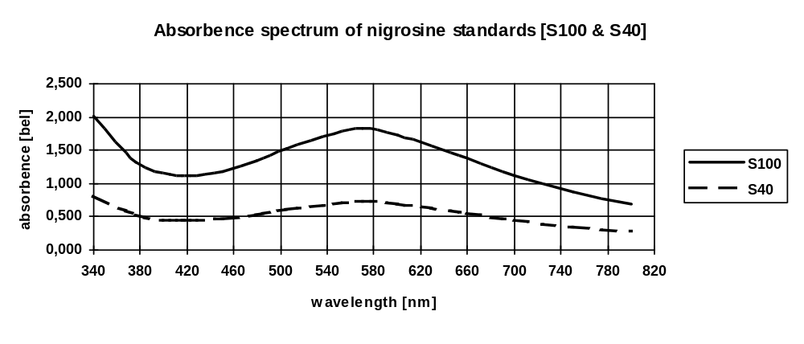
Fig. 2

Error Budget / Tolerance Zone
The tolerance zone consists of following uncertainties:

a) Uncertainty of Method
b) Uncertainty of AUT (Analyser Under Test)
c) Uncertainty of standard and its reference-determination

The method- and analyser uncertainties are fix, the standard uncertainty may change with each new lot of validation kit. Refer to the packing insert of the validation kit for the reference no’s of the calibration certificates which contains the valid reference-value uncertainties (u₁). If necessary make a recalculation of G_{total} as described in this procedure and apply it in the validation protocol or the validation spreadsheets.

The total uncertainty contains error components type A and error components type B

For the type B error components, listed in Table 2, the estimated maximum-error is divided by square root of 3 since the distribution of the variation of the error components is unknown.

List of uncertainties:
Source | Type | Uncertainty | u_{x}
Standard | B | Uncertainty of reference-value determination by the accredited calibration lab (to be divided by 2 if k=2) | u₁
 | B | Long-term stability for 18months (max. value to be divided by 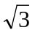) | u₂
 | B | temperature dependence for max. ±0,2°C (max. value to be divided by ) | u₃
 | B | cuvette variation (max. value to be divided by ) | u₄
Method | B | uncertainty caused by wavelength uncertainty of analyser (max. value to be divided by ) | u₅
Analyser | A | Specified absorbence-uncertainty of analyser | u₆

Table 2

Calculation of G_{total}
* divided by 2 because k- factor = 2 according calibration certificate

Analyser, wavelength and method-specific uncertainty’s of absorbence
Analyser / wavelength | uncertainties
 | Solution | u₁ | u₂ | u₃ | u₄ | u₅ | u₆ | G_{total}**
HITACHI, 340nm | S100 | 0,020* | 0,180 | 0,001 | 0,005 | 0,040 | 0,001 | 0,210
HITACHI, 376nm | S100 | 0,012* | 0,100 | 0,001 | 0,005 | 0,010 | 0,001 | 0,110
HITACHI, > 376nm | S100 | 0,012* | 0,050 | 0,001 | 0,005 | 0,010 | 0,001 | 0,061
ES 300/600/700, 422nm | S40 | 0,004* | 0,050 | 0,015 | 0,000 | 0,001 | 0,003 | 0,063

Table 2

* Example; value may change with new reference-values for new lot. Refer to
packing insert of validation-kit

** Calculation of G_{total} according chapter 6.2

Literature
- DIN 1319
„Grundbegriffe der Meßtechnik“
Basic concepts of measurements; concepts for uncertainty of measurement and evaluation of measuring instruments

- Absorbence Standard Nigrosine (S100 / S40)
Standards in absorbtion spectrometry-Techniques in visible and UV spectrometry; Vol I, UV spectrometry group (1981), Chapman and Hall Ltd.

- Vocabulary and symbols
ISO 3534-1977(E/F)
Statistics - Vocabulary and symbols, first edition - 1977-07-01
Statistique - Vocabulaire et symboles, Première édition - 1977-07-01

- Photometer specifications
DIN 5030 Teil 1, Juni 1985
DIN 5030 Teil 2, Sept. 1982
DIN 5030 Teil 3, Dez. 1984
Spektrale Strahlungsmessung

- Guidelines for the Expression of Uncertainty of Measurement in Calibrations
Western European Calibration Co-operation, WECC Doc. 19-1990

History of Changes
Version | Date | Changes, Amendments,
V 0.1 | March ‘97 | 1. Edition
V 1.0 | November ‘97 | Error budget calculation according WECC 19-1990
V1.01 | November ‘97 | Some minor changes in wording
V1.02 | November ‘97 | Some minor changes in wording
V1.1 | Vovember ‘97 | Change of Version No. only
Table 4

Appendices (Example for validation kit packing-list)
2 Pages

