Laboratory Accreditation
Specification Validation Procedure
Traceability of dye solutions for
Linearity check
Version 1.1

Date: December 1997
Written by: | Mr. Mathew, LI-E1
Authorized by: | Mr. Kolsch, LI-TG
Checked by: | Mr. Bamberg, LI-E1
Released by: | Mr. De Caluwé, LI-E

This sheet provides a Validation procedure to comply with the requirements of laboratory accreditation standards.

This sheet is an uncontrolled copy.

Laboratory Accreditation Spec. Validation Procedure
on Traceability of dye solutions for
Linearity check
Content:

1 Validity
2 General description & measuring theory
3 Traceability of the Validation Standards
3.1 Calibration hierarchy of linearity standards
3.1.1 Used scales for S100 subdilutions
4 Error Budget
4.1 Hierarchy of Stock- and Subdilutions
4.2 Solution S100 (stock-solution)
4.3 Solution S80
4.4 Solution S60
4.5 Solution S40
4.6 Solution S20
4.6.1 Tolerance Zone
5 Literature
6 History of Changes

Purpose
This validation procedure describes the traceability chain and the error budgets for the dilution series S20, S40, S60, S80 and S100 used for the photometer linearity check. Since the quantity of each production-lot can change, some contents of this procedure are lot-dependent (due to the usage of different scales related to the production quantity).

Validity
This procedure is valid for validation kits with lot no. 06 or higher.

Solutions | Analyser
S100, S80, S60, S40, S20, KS100* | HITACHI, ES300, ES600, ES700, KEYSYS
table 1 * = identical with S100

General description & measuring theory
The dilution series used for the photometer linearity check consists from 4 subdilutions which were produced from the stock solution S100. The absolute value of S100 and its subdilutions is not critical, but the dilution ratio between each subdilution.

Traceability of the Validation Standards
All solutions are produced in a production environment where all equipment and production personnel is submitted to the requirements of GMP, FDA and ISO9001. Due to the usage of very precise scales which are calibrated regularly, the traceability to national weight standards is guaranteed. All scales are calibrated either by the internal calibration facility or directly by the „Eichamt Mannheim“ which is the local representation of the PTB (Physikalisch Technische Bundesanstalt). The dilution ratios between all dyes is checked by a „SWEDISH NATIONAL LABORA-TORY“ (SP-Sveriges Provnings- och Forskningsinstitut, 15 Boras). The reference no’s. of the calibration certificates are listed in the packing inserts of each validation kit. The transmittance standard as well as the wavelength standard at SP are traceable to the „National Physical Laboratory, Great Britain“.

Calibration hierarchy of linearity standards

National Physical Laboratory
Great Britain

NBS Transmittance-Standard

HOLMIUM Wavelength-Standard

SP
Swedish National Testing
and Research Institute

Boehringer Mannheim GmbH

Liquid Volume Standards
S100, S80, S60, S40, S20
KS100

AUT

Analyzer under Test

fig. 1

Used scales for S100 subdilutions
scale | type | cal. ID | inaccuracy | calibration interval | calibration  standard | used for dyes
W1 | SARTORIUS 2022 |  | 0.1mg | daily &  3 months | weight set 7035, class E2 | nigrosine, S100
W2 | METTLER PK 4800 |  | 0.1g | daily &  3 months |  | *
W3 | METTLER PK 36 |  | 0.1g | daily &  3 months |  | *
W4 | METTLER ID5 MultiRange 60kg |  | 1.0g | daily &  3 months |  | S20 - S80
W5 | METTLER PM 4000 |  |  | daily &  3 months |  | *
W6 | METTLER ID5 MultiRange 1500kg |  |  | daily &  3 months |  | *

table 2
Absorbence spectrum of nigrosine
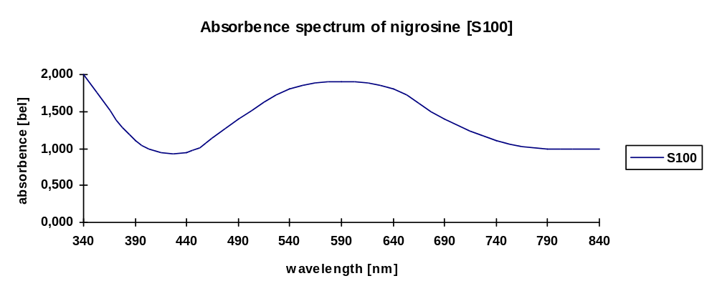
fig. 2

Error Budget

Hierarchy of Stock- and Subdilutions

Stock Solution S100

METTLER ID5
MultiRange
W4

S 80
= 80% of S 100

S 60
= 60% of S 100

S 40
= 40% of S 100

S 20
= 20% of S 100

fig. 3

Solution S100 (stock-solution)

Due to the fact that the linearity of the EUT-photometer is checked by the dilution (absorbence) ratio between S100 and its subdilutions, the absolute absorbence of S100 has none impact to the results. Therefore for S100 the dye stability has to be taken into consideration only.

Total amount [Total]: 26000.00g
Nigrosine amount [NIG]: 2.08g
Water (BS) amount [BS ] 25997.92g

Used scale W1 (for nigrosine): Sartorius 2022
Used scale W4: METTLER ID5 MultiRange
Scale calibration interval: 6 month
Scale Inaccuracy W1 u_{scaleW1} 0.1mg
Scale Inaccuracy W4 u_{scaleW4} ±1.000g

Instability of dye u_{instable} ±1%

Inaccuracy caused by dye-instability ± 1.000%

Total inaccuracy: ≈ ± 1 %

Solution S80

Total amount [Total]: 7500g
S100 amount [S100]: 6000g
Water (BS) amount [BS ] 1500g

Used scale: METTLER ID5 MultiRange
Scale calibration interval: 6 month
Scale Inaccuracy u_{scale} ±1.000g
Instability of dye u_{instable} ±1%

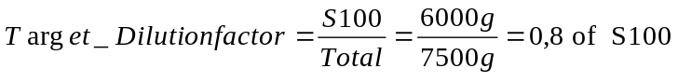

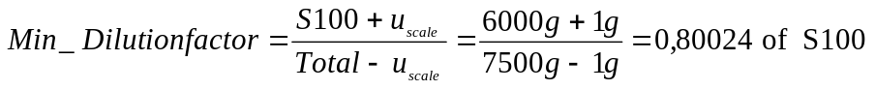

Inaccuracy caused by scale expressed dilution error: ± 0.024% (neglect)
Inaccuracy caused by dye-instability ± 1.000%

Total inaccuracy: ≈ ± 1 %

Solution S60

Total amount [Total]: 7500g
S100 amount [S100]: 4500g
Water (BS) amount [BS ] 3000g

Used scale: METTLER ID5 MultiRange
Scale calibration interval: 6 month
Scale Inaccuracy u_{scale} ±1.000g
Instability of dye u_{instable} ±1%

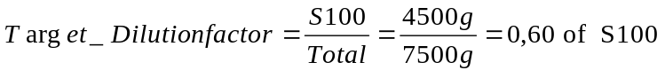

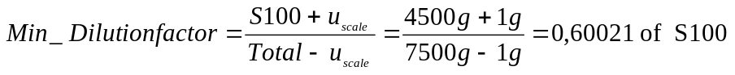

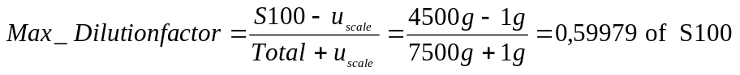

Inaccuracy caused by scale expressed dilution error: ± 0.021% (neglect)
Inaccuracy caused by dye-instability ± 1.000%

Total inaccuracy: ≈ ± 1 %

Solution S40

Total amount [Total]: 14000g
S100 amount [S100]: 5600g
Water (BS) amount [BS ] 8400g

Used scale: METTLER ID5 MultiRange
Scale calibration interval: 6 month
Scale Inaccuracy u_{scale} : ±1.000g
Instability of dye u_{instable} : ±1%

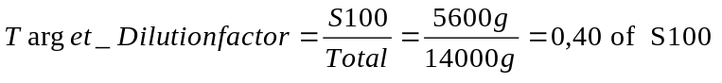

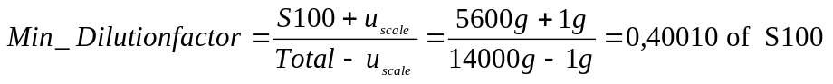

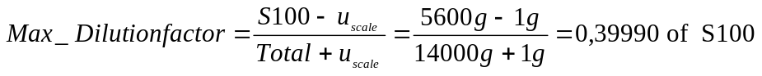

Inaccuracy caused by scale expressed dilution error: ± 0.010% (neglect)
Inaccuracy caused by dye-instability ± 1.000%

Total inaccuracy: ≈ ± 1 %

Solution S20

Total amount [Total]: 7500g
S100 amount [S100]: 1500g
Water (BS) amount [BS ] 6000g

Used scale: METTLER ID5 MultiRange
Scale calibration interval: 6 month
Scale Inaccuracy u_{scale} : ±1.000g
Instability of dye u_{instable} : ±1%

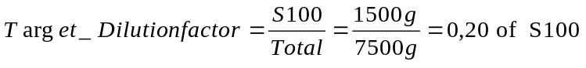

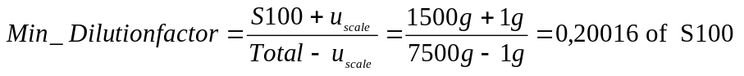

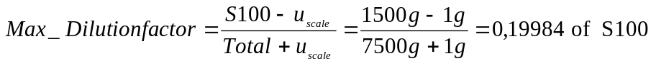

Inaccuracy caused by scale expressed dilution error: ± 0.016% (neglect)
Inaccuracy caused by dye-instability ± 1.000%

Total inaccuracy: ≈ ± 1 %

Tolerance Zone

The tolerance zone consists from the uncertainty of the validation method itself and the analysers uncertainty. The table below shows the total uncertainty for all analysers which can be checked by the dilution series S20,S40, S60, S80 and S100.
Furthermore an analyser specific method-uncertainty is given. This uncertainty describes, for example, additional uncertainties which are caused by cuvettes on systems where no cuvette-blank for the elimination of the cuvette impact can be used.

For all analysers the medians of the measurements for each dilution step are used.

The tolerance zones are symmetrical. The total uncertainty G_{total} is specified as follows:
G_{total} = G_{analyzer} + u_{method1} + u_{method2}

G_{total} = Total uncertainty
G_{analyzer} = specified analyser linearity uncertainty
u_{method1} = basic uncertainty of method including instability of solutions
u_{method2} = analyser specific uncertainty of method (e.g. impact of cuvettes)

Analyser type | G_{analyzer} | u_{method1} | u_{method2} | G_{total}
HITACHI 917 | 1.5 % | 1.0 % |  | 2.5 %
HITACHI 912 | 1.5 % | 1.0 % |  | 2.5 %
HITACHI 911 | 1.5 % | 1.0 % |  | 2.5 %
HITACHI 904 | 1.5 % | 1.0 % |  | 2.5 %
HITACHI 902 | 1.5 % | 1.0 % |  | 2.5 %
HITACHI 747-100 | 1.5 % | 1.0 % |  | 2.5 %
HITACHI 747-200 | 1.5 % | 1.0 % |  | 2.5 %
HITACHI 747-400 | 1.5 % | 1.0 % |  | 2.5 %
HITACHI 737
HITACHI 717 | 1.5 % | 1.0 % |  | 2.5 %
HITACHI 705 | 1.5 % | 1.0 % |  | 2.5 %
HITACHI 704 | 1.5 % | 1.0 % |  | 2.5 %
ES 300 | 1.0 % | 1.0 % | 0.5 % (water carry-over) | 2.5 %
ES 600 / ES 700 | 1.0 % | 1.0 % | 0.5 % (water carry-over) | 2.5 %
KEYSYS | 1.0 % | 1.0 % | 0.5 % (cuvette impact) | 2.5 %
table 3

Literature
- DIN 1319
„Grundbegriffe der Meßtechnik“
Basic concepts of measurements; concepts for uncertainty of measurement and evaluation of measuring instruments

- Absorbence Standard Nigosine (S100)
Standards in absorption spectrometry-Techniques in visible and UV spectrometry; Vol I, UV spectrometry group (1981), Chapman and Hall Ltd.

- Vocabulary and symbols
ISO 3534-1977(E/F)
Statistics - Vocabulary and symbols, first edition - 1977-07-01
Statistique - Vocabulaire et symboles, Première édition - 1977-07-01

- Photometer specifications
DIN 5030 Teil 1, Juni 1985
DIN 5030 Teil 2, Sept. 1982
DIN 5030 Teil 3, Dez. 1984
Spektrale Strahlungsmessung
- Guidelines for the Expression of Uncertainty of Measurement in Calibrations
Western European Calibration Co-operation, WECC Doc. 19-1990

History of Changes
Version | Date | Changes, Amendments,
V 0.1 | March ‘97 | 1. Edition
V 1.1 | Dec. ‘97 | Adapted to ref. determin. at SP, Sweden
table 4

